Metrics extended trends by approaches

Metrics performance overview

On the clustermaps in Figure 3 and Supplementary Figure 7 we observed a trade-off between local mixing and global batch correction metrics. To establish the origin of this trend, we analyzed the harmonization metrics by metric group, harmonization method and batch removal strategy. In our analysis, we treated the metrics of the clustermap-selected best approaches (Figure 3) as a separate group. The results are summarized in the three figures of the current section (Extended Figures 1-3).

For the global PCA-based metrics we selected Principal Component Regression (PCReg) as the least biased of them. PCReg is reported here in polarity-adjusted form, so that a value of 0 indicates that the annotation column explains all of the PCA variation and a value of 1 indicates that it explains none of it. We compared its distribution for the principal batch column, RNA_BATCH, with that for the biology column Diagnosis_cell_type_unified. We annotated the resulting scatter plots by harmonization method (Extended Figure 1A) and by batch removal strategy (Extended Figure 1B), obtaining a weak negative correlation (Spearman r = -0.159, p = 3.7 * 10⁻¹⁴, 95% CI -0.20 to -0.11). The clustermap-selected best approaches occupied the upper-right quadrant of the plot, showing extensive overlap of both batches and biological groups (median 0.871 and MAD 0.122 by batch against a median of 0.626 for the remaining approaches; median 0.820 and MAD 0.063 by biology against 0.802). Only the batch difference between the best approaches and the rest was significant (two-sided Mann-Whitney U test, p = 6.3 * 10-3 for batch and p = 0.69 for biology).

05_combat and 29_combat_ref harmonization showed better separation of biology for A, B, I, J and E1-E3 strategies (Extended Figure 1A; median PCReg Diagnosis_cell_type_unified 0.568 over these strategies against 0.778 for the remaining methods, full range 0.357-0.823), but they were not selected in the clustermap-based assessment (Figure 3). 33_amdbnorm returns a PCReg RNA_BATCH of exactly 1.0000 in all 14 of its runs, and 13_fsmvn reaches a median of 1.0000 (range 0.9967-1.0000) — a global metric pinned at its theoretical optimum — yet neither was selected as the best approaches in the clustermap because of poor performance of other metrics (except for S0 strategy, Figure 3). It should also be noted that 33_amdbnorm completed only 14 of its 84 possible runs, the remainder being terminated by the three-hour timeout (Supplementary Figure 6). Smooth quantile harmonization (14_qsmooth) showed the lowest batch correction performance by PCReg (Extended Figure 1A, median 0.208, MAD 0.098). At the level of batch removal strategies, malignant only, FFPE only and S0 showed the worst performance by biology and formed quasi-horizontal lines (medians 0.939, 0.925 and 0.883, respectively), whereas the RNA-seq-only strategy had the greatest average ability to correct batch variation (Extended Figure 1B, median 0.872). Notably, the malignant only and FFPE only strategies did not have normal B cells, so their number of unique classes by Diagnosis_cell_type_unified was only four (four in every malignant-only run and in 163 of the 164 FFPE-only runs). The FF-only strategy showed comparatively less overlap of both batch and biology groups in PCA space (median 0.529 and 0.745, respectively). Harmonization methods formed diagonal bands running from the upper left to the lower right of the plot; those close to the PCReg RNA_BATCH = 1 boundary became vertical, such as 21_harmonizr and 02_median_scaling (Extended Figure 1A).

It should be noted that the S0 01_raw dataset (strict NA handling, no post-removal), that is, the full dataset of 7,174 samples and 3,447 genes without harmonization, had PCReg RNA_BATCH 0.226. This corresponds to 77.4% of the total PCA variance in all PCs being explained by batch — a baseline that successful harmonization is expected to reduce, thereby raising the polarity-adjusted PCReg value.

To resolve the variation at the level of individual components, we calculated the percentage of variance explained by each of the first ten PCs together with the R2 explained by RNA_BATCH for each of them. The resulting heatmaps (Extended Figure 1C) showed that five methods (20_shambhala, 18_rank, 17_quantile, 15_fsqn_py, 25_angel) had a slow decay of variance percentage explained by PC, starting with 17.3-25.3% for the first PC, 11.3-15.3% for the second, and so on. A further eight methods (33_amdbnorm, 28_npn, 26_xpn, 22_tmm, 23_vst, 10_mnn, 09_ruv, 12_scanorama) and the group of clustermap best approaches had more variance explained by the first component (26.2-43.3%) and the same slow decay over PCs. The remaining 18 methods concentrated a large proportion of the variance in the first PC (up to 79.9% in 11_harmony, 79.5% in 27_dwd).

PCA variance explained by batch (R² by RNA_BATCH) showed a more complicated pattern. For the five leading methods by average PCReg RNA_BATCH (33_amdbnorm, 13_fsmvn, 03_limma, 07_pycombat, 28_npn) R² values were below 1% for all PCs (0.0024 at maximum, for 07_pycombat PC2), implying that the batches almost completely overlapped in PCA space. Local mixing for these approaches was nonetheless poor (Figure 3) with the exception of 33_amdbnorm applied to the NGS and Illumina microarrays (Supplementary Figure 17) as we showed earlier in this study. 19 of the 31 methods showed a lower RNA_BATCH R2 for the first PC than for the subsequent PCs. Of the five methods that showed a smooth decay in the percentage of variance explained, four (all but 20_shambhala) had their maximum RNA_BATCH R2 at a component other than the first. This pattern suggests that these methods do not abolish batch-level variance but displace it into lower-ranked PCs, which manifests itself as poor local mixing performance. The group of clustermap best approaches showed average 37.9 and 11.6% total variance explained and 22.9 and 15.2% R² RNA_BATCH by first and second PC, respectively. 14_qsmooth, the worst method by PCA-based performance, showed averages of 53.7 and 13.5% total variance explained and 90.8 and 67.1% R² RNA_BATCH by first and second PC, respectively. No harmonization (01_raw) resulted in 64.8 and 65.9% R2 RNA_BATCH and 73.5 and 9.7% of total variance explained by first and second PC. The 73.5 differs from 81.1% in Figure 4A because the former was averaged among all the batch removal strategies and imputations, and the latter was calculated for precisely one approach: S0 strategy, 01_raw harmonization, strict NA handling and no post-removal.

Extended Figure 1. Global PCA-based metrics performance by harmonization methods and batch removal strategies. (A) Scatterplot of PCReg Diagnosis_cell_type_unified versus PCReg RNA_BATCH, color annotated by harmonization method. The clustermap best approaches are shown with black asterisks. (B) Scatterplot of PCReg Diagnosis_cell_type_unified versus PCReg RNA_BATCH, color annotated by batch removal strategy, with the same highlighting of the clustermap best approaches. (C) Heatmaps showing percentage of total variance explained (left heatmap) and percentage of the RNA_BATCH-explained variance for the first 10 PCs, grouped by harmonization method and sorted by PCReg RNA_BATCH. The composite group of the best approaches is shown by the black cell with an exclamation sign on the harshness level color annotation.
Alt text: Global PCA-based metric panels: scatter plots of biology versus batch principal-component regression colored by method and by strategy, and heat maps of variance and batch-explained variance across the first ten principal components.
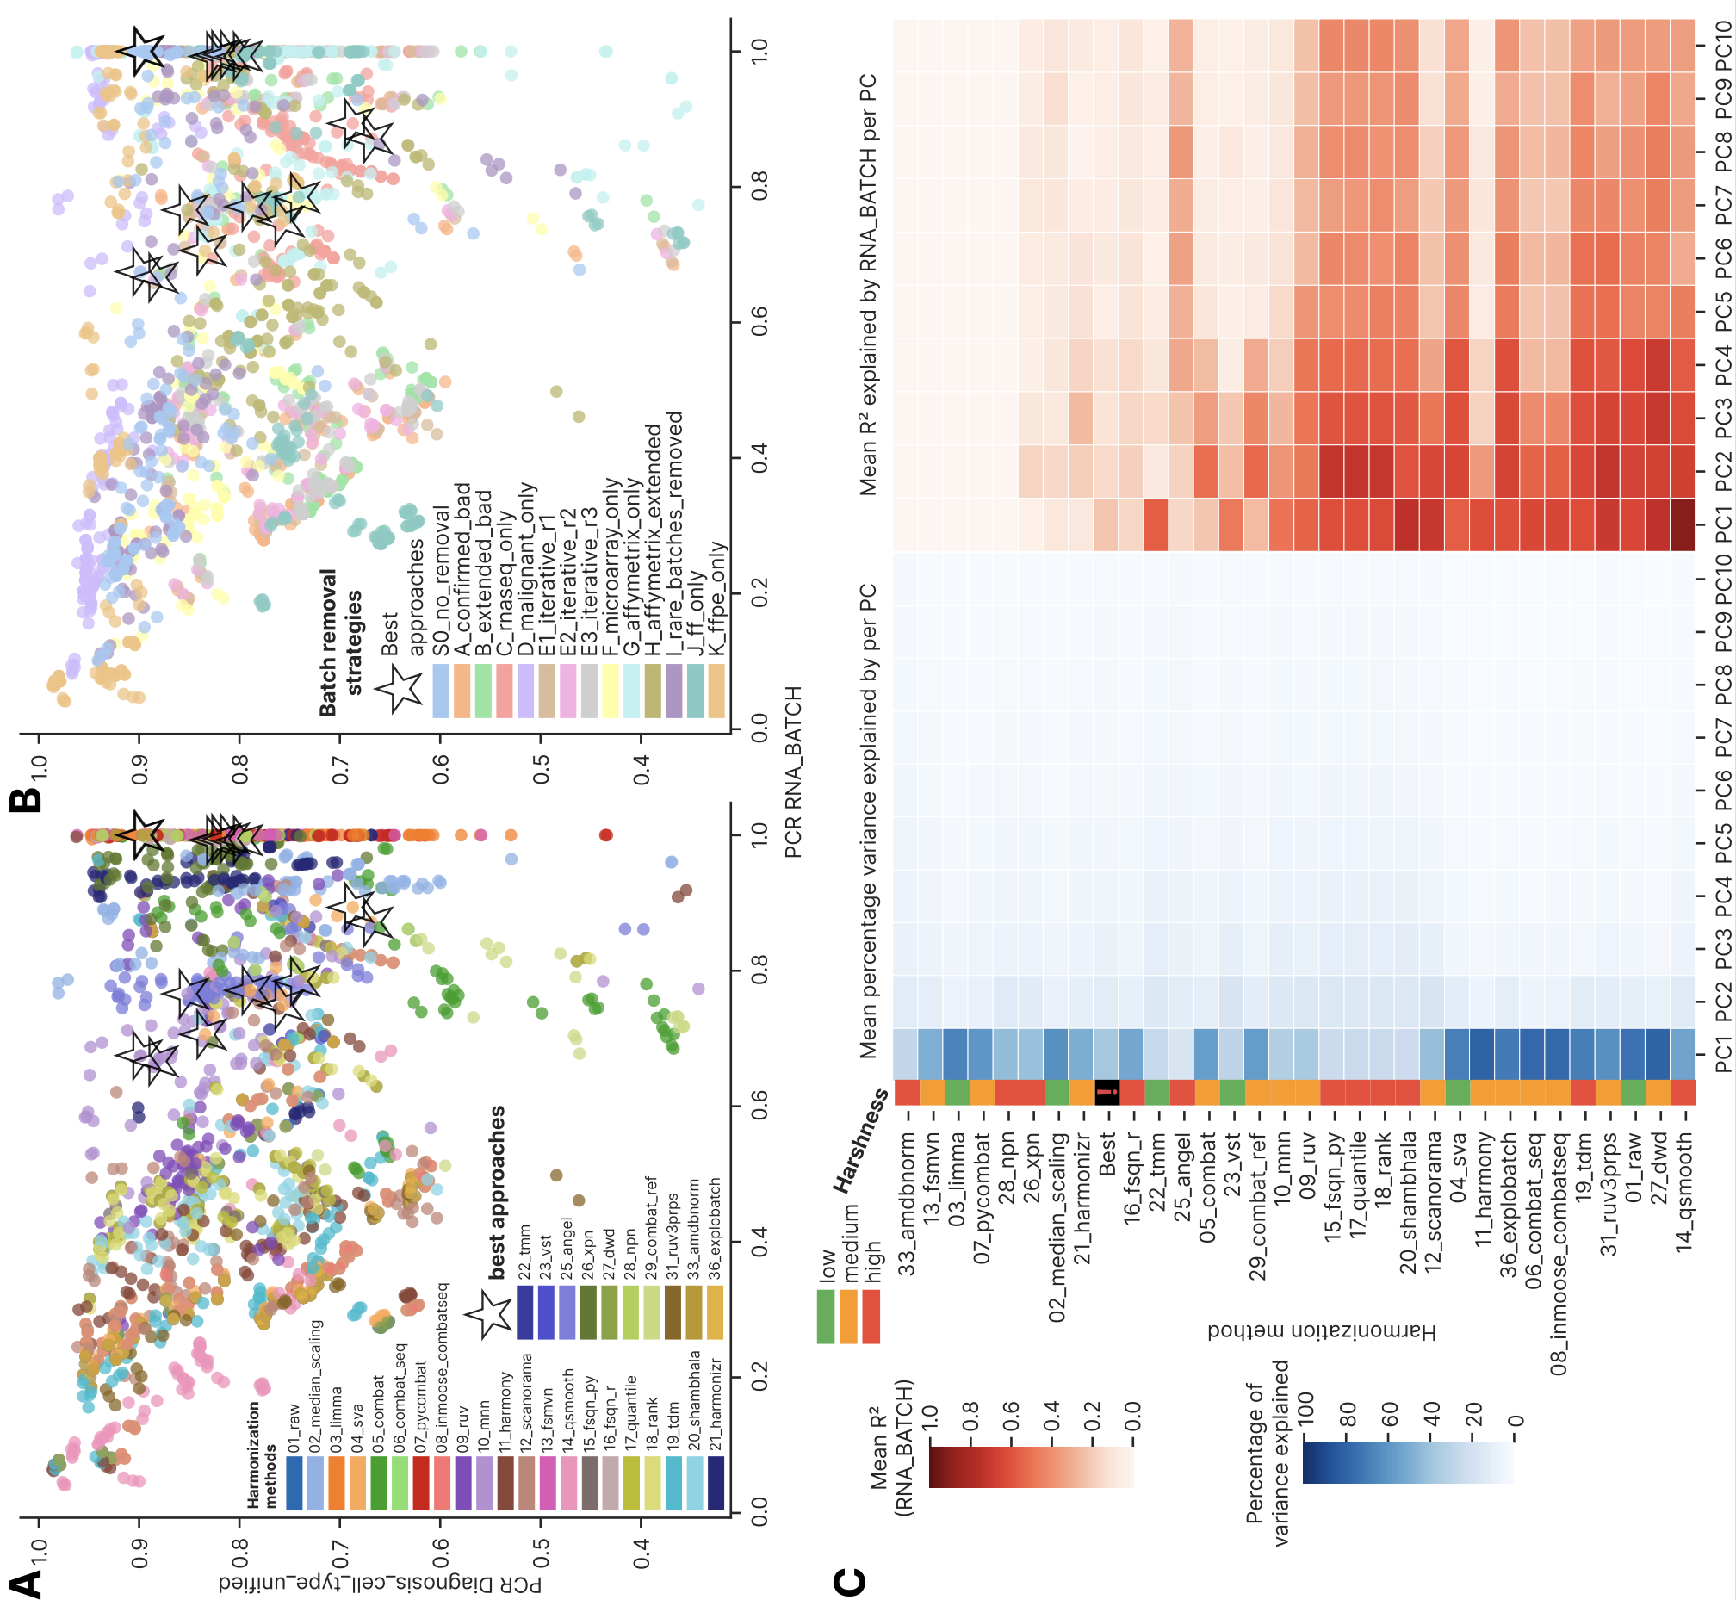

We next examined the performance of the local mixing (local neighborhood) metrics (Extended Figure 2). As a representative metric we selected Local Inverse Simpson's index (LISI) because it was distributed across the whole local-metric cluster in Supplementary Figure 7, and visualized it for the same biology and batch columns by harmonization method (Extended Figure 2A) and batch removal strategy (Extended Figure 2B). The clustermap best approaches occupied the right half of the scatterplots, showing higher than average local batch mixing but no visible trend in the local preservation of biological groups (two-sided Mann-Whitney p = 2.0*10⁻⁷ for batch and 0.80 for biology). 10_mnn harmonization conferred the highest degree of local batch mixing (median 1.72, MAD 0.209, median for all approaches 1.16 and MAD 0.103), as shown earlier in Figure 3. 14_qsmooth was the worst one by batch mixing as in the case of PCReg by RNA_BATCH, showing median 1.07 and MAD 0.032. Batch removal strategies formed separate curved bands, layered in an order resembling that of PCReg by biology in Extended Figure 1B: FFPE only and malignant only had lowest local mixing of biology groups (median 1.07 and 1.10, respectively), and FF only had the highest local biology mixing, followed by Affymetrix extended and RNA-seq only (median 1.62, 1.41 and 1.39, respectively). We also observed a positive correlation between biology and batch mixing (Spearman r = 0.527, p = 7*10⁻¹⁶⁰ for the entire dataset), which implies a trade-off: better local mixing of batches is accompanied by lower integrity of biology-defined local neighborhoods. The significant positive correlation (FDR p < 0.05, Spearman r varied from 0.374 to 0.815 with median 0.617) was observed for all batch removal strategies except the G one.

As an additional local mixing metric, we visualized tSNE entropy calculated by RNA batch (Extended Figure 2C) – which by construction tracks the mixing of batches in the tSNE embedding. As in the case of LISI, 10_mnn was the best method (median 0.179, MAD 0.025), 14_qsmooth was the worst one (median 0.0178, MAD 0.0086). Among the batch removal strategies, RNA-seq only and FF only were the best (median 0.089 and 0.063, respectively), whereas FFPE only and Affymetrix only were the worst (median 0.011 and 0.015, respectively). The clustermap best approaches occupied local peaks in the heatmap, indicating that tSNE entropy reliably represents local mixing performance. To contrast the local tSNE mixing, we also visualized a global tSNE metric, namely tSNE centroid dispersion, in the analogous heatmap (Extended Figure 2D). Harmonization methods separated cleanly into low- and high-dispersion regions (method means ranging from 0.24 for 13_fsmvn to 1.00 for 27_dwd), and the clustermap best approaches tended to lie at the boundary between them. This pattern suggests that tSNE centroids are poor measures of harmonization quality, because tSNE does not preserve global distances, and global metrics should be calculated in PCA space, whereas the local ones are inherently linked to the non-linear dimensional reduction approaches such as tSNE and UMAP.

Extended Figure 2. Local mixing-based metrics performance by harmonization methods and batch removal strategies. (A) Scatterplot of cell-type LISI (cLISI) Diagnosis_cell_type_unified versus integration LISI (iLISI) RNA_BATCH, color annotated by harmonization method. Both metrics are non-normalized, and the normalized ones were used in the Figure 3 clustermap. (B) Scatterplot of cLISI Diagnosis_cell_type_unified versus iLISI RNA_BATCH, color annotated by batch removal strategy. (C) Heatmap of tSNE entropy calculated by RNA_BATCH, ordered by harmonization methods and batch removal strategies. (D) The analogous heatmap of tSNE centroid dispersion calculated by RNA_BATCH. For all panels, the clustermap-based best approaches are shown with black asterisks.
Alt text: Local-mixing metric panels: scatter plots of biology versus batch LISI colored by method and by strategy, and heat maps of tSNE entropy and tSNE centroid dispersion by RNA batch.

As a final part of the harmonization quality metrics comparison among the approaches, we examined the metrics that fall outside the main global/local axis, as well as the selected quantiles from the gene expression distributions (Extended Figure 3). To test systematically whether harmonization drives convergence of gene expression distributions, we plotted the mean Kolmogorov-Smirnov D statistic computed within batches over 1,000 randomly selected genes against the mean between-batch (RNA_BATCH) D statistic for the same 1,000 genes (Extended Figure 3A).

The clustermap best approaches were in the lower half of the plot (median 0.445, MAD 0.041) indicating closely similar gene expression distributions within each batch group. Individual harmonization methods formed vertical bands of data points, implying that the tools differ in their ability to transform batch distributions to a common shape. At the level of batch removal strategies (Extended Figure 3B), on the other hand, horizontal layers formed at a fixed within-batch mean D statistic, with the RNA-seq only strategy occupying the lower left corner of the plot (KS cohort within batch mean D median 0.439 and MAD 0.015, KS mean D RNA_BATCH median 0.332, MAD 0.052).

We then compared the percentage of samples and genes without missing values (Extended Figure 3C, D, respectively) by harmonization approaches. All samples had all genes with defined expression values for 18 of the 31 harmonization methods, regardless of the batch removal strategy used; 9 further methods lost a minor share of 0.003-1.4% of samples to at least one missing value, and 4 methods (26_xpn, 20_shambhala, 15_fsqn_py and 17_quantile) lost 30.2-38.1%. At the level of genes with NA (Extended Figure 3D), the same 18 harmonization methods returned no missing value at all, 10 further methods had 0.004-2.41% of genes carrying a missing value in at least one sample, 15_fsqn_py and 17_quantile had 13.0 and 16.2%, and 21_harmonizr lost every gene in 8 of the 14 batch removal strategies.

The harmonization methods differed markedly in the expression range of their outputs (Extended Figure 3E). 08_inmoose_combatseq and 06_combat_seq produced extreme outliers, with mean maximum expression of 1.46*1011 and 2.76*108 respectively, whereas their 99th percentiles were only 17.9 and 18.5. 20_shambhala had generally high expression outputs, with 555004.7 maximum expression and 1359.6 median. 19_tdm had 75.1 median and 568.9 maximum value. 18_rank and 25_angel collapsed the entire distribution to the interval between 0 and 1, and 28_npn had expression median below zero (-0.01). All remaining methods were comparable with the standard RNA-seq log2 (transcripts per million, TPM) range, having median expression at the level of 1.90-7.08. In total, 19 of the 31 harmonization methods had a mean minimum gene expression value below zero (the lowest being -40.6 for 13_fsmvn). Relative to the full set of approaches, the best ones showed greater uniformity of expression profile (Extended Figure 3F). SVA, FSQN R, FSMVN and AMDBNorm started with zero or negative values: -10.8 to -4.98 for SVA, -8.07 to 0 for FSQN R, -19.4 for FSMVN and -6.25 for AMDBNorm. MNN started from positive values (1.61 to 2.44); across the fifteen best approaches the median expression lay between 2.63 and 6.70 and the maximum between 12.6 and 28.6. This greater uniformity brings the best approaches close to a typical log2(TPM) distribution, whereas methods returning atypical expression profiles (20_shambhala, 08_inmoose_combatseq and 06_combat_seq) performed poorly.

Extended Figure 3. Additional quality metrics and gene expression snapshots by harmonization methods and batch removal strategies. (A) Scatterplot of mean D statistic of Kolmogorov-Smirnov test between all sample pairs within batches versus mean between-batches (by RNA_BATCH) D statistics, colored by harmonization methods. (B) The same scatterplot colored by batch removal strategies. (C) Heatmap of percentage samples without NA gene expression values, ordered by harmonization methods and batch removal strategies. (D) The analogous heatmap of percentage genes without NA gene expression values. For the panels A-D, the clustermap-based best approaches are shown with black asterisks. (E) Heatmap showing gene expression minimum, maximum, the 1st, 5th, 25th, 50th (median), 95th and 99th percentile as well as gene standard deviation, averaged and visualized for harmonization methods. The methods are ordered by ascending PCReg RNA_BATCH. (F) The analogous heatmap for the 15 clustermap-selected best approaches.
Alt text: Additional-metric panels: Kolmogorov–Smirnov within- versus between-batch distribution scatter plots, heat maps of the percentage of samples and genes without missing values, and heat maps of expression-value distribution statistics by method and for the best approaches.

Global metrics
Among the global metrics we first analyzed principal component regression (PCReg) by batch and biology columns (Extended Figure 4), comparing different harmonization methods (Extended Figure 4A), batch removal strategies (Extended Figure 4B) and the clustermap best approaches. 12 of the 31 harmonization methods showed better PCA overlap of batches than biology and were considered to be of ‘good’ quality, and the clustermap best approaches were deemed ‘good’ too. Five of the methods (33_amdbnorm, 13_fsmvn, 03_limma, 07_pycombat, 28_npn) showed mean PCReg values of 0.999 or above, with 33_amdbnorm at exactly 1.0000, indicating essentially complete overlap of batches in PCA space. At the level of batch removal strategies, only two of them (C and G) demonstrated higher overlap by batch compared to biology, which suggests that the harmonization method affects the PCA-level resolution of batches more than the prior batch removal strategy does.

Extended Figure 4. Principal component regression metrics comparison. (A) Barplot showing PCReg metrics by 3 columns visualized by harmonization methods, sorted by PCReg RNA_BATCH. Color annotations below the bars show method harshness score and overall quality. Best group means a composed group of the clustermap best approaches. (B) The analogous barplot for 4 PCReg metrics by batch removal strategies. Higher values indicate better overlap of classes by a given column in the PCA space. Error bars indicate 95% confidence interval (CI) estimation.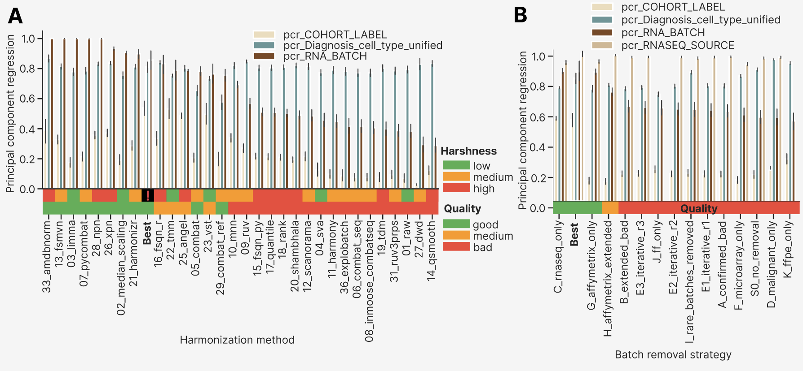

As a next step of global metrics analysis, we compared PCReg RNA_BATCH by imputations, looking at individual harmonization methods (Extended Figure 5A). Strict imputation was marginally poorer than KNN (mean PCReg RNA_BATCH 0.370 against 0.390 over the affected methods), whereas softimpute exceeded KNN by 1.7-9.7 percentage points (mean 4.8) for the 11 lowest-PCReg methods: 12_scanorama, 04_sva, 11_harmony, 36_explobatch, 06_combat_seq, 08_inmoose_combatseq, 19_tdm, 31_ruv3prps, 01_raw (no harmonization), 27_dwd and 14_qsmooth (the worst method by PCReg RNA_BATCH). We then compared PCReg RNA_BATCH by batch removal strategies, again investigating individual harmonization methods (Extended Figure 5B). The multiplatform strategies (S0, A, B, D, E1-E3, I) and FF only (J) reproduced the overall ordering of methods seen in the imputation plots (Extended Figure 5A), whereas RNA-seq only (C), FFPE only (K) and Affymetrix strategies (G, H) deviated from the general methods order by PCReg RNA_BATCH. In the C strategy every method reached a mean PCReg RNA_BATCH of at least 0.76; the corresponding floors were 0.72 for G and 0.46 for H. The 16_fsqn_r method also performed worse than its own average: 0.76 in G and 0.58 in H, against 0.83 averaged over all strategies (Extended Figure 4A). In the K strategy it fell to 0.08, and in the microarray-only strategy F to 0.30, indicating that FSQN is not applicable to FFPE datasets. Earlier in the main results we have shown that post-removal is the least important step in the computational pipeline. As a further check we compared PCReg RNA_BATCH by harmonization method with and without post-removal (Extended Figure 5C). Post-removal raised the mean PCReg RNA_BATCH for 30 of the 31 methods, but the median shift was only 0.030. The largest gains were for 22_tmm (0.70 to 0.88) and 23_vst (0.70 to 0.83), and 12_scanorama was the only method for which post-removal lowered the metric (0.49 to 0.48).

We defined the PCReg metric so that 1 denotes the best possible overlap in PCA space for a given column, that is, none of the variance is explained by that column. Conversely, 0 PCReg means that the entire variance is explained by the column, and this is the worst scenario for batch columns (RNA_BATCH, PLATFORM_RNA, COHORT_LABEL, RNASEQ_SOURCE) and the best one for the biology one (Major_Group, Diagnosis_cell_type_unified, TUMOR_NORMAL). Because the variance is unevenly distributed across the PCs, we compared PCReg RNA_BATCH against R² of RNA_BATCH in the first PCs by harmonization methods and batch removal strategies (Extended Figure 5D, 5E, respectively). As expected, we observed a strong negative relationship between the two, with the clustermap best approaches occupying the lower right corner of the plot. 10_mnn, 20_shambhala and 16_fsqn_r were shifted above the main diagonal, suggesting that their batch-explained variance is moved towards lower rank PCs. The same was true for the C strategy (Extended Figure 5E).

For all the batch removal strategies we also investigated batch-explained variance for the first 10 PCs (Extended Figure 5F), examining the percentage of variance explained and the R2 for RNA_BATCH at each PC. The joint group of the clustermap best approaches was the second one after the C strategy (shown earlier in Extended Figure 4B). At the heatmap both the strategy C and the clustermap best approaches group showed the lowest average percentage of variance explained by the first PC (30.4 and 37.9%, respectively), and the smoothest decay of the percentage by PC’s number. The G strategy showed the highest average percentage, 66.0%, presumably because the already quantile-normalized SOM cohort makes up a larger share of the samples in this strategy than in any other. The decay trajectory of R² RNA_BATCH for the strategy C and the best approaches started at 0.29 and 0.23, respectively, whereas the rest strategies (except for G and H) had higher first PC values. 10 of the 14 batch removal strategies had a lower R2 RNA_BATCH for the first PC than for the second.

Extended Figure 5. Global metrics comparison by imputation, harmonization methods and batch removal strategies. (A) Boxplots of PCReg RNA_BATCH by harmonization methods stratified by imputation. Methods are ordered by mean PCReg RNA_BATCH across all batch removal strategies, imputations and post-removals. The clustermap best approaches are highlighted in bold. (B) Boxplots of PCReg RNA_BATCH by harmonization methods stratified by batch removal strategies. Harmonization methods order is the same as in panel A, but with the group of clustermap best approaches is empty for strategies where no best approaches were selected. (C) Boxplots of PCReg RNA_BATCH by harmonization methods stratified by post-removal. The group of clustermap best approaches is empty in the post-removal boxplot because only the approaches without post-removal were selected. (D) Scatterplot showing correlation of PCReg RNA_BATCH and RNA_BATCH R² by first PC, color annotated by harmonization methods with black stars indicating the clustermap best approaches. (E) The same scatterplot color annotated by batch removal strategies. (F) Heatmaps showing percentage of total variance explained (left heatmap) and percentage of the RNA_BATCH-explained variance for the first 10 PCs, grouped by batch removal strategy and sorted by PCReg RNA_BATCH. The composite group of the best approaches is shown by bold font.
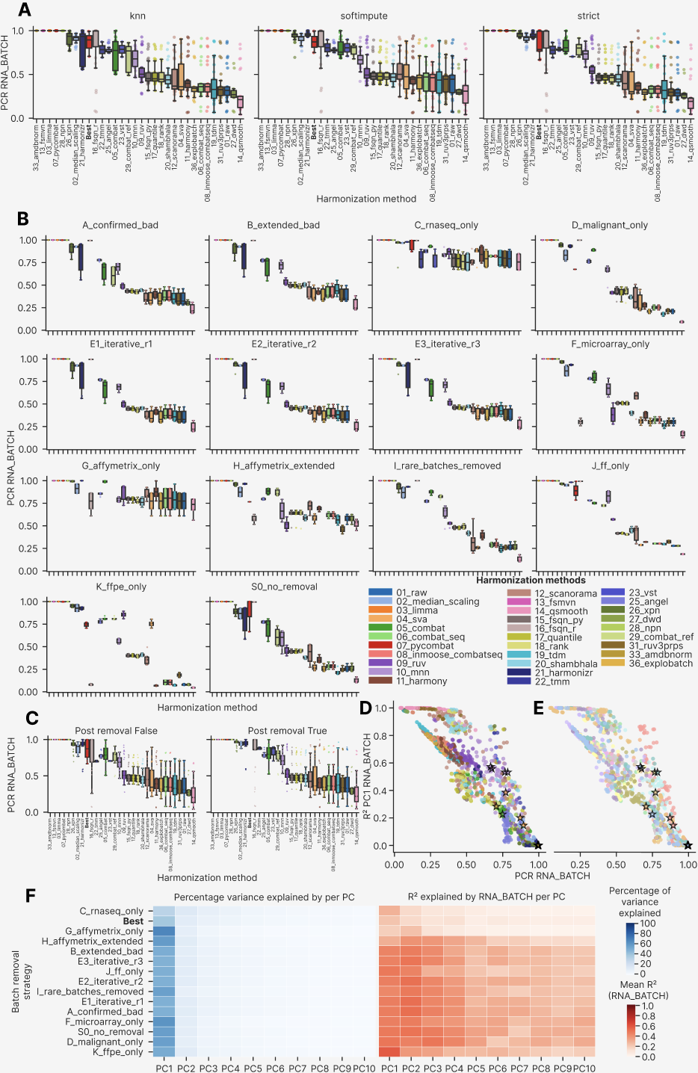
As the last step of global metrics analysis, we compared PCReg by various columns and non-PCReg metrics with the pre-established standard of PCReg RNA_BATCH (Extended Figure 6). PLATFORM_RNA is a coarser annotation than RNA_BATCH: one class of PLATFORM_RNA could correspond to 2-3 classes for RNA_BATCH. Therefore, PCReg by PLATFORM_RNA and PCReg by RNA_BATCH followed a strictly linear relationship (Extended Figure 6A), with the FFPE-only and FF-only strategies lying closest to the 1:1 diagonal. This follows from the fact that selecting FFPE-only or FF-only batches reduces the batch and platform classes to a 1:1 correspondence: for each platform only its FFPE or FF batch was selected. In the remaining strategies the multi-batch PLATFORM_RNA column explained less variance in PCA space than RNA_BATCH, so these strategies lie above the 1:1 diagonal. For COHORT_LABEL (Extended Figure 6B) we observed the inverse pattern: the approaches generally had higher COHORT_LABEL related variance (lower PCReg COHORT_LABEL) than the RNA_BATCH derived one. The clustermap best approaches were consistently found in the best third of the plots.

Dispersion separability criterion (DSC) was selected as an orthogonal PCA-based global metric, but it showed a monotonic, sigmoidal dependence on PCReg for the RNA_BATCH column (Extended Figure 6C). The dependence of DSC by PLATFORM_RNA on DSC by RNA_BATCH was again monotonic and linear on a logarithmic scale (Extended Figure 6D), without the non-trivial structure seen for PCReg (Extended Figure 6A). In contrast, DSC by COHORT_LABEL formed two clouds of points that were not explained by the batch removal strategy (Extended Figure 6E) and are more plausibly attributed to the harmonization method. All 15 clustermap best approaches fell below the overall median DSC RNA_BATCH of 0.962, but the four MNN approaches (0.781-0.957) lay at the very boundary, two orders of magnitude above the FSQN R ones (0.0013-0.0098). Such behavior follows from the definition of DSC as the ratio of between-group to within-group scatter, a quantity that remains sensitive to outliers even after log transformation.

Among the non-linear global metrics, we visualized and studied tSNE centroid dispersion (Extended Figure 6F, G, H) and Average Silhouette Width (ASW, Extended Figure 6I and J) – all by the RNA_BATCH column. As expected, tSNE centroid dispersion correlated negatively with PCReg, following a non-linear, arc-shaped pattern. A subgroup of 11_harmony approaches in the J and K strategies fell below the general trend, showing an improved tSNE centroid dispersion: 0.55-0.78 against a K-wide median of 0.87, and 0.62-0.68 against a J-wide median of 0.81 (Extended Figure 6F, G). For the dependency of tSNE centroid dispersion and PCReg we also investigated whether post-removal affects the approaches moving them towards better or poorer performance (Extended Figure 6H): we found no systematic shift except for the G strategy, whose median PCReg RNA_BATCH rose from 0.78 before post-removal to 0.88 after it. This can again be attributed to the SOM cohort, which contributes roughly 800 of the 2,801 GPL570 samples in this strategy. It also means that removing a single cohort after harmonization does not appreciably improve performance in most cases. ASW depended on PCReg in a noisier manner, with the G and K strategies showing the worst performance (mean ASW RNA_BATCH 0.165 and 0.078 against -0.066 to -0.019 for the remaining strategies) (Extended Figure 6I). Again, the G strategy was an upward outlier, located in the zone of 0.02-0.34 ASW but with the same high PCReg as the clustermap best approaches (PCReg 0.65-1.00). 02_median_scaling and 33_amdbnorm were the top-performing harmonization methods by ASW (mean ASW RNA_BATCH -0.286 and -0.276) (Extended Figure 6J).

Extended Figure 6. Additional global metrics analysis. (A) Scatterplot showing correlation of PCReg PLATFORM_RNA with PCReg RNA_BATCH. (B) Scatterplot of PCReg COHORT_LABEL versus PCReg RNA_BATCH. (C) Scatterplot of DSC RNA_BATCH versus PCReg RNA_BATCH. (D) Scatterplot of DSC PLATFORM_RNA versus DSC RNA_BATCH. (E) Scatterplot of COHORT_LABEL versus DSC RNA_BATCH. Scatterplots in the panel A-E are color annotated by batch removal strategy. (F) Scatterplot of tSNE centroid disp RNA_BATCH versus PCReg RNA_BATCH, color annotated by batch removal strategy. (G) The same scatterplot of tSNE centroid disp RNA_BATCH versus PCReg RNA_BATCH, color annotated by harmonization method. (H) The same scatterplot with color annotation by post-removal and connection lines that show transition between approaches with and without post-removal. (I) Scatterplot of ASW RNA_BATCH versus PCReg RNA_BATCH, color annotated by batch removal strategy. (J) The same scatterplot of ASW RNA_BATCH versus PCReg RNA_BATCH, color annotated by harmonization method.
Black empty stars on all the panels of this figure show the clustermap best approaches.
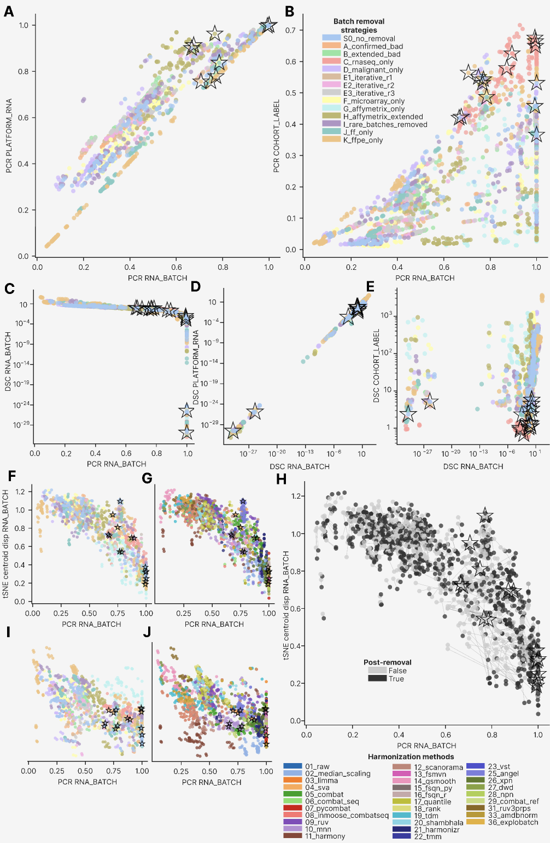
Taken as a whole, the global metrics behaved much like the PCReg family. The R2 of the first principal component, the dispersion separability criterion, tSNE centroid dispersion and average silhouette width all correlated monotonically with PCReg, either linearly or non-linearly. Outliers that departed from the main dependence in the perpendicular direction, and that appeared better than average, were not corroborated by the clustermap best methods and therefore performed worse on the other metrics, particularly the local ones.

Local metrics

Local neighborhood quality was assessed by kBET acceptance rate, iLISI, cLISI, graph connectivity and tSNE/UMAP mixing entropy per biological and batch group. We expected the best approaches to mix batch labels within the local neighborhood of each sample while preserving the local integrity of the biological groups.

The LISI metrics (local inverse Simpson's index) identified 10_mnn as the top-performing harmonization method for mixing RNA_BATCH labels, and the clustermap best approaches formed the second group (Extended Figure 7A). The best approaches performed well by LISI because they were drawn from the high-local-mixing clusters of the main clustermap and were confirmed visually on tSNE and UMAP plots to mix batches while preserving the biological groups. Of the 31 methods, only six (10_mnn, 33_amdbnorm, 02_median_scaling, 28_npn, 16_fsqn_r, 25_angel) were considered ‘good’ because their LISI by biology (Diagnosis_cell_type_unified) was lower than the one by RNA_BATCH – indicating better batch than biology local mixing. Four further methods (13_fsmvn, 26_xpn, 03_limma, 12_scanorama) were of ‘medium’ quality since their biology LISI was higher than the batch one, but the 95% CI overlapped between batch and biology.

LISI metrics stratification by batch removal strategy again placed the clustermap best approaches first (Extended Figure 7B): they had highest LISI by RNA_BATCH. The J and S0 strategies followed on LISI RNA_BATCH, but their local biology mixing (LISI Diagnosis_cell_type_unified) exceeded their batch mixing. Two strategies, D and K, had better local mixing by batch than the one by biology and were deemed ‘good’ by this criterion. We also visualized the batch and biology LISI metrics on heatmaps by harmonization method and batch removal strategy (Extended Figure 7C, D, respectively). The best approaches occupied local peaks for batch but did not occupy the corresponding local minima for biology, which reflects the subtlety of the biological differences relative to the technical ones in this FL dataset.

Extended Figure 7. LISI metrics of local neighborhood. (A) Barplot of the LISI metrics by 3 columns (Diagnosis_cell_type_unified, COHORT_LABEL, RNA_BATCH) visualized by harmonization methods, sorted by iLISI RNA_BATCH. Color annotations below the bars show method harshness score and overall quality. Best group means a composed group of the clustermap best approaches. (B) The analogous barplot for 4 LISI metrics by batch removal strategies (added the metric for the RNASEQ_SOURCE column). Higher values indicate better overlap of classes by a given column in a local nearest neighbors’ environment. Error bars indicate 95% confidence interval (CI) estimation. (C) Heatmap of LISI by RNA_BATCH, clustered by harmonization methods (columns) and batch removal strategies (rows). Each cell shows the metric value averaged by imputations and post-removals. (D) The similar heatmap for LISI by Diagnosis_cell_type_unified. Best approaches are marked as black asterisks in the panels C and D.
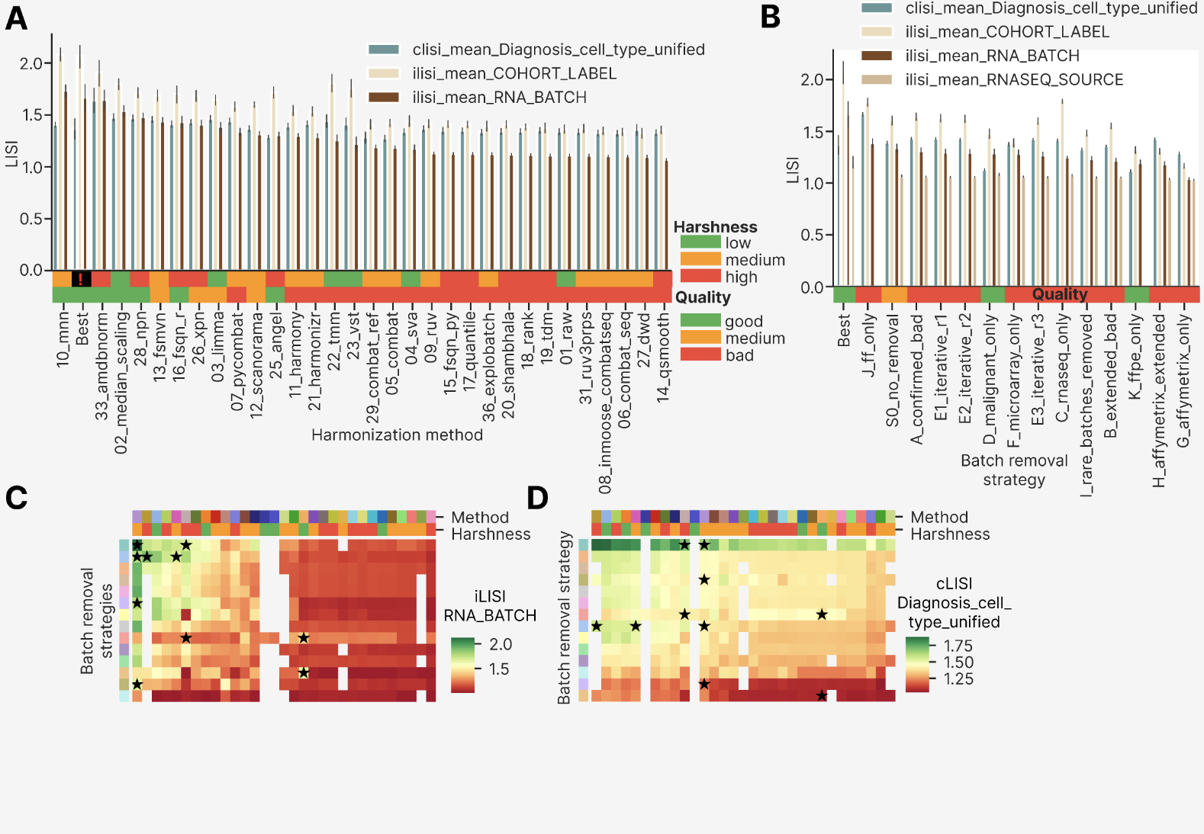

We then compared LISI with other local metrics (Extended Figure 8). There was a weak positive relationship between LISI and kBET acceptance rate for the same RNA_BATCH column (Extended Figure 8A, B). Among all 2,234 attempts, 82.0% fell below a kBET acceptance rate of 0.01 and 97.0% below 0.10, confirming that the composition of the local neighborhood remained batch-biased after most harmonization methods, even where the global PCReg had improved substantially. Only 5 of the 15 clustermap best approaches achieved kBET rates above the threshold of 0.10, all being SVA ones (for RNA-seq and FFPE only strategies). The MNN best approaches (for the cross-platform harmonization) had the highest LISI values between 1.9 and 2.1 but relatively lower kBET values (Extended Figure 8A). Other harmonization methods were also unevenly distributed along the kBET-LISI axis: 02_median_scaling had disproportionately high LISI, whereas 25_angel was shifted towards kBET, which points to distinct modes of local batch mixing between methods. The fact that the clustermap best approaches occupied area above the y = -x diagonal (with two exceptions of 16_fsqn_r) suggests that both modes genuinely improve batch correction. At the level of batch removal strategies (Extended Figure 8B), the C strategy was the highest by kBET, with a compact group of 41 approaches drawn from 18 methods between 0.654 and 0.867. Their LISI values were nonetheless confined to 1.24-1.38, and none of these approaches was selected by the integrative clustermap. S0 and D strategies tended to have near-zero kBET, whereas both Affymetrix strategies (G and H) and the I strategy (rare batches removed) were close to the minimum LISI values floor.
Looking at kBET acceptance rate by different columns (Extended Figure 8C, D), we found that eight harmonization methods exceeded the kBET acceptance rate RNA_BATCH of 01_raw (mean 0.027) — 22_tmm (0.331), 23_vst (0.230), 10_mnn (0.044), 04_sva and 36_explobatch (0.036 each), 13_fsmvn (0.035), 20_shambhala (0.029) and 19_tdm (0.028) — although only 22_tmm and 23_vst did so by a wide margin, and the remaining 22 methods fell below 01_raw and can therefore be deemed ‘bad’ (Extended Figure 8C). kBET by PLATFORM_RNA was above 0.1 for 27 of the 29 methods for which it is defined (it is undefined for 22_tmm and 23_vst, which were run only on the single-platform C strategy); only 05_combat (0.100) and 36_explobatch (0.075) fell below, indicating that good local mixing by platform is abolished by the FF/FFPE distinction in almost every method. The clustermap best approaches were the third best method by kBET RNA_BATCH, whereas 22_tmm and 23_vst performed better only because they were applied to the C strategy alone, in which all methods benefit from the greater comparability of RNA-seq platforms. At the level of batch removal strategies (Extended Figure 8D), the strategies C, H, J and G were considered ‘good’ by the same criterion relative to S0 (mean kBET RNA_BATCH 0.205, 0.015, 0.012 and 0.011 against 0.0034 for S0), and the clustermap best approaches were the second top by kBET RNA_BATCH. The strategies B, D and I had the poorest performance (0.0020, 0.0016 and 0.0004), indicating that removing a few batches, or selecting malignant samples only, does not improve local mixing of batches.

We then examined two further local mixing metrics that strongly influenced harmonization quality: tSNE and UMAP entropy. tSNE entropy strongly correlated with LISI by RNA_BATCH, with 10_mnn and the three clustermap 04_sva approaches forming a distinct linear trend with higher tSNE entropy to LISI ratio (Extended Figure 8E). Fewer differences were apparent between batch removal strategies, with the S0, I, H and F strategies located in the lower side of the trend line (Extended Figure 8F). UMAP and tSNE entropies correlated even more strongly, without any new and nontrivial differences by harmonization methods (Extended Figure 8I) or batch removal strategies (Extended Figure 8J).

Overall, fewer harmonization methods reached a ‘good’ level on the local metrics (Extended Figure 7A) than on the global ones (Extended Figure 4A), reflecting the fact that mixing batches locally is harder than overlapping them globally in PCA space.

Extended Figure 8. Analysis of a more diverse set of local mixing metrics: LISI, kBET acceptance rate, tSNE and UMAP entropy. (A) Scatterplot showing LISI and kBET acceptance rate by RNA_BATCH, color annotated by harmonization methods. (B) The same scatterplot color annotated by harmonization strategies. (C) Barplot of the kBET metrics by 3 columns (PLATFORM_RNA, COHORT_LABEL, RNA_BATCH) visualized by harmonization methods, sorted by kBET acceptance rate RNA_BATCH. Color annotations below the bars show method harshness score and overall quality. Best group means a composed group of the clustermap best approaches. (D) The analogous barplot for the same 3 kBET metrics by batch removal strategies. Higher values indicate better overlap of classes by a given column in a local nearest neighbors’ environment. Error bars indicate 95% confidence interval (CI) estimation. (E) Scatterplot of tSNE entropy vs LISI by RNA_BATCH, color annotated by harmonization methods. (F) The same scatterplot color annotated by batch removal strategies. (G) Scatterplot of tSNE entropy vs tSNE centroid dispersion by RNA_BATCH, color annotated by harmonization methods. (H) The same scatterplot color annotated by batch removal strategies. (I) Scatterplot of UMAP entropy vs tSNE entropy by RNA_BATCH, color annotated by harmonization methods. (J) The same scatterplot color annotated by batch removal strategies. (K) Scatterplot of UMAP centroid dispersion vs tSNE centroid dispersion by RNA_BATCH, color annotated by harmonization methods. (L) The same scatterplot color annotated by batch removal strategies. The clustermap best approaches are shown as empty black stars on the panels A, B and E – L.
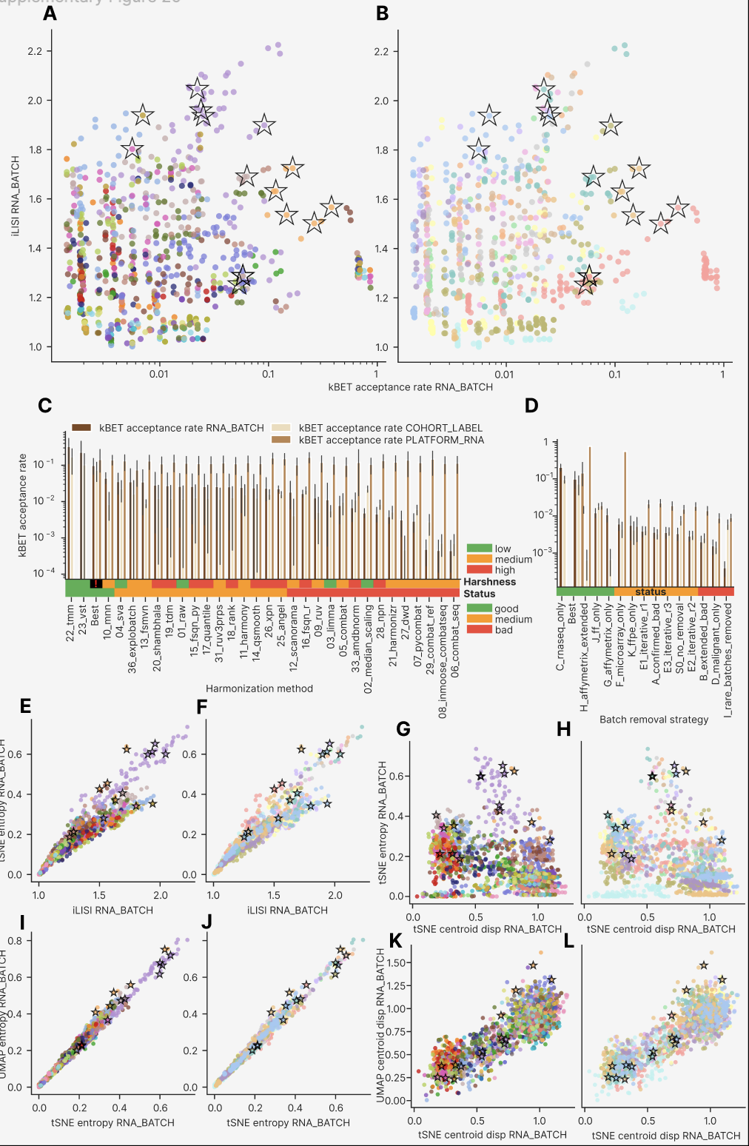

Local and global metrics relationship

The central analytical challenge in cross-platform harmonization is the inverse relationship between global batch correction and local biological preservation. To characterize this trade-off empirically, we visualized local versus global metrics behavior on scatterplots (Extended Figure 8G, 8H, 8K, 8L and Extended Figure 9).

tSNE centroid dispersion is the natural complement to tSNE entropy: it quantifies the separation of groups in the same embedding in which entropy quantifies their local mixing. We observed a negative relationship between these metrics: 10_mnn, together with a minority of the 04_sva, 11_harmony, 12_scanorama and 16_fsqn_r approaches, formed a diagonal cloud with high tSNE entropy values (0.3 – 0.75), whereas the remaining harmonization methods separated into two dense, approximately round clouds (Extended Figure 8G). Batch removal strategies, on the other hand, formed layers of negatively correlating metrics, each layer located in both clouds on top of each other and being randomly mixed in the 10_mnn cloud (Extended Figure 8H). This indicates that a given harmonization method can produce either good or poor batch overlap in a tSNE embedding, but that the composition of the batches themselves governs how well they mix locally. Only MNN mixed batches well across most batch removal strategies; for the other methods, the choice of harmonization had little influence on local batch mixing.

As an additional check, we compared tSNE and UMAP centroid dispersion on scatterplots: we found a strong positive relationship and the same separation of harmonization methods into two clouds (Extended Figure 8K) and batch removal strategies were scattered each in both clouds (Extended Figure 8L). The clustermap best approaches were randomly distributed along the trend line, indicating that local mixing took priority over global separation even for non-linear embeddings (tSNE and UMAP).

We then compared LISI and kBET against PCReg as the main global metric established earlier (Extended Figure 9). LISI by RNA_BATCH showed a weakly positive relationship with PCReg, having 10_mnn, 04_sva, 11_harmony, 12_scanorama and 16_fsqn_r above the general trend (Extended Figure 9A). Batch removal strategies showed a layered structure (Extended Figure 9B) resembling, though noisier than, the pattern seen for tSNE centroid dispersion and tSNE entropy (Extended Figure 8H). As previously in Extended Figure 7 and 8, the clustermap best approaches occupied the top-right corner of the scatterplots.

The analogous comparison of LISI and PCReg by the main biology column Diagnosis_cell_type_unified was noisier but revealed a weak negative relationship overall (Extended Figure 9C, D). The clustermap best approaches were distributed uniformly in the space of these two metrics, indicating that biology preservation was secondary to batch mixing. Whereas the distribution of harmonization methods by LISI and PCReg for Diagnosis_cell_type_unified appeared random (Extended Figure 9C), batch removal strategies formed horizontal layers with variable PCReg and fixed LISI (Extended Figure 9D), probably reflecting the differing effective number of biological groups in each strategy. Indeed, the D and K strategies contained only four malignant groups (FL, DLBCL, Burkitt Lymphoma and High-Grade B Cell Lymphoma) and they had lowest LISI. The J strategy, by contrast, contained the full range of normal B cell types and fewer malignancies than the others, and had the highest LISI. This implies that local metrics are strongly affected by the effective number of classes, whereas global metrics such as PCReg are more robust to such changes in the dataset.

Finally, we compared PCReg and kBET acceptance rate by RNA_BATCH (Extended Figure 9E, F). The comparison revealed a weakly positive dependence, where only 04_sva and 10_mnn had kBET above 0.1 for five or more approaches (10 and 9 respectively; the next method, 11_harmony, reached four; Extended Figure 9E). Interestingly, of the 198 approaches with a PCReg RNA_BATCH above 0.9999 — produced by 03_limma, 07_pycombat, 13_fsmvn, 21_harmonizr, 28_npn and 33_amdbnorm — 98.5% demonstrated kBET below 0.1. Among the batch removal strategies, C showed the highest kBET, unlike the case of LISI by biology (Extended Figure 9D). There was a compact group of RNA-seq only approaches having kBET between 0.6 and 0.9 and PCReg between 0.8 and 1.0 – yet none of them was selected among the clustermap best approaches. This illustrates the general trend: attaining the maximum of any single metric, even a local mixing one, does not make an approach the best by clustermap or confirm it under visual inspection. Only the complete set of metrics, viewed together in the clustermap, reveals the truly best approaches.

Extended Figure 9. Comparison of kBET and LISI against PCReg. (A) Scatterplot of LISI vs PCReg by RNA_BATCH, color annotated by harmonization methods. (B) The same scatterplot color annotated by batch removal strategies. (C) Scatterplot of LISI vs PCReg by Diagnosis_cell_type_unified, color annotated by harmonization methods. (D) The same scatterplot color annotated by batch removal strategies. (E) Scatterplot of kBET acceptance rate vs PCReg by RNA_BATCH, color annotated by harmonization methods. (F) The same scatterplot color annotated by batch removal strategies. The clustermap best approaches are shown as empty black stars on all the panels of this figure.
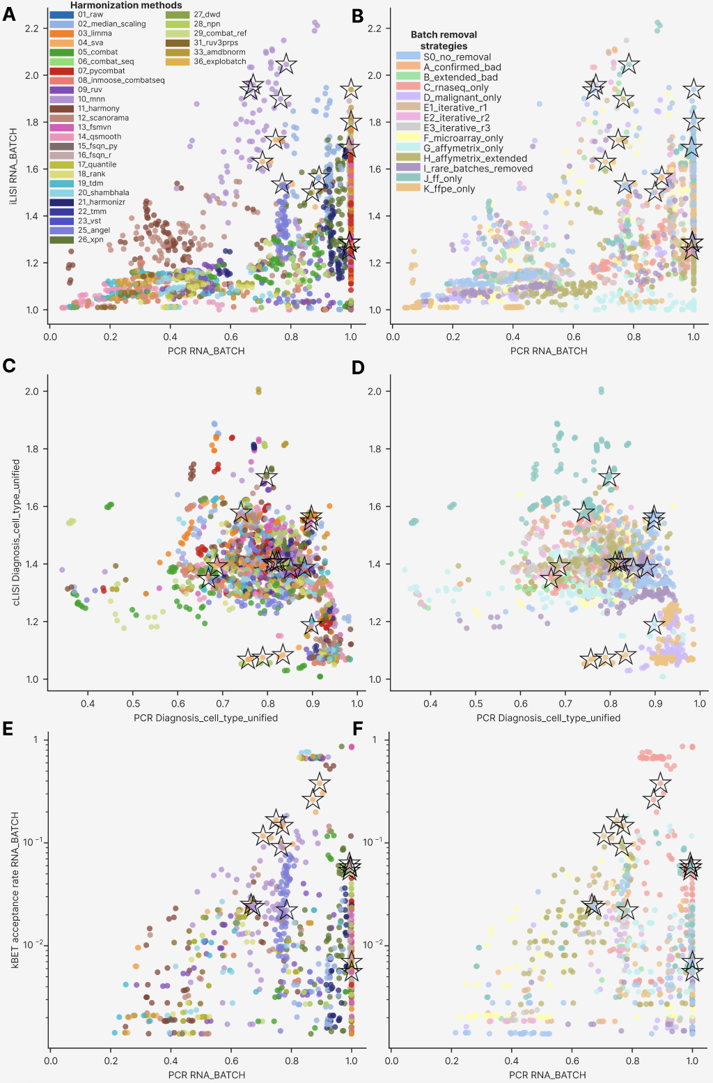

Structural and other metrics performance

In the next part of the analysis we compared distributional similarity, graph connectivity, Watermelon score, distance ratio and expression properties (Extended Figure 10). For distributional similarity we selected the metric KS fraction significant, which quantifies the fraction of pairs within a given column whose gene expression distributions differ significantly by the Kolmogorov-Smirnov test. We visualized KS fraction significant by columns PLATFORM_RNA, COHORT_LABEL, RNA_BATCH by harmonization method (Extended Figure 10A) and batch removal strategy (Extended Figure 10B). 29 of the 31 harmonization methods showed a KS fraction significant for RNA_BATCH lower than that of 01_raw (0.948, the second-highest value after 27_dwd at 0.965) and were considered ‘good’ by this metric, as were the clustermap best approaches (0.560). The metric fell below 0.7 for only ten methods, ranging from 28_npn (0.173) and 26_xpn (0.217) to 03_limma (0.691), and remained above 0.7 for the other 21. Even the clustermap best approaches left 56.0% of cohort pairs with significant differences in gene expression profile, so convergence of distributions is never complete. For batch removal strategies (Extended Figure 10B) we saw the lowest KS fraction significant in the S0 strategy, and the comparable one in the clustermap best approaches and in the C strategy, so all three were of medium quality, and the remaining strategies were considered ‘bad’.

We then examined graph connectivity as an orthogonal measure of local mixing. Comparing graph connectivity between Diagnosis_cell_type_unified and PLATFORM_RNA (Extended Figure 10C, D) revealed no dependence, although the clustermap-derived best approaches had relatively high connectivity for both columns: 0.832-1.000 for PLATFORM_RNA and 0.688-1.000 for Diagnosis_cell_type_unified. Harmonization methods were also distributed non-randomly (Extended Figure 10C): 10_mnn, 25_angel, 09_ruv and 16_fsqn_r were located in the upper right corner close to the clustermap best approaches, whereas 02_median_scaling, 07_pycombat, 03_limma, 04_sva (surprisingly) and 11_harmony were situated in the lower left corner of the plot, showing both lower biology preservation and a more fragmented platform-level distribution. At the level of batch removal strategies (Extended Figure 10D), only D and K deviated appreciably from the remaining strategies: they formed two compact clouds below the main peak, with mean graph connectivity by Diagnosis_cell_type_unified of 0.646 for D and 0.727 for K against 0.799-0.854 for the remaining strategies. Each of them contains only four biological groups, so all else being equal their connectivity should be higher; that it is not is most plausibly explained by their composition from heterogeneous FFPE batches, with additional malignant FF batches in D.

As an additional metric of global distance separation, we calculated the ratio of the within-group to the between-group Euclidean distance and compared it by RNA_BATCH and Diagnosis_cell_type_unified (Extended Figure 10E, F). As expected, the clustermap best approaches lay at the right of the plot, with a distance ratio RNA_BATCH of 0.845-1.032 (median 0.914 against 0.757 for the full set) and no shift in distance ratio by Diagnosis_cell_type_unified, underlining that these approaches prioritize batch overlap over the preservation of biological differences. Surprisingly, 07_pycombat, 03_limma and a minority of 02_median_scaling approaches lay even further to the right (Extended Figure 10E). This is a further illustration of the same principle: no single metric can be used to select the best harmonization approaches, whereas a clustermap of all of them can. 27_dwd (mean 0.508) and 14_qsmooth (0.531) had the poorest performance by RNA_BATCH distance ratio, both below no harmonization at all (01_raw, 0.566). Batch removal strategies were distributed more randomly along the distance ratio axes (Extended Figure 10F), with D, S0 and K having the highest mean distance ratio by biology (0.931, 0.921 and 0.912, that is, the least biology preservation) and G and J the lowest (0.756 and 0.760), which for J (FF only) could be explained by its smaller biological groups.

We next analyzed the Watermelon (WM) score, which measures how well a harmonization approach separates classes on a clustermap in gene expression space. The clustermap best approaches were slightly shifted to the low values of WM by RNA_BATCH (Extended Figure 10G, H), whereas no directional change was apparent for WM by Diagnosis_cell_type_unified. By harmonization methods 10_mnn and three RNA-seq only instances of 11_harmony had the lowest WM by RNA_BATCH (Extended Figure 10G). Batch removal strategies revealed the poorest performance by RNA_BATCH for the G strategy (GPL570 only) and the best performance by biology for D and K strategies that have only four malignant classes each (Extended Figure 10H). The S0 and I strategies showed a relative decrease in WM by Diagnosis_cell_type_unified (more biology classes). We then averaged the WM score over all batch columns and all biology columns and plotted the two against each other (Extended Figure 10I, J). Even more clearly than for the individual WM metrics, the clustermap best approaches formed no compact or displaced group in this plot. As before, there was a compact group of 10_mnn approaches with low WM score by batch columns (Extended Figure 10I). Batch removal strategies separated into compact groups still more clearly (Extended Figure 10J): the malignant only (D) approaches had the lowest WM by biology (poorest performance) and high WM by batch (poor performance), whereas the FFPE only strategies were highest by WM biology, which is notable given that their number of biological classes is the same (4 malignancies). The C strategy had among the lowest mean Watermelon scores by batch columns (0.335, fifth to ninety-fifth percentile 0.213-0.392), second only to J (0.320), whereas G again had the highest (0.434, 0.372-0.471).

The last of the ‘other’ metrics in our analysis was gene expression quantiles and standard deviation by batch removal strategy (Extended Figure 10K). In contrast to the analysis by harmonization method reported in the main article, the average gene expression properties were indistinguishable between batch removal strategies, except for G, which had the highest maximum gene expression and the largest standard deviation.

Taken together, the distributional similarity and distance ratio metrics differentiated the clustermap best approaches, but Watermelon score did not. The WM score may therefore capture a mode of harmonization quality that the clustermap does not. Future harmonization pipelines should treat the WM score as an independent metric group, on an equal footing with the PCA-based global and the tSNE/UMAP-based local metrics.

Extended Figure 10. Structural and other metrics performance. (A) Barplot of the KS fraction significant metrics by 3 columns (PLATFORM_RNA, COHORT_LABEL, RNA_BATCH) visualized by harmonization methods, sorted by KS fraction significant RNA_BATCH. Color annotations below the bars show method harshness score and overall quality. Best group means a composed group of the clustermap best approaches. (B) The analogous barplot for the same 3 KS metrics by batch removal strategies. Higher values indicate higher proportion of pairwise comparisons with significant differences in gene expression distributions by Kolmogorov-Smirnov test. Error bars indicate 95% confidence interval (CI) estimation. (C) Scatterplot of graph connectivity by Diagnosis_cell_type_unified versus PLATFORM_RNA, color annotated by harmonization methods. (D) The same scatterplot color annotated by batch removal strategies. (E) Scatterplot of distance ratio (intragroup to intergroup) by Diagnosis_cell_type_unified versus RNA_BATCH, color annotated by harmonization methods. (F) The same scatterplot color annotated by batch removal strategies. (G) Scatterplot of Watermelon score by Diagnosis_cell_type_unified versus RNA_BATCH, color annotated by harmonization methods. (H) The same scatterplot color annotated by batch removal strategies. (I) Scatterplot of mean Watermelon score by biology columns versus the same score by batch columns, color annotated by harmonization methods. (J) The same scatterplot color annotated by batch removal strategies. The clustermap best approaches are shown as empty black stars on the panels C – J. (K) Heatmap showing gene expression quantiles and standard deviation by harmonization strategies.
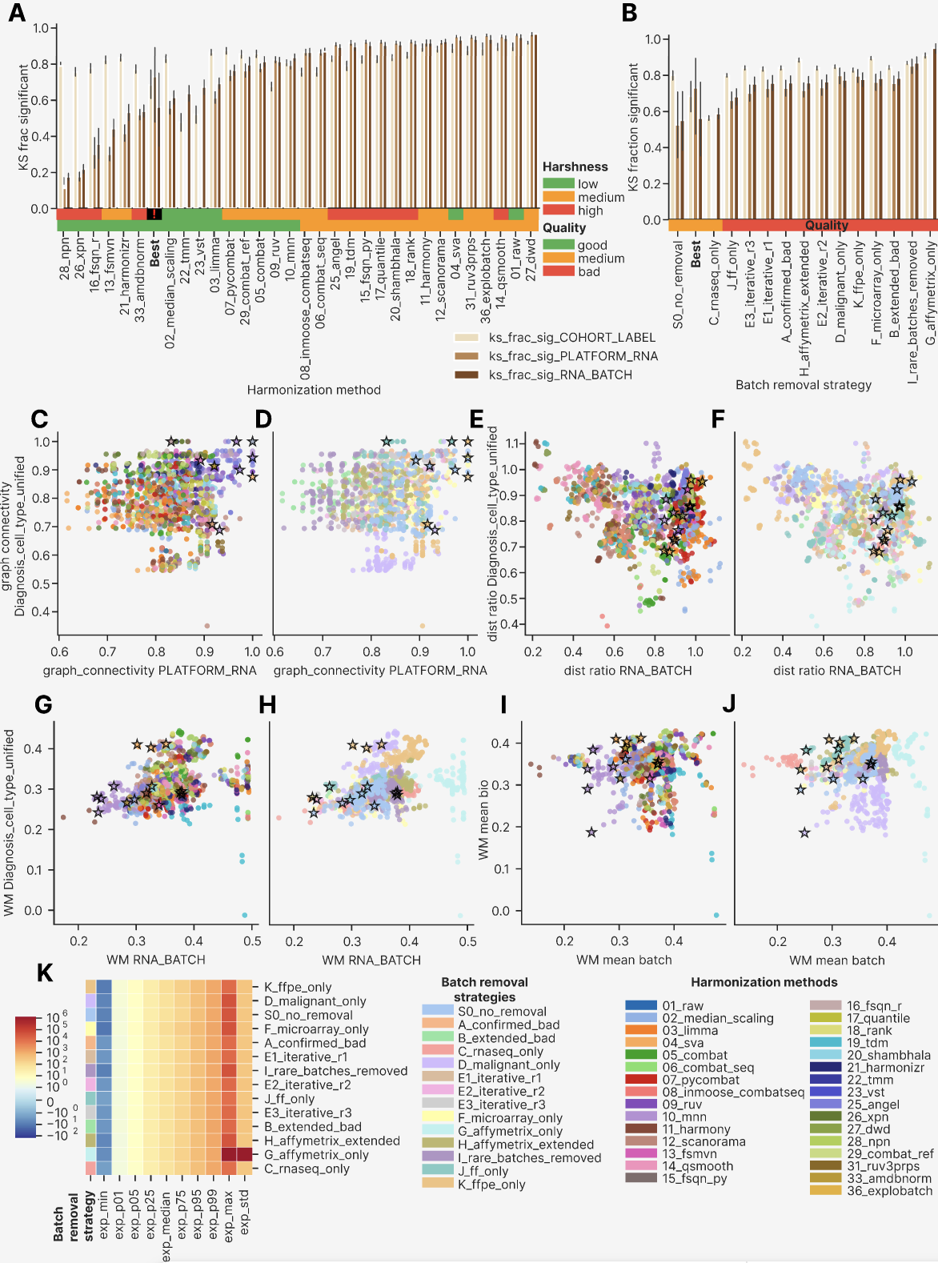

Impact of harmonization method harshness on harmonization quality

As an additional study of harmonization methods, we compared major metric types by harmonization method harshness (Extended Figure 11). We began from the widely held premise that perfect batch mixing and biology separation require the most elaborate methods available, those that reshape the gene expression distribution most extensively. We set out to test whether this holds for our multiplatform FL dataset.

In the case of PCReg RNA_BATCH (Extended Figure 11A) 11 out of 14 batch removal strategies had methods with low harshness showing the highest metric, the exceptions were C, G and J strategies. Conversely, for PCReg Diagnosis_cell_type_unified (Extended Figure 11B) in 7 strategies low harshness showed the lowest metric (best performance), and 9 strategies had high harshness methods with the highest metric.

The local metrics showed a similar pattern, with low-harshness methods performing best. tSNE entropy by RNA batch (Extended Figure 11C) had 6 strategies with low harshness being the best and 8 more with medium harshness having the highest performance. For LISI RNA_BATCH the pattern favored low harshness still more strongly (Extended Figure 11D): it was the best in 10 strategies and medium harshness was the best in the rest 4 ones. For LISI Diagnosis_cell_type_unified, by contrast, low-harshness methods performed worst (highest LISI by biology) in 12 strategies (Extended Figure 11E). Unlike PCReg, where low harshness methods had both highest batch PCReg and the lowest biology one, for LISI we observed the local mixing trade-off described in the main article: stronger local mixing of batches is accompanied by weaker local preservation of biology.

As a final part of the methods harshness comparison, we visualized KS fraction significant RNA_BATCH by harshness and strategies (Extended Figure 11F). Here we observed the best performance of high harshness methods (lowest metric) in 13 strategies out of the 14 total ones, 4 strategies had the worst performance for low harshness methods, and in the remaining 10 the worst behavior was observed for medium harshness methods.

Taken together, the harshness comparisons give a nuanced picture: low harshness methods tend to outperform the high harshness ones in terms of PCReg by batch and biology, whereas by local mixing they both better mix batches and worse preserve biology. Finally, high harshness methods better converge gene expression distributions to the same shape for different batches. In other words, milder interventions in the data are preferable, and the harshest transformations yield only an apparent success — matched expression distributions — rather than a real one.

Extended Figure 11. Barplots comparing metrics of different harshness harmonization methods by batch removal strategies. (A) PCReg RNA_BATCH. (B) PCReg Diagnosis_cell_type_unified. (C) tSNE entropy RNA_BATCH. (D) LISI RNA_BATCH. (E) LISI Diagnosis_cell_type_unified. (F) KS fraction significant RNA_BATCH. In each barplot, the harmonization strategies are sorted by the metric shown, and the clustermap best methods are shown as a surrogate batch removal strategy.
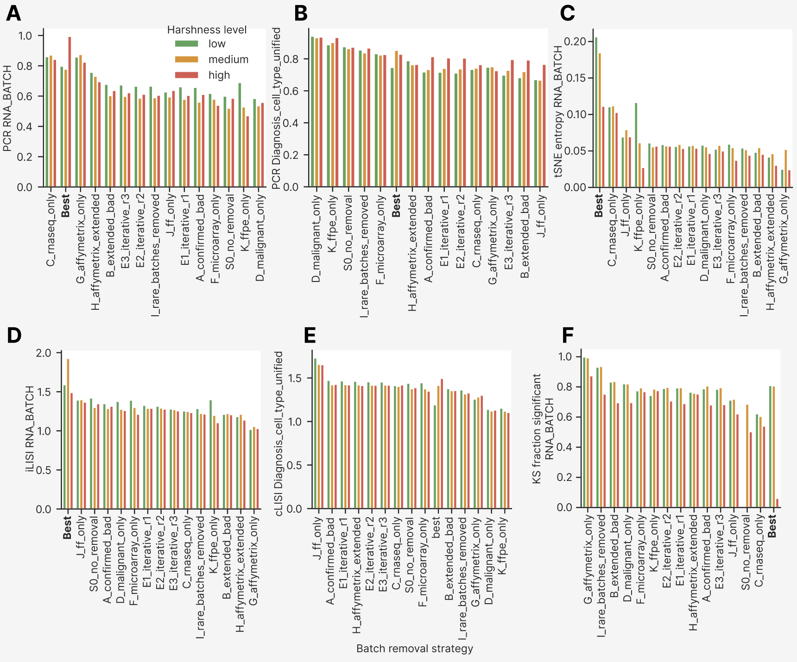

Composite performance score of harmonization methods and batch removal strategies
As the last part of the harmonization metrics extended analysis, we built a composite performance score as the mean of all 87 polarity-adjusted scoring metrics and visualized it by harmonization methods and batch removal strategies (Extended Figure 12).

The group of clustermap best approaches was indeed the best by composite score, reaching 0.602 (Extended Figure 12A), whereas the next-best strategy, C, reached 0.578. Global distance metrics were the most numerous (47 of the 87 scoring metrics) and therefore contributed 0.360 of the total score of the best group, but they were homogeneous across the batch removal strategies. In contrast, the local neighborhood metrics contributed only 0.109 to the total score of the best group, yet they separated the strategies most sharply: C reached 0.095 and J 0.064, the remaining eleven strategies clustered between 0.047 and 0.052 without appreciable differences, and G was lowest at 0.037. The distributional similarity and remaining metric groups produced no visible differences between batch removal strategies.
The pattern of metric type impact by harmonization methods was more complicated (Extended Figure 12B). The two leading methods after the clustermap best group, which was again first overall, were 22_tmm and 23_vst — apparently because they were applied to the C strategy alone. Methods 33_amdbnorm, 28_npn and 10_mnn were the 3rd – 5th, respectively, the local contribution falling from 0.083 in 33_amdbnorm to 0.072 in 28_npn and then rising to 0.106 in 10_mnn, whose gain in local mixing was offset by lower global (0.343 against 0.356-0.358) and distributional (0.065 against 0.078-0.084) contributions.

Comparison of the metrics computational groups revealed that PCA-based variance decomposition metrics (PCReg, DSC etc) varied little across batch removal strategies (a spread of 0.017 between the highest and lowest strategy, Extended Figure 12C) and introduced a minor spread of 0.030 across harmonization methods (Extended Figure 12D). Neighbor-based integration and tSNE/UMAP embedding were the two principal groups of local metrics, and they separated the C strategy from the rest most strongly (spreads of 0.043 and 0.039 across strategies) and likewise separated the leading methods from the rest (spreads of 0.049 and 0.054 across methods). The Watermelon score and the missing-value metrics produced no differences, and the remaining three groups contributed intermediate spreads across methods: 0.036 for distributional similarity, 0.022 for graph connectivity and 0.019 for pairwise Euclidean distance.

Finally, we investigated the impact of metrics calculated by different annotation columns, again by batch removal strategies and harmonization methods (Extended Figure 12E, F, respectively). The biology columns (Major_group, Diagnosis_cell_type_unified, TUMOR_NORMAL) contributed no appreciable difference to the composite score, and in total they comprised 18 of the 87 scoring metrics, about a fifth of the equally weighted average. Among the batch columns, COHORT_LABEL and RNA_BATCH introduced the most variability between the leading and trailing strategies and harmonization methods.

Taken together, the metrics of local type were the most important in the total composite score even though, at 22 of the 87 scoring metrics, they accounted for only 8.1-18.1% of the composite. Batch-related metrics supplied 57 of the 87 metrics and 60.7-67.4% of the composite, while the biology metrics barely separated the good from the bad harmonization methods or batch removal strategies (a spread of 0.053 across strategies against 0.122 for the batch metrics).

Extended Figure 12. Stacked barplots showing impact of metric type, group and column into the equally weighted composite score. (A) Metric type by batch removal strategy. (B) Metric type by harmonization method. (C) Metric group by batch removal strategy. (D) Metric group by harmonization method. (E) Metric column by batch removal strategy. (F) Metric column by harmonization method. In all barplots bars are sorted by average value descending.
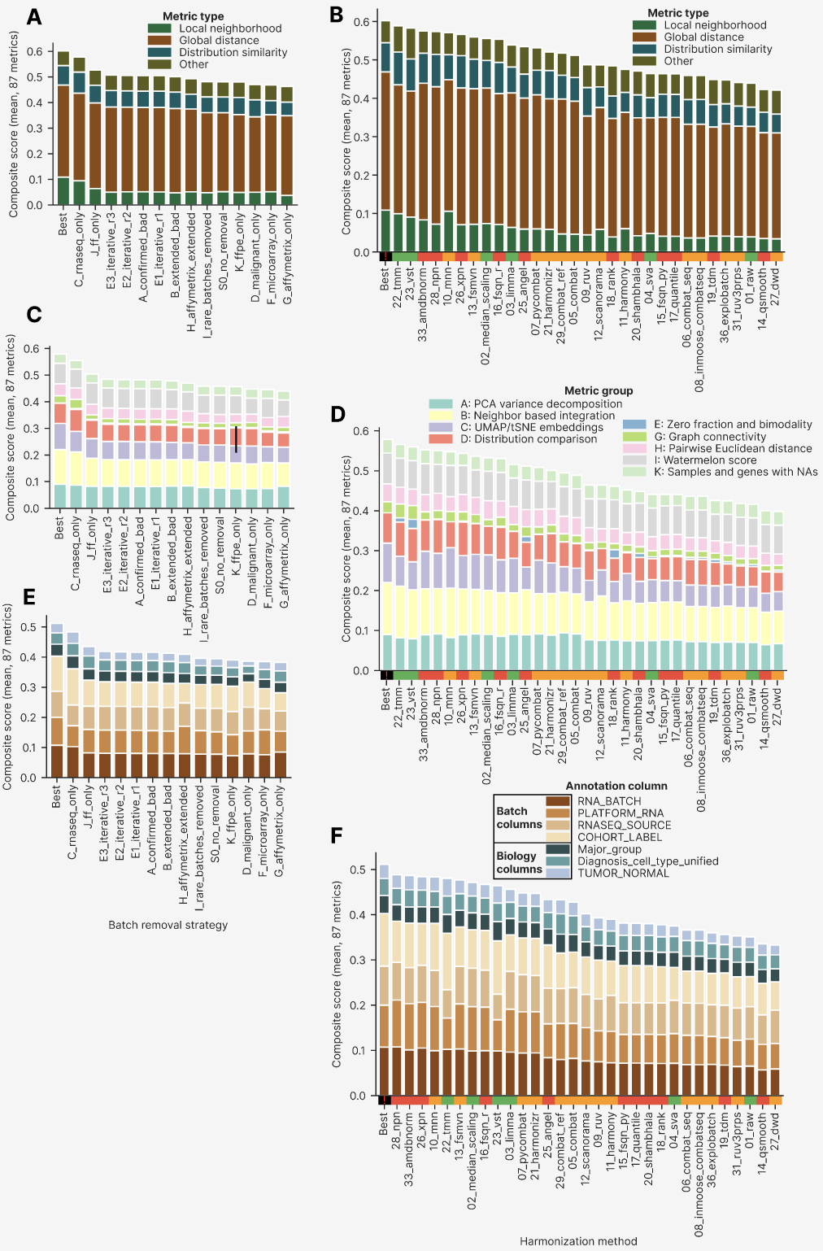
We sorted and visualized all the approaches by their composite score (Extended Figure 13). The resulting curve had an upper tail of high-scoring outliers (composite score above 0.6), containing 150 of the 2,234 approaches (6.7%), 9 of the 15 clustermap best approaches among them. This pattern supports the general strategy for harmonizing datasets with pronounced technical and subtle biological differences: a small minority of harmonization approaches (under 7%) are promising from the point of view of the actual PCA/UMAP/tSNE plots and quality metrics. To identify them, one should build a clustermap of the quality metrics, or perform another integrative analysis of them, and then confirm the result visually on dimensionality reduction plots. There is no shortcut in cross-platform transcriptomic harmonization.

Extended Figure 13. Individual approaches sorted by the composite score, color annotated by batch removal strategy, imputation, harmonization method, post-removal and harshness level. The clustermap best approaches are shown with black stars.
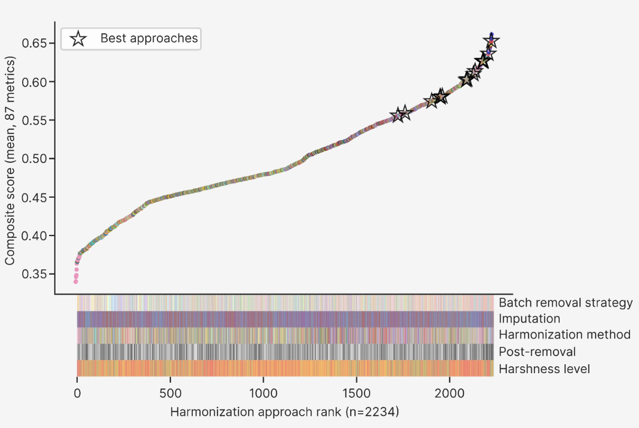

Summary of metric trends
The analyzes above rest on the same 2,234 successful approaches used in the main article: 31 harmonization methods applied across 14 batch removal strategies, three imputation schemes and two post-removal settings, scored on 87 polarity-adjusted metrics. Five trends run through them consistently, and are set out here in the order of the evidence presented above.
First, global and local metrics measure different things, and agreement between them is the exception rather than the rule. Principal component regression, the dispersion separability criterion, tSNE centroid dispersion, average silhouette width and the R2 of the leading principal components all varied monotonically with one another, whether linearly or through a saturating curve, so that any one of them stands in for the global family. Local mixing did not follow. Five methods (33_amdbnorm, 13_fsmvn, 03_limma, 07_pycombat and 28_npn) reached a mean PCReg RNA_BATCH of 0.999 or above, with a batch-explained variance below 0.25% at every one of the first ten principal components, and yet 98.5% of the 198 approaches they generated had a kBET acceptance rate below 0.1. A global metric at its theoretical optimum is therefore not evidence of successful harmonization; it is equally consistent with a transformation that has destroyed the structure it was meant to align.
Second, batch-explained variance is frequently displaced rather than removed. Nineteen of the 31 methods, and 10 of the 14 batch removal strategies, showed a lower RNA_BATCH R2 at the first principal component than at some later component. The five methods with the slowest decay of explained variance (25_angel, 20_shambhala, 15_fsqn_py, 17_quantile and 18_rank) illustrate this most clearly: four of them placed their maximum batch R2 at a component other than the first. Reporting only the leading component, or only a metric aggregated over the leading component, will systematically overstate how much batch structure has been eliminated.
Third, the trade-off between mixing batches and preserving biology is real but modest, and it is dominated by the composition of the dataset. Across all approaches the un-normalized iLISI for RNA_BATCH and cLISI for Diagnosis_cell_type_unified correlated positively (Spearman r = 0.527, p = 7 * 10-160), and the correlation was significant within every batch removal strategy except G (r from 0.374 to 0.815, median 0.617). Polarity-adjusted PCReg showed the same tension far more weakly (Spearman r = -0.159, p = 3.7 * 10-14). The strategies themselves separated much more strongly than the methods did: the strategies with the fewest biological classes, malignant only and FFPE only, had both the lowest cLISI (median 1.10 and 1.07) and the highest PCReg by biology (median 0.939 and 0.925). Local metrics are sensitive to the effective number of classes in a way that global metrics are not, and comparisons of local metrics across strategies with different class structures are not directly interpretable.
Fourth, elaborate transformations do not outperform simple ones. Grouping the methods by harshness, the low-harshness tier gave the highest PCReg RNA_BATCH in 11 of the 14 strategies and the highest LISI RNA_BATCH in 10 of 14, while the high-harshness tier was the worst on tSNE entropy in 12 of 14. High harshness prevailed on exactly one axis, distributional convergence: it gave the lowest KS fraction significant in 13 of the 14 strategies. Harsh transformations therefore succeed at making expression distributions look alike without making the underlying samples more comparable, which is precisely the failure mode that a distribution-based metric alone cannot detect. Consistent with this, the methods that produced the most atypical expression ranges — 08_inmoose_combatseq and 06_combat_seq, with mean maxima of 1.46 * 1011 and 2.76 * 108, and 20_shambhala, with a median of 1,359.6 — ranked poorly overall, whereas the 15 best approaches stayed close to a conventional log2(TPM) profile (median 2.63 to 6.70, maximum 12.6 to 28.6).
Fifth, the composite score is decided by the small local component. Local neighborhood metrics made up 22 of the 87 scoring columns and contributed only 8.1 to 18.1% of the composite, yet they accounted for its largest between-group spread: 0.043 across strategies for neighbor-based integration and 0.049 across methods, against 0.017 and 0.030 for the PCA-based variance decomposition group. Batch-annotated columns supplied 57 of the 87 metrics and 60.7 to 67.4% of the composite, while the 18 biology columns separated good from bad approaches only weakly (a spread of 0.053 across strategies against 0.122 for the batch columns). The clustermap best approaches were first overall (0.602) ahead of the RNA-seq-only strategy (0.578), and 9 of the 15 fell in the high-scoring tail above 0.6 that contains just 150 of the 2,234 approaches (6.7%).
The practical conclusion is that no single metric, and no single metric family, identifies a usable harmonization approach. Global metrics are necessary but easily saturated; local metrics are discriminating but confounded by class composition; distributional metrics reward exactly the transformations that should be treated with most suspicion. Only the joint reading of all metric groups, followed by visual confirmation on dimensionality reduction plots, separates the approaches that work from those that merely score well.

