Evolutionary arms race between transposable elements and human genes: telomere-to-telomere genome co-mapping identifies young L1 clusters in the interferon-alpha domain
Author: Daniil Nikitin^{1*}

Affiliation:
Institute of Molecular Biology, National Academy of Science of the Republic of Armenia

*Correspondence: danya.nikitin.orel@gmail.com

ABSTRACT

INTRODUCTION

RESULTS

Mapping and enrichment of TEs on gene TSS 10 kb neighborhoods at the level of major subfamilies

At the level of subfamilies the overall pattern of TEs enrichment in genes TSS vicinity was the most complicated (Supplementary Figure 1, Supplementary Table X): among 1143 families, only 14 were missing in gene TSS vicinity: 6 DNA elements (X22_DNA, Eulor6A, Eulor6C, Eulor7, Eulor5B, Chompy-6_Croc), 5 LTR ones (X1_LR, LTR108c_Mam, HERV-Fc1_LTR3, HERV1_LTRe, HERV-Fc1_LTR2), 2 LINEs (MamRTE2, X21_LINE) and one SINE element (Alu-VAR_rnd-5_family-1084). All of them had relatively low copy number (19.6 on average, 45 at maximum), and at least one of the adjusted p-value (by Fisher exact test or the random permutation control) was above the significance level of 0.05. Circular map of major TE subfamilies (those that have >= 1000 members, 385 subfamilies) onto TSS-proximal and distal genomic regions can be found in Supplementary Figure 2.
Degree of enrichment by subfamily (the ratio of observed to random odds ratio) varied from 0.05 (UCON7, DNA elements, 1 TSS-linked copy and 133 in total, significant depletion) to 11.6 (MER57E3, LTRs, 101 TSS-linked copies and 154 total ones, significant enrichment), but there was no connection between number of subfamily members and the enrichment (Supplementary Figure 3A). Diverence did not correlate with degree of enrichment (Supplementary Figure 3B), whereas it perfectly correlated with average divergence of TEs mapped in the vicinity of gene TSS (Supplementary Figure 3C), as it was shown for TE families in Figure 1. As in the case of TE families, SINE subfamilies showed the highest degree of enrichment, and it was statistically indistinguishable with SVA elements (Supplementary Figure 3D). Subfamilies of the rest for classes (LINEs, LTRs, DNA elements and helitrons) were depleted in the vicinity of TSS. Observed and random odds ratios followed the same patters for TE subfamilies as in the case of TE families (Supplementary Figure 3E, 3F, respectively).
Random odds ratio perfectly depended on average subfamily length (Supplementary Figure 3G), whereas average subfamily length had complex connection with avearage divergence of TEs depending on the element class and family (Supplementary Figure 3H), without a clear linear or non-linear pattern by TE class.
Figure 3. Evolutionary trajectory of TSS enrichment in human L1 elements.
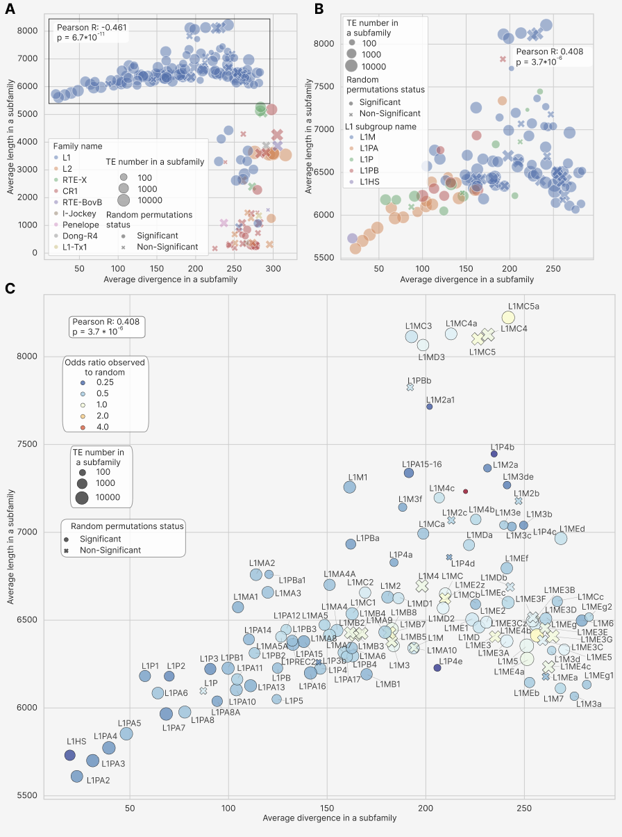
We noticed that full-length L1 elements with an average length at least 5600 bp formed a smooth non-linear curve with average length in subfamily growing from 5500 to 6400 with divergence growing from 2 to 20% (Figure 3A). The widely recognized L1 subgroups (each encompassing one or multiple subfamilies) L1HS, L1M, L1P, L1PA and L1PB formed a sequencial pattern with growing of average length of individual subfamilies as well as length variance between subfamilies over evolutionary time (Figure 3B). Moreover, L1 subfamilies with higher divergence were tending to have higher degree of enrichment, changing from approximately one/quarter depletion (0.214 for the youngest and the most active L1HS human subfamily, 77 copies near gene TSS and 1554 in total) to neutral state of observed to random odds ratio being around one (Figure 3B), with notable exception of L1P4c subfamily (7.49 enrichment, 31 copies near TSS with 45 in total). The mammalian-wide subgroup L1M was not only significantly above all the rest subgroups by average divergence (Supplementary Figure 3I, 225 compared to 20 in L1HS, 146 in L1P, 104 in L1PA and 129 in L1PB), but also demonstrated higher median length by subfamilies (Supplementary Figure 3J, 6508 bp compared to 5731 in L1HS, 6228 in L1P, 6104 in L1PA, 6348 in L1PB, significant difference only with L1PA and L1PB) and, the most importantly, showed higher median observed to random odds ratio by subfamilies (Supplementary Figure 3K, 0.624 compared to 0.214 in L1HS, 0.371 in L1P, 0.396 in L1PA, 0.457 in L1PB, significant difference everywhere except L1HS).

Subfamilies with highest level of enrichment in genes by classes
Table 2 shows enrichment of the top and bottom 3 subfamilies of each major TE class (LINEs, SINEs, LTRs, DNA elements) by their enrichment score and all SVA elements and helitrons, filtered by significance according to the permutation based empirical adjusted p-value (< 0.05). Markedly, both top and bottom SINE subfamilies (5 Alu ones and one MIR element) were enriched over the random background control, reaching 1.89 enrichment, all the two significant SVA subfamilies were enriched and all the two Helitrons were depleted.
Table 2. Top and bottom TE subfamilies by their enrichment scores and classes, filtered by the permutation based empirical adjusted p-value.
Subfamily name | Family name | TE count is TSS | TE count total | Observed to random odds ratio fold change | Adjusted empirical p-value | Adjusted Fisher p-value | Enrichment direction
LINEs
X21_LINE | CR1 | 0 | 45 | 0.000 | 0.037 | 0.055 | Depleted
X1_LINE | CR1 | 1 | 83 | 0.078 | 0.011 | 0.020 | Depleted
L1P4b | L1 | 5 | 101 | 0.185 | 0.011 | 0.295 | Depleted
L2-1_AMi | L2 | 156 | 826 | 1.434 | 0.011 | 7.1*10⁻¹⁹ | Enriched
X7A_LINE | CR1 | 209 | 1014 | 1.781 | 0.011 | 3.6*10⁻³⁰ | Enriched
L1P4c | L1 | 31 | 45 | 7.494 | 0.011 | 5.5*10⁻²² | Enriched
LTRs
LTR22E | ERVK | 1 | 87 | 0.066 | 0.011 | 0.0147 | Depleted
LTR22C2 | ERVK | 1 | 71 | 0.090 | 0.029 | 0.037 | Depleted
LTR27D | ERV1 | 4 | 216 | 0.118 | 0.011 | 1.4*10⁻⁴ | Depleted
LTR13A | ERVK | 63 | 160 | 3.895 | 0.011 | 6.6*10⁻²⁵ | Enriched
LTR46 | ERV1 | 74 | 180 | 4.214 | 0.011 | 1.6*10⁻³⁰ | Enriched
MER57E3 | ERV1 | 101 | 154 | 11.618 | 0.011 | 1.1*10⁻⁶⁶ | Enriched
SINEs
AluY | Alu | 17358 | 111981 | 1.249 | 0.011 | <10⁻²⁰⁰ | Enriched
AluYk2 | Alu | 1663 | 10601 | 1.263 | 0.011 | 2.6*10⁻¹¹⁶ | Enriched
Alu | Alu | 1111 | 7106 | 1.271 | 0.011 | 3.1*10⁻⁷⁷ | Enriched
AluYe6 | Alu | 74 | 341 | 1.876 | 0.020 | 1.5*10⁻¹² | Enriched
FLAM_C | Alu | 7049 | 32847 | 1.890 | 0.011 | <10⁻²⁰⁰ | Enriched
MIR1_Amn | MIR | 3012 | 13598 | 1.947 | 0.011 | <10⁻²⁰⁰ | Enriched
DNA elements
UCON7 | - | 1 | 133 | 0.050 | 0.011 | 4.0*10⁻⁴ | Depleted
Charlie11 | hAT-Charlie | 1 | 70 | 0.075 | 0.011 | 0.054 | Depleted
Eulor9A | - | 3 | 116 | 0.176 | 0.045 | 0.025 | Depleted
EutTc1-N2 | TcMar-Tc1 | 51 | 150 | 3.470 | 0.011 | 3.7*10⁻¹⁷ | Enriched
UCON89 | hAT | 20 | 49 | 4.439 | 0.011 | 6.5*10⁻⁹ | Enriched
EutTc1-N1 | TcMar-Tc1 | 21 | 44 | 5.380 | 0.011 | 7.5*10⁻¹¹ | Enriched
SVA elements
SVA_A | SVA | 470 | 2390 | 1.475 | 0.011 | 3.7*10⁻⁶⁰ | Enriched
SVA_E | SVA | 204 | 934 | 1.662 | 0.011 | 4.3*10⁻³³ | Enriched
Helitrons
Helitron1Nb_Mam | Helitron | 18 | 256 | 0.469 | 0.029 | 0.468 | Depleted
Helitron2Na_Mam | Helitron | 29 | 407 | 0.519 | 0.011 | 0.376 | Depleted

DISCUSSION
In

Subfamilies evolutionary dynamics
In

MATERIALS AND METHODS

Human TEs
Переписать иначе!
Coordinates and class/family annotations for human TEs were obtained from the RepeatMasker track (Tarailo-Graovac and Chen 2009) based on the T2T human genome assembly, using the Table Browser tool (Group: Variation and Repeats, Track: RepeatMasker, Table: T2T RepeatMasker). The T2T RepeatMasker annotation itself was derived from(Hoyt et al. 2022b), and average divergence scores (number of substitutions per 1000 base pairs) were extracted from the same UCSC RepeatMasker track.
Each TE was categorized by RepeatMasker into hierarchical levels of classification (Tarailo-Graovac and Chen 2009):
- Class, representing the highest level, defined by the mechanism of transposition.
- Family, representing an intermediate level, grouping elements of shared evolutionary origin that typically exhibit similar structural features and transposition mechanisms (e.g., Alu and L1 elements).
In this study, we adopted the RepeatMasker classification as provided in the T2T genome assembly without modification, ensuring consistency with the widely accepted TE annotation framework.
The dataset comprised elements assigned to the following classes: LINE, SINE, LTR, SVA (annotated as “Retroposon” in the source table), Helitron (denoted as “RC” for rolling-circle elements), and DNA transposons. In total, the dataset included 3,709,429 entries: 1,706,485 SINEs, 1,005,214 LINEs, 531,410 LTRs, 458,177 DNA elements, 6,274 SVAs, and 1,869 Helitrons.
Although SVA elements are evolutionarily and functionally related to Alu elements (Jacobs et al. 2014), SINEs and SVAs were treated as distinct classes in accordance with RepeatMasker nomenclature. Likewise, Helitrons were considered as a separate TE class, despite their mechanistic classification as a subset of DNA transposons due to their rolling-circle replication mechanism (Barro-Trastoy and Köhler 2024).

Human genes and TSS
Human genes coordinates were downloaded from UCSC Genome Browser (Perez et al. 2025) via the Table Browser tool, using the January 2022 assembly (T2T CHM13v2.0/hs1). Data were extracted from the group Genes and Gene Predictions, track NCBI RefSeq, and table RefSeq All. Only curated gene entries were retained by filtering for accessions beginning with prefixes NM, NR, NP, or YP. Transcription start site (TSS) coordinates were defined as the leftmost exon start (5′ UTR exon) for genes on the positive strand and the rightmost exon end for genes on the negative strand. The 10 kb promoter regions (TSS neighborhoods) were then constructed by extending 5 kb upstream and downstream of each TSS.
HUGO gene symbols (column geneName2) were used as primary identifiers, yielding 28,738 unique genes. Transcript isoforms corresponding to the same gene but differing in TSS position were treated as distinct entities during epigenomic profiling and RE mapping. The complete set of TSS 10 kb neighborhoods used in the mapping is provided in Supplementary File 1 (38,704 entries including isoforms).

Mapping of TEs on gene TSS 10 kb neighborhoods
The mapping of TE coordinates with their divergence onto gene TSS 10 kb neighborhoods was done using bedtools (bedtools map utility) (Quinlan and Hall 2010), any TEs that have been intersecting with the 10 kb interval for a given gene were taken into the analysis. This could lead to artificial underestimation of enrichment and regulatory impact of longer TE classes (LINEs and LTR elements), so the appropriate random permutation controls were applied as described later.

Random control of TEs enrichment
To control TE enrichment near genes against a random background, we performed 1000 random permutations of TEs coordinates by the bedtools shuffle command, selecting random state number (seed) from 1 to 1000. An empirical p-value was calculated as fraction of random odds ratios (OR) that were above or below the observed one, depending on whether the observed OR was below or above the median across the random 1000 OR values. Then the empirical p-value was lower clipped by 2 / (N + 1), where N was the permutations number (1000).
An enrichment score was calculated as a fold change of observed versus random ORs.

Statistical tests
Group comparisons were done by Mann-Whitney U-test (On a Test of Whether one of Two Random Variables is Stochastically Larger than the Other on JSTOR, n.d.) ​implemented in scipy python library (Virtanen et al. 2020)​. Multiple hypotheses were corrected by the False Discovery Rate approach (Benjamini and Hochberg 1995)​ implemented in the python statmodels library (Seabold and Perktold 2010)​. OR and p-values for TE classes and families’ enrichment in the TSS 10 kb of genes, as well as enrichments of GO terms in TE groups by functional group were calculated using Fisher exact test (Mays and Stark 2026)​ in scipy. Linear correlation coefficients and their p-values were calculated by Pearson (Waldmann 2019). Distributions were compared by Kolmogorov-Smirnov test (Cardoso and Galeno 2023) implemented in scipy.

Gene Ontology and other functional annotations
TSS for isoforms of the same gene were considered as distinct unique entities, with enrichment, divergence and epigenomic analyses performed independently for them. For the Gene Ontology (GO) analysis gene names were deduplicated among the TSS that were extracted as enriched by a certain criterium. GO analysis was performed using goatools python library ​(Klopfenstein et al. 2018) on a local database downloaded on Dec 31st, 2025. FDR-corrected Fisher exact test p-value 0.1 was selected as a threshold value for GO terms.

Visualization
Plots for this article were drawn using matplotlib ​(Hunter 2007), plotly (Plotly Inc, n.d.), statannotations (GitHub - trevismd/statannotations, n.d.) and seaborn (Waskom 2021)​ libraries in Python 3.11. Supervenn plots were built using the supervenn python library (GitHub - gecko984/supervenn, n.d.). Network visualizations were built using networkx (Hagberg et al. 2008) and pyvis (Perrone Gary, Unpingco Gary, and Lu Gary 2020) libraries in python.
UCSC Genome Browser tracks were visualized using the Genome Browser web portal (Casper et al. 2026)​.

Data analysis
Data analysis was performed in a Jupyter Notebook environment using pandas (team, n.d.)​ and numpy ​(Harris et al. 2020) for tabular data handling and analysis.

AI usage
Gemini PRO (Comanici et al. 2025) was used for code refining, assistance with literature search and pre-classification of GO terms into large biological groups. Chat GPT was used for grammar corrections of the manuscript (Biswas 2023).

ETHICAL STATEMENT
This study represents a purely computational analysis based on publicly available genomic datasets. All data analyzed were obtained from the T2T genome assembly and the RepeatMasker track (Hoyt et al. 2022a) accessible through public repositories. As no new biological material was collected and the study did not involve human participants, animal subjects, or experimental interventions, ethical approval and informed consent were not required. All data retrieval and analysis were conducted in accordance with established ethical standards for the use of secondary biological data.

CONFLICT OF INTEREST
The author declares no conflict of interest.

AUTHORS CONTRIBUTION
Daniil Nikitin: Conceptualization, data curation, formal analysis, funding acquisition, investigation, methodology development, project administration, resource provision, software development, supervision, validation, visualization, and writing (original draft, review, and editing).
As the sole author, I fulfill all established criteria for authorship. I made substantial contributions to the conception and design of the study, as well as to the acquisition, analysis, and interpretation of the data. I drafted the manuscript and critically revised it for important intellectual content, approved the final version for publication, and agree to take full responsibility for all aspects of the work.

ACKNOWLEDGEMENTS
.

SUPPLEMENTARY MATERIAL
Supplementary Figure 1.
.

DATA AVAILABILITY
The primary genomic and TE datasets analyzed in this study are derived from publicly available resources. The telomere-to-telomere (T2T-CHM13v2.0) human genome assembly and associated RepeatMasker annotations were obtained from the UCSC Genome Browser https://hgdownload.soe.ucsc.edu/goldenPath/hs1/bigZips/.
All code used for proximity mapping, statistical analysis, and GO functional networking is available in the GitHub repository: https://github.com/Nikit357/T2T_genes_evolution.
Comprehensive tables of TE-gene intersections, including divergence and family-level enrichment statistics, have been deposited in the same GitHub repository.

REFERENCES

