**Project Final Report**

CS586 – Software System Architecture

April 25 2018

**NIKITA JADHAV**

A20401223

1. **MDA-EFSM model for the GasPump components**
2. **MDA-EFSM Events:**

Activate()

Start()

PayType(int t) //credit: t=1; cash: t=2; debit: t=3

Reject()

Cancel()

Approved()

StartPump()

Pump()

StopPump()

SelectGas(int g) // Regular: g=1; Super: g=2; Premium: g=3; Diesel: g=4

Receipt()

NoReceipt()

CorrectPin()

IncorrectPin()

Continue()

**ii. MDA-EFSM Actions:**

StorePrices // stores price(s) for the gas from the temporary data store

PayMsg // displays a type of payment method

StoreCash // stores cash from the temporary data store

DisplayMenu // display a menu with a list of selections

RejectMsg // displays credit card not approved message

SetPrice(int g, int M) // set the price for the gas identified by g identifier as in SelectGas(int g); if M=1, the price may be increased ReadyMsg // displays the ready for pumping message

SetInitialValues // set G (or L) and total to 0;

PumpGasUnit // disposes unit of gas and counts # of units disposed GasPumpedMsg // displays the amount of disposed gas

StopMsg // stop pump message and receipt? msg (optionally)

PrintReceipt // print a receipt

CancelMsg // displays a cancellation message

ReturnCash // returns the remaining cash

WrongPinMsg // displays incorrect pin message

StorePin // stores the pin from the temporary data store

EnterPinMsg // displays a message to enter pin

InitializeData // set the value of price and cash to 0

1. **A state diagram of the MDA-EFSM**

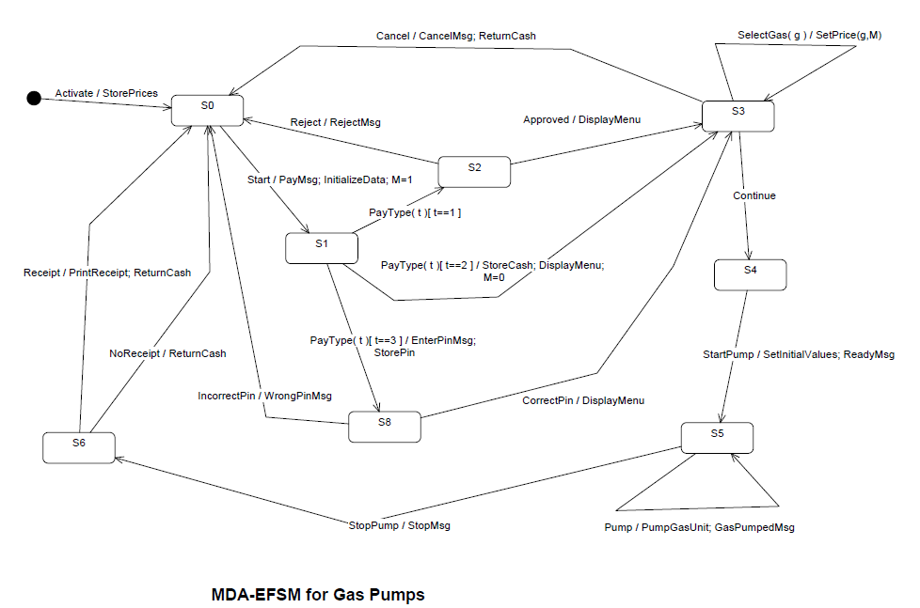

1. **Pseudocode**

**Operations of the Input Processor (GasPump-1)**

Activate(float a, float b) { if ((a>0)&&(b>0)) {

d->temp_a=a; d->temp_b=b; m->Activate()

}

}

Start() {

m->Start();

}

PayCredit() {

m->PayType(1);

}

Reject() {

m->Reject();

Approved() {

m->Approved();

}

Diesel() {

m->SelectGas(4)

}

Regular() {

m->SelectGas(1)

}

StartPump() {

if (d->price>0) {

m->Continue(); m->StartPump();

}

}

PumpGallon() {

m->Pump();

}

PayDebit(string p) {

d->temp_p=p; m->PayType(3);

StopPump() {

m->StopPump(); m->Receipt();

}

}

Pin(string x) {

if (d->pin==x) m->CorrectPin() else m->InCorrectPin();

FullTank() {

m->StopPump(); m->Receipt();

}

}

Cancel() {

m->Cancel();

}

**Operations of the Input Processor (GasPump-2)**

Activate(int a, int b, int c) {

if ((a>0)&&(b>0)&&(c>0)) { d->temp_a=a;

d->temp_b=b; d->temp_c=c m->Activate()

}

Super() {

m->SelectGas(2); m->Continue();

}

Premium() {

m->SelectGas(3); m->Continue();

}

Notice:

cash: contains the value of cash deposited price: contains the price of the selected gas L: contains the number of liters already pumped

cash , L, price are in the data store

m: is a pointer to the MDA-EFSM object

d: is a pointer to the Data Store object

}

PayCash(float c) {

if (c>0) {

d->temp_cash=c; m->start();

m->PayType(2)

}

}

PayCredit() {

m->start();

m->PayType(1);

}

Reject() {

m->Reject();

}

Approved() {

m-> Approved();

}

Cancel() {

m->Cancel();

}

Regular() {

m->SelectGas(1); m->Continue();

}

StartPump() {

m->StartPump();

}

PumpLiter() {

if (d->cash>0)&&(d->cash < d->price*(d->L+1))

m->StopPump(); else m->Pump()

}

Stop() {

m->StopPump();

}

Receipt() {

m->Receipt();

}

NoReceipt() {

m->NoReceipt();

}

1. **Class diagram(s) of the MDA of the GasPump components.**

**Overall Class Diagram**

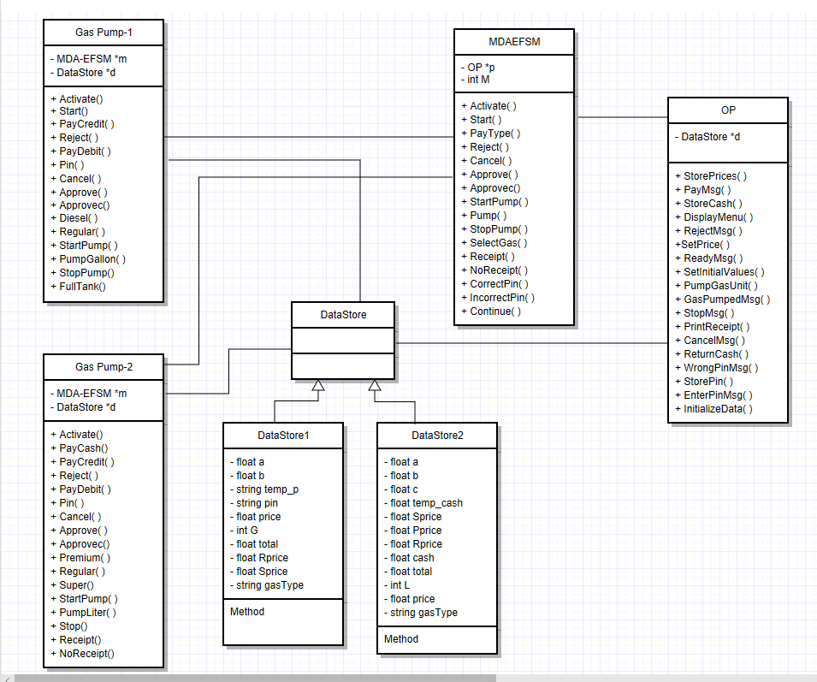

1. **State Pattern Diagram**

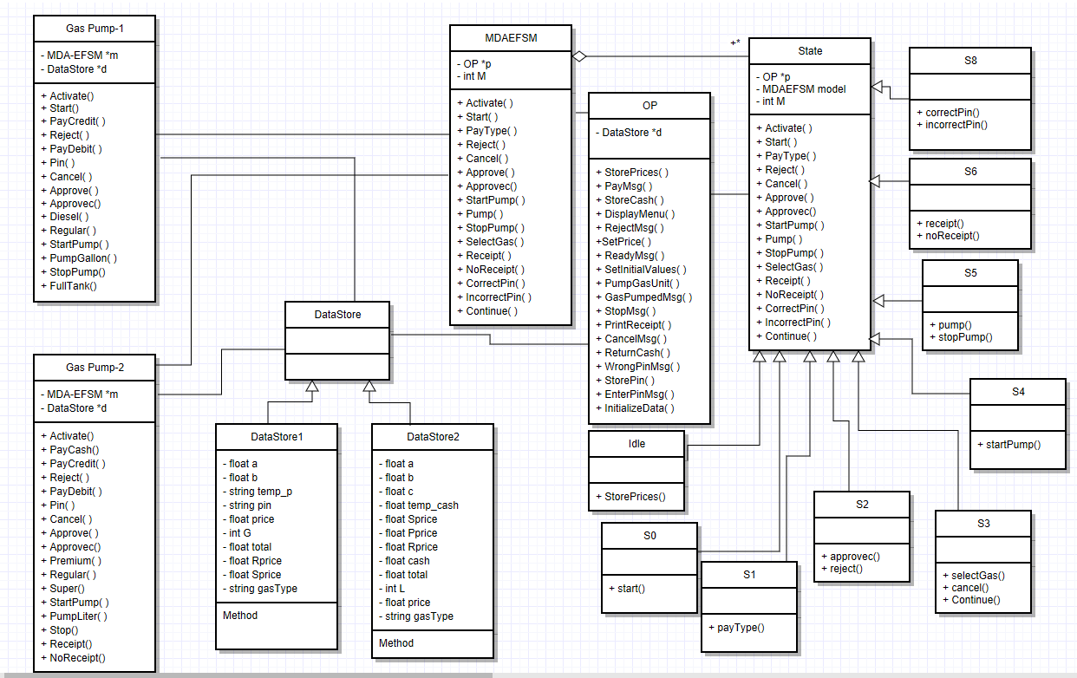

1. **Strategy Pattern**

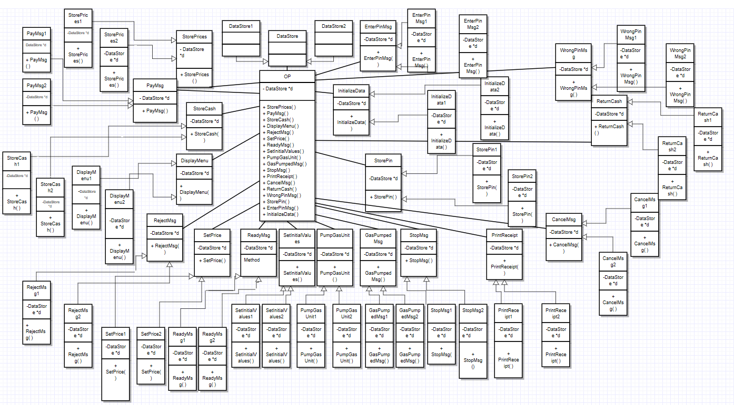

1. **Abstract Factory Pattern**

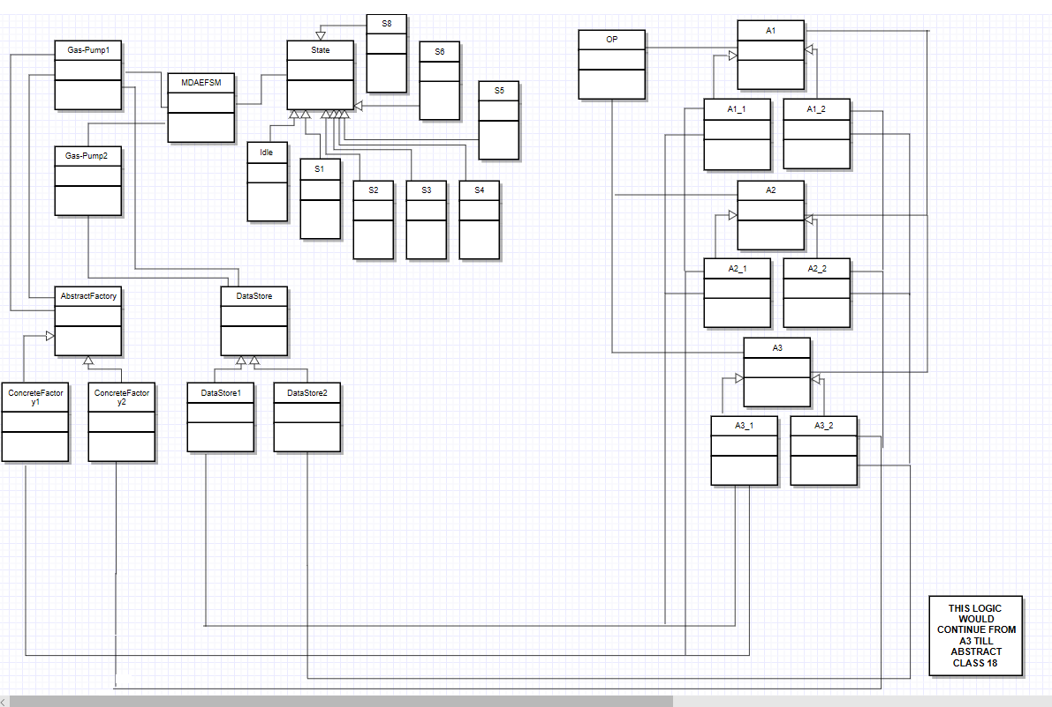

1. **Purpose, Attributes, and Functions of all the classes**

**Class GasPump**

**Class GasPump1**

|  |  |
| --- | --- |
| Purpose and Attributes | Represents GasPump1 implementation  model is object for MDAEFSM  data is object for DataStore |
| Activate (float a, float b) | **if** a > 0 && b > 0  d.a = a;  d.b = b;  model.activate();  **else**  print (“Price should be > 0”) |
| Start () | model.Start (); |
| PayDebit() | Model.payType(3); |
| PayCredit () | model.payType (1); |
| Pin() | d.temp_p=x;  d.pin=d.temp_p; |
| Reject () | model.reject (); |
| Cancel () | model.cancel (); |
| Approve (String p) | if(p.equals(d.pin))  {  model.correctPin();  }  else  {  model.incorrectPin();  } |
| Approvec() | model.approvec(); |
| Diesel () | model.selectGas (4,1); |
| Regular () | model.selectGas (1,1); |
| StartPump () | model.Continue();  if(d.price>0)  {  model.startPump();  } |
| PumpGallon () | model.pump (); |
| StopPump () | model.stopPump ();  model.receipt (); |
| FullTank() | Model.receipt(); |

**Class GasPump2**

|  |  |
| --- | --- |
| Purpose and Attributes | Represents GasPump2 implementation  model is object for MDAEFSM  data is object for DataStore |
| Activate (int a, int b, int c) | **if** a > 0 && b > 0 && c > 0  d.a = a;  d.b = b;  d.c = c;  model.activate();  **else**  print (“Price should be > 0”) |
| Start () | model.Start (); |
| PayCash () | **if** cash > 0  d.temp_cash = cash;  model.payType(2);  d.M=0;  **else**  print (“Cash should be > 0”) |
| PayCredit() | **model.payType(1);**  **d.M=1;** |
| Reject() | **Model.reject();** |
| Cancel () | model.Cancel (); |
| Premium () | if(d.M==1)  {  model.selectGas(3,1);  }  else  model.selectGas(3, 0); |
| Regular () | if(d.M==1)  {  model.selectGas(1,1);  }  else  model.selectGas(1, 0); |
| Super () | if(d.M==1)  {  model.selectGas(2,1);  }  else  model.selectGas(2, 0); |
| StartPump () | model.Continue();  if(d.M==1)  {  model.startPump();  d.price= (float)(1.1 * d.price);  d.L=0;    }  else if(d.M==0)  {  model.startPump();  d.L=0;  } |
| PumpLiter () | **if ((d.M==0) && (d.cash < d.price * (d.L + 1)))**  **{**  **System.out.println("Limited Balance");**  **model.stopPump();**  **}**  **else if((d.M==0) && (d.cash>=d.price * (d.L + 1)))**  **{**  **model.pump();**    **}**  **else if((d.M==1))**  **{**  **model.pump();**  **}** |
| Approve() | **Model.approve()**  **d.M=1;** |
| Approvec() | **Model.approvec()** |
| Stop () | model.stopPump (); |
| Receipt () | model.Receipt (); |
| NoReceipt () | model.NoReceipt (); |

**State Pattern**

**Class MDAEFSM**

|  |  |
| --- | --- |
| Purpose and Attributes | This class implements the common functionality among two GasPumps.  f is an object of AF (Abstract Factory).  op is an object of OP. |
| MDAEFSM | It is the constructor. It sets the current state of the GasPump to Start |
| Activate() | Call State Function Activate() |
| Start() | Call State Function Start() |
| PayType(int g) | Call State Function PayType(int g) |
| Approve() | Call State Function Approve() |
| Approvec() | Call State Function Approvec() |
| Cancel() | Call State Function Cancel() |
| StartPump() | Call State Function StartPump() |
| Pump() | Call State Function Pump() |
| StopPump() | Call State Function StopPump() |
| SelectGas(int g, int M) | Call State Function SelectGas(int g, int M) |
| Receipt() | Call State Function Receipt() |
| NoReceipt() | Call State Function NoReceipt() |
| Reject() | Call State Function Reject() |
| Continue() | Call State Function Continue() |
| correctPin() | Call State Function correctPin() |
| incorrectPin() | Call State Function incorrectPin() |

**Class Idle**

|  |  |
| --- | --- |
| Purpose and Attributes | This is the concrete class for the Idle State.  Idle() is the class constructor. |
| Activate() | Calls StorePrices() to store price of gases in temporary variables and set the state to S0 |

**Class S0**

|  |  |
| --- | --- |
| Purpose and Attributes | This is the concrete class for the S0 State.  S0() is the class constructor. |
| Start() | Calls PayMsg()  Displays a pay message  Calls InitializeData()  M=1  Set the state to S1 |

**Class S1**

|  |  |
| --- | --- |
| Purpose and Attributes | This is the concrete class for the S1 State.  S1() is the class constructor. |
| PayType(int t) | If ( PayType == 1 ie credit and state is S1)  Then set state to S2  Set M=1  Else if ( PayType == 2 ie cash and state is S1)  {Then call StoreCash() to store the cash inserted value in Temp_cash.  Call DisplayMenu() to display menu of operations of gaspump1  Set state to S3  Set M=0  }  Else if( PayType == 3 ie debit and state is S1)  {Then call EnterPinMsg() & StorePin()  Set state to S8  Set M=1  } |

**Class S2**

|  |  |
| --- | --- |
| Purpose and Attributes | This is the concrete class for the S2 State.  S2() is the class constructor. |
| Approvec() | If state is in S2 then  Sets state to S3  Calls DisplayMenu() to display menu of operations of gaspump1 |
| Reject() | If state is in S2 then  Sets state to S0  Calls RejectMsg() to display a reject message |

**Class S3**

|  |  |
| --- | --- |
| Purpose and Attributes | This is the concrete class for the S3 State.  S3() is the class constructor. |
| SelectGas(int g) | If state is in S3 then  Sets state to S3  Calls SetPrice(int g,int M) to store price of selected gas in price parameter from temp_cash |
| Cancel() | If state is in S3 then  Sets state to S0  Calls CancelMsg() to display a cancel message Calls ReturnCash() to return the left cash |
| Continue() | If state is in S3 then  Set state to S4 |

**Class S4**

|  |  |
| --- | --- |
| Purpose and Attributes | This is the concrete class for the S4 State.  S4() is the class constructor. |
| StartPump() | If state is in S4 then  Sets state to S5  Calls SetInitialValues() to set value of G/L and total to 0  Calls ReadyMsg() to display that gaspump is ready to pump |

**Class S5**

|  |  |
| --- | --- |
| Purpose and Attributes | This is the concrete class for the S5 State.  S5() is the class constructor. |
| Pump() | If state is in S5 then  Calls PumpGasUnit() to increments value of G by 1 and calculates the value of total and GasPumpedMsg() to display the gallons of disposed gas |
| StopPump() | If state is in S5 then it sets state to S6  Calls StopMsg() to display a stop message  Calls PrintReceipt() to print the receipt |

**Class S6**

|  |  |
| --- | --- |
| Purpose and Attributes | This is the concrete class for the S6 State.  S6() is the class constructor. |
| Receipt() | If state is in S6 then it sets state to S0  Calls PrintReceipt() to print receipt  Calls ReturnCash() to return cash |
| NoReceipt() | If state is in S6 then it sets state to S0  Calls ReturnCash() to return cash |

**Class S8**

|  |  |
| --- | --- |
| Purpose and Attributes | This is the concrete class for the S8 State.  S8() is the class constructor. |
| correctPin() | If state is in S8 then it sets state to S3  Calls DisplayMenu() |
| incorrectPin() | If state is in S8 then it sets state to S0  Calls WrongPinMsg() |

**Strategy Pattern:**

**Class StoreData**

|  |  |
| --- | --- |
| Purpose and Attributes | This class represents the abstract factory class of action StoreData.  data is an object of DataStore |
| StoreData() | Abstract method |

**Class StoreData1**

|  |  |
| --- | --- |
| Purpose and Attributes | This class represents the concrete class for StoreData action in GasPump1 and is used to store the values of temporary variables a and b |
| StoreData() | Stores values of temporary variables a and b |

**Class StoreData2**

|  |  |
| --- | --- |
| Purpose and Attributes | This class represents the concrete class for StoreData action in GasPump2 and is used to store the values of temporary variables a, b and c |
| StoreData() | Stores values of temporary variables a, b and c |

**Class PayMsg**

|  |  |
| --- | --- |
| Purpose and Attributes | This class represents the abstract class for PayMsg action |
| PayMsg() | Abstract method |

**Class PayMsg1**

|  |  |
| --- | --- |
| Purpose and Attributes | This class represents the concrete class for PayMsg action for GasPump1. |
| PayMsg() | Ask for the payment type from user for GasPump1 |

**Class PayMsg2**

|  |  |
| --- | --- |
| Purpose and Attributes | This class represents the concrete class for PayMsg action for GasPUmp2. |
| PayMsg() | Ask for the payment type from the user for GasPump2 |

**Class StoreCash**

|  |  |
| --- | --- |
| Purpose and Attributes | This class represents the abstract factory class of action StoreCash.  data is an object of DataStore |
| StoreCash() | Abstract method |

**Class StoreCash1**

|  |  |
| --- | --- |
| Purpose and Attributes | This class is not supported by GasPump1 as it does not support payment by cash. |
| StoreCash() | No action |

**Class StoreCash2**

|  |  |
| --- | --- |
| Purpose and Attributes | This class represents the concrete class for action StoreCash GasPump2 version and is used to store cash in temp_cash in float format. |
| StoreCash() | Stores cash inserted into the GasPump2 |

**Class DisplayMenu**

|  |  |
| --- | --- |
| Purpose and Attributes | This class represents the abstract class for DisplayMenu action |
| DisplayMenu() | Abstract method |

**Class DisplayMenu1**

|  |  |
| --- | --- |
| Purpose and Attributes | This class is used to represent the concrete class for DisplayMenu action for GasPump1 |
| DisplayMenu() | Display Menu for GasPump1 |

**Class DisplayMenu2**

|  |  |
| --- | --- |
| Purpose and Attributes | This class is used to represent the concrete class for DisplayMenu action for GasPump2 |
| DisplayMenu() | Display Menu for GasPump2 |

**Class RejectMsg**

|  |  |
| --- | --- |
| Purpose and Attributes | This class represents the abstract class for RejectMsg action |
| RejectMsg() | Abstract method |

**Class RejectMsg1**

|  |  |
| --- | --- |
| Purpose and Attributes | This class is used to represent the concrete class for RejectMsg action for GasPump1 |
| RejectMsg() | Display credit card rejected message. |

**Class RejectMsg2**

|  |  |
| --- | --- |
| Purpose and Attributes | This class is not supported by GasPump2 as it does not support payment by credit card. |
| RejectMsg() | No action |

**Class SetPrice**

|  |  |
| --- | --- |
| Purpose and Attributes | This class represents the abstract factory class of action SetPrice.  data is an object of DataStore |
| SetPrice() | Abstract method |

**Class SetPrice1**

|  |  |
| --- | --- |
| Purpose and Attributes | This class is used to represent the concrete class for SetPrice action for GasPump1 and is used to set the value of Rprice and Sprice as per the values entered by users for a and b respectively. |
| SetPrice() | Assign values to Rprice and Sprice |

**Class SetPrice2**

|  |  |
| --- | --- |
| Purpose and Attributes | This class is used to represent the concrete class for SetPrice action for GasPump2 and is used to set the value of Rprice, Sprice and Pprice as per the values entered by users for a, b and c respectively. |
| SetPrice() | Assign values to Rprice, Sprice and Pprice. |

**Class ReadyMsg**

|  |  |
| --- | --- |
| Purpose and Attributes | This class represents the abstract class for action ReadyMsg.  data is an object for DataStore |
| ReadyMsg() | Abstract method |

**Class ReadyMsg1**

|  |  |
| --- | --- |
| Purpose and Attributes | This class represents the concrete class for ReadyMsg action for GasPump1  data is an object for DataStore |
| ReadyMsg() | Call DataStore1 to increment the value of G.  Display ready to dispense message. |

**Class ReadyMsg2**

|  |  |
| --- | --- |
| Purpose and Attributes | This class represents the concrete class for ReadyMsg action for GasPump2  data is an object for DataStore |
| ReadyMsg() | Call DataStore2 to increment the value of L.  Display ready to dispense message. |

**Class SetInitialValues**

|  |  |
| --- | --- |
| Purpose and Attributes | This class represents the abstract factory class of action SetInitialValues.  data is an object of DataStore |
| SetInitialValues() | Abstract method |

**Class SetInitialValues1**

|  |  |
| --- | --- |
| Purpose and Attributes | This class represents the concrete class for SetInitialValues action of GasPump1.  data is an object for DataStore1 |
| SetInitialValues() | Sets the initial values of G and total to 0. |

**Class SetInitialValues2**

|  |  |
| --- | --- |
| Purpose and Attributes | This class represents the concrete class for SetInitialValues action of GasPump2.  data is an object for DataStore2 |
| SetInitialValues() | Sets the initial values of L and total to 0. |

**Class PumpGasUnit**

|  |  |
| --- | --- |
| Purpose and Attributes | This class represents the abstract factory class for PumpGasUnit action.  data is an object of DataStore |
| PumpGasUnit() | Abstract method |

**Class PumpGasUnit1**

|  |  |
| --- | --- |
| Purpose and Attributes | This class represents the concrete class for PumpGasUnit for GasPump1.  Fetches the values for G and total from DataStore1 |
| PumpGasUnit() | Calculates and update values of G and total. |

**Class PumpGasUnit2**

|  |  |
| --- | --- |
| Purpose and Attributes | This class represents the concrete class for PumpGasUnit for GasPump2.  Fetches the values for G and total from DataStore2 |
| PumpGasUnit() | Calculates and update values of L and total. |

**Class GasPumpedMsg**

|  |  |
| --- | --- |
| Purpose and Attributes | This class represents the abstract class for GasPumpedMsg action.  data is an object for DataStore |
| GasPumpedMsg() | Abstract method |

**Class GasPumpedMsg1**

|  |  |
| --- | --- |
| Purpose and Attributes | This class represents the concrete class for GasPumpedMsg action.  It fetches the type of gas and total number of gallons from DataStore1 and displays the same. |
| GasPumpedMsg() | Displays type of gas and total gallons dispensed. |

**Class GasPumpedMsg2**

|  |  |
| --- | --- |
| Purpose and Attributes | This class represents the concrete class for GasPumpedMsg action.  It fetches the type of gas and total number of liters from DataStore1 and displays the same. |
| GasPumpedMsg() | Displays type of gas and total liters dispensed. |

**Class StopMsg**

|  |  |
| --- | --- |
| Purpose and Attributes | This class represents the abstract factory class for StopMsg action. |
| StopMsg() | Abstract method |

**Class StopMsg1**

|  |  |
| --- | --- |
| Purpose and Attributes | This class represents the concrete class for action StopMsg for GasPump1. |
| StopMsg() | Display GasPump Stopping for GasPump1. |

**Class StopMsg2**

|  |  |
| --- | --- |
| Purpose and Attributes | This class represents the concrete class for action StopMsg for GasPump2. |
| StopMsg() | Display GasPump Stopping for GasPump2. |

**Class PrintReceipt**

|  |  |
| --- | --- |
| Purpose and Attributes | This class represents the abstract factory class of PrintReceipt action.  data is an object of DataStore |
| PrintReceipt() | Abstract method |

**Class PrintReceipt1**

|  |  |
| --- | --- |
| Purpose and Attributes | This class represents the concrete class for PrintReceipt action for GasPump1.  It generates and prints the receipt for GasPump1 by fetching the values of G, GasType and total gallons. |
| PrintReceipt() | Generates and displays receipt which includes no. of gallons of gasType and the total amount. |

**Class PrintReceipt2**

|  |  |
| --- | --- |
| Purpose and Attributes | This class represents the concrete class for PrintReceipt action for GasPump2.  It generates and prints the receipt for GasPump2 by fetching the values of G, GasType and total liters and cash inserted by user. |
| PrintReceipt() | Generates and displays receipt which includes no. of liters of gasType and the total amount along with the cash amount inserted by user. |

**Class CancelMsg**

|  |  |
| --- | --- |
| Purpose and Attributes | This class represents the abstract factory class for CancelMsg action |
| CancelMsg() | Abstract method |

**Class CancelMsg1**

|  |  |
| --- | --- |
| Purpose and Attributes | This class represents the concrete class for CancelMsg action for GasPump1. |
| CancelMsg() | Display Transaction cancellation message for GasPump1. |

**Class CancelMsg2**

|  |  |
| --- | --- |
| Purpose and Attributes | This class represents the concrete class for CancelMsg action of GasPump2. |
| CancelMsg() | Display Transaction cancellation message for GasPump2. |

**Class ReturnCash**

|  |  |
| --- | --- |
| Purpose and Attributes | This class represents the abstract factory class for ReturnCash action.  data is an object of DataStore |
| ReturnCash() | Abstract method |

**Class ReturnCash1**

|  |  |
| --- | --- |
| Purpose and Attributes | This class is not supported by GasPump1 as it does not support payment by cash. |
| ReturnCash() | No action. |

**Class ReturnCash2**

|  |  |
| --- | --- |
| Purpose and Attributes | This class represents the concrete class for ReturnCash action for GasPump2 in float format.  It fetches the data for cash and total from DataStore2 and computes the difference of cash and total. |
| ReturnCash() | Displays returning cash message if the difference > 0 else it displays no cash to return message. |

**Abstract Factory Pattern**

**Class AbstractFactory:**

|  |  |
| --- | --- |
| Purpose and Attributes | Represents the Abstract class for factory that has different classes of GasPump |
| AbstractFactory | Create objects for MDAEFSM actions. |

**Class ConcreteFactory1:**

|  |  |
| --- | --- |
| Purpose and Attributes | Represents the concrete class for GasPump1’s factory; used to handle creation of class objects specific to GasPump1 |
| Actions | Create objects to every Strategy classes for GasPump1.  Return objects of every Strategy class for GasPump1. |

**Class ConcreteFactory2:**

|  |  |
| --- | --- |
| Purpose and Attributes | Represents the concrete class for GasPump2’s factory; used to handle creation of class objects specific to GasPump2 |
| Actions | Create objects to every Strategy classes for GasPump2.  Return objects of every Strategy class for GasPump2. |

**Output**

**Class Output:**

Purpose and Attributes - Op is for output and it represents the Output processor of the MDA.

* data is object of Data Store and af is object of Abstract Factory.

|  |  |
| --- | --- |
| Op () | Constructor and pass Object of Abstract Factory |
| cancelMsg () | Create factory object and call the CancelMsg strategy class function CancelMsg() |
| displayMenu () | Create factory object and call the DisplayMenu strategy class function DisplayMenu() |
| gasPumpedMsg () | Create factory object and call the GasPumpedMsg strategy class function GasPumpedMsg() |
| payMsg () | Create factory object and call the PayMsg strategy class function PayMsg() |
| printReceipt () | Create factory object and call the PrintReceipt strategy class function PrintReceipt() |
| pumpGallon () | Create factory object and call the PumpGallon strategy class function PumpGallon() |
| readyMsg() | Create factory object and call the ReadyMsg strategy class function ReadyMsg() |
| rejectMsg () | Create factory object and call the RejectMsg strategy class function RejectMsg() |
| returnCash () | Create factory object and call the ReturnCash strategy class function ReturnCash() |
| setinitialValues () | Create factory object and call the SetInitialMsg strategy class function SetInitialValues() |
| setPrice () | Create factory object and call the SetPrice strategy class function SetPrice() |
| stopMsg () | Create factory object and call the StopMsg strategy class function StopMsg() |
| storeCash () | Create factory object and call the StoreCash strategy class function StoreCash() |
| storePrices () | Create factory object and call the StoreData strategy class function StorePrices() |
| enterPinMsg() | Create factory object and call the EnterPinMsg() strategy class function EnterPinMsg() |
| WrongPinMsg() | Create factory object and call the WrongPinMsg strategy class function WrongPinMsg() |
| InitializeData() | Create factory object and call the InitializeData strategy class function InitializeData() |

**Data Store**

**Class DataStore:**

Purpose and Attributes - Abstract class for DataStore; classes DataStore1 and DataStore2 extend this class DataStore.

**Class DataStore1:**

|  |  |
| --- | --- |
| Purpose and Attributes | Represents the concrete class for DataStore in GasPump1 |
| Variables | Permanent:  gasType as String  Rprice as float  Sprice as float  Price as float  G as int // number of gallons  Total as float  Pin as String  Temp_p as String  Temporary:  a as float // *a* is the price of the Regular gas per gallon  b as float // *b* is the price of Super gas per gallon |

**Class DataStore2:**

|  |  |
| --- | --- |
| Purpose and Attributes | Represents the concrete class for DataStore in GasPump2 |
| Variables | Permanent:  gasType as String  Rprice as int  Sprice as int  Pprice as int  Cash as float  Price as int  L as int // L is number of liters  Total as int  M as int  Temporary:  a as int // *a* is the price of Regular gas,  b as int // *b* is the price of Premium gas  c as int // *c* is the price of Super gas per liter  temp_cash as float. |

1. **Sequence Diagram**
2. Scenario-I should show how one gallon of Diesel gas is disposed in GasPump-1, i.e., the following sequence of operations is issued: Activate(4.2, 7.2), Start(), PayDebit(“abc”), Pin(“abc”), Diesel(), StartPump(), PumpGallon(), FullTank()

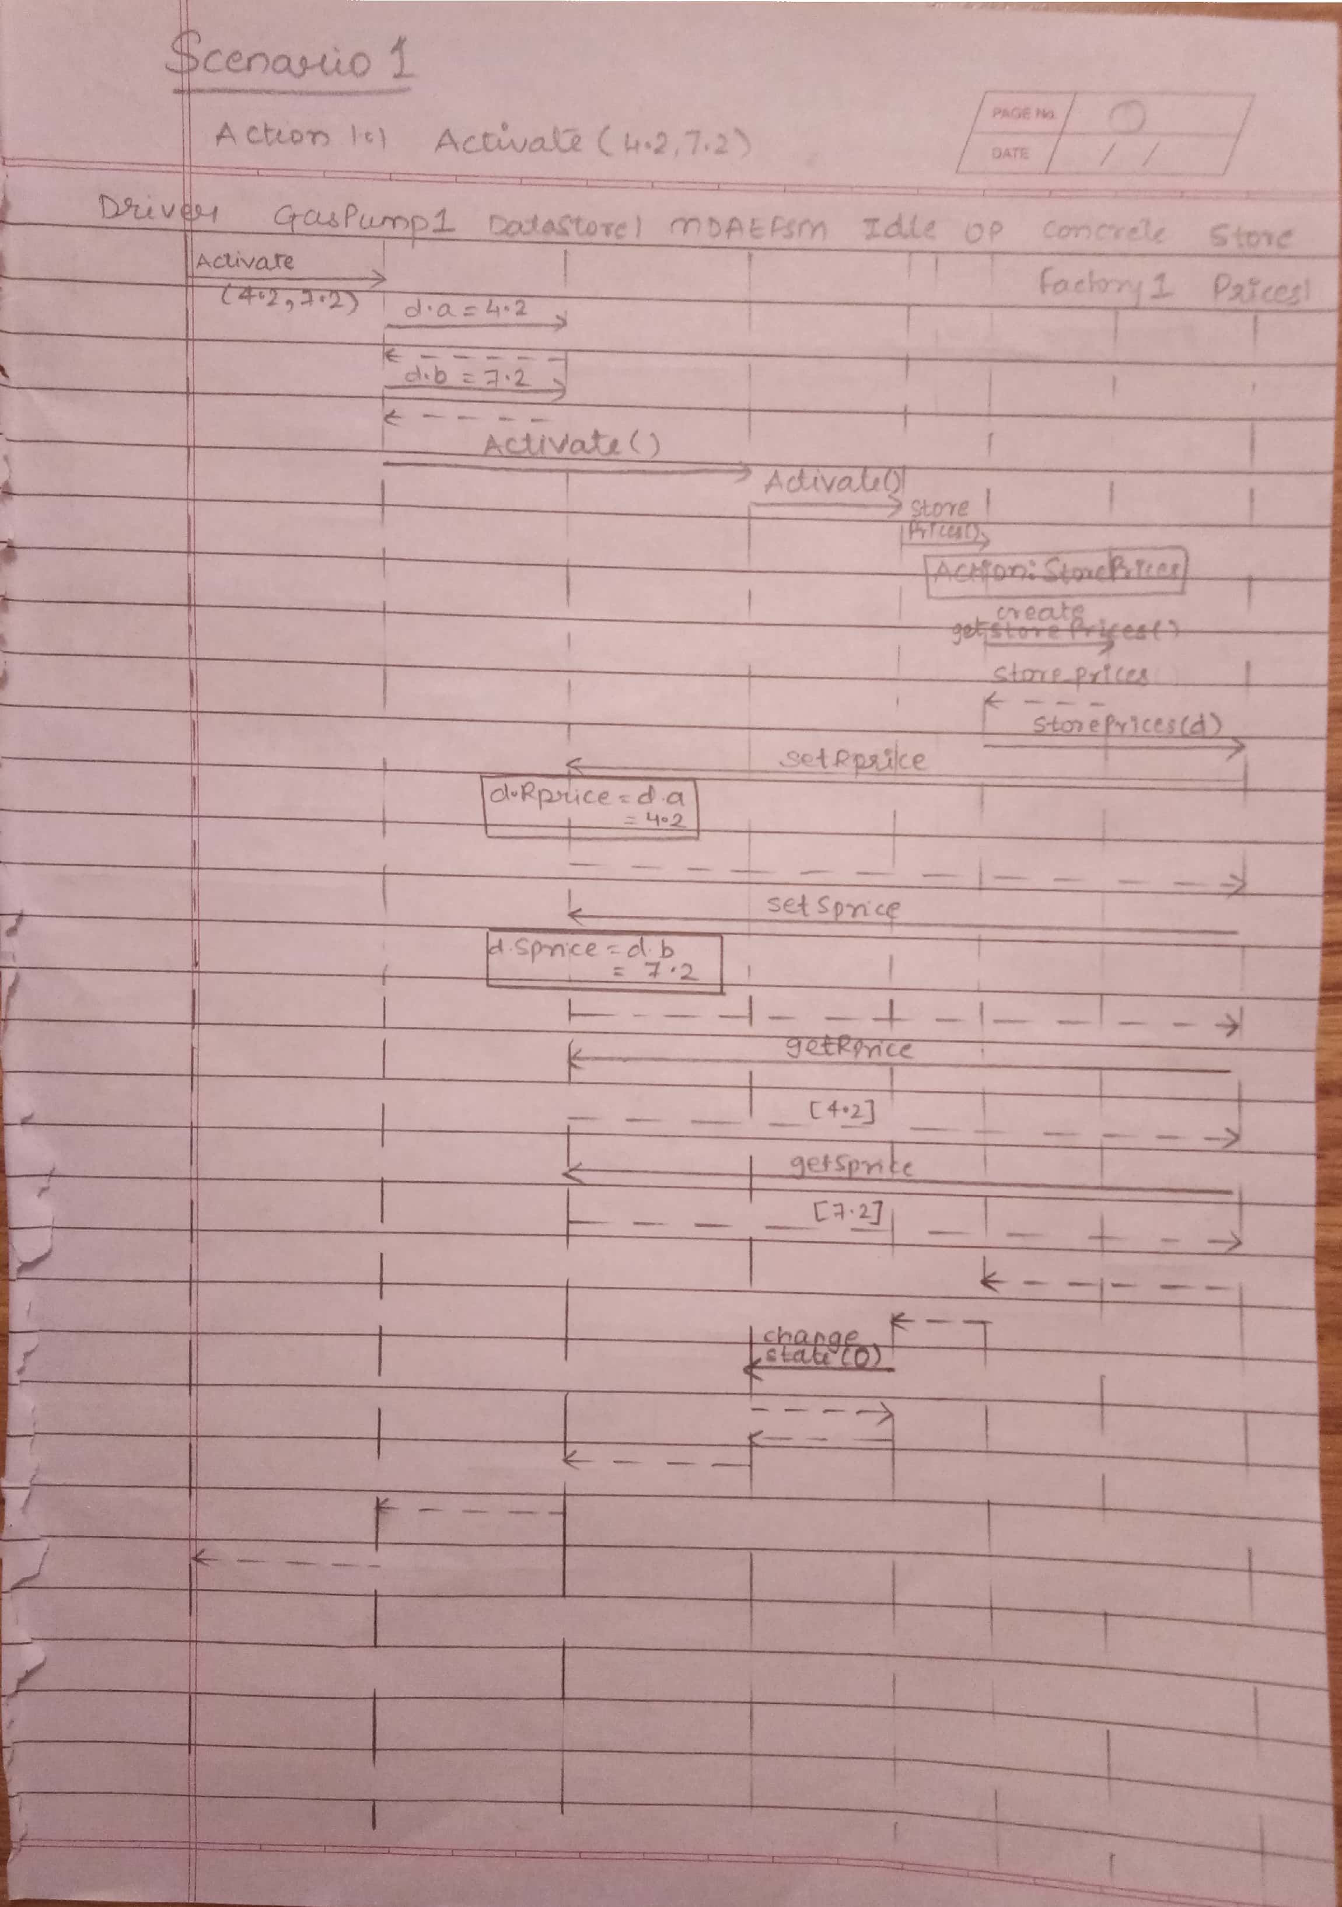

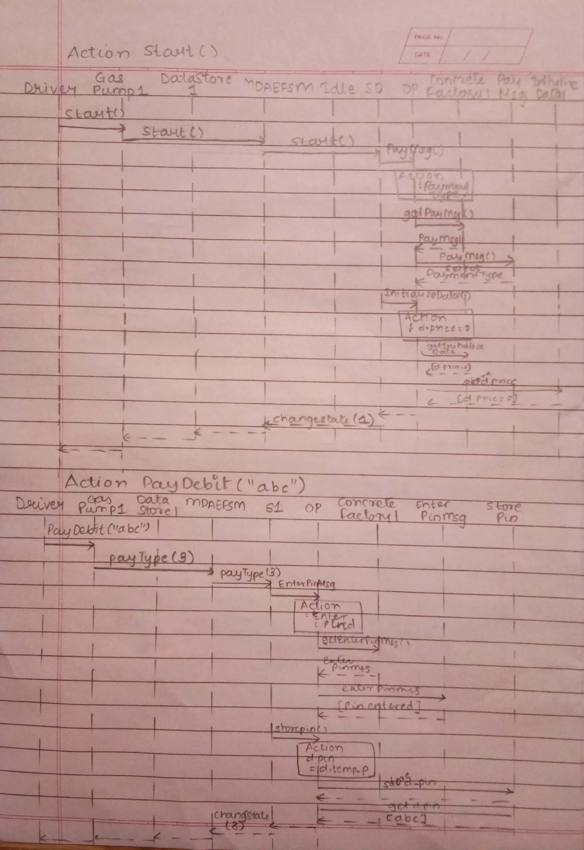

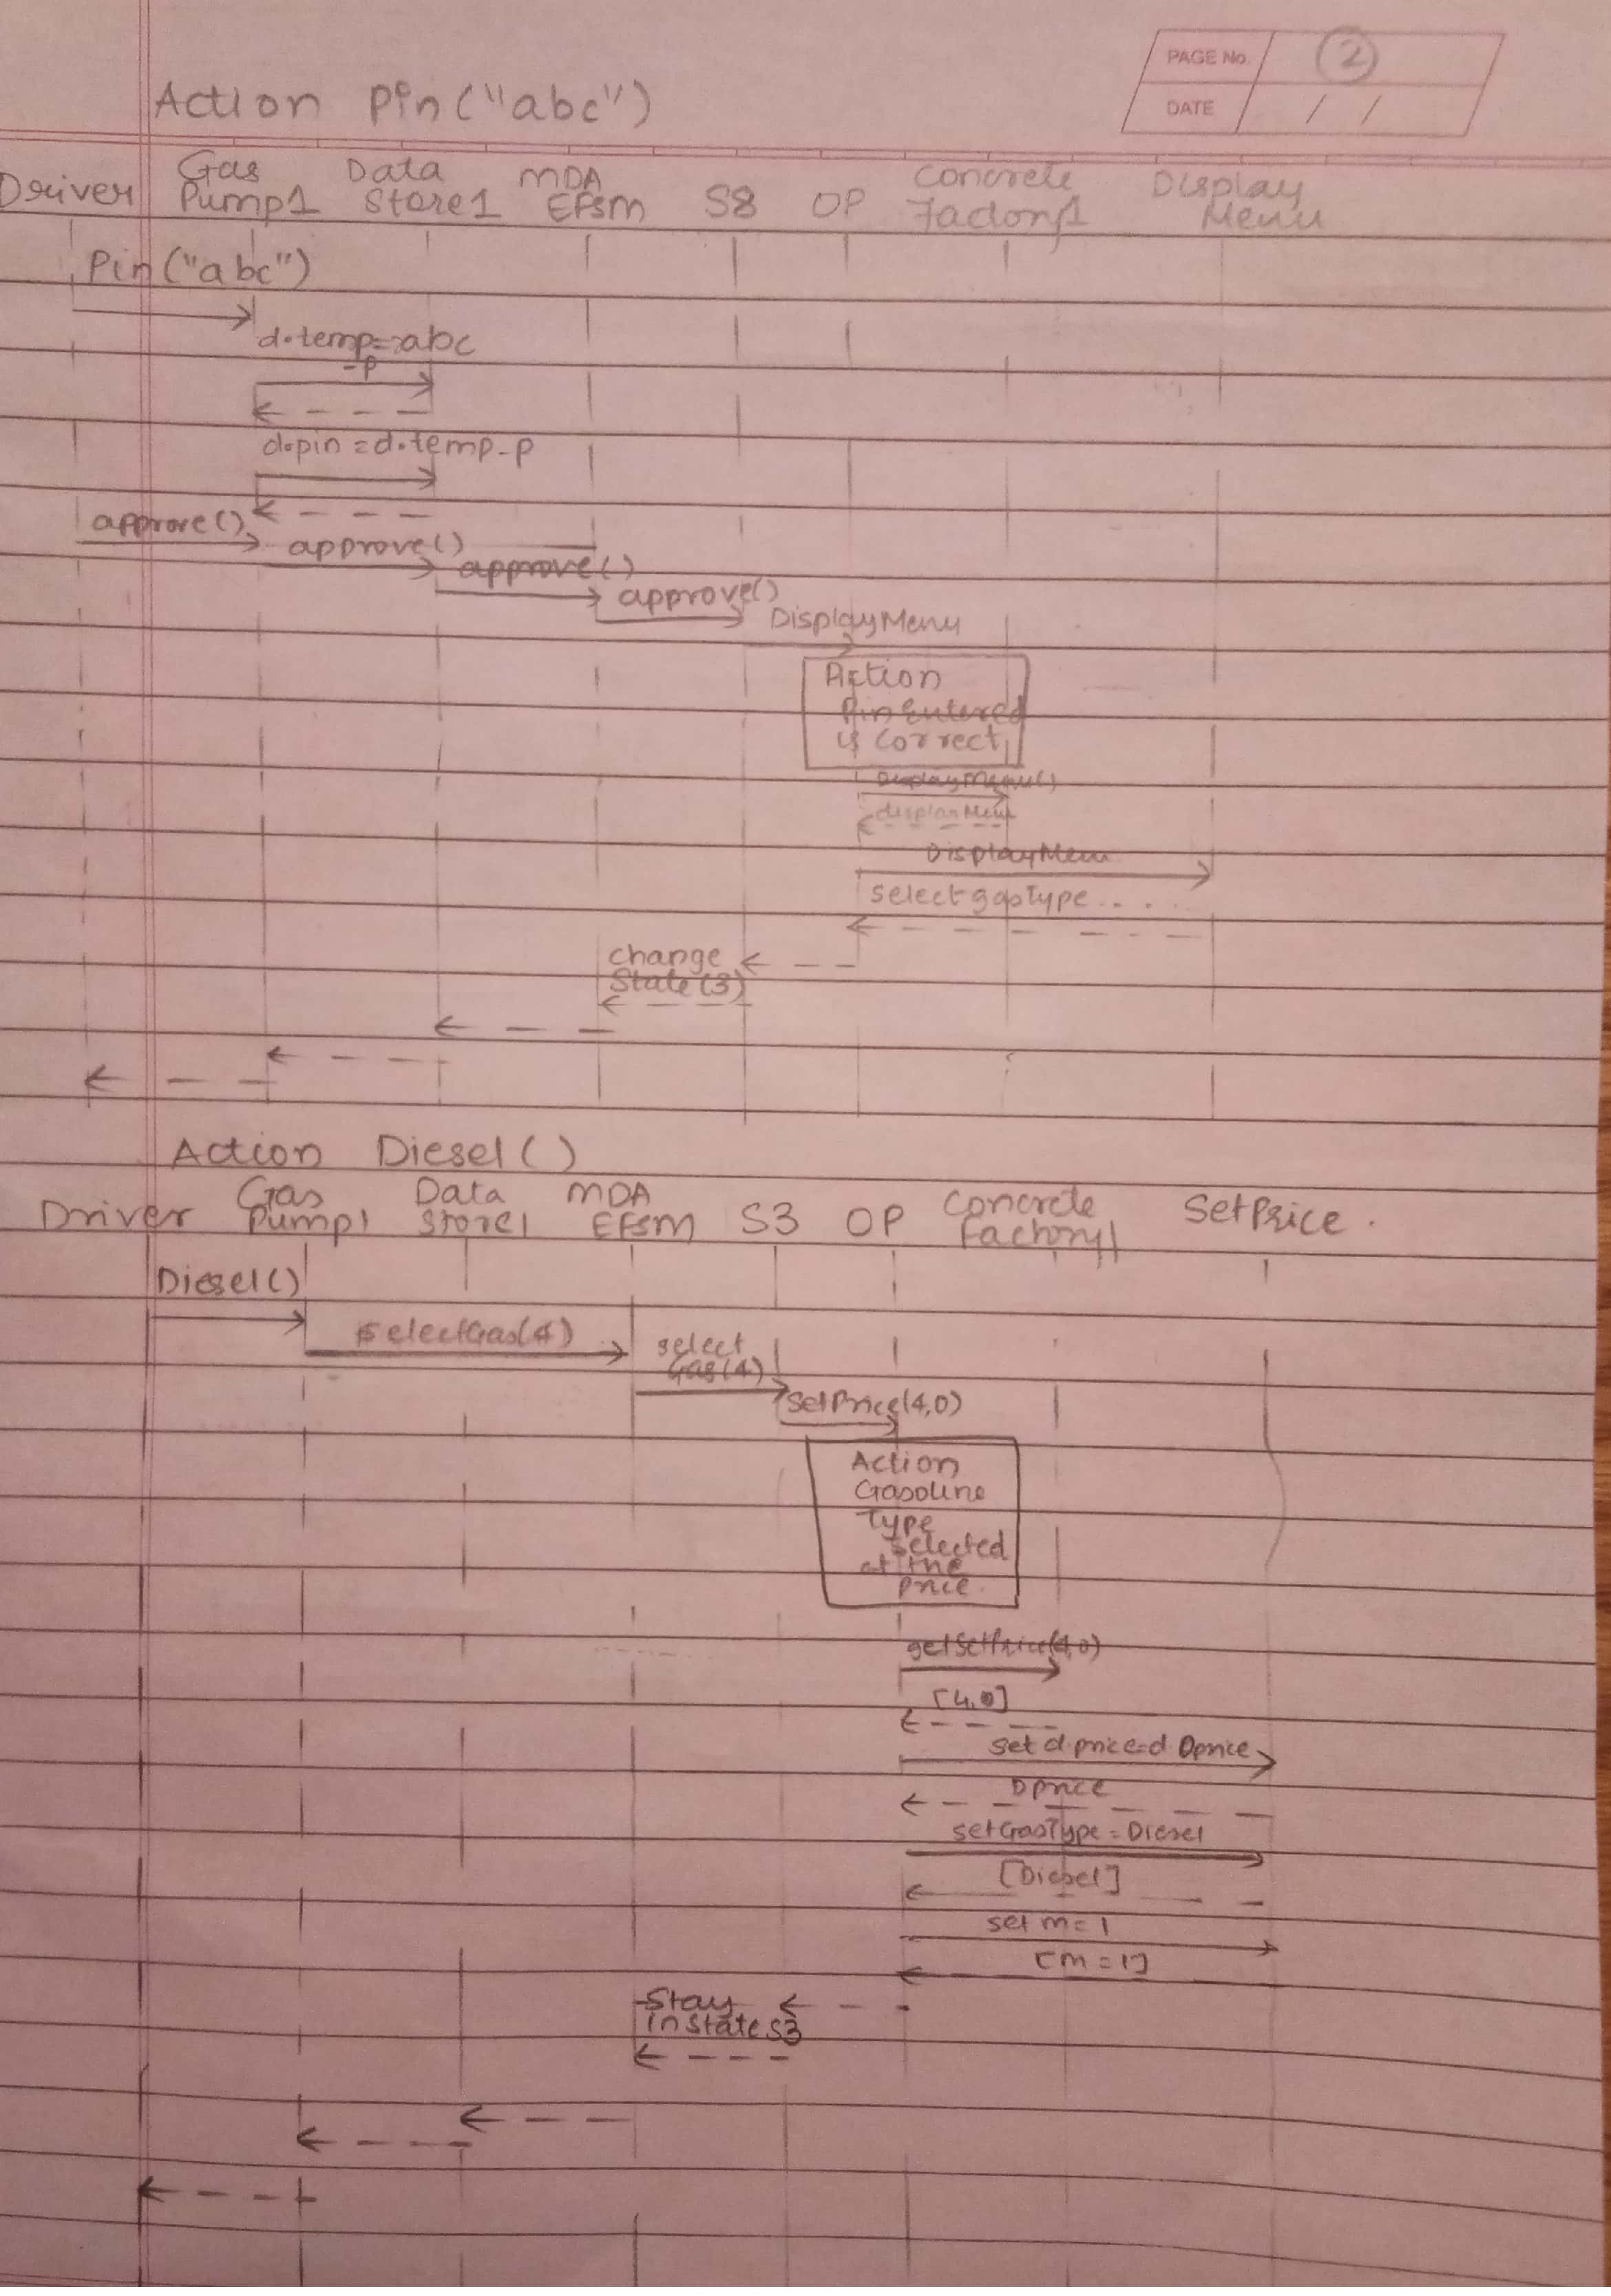

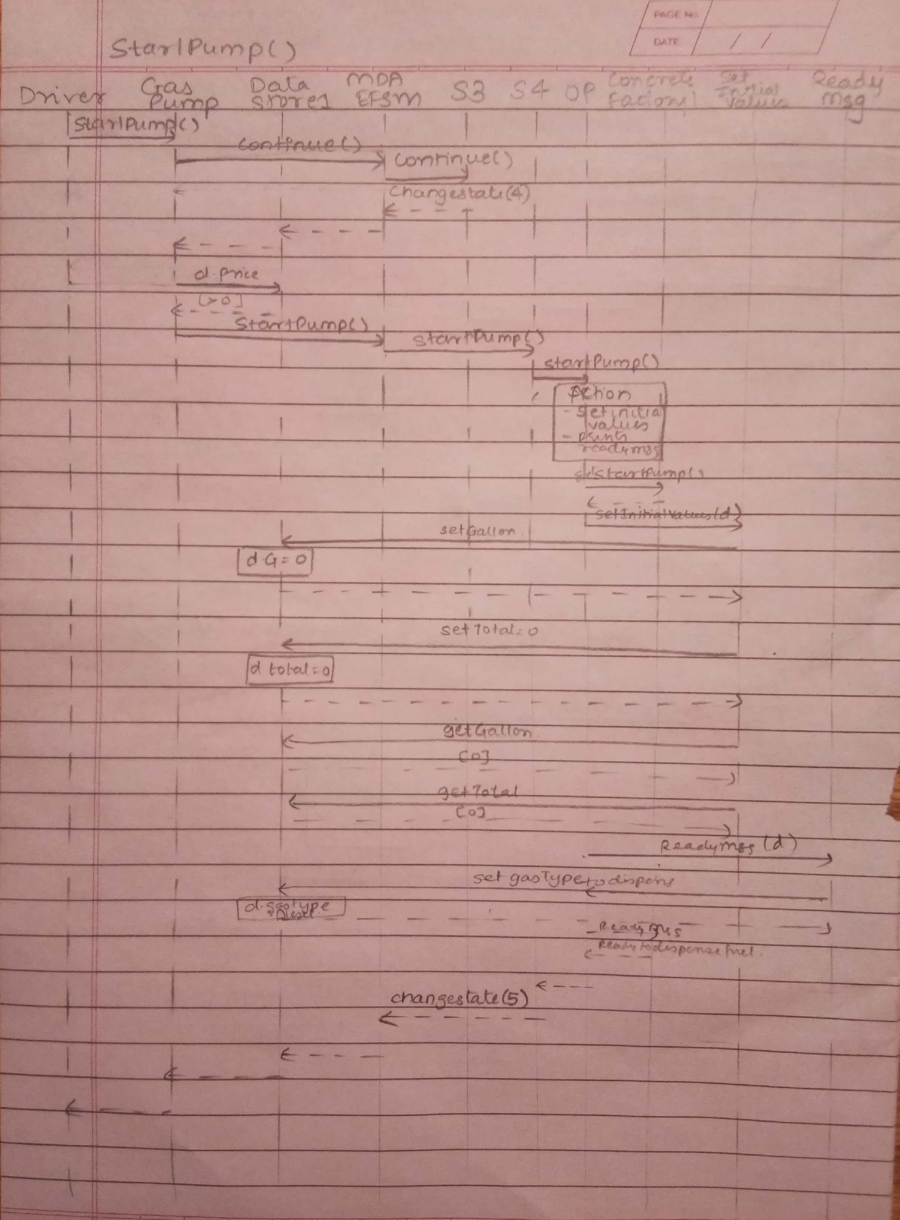

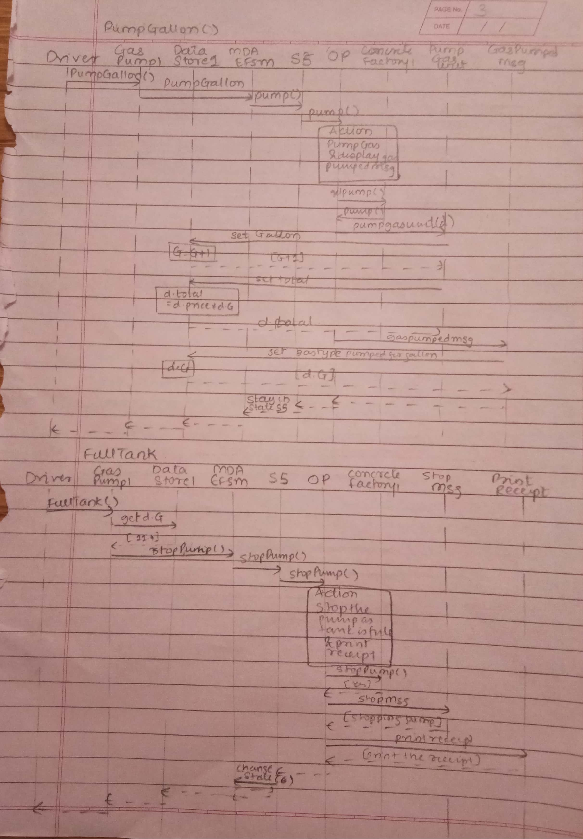

1. Scenario-II should show how one liter of Premium gas is disposed in GasPump-2, i.e., the following sequence of operations is issued: Activate(3, 4, 5.2), PayCash(10), Premium(), StartPump(), PumpLiter(), PumpLiter(), NoReceipt()

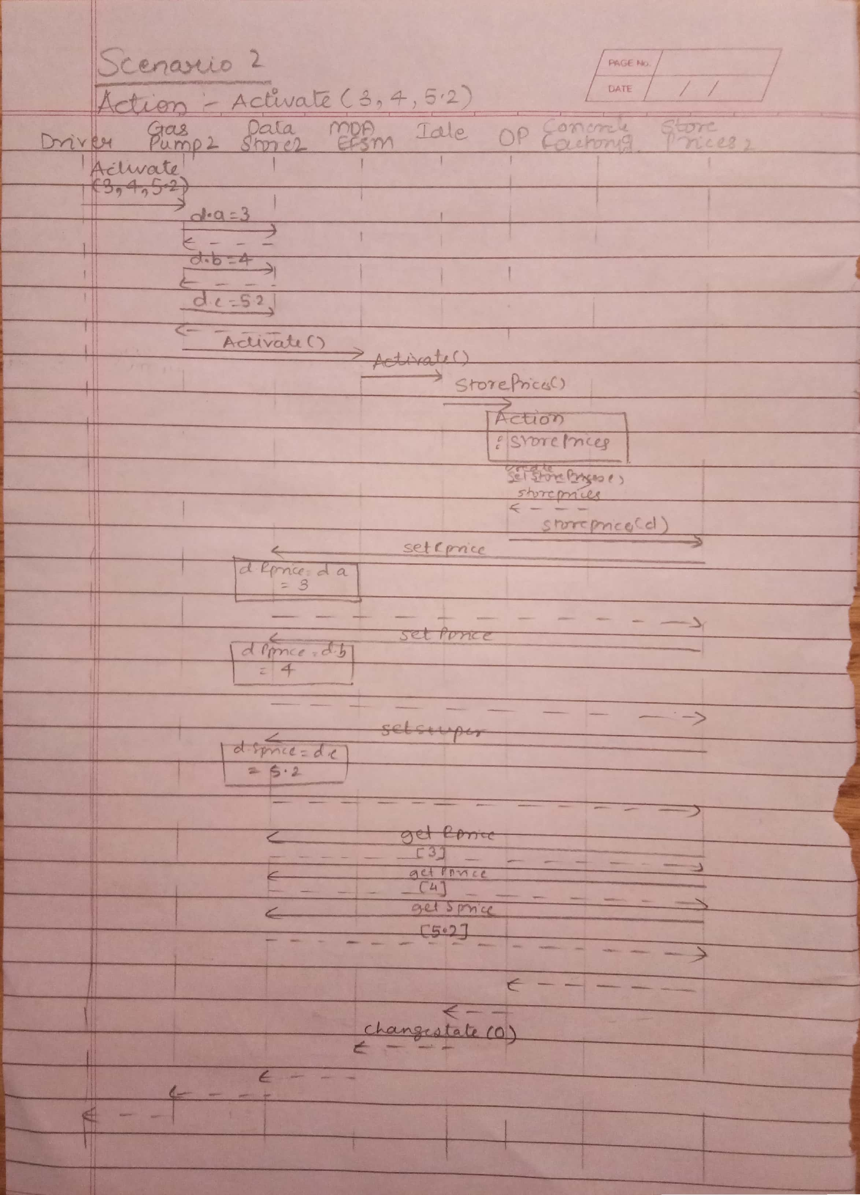

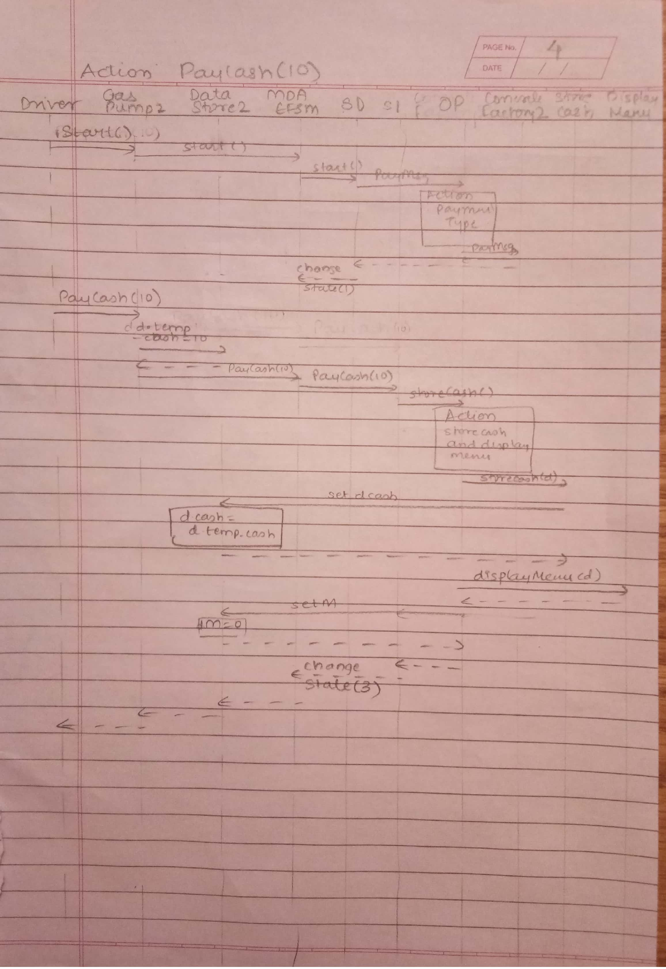

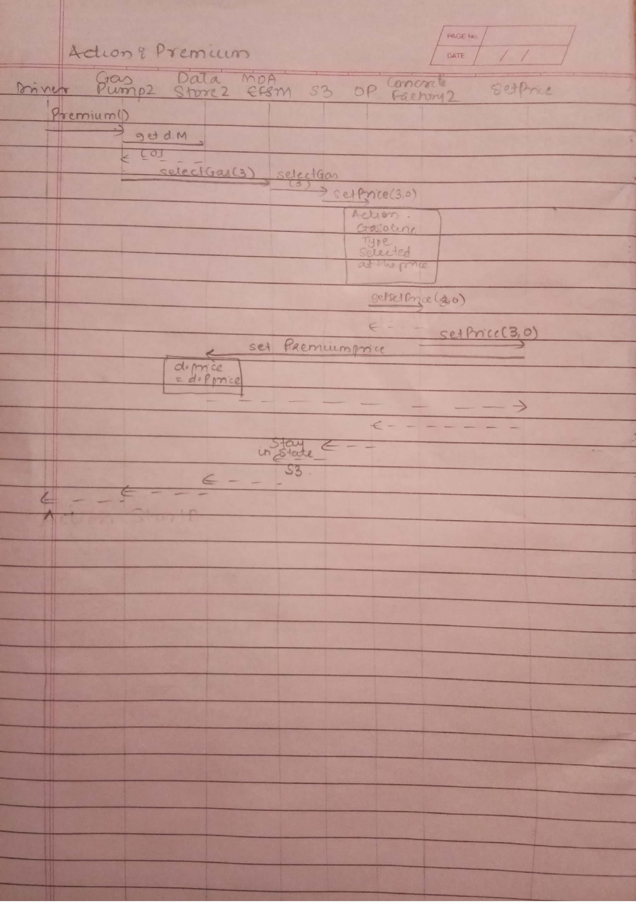

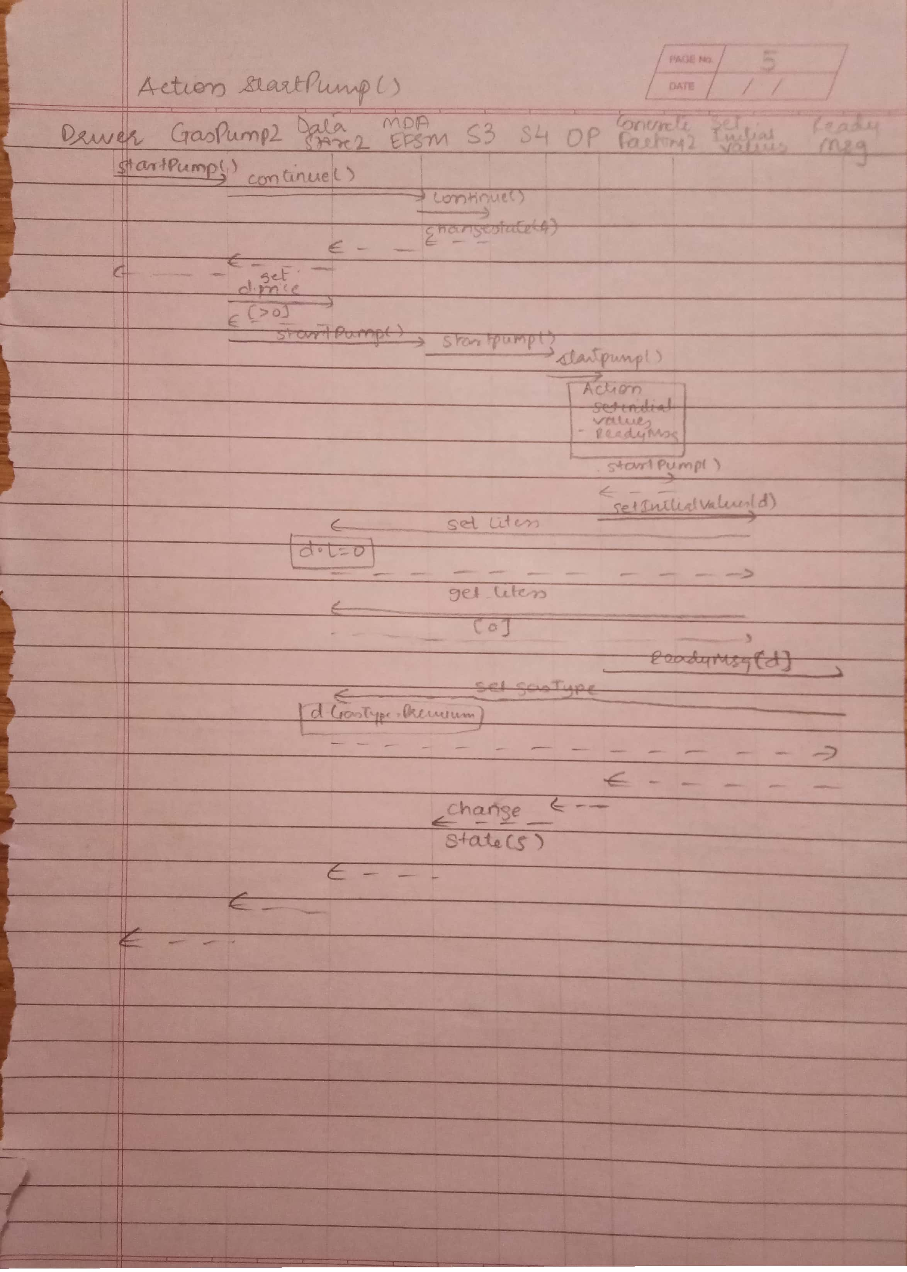

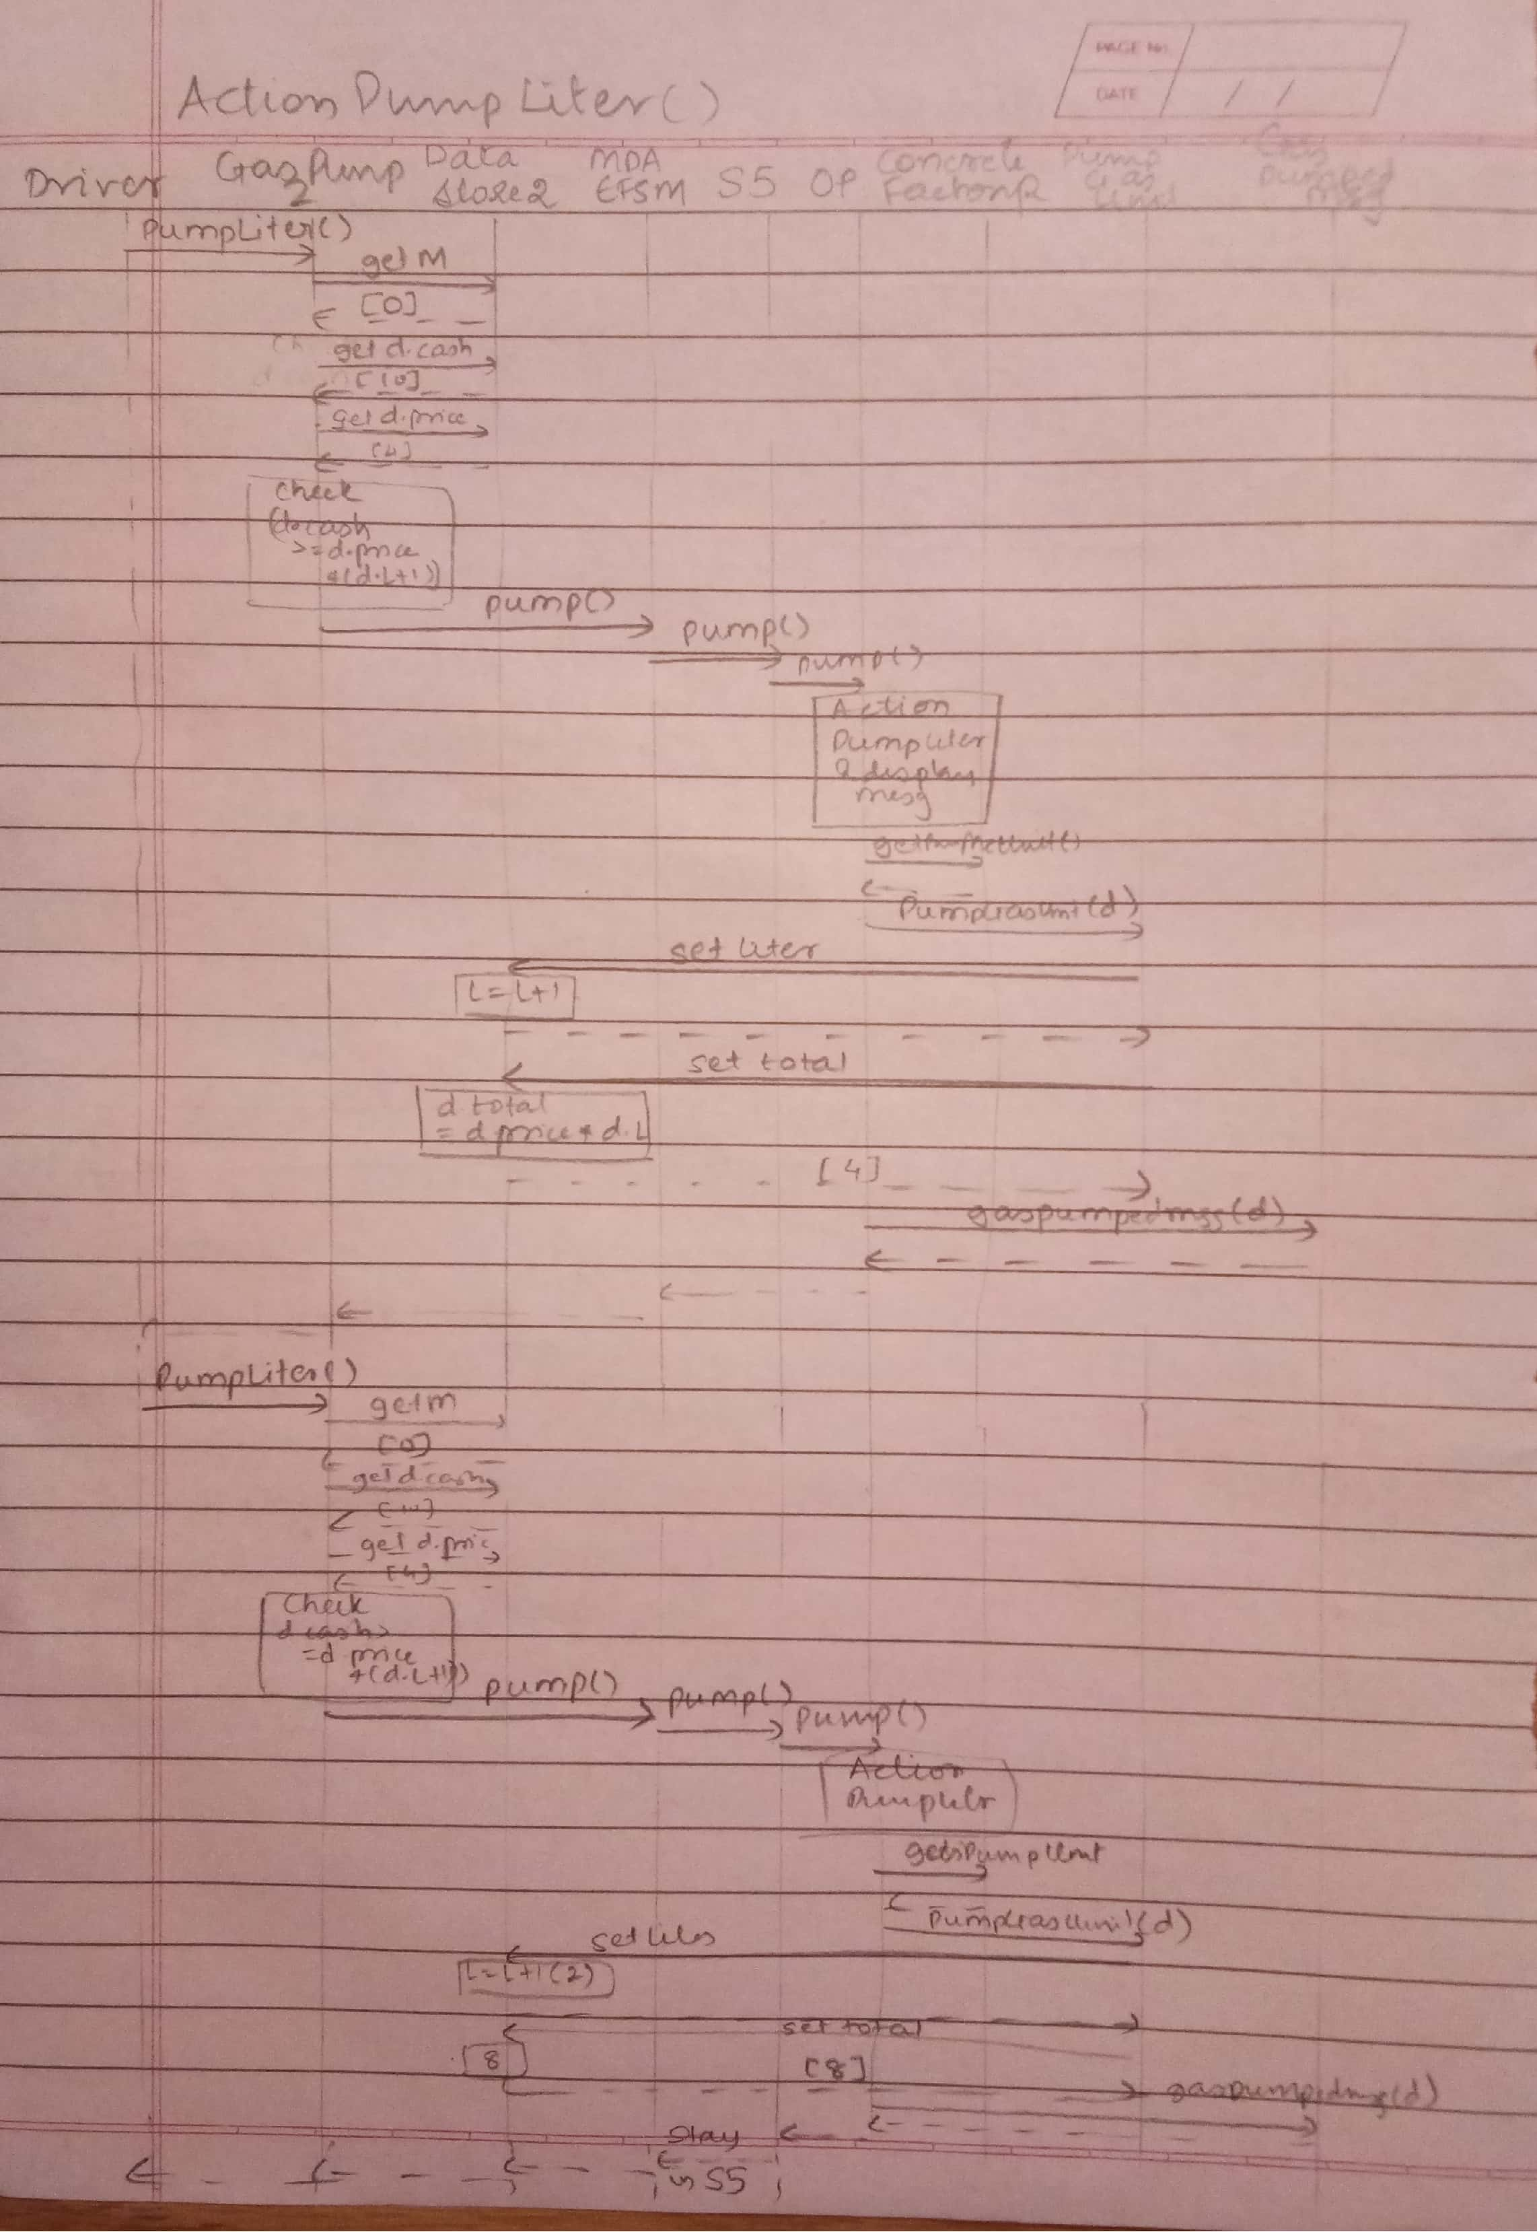

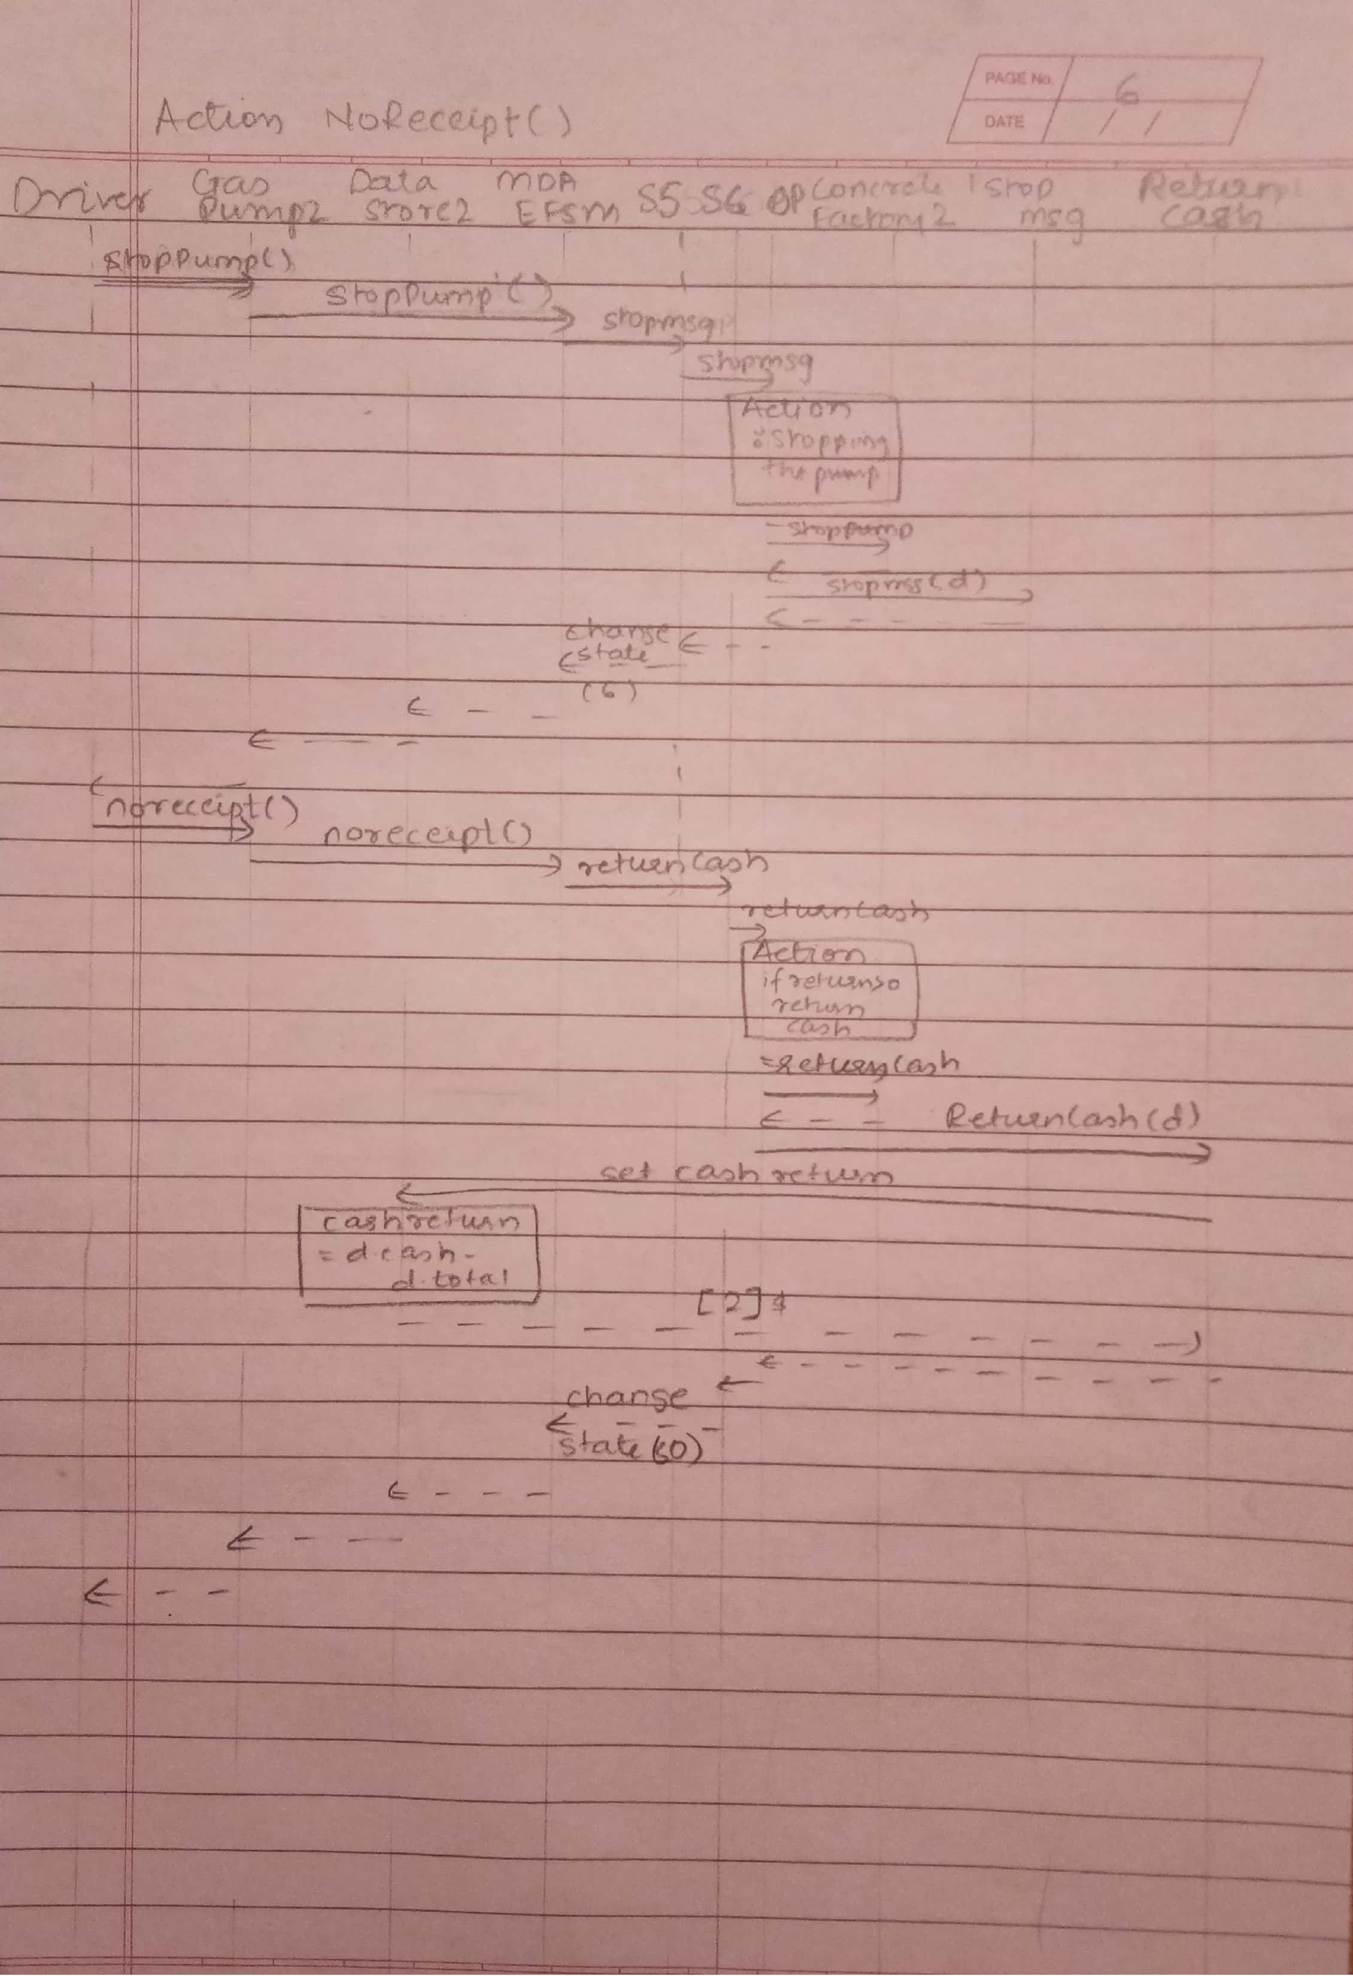

**5. Source Code**

**5.1 Driver**

package Main;

import AbstractFactory.*;

import GasPump.*;

import java.io.BufferedReader;

import java.io.InputStreamReader;

import java.io.IOException;

import java.util.Scanner;

public class Driver {

public static void main(String[] args) {

BufferedReader scan = new BufferedReader(new InputStreamReader(System.in));

System.out.println("Select the GasPump:");

System.out.println("1.GasPump1");

System.out.println("2.GasPump2");

int pump_type;

String input = "initial";

String x = null;

String p = null;

try {

pump_type = Integer.parseInt(scan.readLine());

switch (pump_type) {

case 1: {

ConcreteFactory1 cf1 = new ConcreteFactory1();

GasPump1 gp1 = new GasPump1(cf1);

System.out.println(

"GasPump-1 " +

"\n Operations to Perform: " + "\n 0. Activate(float a, float b) " + "\n 1. Start " + "\n 2. PayDebit " + "\n 3. For Debit(Pin) " +"\n 4. ApproveDebit" + "\n c. PayCredit " +"\n a. ApproveCredit " +"\n r. Reject "

+ "\n 5. Regular " + "\n 6. Diesel " + "\n 7. Cancel " + "\n 8. StartPump " +

"\n 9. PumpGallon " +"\n 10. FullTank " + "\n s. StopPump" + "\n e. Exit"

);

while (!input.equals("e")) {

gp1.printOperations();

input = scan.readLine();

switch (input) {

case "0":

{ // Activate function

System.out.println("GasPump has been activated");

float a, b;

System.out.println("Enter the price for the Regular Gas: ");

try

{

a = Float.parseFloat(scan.readLine());

System.out.println("Enter the price for the Diesel Gas: ");

b = Float.parseFloat(scan.readLine());

gp1.Activate(a, b);

}

catch (NumberFormatException e)

{

System.out.println("Please enter a valid number --> float");

}

break;

}

case "1": { // Start function

System.out.println(" GasPump has been started");

gp1.Start();

break;

}

case "2": { // PayDebit function

System.out.println("PayDebit for any purchase");

break;

}

case "3": { // Pin function

System.out.println("Enter the pin: ");

Scanner in = new Scanner(System.in);

x = in.nextLine();

gp1.Pin(x);

gp1.PayDebit();

break;

}

case "4": { // Approve function

System.out.println("Please enter the pin: ");

Scanner in = new Scanner(System.in);

p = in.nextLine();

gp1.approve(p);

break;

}

case "r": { // Reject function

System.out.println("PayType has been rejected");

gp1.Reject();

break;

}

case "5": { // Regular gas selected

System.out.println("Regular gas has been selected");

gp1.Regular();

break;

}

case "6": { // Diesel gas selected

System.out.println("Diesel gas has been selected");

gp1.Diesel();

break;

}

case "7": { // Cancel function

System.out.println("Process Cancelled");

gp1.Cancel();

break;

}

case "8": { // StartPump function

System.out.println("GasPump has started to dispense the gas");

gp1.StartPump();

break;

}

case "9": { // PumpGallon function

System.out.println("Gas Dispensed");

gp1.PumpGallon();

break;

}

case "c":{ //PayCredit function

System.out.println("PayCredit for any purchase");

gp1.PayCredit();

break;

}

case "a":{ //Approve credit card function

gp1.approvec();

break;

}

case "10": { // FullTank

System.out.println("Tank Full");

gp1.FullTank();

break;

}

case "s": { // StopPump

System.out.println("GasPump has been stopped");

gp1.StopPump();

break;

}

case "e": { // Exit

break;

}

default: { // selected operation other than the ones mentioned in menu

System.out.println("Make a valid selection '" + input + "'");

break;

}

}

} // end of while

System.out.println("Exiting from GasPump1");

break;

} // end of GasPump1

case 2: {

ConcreteFactory2 cf2 = new ConcreteFactory2();

GasPump2 gp2 = new GasPump2(cf2);

System.out.println(

"GasPump-2 " +

"\n Operations to Perform: " + "\n 0. Activate (int a, int b, int c)" + "\n 1. PayCash" + "\n 2. PayCredit" +

"\n a. Approve " + "\n r. Reject " + "\n 3. Regular " + "\n 4. Super " + "\n 5. Premium " + "\n 6. Cancel" + "\n 7. StartPump" +

"\n 8. PumpLiter" + "\n 9. Stop " + "\n p. PrintReceipt" + "\n n. NoReceipt" + "\n e. Exit");

while (!input.equals("e")) {

gp2.printOperations();

input = scan.readLine();

switch (input) {

case "0": { // Activate function

System.out.println("GasPump has been activated");

int a, b, c;

System.out.println("Enter the price for the Regular Gas ");

try {

a = Integer.parseInt(scan.readLine());

System.out.println("Enter the price for the Premium Gas ");

b = Integer.parseInt(scan.readLine());

System.out.println("Enter the price for the Super Gas ");

c = Integer.parseInt(scan.readLine());

gp2.Activate(a, b, c);

} catch (NumberFormatException e) {

System.out.println("Please enter a valid number --> int");

}

break;

}

case "1": { // PayCash function

gp2.Start();

System.out.println("Insert cash amount");

try {

float cash = Float.parseFloat(scan.readLine());

gp2.PayCash(cash);

} catch (NumberFormatException e) {

System.out.println("Please enter a valid number --> float");

}

break;

}

case "2":{ // PayCredit function

gp2.Start();

System.out.println("PayCredit for any purchase");

gp2.PayCredit();

break;

}

case "a":{ // Approve the credit card function

gp2.approvec();

break;

}

case "r": { // Reject function

System.out.println("PayType has been rejected");

gp2.Reject();

break;

}

case "3": { // Regular gas selected

System.out.println("Regular gas has been selected");

gp2.Regular();

break;

}

case "4": { // Super gas selected

System.out.println("Super gas has been selected");

gp2.Super();

break;

}

case "5": { // Premium gas selected

System.out.println("Premium gas has been selected");

gp2.Premium();

break;

}

case "6": { // Cancel function

System.out.println("Process has been cancelled");

gp2.Cancel();

break;

}

case "7": { // Start function

System.out.println("GasPump has been started");

gp2.StartPump();

break;

}

case "8": { // PumpLiter function

System.out.println("Gas has been dispensed");

gp2.PumpLiter();

break;

}

case "9": { // Stop function

System.out.println("GasPump has been stopped");

gp2.Stop();

break;

}

case "p": { // PrintReceipt

System.out.println("Printing the Receipt");

gp2.Receipt();

break;

}

case "n": { // NoReceipt

System.out.println("No Receipt has been selected");

gp2.NoReceipt();

break;

}

case "e": { // Exit

break;

}

default: { //selected operation other than the ones mentioned in menu

System.out.println("Make a valid selection '" + input + "'");

break;

}

}

} // end of while

System.out.println("Exiting from GasPump2");

break;

} // end of GasPump2

default: {

System.out.println("Select a valid GasPump");

System.exit(1);

}

}

} catch (IOException ioe) {

System.out.println("Terminating Application");

System.exit(1);

}

}

}

**5.2 Gas Pump**

package GasPump;

import AbstractFactory.AbstractFactory;

import DataRepository.DataStore;

import MDA.MDAEFSM;

import Output.Output;

/*

*

* This class is inherited by GasPump1 and GasPump2 and they will call the superclass's constructor passing in its own ConcreteFactory

as the AbstractFactory field. The ConcreteFactory class makes sure each returned object has the proper

object references

*/

public abstract class GasPump {

DataStore data;

MDAEFSM model;

GasPump(AbstractFactory af) {

this.data = af.getDataObj();

this.model = new MDAEFSM();

this.model.setOP(new Output(af));

}

/*

display menu corresponding to each GasPump

*/

public abstract void printOperations();

}

**5.2.1 GasPump1**

package GasPump;

import AbstractFactory.AbstractFactory;

import DataRepository.DataStore1;

/*

Processing input of GasPump1

*/

public class GasPump1 extends GasPump {

public GasPump1(AbstractFactory af) {

super(af);

}

/*

display menu

*/

@Override

public void printOperations() {

System.out.println(

"\nSelect operation: " +

"\n 0. Activate(float a, float b) " + " 1. Start " + " 2. PayDebit " + " 3. For Debit(Pin) "+" 4.ApproveDebit" +

"\n c. PayCredit " +" a. ApproveCredit " + " r. Reject "+

"\n 5. Regular " + " 6. Diesel " +

"\n 7. Cancel " + " 8. StartPump " + " 9. PumpGallon " +

"\n 10. FullTank " + " s. StopPump " + " e. Exit "

);

}

/*

Check the input parameters and call the

activate()

a: price of Regular gas

b: price of Diesel gas

*/

public void Activate(float a, float b) {

if (a > 0 && b > 0) {

DataStore1 d = (DataStore1) this.data;

d.a = a;

d.b = b;

model.activate();

}

else {

System.out.println("Failed! Price should be > $0");

}

}

/*

Call the start()

*/

public void Start() {

model.start();

}

/*

Call the payType() and print a debit card authentication message

*/

public void PayDebit() {

model.payType(3);

}

/*

Call the payType() and print a credit card authentication message

*/

public void PayCredit() {

model.payType(1);

}

/*

Call the Pin() with x-input as the string

*/

public void Pin(String x) {

DataStore1 d = (DataStore1) data;

d.temp_p=x;

d.pin=d.temp_p;

}

/*

Call the reject()

*/

public void Reject() {

model.reject();

}

/*

Call the cancel()

*/

public void Cancel() {

model.cancel();

}

/*

Call the selectGas()and pass in 1 as the gas-type

*/

public void Regular() {

model.selectGas(1,1);

}

/*

Call the selectGas()and pass in 4 as the gas-type

*/

public void Diesel() {

model.selectGas(4,1);

}

/*

Call the startPump()

*/

public void StartPump() {

DataStore1 d = (DataStore1) data;

model.Continue();

if(d.price>0)

{

model.startPump();

}

}

/*

Call the pump()

*/

public void PumpGallon() {

model.pump();

}

/*

Call the approve() for debit card

*/

public void approve(String p)

{

DataStore1 d = (DataStore1) this.data;

if(p.equals(d.pin))

{

model.correctPin();

}

else

{

model.incorrectPin();

}

}

/*

Call the approvec() for credit card

*/

public void approvec()

{

model.approvec();

}

/*

call the stopPump()

GasPump1 always prints receipts.

*/

public void StopPump() {

model.stopPump();

}

/*

call the FullTank() and receipt()

*/

public void FullTank() {

model.receipt();

}

}

**5.2.2 GasPump2**

package GasPump;

import AbstractFactory.AbstractFactory;

import DataRepository.DataStore2;

/*

Processor input for GasPump2

*/

public class GasPump2 extends GasPump {

public GasPump2(AbstractFactory af) {

super(af);

}

/*

display Menu

*/

@Override

public void printOperations() {

System.out.println(

"\nSelect operation: " +

"\n 0. Activate(int a, int b, int c)" + " 1. PayCash " +

"\n 2. PayCredit "+ " a. Approve " + " r. Reject " +

"\n 3. Regular " + " 4. Super " + " 5. Premium " + " 6. Cancel " +

"\n 7. StartPump " + " 8. PumpLiter " + " 9. Stop " +

"\n p. PrintReceipt " + " n. NoReceipt " + " e. Quit the program ");

}

/*

Check the input parameters and call activate()

a: price of Regular gas

b: price of Super gas

c: price of Premium gas

*/

public void Activate(int a, int b, int c) {

if (a > 0 && b > 0 && c > 0) {

DataStore2 d = (DataStore2) data;

d.a = a;

d.b = b;

d.c = c;

model.activate();

} else {

System.out.println("Failed! Price should be > $0");

}

}

/*

Call the start()

*/

public void Start() {

model.start();

}

/*

call the payType()

*/

public void PayCash(float cash) {

if (cash > 0) {

DataStore2 d = (DataStore2) data;

d.temp_cash = cash;

model.payType(2);

d.M=0;

} else {

System.out.println("Cash should be > $0");

}

}

/*

Call the cancel()

*/

public void Cancel() {

model.cancel();

}

/*

Call the Reject()

*/

public void Reject() {

model.reject();

}

/*

Call the selectGas()and pass in 1 as the gas-type

*/

public void Regular() {

DataStore2 d = (DataStore2) data;

if(d.M==1)

{

model.selectGas(1,1);

}

else

model.selectGas(1, 0);

}

/*Call the selectGas()and pass in 2 as the gas-type

*/

public void Super() {

DataStore2 d = (DataStore2) data;

if(d.M==1)

{

model.selectGas(2,1);

}

else

model.selectGas(2, 0);

}

/*Call the selectGas()and pass in 3 as the gas-type

*/

public void Premium() {

DataStore2 d = (DataStore2) data;

if(d.M==1)

{

model.selectGas(3,1);

}

else

model.selectGas(3, 0);

}

/*

Call the startPump()

*/

public void StartPump() {

DataStore2 d = (DataStore2) data;

model.Continue();

if(d.M==1)

{

model.startPump();

d.price= (float)(1.1 * d.price);

d.L=0;

//System.out.println("Price*****="+d.price+"Liters="+d.L);

}

else if(d.M==0)

{

model.startPump();

d.L=0;

//System.out.println("Price="+d.price+"Liters="+d.L);

}

}

public void PayCredit() {

DataStore2 d = (DataStore2) data;

model.payType(1);

d.M=1;

}

/*

If there is not enough cash to pump another liter, print a message indicating as such,

and call the stopPump()

Otherwise, call the pump()

*/

public void PumpLiter() {

DataStore2 d = (DataStore2) data;

if ((d.M==0) && (d.cash < d.price * (d.L + 1)))

{

System.out.println("Limited Balance");

model.stopPump();

}

else if((d.M==0) && (d.cash>=d.price * (d.L + 1)))

{

model.pump();

}

else if((d.M==1))

{

model.pump();

}

}

/*

Call the approvec() for credit card

*/

public void approvec()

{

model.approvec();

}

/*

Call the approve() for debit card

*/

public void approve()

{

DataStore2 d = (DataStore2) data;

d.M=1;

}

/*

Call the stopPump()

*/

public void Stop() {

model.stopPump();

}

/*

Call the receipt()

*/

public void Receipt() {

model.receipt();

}

/*

Call the noReceipt()

*/

public void NoReceipt() {

model.noReceipt();

}

}

**5.3 Output**

package Output;

import AbstractFactory.AbstractFactory;

import DataRepository.DataStore;

import Strategy.CancelMsg;

import Strategy.DisplayMenu;

import Strategy.GasPumpedMsg;

import Strategy.PayMsg;

import Strategy.PrintReceipt;

import Strategy.PumpGasUnit;

import Strategy.ReadyMsg;

import Strategy.RejectMsg;

import Strategy.ReturnCash;

import Strategy.SetInitialValues;

import Strategy.SetPrice;

import Strategy.StopMsg;

import Strategy.StoreCash;

import Strategy.StorePrices;

import Strategy.EnterPinMsg;

import Strategy.InitializeData;

import Strategy.StorePin;

import Strategy.WrongPinMsg;

/*

Output processor for the Gas Pump

*/

public class Output {

private CancelMsg cancelMsg;

private DisplayMenu displayMenu;

private GasPumpedMsg gasPumpedMsg;

private PayMsg payMsg;

private PrintReceipt printReceipt;

private PumpGasUnit pumpGasUnit;

private ReadyMsg readyMsg;

private RejectMsg rejectMsg;

private ReturnCash returnCash;

private SetInitialValues setInitialValues;

private SetPrice setPrice;

private StopMsg stopMsg;

private StoreCash storeCash;

private StorePrices storePrices;

private DataStore data;

private EnterPinMsg enterPinMsg;

private InitializeData initializeData;

private StorePin storePin;

private WrongPinMsg wrongPinMsg;

public Output(AbstractFactory af) {

this.cancelMsg = af.getCancelMsg();

this.displayMenu = af.getDisplayMenu();

this.gasPumpedMsg = af.getGasPumpedMsg();

this.payMsg = af.getPayMsg();

this.printReceipt = af.getPrintReceipt();

this.pumpGasUnit = af.getPumpGasUnit();

this.readyMsg = af.getReadyMsg();

this.rejectMsg = af.getRejectMsg();

this.returnCash = af.getReturnCash();

this.setInitialValues = af.getSetInitialValues();

this.setPrice = af.getSetPrice();

this.stopMsg = af.getStopMsg();

this.storeCash = af.getStoreCash();

this.storePrices = af.getStorePrices();

this.storePin = af.getStorePin();

this.enterPinMsg = af.getEnterPinMsg();

this.initializeData = af.getInitializeData();

this.wrongPinMsg = af.getWrongPinMsg();

}

/*

* Meta-actions (implemented using Strategy pattern)

*/

public void CancelMsg() {

this.cancelMsg.cancelMsg();

}

public void DisplayMenu() {

this.displayMenu.displayMenu();

}

public void GasPumpedMsg() {

this.gasPumpedMsg.gasPumpedMsg();

}

public void PayMsg() {

this.payMsg.payMsg();

}

public void PrintReceipt() {

this.printReceipt.printReceipt();

}

public void PumpGasUnit() {

this.pumpGasUnit.pumpGasUnit();

}

public void ReadyMsg() {

this.readyMsg.readyMsg();

}

public void RejectMsg() {

this.rejectMsg.rejectMsg();

}

public void ReturnCash() {

this.returnCash.returnCash();

}

public void SetInitialValues() {

this.setInitialValues.setInitialValues();

}

public void SetPrice(int g, int M) {

this.setPrice.setPrice(g,M);

}

public void StopMsg() {

this.stopMsg.stopMsg();

}

public void StoreCash() {

this.storeCash.storeCash();

}

public void StorePin() {

this.storePin.storePin();

}

public void StorePrices() {

this.storePrices.storePrices();

}

public void EnterPinMsg() {

this.enterPinMsg.enterPinMsg();

}

public void WrongPinMsg() {

this.wrongPinMsg.wrongPinMsg();

}

public void InitializeData() {

this.initializeData.initializeData();

}

}

**5.4 DataStore**

package DataRepository;

/*

This class groups all DataStore classes under 1 abstract superclass

*/

public abstract class DataStore {

}

**DataStore1**

package DataRepository;

/*

GasPump1 data storage object for storing the Data specific to GasPump1

*/

public class DataStore1 extends DataStore {

public String gasType;

public float Rprice;

public float Sprice;

public float price;

public int G;

public float total;

public String pin;

public String temp_p;

// temporary variables

public float a;

public float b;

}

**DataStore2**

package DataRepository;

/*

GasPump2 data storage object for storing the Data specific to GasPump2

*/

public class DataStore2 extends DataStore {

public String gasType;

public int Rprice;

public int Sprice;

public int Pprice;

public float cash;

public float price;

public int L;

public float total;

public int M;

// temporary variables

public int a;

public int b;

public int c;

public float temp_cash;

}

**5.5 State Pattern**

**MDAEFSM**

package MDA;

import Output.Output;

/*

State classes are responsible for performing

1) Actions

2) State transitions

*/

public class MDAEFSM {

protected State s;

protected State[] LS;

private Output op;

public int M;

public MDAEFSM() {

// list of states in the EFSM

LS = new State[10];

// instantiate each state, passing in a reference to this VM class

LS[9] = new Idle(this);

LS[0] = new S0(this);

LS[1] = new S1(this);

LS[2] = new S2(this);

LS[3] = new S3(this);

LS[4] = new S4(this);

LS[5] = new S5(this);

LS[6] = new S6(this);

LS[8] = new S8(this);

s = LS[9]; // Initially in the Idle State

}

public Output getOP() {

return op;

}

public void setOP(Output op) {

this.op = op;

}

/*

State operations

*/

public void activate() {

s.activate();

}

public void start() {

s.start();

}

/*

t = 1 represents credit card payment type

t = 2 represents cash payment type

t = 3 represents debit card payment type

*/

public void payType(int t) {

s.payType(t);

}

public void approve() {

s.approve();

}

public void approvec()

{

s.approvec();

s.M=1;

}

public void reject() {

s.reject();

}

public void cancel() {

s.cancel();

}

/*

g = 1 represents Regular gas

g = 2 represents Super gas

g = 3 represents Premium gas

g = 4 represents Diesel gas

*/

public void selectGas(int g, int M) {

s.selectGas(g,M);

}

public void startPump() {

s.startPump();

}

public void pump() {

s.pump();

}

public void stopPump() {

s.stopPump();

}

public void receipt() {

s.receipt();

}

public void noReceipt() {

s.noReceipt();

}

public void Continue()

{

s.Continue();

}

public void correctPin()

{

s.correctPin();

}

public void incorrectPin()

{

s.incorrectPin();

}

}

**STATE**

package MDA;

/*

State superclass in the De-centralized State Design Pattern

most state-subclasses would only ACTUALLY implement only 1 or 2 of the methods.

The rest would have empty bodies and that is a waste of both coding space and memory space.

*/

public abstract class State {

MDAEFSM model;

public int M;

public State(MDAEFSM model) {

this.model = model;

}

void activate() {notAllowed();}

void start() {notAllowed();}

/*

credit: t=1

cash: t=2

debit: t=3

*/

void payType(int t) {notAllowed();}

void approve() {notAllowed();}

void approvec() {notAllowed();}

void reject() {notAllowed();}

/*

Regular: g=1

Super: g=2

Premium: g=3

Diesel g=4

*/

void selectGas(int g, int M) {notAllowed();}

void cancel() {notAllowed();}

void startPump() {notAllowed();}

void pump() {notAllowed();}

void stopPump() {notAllowed();}

void receipt() {notAllowed();}

void noReceipt() {notAllowed();}

void correctPin() {notAllowed();}

void incorrectPin() {notAllowed();}

void Continue() {notAllowed();}

/*

Print a "not allowed" message

*/

private void notAllowed() {

System.out.println("OPERATION NOT ALLOWED IN THIS STATE");

}

}

**IDLE**

package MDA;

/*

Idle State

*/

class Idle extends State {

Idle(MDAEFSM model) {

super(model);

}

/*

Transit to State S0 and call the StorePrices()

*/

@Override

void activate() {

if (model.s == model.LS[9]) {

model.s = model.LS[0];

model.getOP().StorePrices();

}

}

}

**State S0**

package MDA;

/*

State S0

*/

class S0 extends State {

S0(MDAEFSM model) {

super(model);

}

/*

Transit to State S1 and call the PayMsg()

*/

@Override

void start() {

if (model.s == model.LS[0]) {

model.s = model.LS[1];

model.getOP().PayMsg();

model.getOP().InitializeData();

model.M=1;

}

}

}

**State S1**

package MDA;

/*

State S1

*/

class S1 extends State {

S1(MDAEFSM model) {

super(model);

}

/*

creditcard:

Transition to State S2

cash:

Transition to State S3

Call StoreCash() and DisplayMenu()

debit:

Transition to State S8

Call EnterPinMsg() and StorePin()

*/

@Override

void payType(int t)

{

if ((t == 1) && (model.s == model.LS[1]))

{

model.s = model.LS[2];

model.M=1;

}

else if ((t == 2) && (model.s == model.LS[1]))

{

model.s = model.LS[3];

model.getOP().StoreCash();

model.getOP().DisplayMenu();

model.M=0;

}

else if((t == 3) && (model.s == model.LS[1]))

{

model.s = model.LS[8];

model.getOP().EnterPinMsg();

model.getOP().StorePin();

model.M=1;

}

}

}

**State S2**

package MDA;

/*

State S2

*/

class S2 extends State {

S2(MDAEFSM model) {

super(model);

}

/*

Transition to State S3 and call DisplayMenu()

*/

@Override

void approvec() {

if (model.s == model.LS[2]) {

model.s = model.LS[3];

System.out.println("Paytype Approved");

model.getOP().DisplayMenu();

}

}

/*

Transition to State S2 and call RejectMsg()

*/

@Override

void reject() {

if (model.s == model.LS[2]) {

model.s = model.LS[0];

model.getOP().RejectMsg();

}

}

}

**State S3**

package MDA;

/*

State S3

*/

class S3 extends State {

S3(MDAEFSM model) {

super(model);

}

/*

Stay in state S3 and call SetPrice(g,M)

*/

@Override

void selectGas(int g,int M) {

if (model.s == model.LS[3]) {

model.getOP().SetPrice(g,M);

}

}

/*

Transition to State S0 and call CancelMsg() and ReturnCash()

*/

@Override

void cancel() {

if (model.s == model.LS[3]) {

model.s = model.LS[0];

model.getOP().CancelMsg();

model.getOP().ReturnCash();

}

}

/*

Transition to State S4

*/

@Override

void Continue()

{

if (model.s == model.LS[3])

{

model.s = model.LS[4];

}

}

}

**State S4**

package MDA;

/*

State S4

*/

class S4 extends State {

S4(MDAEFSM model) {

super(model);

}

/*

Transition to State S5 and call SetInitialValues() and ReadyMsg()

*/

@Override

void startPump() {

if ((model.s == model.LS[4]))

{

model.s = model.LS[5];

model.getOP().SetInitialValues();

model.getOP().ReadyMsg();

}

}

}

**State S5**

package MDA;

import Output.Output;

/*

State classes are responsible for performing

1) Actions

2) State transitions

*/

public class MDAEFSM {

protected State s;

protected State[] LS;

private Output op;

public int M;

public MDAEFSM() {

// list of states in the EFSM

LS = new State[10];

// instantiate each state, passing in a reference to this VM class

LS[9] = new Idle(this);

LS[0] = new S0(this);

LS[1] = new S1(this);

LS[2] = new S2(this);

LS[3] = new S3(this);

LS[4] = new S4(this);

LS[5] = new S5(this);

LS[6] = new S6(this);

LS[8] = new S8(this);

s = LS[9]; // Initially in the Idle State

}

public Output getOP() {

return op;

}

public void setOP(Output op) {

this.op = op;

}

/*

State operations

*/

public void activate() {

s.activate();

}

public void start() {

s.start();

}

/*

t = 1 represents credit card payment type

t = 2 represents cash payment type

t = 3 represents debit card payment type

*/

public void payType(int t) {

s.payType(t);

}

public void approve() {

s.approve();

}

public void approvec()

{

s.approvec();

s.M=1;

}

public void reject() {

s.reject();

}

public void cancel() {

s.cancel();

}

/*

g = 1 represents Regular gas

g = 2 represents Super gas

g = 3 represents Premium gas

g = 4 represents Diesel gas

*/

public void selectGas(int g, int M) {

s.selectGas(g,M);

}

public void startPump() {

s.startPump();

}

public void pump() {

s.pump();

}

public void stopPump() {

s.stopPump();

}

public void receipt() {

s.receipt();

}

public void noReceipt() {

s.noReceipt();

}

public void Continue()

{

s.Continue();

}

public void correctPin()

{

s.correctPin();

}

public void incorrectPin()

{

s.incorrectPin();

}

}

**State S6**

package MDA;

/*

State S6

*/

class S6 extends State {

S6(MDAEFSM model) {

super(model);

}

/*

Transition to State S0 and call PrintReceipt() and ReturnCash()

*/

@Override

void receipt() {

if (model.s == model.LS[6]) {

model.s = model.LS[0];

model.getOP().PrintReceipt();

model.getOP().ReturnCash();

}

}

/*

Transition to State S0 and call ReturnCash()

*/

@Override

void noReceipt() {

if (model.s == model.LS[6]) {

model.s = model.LS[0];

model.getOP().ReturnCash();

}

}

}

**State S8**

package MDA;

/*

State S8

*/

class S8 extends State {

S8(MDAEFSM model) {

super(model);

}

/*

Transition to State S3 and call DisplayMenu()

*/

@Override

void correctPin() {

if (model.s == model.LS[8]) {

model.s = model.LS[3];

System.out.println("Pin number entered correct....Card Approved");

model.getOP().DisplayMenu();

}

}

/*

Transition to State S0 and call WrongPinMsg()

*/

@Override

void incorrectPin() {

if (model.s == model.LS[8]) {

model.s = model.LS[0];

model.getOP().WrongPinMsg();

}

}

}

**5.6 Strategy Pattern**

**5.6.1 Class CancelMsg**

package Strategy;

/*

Abstract CancelMsg action strategy.

*/

public abstract class CancelMsg

{

public CancelMsg()

{

}

public abstract void cancelMsg();

}

**5.6.2 Class CancelMsg1**

package Strategy;

/*

GasPump1:CancelMsg prints cancellation messsage

*/

public class CancelMsg1 extends CancelMsg

{

@Override

public void cancelMsg()

{

System.out.println("Cancelling transaction ... ");

}

}

**5.6.3 Class CancelMsg2**

package Strategy;

/*

GasPump2:CancelMsg prints cancellation message

*/

public class CancelMsg2 extends CancelMsg

{

@Override

public void cancelMsg()

{

System.out.println("Cancelling transaction ... ");

}

}

**5.6.4 Class DisplayMenu**

package Strategy;

import DataRepository.DataStore;

/*

Abstract DisplayMenu action strategy

*/

public abstract class DisplayMenu

{

DataStore data;

public DisplayMenu(DataStore data)

{

this.data = data;

}

public abstract void displayMenu();

}

**5.6.5 Class DisplayMenu1**

package Strategy;

import DataRepository.DataStore;

import DataRepository.DataStore1;

/*

GasPump1:DisplayMenu prints the main menu

*/

public class DisplayMenu1 extends DisplayMenu

{

public DisplayMenu1(DataStore data)

{

super(data);

}

/*

Print a menu and display "credit card approved" message

*/

@Override

public void displayMenu()

{

DataStore1 d = (DataStore1) data;

System.out.println("Please select gas type:");

System.out.println(

"(5) Regular [$" + d.Rprice + "/gal] " +

"\n(6) Diesel [$" + d.Sprice + "/gal]");

System.out.println("Otherwise, select (7) to cancel");

}

}

**5.6.6 Class DisplayMenu2**

package Strategy;

import DataRepository.DataStore;

import DataRepository.DataStore2;

/*

GasPump2:DisplayMenu prints the main menu

*/

public class DisplayMenu2 extends DisplayMenu

{

public DisplayMenu2(DataStore data)

{

super(data);

}

@Override

public void displayMenu()

{

DataStore2 d = (DataStore2) data;

System.out.println("Please select gas type: ");

System.out.println(

"(3) Regular [$" + d.Rprice + "/liter] " +

"\n(4) Super [$" + d.Sprice + "/liter] " +

"\n(5) Premium [$" + d.Pprice + "/liter]");

System.out.println("Otherwise, select (6) to cancel");

}

}

**5.6.7 Class EnterPinMsg**

package Strategy;

/*

Abstract EnterPinMsg action strategy

*/

import DataRepository.DataStore;

public abstract class EnterPinMsg

{

DataStore data;

public EnterPinMsg(DataStore data)

{

this.data = data;

}

public abstract void enterPinMsg();

}

**5.6.8 Class EnterPinMsg1**

package Strategy;

import DataRepository.DataStore;

import DataRepository.DataStore1;

public class EnterPinMsg1 extends EnterPinMsg

{

public EnterPinMsg1(DataStore data)

{

super(data);

}

@Override

public void enterPinMsg()

{

DataStore1 d = (DataStore1) data;

System.out.println("Pin entered");

}

}

**5.6.9 Class EnterPinMsg2**

package Strategy;

import DataRepository.DataStore;

public class EnterPinMsg2 extends EnterPinMsg

{

public EnterPinMsg2(DataStore data)

{

super(data);

}

@Override

public void enterPinMsg()

{

}

}

**5.6.10 Class GasPumpedMsg**

package Strategy;

import DataRepository.DataStore;

/*

Abstract GasPumpedMsg action strategy

*/

public abstract class GasPumpedMsg

{

DataStore data;

public GasPumpedMsg(DataStore data)

{

this.data = data;

}

public abstract void gasPumpedMsg();

}

**5.6.11 Class GasPumpedMsg1**

package Strategy;

import DataRepository.DataStore;

import DataRepository.DataStore1;

/*

GasPump1:GasPumpedMsg prints a message that gasoline has been pumped

*/

public class GasPumpedMsg1 extends GasPumpedMsg

{

public GasPumpedMsg1(DataStore data)

{

super(data);

}

/*

Print a message that 1 gallon of gasoline has been pumpped

along with the total

*/

@Override

public void gasPumpedMsg()

{

DataStore1 d = (DataStore1) data;

System.out.println("Pumped 1 gallon of " + d.gasType + " gasoline");

System.out.println("Total # of gallons pumped: " + d.G);

}

}

**5.6.12 Class GasPumpedMsg2**

package Strategy;

import DataRepository.DataStore;

import DataRepository.DataStore2;

/*

GasPump2:GasPumpedMsg prints a message that gasoline has been pumped

*/

public class GasPumpedMsg2 extends GasPumpedMsg

{

public GasPumpedMsg2(DataStore data)

{

super(data);

}

/*

Print a a message that 1 liter of gasoline has been pumped

along with total number of liters pumped.

*/

@Override

public void gasPumpedMsg()

{

DataStore2 d = (DataStore2) data;

System.out.println("Pumped 1 liter of " + d.gasType + " gasoline");

System.out.println("Total # of liters pumped: " + d.L);

}

}

**5.6.13 Class InitializeData**

package Strategy;

import DataRepository.DataStore;

/*

Abstract InitializeData action strategy

*/

public abstract class InitializeData

{

DataStore data;

public InitializeData(DataStore data)

{

this.data = data;

}

public abstract void initializeData();

}

**5.6.14 Class InitializeData1**

package Strategy;

import DataRepository.DataStore;

import DataRepository.DataStore1;

/*

GasPump1:InitializeData will initialize the value of price and cash

*/

public class InitializeData1 extends InitializeData

{

public InitializeData1(DataStore data)

{

super(data);

}

/*

Set the price to zero for this transaction

& cash can't be set since no cash transaction

*/

@Override

public void initializeData()

{

DataStore1 d = (DataStore1) data;

d.price = 0;

}

}

**5.6.15 Class InitializeData2**

package Strategy;

import DataRepository.DataStore;

/*

GasPump2:InitializeData doesn't initilaise pricec & cash

*/

public class InitializeData2 extends InitializeData

{

public InitializeData2(DataStore data) {

super(data);

}

@Override

public void initializeData()

{

}

}

**5.6.16 Class PayMsg**

package Strategy;

/*

Abstract PayMsg action strategy

*/

public abstract class PayMsg

{

public PayMsg()

{

}

public abstract void payMsg();

}

**5.6.17 Class PayMsg1**

package Strategy;

/*

GasPump1:PayMsg prompts for payment selection

*/

public class PayMsg1 extends PayMsg

{

@Override

public void payMsg()

{

System.out.println("Please select payment type");

}

}

**5.6.18 Class PayMsg2**

package Strategy;

/*

GasPump2:PayMsg prompts for payment selection

*/

public class PayMsg2 extends PayMsg {

@Override

public void payMsg() {

System.out.println("Please select payment type: ");

}

}

**5.6.19 Class PrintReceipt**

package Strategy;

import DataRepository.DataStore;

// Abstract for PrintReceipt

public abstract class PrintReceipt

{

DataStore data;

public PrintReceipt(DataStore data)

{

this.data = data;

}

public abstract void printReceipt();

}

**5.6.20 Class PrintReceipt1**

package Strategy;

import DataRepository.DataStore;

import DataRepository.DataStore1;

// generating and printing receipt for GasPump1

public class PrintReceipt1 extends PrintReceipt

{

public PrintReceipt1(DataStore data)

{

super(data);

}

@Override

public void printReceipt()

{

System.out.println("\nFollowing is the Receipt");

DataStore1 d = (DataStore1) data;

System.out.println(d.G + " gallons of " + d.gasType + " gas @ $" + d.price + "/gallon");

System.out.println("Total: $" + d.total);

}

}

**5.6.21 Class PrintReceipt2**

package Strategy;

import DataRepository.DataStore;

import DataRepository.DataStore2;

// generating and printing receipt for GasPump2

public class PrintReceipt2 extends PrintReceipt

{

public PrintReceipt2(DataStore data)

{

super(data);

}

@Override

public void printReceipt()

{

System.out.println("\nFollowing is the Receipt");

DataStore2 d = (DataStore2) data;

System.out.println(d.L + " liters of " + d.gasType + " gas @ $" + d.price + "/liter");

System.out.println("Cash inserted: $" + d.cash);

System.out.println("Total: $" + (float) d.total);

}

}

**5.6.22 Class PumpGasUnit**

package Strategy;

import DataRepository.DataStore;

/*

Abstract PumpGasUnit action strategy

*/

public abstract class PumpGasUnit

{

DataStore data;

public PumpGasUnit(DataStore data)

{

this.data = data;

}

public abstract void pumpGasUnit();

}

**5.6.23 Class PumpGasUnit1**

package Strategy;

import DataRepository.DataStore;

import DataRepository.DataStore1;

/*

GasPump1:PumpGasUnit for pumping a gallon of gas

*/

public class PumpGasUnit1 extends PumpGasUnit

{

public PumpGasUnit1(DataStore data)

{

super(data);

}

/*

Read and update attributes corresponding to pumping a gallon of gas

*/

@Override

public void pumpGasUnit()

{

DataStore1 d = (DataStore1) data;

d.G++;

d.total = d.price * d.G;

}

}

**5.6.24 Class PumpGasUnit2**

package Strategy;

import DataRepository.DataStore;

import DataRepository.DataStore2;

/*

GasPump2 PumpGasUnit action for pumping a liter of gas

*/

public class PumpGasUnit2 extends PumpGasUnit {

public PumpGasUnit2(DataStore data) {

super(data);

}

/*

Read and update attributes corresponding to pumping a liter of gas

*/

@Override

public void pumpGasUnit() {

DataStore2 d = (DataStore2) data;

d.L++;

d.total = d.price * d.L;

}

}

**5.6.25 Class ReadyMsg**

package Strategy;

import DataRepository.DataStore;

/*

Abstract ReadyMsg action strategy

*/

public abstract class ReadyMsg

{

DataStore data;

public ReadyMsg(DataStore data)

{

this.data = data;

}

public abstract void readyMsg();

}

**5.6.26 Class ReadyMsg1**

package Strategy;

import DataRepository.DataStore;

import DataRepository.DataStore1;

/*

GasPump1:ReadyMsg prints a ready message

*/

public class ReadyMsg1 extends ReadyMsg

{

public ReadyMsg1(DataStore data)

{

super(data);

}

/*

display message GasPump is ready to dispense 1 gallon of selected gasline

*/

@Override

public void readyMsg()

{

System.out.println("\nReady to Dispense Gas");

DataStore1 d = (DataStore1) data;

System.out.println("Select (9) to dispense 1 gallon of " + d.gasType + " gasoline");

System.out.println("Otherwise, select (s) to stop");

}

}

**5.6.27 Class ReadyMsg2**

package Strategy;

import DataRepository.DataStore;

import DataRepository.DataStore2;

/*

GasPump2:ReadyMsg print a ready message

*/

public class ReadyMsg2 extends ReadyMsg

{

public ReadyMsg2(DataStore data)

{

super(data);

}

/*

display message GasPump is ready to dispense 1 liter of selected gasline

*/

@Override

public void readyMsg()

{

System.out.println("\nREADY TO DISPENSE FUEL");

DataStore2 d = (DataStore2) data;

System.out.println("Select (8) to dispense 1 liter of " + d.gasType + " gasoline");

System.out.println("Otherwise, select (9) to stop");

}

}

**5.6.28 Class RejectMsg**

package Strategy;

/*

Abstract RejectMsg action strategy

*/

public abstract class RejectMsg

{

public RejectMsg()

{

}

public abstract void rejectMsg();

}

**5.6.29 Class RejectMsg1**

package Strategy;

/*

GasPump1:RejectMsg prints credit card rejection message

*/

public class RejectMsg1 extends RejectMsg

{

/*

display credit card rejected message

*/

@Override

public void rejectMsg()

{

System.out.println("CREDIT CARD REJECTED");

System.out.println("Cancelling transaction ...");

}

}

**5.6.30 Class RejectMsg2**

package Strategy;

/*

GasPump2:RejectMsg prints credit card rejection message

*/

public class RejectMsg2 extends RejectMsg

{

/*

display credit card rejected message

*/

@Override

public void rejectMsg()

{

System.out.println("CREDIT CARD REJECTED");

System.out.println("Cancelling transaction ...");

}

}

**5.6.31 Class ReturnCash**

package Strategy;

import DataRepository.DataStore;

/*

Abstract ReturnCash action strategy

*/

public abstract class ReturnCash

{

DataStore data;

/*public ReturnCash()

{

}*/

public ReturnCash(DataStore data)

{

this.data = data;

}

public abstract void returnCash();

}

**5.6.32 Class ReturnCash1**

package Strategy;

import DataRepository.DataStore;

/*

GasPump1:ReturnCash does not support since cash not used

*/

public class ReturnCash1 extends ReturnCash

{

/*

GasPump1 does not support payment with cash so no action

*/

public ReturnCash1(DataStore data)

{

super(data);

}

@Override

public void returnCash()

{

}

}

**5.6.33 Class ReturnCash2**

package Strategy;

import DataRepository.DataStore;

import DataRepository.DataStore2;

/*

GasPump2:ReturnCash returns the outstanding amount of cash

*/

public class ReturnCash2 extends ReturnCash {

public ReturnCash2(DataStore data)

{

super(data);

}

/*

This method first reads the shared data structure to calculate the amount of cash to return

If there is any amount greater than $0 that is owed to the user, print a message indicating so,

and return the cash

Then, reset the data structure "cash" attribute to 0

*/

@Override

public void returnCash()

{

DataStore2 d = (DataStore2) data;

float cash_return = d.cash - d.total;

if (cash_return > 0)

{

System.out.println("Cash to be returned: $" + cash_return);

System.out.println("Returning $" + cash_return);

}

else

{

System.out.println("No cash to return");

}

d.cash = 0;

System.out.println("Transaction completed");

}

}

**5.6.34 Class SetInitialValues**

package Strategy;

import DataRepository.DataStore;

/*

Abstract SetInitialValues action strategy

*/

public abstract class SetInitialValues

{

DataStore data;

public SetInitialValues(DataStore data)

{

this.data = data;

}

public abstract void setInitialValues();

}

**5.6.35 Class SetInitialValues1**

package Strategy;

import DataRepository.DataStore;

import DataRepository.DataStore1;

/*

GasPump1:SetInitialValues will initialize the value of G and total

*/

public class SetInitialValues1 extends SetInitialValues

{

public SetInitialValues1(DataStore data)

{

super(data);

}

/*

Set the number of gallons pumped and payment balance initially to zero for this transaction

*/

@Override

public void setInitialValues()

{

DataStore1 d = (DataStore1) data;

d.G = 0;

d.total = 0;

}

}

**5.6.36 Class SetInitialValues2**

package Strategy;

import DataRepository.DataStore;

import DataRepository.DataStore2;

/*

GasPump2:SetInitialValues will initialize the values of L and total

*/

public class SetInitialValues2 extends SetInitialValues

{

public SetInitialValues2(DataStore data)

{

super(data);

}

/*

Set the number of liters pumped and payment balance initially to zero for this transaction

*/

@Override

public void setInitialValues()

{

DataStore2 d = (DataStore2) data;

d.L = 0;

//d.total = 0;

}

}

**5.6.37 Class SetPrice**

package Strategy;

import DataRepository.DataStore;

/*

Abstract SetPrice action strategy

*/

public abstract class SetPrice

{

DataStore data;

public SetPrice(DataStore data)

{

this.data = data;

}

public abstract void setPrice(int g, int M);

}

**5.6.38 Class SetPrice1**

package Strategy;

import DataRepository.DataStore;

import DataRepository.DataStore1;

/*

GasPump1:SetPrice updates the values of Rprice and Sprice based on a and b respectively

*/

public class SetPrice1 extends SetPrice

{

public SetPrice1(DataStore data)

{

super(data);

}

/*

Set the price per gallon for this transaction according to the type of gas which was selected to be pumped

g = 1: Regular gas

g = 4: Diesel gas

*/

@Override

public void setPrice(int g, int M) {

DataStore1 d = (DataStore1) data;

if (g == 1)

{

// Regular selected

d.price = d.Rprice;

d.gasType = "Regular";

M=1;

}

else if (g == 4)

{

// Diesel selected

d.price = d.Sprice;

d.gasType = "Diesel";

M=1;

}

System.out.println(d.gasType + " gasoline selected @ price of $" + d.price + "/gallon");

System.out.println("Select (8) to start the pump");

}

}

**5.6.39 Class SetPrice2**

package Strategy;

import DataRepository.DataStore;

import DataRepository.DataStore2;

/*

* GasPump2: SetPrice updates the values of Rprice, Sprice and Pprice based on a, b and c respectively

*/

public class SetPrice2 extends SetPrice

{

public SetPrice2(DataStore data)

{

super(data);

}

/*

Set the price per gallon for this transaction according to the type of gas which was selected to be pumped

g = 1: Regular gas

g = 2: Super gas

g = 3: Premium gas

*/

@Override

public void setPrice(int g, int M)

{

DataStore2 d = (DataStore2) data;

if (g == 1 )

{

// Regular selected

d.price = d.Rprice;

d.gasType = "Regular";

}

else if (g == 2)

{

// Super selected

d.price = d.Sprice;

d.gasType = "Super";

}

else if (g == 3)

{

// Premium selected

d.price = d.Pprice;

d.gasType = "Premium";

}

System.out.println(d.gasType + " gasoline selected @ price of $" + d.price + "/liter");

System.out.println("Select (7) to start the pump");

}

}

**5.6.40 Class StopMsg**

package Strategy;

/*

Abstract StopMsg action strategy

*/

public abstract class StopMsg

{

public StopMsg()

{

}

public abstract void stopMsg();

}

**5.6.41 Class StopMsg1**

package Strategy;

/*

GasPump1:StopMsg displays a message stating that the pump1 is stopping.

*/

public class StopMsg1 extends StopMsg

{

@Override

public void stopMsg()

{

System.out.println("Stopping the pump ...");

}

}

**5.6.42 Class StopMsg2**

package Strategy;

/*

GasPump2:StopMsg displays a message stating that the pump2 is stopping

*/

public class StopMsg2 extends StopMsg {

@Override

public void stopMsg() {

System.out.println("Stopping the Pump ...");

}

}

**5.6.43 Class StoreCash**

package Strategy;

import DataRepository.DataStore;

/*

Abstract StoreCash action strategy

*/

public abstract class StoreCash

{

DataStore data;

/*public StoreCash()

{

}*/

public StoreCash(DataStore data)

{

this.data = data;

}

public abstract void storeCash();

}

**5.6.44 Class StoreCash1**

package Strategy;

import DataRepository.DataStore;

/*

GasPump1:StoreCash not supported

*/

public class StoreCash1 extends StoreCash

{

/*

GasPump1 does not bolster payment with cash, and so this method should never be invoked

by GasPump1

*/

public StoreCash1(DataStore data)

{

super(data);

}

@Override

public void storeCash() {

}

}

**5.6.45 Class StoreCash2**

package Strategy;

import DataRepository.DataStore;

import DataRepository.DataStore2;

/*

GasPump2:StoreCash updates the shared data structure with the inserted cash amount

during each transaction

*/

public class StoreCash2 extends StoreCash

{

public StoreCash2(DataStore data)

{

super(data);

}

/*

Read the temporarily cash information and store it in the cash attribute of the shared data structure.

print the amount of cash that was inserted

*/

@Override

public void storeCash()

{

DataStore2 d = (DataStore2) data;

d.cash = d.temp_cash;

System.out.println("Inserted/Deposited Sum of cash: $" + d.cash);

}

}

**5.6.46 Class StorePin**

package Strategy;

import DataRepository.DataStore;

/*

Abstract StorePin action strategy

*/

public abstract class StorePin

{

DataStore data;

public StorePin(DataStore data)

{

this.data = data;

}

public abstract void storePin();

}

**5.6.47 Class StorePin1**

package Strategy;

import DataRepository.DataStore;

import DataRepository.DataStore1;

/*

*/

public class StorePin1 extends StorePin

{

public StorePin1(DataStore data)

{

super(data);

}

@Override

public void storePin()

{

DataStore1 d = (DataStore1) data;

d.pin = d.temp_p;

System.out.println("Pin stored: $" + d.pin);

}

}

**5.6.48 Class StorePin2**

package Strategy;

import DataRepository.DataStore;

public class StorePin2 extends StorePin

{

public StorePin2(DataStore data)

{

super(data);

}

@Override

public void storePin() {

}

}

**5.6.49 Class WrongPinMsg**

package Strategy;

import DataRepository.DataStore;

/*

Abstract CancelMsg action strategy.

*/

public abstract class WrongPinMsg

{

DataStore data;

public WrongPinMsg()

{

}

public abstract void wrongPinMsg();

}

**5.6.50 Class WrongPinMsg1**

package Strategy;

import DataRepository.DataStore;

public class WrongPinMsg1 extends WrongPinMsg

{

@Override

public void wrongPinMsg() {

System.out.println("Pin Number entered is wrong!!!");

}

}

**5.6.51 Class WrongPinMsg2**

package Strategy;

import DataRepository.DataStore;

/*

GasPump2:WrongPinMsg does not support since debit card is not used

*/

public class WrongPinMsg2 extends WrongPinMsg

{

/*

GasPump2 does not support payment with debit card so no action

*/

@Override

public void wrongPinMsg()

{

}

}

**5.6.52 Class StorePrices**

package Strategy;

import DataRepository.DataStore;

/*

Abstract StorePrices action strategy

*/

public abstract class StorePrices {

DataStore data;

public StorePrices(DataStore data) {

this.data = data;

}

public abstract void storePrices();

}

**5.6.53 Class StorePrices1**

package Strategy;

import DataRepository.DataStore;

import DataRepository.DataStore1;

/*

GasPump1 StorePrices action stores the "a" and "b" price parameters specified by

method "Activate" of the InputProcessor for GasPump1

*/

public class StorePrices1 extends StorePrices

{

public StorePrices1(DataStore data)

{

super(data);

}

/*

Read the temporary variables "a" and "b"

& Initialize the gas prices

*/

@Override

public void storePrices()

{

DataStore1 d = (DataStore1) data;

d.Rprice = d.a;

d.Sprice = d.b;

System.out.println("GasPump1 triggered successfully!!!");

}

}

**5.6.54 Class StorePrices2**

package Strategy;

import DataRepository.DataStore;

import DataRepository.DataStore2;

/*

GasPump2 StorePrices action responsible for storing the "a", "b", "c" price parameters specified by

method "Activate" of the InputProcessor for GasPump2

*/

public class StorePrices2 extends StorePrices

{

public StorePrices2(DataStore data)

{

super(data);

}

/*

Read the temporary variables "a", "b", and "c"

& initialize the gas prices

*/

@Override

public void storePrices()

{

DataStore2 d = (DataStore2) data;

d.Rprice = d.a;

d.Sprice = d.b;

d.Pprice = d.c;

System.out.println("GasPump2 triggered successfully!!!");

}

}

**5.7 Abstract Factory Pattern**

**Abstract Factory**

package AbstractFactory;

import DataRepository.DataStore;

import Strategy.CancelMsg;

import Strategy.DisplayMenu;

import Strategy.EnterPinMsg;

import Strategy.GasPumpedMsg;

import Strategy.InitializeData;

import Strategy.PayMsg;

import Strategy.PrintReceipt;

import Strategy.PumpGasUnit;

import Strategy.ReadyMsg;

import Strategy.RejectMsg;

import Strategy.ReturnCash;

import Strategy.SetInitialValues;

import Strategy.SetPrice;

import Strategy.StopMsg;

import Strategy.StoreCash;

import Strategy.StorePin;

import Strategy.StorePrices;

import Strategy.WrongPinMsg;

/*

takes all the ConcreteFactory classes in 1 AbstractFactory class

Consists of the methods that concreteFactory class needs to implement

*/

public abstract class AbstractFactory {

public abstract DataStore getDataObj();

public abstract CancelMsg getCancelMsg();

public abstract DisplayMenu getDisplayMenu();

public abstract GasPumpedMsg getGasPumpedMsg();

public abstract PayMsg getPayMsg();

public abstract PrintReceipt getPrintReceipt();

public abstract PumpGasUnit getPumpGasUnit();

public abstract ReadyMsg getReadyMsg();

public abstract RejectMsg getRejectMsg();

public abstract ReturnCash getReturnCash();

public abstract SetInitialValues getSetInitialValues();

public abstract SetPrice getSetPrice();

public abstract StopMsg getStopMsg();

public abstract StoreCash getStoreCash();

public abstract StorePrices getStorePrices();

public abstract WrongPinMsg getWrongPinMsg();

public abstract EnterPinMsg getEnterPinMsg();

public abstract InitializeData getInitializeData();

public abstract StorePin getStorePin();

}

**Concrete Factory 1**

package AbstractFactory;

import DataRepository.DataStore;

import DataRepository.DataStore1;

import Strategy.CancelMsg;

import Strategy.CancelMsg1;

import Strategy.DisplayMenu;

import Strategy.DisplayMenu1;

import Strategy.EnterPinMsg;

import Strategy.EnterPinMsg1;

import Strategy.GasPumpedMsg;

import Strategy.GasPumpedMsg1;

import Strategy.InitializeData;

import Strategy.InitializeData1;

import Strategy.PayMsg;

import Strategy.PayMsg1;

import Strategy.PrintReceipt;

import Strategy.PrintReceipt1;

import Strategy.PumpGasUnit;

import Strategy.PumpGasUnit1;

import Strategy.ReadyMsg;

import Strategy.ReadyMsg1;

import Strategy.RejectMsg;

import Strategy.RejectMsg1;

import Strategy.ReturnCash;

import Strategy.ReturnCash1;

import Strategy.SetInitialValues;

import Strategy.SetInitialValues1;

import Strategy.SetPrice;

import Strategy.SetPrice1;

import Strategy.StopMsg;

import Strategy.StopMsg1;

import Strategy.StoreCash;

import Strategy.StoreCash1;

import Strategy.StorePin;

import Strategy.StorePin1;

import Strategy.StorePrices;

import Strategy.StorePrices1;

import Strategy.WrongPinMsg;

import Strategy.WrongPinMsg1;

/*

This class is the factory that produces the necessary driver objects for GasPump1

Instantiates the proper action strategies with the shared data structure

OutputProcessor object will be instantiated with an object of this class when it needs to

display output for GasPump1. Output processor will call the methods provided by this class in order to bind

GasPump1 specific actions.

*/

public class ConcreteFactory1 extends AbstractFactory {

private DataStore data;

public ConcreteFactory1() {

// create DataStore object

this.data = new DataStore1();

}

// Returns the shared data structure

@Override

public DataStore getDataObj() {

return this.data;

}

/*

Returns the CancelMsg class

*/

@Override

public CancelMsg getCancelMsg() {

return new CancelMsg1();

}

/*

Returns the DisplayMenu class

*/

@Override

public DisplayMenu getDisplayMenu() {

return new DisplayMenu1(this.data);

}

/*

Returns the GasPumpedMsg class

*/

@Override

public GasPumpedMsg getGasPumpedMsg() {

return new GasPumpedMsg1(this.data);

}

/*

Returns message to ask the user for Payment

*/

@Override

public PayMsg getPayMsg() {

return new PayMsg1();

}

/*

Returns the PrintReceipt class which is responsible to print receipt

*/

@Override

public PrintReceipt getPrintReceipt() {

return new PrintReceipt1(this.data);

}

/*

Returns the PumpGasUnit class which is used to "pumping" a unit of gas

*/

@Override

public PumpGasUnit getPumpGasUnit() {

return new PumpGasUnit1(this.data);

}

/*

Returns the ReadyMsg class which prompts the user to start pumping gas

*/

@Override

public ReadyMsg getReadyMsg() {

return new ReadyMsg1(this.data);

}

/*

Returns the RejectMsg class and displays card rejected message

*/

@Override

public RejectMsg getRejectMsg() {

return new RejectMsg1();

}

/*

Returns the ReturnCash but cash is not a supported payment

*/

@Override

public ReturnCash getReturnCash() {

return new ReturnCash1(this.data);

}

/*

Returns the SetInitialValues class for initializing

*/

@Override

public SetInitialValues getSetInitialValues() {

return new SetInitialValues1(this.data);

}

/*

Returns the SetPrice class to set the price of Gas

*/

@Override

public SetPrice getSetPrice() {

return new SetPrice1(this.data);

}

/*

Returns the StopMsg class which informs the user that gaspump stopped

*/

@Override

public StopMsg getStopMsg() {

return new StopMsg1();

}

/*

Returns the StoreCash action but as GasPump1 does not support cash as payment so will have an empty body for GasPump1

*/

@Override

public StoreCash getStoreCash() {

return new StoreCash1(this.data);

}

/*

Returns the StorePrices action for storing data

*/

@Override

public StorePrices getStorePrices() {

return new StorePrices1(this.data);

}

@Override

public StorePin getStorePin() {

return new StorePin1(this.data);

}

@Override

public EnterPinMsg getEnterPinMsg() {

return new EnterPinMsg1(this.data);

}

@Override

public WrongPinMsg getWrongPinMsg() {

return new WrongPinMsg1();

}

@Override

public InitializeData getInitializeData() {

return new InitializeData1(this.data);

}

}

**Concrete Factory 2**

package AbstractFactory;

import DataRepository.DataStore;

import DataRepository.DataStore2;

import Strategy.CancelMsg;

import Strategy.CancelMsg2;

import Strategy.DisplayMenu;

import Strategy.DisplayMenu2;

import Strategy.EnterPinMsg;

import Strategy.EnterPinMsg2;

import Strategy.GasPumpedMsg;

import Strategy.GasPumpedMsg2;

import Strategy.InitializeData;

import Strategy.InitializeData2;

import Strategy.PayMsg;

import Strategy.PayMsg2;

import Strategy.PrintReceipt;

import Strategy.PrintReceipt2;

import Strategy.PumpGasUnit;

import Strategy.PumpGasUnit2;

import Strategy.ReadyMsg;

import Strategy.ReadyMsg2;

import Strategy.RejectMsg;

import Strategy.RejectMsg2;

import Strategy.ReturnCash;

import Strategy.ReturnCash2;

import Strategy.SetInitialValues;

import Strategy.SetInitialValues2;

import Strategy.SetPrice;

import Strategy.SetPrice2;

import Strategy.StopMsg;

import Strategy.StopMsg2;

import Strategy.StoreCash;

import Strategy.StoreCash2;

import Strategy.StorePin;

import Strategy.StorePin2;

import Strategy.StorePrices;

import Strategy.StorePrices2;

import Strategy.WrongPinMsg;

import Strategy.WrongPinMsg2;

/*

This class is the factory that produces the necessary driver objects for GasPump2

Output processor will call the methods provided by this class in order to bind

GasPump2 specific actions.

*/

public class ConcreteFactory2 extends AbstractFactory {

private DataStore data;

public ConcreteFactory2() {

// Create DataStore object

data = new DataStore2();

}

/*

Returns the shared data structure

*/

@Override

public DataStore getDataObj() {

return this.data;

}

/*

Returns the CancelMsg class to display cancel message

*/

@Override

public CancelMsg getCancelMsg() {

return new CancelMsg2();

}

/*

Returns the DisplayMenu class to display menu for GasPump2

*/

@Override

public DisplayMenu getDisplayMenu() {

return new DisplayMenu2(this.data);

}

/*

Returns the GasPumpedMsg class that displays the unit of gas has been pumped

*/

@Override

public GasPumpedMsg getGasPumpedMsg() {

return new GasPumpedMsg2(this.data);

}

/*

Returns the Payment prompt message

*/

@Override

public PayMsg getPayMsg() {

return new PayMsg2();

}

/*

Returns the PrintReceipt class for printing receipt

*/

@Override

public PrintReceipt getPrintReceipt() {

return new PrintReceipt2(this.data);

}

/*

Returns the PumpGasUnit class which is responsible to "pumping" a unit of gas for GasPump2

*/

@Override

public PumpGasUnit getPumpGasUnit() {

return new PumpGasUnit2(this.data);

}

/*

Returns the ReadyMsg class which tells user to start pumping

*/

@Override

public ReadyMsg getReadyMsg() {

return new ReadyMsg2(this.data);

}

/*

Returns the RejectMsg class for GasPump2 does not support credit card as payment so action strategy method will have an empty body

*/

@Override

public RejectMsg getRejectMsg() {

return new RejectMsg2();

}

/*

Returns the ReturnCash action will display return cash along with any cash which is to be returned

*/

@Override

public ReturnCash getReturnCash() {

return new ReturnCash2(this.data);

}

/*

Returns the SetInitialValues class

*/

@Override

public SetInitialValues getSetInitialValues() {

return new SetInitialValues2(this.data);

}

/*

Returns the SetPrice class for setting the price of gas

*/

@Override

public SetPrice getSetPrice() {

return new SetPrice2(this.data);

}

/*

Returns the StopMsg class which displays GasPump has stopped

*/

@Override

public StopMsg getStopMsg() {

return new StopMsg2();

}

/*

Returns the StoreCash class which provides the appropriate action for storing cash

on GasPump2.

*/

@Override

public StoreCash getStoreCash() {

return new StoreCash2(this.data);

}

/*

Returns the StorePrices class which stores temporary data

*/

@Override

public StorePrices getStorePrices() {

return new StorePrices2(this.data);

}

@Override

public StorePin getStorePin() {

return new StorePin2(this.data);

}

@Override

public EnterPinMsg getEnterPinMsg() {

return new EnterPinMsg2(this.data);

}

@Override

public WrongPinMsg getWrongPinMsg() {

return new WrongPinMsg2();

}

@Override

public InitializeData getInitializeData() {

return new InitializeData2(this.data);

}

}

**Conclusion:**

In this project I have implemented two Gas Pump Components using three patterns State Pattern, Strategy pattern and Abstract Factory Pattern. I have documented two given scenarios using separate sequence diagrams for each action. The coding of the System is done using Object Oriented programming language (JAVA). The source files of the system are also included in the project.