**Programming Assignment 1**

**NAPSTER PEER TO PEER SHARING SYSTEM**

CS550 – Advanced Operating System

February 22, 2018

**NIKITA V. JADHAV**

A20401223

**Output:**

On Machine 1, CentralIndexServer is running and starts listening for incoming connections from the Peers.

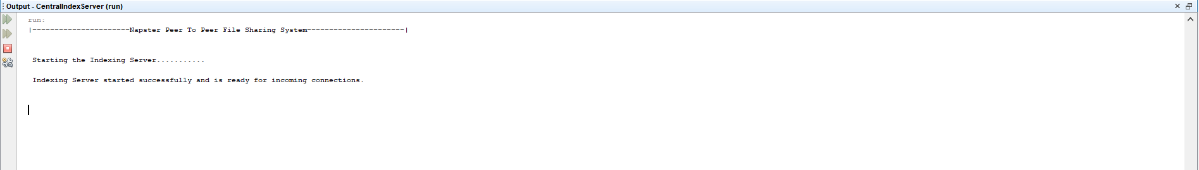

On Machine 2, Peer1 is run and is allowed to register the files with the CentralIndexServer

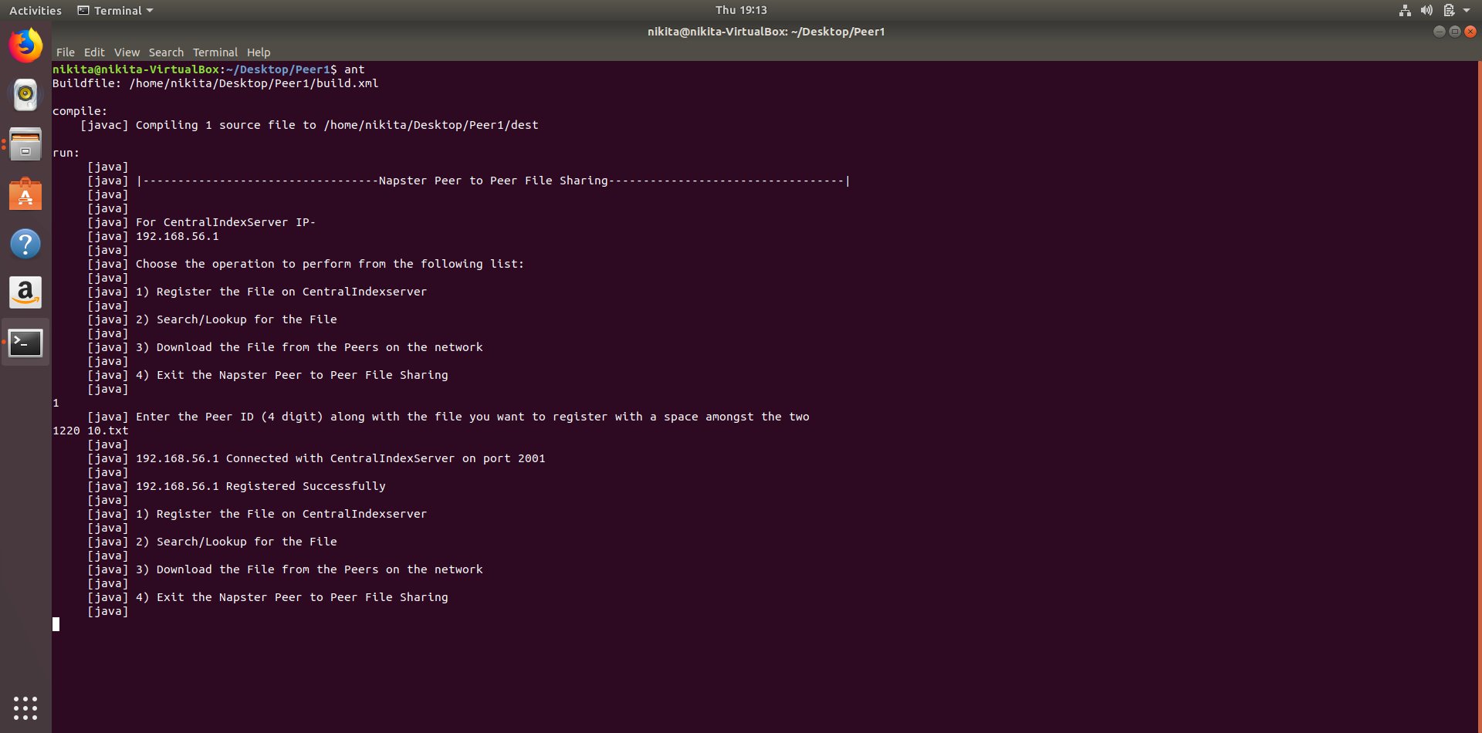

On Machine 3, Peer2 is run and is allowed to register the files with the CentralIndexServer

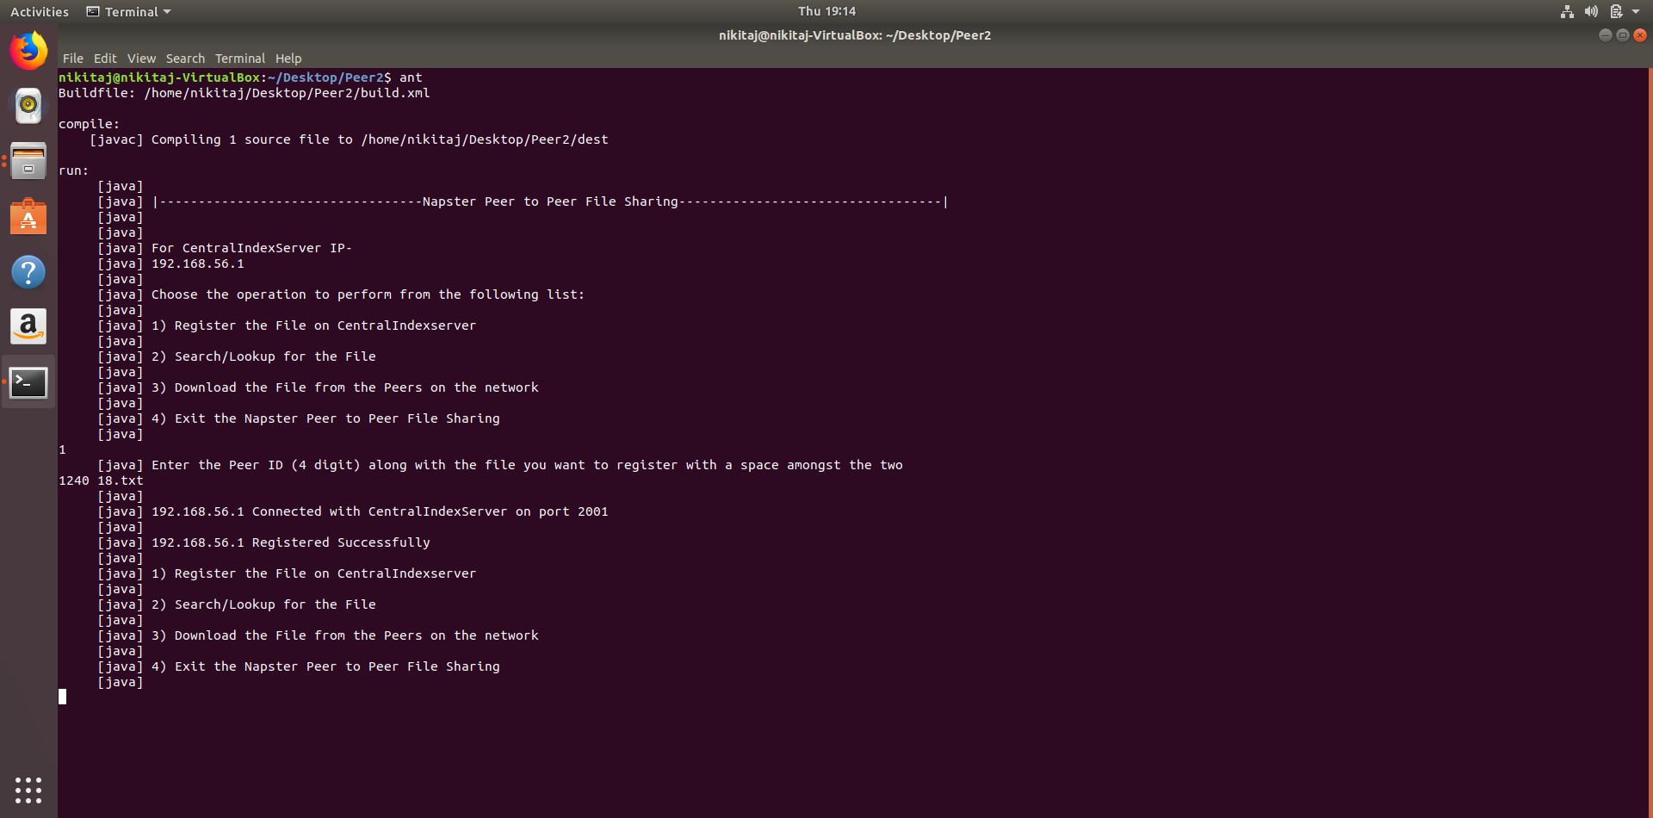

On Machine 4, Peer3 is run and is allowed to register the files with the CentralIndexServer

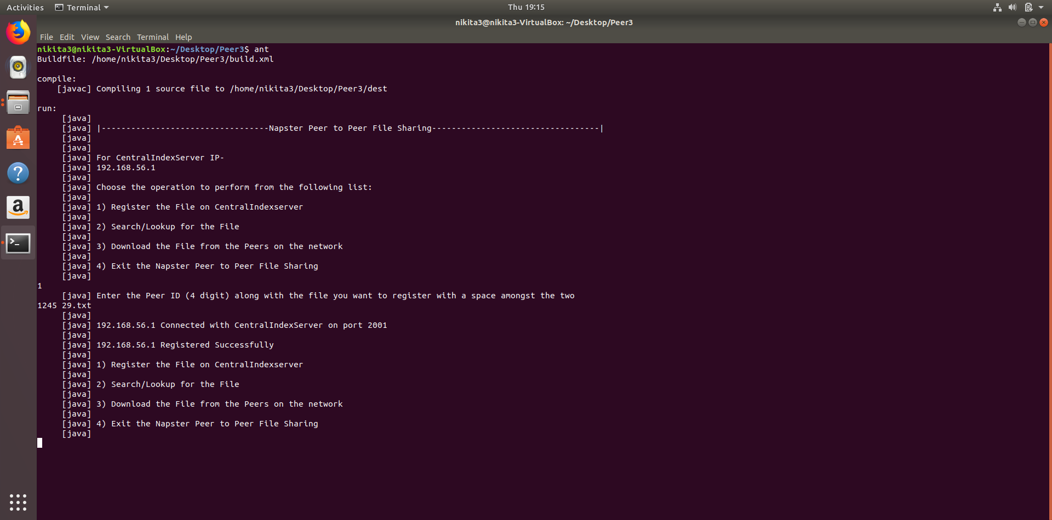

CentralIndexServer registers the Peer ID and the filename of Peer1, Peer2 & Peer3

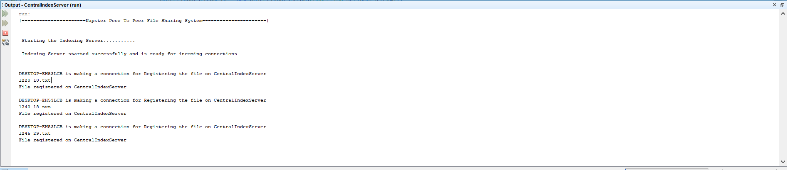

On Machine3, Peer2 is run and it issues a Search Request for the file which was registered by Peer3. The Search result is returned with the Peer ID of the peer and the IP Address of the Peer which contains the file.

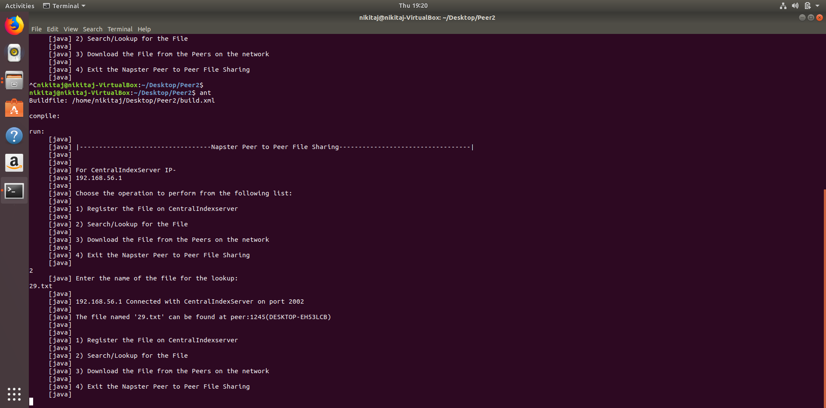

On Machine2, Peer1 is run and it issues a Search Request for the file which was registered by Peer2. The Search result is returned with the Peer ID of the peer and the IP Address of the Peer which contains the file.

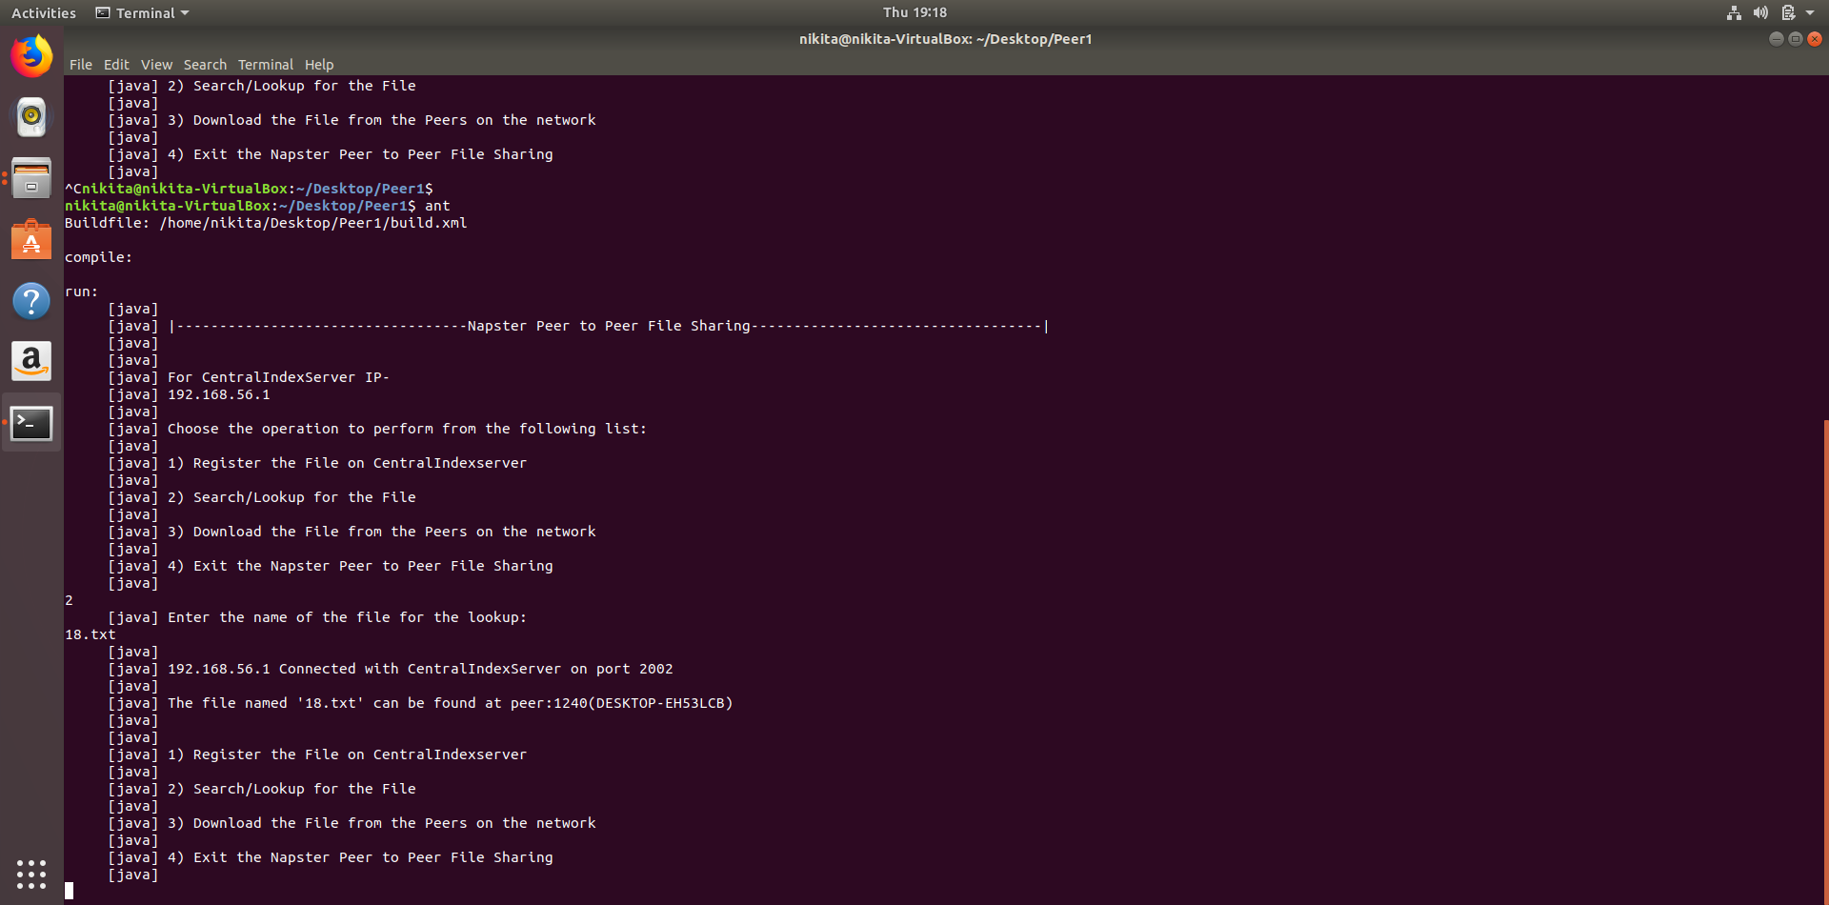

On Machine4, Peer3 is run and it issues a Search Request for the file which was registered by Peer2. The Search result is returned with the Peer ID of the peer and the IPAddress of the Peer which contains the file.

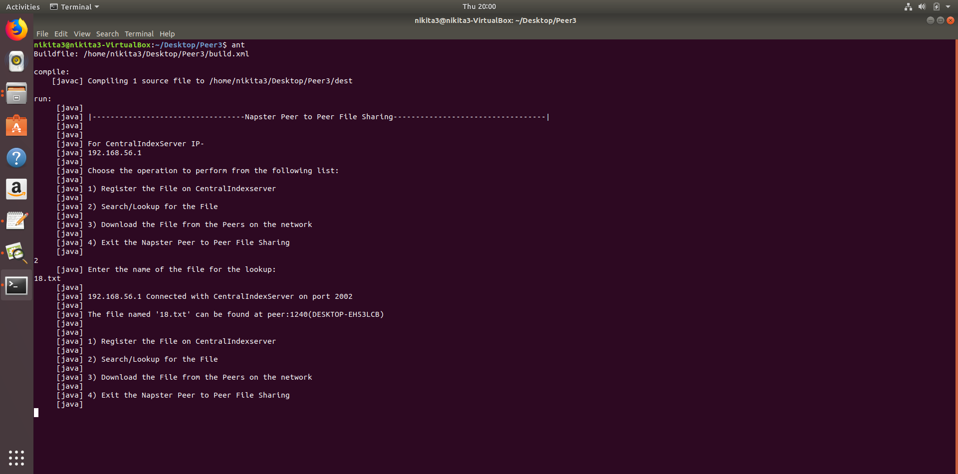

On Machine4, Peer3 is run and it issues a Download Request for the file which was registered by Peer2 and Peer3 downloads the file from Peer1.

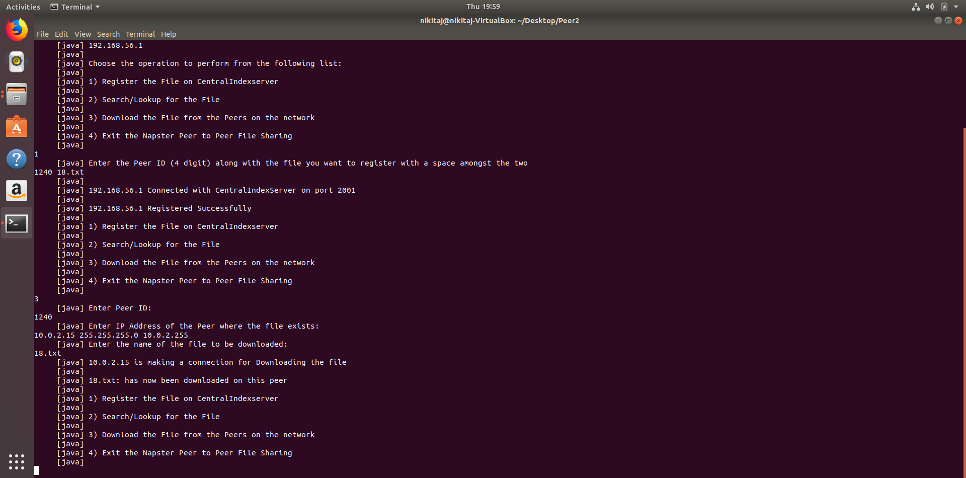

Screenshot for the Search Result returned from the CentralIndexServer for the file searched on the peers.

