Имя и Фамилия Nikita Kotov Дата 14.02.2022

Тестовое приложение:

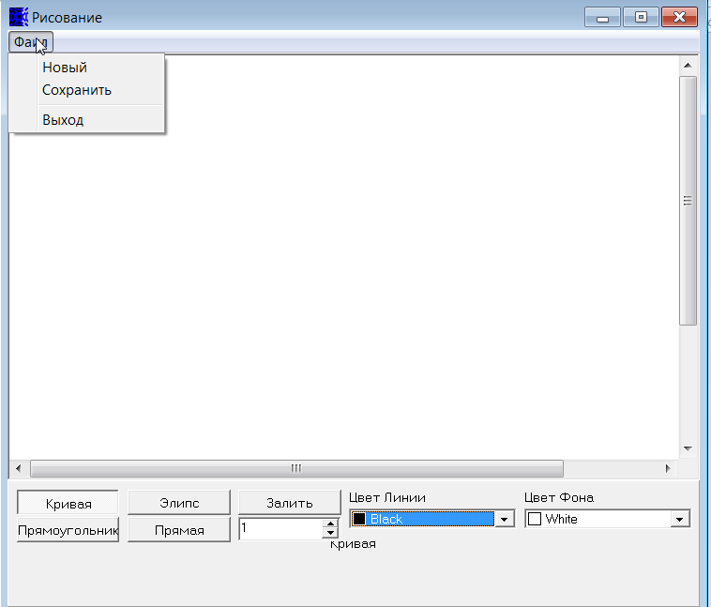

**Приложение для рисования разных фигур, каждая кнопка соответствует отдельной фигуре (Кривая работает как карандаш).**

**Что бы нарисовать фигуру, нужно выбрать фигуру нажатием на соответствующую кнопку, затем зажав левую кнопку мышки протянув по рабочей области нарисовать фигуру нужного размера.**

**Можно выбрать цвет линии фигуры, также можно выбрать толщину линии максимум 99 (с помощью стрелок или ввести вручную целое число).**

**Что бы залить фигуру, нужно выбрать цвет фона, нажать кнопку залить и затем левой кнопкой мыши нажать на области для заливки. Можно создать новый документ, а также сохранить рисунок.**

**1.** Напишите идеи тестов, которые вы выполните для проверки работоспособности этой программы. Запишите возникшие у вас вопросы.

|  |  |  |
| --- | --- | --- |
| 1. Open the app | 1. Open the saved file using the app |  |
| 1. Close the app with the "X" button |  |  |
| 1. Check the operation of the "Curve" function |  |  |
| 1. Check the operation of the "Ellipse" function |  |  |
| 1. Check the operation of the "Rectangle" function |  |  |
| 1. Check the operation of the "Direct" function |  |  |
| 1. Check the operation of the "Fill" function |  |  |
| 1. Check the color change |  |  |
| 1. Check the background color change |  |  |
| 1. Check the acceptable line thickness value |  |  |
| 1. Check acceptable line thickness value by entering a value from the keyboard |  |  |
| 1. Check the creation of a new file |  |  |
| 1. Check the interface language |  |  |
| 1. Close the application with the " Файл-Выход " button |  |  |
| 1. Leave the thickness selection field empty |  |  |
| 1. Set a negative value to the thickness |  |  |
| 1. Check the app name |  |  |
| 1. Check the saving |  |  |

**2.** Напишите основные тест-кейсы, которые Вы выполните для проверки работоспособности этой программы. Запишите возникшие у вас вопросы.

|  |  |  |  |  |  |  |
| --- | --- | --- | --- | --- | --- | --- |
| ID | Title | Test Level | Steps | Expected result | Status | Error code |
| B1 | Open the app | Smoke | Precondition: Download the app S1. Double-click on the app icon | 1.The app is open | Passed |  |
| B2 | Close the app with the "X" button | Smoke | Precondition: Open the app S1. Click on the “X” button | 1.The app is close | Passed |  |
| B3 | Check the operation of the "Curve" function | Crit. Path | Precondition: Open the app S1. Click to the "Curve" button  S2. Draw a curved line while holding down the left mouse button  S3. Release the button | 1. The button looks pressed  3. A curved line is drawn | Passed | B13-Bug |
| B4 | Check the operation of the "Ellipse" function | Crit. Path | Precondition: Open the app S1. Click to the " Ellipse " button  S2. Draw a Ellipse while holding down the left mouse button S3. Release the button | 1. The button looks pressed  2. 3. A Ellipse is drawn | Passed | B13-Bug |
| B5 | Check the operation of the "Rectangle" function | Crit. Path | Precondition: Open the app S1. Click to the " Rectangle " button  S2. Draw a Rectangle while holding down the left mouse button  S3. Release the button | 1. The button looks pressed  2. 3. A Rectangle is drawn | Passed | B13-Bug |
| B6 | Check the operation of the "Direct" function | Crit. Path | Precondition: Open the app S1. Click to the " Direct " button  S2. Draw a Direct line while holding down the left mouse button  S3. Release the button | 1. The button looks pressed  2. 3. A Direct line is drawn | Passed | B13-Bug |
| B7 | Check the operation of the "Fill" function | Crit. Path | Precondition: Open the app and draw a figure  S1. Click to the "Fill " button  S2. Choose a fill color  S3. Click on figure | 1. The button looks pressed  2. The selected color appeared in the box on the left in the background color field  3. The figure was painted in the chosen color | Passed | B13-Bug |
| B8 | Check the color change | Crit. Path | Precondition: Open the app S1. Click the arrow in the " Line color " field  S2. Choose a color  S3. Draw a figure or line | 1. Opened a drop box  2. The selected color appeared in the box on the left in the background color field  3. A line of the selected color will be drawn | Passed | B13-Bug |
| B9 | Check the background color change | Crit. Path | Precondition: Open the app S1. Click the arrow in the " background color " field  S2. Choose a color  S3. Draw a figure | 1. Opened a drop box  2. The selected color appeared in the box on the left in the background color field  3. A figure of the selected color will be drawn | Passed | B13-Bug |
| B10 | Check the acceptable line thickness value | Crit. Path | Precondition: Open the app S1. Select the thickness using the arrows in the field under the "Fill" button (from 1 to 99)  S2. Draw a figure or line | 1. The value in the field has changed to the specified one  2. The shape or line is drawn with the desired thickness | Passed | B13-Bug |
| B11 | Check acceptable line thickness value by entering a value from the keyboard | Crit. Path | Precondition: Open the app S1. Select the thickness using the keyboard in the field under the "Fill" button  S2. Draw a figure or line | 1. The value in the field has changed to the specified one  2. The shape or line is drawn with the desired thickness | Passed | B13-Bug |
| B12 | Check the creation of a new file | Crit. Path | Precondition: S1. Click to “Файл” button  S2. Click to “Новый” button | 1. A list appeared  2. A blank sheet will appear | Passed | B13-Bug |
| B13 | Check the interface language |  | Precondition: Open the app S1. Check the interface language | 1. Interface language is Russian | Failed | B13-Bug |
| B14 | Close the application with the " Файл-Выход " button | Smoke | Precondition: Open the app S1. Click to “Файл” button  S2. Click to “Выход” button | 1. A list appeared  2. The app is close | Passed | B13-Bug |
| B15 | Leave the thickness selection field empty | Crit. Path | Precondition: Open the app S1. Delete the values in the field under the "Fill in" button  S2.Tap to list | 1. The field under the "Fill in" button is empty  2. Error " Is not a valid integer value " appeared | Passed |  |
| B16 | Set a negative value to the thickness | Extended | Precondition: Open the app S1. Select the negative thickness using the arrows in the field under the "Fill" button (...<0) | 1. The value does not fall below zero | Failed | B16-Bug |
| B17 | Check the app name | Crit. Path | Precondition: Open the app S1. Check the app name | 1. Application name "Рисование" | Failed | B13-Bug |
| B18 | Check the saving | Smoke | Precondition: Open the app S1. Click to “Файл” button  S2. Click to “Сохранить” button  S3. Name the file  S4. Choose a format  S5. Click save | 1. A list appeared  2. The save window opened  3.  4.  5. The file has been saved (in the selected format) | Passed | B13-Bug |
| B19 | Open the saved file using the app | Smoke | Precondition: Create and save the file  S1. Open the file using the application  S2. Check the contents of the file | 1. The app is open  2. Your file has opened (with your drawings) | Failed | B25-Bug |
|  |  |  |  |  |  |  |

|  |  |
| --- | --- |
| **3.** Напишите баг-репорты по замеченным «нюансам работы» приложения. Запишите возникшие у вас вопросы. **Пожалуйста, начните с наиболее серьёзных ошибок!** | |
| Bug ID B13-Bug | |
| Summary [The App] Incorrect interface language |  |
| Description: The app has an incorrect interface language | |
| Severity: Major  Priority:ASAP  Steps to reproduce   1. Open the app 2. Check the interface language   AR: Incorrect interface language  ER: Interface language is Russian | |
| Bug ID B16-Bug | |
| |  |  | | --- | --- | | Summary [The field under the "Fill" button] Negative thickness value |  |   Description: A negative value appears in the field under the “Fill” button | |
| Severity: Minor  Priority:High  Steps to reproduce   1. Select the negative thickness using the arrows in the field under the "Fill" button (...<0) 2. Check the field   AR: In the negative value field  ER: The value does not fall below zero | |
| Bug ID B25-Bug | |
| |  |  | | --- | --- | | Summary [The App] When opening a file (saved earlier) using the application, the content is missing |  | | |
| Description: When opening a file (saved earlier) using the application, the content is missing, an empty sheet (new file) opens | |
| Severity: Major  Priority:ASAP  Steps to reproduce   1. Create and save the file 2. Open the file using the application 3. Check the contents of the file   AR: There is no content inside the file  ER: Your file has opened (with your drawings) | |
| Bug ID | |
| |  |  | | --- | --- | | Summary |  |   Description | |
| Steps to reproduce | |
| Bug ID | |
| Summary | |
| Description | |
| Severity | |
| Steps to reproduce | |