Your name Nikita Kotov Date 11.04.2022

**Good luck!**

**Introduction to the project:**

|  |  |
| --- | --- |
| Imagine that you are assigned to a new project as a tester.  Testing team: you and test team lead Mike.  This is a small mobile project for iOS.  “Canteen menu” application is developed for a huge company located all over the world. Application is targeted on company’s canteens stuff. It will be used for week menu management (creation, edition, etc).  Canteen employees are equipped with iPads or iPhones X.  After login to the application user (canteen employee) is redirected to “Menu List” screen with the list of menus for different company’s canteens (in different locations), “Country”, “City”, “Canteen” filters.  **New feature “Menu Editor” will be implemented during the upcoming iteration.**  Your task is:   1. Review the requirements for the new feature provided by BA Barbara 2. In case of any questions you have to write email to Barbara with request to clarify your questions 3. Provide estimations for test activities for this feature by email to your test lead Mike 4. Write test cases for the feature 5. Review provided screens with the implemented feature 6. Find and submit bugs in case of any 7. Send test results and your decision about quality of the feature to Mike (\*optional)   **Below you will find requirements for the feature and templates for emails, test cases, bug reports, etc. Please fill in only those templates that you think reasonable in scope of this feature. You can write any additional information if required.** | E:\lectures\Test 3\1.png |
| **Requirements for the new feature:**  AS an administrator  I CAN **create menu**:   1. I am in “Menu List” screen 2. I click “create” button - “Menu Editor” screen opens 3. I type canteen name in “Menu name” field 4. I choose canteen from list and click it 5. I select “To” date from date picker 6. I select “From” date from date picker 7. I click “save” button – “Menu List” screen opens, new menu is added to the list | E:\lectures\Test 3\2crop.png |
| AS an administrator  I CAN **edit menu**:   1. I am in “Menu List” screen 2. I click edit icon C:\Users\Lidziya_Smirnova\Desktop\Icons\89031-200.png - “Menu Editor” screen opens 3. From the dates panel I choose date I want to add dish offers to 4. In dish categories list I choose category I want to add dish offers to 5. If there are no dishes in the category – empty field is displayed 6. If the number of dishes exceeds the screen – the list can be scrolled 7. I can remove dish from the list 8. “Add dish” feature will be implemented later | |
| E:\lectures\Test 3\2.png | E:\lectures\Test 3\2a.png |

**Clarification letter to BA regarding new feature:**

|  |  |
| --- | --- |
| **To:** | Barbara Smith |
| **CC:** | Mike |
| **Subject:** | [Important] Questions about requirements |
| Good day, Barbara.  After studying the requirements, questions arose, answers to which are necessary. Please read the list and give an answer soon.   * + - 1. 1. There is an error in the 3rd item of the menu creation requirement (I type canteen name in “Menu name” field). [I believe that this paragraph of the requirements is incorrect and it needs to be changed: 3. I type name menu in "Menu name" field.]       2. What is the maximum and minimum number of characters the “Menu Name” field can contain?       3. What characters can the “Menu Name" field contain?       4. Are the "Menu Name", " Canteen X " and date fields mandatory fields?       5. What happens if you leave any field or all fields from paragraph 4 of this letter empty?   Thank you and have a nice day!  **Kind regards, Nikita Kotov** | |

**Test estimations for new feature to Test team lead:**

|  |  |
| --- | --- |
| **To:** | Mike |
| **CC:** | Barbara Smith |
| **Subject:** | Estimation |
| Good day, Mike.  I have prepared an estimate for this project. It is presented below:  Application installation and registration - 10 minutes.  The time to study the requirements is 60 minutes.  The number of test cases is 10-15, the time to create test cases is 150 minutes.  The execution time of the test cases is 100 minutes.  The number of test cases to run is 2 times, so the final execution time of the test cases is 200 minutes.  The time to create error reports is 200 minutes  Result: 5 + 5 + 60 + 150 + 100 + 200 = 520  Risks - 30% of the time. (520 \* 30 / 100 = 156)  520 + 156 = 676=680 minutes  680/60=11.3 hours  11.3/6 (hours of work per day)=2 days  **Kind regards, Nikita Kotov** | |

**Test cases for new feature:**

|  |  |  |  |  |  |  |
| --- | --- | --- | --- | --- | --- | --- |
| **№** | **Req №** | **Module** | **Test Description** | **Expected results** | **Passed/Failed** | **Comments** |
| 1 | №2 | Create menu | Title: Opening the Menu Editor window  Test level: Smoke  Steps:  Precondition: Open the app as an administrator  1.Click “create” button | 1. “Menu Editor” screen opens | Passed |  |
| **№** | **Req №** | **Module** | **Test Description** | **Expected results** | **Passed/Failed** | **Comments** |
| 2 | №3 | Create menu | Title: Choosing a canteen from the list  Test level: CP  Steps:  Precondition: Open the app as an administrator.  1. Click “create” button  2. Enter the menu name in the “Menu Name” field | 2. The menu name is displayed in the ‘Menu name” field | Passed | In this test case, the requirement "I type canteen name in “Menu name” field" is rephrased to "I type Menu name in “Menu name” field" |
| **№** | **Req №** | **Module** | **Test Description** | **Expected results** | **Passed/Failed** | **Comments** |
| 3 | №4 | Create menu | Title: Choosing a canteen from the list  Test level: CP  Steps:  Precondition: Open the app as an administrator.  1. Click “create” button  2. Click on the dropdown “Canteen X”  3.In the list, find and select the desired a canteen (click on the selected a canteen) | 3. The canteen field contains the selected canteen | Passed |  |
| **№** | **Req №** | **Module** | **Test Description** | **Expected results** | **Passed/Failed** | **Comments** |
| 4 | №5-6 | Create menu | Title: Date Selection  Test level: CP  Steps:  Precondition: Open the app as an administrator  1. Click “create” button  2. Click on the date picker “TO” and select “To” date from date picker  3. Click on the date picker “From” and select “From” date from date picker | 2-3. The selected dates are shown in the " To " list and in the "from" list | Passed |  |
| **№** | **Req №** | **Module** | **Test Description** | **Expected results** | **Passed/Failed** | **Comments** |
| 5 | №7 | Create menu | Title: Date Selection  Test level: CP  Steps:  Precondition: Open the app as an administrator.  1. Click “create” button  2. Enter the menu name in the “Menu name” field  3. Click on the dropdown “Canteen X”  4. In the list, find and select the desired a canteen (click on the selected a canteen)  5. Click on the date picker “TO” and select “To” date from date picker  6. Click on the date picker “From” and select “From” date from date picker  7. click “Save” | 7. “Menu List” screen opens, new menu is added to the list | Failed | Critical error #1. This does not allow us to pass the following test cases, as we need to create a menu to pass the remaining test cases. |
| **№** | **Req №** | **Module** | **Test Description** | **Expected results** | **Passed/Failed** | **Comments** |
| 6 | №2 | Edit menu | Title: Editing an existing menu  Test level: Smoke  Steps:  Precondition: Open the app as an administrator.  1. Click on the edit icon (pencil). | 1. “Menu Editor” screen opens | block | Critical error #1 blocks the passing of the test |
| **№** | **Req №** | **Module** | **Test Description** | **Expected results** | **Passed/Failed** | **Comments** |
| 7 | №3 | Edit menu | Title: Editing an existing menu  Test level: CP  Steps:  Precondition: Open the app as an administrator.  1. Click on the edit icon (pencil).  2. From the dates panel choose date want to add dish offers to | 2. The color of the selected date field will change | block | Critical error #1 blocks the passing of the test |
| **№** | **Req №** | **Module** | **Test Description** | **Expected results** | **Passed/Failed** | **Comments** |
| 8 | №4-5 | Edit menu | Title: Choosing a dish category  Test level: CP  Steps:  Precondition: Open the app as an administrator  1. Click on the edit icon (pencil).  2. From the dates panel choose date want to add dish offers to  3. Choose corresponding category of the dish (Soup, Main dish, Dessert)  4. Check the dishes field | 3. The selected category will be highlighted  4. If there are no dishes in the category – empty field is displayed. If there are dishes in the category, dishes are displayed | block | Critical error #1 blocks the passing of the test |
| **№** | **Req №** | **Module** | **Test Description** | **Expected results** | **Passed/Failed** | **Comments** |
| 9 | №7 | Edit menu | Title: Remove dish from the list  Test level: CP  Steps:  Precondition: Open the app as an administrator  1. Click on the edit icon (pencil).  2. From the dates panel choose date want to add dish offers to  3. Choose corresponding category of the dish (Soup, Main dish, Dessert)  4. Click on delete icon in the dishes field | 4. Dish removed. The dish field will disappear | block | Critical error #1 blocks the passing of the test |

**“Menu Editor” feature is ready for testing:**

Developers have finished implementation of “Menu Editor” feature. Build with the feature is released and successfully installed.

When editing the menu you see the following screen:

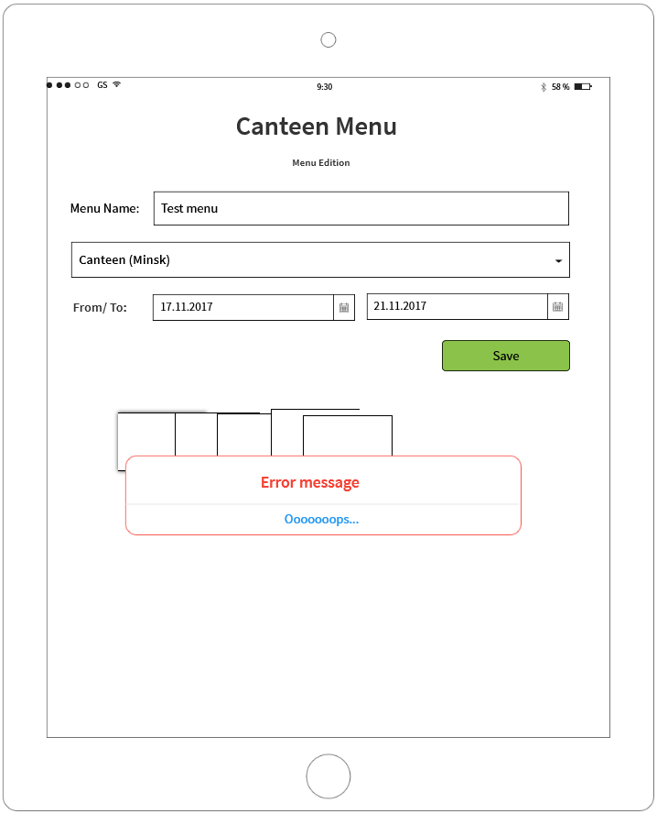

**If you see any bugs in this screen, you can post them below:**

**Bug reports:**

|  |  |
| --- | --- |
| **Bug ID** | **#1** |
| **Summary** | [Menu Edition (after clicking Save)] Blocking error when saving in administrator mode |
| **Description** | In the Menu Editor screen, after filling in all the fields and pressing the save button, a blocking error appears (in administrator mode). |
| **Severity** | Critical |
| **Priority** | ASAP |
| **Steps to reproduce** | Precondition: Open the app.  1. Click edit icon C:\Users\Lidziya_Smirnova\Desktop\Icons\89031-200.png - “Menu Editor” screen opens  2. Enter the menu name in the “Menu name” field  3. Click on the dropdown “Canteen X”  4. In the list, find and select the desired a canteen (click on the selected a canteen)  5. Click on the date picker “TO” and select “To” date from date picker  6. Click on the date picker “From” and select “From” date from date picker  7. click “Save”.  AR: Error message Oooooops…  ER: “Menu List” screen opens, new menu is added to the list |

**Thank you!**