Міністерство освіти і науки України
НТУУ «Київський політехнічний інститут»
Фізико-технічний інститут

Лабораторна робота
Компʼютерні мережі

тема : «Програма CPT»

Виконав:
Студент 3 курсу КПІ,
ФТІ, групи ФІ-41
Льовкін М.С.

Перевірив:
Терещенко І.М.

Виконання
1.
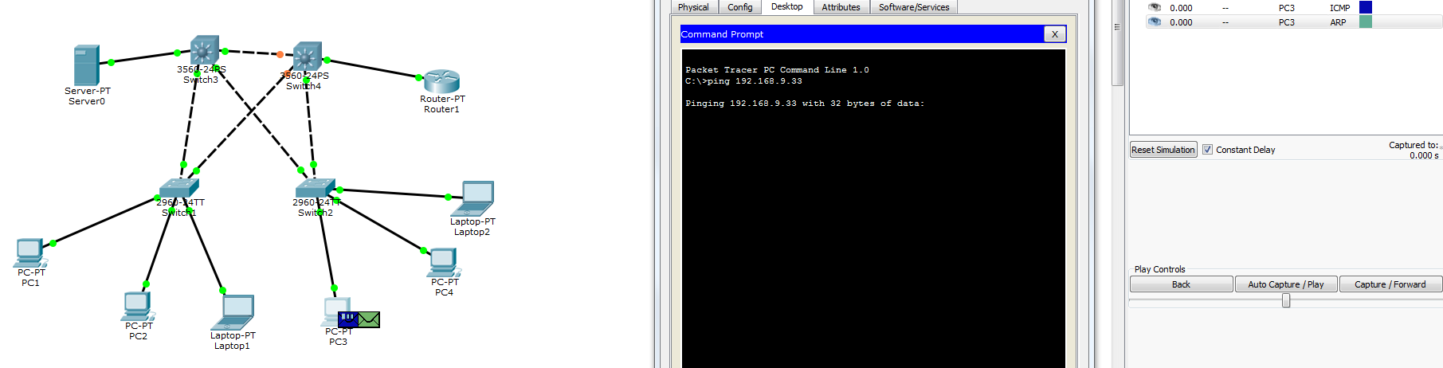
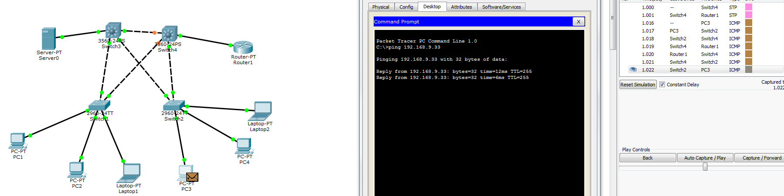
2.
SW1#show spanning-tree
VLAN0001
Spanning tree enabled protocol ieee
Root ID Priority 32769
Address 0005.5EE8.283E
Cost 4
Port 25(GigabitEthernet0/1)
Hello Time 2 sec Max Age 20 sec Forward Delay 15 sec

Bridge ID Priority 32769 (priority 32768 sys-id-ext 1)
Address 0060.3E27.9775
Hello Time 2 sec Max Age 20 sec Forward Delay 15 sec
Aging Time 20

Interface Role Sts Cost Prio.Nbr Type
---------------- ---- --- --------- -------- --------------------------------
Fa0/3 Desg FWD 19 128.3 P2p
Gi0/1 Root FWD 4 128.25 P2p
Gi0/2 Desg FWD 4 128.26 P2p

VLAN0010
Spanning tree enabled protocol ieee
Root ID Priority 32778
Address 0005.5EE8.283E
Cost 4
Port 25(GigabitEthernet0/1)
Hello Time 2 sec Max Age 20 sec Forward Delay 15 sec

Bridge ID Priority 32778 (priority 32768 sys-id-ext 10)
Address 0060.3E27.9775
Hello Time 2 sec Max Age 20 sec Forward Delay 15 sec
Aging Time 20

Interface Role Sts Cost Prio.Nbr Type
---------------- ---- --- --------- -------- --------------------------------
Fa0/1 Desg FWD 19 128.1 P2p
Fa0/2 Desg FWD 19 128.2 P2p
Gi0/1 Root FWD 4 128.25 P2p
Gi0/2 Desg FWD 4 128.26 P2p

SW2#show spanning-tree
VLAN0001
Spanning tree enabled protocol ieee
Root ID Priority 32769
Address 0005.5EE8.283E
Cost 4
Port 25(GigabitEthernet0/1)
Hello Time 2 sec Max Age 20 sec Forward Delay 15 sec

Bridge ID Priority 32769 (priority 32768 sys-id-ext 1)
Address 0040.0B1A.8705
Hello Time 2 sec Max Age 20 sec Forward Delay 15 sec
Aging Time 20

Interface Role Sts Cost Prio.Nbr Type
---------------- ---- --- --------- -------- --------------------------------
Fa0/3 Desg FWD 19 128.3 P2p
Gi0/1 Root FWD 4 128.25 P2p
Gi0/2 Desg FWD 4 128.26 P2p

VLAN0010
Spanning tree enabled protocol ieee
Root ID Priority 32778
Address 0005.5EE8.283E
Cost 4
Port 25(GigabitEthernet0/1)
Hello Time 2 sec Max Age 20 sec Forward Delay 15 sec

Bridge ID Priority 32778 (priority 32768 sys-id-ext 10)
Address 0040.0B1A.8705
Hello Time 2 sec Max Age 20 sec Forward Delay 15 sec
Aging Time 20

Interface Role Sts Cost Prio.Nbr Type
---------------- ---- --- --------- -------- --------------------------------
Fa0/1 Desg FWD 19 128.1 P2p
Fa0/2 Desg FWD 19 128.2 P2p
Gi0/1 Root FWD 4 128.25 P2p
Gi0/2 Desg FWD 4 128.26 P2p

SW3#show spanning-tree
VLAN0001
Spanning tree enabled protocol ieee
Root ID Priority 32769
Address 0005.5EE8.283E
This bridge is the root
Hello Time 2 sec Max Age 20 sec Forward Delay 15 sec

Bridge ID Priority 32769 (priority 32768 sys-id-ext 1)
Address 0005.5EE8.283E
Hello Time 2 sec Max Age 20 sec Forward Delay 15 sec
Aging Time 20

Interface Role Sts Cost Prio.Nbr Type
---------------- ---- --- --------- -------- --------------------------------
Fa0/24 Desg FWD 19 128.24 P2p
Gi0/1 Desg FWD 4 128.25 P2p
Gi0/2 Desg FWD 4 128.26 P2p

VLAN0010
Spanning tree enabled protocol ieee
Root ID Priority 32778
Address 0005.5EE8.283E
This bridge is the root
Hello Time 2 sec Max Age 20 sec Forward Delay 15 sec

Bridge ID Priority 32778 (priority 32768 sys-id-ext 10)
Address 0005.5EE8.283E
Hello Time 2 sec Max Age 20 sec Forward Delay 15 sec
Aging Time 20

Interface Role Sts Cost Prio.Nbr Type
---------------- ---- --- --------- -------- --------------------------------
Fa0/24 Desg FWD 19 128.24 P2p
Gi0/1 Desg FWD 4 128.25 P2p
Gi0/2 Desg FWD 4 128.26 P2p
Fa0/1 Desg FWD 19 128.1 P2p

SW4#show spanning-tree
VLAN0001
Spanning tree enabled protocol ieee
Root ID Priority 32769
Address 0005.5EE8.283E
Cost 8
Port 26(GigabitEthernet0/2)
Hello Time 2 sec Max Age 20 sec Forward Delay 15 sec

Bridge ID Priority 32769 (priority 32768 sys-id-ext 1)
Address 000D.BD7D.8B9B
Hello Time 2 sec Max Age 20 sec Forward Delay 15 sec
Aging Time 20

Interface Role Sts Cost Prio.Nbr Type
---------------- ---- --- --------- -------- --------------------------------
Fa0/1 Desg FWD 19 128.1 P2p
Fa0/24 Altn BLK 19 128.24 P2p
Gi0/1 Altn BLK 4 128.25 P2p
Gi0/2 Root FWD 4 128.26 P2p

VLAN0010
Spanning tree enabled protocol ieee
Root ID Priority 32778
Address 0005.5EE8.283E
Cost 8
Port 26(GigabitEthernet0/2)
Hello Time 2 sec Max Age 20 sec Forward Delay 15 sec

Bridge ID Priority 32778 (priority 32768 sys-id-ext 10)
Address 000D.BD7D.8B9B
Hello Time 2 sec Max Age 20 sec Forward Delay 15 sec
Aging Time 20

Interface Role Sts Cost Prio.Nbr Type
---------------- ---- --- --------- -------- --------------------------------
Fa0/1 Desg FWD 19 128.1 P2p
Fa0/24 Altn BLK 19 128.24 P2p
Gi0/2 Root FWD 4 128.26 P2p

3.4.

Laptop2
C:\>ping 169.254.178.154

Pinging 169.254.178.154 with 32 bytes of data:

Reply from 169.254.178.154: bytes=32 time=12ms TTL=128
Reply from 169.254.178.154: bytes=32 time<1ms TTL=128
Reply from 169.254.178.154: bytes=32 time=1ms TTL=128
Reply from 169.254.178.154: bytes=32 time<1ms TTL=128

Ping statistics for 169.254.178.154:
Packets: Sent = 4, Received = 4, Lost = 0 (0% loss),
Approximate round trip times in milli-seconds:
Minimum = 0ms, Maximum = 12ms, Average = 3ms

PC1
C:\>ping 192.168.9.38

Pinging 192.168.9.38 with 32 bytes of data:

Reply from 192.168.9.38: bytes=32 time=11ms TTL=128
Reply from 192.168.9.38: bytes=32 time<1ms TTL=128
Reply from 192.168.9.38: bytes=32 time<1ms TTL=128
Reply from 192.168.9.38: bytes=32 time<1ms TTL=128

Ping statistics for 192.168.9.38:
Packets: Sent = 4, Received = 4, Lost = 0 (0% loss),
Approximate round trip times in milli-seconds:
Minimum = 0ms, Maximum = 11ms, Average = 2ms

3.5.
R0#show standby
FastEthernet0/0.1 - Group 110
State is Active
4 state changes, last state change 00:06:22
Virtual IP address is 192.168.9.33
Active virtual MAC address is 0000.0C07.AC6E
Local virtual MAC address is 0000.0C07.AC6E (v1 default)
Hello time 3 sec, hold time 10 sec
Next hello sent in 0.026 secs
Preemption enabled
Active router is local
Standby router is 192.168.9.35
Priority 150 (configured 150)
Group name is hsrp-Fa-110 (default)
FastEthernet0/0.2 - Group 101
State is Standby
6 state changes, last state change 00:06:39
Virtual IP address is 192.168.9.65
Active virtual MAC address is 0000.0C07.AC65
Local virtual MAC address is 0000.0C07.AC65 (v1 default)
Hello time 3 sec, hold time 10 sec
Next hello sent in 0.856 secs
Preemption enabled
Active router is 192.168.9.67
Standby router is local
Priority 100 (default 100)
Group name is hsrp-Fa-101 (default)

R1#show standby
FastEthernet0/0.1 - Group 110
State is Standby
8 state changes, last state change 19:12:28
Virtual IP address is 192.168.9.33
Active virtual MAC address is 0000.0C07.AC6E
Local virtual MAC address is 0000.0C07.AC6E (v1 default)
Hello time 3 sec, hold time 10 sec
Next hello sent in 2.079 secs
Preemption enabled
Active router is 192.168.9.34
Standby router is local
Priority 100 (default 100)
Group name is hsrp-Fa-110 (default)
FastEthernet0/0.2 - Group 101
State is Active
4 state changes, last state change 19:06:05
Virtual IP address is 192.168.9.65
Active virtual MAC address is 0000.0C07.AC65
Local virtual MAC address is 0000.0C07.AC65 (v1 default)
Hello time 3 sec, hold time 10 sec
Next hello sent in 0.818 secs
Preemption enabled
Active router is local
Standby router is 192.168.9.66
Priority 150 (configured 150)
Group name is hsrp-Fa-101 (default)

3.6.
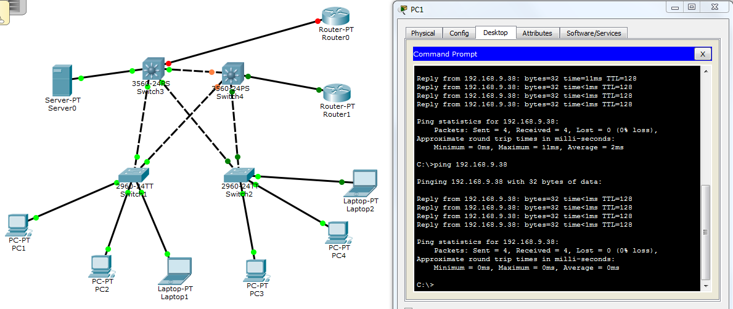
Видно что все работает как надо, значит для первой подсети, VLAN 10 используется резервный роутер — Router1.
4.2.
SW1#show spanning-tree
VLAN0001
Spanning tree enabled protocol ieee
Root ID Priority 24577
Address 000D.BD7D.8B9B
Cost 4
Port 26(GigabitEthernet0/2)
Hello Time 2 sec Max Age 20 sec Forward Delay 15 sec

Bridge ID Priority 32769 (priority 32768 sys-id-ext 1)
Address 0060.3E27.9775
Hello Time 2 sec Max Age 20 sec Forward Delay 15 sec
Aging Time 20

Interface Role Sts Cost Prio.Nbr Type
---------------- ---- --- --------- -------- --------------------------------
Fa0/3 Desg FWD 19 128.3 P2p
Gi0/1 Desg FWD 4 128.25 P2p
Gi0/2 Root FWD 4 128.26 P2p

VLAN0010
Spanning tree enabled protocol ieee
Root ID Priority 24586
Address 0005.5EE8.283E
Cost 4
Port 25(GigabitEthernet0/1)
Hello Time 2 sec Max Age 20 sec Forward Delay 15 sec

Bridge ID Priority 32778 (priority 32768 sys-id-ext 10)
Address 0060.3E27.9775
Hello Time 2 sec Max Age 20 sec Forward Delay 15 sec
Aging Time 20

Interface Role Sts Cost Prio.Nbr Type
---------------- ---- --- --------- -------- --------------------------------
Fa0/1 Desg FWD 19 128.1 P2p
Fa0/2 Desg FWD 19 128.2 P2p
Gi0/1 Root FWD 4 128.25 P2p
Gi0/2 Desg FWD 4 128.26 P2p

SW2#show spanning-tree
VLAN0001
Spanning tree enabled protocol ieee
Root ID Priority 24577
Address 000D.BD7D.8B9B
Cost 4
Port 26(GigabitEthernet0/2)
Hello Time 2 sec Max Age 20 sec Forward Delay 15 sec

Bridge ID Priority 32769 (priority 32768 sys-id-ext 1)
Address 0040.0B1A.8705
Hello Time 2 sec Max Age 20 sec Forward Delay 15 sec
Aging Time 20

Interface Role Sts Cost Prio.Nbr Type
---------------- ---- --- --------- -------- --------------------------------
Fa0/3 Desg FWD 19 128.3 P2p
Gi0/1 Desg FWD 4 128.25 P2p
Gi0/2 Root FWD 4 128.26 P2p

VLAN0010
Spanning tree enabled protocol ieee
Root ID Priority 24586
Address 0005.5EE8.283E
Cost 4
Port 25(GigabitEthernet0/1)
Hello Time 2 sec Max Age 20 sec Forward Delay 15 sec

Bridge ID Priority 32778 (priority 32768 sys-id-ext 10)
Address 0040.0B1A.8705
Hello Time 2 sec Max Age 20 sec Forward Delay 15 sec
Aging Time 20

Interface Role Sts Cost Prio.Nbr Type
---------------- ---- --- --------- -------- --------------------------------
Fa0/1 Desg FWD 19 128.1 P2p
Fa0/2 Desg FWD 19 128.2 P2p
Gi0/1 Root FWD 4 128.25 P2p
Gi0/2 Desg FWD 4 128.26 P2p

SW3#show spanning-tree
VLAN0001
Spanning tree enabled protocol ieee
Root ID Priority 24577
Address 000D.BD7D.8B9B
Cost 8
Port 26(GigabitEthernet0/2)
Hello Time 2 sec Max Age 20 sec Forward Delay 15 sec

Bridge ID Priority 28673 (priority 28672 sys-id-ext 1)
Address 0005.5EE8.283E
Hello Time 2 sec Max Age 20 sec Forward Delay 15 sec
Aging Time 20

Interface Role Sts Cost Prio.Nbr Type
---------------- ---- --- --------- -------- --------------------------------
Fa0/24 Altn BLK 19 128.24 P2p
Gi0/1 Altn BLK 4 128.25 P2p
Gi0/2 Root FWD 4 128.26 P2p
Fa0/2 Desg FWD 19 128.2 P2p

VLAN0010
Spanning tree enabled protocol ieee
Root ID Priority 24586
Address 0005.5EE8.283E
This bridge is the root
Hello Time 2 sec Max Age 20 sec Forward Delay 15 sec

Bridge ID Priority 24586 (priority 24576 sys-id-ext 10)
Address 0005.5EE8.283E
Hello Time 2 sec Max Age 20 sec Forward Delay 15 sec
Aging Time 20

Interface Role Sts Cost Prio.Nbr Type
---------------- ---- --- --------- -------- --------------------------------
Fa0/24 Desg FWD 19 128.24 P2p
Gi0/1 Desg FWD 4 128.25 P2p
Gi0/2 Desg FWD 4 128.26 P2p
Fa0/1 Desg FWD 19 128.1 P2p
Fa0/2 Desg FWD 19 128.2 P2p

SW4#show spanning-tree
VLAN0001
Spanning tree enabled protocol ieee
Root ID Priority 24577
Address 000D.BD7D.8B9B
This bridge is the root
Hello Time 2 sec Max Age 20 sec Forward Delay 15 sec

Bridge ID Priority 24577 (priority 24576 sys-id-ext 1)
Address 000D.BD7D.8B9B
Hello Time 2 sec Max Age 20 sec Forward Delay 15 sec
Aging Time 20

Interface Role Sts Cost Prio.Nbr Type
---------------- ---- --- --------- -------- --------------------------------
Fa0/1 Desg FWD 19 128.1 P2p
Fa0/24 Desg FWD 19 128.24 P2p
Gi0/1 Desg FWD 4 128.25 P2p
Gi0/2 Desg FWD 4 128.26 P2p

VLAN0010
Spanning tree enabled protocol ieee
Root ID Priority 24586
Address 0005.5EE8.283E
Cost 8
Port 26(GigabitEthernet0/2)
Hello Time 2 sec Max Age 20 sec Forward Delay 15 sec

Bridge ID Priority 28682 (priority 28672 sys-id-ext 10)
Address 000D.BD7D.8B9B
Hello Time 2 sec Max Age 20 sec Forward Delay 15 sec
Aging Time 20

Interface Role Sts Cost Prio.Nbr Type
---------------- ---- --- --------- -------- --------------------------------
Fa0/1 Desg FWD 19 128.1 P2p
Fa0/24 Altn BLK 19 128.24 P2p
Gi0/2 Root FWD 4 128.26 P2p

