

Introduction to Programming

Lab Worksheet

Program02

Python

Name: Nikita Chaudhary

Level 4 Section: A

British Id: 10313

Level 4 BSc. Hons Computing

Subject: Fundamental Of Computer Programming (FOCP)

The British College (TBC)

1.Last week you wrote a program that printed out a cheery greeting including your name. Take a copy of it, and modify it so that the user enters their name at the keyboard, and then receives a greeting. For example: Hello, what is your name? Mr Apricot Hello, Mr Apricot. Good to meet you!

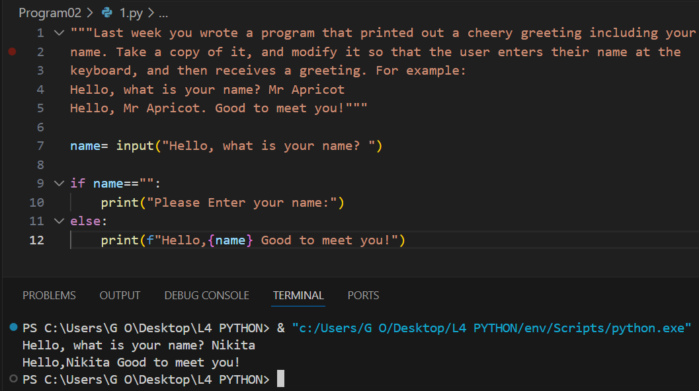

2.Write a program that prompts a user to enter a temperature in Celsius, and then displays the corresponding temperature in Fahrenheit, like so: Enter a temperature in Celsius: 32.5 32.5C is equivalent to 90.5F.

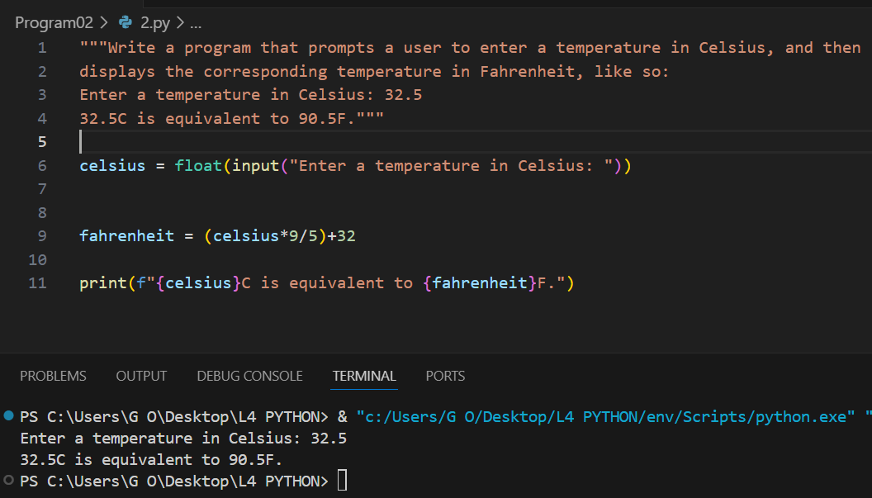

3.The Head of Computing at the University of Poppleton is tasked with dividing a group of students into lab groups. A lab group is usually 24 students, but this is sometimes varied to create groups of similar size. Write a program that prompts for the number of students and group size, and then displays how many groups will be needed and how many will be left over in a smaller group. How many students? 113 Required group size? 22 There will be 5 groups with 3 students left over. For bonus credit, see if you can fix the grammar in the output. So if there were 101 students in groups of 20 the output would be: There will be 5 groups with 1 student left over.

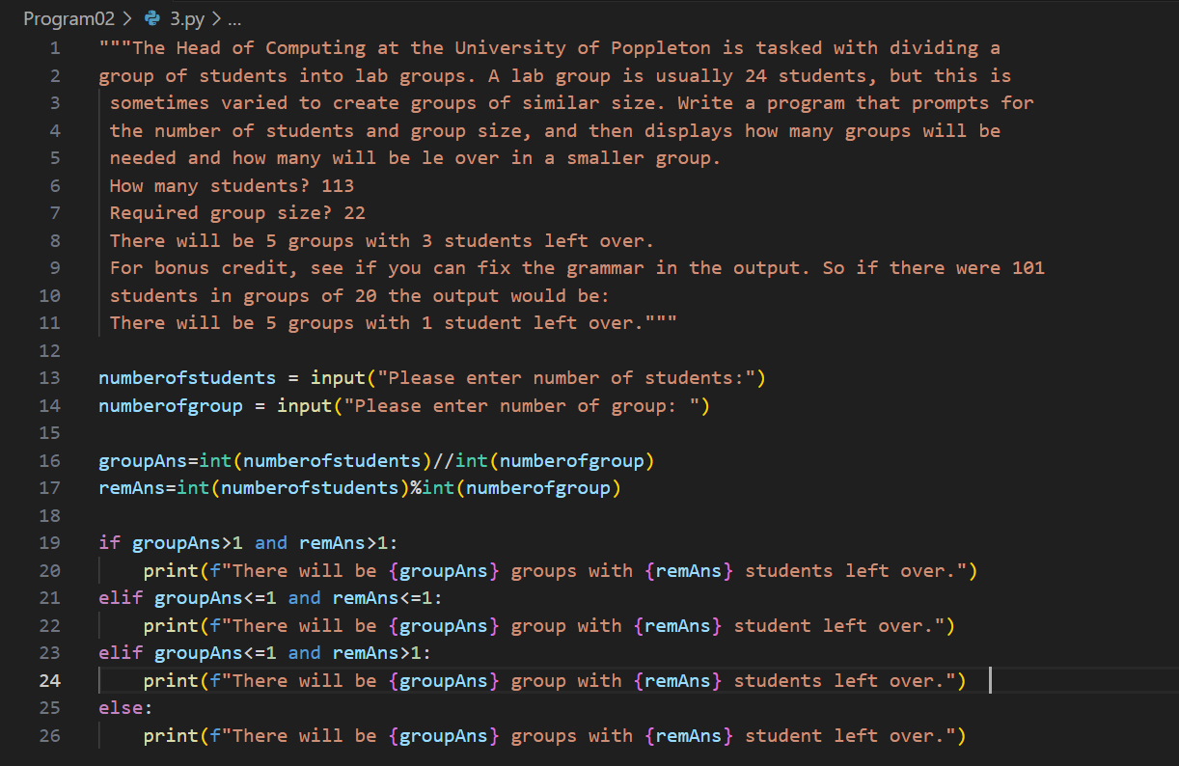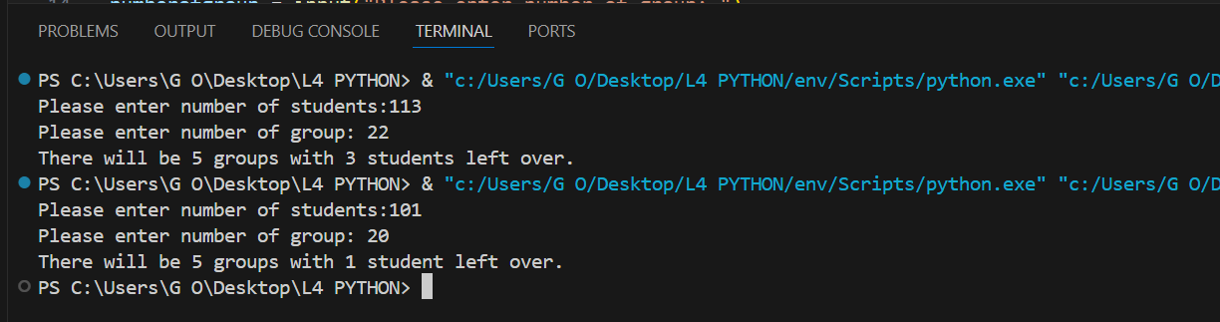

4.A kindly teacher wishes to distribute a tub of sweets between her pupils. She will first count the sweets and then divide them according to how many pupils attend that day. Write a program that will tell the teacher how many sweets to give to each pupil, and how many she will have left over.

