

Introduction to Programming

Lab Worksheet

Program03

Python

Name: Nikita Chaudhary

Level 4 Section: A

British Id: 10313

Level 4 BSc. Hons Computing

Subject: Fundamental Of Computer Programming (FOCP)

The British College (TBC)

1. Modify your greeting program so that if the user does not enter a name (i.e. they just press enter), the program responds "Hello, Stranger!". Otherwise it should print a greeting with their name as before.

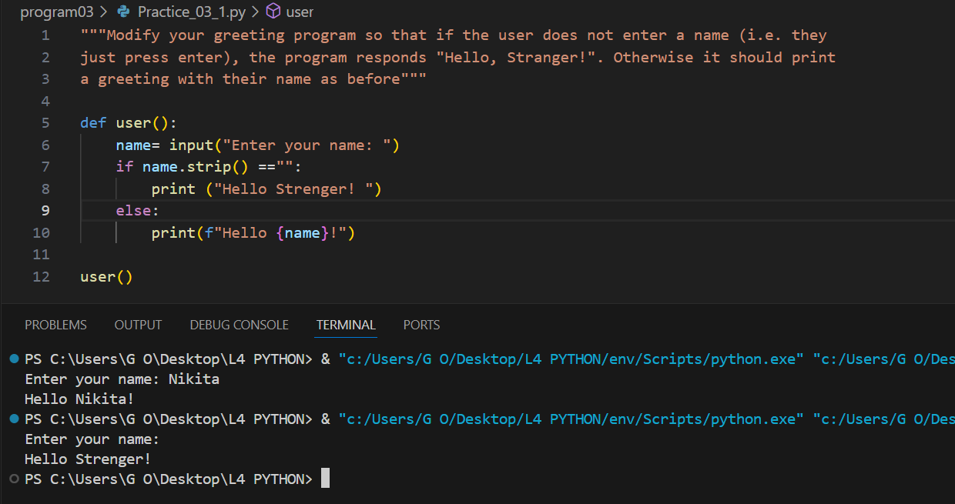

2. Write a program that simulates the way in which a user might choose a password. The program should prompt for a new password, and then prompt again. If the two passwords entered are the same the program should say "Password Set" or similar, otherwise it should report an error.

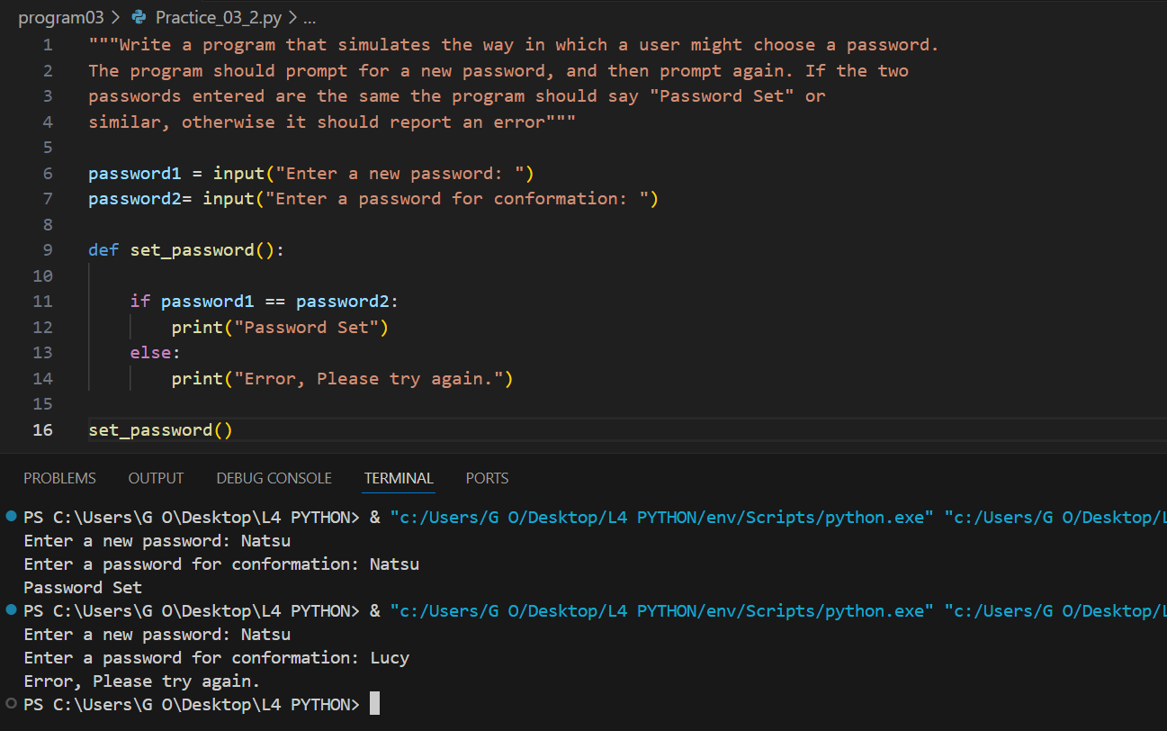

3. Modify your previous program so that the password must be between 8 and 12 characters (inclusive) long.

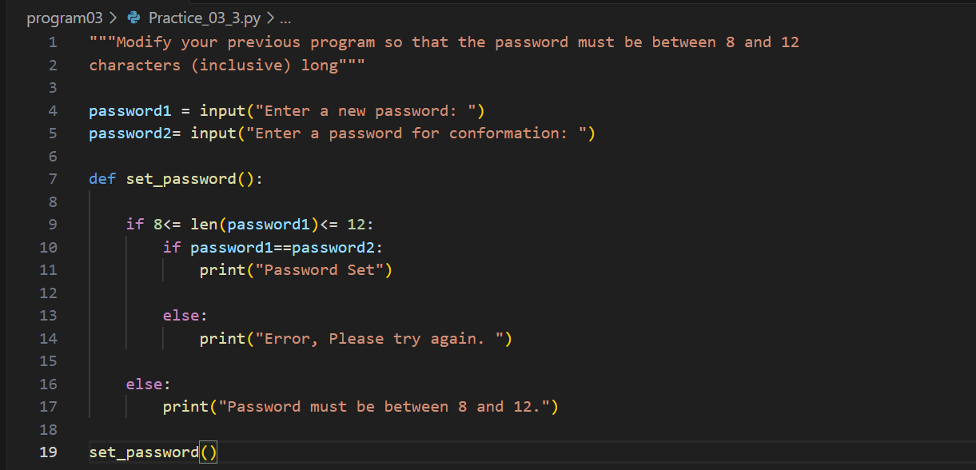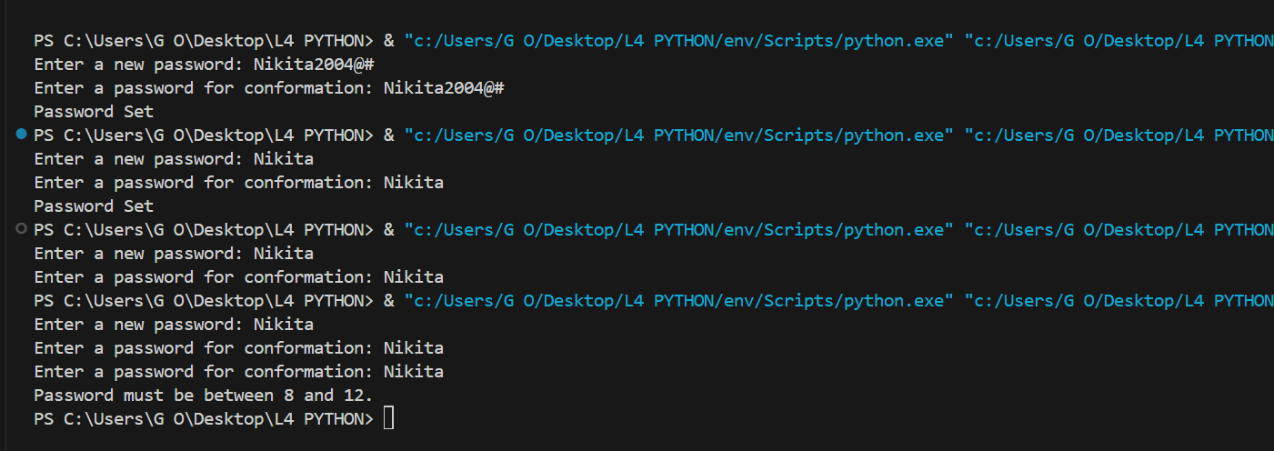

4. Modify your program again so that the chosen password cannot be one of a list of common passwords, defined thus: BAD_PASSWORDS = ['password', 'letmein', 'sesame', 'hello', 'justinbieber']

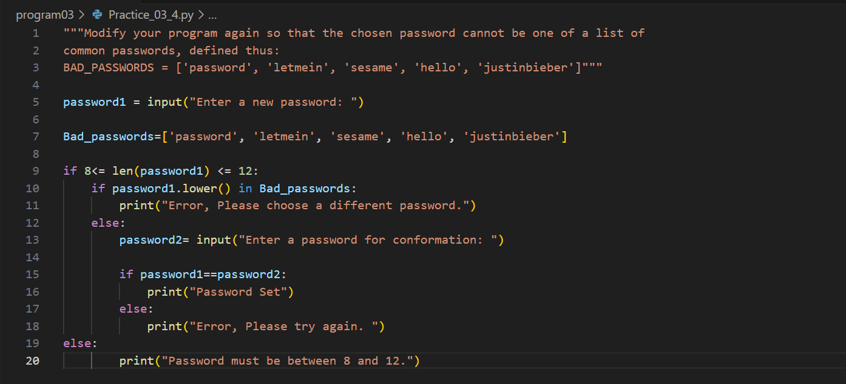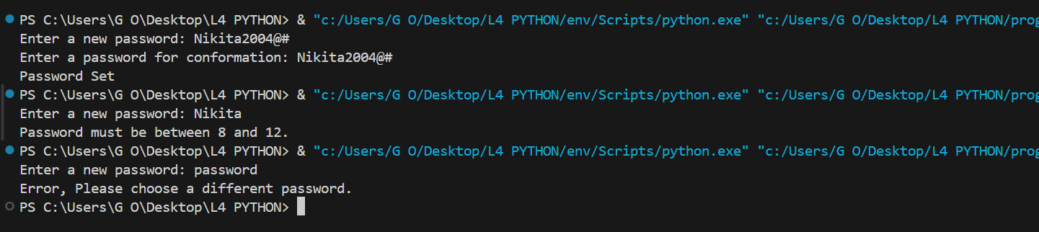

5. Modify your program a final time so that it executes until the user successfully chooses a password. That is, if the password chosen fails any of the checks, the program should return to asking for the password the first time.

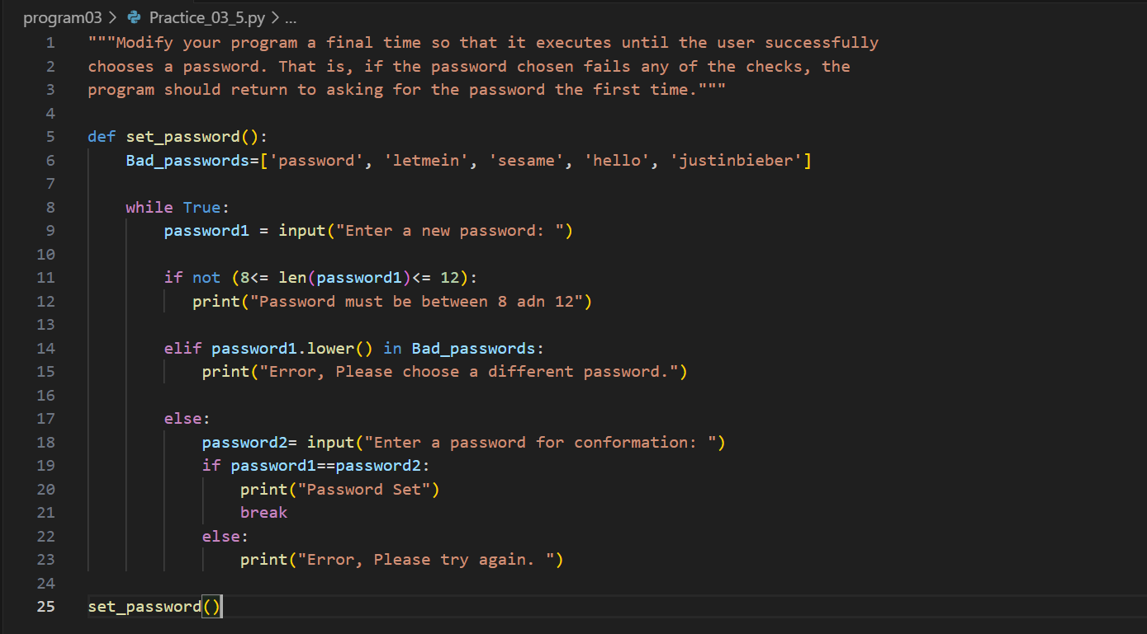

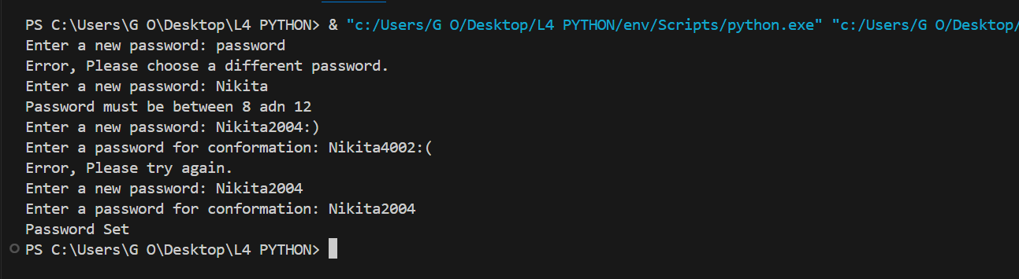

6. Write a program that displays the "Seven Times Table". That is, the result of multiplying 7 by every number from 0 to 12 inclusive. The output might start:

0 x 7 = 0, 1 x 7 = 7, 2 x 7 = 14 and so on.

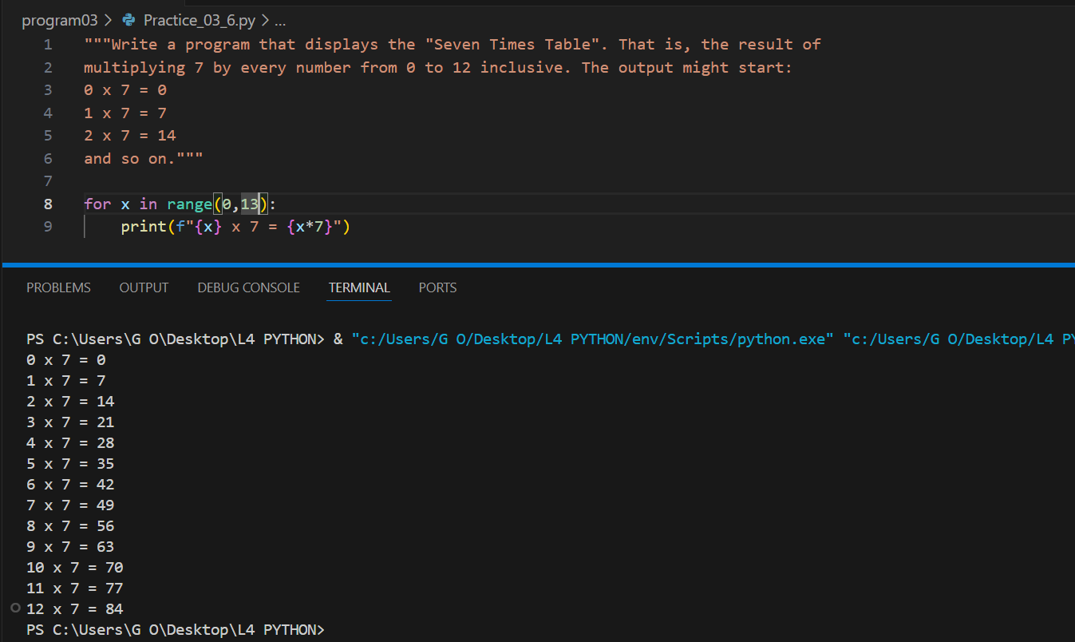

7. Modify your "Times Table" program so that the user enters the number of the table they require. This number should be between 0 and 12 inclusive.

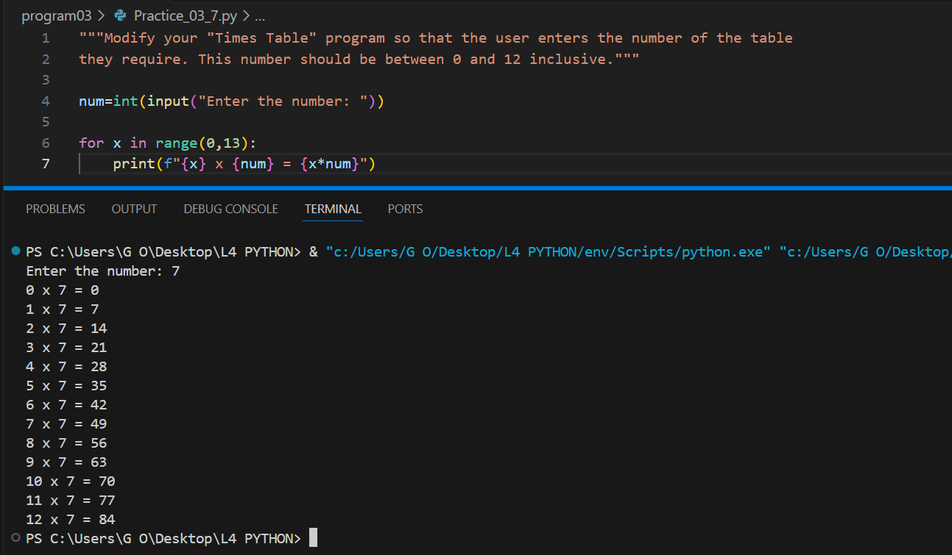

8. Modify the "Times Table" again so that the user still enters the number of the table, but if this number is negative the table is printed backwards. So entering "-7" would produce the Seven Times Table starting at "12 times" down to "0 times".

