

**Module Title**

**Introduction to Programming**

**Assessment Weightage & Type**

**60% Individual Coursework**

**Year**

**2023-24**

**Student Name: Nikita Chaudhary**

**UWE ID: 23085220**

**Assignment Due Date: April 12, 2024**

**Assignment Submission Date:**

Task1

To create account in moqups.

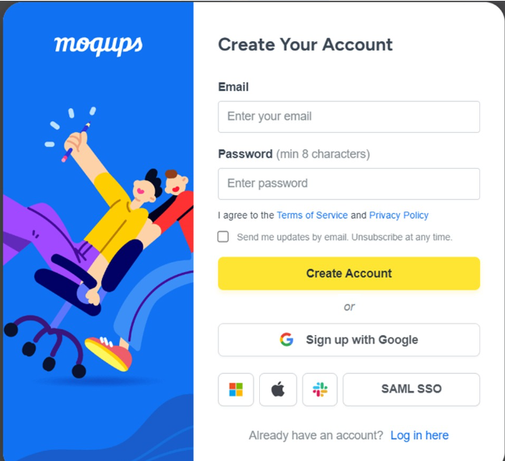

To create a page in moqups.

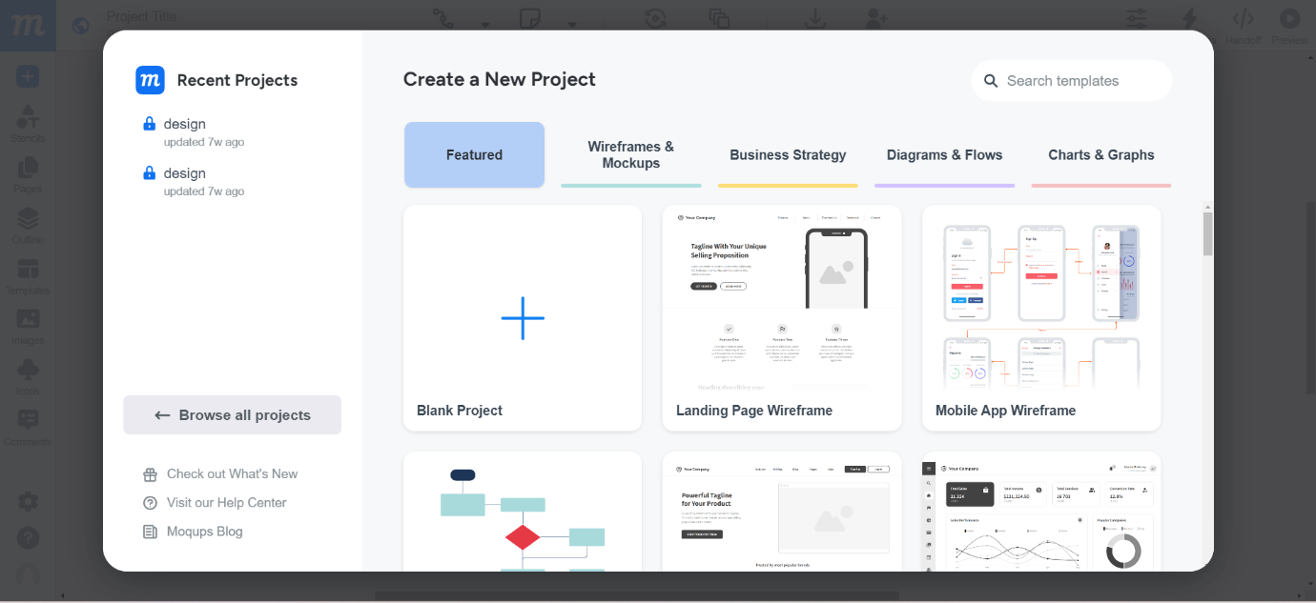

Task 2

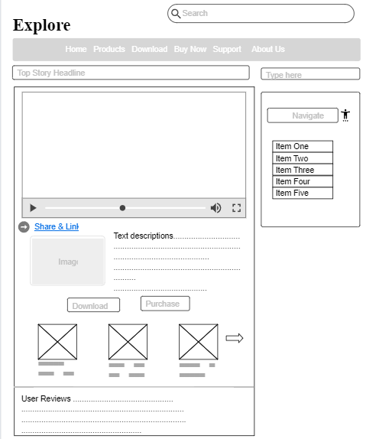

Task3

