

**Module Title**

**Introduction to Programming**

**Assessment Weightage & Type**

**60% Individual Coursework**

**Year**

**2023-24**

**Student Name: Nikita Chaudhary**

**UWE ID: 23085220**

**Assignment Due Date: April 12, 2024**

**Assignment Submission Date:**

***Exercise-1***

Write the HTML code which use of:

▪ The italics tag

▪ The Center tag

▪ The paragraph tag

▪ The Break tag

▪ The Font tag and its attributes

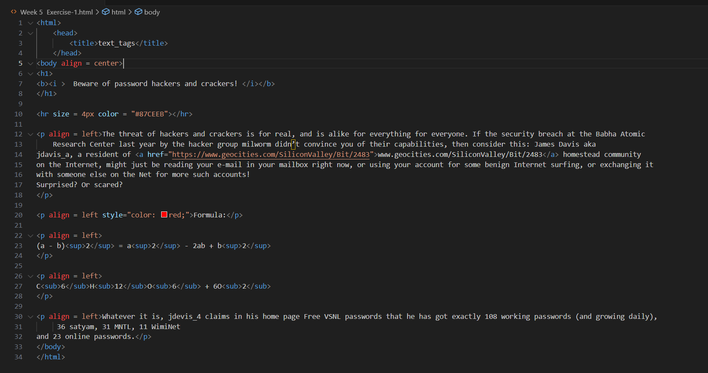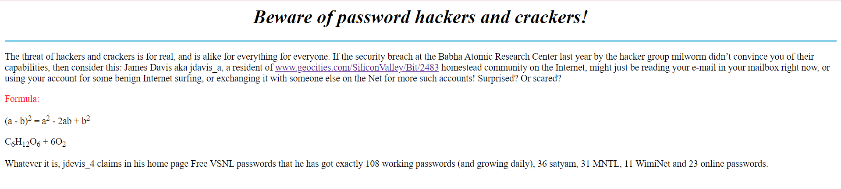

***Exercise-2***

Looking at the screen given below write the HTML code making use of following tags

Unordered Lists

Ordered Lists

Definition Lists

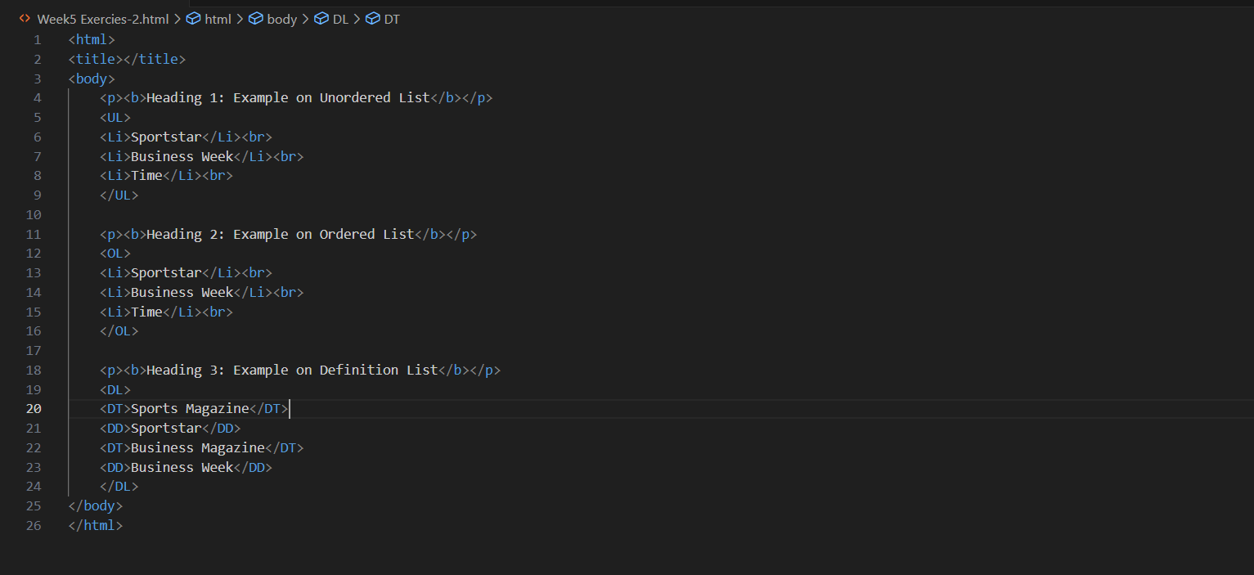Heading tag

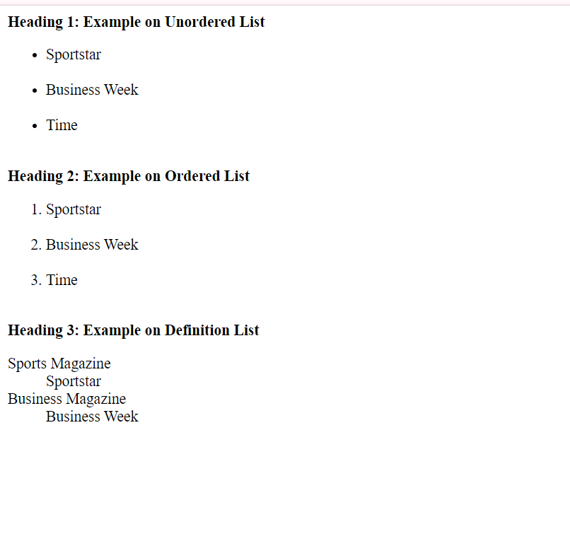

***Exercise-3***

**Page 1 detail:**

Use “landscape.jpg” image as page background and display the content on top of it. Text

content should visible, background image should not affect the text content.

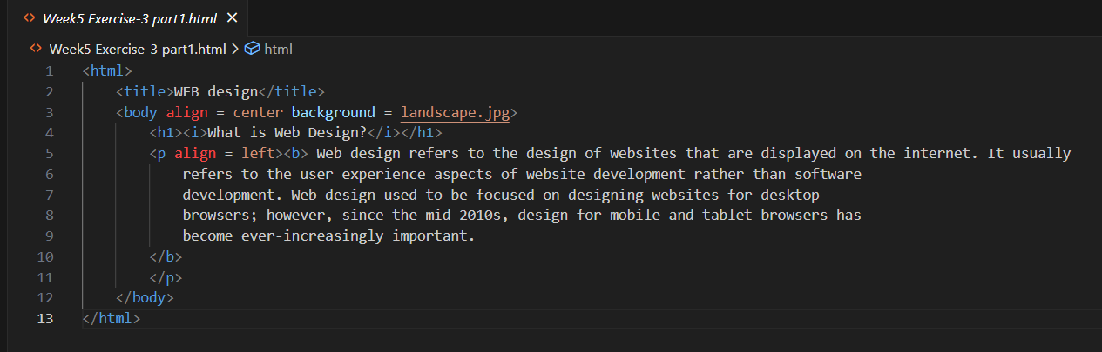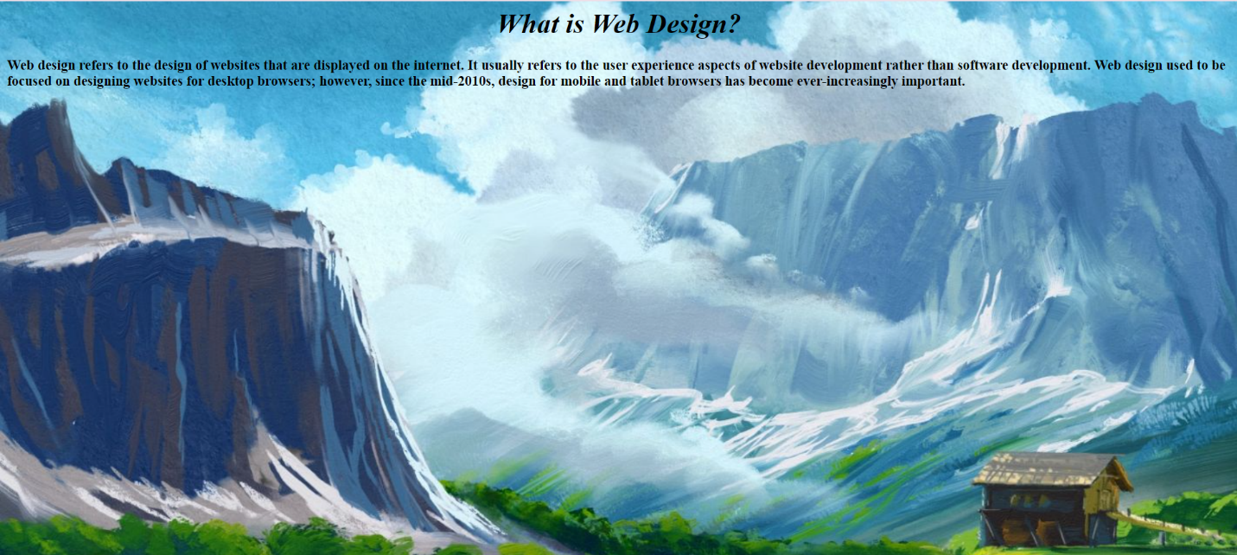

**Page 2 detail:**

Use “BLACK color” as background color and display text content on top of it using

“WHITE color”

