

**Module Title**

**Introduction to Programming**

**Assessment Weightage & Type**

**60% Individual Coursework**

**Year**

**2023-24**

**Student Name: Nikita Chaudhary**

**UWE ID: 23085220**

**Assignment Due Date: April 12, 2024**

**Assignment Submission Date:**

***Exercise-1***

Design a web page using four different image files ‘image1.jpg’, ‘image2.jpg’,

‘image3.jpg’ and ‘image4.png’ according to the following specifications.

• Use a border 5px for ‘image1.jpg’.

• Resize the width and height of ‘image2.jpg’ 100 pixels each. Use anchor tag on

this image and open original image.

• Align ‘image3.jpg” to either left or right side

• Leave space of 50px horizontally and vertically in ‘image4.png’

• align the text with respect to the images so as to obtain the appropriate output

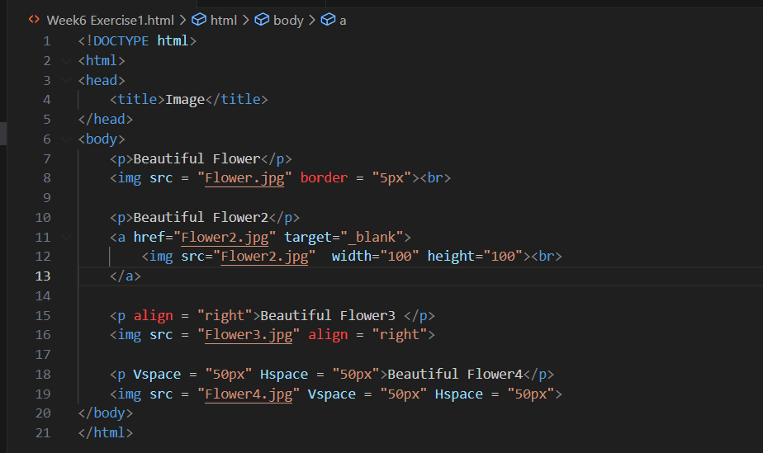

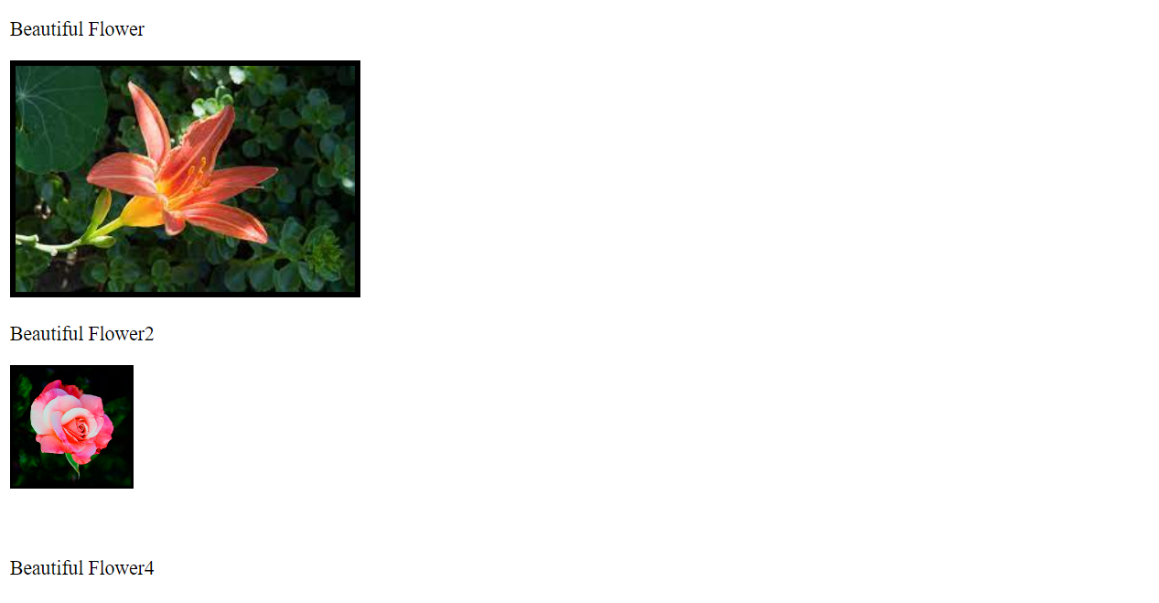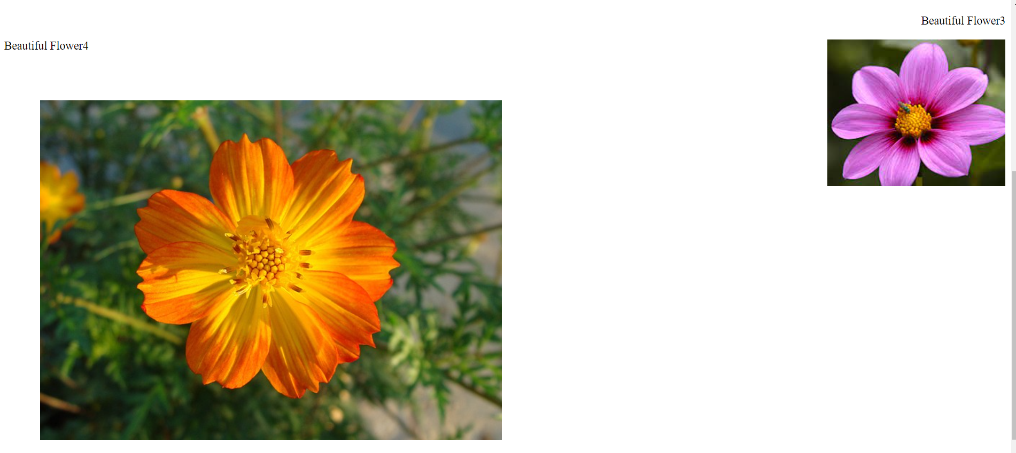

***Exercise-2***

Create a document home.html with two links to an external document (about.html). The

first link should lead to the beginning of the about.html. The second link should lead to a

particular section Contact information in the about.html.

home.html should also contain a Google logo of size 400px X 100px. On clicking this

image, it should redirect to [www.google.com](http://www.google.com)

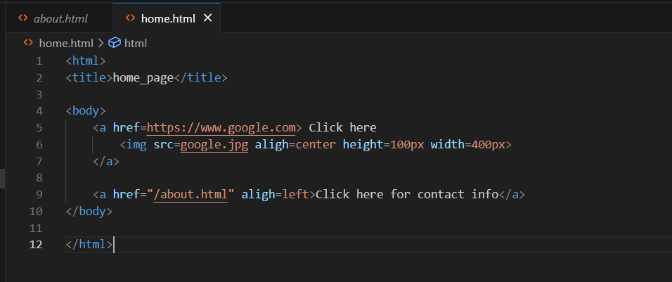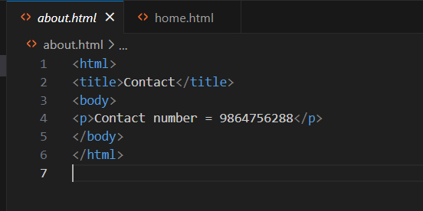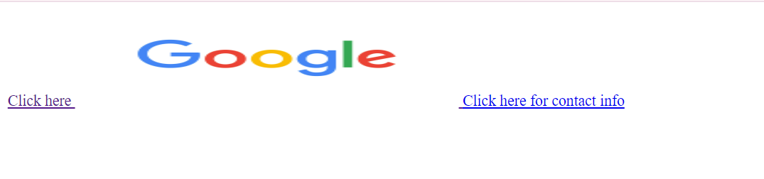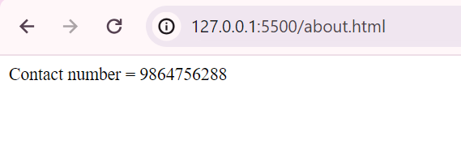

***Exercise-3***

Create a Web page giving the following Bus details.

Place a border for the table and use cell padding to present the cell data with clarity.

Align the table in the center of the screen. Use a caption saying ‘Bus Sewa Time Table

and Fare List’.

