WEEK 2 — DATA PREPROCESSING
AND EXPLORATORY ANALYSIS
Fashion Apparel Sales & Product Performance
A simulated apparel-business dataset study covering data cleaning, missing-value treatment, outlier handling, normalization, exploratory analysis, hypotheses, and future machine-learning applications.
Prepared as a technical data-analysis report

1. Introduction
This project demonstrates a complete data preprocessing and exploratory data analysis workflow using a simulated fashion apparel sales dataset. The dataset represents product-level information that could be collected by an apparel retailer or e-commerce business, including category, material, season, price, discount, customer rating, inventory, units sold, return rate, customer age, region, size, production cost, and revenue.
The objective is to transform a deliberately imperfect raw dataset into a consistent analytical dataset and then use exploratory analysis to identify distributions, category-level patterns, seasonal differences, relationships between variables, and potential business questions that could later be addressed with statistical or machine-learning models.

2. Dataset Description
A dataset of 5,000 apparel product records was simulated. To make the preprocessing workflow realistic, the raw version was intentionally introduced with missing values, duplicate records, inconsistent category labels, unusually high prices, and unusually high sales values.
Column | Description | Type
Product_ID | Unique product identifier | ID
Category | Apparel product category | Categorical
Material | Primary material | Categorical
Season | Target season | Categorical
Price | Product selling price | Numerical
Discount_Percentage | Applied discount percentage | Numerical
Customer_Rating | Customer rating | Numerical
Stock_Level | Available stock | Numerical
Units_Sold | Units sold | Numerical
Return_Rate | Product return rate | Numerical
Customer_Age | Customer age | Numerical
Region | Customer/business region | Categorical
Size | Product size | Categorical
Production_Cost | Estimated production cost | Numerical
Revenue | Calculated product revenue | Numerical

3. Data Preprocessing

3.1 Initial Data Inspection
The raw dataset was first inspected using dataframe structure information, descriptive statistics, missing-value counts, duplicate detection, and categorical frequency counts. This established the data types, scale of numerical variables, presence of missing values, duplicate records, and inconsistent category labels before transformation.

3.2 Missing-Value Treatment
Missing values were deliberately introduced in Price, Customer_Rating, Region, and Material. Numerical missing values were imputed using the median because it is less sensitive to extreme values than the mean. Categorical missing values were filled using the mode, preserving the most common category without introducing an artificial class.

3.3 Duplicate Removal
Fifty duplicate rows were introduced into the raw dataset. Duplicate records were identified and removed using dataframe duplicate detection and drop_duplicates(). The final cleaned dataset returned to 5,000 records.

3.4 Categorical Standardization
The Category field contained inconsistent representations of the same apparel class, including “tshirt”, “T shirt”, and “T-SHIRT”. These were standardized to “T-Shirt” to prevent one logical category from being treated as multiple categories during grouping, visualization, or model training.

3.5 Outlier Detection and Treatment
Potential outliers were assessed for Price and Units_Sold using the Interquartile Range (IQR) method. Instead of automatically deleting extreme observations, IQR capping was applied. This is appropriate for apparel data because unusually expensive products or unusually high sales can represent legitimate business observations. Capping limits their influence while retaining the records.
Revenue was recalculated after Price and Units_Sold were capped so that the derived variable remained consistent with the cleaned inputs.

3.6 Normalization
Min-Max normalization was applied to Price, Discount_Percentage, Customer_Rating, Stock_Level, Units_Sold, Return_Rate, Customer_Age, Production_Cost, and Revenue. The transformed values were scaled to a 0–1 range and saved separately from the original-unit cleaned dataset.

4. Exploratory Data Analysis
Exploratory analysis was performed on the cleaned dataset using the original units so that the results remain directly interpretable from a business perspective.

4.1 Product Category Distribution
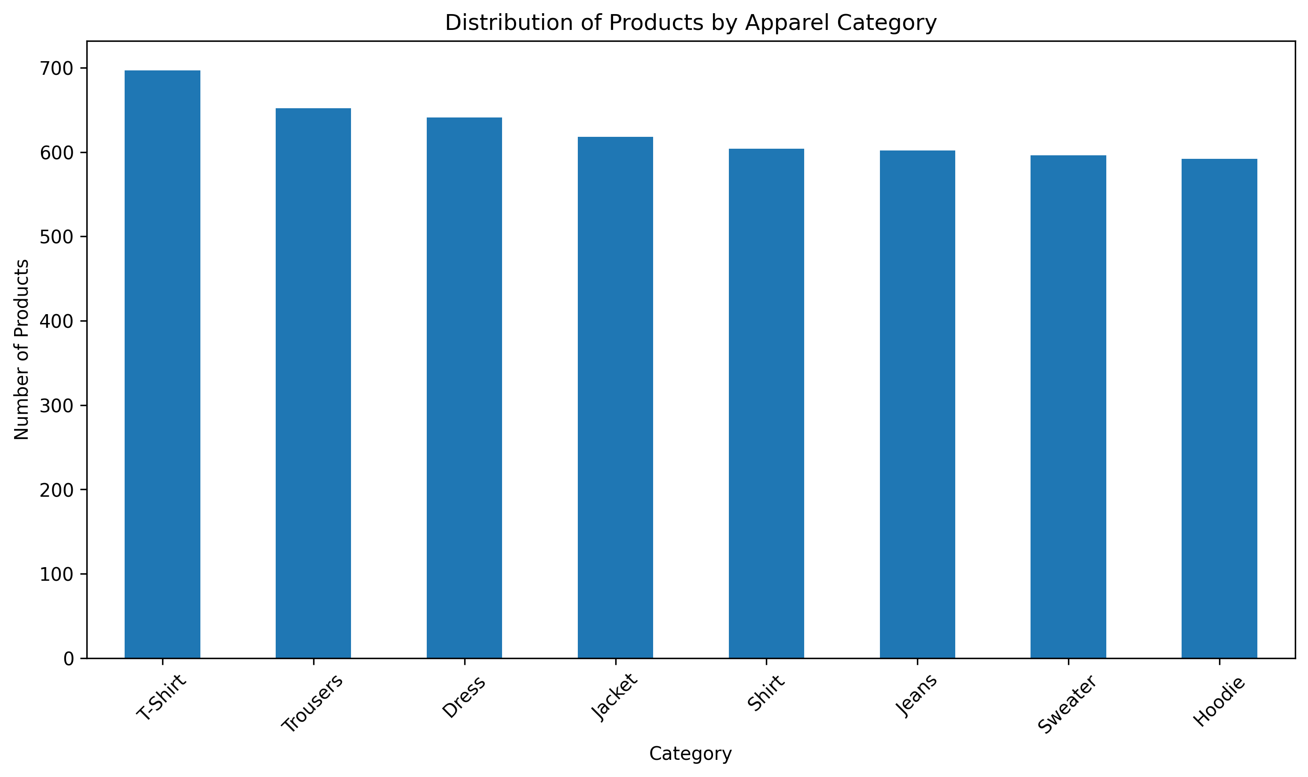
Figure 4.1: Product Category Distribution
The category distribution provides an overview of how the simulated product records are distributed across apparel classes.

4.2 Price Distribution
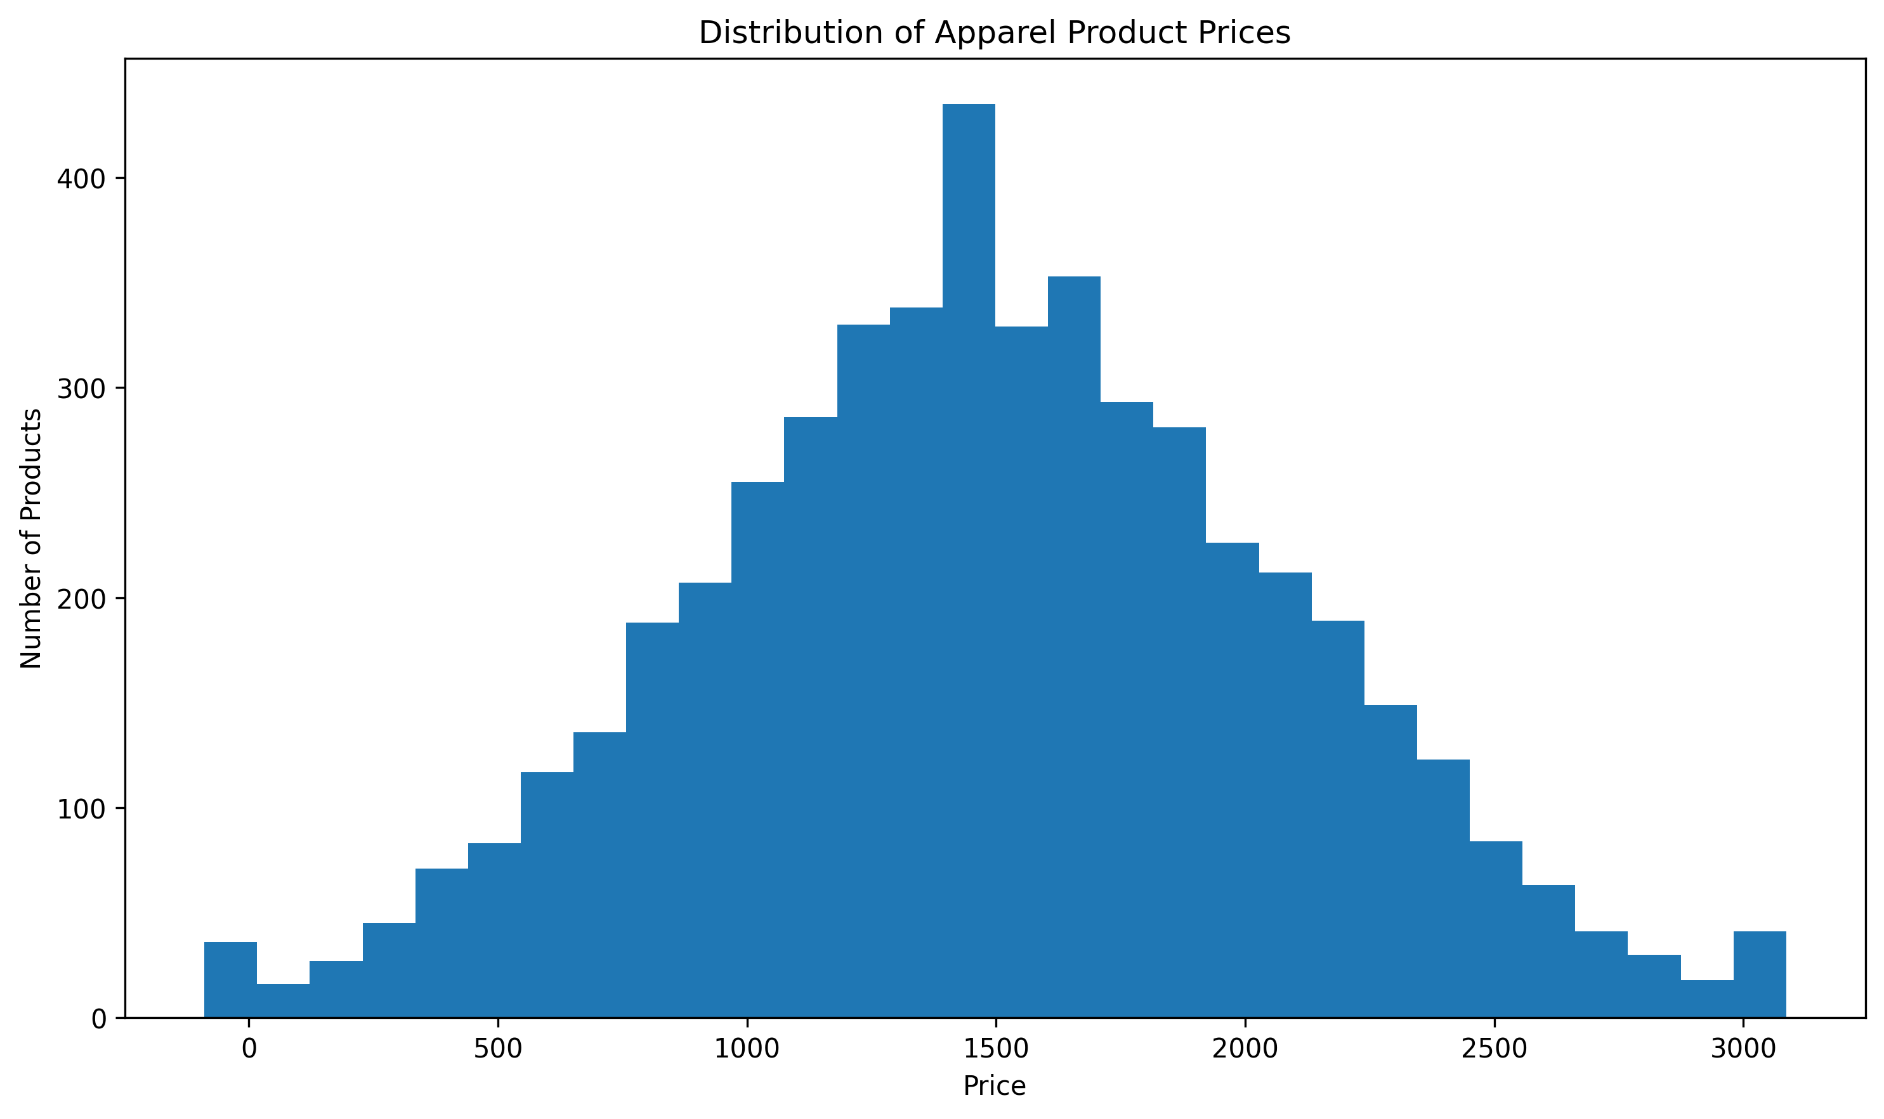
Figure 4.2: Price Distribution
The price histogram shows the spread of apparel product prices after preprocessing and outlier treatment.

4.3 Units Sold by Category
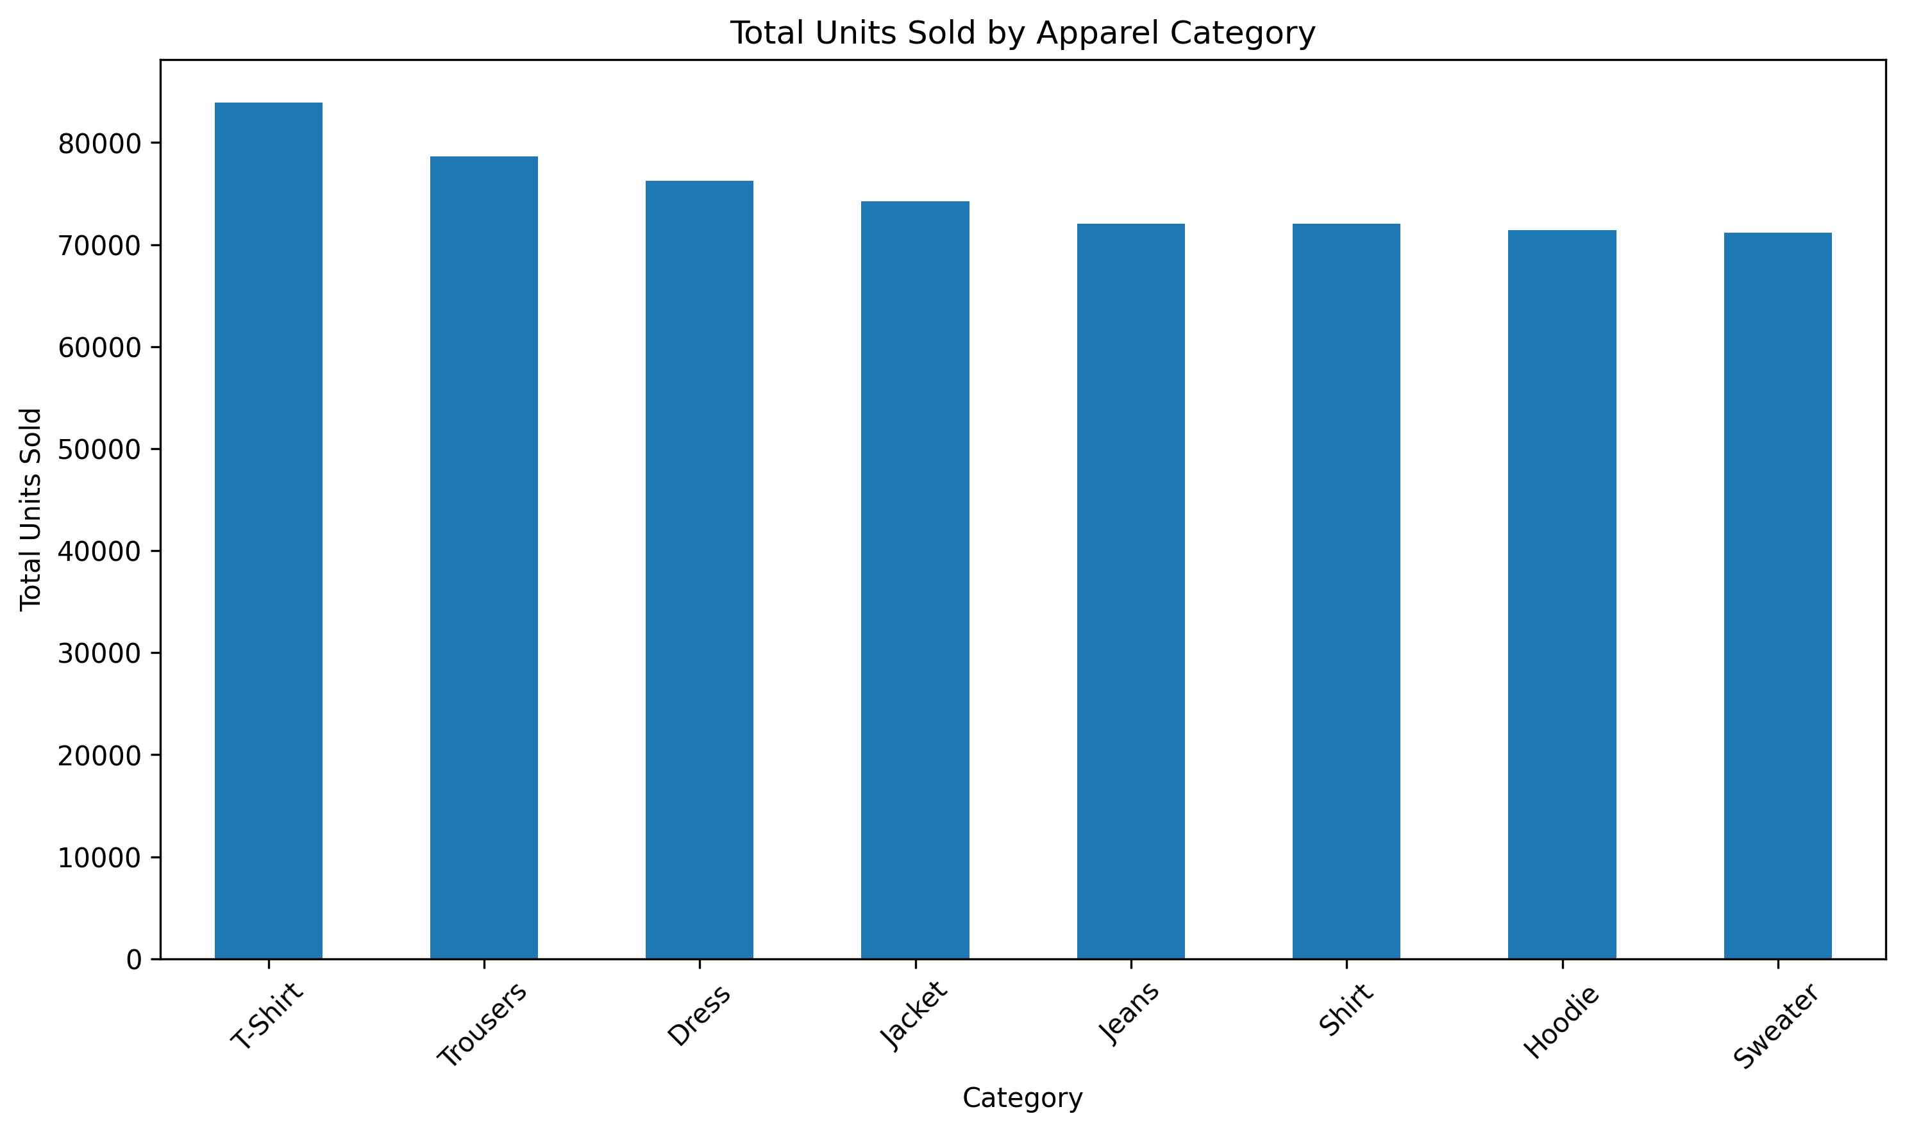
Figure 4.3: Units Sold by Category
T-Shirt has the highest total simulated unit sales, followed by Trousers and Dress.

4.4 Seasonal Sales
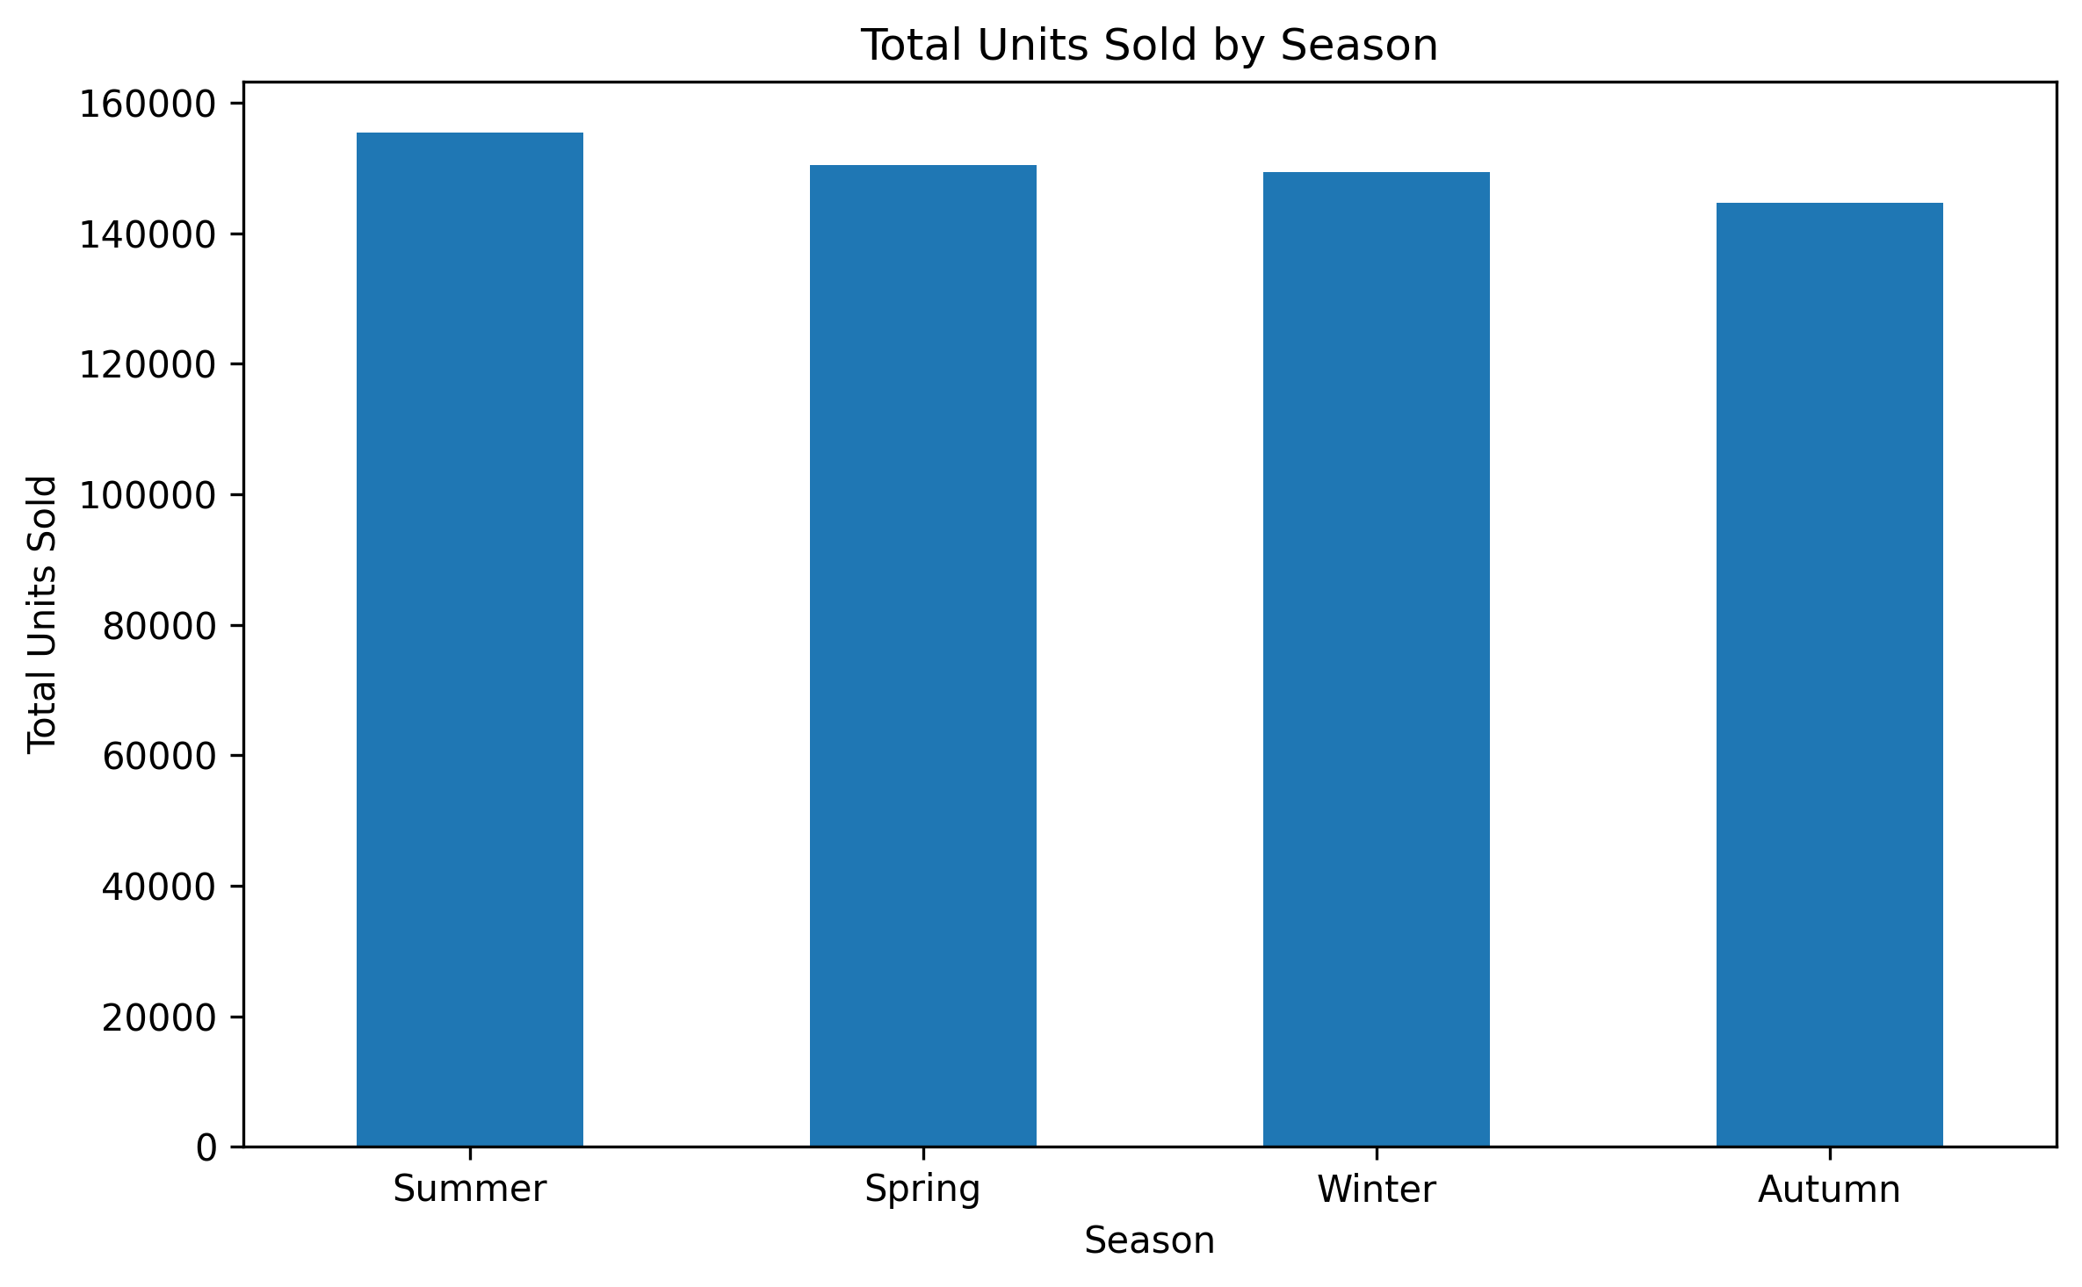
Figure 4.4: Seasonal Sales
Summer has the highest total simulated unit sales, followed by Spring, Winter, and Autumn.

4.5 Discount Percentage vs Units Sold
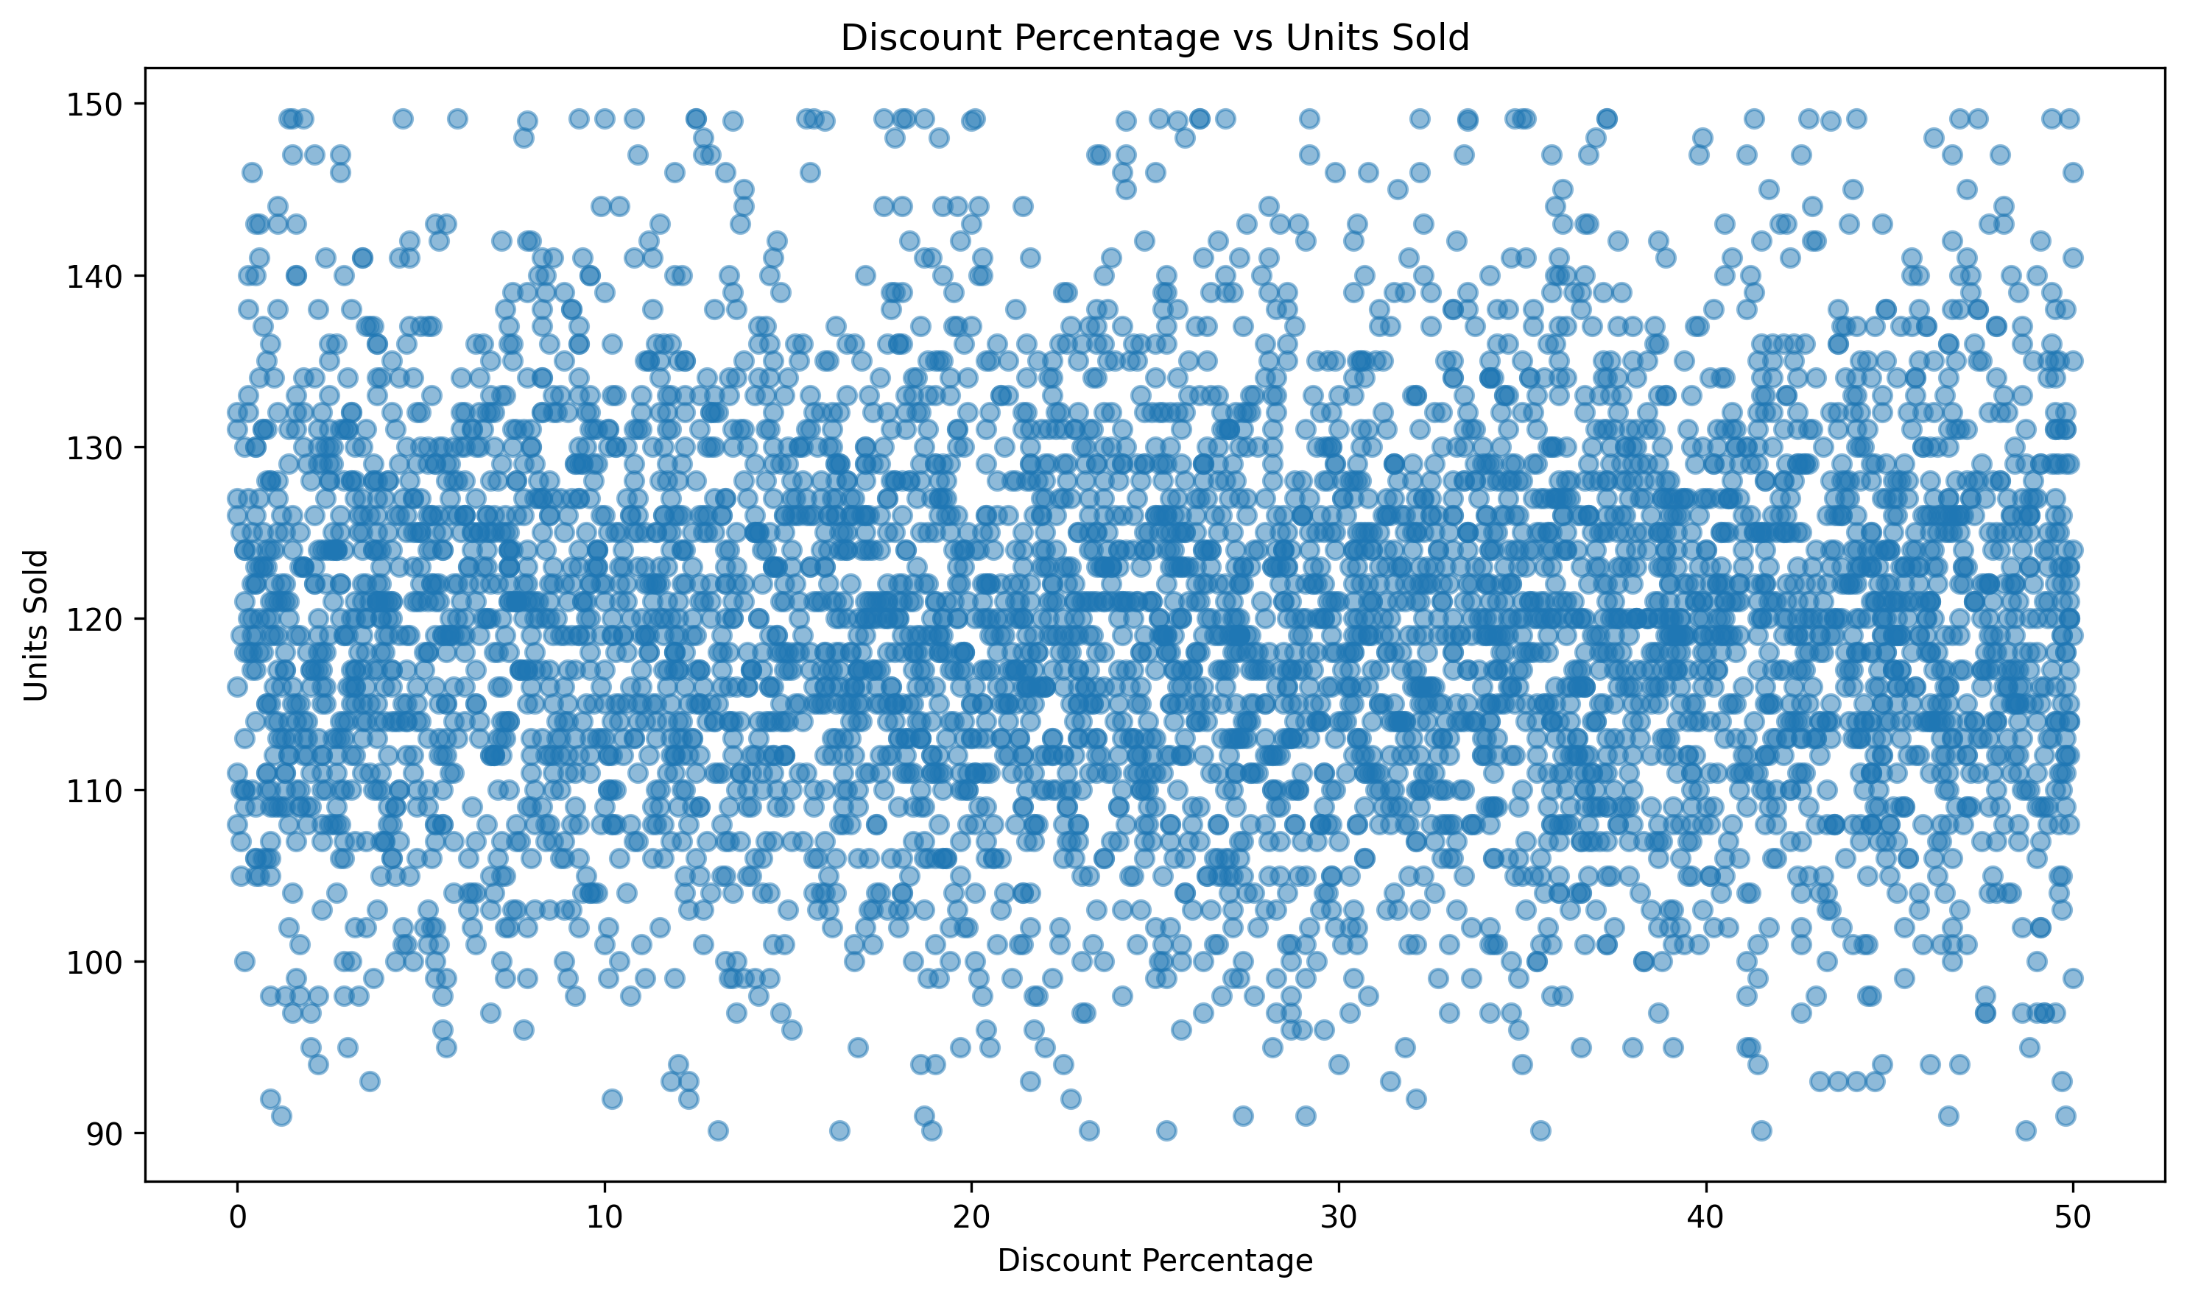
Figure 4.5: Discount Percentage vs Units Sold
The scatter plot examines whether discount levels show a visible linear association with unit sales.

4.6 Customer Rating vs Units Sold
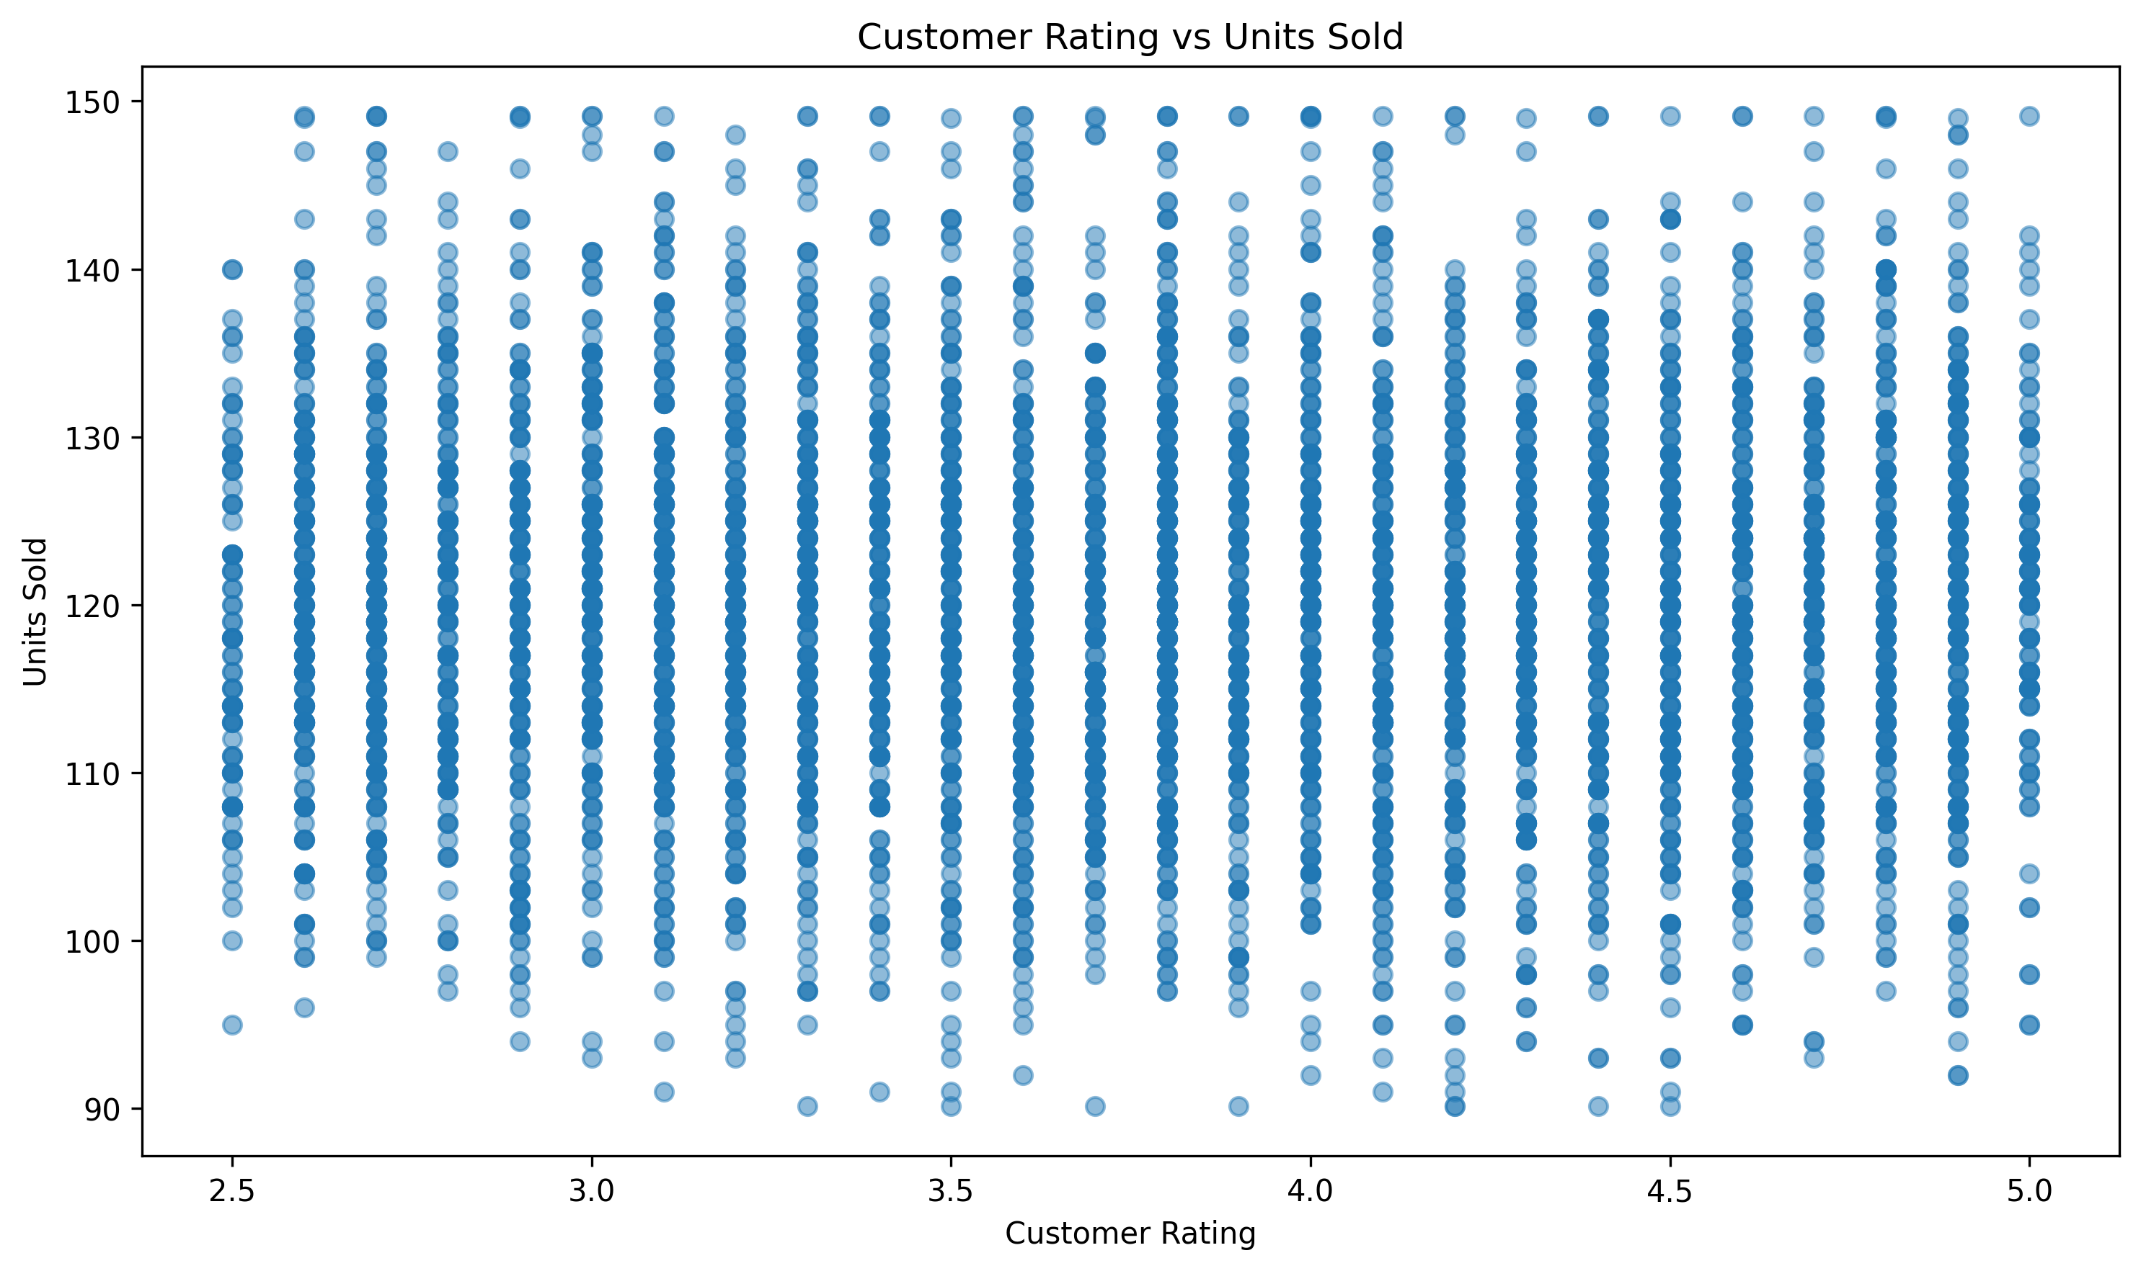
Figure 4.6: Customer Rating vs Units Sold
The scatter plot examines whether customer ratings show a visible linear association with unit sales.

4.7 Average Return Rate by Category
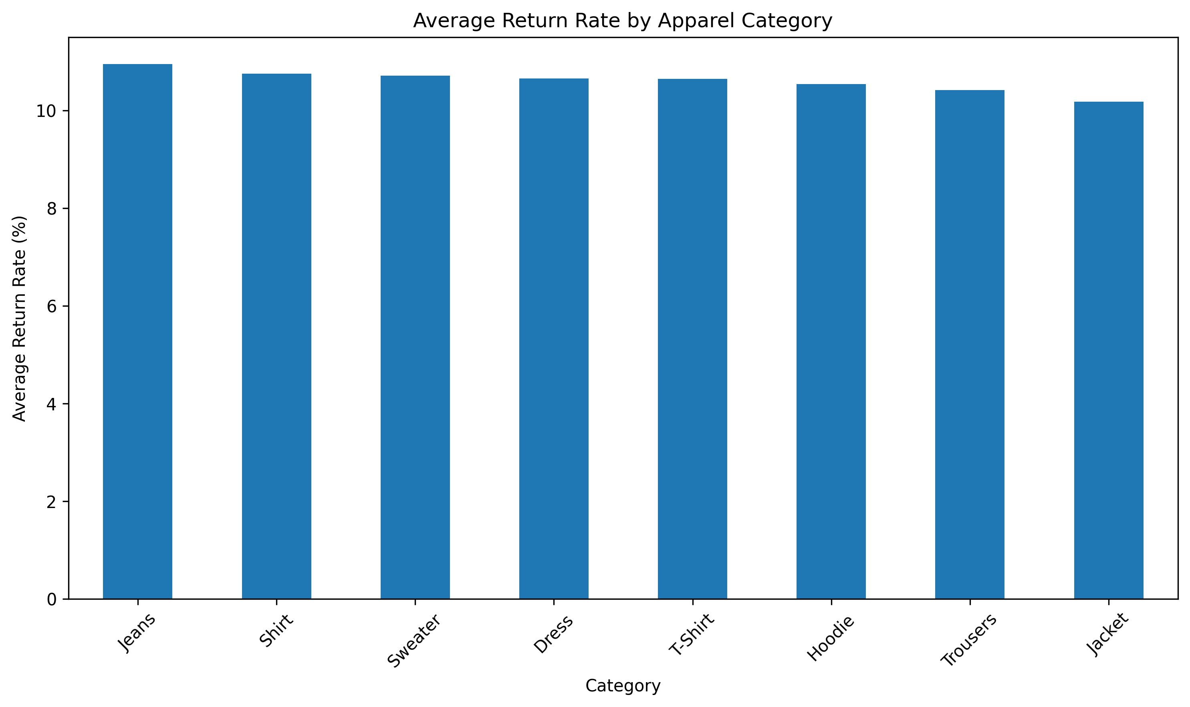
Figure 4.7: Average Return Rate by Category
Jeans has the highest average return rate among the apparel categories, followed by Shirt and Sweater.

4.8 Revenue by Category
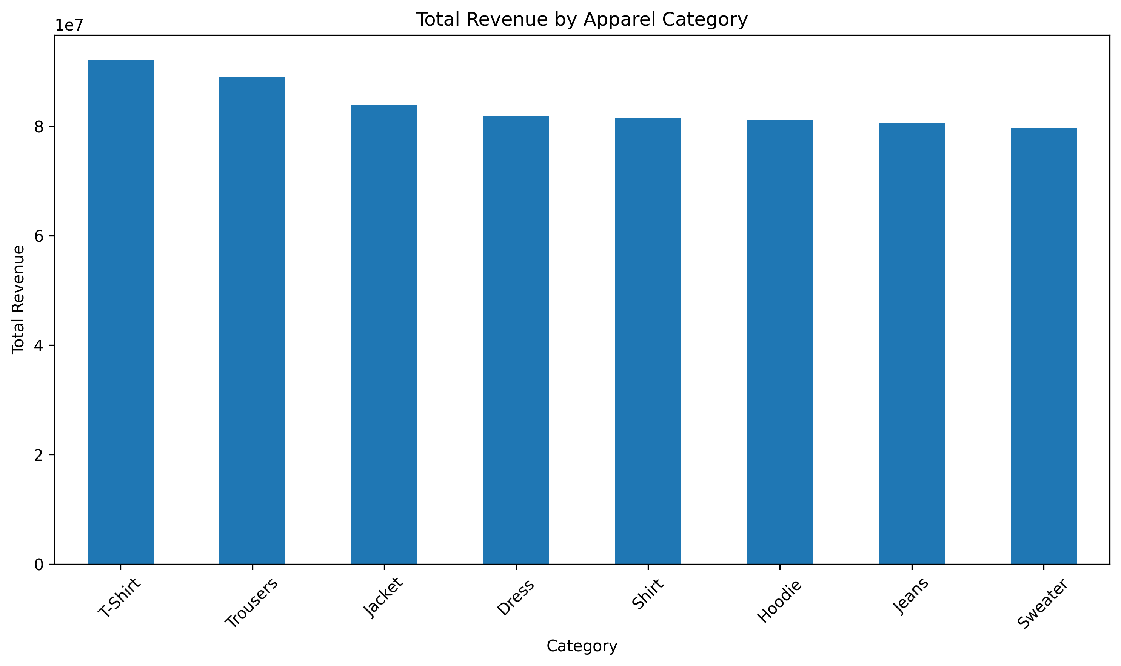
Figure 4.8: Revenue by Category
T-Shirt generates the highest total simulated revenue, followed by Trousers and Jacket.

4.9 Revenue Distribution
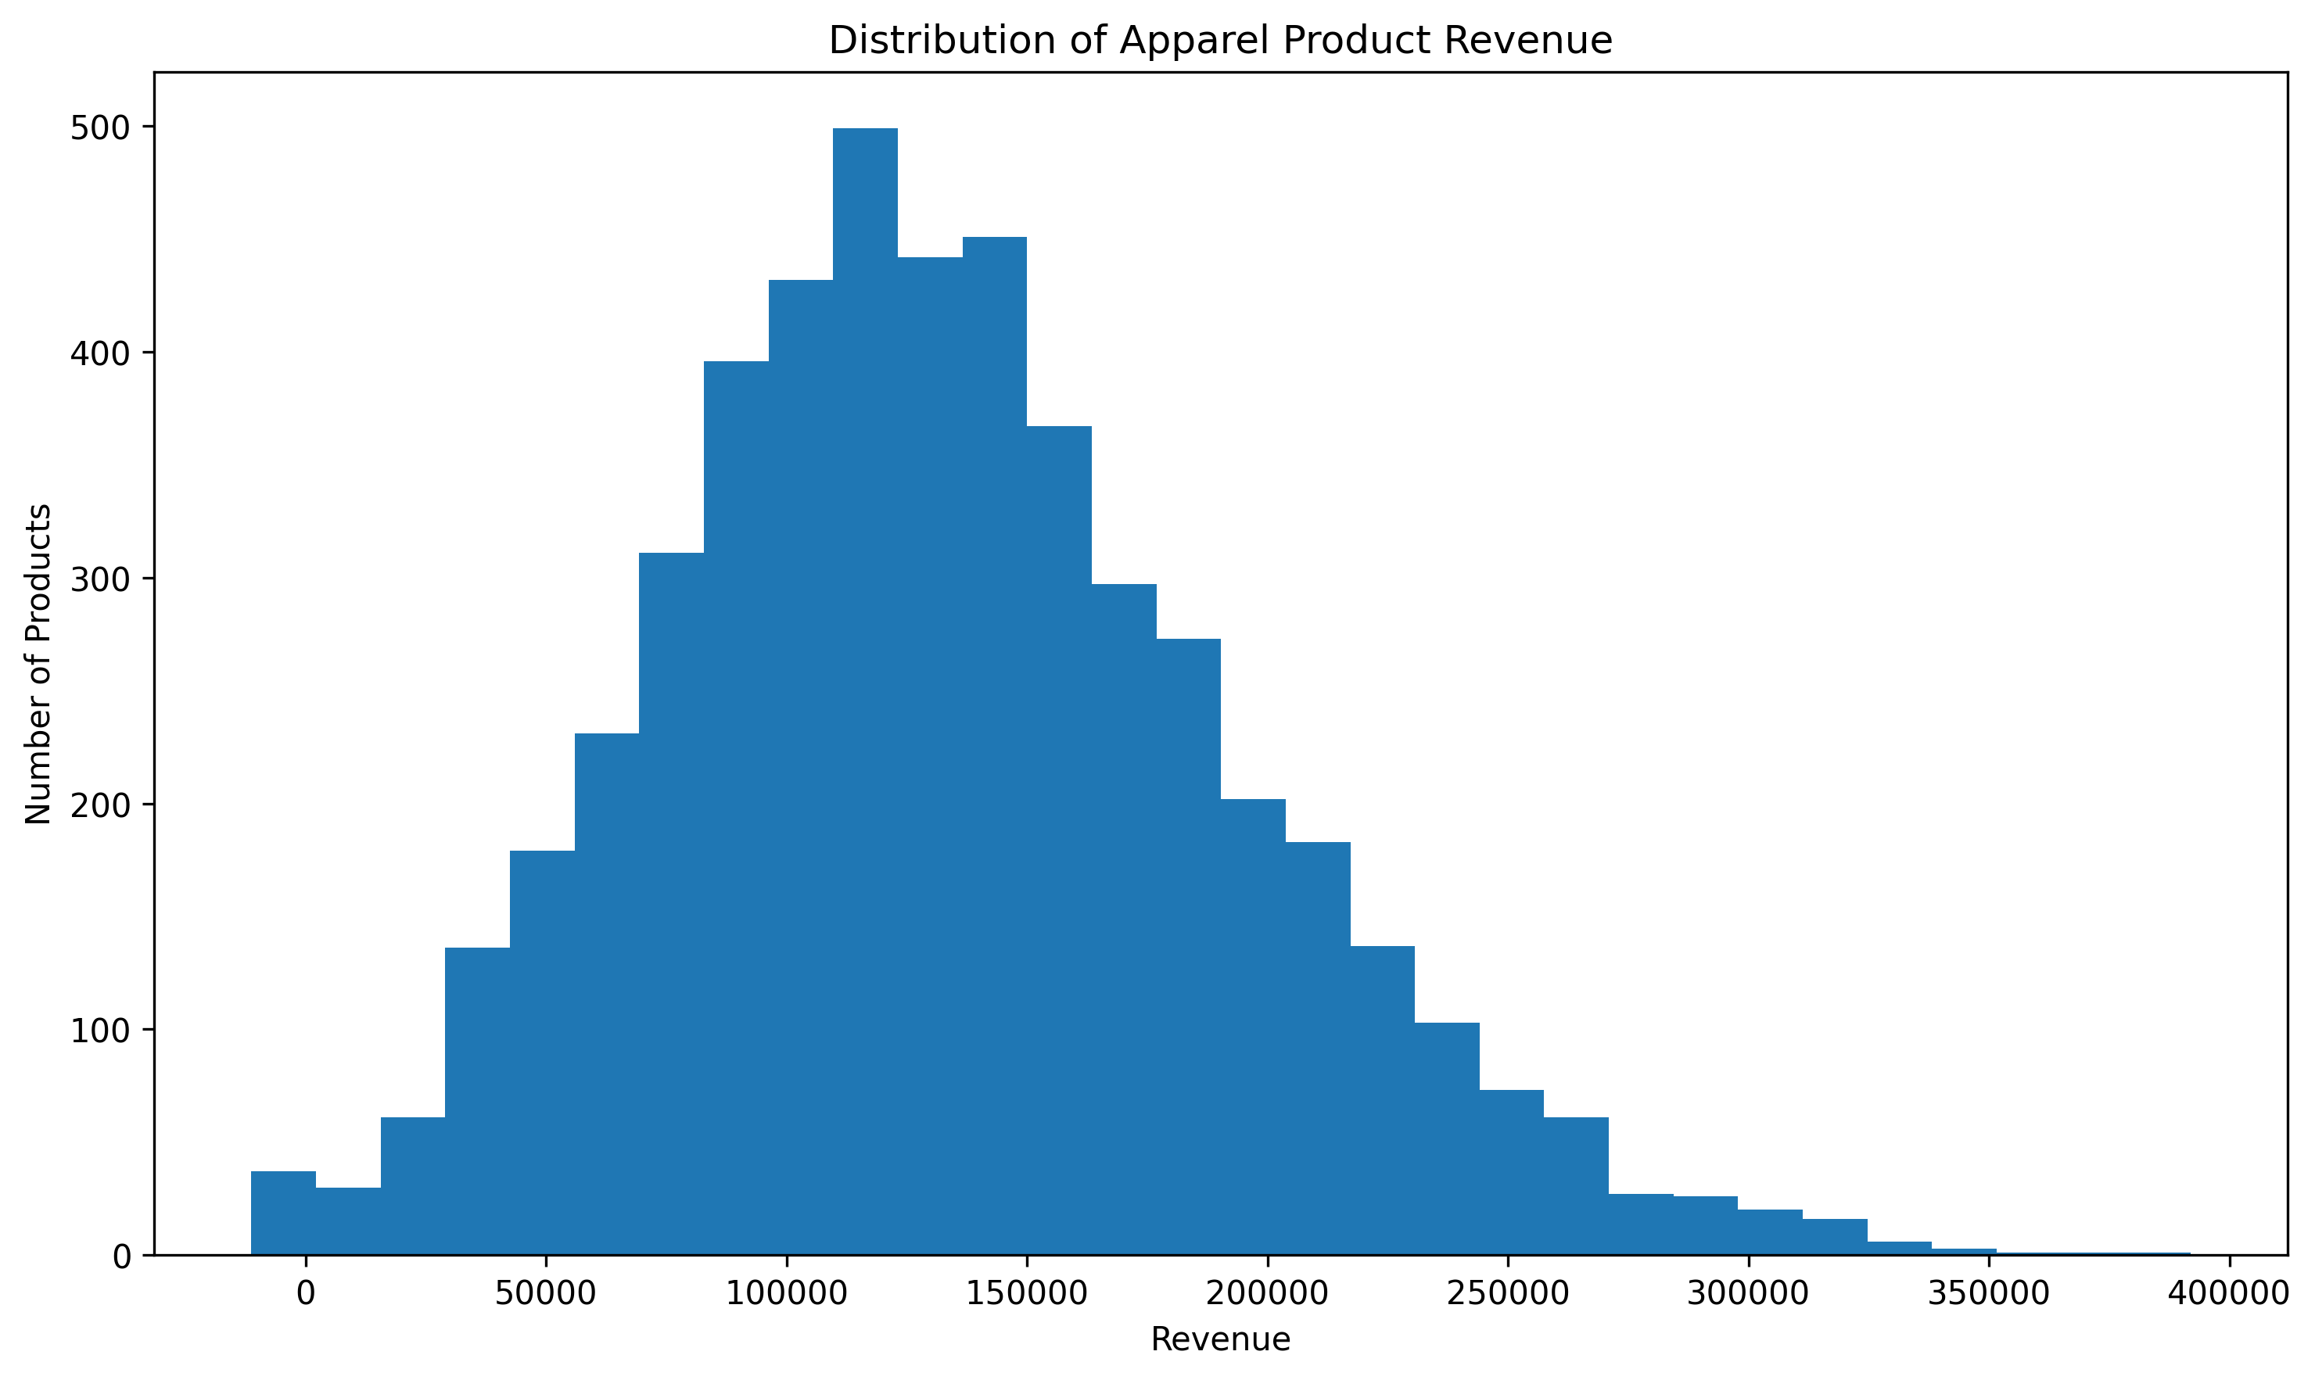
Figure 4.9: Revenue Distribution
The revenue histogram shows the distribution of calculated product-level revenue after cleaning.

4.10 Correlation Analysis
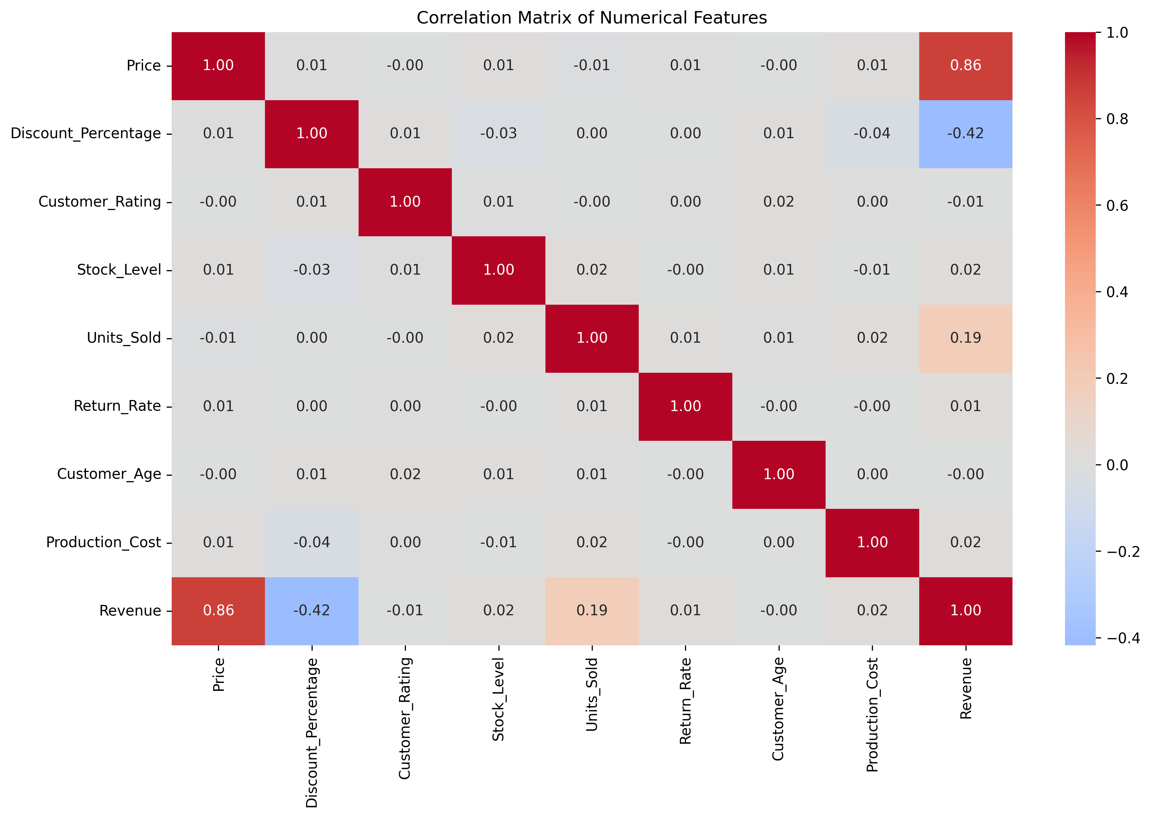
Figure 4.10: Correlation Analysis
The correlation matrix summarizes linear relationships among numerical variables. Correlation is descriptive and does not establish causation.

5. Key Findings
- The cleaned analytical dataset contains 5,000 records and 15 variables.
- Total simulated units sold are 599,846.5, while total simulated revenue is ₹669,768,358.06.
- The average product price is ₹1,497.77, with an average discount of 25.37%.
- The average customer rating is 3.77, and the average return rate is 10.61%.
- T-Shirt is the strongest category by total units sold, with 83,948.25 simulated units.
- T-Shirt also has the highest total simulated revenue at ₹92,048,367.40.
- Jeans has the highest average return rate at approximately 10.96%.
- Summer has the highest total simulated unit sales at 155,449.25 units.
- Units_Sold and Revenue have a weak positive linear correlation of approximately 0.186.
- Discount Percentage and Units Sold are almost uncorrelated (0.001), and Customer Rating and Units Sold are also nearly uncorrelated (-0.004).
- Because the dataset is simulated using largely independent random variables, these weak correlations should not be interpreted as causal business effects.

6. Hypotheses for Further Analysis
- H1: Apparel categories differ in their sales performance.
- H2: Seasonal demand varies across apparel products.
- H3: Higher discount percentages may be associated with increased units sold.
- H4: Customer ratings may be associated with product sales performance.
- H5: Some apparel categories may have higher return rates than others.
- H6: Product price and production cost may influence revenue and profitability.
These hypotheses are proposed for further statistical testing or predictive modeling. They are not treated as proven relationships based on exploratory analysis alone.

7. Future Machine Learning Applications
Demand Forecasting: Units sold could serve as a target for predicting future product demand using historical sales, season, category, price, discount, and inventory features.
Return Prediction: Return_Rate can support classification or regression models to identify products with elevated return risk.
Customer/Product Segmentation: Category, material, price, rating, sales, and regional variables can be used to identify product or market segments.
Revenue Prediction: Revenue can be modeled from product, pricing, discount, inventory, and sales-related variables.
Inventory Optimization: Sales and stock variables can support replenishment and stock-level prediction systems.
Recommendation Systems: Category, material, season, size, rating, and behavioral information could later support personalized product recommendations.
For a real deployment, additional time-based transaction data, product lifecycle information, promotion history, and regional demand signals would be useful. Train/test splitting should also respect temporal or group structure where appropriate to avoid information leakage.

8. Conclusion
This project demonstrates an end-to-end preprocessing and exploratory analysis workflow for a simulated fashion apparel dataset. The raw data was inspected, missing values were imputed, duplicate records were removed, inconsistent categories were standardized, extreme numerical values were capped using the IQR method, and numerical variables were normalized using Min-Max scaling.
The EDA identified descriptive patterns in category-level sales and revenue, seasonal demand, return rates, and relationships among numerical variables. The analysis also established hypotheses and a path toward future machine-learning applications such as demand forecasting, return prediction, revenue prediction, segmentation, and inventory optimization.
A key limitation is that the dataset is simulated. The findings therefore demonstrate the analytical workflow rather than representing actual apparel-market behavior. Real-world data would be required to validate the business hypotheses.

