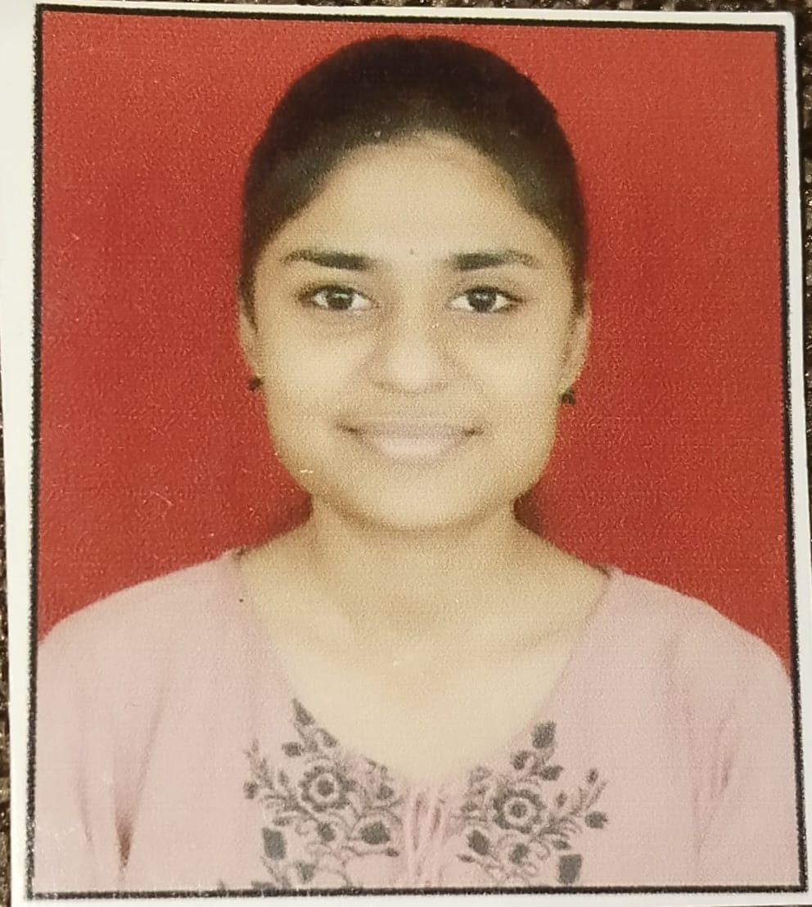

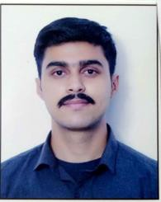

**Nikita Nagnath Kendre**

nikitakendre03@gmail.com

**DES Pune University ,Pune**

Research AI Agent

Program Feedback

# Engaging with IBM SkillsBuild has diversified my skills and prepared me for future career prospects through interactive modules and supportive mentorship, enhancing my employability and fostering continuous growth.

Project Short Summary

The AI Nutrition Agent revolutionizes health management by offering **personalized and adaptive meal plans** tailored to individual health goals, medical conditions, and lifestyle preferences. Unlike generic diet apps, it uses **IBM Watsonx, Granite AI models**

#skillsbuild