Task 01)

#include <iostream>

#include <string>

using namespace std;

int random(int a, int b) {

return rand() % (b - a + 1) + a;

}

string sum() {

int cube2, cube1;

cube1 = random(1, 6);

cube2 = random(1, 6);

return to_string(cube1 + cube2 );

}

Result

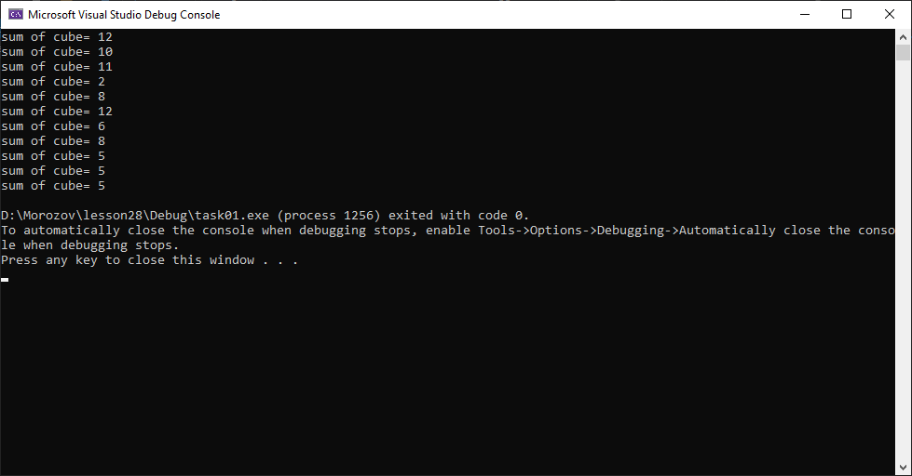

#include <iostream>

#include <ctime>

using namespace std;

string sum();

int main() {

srand(time (0));

int n = 10;

for (int i = 1; i <= n; i++) {

cout << "sum of cube= " << sum() << endl;

}

return 0;

}

#include <iostream>

#include <string>

using namespace std;

int random(int a, int b) {

return rand() % (b - a + 1) + a;

}

string detect_mood() {

const int MOOD_NUMBER = 5;

const string GOOD_MOOD = ":()";

const string SHOUTED_MOOD = ":)";

const string BAD_MOOD = ":(";

const string NERVOUS_MOOD = ":/";

const string HAPPY_MOOD = ":))";

string mood = "";

int dmood = rand()% MOOD_NUMBER + 1;

switch (dmood)

{

case 1: mood += ":0"; break;

case 2: mood += ":)"; break;

case 3: mood += ":("; break;

case 4: mood += ":))"; break;

case 5: mood += ":/"; break;

}

return mood;

}