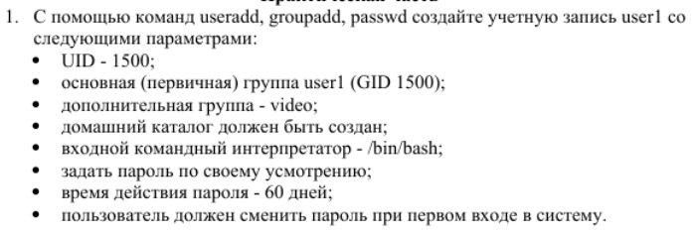











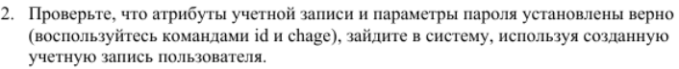

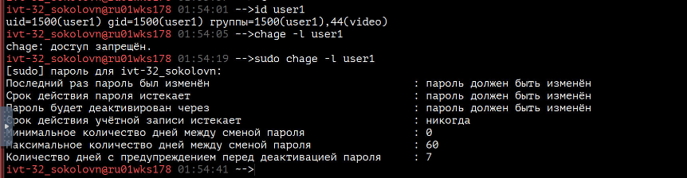

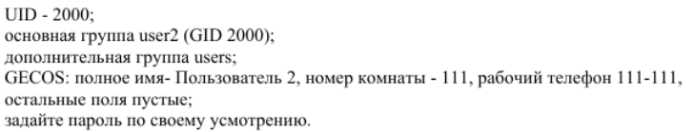



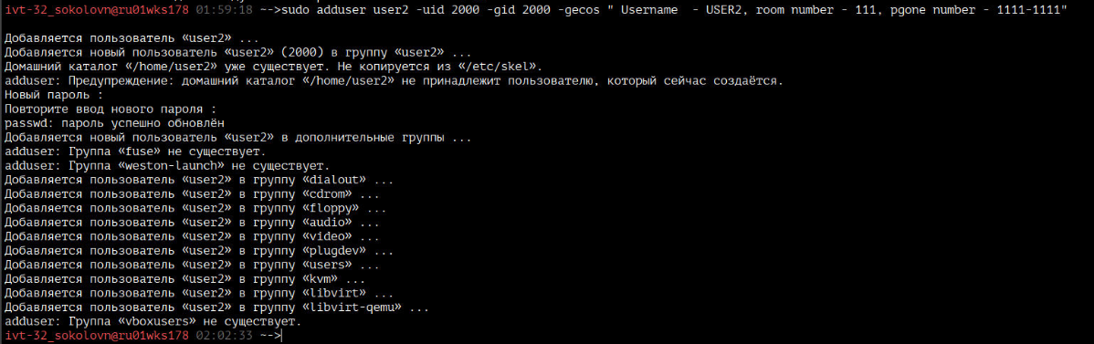



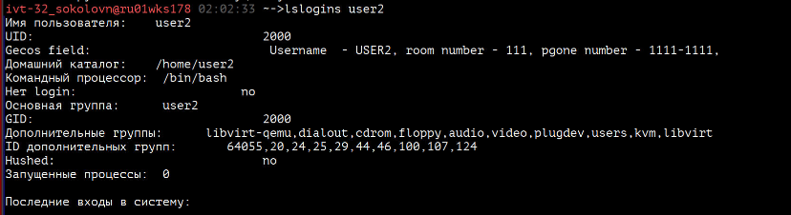

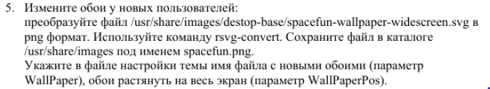





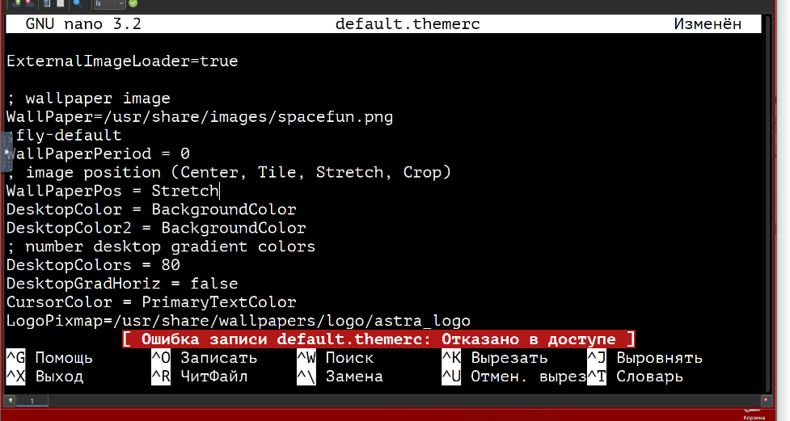

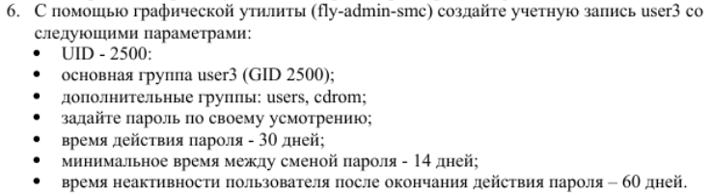

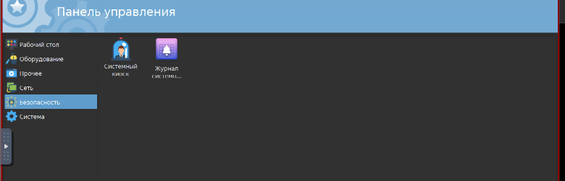

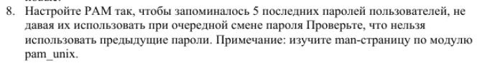

sudo nano /etc/pam.d/common-password

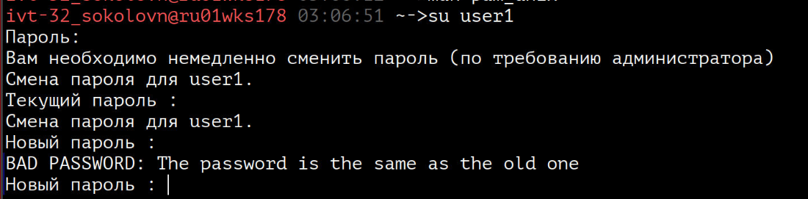

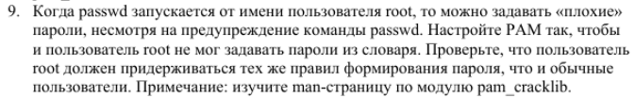

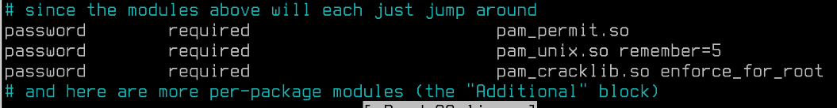

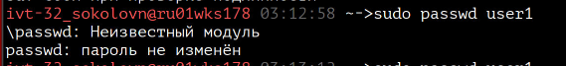



sudo nano /etc/environment

VAR="значение"

echo $VAR

12)- 