**MODULE: 3 (JavaScript Essentials)**

**• What is React Js?**

React, sometimes referred to as a frontend JavaScript framework, is a JavaScript library created by Facebook. React is a tool for building UI components.

**• What is NPM in React Js?**

In React.js, NPM (Node Package Manager) is a package manager for JavaScript, used for managing and sharing reusable code packages/modules. It simplifies the process of integrating third-party libraries, frameworks, and tools into your React.js projects.

**• What is Role of Node Js in react Js?**

Node.js is a JavaScript runtime environment that allows developers to run JavaScript code outside of a web browser. While React.js is a frontend library for building user interfaces, Node.js plays a crucial role in the React.js ecosystem in several ways:

* Server-side rendering (SSR)
* Build tools and bundling
* API integration
* Development environment

Deployment

**• What is CLI command In React Js?**

CLI (Command-Line Interface) commands in React.js are shortcuts you use in your computer's terminal or command prompt to do different tasks while working on a React project. These commands help you set up your project, start a development server to see your changes in real-time, build your project for production, run tests, and more.

For example:

You use a command like create-react-app my-app to start a new React project named my-app.

Then, you can use npm start or yarn start to start a server that shows your React app in your web browser as you work on it.

When you're ready to share your app or put it online, you can use npm run build or yarn build to create a final version that's optimized for the web.

**• What is Components in React Js?**

In simple terms, components in React.js are like building blocks or pieces of a puzzle that you use to create your web application. Each component represents a specific part of your user interface, such as a button, a form, a header, or even a whole section of your webpage.

For example:

if you're building a website, you might have a Header component for the top section of your page, a Sidebar component for the side menu, a Post component for displaying blog posts, and so on. Each of these components encapsulates its own logic and UI, making it easier to understand and maintain your codebase

• What is Header and Content Components in React Js?

The Header component in a React.js application typically represents the top section of a webpage or application. It often contains the site's logo, navigation menu, and other elements that are consistent across different pages or views.

Example:

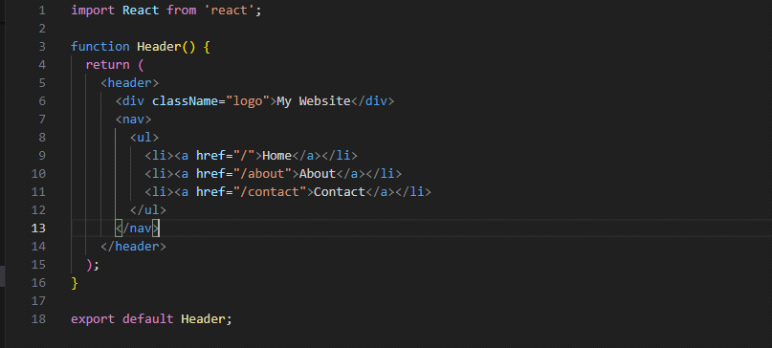

output:

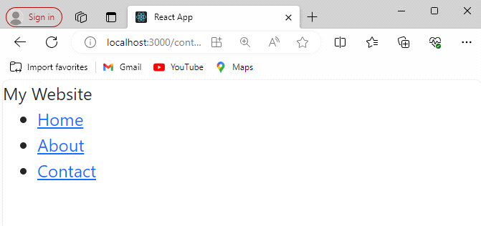

Content Component:The Content component in a React.js application represents the main content area of a webpage or application. It typically contains the dynamic content that changes based on user interactions or data fetched from a server.

Example:

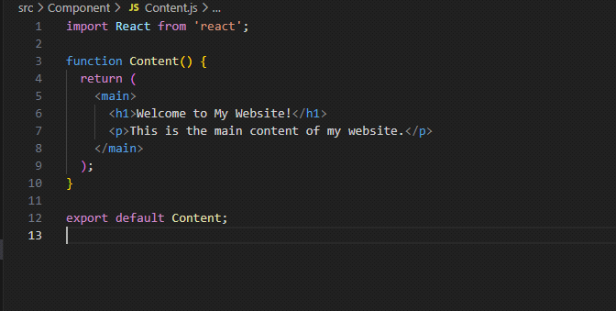

output:

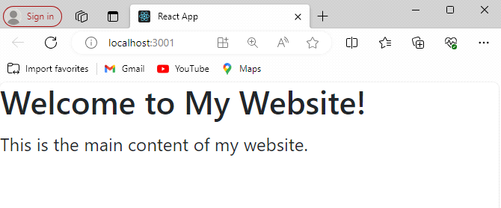

**• How to install React Js on Windows, Linux Operating System? How to install NPM and How to check version of NPM?**

Installing React.js and NPM on Windows:

Install Node.js:

Go to the official Node.js website: Node.js Downloads.

Download the Windows Installer (.msi) for your system.

Double-click the downloaded installer and follow the installation instructions.

Check NPM Installation:

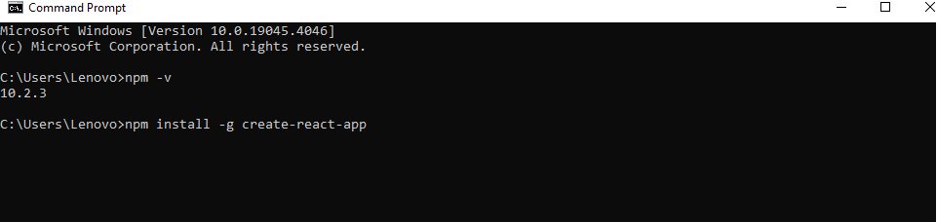

Installing React.js and NPM on Linux:

Install Node.js and NPM:

Open a terminal window.

Run the following command to install Node.js and NPM using the package manager for your Linux distribution:

For Ubuntu/Debian:

sudo apt update

sudo apt install nodejs npm

For CentOS/RHEL:

sudo yum install epel-release

sudo yum install nodejs npm

Check NPM Installation:

After installing Node.js, NPM should be installed alongside it.

To check if NPM is installed, type the following command and press Enter:

If NPM is installed, it will display the version number.

Install Create React App:

Once NPM is installed, you can use it to install Create React App globally. This tool helps in setting up React projects quickly.

In the terminal, type the following command and press Enter:

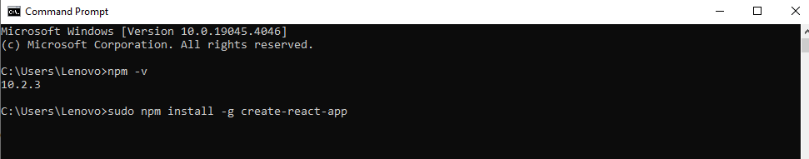

• How to check version of React Js?

To check the version of React.js installed in your project, you can follow these steps:

1.Navigate to Your Project Directory:

Open a terminal or command prompt window and navigate to the directory where your React.js project is located.

2.Install npm-check-updates (Optional):

If you don't already have npm-check-updates installed globally, you can install it using the following command:

npm install -g npm-check-updates

3.Check React.js Version:

If you're using npm-check-updates, you can run the following command in your project directory:

ncu

If you prefer using npm, you can list all the installed packages along with their versions by running:

npm list react

4.Check React.js Version in Package. Json:

Another way to check the version of React.js installed in your project is to open the package. Json file in your project directory and look for the react dependency. The version number will be specified next to it.

Here's an example of how the dependencies section might look in your package. Json file:

"dependencies": {

"react": "^17.0.2",

"react-Dom": "^17.0.2",

...

}

**• How to change in components of React Js?**

1.Identify the Component to Change:

Determine which component you want to modify. Components in React.js are typically stored in separate files, so locate the file corresponding to the component you want to change.

2.Open the Component File:

Use a code editor to open the file containing the component you want to modify. This file will typically have a .js extension.

3.Make Changes to the JSX Code:

Within the component file, locate the JSX code that defines the component's structure and appearance. Modify this code according to the changes you want to make. You can add, remove, or modify elements, attributes, styles, or any other JSX expressions. For example, let's say you have a simple Button component that renders a button element with a text label:

import React from 'react';

function Button() {

return <button>Click me</button>;

}

export default Button;

5.If you want to change the button label to "Submit", you would modify the JSX code like this:

import React from 'react';

function Button() {

return <button>Submit</button>;

}

export default Button;

**• How to Create a List View in React Js?**

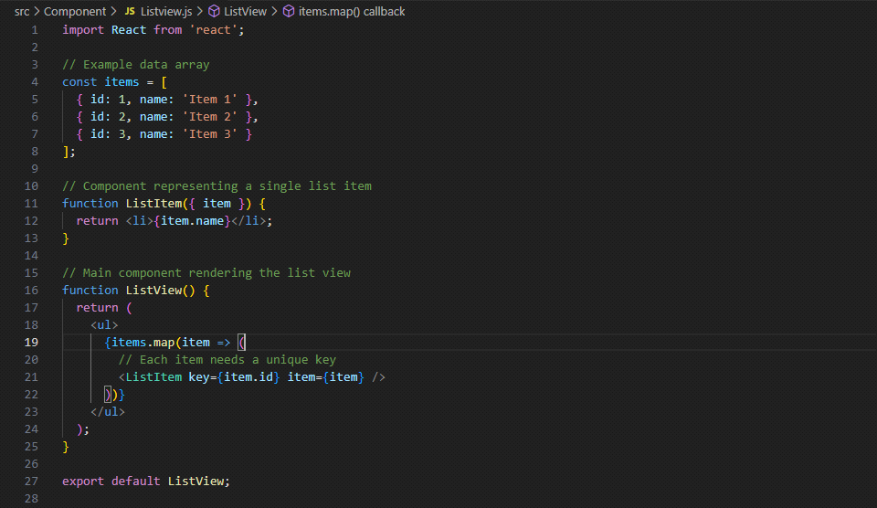

output:

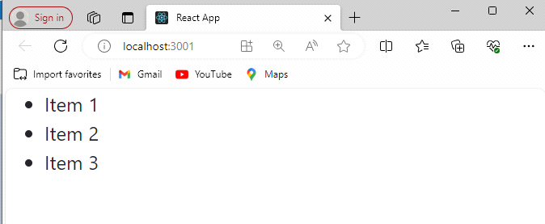

• Create Increment decrement state change by button click?

Example:

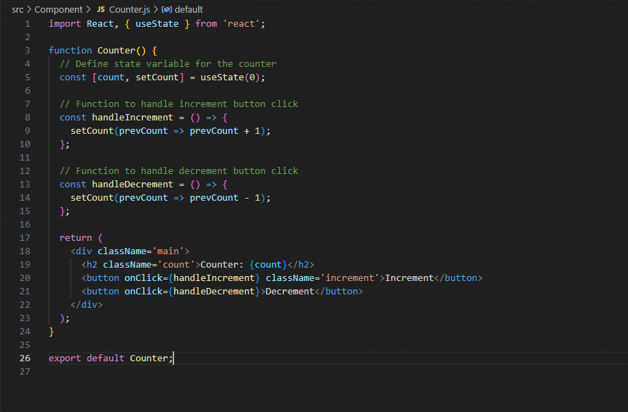

output increment:

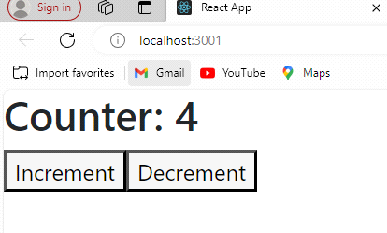

output decrement:

