**MODULE: 4 (List and Hooks)**

**• Explain Life cycle in Class Component and functional component with Hooks**

**-> Brief about life cycle in class component and functional component is shown below.**

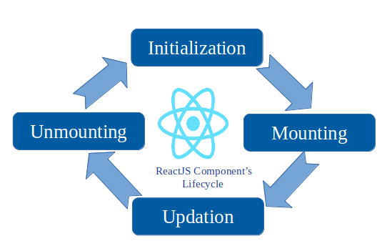

**class component and functional component includes:**

**Mounting:**

**The mounting phase refers to the initial setup and rendering of a component. During the mounting phase ,specific lifecycle methods are called for both class component and functional components with hooks.**

**ComponentWillMount():- This method is called before the component mounts on DOM or we can say before render method is called.**

**ComponentDidMount():- this method is called after the component mounted on DOM or we can say after render method is called.**

**Updating:**

**The updating phase refers to the period during which a component is re-rendered due to changes in its state or props this phase occurs after the initial rendering and involves updating the component to reflect the new state or prop values.**

**componentShouldUpdate():-this method is called when you want to re-render the component on some condition.by default, it return true.**

**componentWillUpdate():-this method is called before re-rendering has done and when you want to do some functionalities just before re-rendering task place.**

**componentDidUpdate():-this method is called after the re-rendering has done or we can say after component mounted on dom.**

**Unmounting:**

**- the unmounting phase in react occurs when a component is being removed from the Dom during this phase, cleanup tasks and actions can be performed before the component is completely taken out of the application.**

**ComponentWillUnmount():- this method is called before the component unmounting on dom.denoting that it will unmounted soon or we can say end of the component life cycle.**

**Example:-Functional component.**

**import React,{UseEffect} from "react";**

**Mounting:**

**UseEffect( () =>{**

**console.log("DidMount");**

**},[] );**

**Updating:**

**UseEffect( () =>{**

**return () => console.log("DidUpdate");**

**},[data.number]);**

**Unmounting:**

**UseEffect( () =>{**

**console.log("DidMount");**

**return () => console.log("WillUnmount");**

**},[]);**

**Example:-Class Components:**

**Mounting:**

**ComponentDidMount(){**

**console.log("DidMount")**

**}**

**Updating:**

**ComponentDidUpdate(){**

**console.log("DidUpdate")**

**}**

**Unmounting:**

**ComponentWillUnmount(){**

**Console.log("WillUnmount")**

**}**