**MODULE:1**

**SE-Overview of IT Industry**

**1.What is software? What is software engineering?**

**Software** is a collection of codes, documents, and triggers that does a specific job and fills a specific requirement.

**Engineering** is the development of products using best practices, principles, and methods.

**2.Explain Types Of Software** 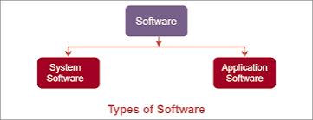

**Application Software:** An application is software that fulfill a specific need or performs tasks.

**System software:** System software is designed to run a computer's hardware and provides a platform for applications to run on top of.

**3.What is SDLC? Explain each phase of SDLC.**

Software development life cycle (SDLC) is also referred to as application development life cycle. It is a term used in system engineering and software engineering to describe the process for planning, developing, testing, and deploying information system.

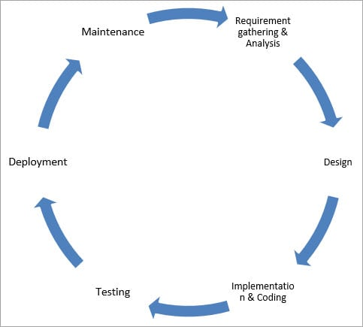

**4.What is DFD? Create a DFD Diagram on Flipkart**

A data flow diagram (DFD) is a graphical or visual representation using a standardized set of symbols and notations to describe a business's operations through data movement.

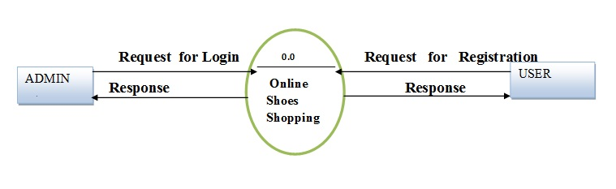

**5.What Is Flowchart? Create A Flowchart To Make Addition Of Two Numbers**.

A flowchart is a picture of the separate steps of a process in sequential order. It is a generic tool that can be adapted for a wide variety of purposes, and can be used to describe various processes, such as a manufacturing process, an administrative or service process, or a project plan.

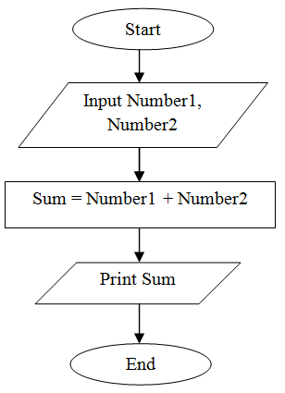

**6.What Is Use-case Diagram? Create A Use-case on Bill Payment on paytm.**

Use-case diagrams describe the high-level functions and scope of a system. These diagrams also identify the interactions between the system and its actors.

