LINUX SECURITY HARDENING
Role-Based Access · Audit Logging · SIEM Dashboard · Persistent Controls

Document | Platform | SIEM
Implementation Guide | Debian | Splunk Enterprise

Tasks Covered in This Guide
# | Task | Technology | Expected Outcome
1 | User Accounts & ACL Configuration | useradd, setfacl, chmod | Owner-only file access enforced
2 | Command History (HISTSIZE) | HISTSIZE, .bashrc, profile.d | Audit trail per user role
3 | Unauthorized Access Logging | Rsyslog | Secure centralized event logs
4 | Security Web Dashboard | Splunk Enterprise | Monitoring logs
5 | Persistent Security Settings | systemd, sysctl, cron | Controls survive reboots

Architecture Overview
How all components work together

The solution is organized into five layered security controls. Each layer addresses a specific threat vector and together they provide defense-in-depth for a Linux system. The diagram below shows the data flow from user actions through to the Splunk SIEM dashboard.

Layer | Component | Protects Against | Log Destination
1 - Identity | useradd + groups | Unauthorized user creation | -
2 - Access | ACL (setfacl) | Cross-project data access | /var/log/security/acl_violations.log
3 - Audit Trail | HISTSIZE policy | Command history tampering | ~/.bash_history
4 - Detection | Rsyslog | Real-time threat detection | /var/log/security/*.log
5 - Visibility | Splunk Dashboard | Delayed incident response | -
6 - Resilience | systemd service | Config drift after reboot | /var/log/security/boot_enforcement.log

Task 1 — User Accounts & ACL Configuration

Objective: Create isolated user accounts for Project-A and Project-B, configure Access Control Lists (ACLs) so each user can only access their own project directory, and restrict home directories to the owner only.

1.1 What Are ACLs and Why Use Them?
Standard Linux permissions use three entities: owner, group, others. ACLs (Access Control Lists) extend this by allowing per-user and per-group rules on any file or directory — without changing ownership. This means you can grant project-a group read/write access to /data/project-a while ensuring project-b users see a permission denied error if they try to access it.

1.2 Users and Group Mapping
Username | Primary Group | Project Directory | Home Dir Permissions
project_a_user1 | project-a | /data/project-a | chmod 700 (owner only)
project_a_user2 | project-a | /data/project-a | chmod 700 (owner only)
project_b_user1 | project-b | /data/project-b | chmod 700 (owner only)
project_b_user2 | project-b | /data/project-b | chmod 700 (owner only)
senior_analyst | senior-analysts | /data/senior-analysts | chmod 700 (owner only)

Setgid: is only one of several special-permission mechanisms in Linux. Beyond it, there are three other major systems that change how permissions work: setuid, sticky bit, and ACLs. Each solves a different access-control problem, and understanding when to use which one is a core part of secure Linux administration.
Setuid: Applies mainly to executable files, not directories.
When set on a binary, the program runs with the file owner’s privileges, not the user’s.

Step 1 — Install ACL Utilities
ACL tools are not always installed by default. Install them first:
# Debian/Ubuntu
sudo apt-get install -y acl
The acl package provides setfacl (set ACL rules) and getfacl (read ACL rules).
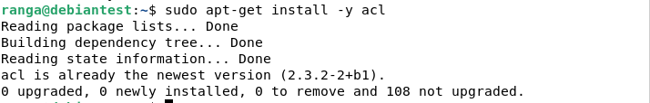

Step 2 — Create Groups
Groups are used as the unit of access control. Each project has its own group, preventing cross-project access:
sudo groupadd project-a
sudo groupadd project-b
sudo groupadd senior-analysts

Step 3 — Create User Accounts
Create each user with a home directory (-m), bash shell (-s /bin/bash), and assign to their project group:
# Create Project-A users
sudo useradd -m -s /bin/bash project_a_user1
sudo useradd -m -s /bin/bash project_a_user2
sudo usermod -aG project-a project_a_user1
sudo usermod -aG project-a project_a_user2

# Create Project-B users
sudo useradd -m -s /bin/bash project_b_user1
sudo useradd -m -s /bin/bash project_b_user2
sudo usermod -aG project-b project_b_user1
sudo usermod -aG project-b project_b_user2

# Create senior analyst
sudo useradd -m -s /bin/bash senior_analyst
sudo usermod -aG senior-analysts senior_analyst

# Set initial passwords (change immediately)
echo 'project_a_user1:TempPass@1234' | sudo chpasswd
There is a specific reason for specifying /bin/bash when creating users. It's the login shell assignment.
When command: run useradd -m -s /bin/bash username is executed, the -s flag sets the user's default shell — the program that starts when they log in. Without specifying it, the system assigns whatever the default shell is configured to be, which varies by Linux distribution and may not be suitable for security configuration.
Why /bin/bash specifically?
Bash (Bourne Again Shell) is chosen here because it supports the HISTSIZE, HISTTIMEFORMAT, and shopt history settings that the security solution relies on. Those are bash-specific features. If a user was assigned /bin/sh or /bin/dash instead, the history configuration in .bashrc would either not load at all or silently ignore bash-specific commands like shopt -s histappend, breaking the audit trail.
What happens if a shell is not specified?
The system falls back to the default defined in /etc/default/useradd. On many systems this is /bin/sh, which is a minimal POSIX shell. On Ubuntu it symlinks to dash, which is faster but deliberately stripped of bash extensions. On some server builds the default might even be /sbin/nologin or /bin/false, which would prevent the user from logging in interactively at all.
The significance of shell choice in a security context
For service accounts (accounts that run background processes but no human ever logs into), we would want /sbin/nologin or /bin/false as the shell — this is a hardening practice that prevents those accounts from being exploited for interactive access if credentials are compromised. For example, the www-data user that runs a web server should never be able to open a shell session.
For this scenario project users, /bin/bash is the right call because they are real human users who need an interactive session, and the bash shell is what loads .bashrc on login, which is where the HISTSIZE and history policies are injected.

Command for checking the group list: getent group
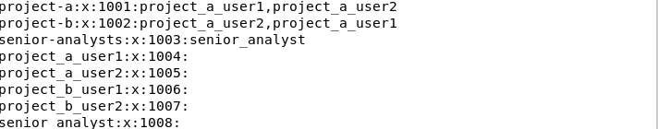

Step 4 — Create Project Directories
Create the shared project directories under /data/ and assign group ownership. The 2770 permission means: setgid (2) so new files inherit the group, owner+group have rwx (77), others have nothing (0):
sudo mkdir -p /data/project-a /data/project-b /data/senior-analysts

# Assign group ownership
sudo chown root:project-a /data/project-a
sudo chown root:project-b /data/project-b
sudo chown root:senior-analysts /data/senior-analysts

# chmod 2770: setgid + owner/group rwx + others none
sudo chmod 2770 /data/project-a
sudo chmod 2770 /data/project-b
sudo chmod 2770 /data/senior-analysts
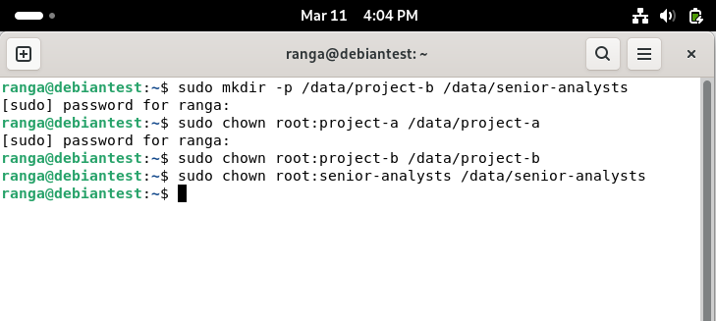

Permissions before applying ACLs
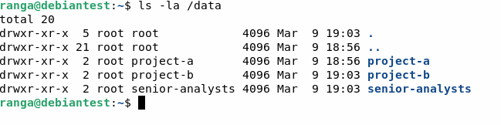

The above output left to right signifies: the first character (d) means it's a directory. The next 9 characters (rwxr-xr-x) are the permission bits split into three groups of three — owner permissions, group permissions, others permissions. Then comes the owner name (root) and group name (root).
So rwxr-xr-x means the owner has full read/write/execute, the group has read and execute only, and others also have read and execute. This tells you right away that before your changes, anyone on the system could read and enter these directories — which is exactly the problem ACLs will fix.
mount | grep /data : Command to check whether ACL is applied on the system

Step 5 — Apply ACLs
Now apply the ACL rules. There are two types: access ACLs (apply to existing directory) and default ACLs (apply to all new files/dirs created inside):
# Project-A: group has rwx, others have nothing
sudo setfacl -m g:project-a:rwx /data/project-a
sudo setfacl -m o::--- /data/project-a

# Default ACLs: new files inherit the same rules
sudo setfacl -d -m g:project-a:rwx /data/project-a
sudo setfacl -d -m o::--- /data/project-a

# Repeat for Project-B
sudo setfacl -m g:project-b:rwx /data/project-b
sudo setfacl -m o::--- /data/project-b
sudo setfacl -d -m g:project-b:rwx /data/project-b
sudo setfacl -d -m o::--- /data/project-b

Understanding the setfacl syntax first
The general format is:
setfacl [flags] -m [type]:[name]:[permissions] [target]
- -m means modify — add or update an ACL rule
- -d means default — the rule applies to new files created inside the directory
- The rule itself is type:name:permissions

Step 6 — Restrict Home Directories
Home directories must be accessible only by the owner. This prevents users from snooping on each other's personal files:
for user in project_a_user1 project_a_user2 project_b_user1 project_b_user2 senior_analyst; do
sudo chmod 700 /home/$user
sudo setfacl -m u:$user:rwx /home/$user
sudo setfacl -m g::--- /home/$user
sudo setfacl -m o::--- /home/$user
done

Step 7 — Verify ACL Configuration
Use getfacl to confirm the rules are applied correctly:
getfacl /data/project-a
# Expected output:
# file: data/project-a
# owner: root
# group: project-a
# flags: -s-
# user::rwx
# group::rwx
# group:project-a:rwx
# mask::rwx
# other::---
# default:group:project-a:rwx
# default:other::---

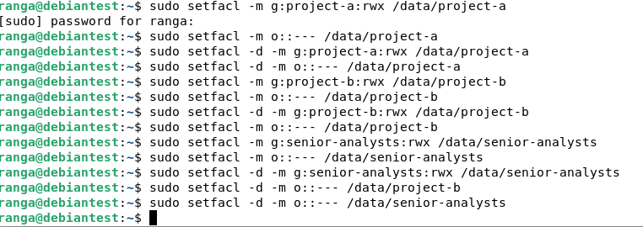
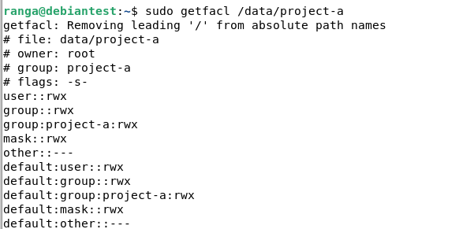
Note: screenshots were usernames and group names have changed, is because the original Debian system with storage of 20GB crashed during the process of setting up splunk forwarder to monitor real-time logs. So a new system was setup with 40GB storage space and manually logs were uploaded to splunk enterprise.
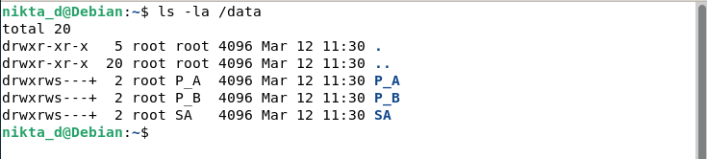

Task 2 — Command History (HISTSIZE) Configuration

Objective: Configure Bash command history so senior analysts retain only their last 10 commands, while all other users retain 50 commands. History is timestamped for forensic audit trails.

2.1 Why Different HISTSIZE Values?
Command history is a critical audit tool — it shows what actions a user took on the system. Senior analysts may have access to sensitive commands, so a smaller history window (10) limits exposure if their session is compromised. All other users retain 50 commands, enough for operational awareness and incident investigation.

User Group | HISTSIZE | Rationale
senior-analysts | 10 | Reduced exposure of privileged commands
project-a, project-b | 50 | Operational audit trail for investigations
All users | Timestamped | HISTTIMEFORMAT="%F %T " logs exact time of each command

2.2 Step-by-Step Instructions

Step 1 — Add HISTSIZE Settings to .bashrc
Edit each user's ~/.bashrc to set their history size. The following settings also improve audit quality:
# For senior_analyst (HISTSIZE=10)
sudo tee -a /home/senior_analyst/.bashrc << 'EOF'

# Security: Command History Policy
export HISTSIZE=10
export HISTFILESIZE=10
export HISTTIMEFORMAT="%F %T " # Timestamp every command
export HISTCONTROL=ignoredups:erasedups # No duplicate entries
shopt -s histappend # Append to history (never overwrite)
PROMPT_COMMAND="history -a; $PROMPT_COMMAND" # Write after each command
EOF

# For project users (HISTSIZE=50)
sudo tee -a /home/project_a_user1/.bashrc << 'EOF'
export HISTSIZE=50
export HISTFILESIZE=50
export HISTTIMEFORMAT="%F %T "
export HISTCONTROL=ignoredups:erasedups
shopt -s histappend
PROMPT_COMMAND="history -a; $PROMPT_COMMAND"
EOF

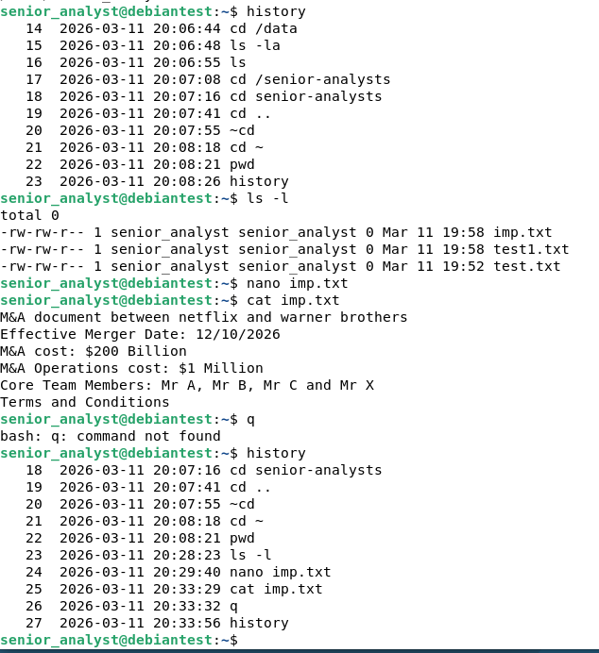

Step 2 — Create Global Fallback via profile.d
The /etc/profile.d/ directory contains scripts that run for every user at login. This provides a fallback and ensures HISTSIZE is enforced even for new users:
sudo tee /etc/profile.d/histsize_defaults.sh << 'EOF'
#!/bin/bash
# Enforce HISTSIZE policy based on group membership
if id -nG "$USER" | grep -qw "senior-analysts"; then
export HISTSIZE=10
export HISTFILESIZE=10
else
export HISTSIZE=50
export HISTFILESIZE=50
fi
export HISTTIMEFORMAT="%F %T "
export HISTCONTROL=ignoredups:erasedups
shopt -s histappend
EOF

sudo chmod +x /etc/profile.d/histsize_defaults.sh

Step 3 — Verify History Settings
# Check senior analyst sees HISTSIZE=10
sudo -u senior_analyst bash -c "source ~/.bashrc && echo HISTSIZE=$HISTSIZE"
# Expected: HISTSIZE=10

# Check project user sees HISTSIZE=50
sudo -u project_a_user1 bash -c "source ~/.bashrc && echo HISTSIZE=$HISTSIZE"
# Expected: HISTSIZE=50

# View timestamped history for a user
sudo -u project_a_user1 bash -c "history"
# Expected output: 1 2024-01-15 09:32:11 ls -la

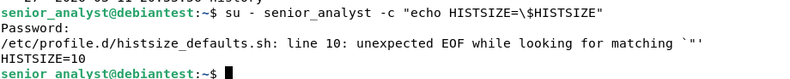

Task 3 — Syslog/Rsyslog Monitoring

Objective: Configuring Rsyslog to capture all unauthorized access attempts, authentication failures, ACL violations, and sudo misuse. Store logs securely for IT review and read in Splunk.

3.1 The Logging Architecture
Layer | Tool | Captures | Config File
Syslog | Rsyslog | Auth failures, SSH events, sudo violations | /etc/rsyslog.d/99-security-monitoring.conf

3.2 Step-by-Step Instructions

Step 1 — Install Required Packages
# Debian/Ubuntu
sudo apt-get install -y rsyslog

Step 2 — Create Secure Log Directory
All security logs are stored in a dedicated directory with restricted permissions. Only root can write; members of the adm group (IT staff) can read:
sudo mkdir -p /var/log/security
sudo chown root:adm /var/log/security
sudo chmod 750 /var/log/security # adm group can read, others cannot

# Create individual log files with correct permissions
for logfile in unauthorized_access auth_failures acl_violations sudo_violations file_access_denied security_events; do
sudo touch /var/log/security/${logfile}.log
sudo chown root:adm /var/log/security/${logfile}.log
sudo chmod 640 /var/log/security/${logfile}.log
done

Step 3 — Deploy Rsyslog Rules
Create the Rsyslog configuration file that routes security events to the appropriate log files. Rules are evaluated top-to-bottom.
# step1: Install required packages
sudo apt-get install -y rsyslog logrotate

# step2: Create secure log directory
# Create directory
sudo mkdir -p /var/log/security

# Set ownership
sudo chown root:adm /var/log/security

# Set permissions — adm group can read, others cannot
sudo chmod 750 /var/log/security

Rsyslog configuration file
sudo nano /etc/rsyslog.d/99-security-monitoring.conf
# Template for detailed log format
$template SecurityFormat,"%timegenerated% %HOSTNAME% %syslogtag%%msg:::sp-if-no-1st-sp%%msg:::drop-last-lf%\n"

# ── Rule 1: ACCESS VIOLATIONS ───────────────────────────────────
# Captures SSH failures, login failures, su failures
if ($syslogfacility-text == 'auth' and \
($msg contains 'Failed' or \
$msg contains 'FAILED' or \
$msg contains 'failure' or \
$msg contains 'Invalid user')) then \
/var/log/security/auth_failures.log;SecurityFormat

if ($syslogfacility-text == 'auth' and \
($msg contains 'Failed' or \
$msg contains 'FAILED' or \
$msg contains 'failure' or \
$msg contains 'Invalid user')) then \
/var/log/security/unauthorized_access.log;SecurityFormat

# ── Rule 2: SUDO VIOLATIONS ───────────────────────────────────
if ($msg contains 'NOT in sudoers' or \
$msg contains 'command not allowed') then \
/var/log/security/sudo_violations.log;SecurityFormat

if ($msg contains 'NOT in sudoers' or \
$msg contains 'command not allowed') then \
/var/log/security/unauthorized_access.log;SecurityFormat

# ── Rule 3: ACL AND PERMISSION VIOLATIONS ─────────────────────
if ($syslogfacility-text == 'kern' and \
($msg contains 'Permission denied' or \
$msg contains 'Operation not permitted')) then \
/var/log/security/acl_violations.log;SecurityFormat

if ($syslogfacility-text == 'kern' and \
($msg contains 'Permission denied' or \
$msg contains 'Operation not permitted')) then \
/var/log/security/unauthorized_access.log;SecurityFormat

# ── Rule 4: SSH EVENTS ────────────────────────────────────────
if ($programname == 'sshd') then \
/var/log/security/auth_failures.log;SecurityFormat

if ($programname == 'sshd') then \
/var/log/security/unauthorized_access.log;SecurityFormat

Validating the Rsyslog configuration
# — Validate Rsyslog configuration
# Test for syntax errors
sudo rsyslogd -N1

# Expected output
# rsyslogd: version 8.x, config validation run
# rsyslogd: End of config validation run. Bye.
________________________________________
# — Restart Rsyslog
sudo systemctl restart rsyslog
sudo systemctl enable rsyslog

# Verify it is running
sudo systemctl status rsyslog
________________________________________
# — Test the configuration
# Generate test auth failure
su - wronguser

# Generate test sudo violation
sudo -u project_a_user1 bash -c "sudo cat /etc/shadow"

# Generate test ACL violation
sudo -u project_b_user1 bash -c "ls /data/project-a"

# Wait a few seconds then check logs
sudo tail /var/log/security/unauthorized_access.log
sudo tail /var/log/security/auth_failures.log
sudo tail /var/log/security/acl_violations.log
________________________________________
Step 11 — Verify log permissions are secure
ls -la /var/log/security/

Step 11 — Verify log permissions are secure
ls -la /var/log/security/
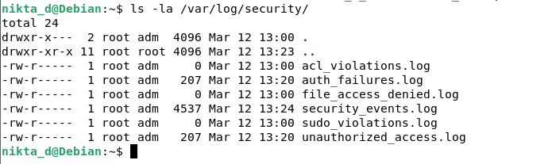
Code for capturing ACL logs
# Capture using ISO date format
sudo grep "$(date '+%Y-%m-%d')" /var/log/syslog | \
grep -iE "failed|denied" | \
sudo tee -a /var/log/security/acl_violations.log

Step 5 — Configure Log Rotation
Prevent logs from filling the disk (size limit per day 1GB) with 90-day daily rotation:
sudo tee /etc/logrotate.d/security-logs << 'ROTATE'
# =============================================================
# Security Log Rotation — 1GB Maximum File Size
# =============================================================
/var/log/security/*.log {

# Also rotate daily regardless of size
Daily

# Rotate when file reaches 1GB
size 1G

# Keep 90 days of rotated logs
rotate 90

# Compress old logs to save space
compress

# Keep most recent rotated file uncompressed
delaycompress

# Do not error if file missing
missingok

# Do not rotate empty files
notifempty

# Create new log file with correct permissions after rotation
create 640 root adm
}

VERIFY | Trigger a test event: sudo -u project_b_user1 cat /data/project-a/test.txt — then check that an entry appears in /var/log/security/acl_violations.log within seconds.

Task 4 — Security Web Dashboard

Objective: Provide IT teams with a Splunk-style dashboard to monitor security violations, visualize event trends, and review the audit trail — all from a browser. Logs were manually loaded into the splunk enterprise.
Note: Real-time monitoring of logs in a VM environment using splunk forwarder was attempted, but the system crashed due to low storage space (20GB)
Panel | Data Source | What IT Teams See
Violation Bar Chart | Acl_violations | Names of messages provided by sys logs by count
24h Timeline Chart | Auth_failures | Event volume over time with peak attack windows highlighted in red

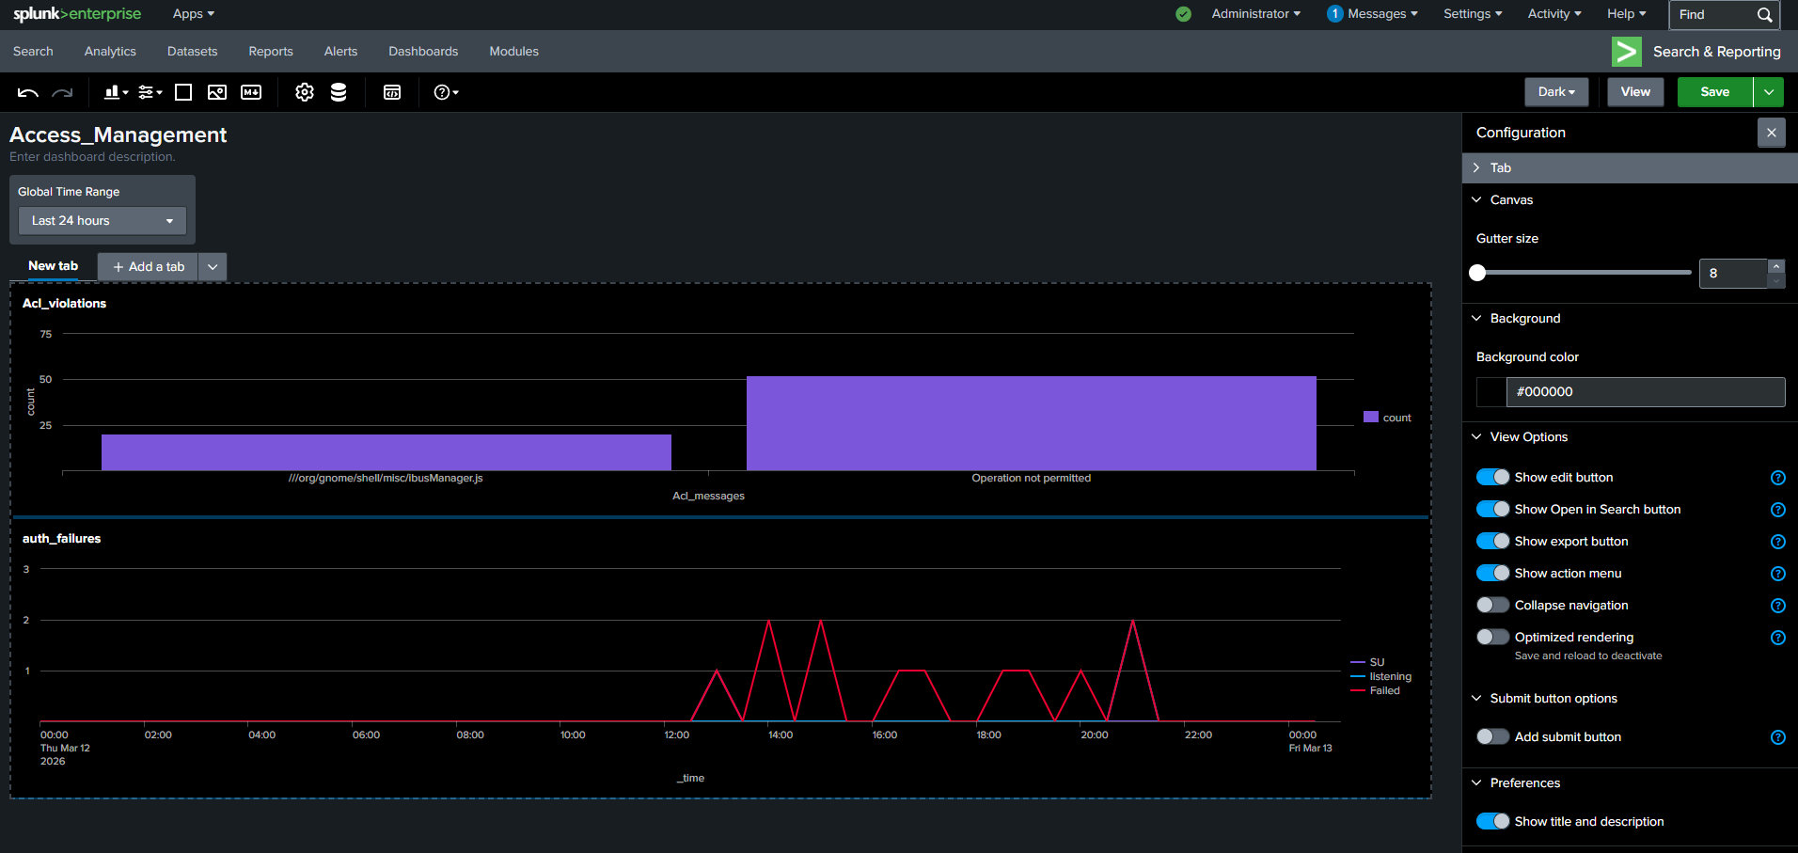

Task 5 — Persistent Security Settings

Objective: Ensure all security controls automatically re-activate after every system reboot using a systemd service, persistent sysctl parameters, and an hourly ACL drift detection cron job.
Mechanism | Handles | Executes
systemd service | ACL re-application, service restart checks, /tmp hardening | At every boot via multi-user.target
/etc/fstab | Secure /tmp mount (noexec, nosuid, nodev) | At every boot during filesystem mount

Step 1 — Create the Boot Enforcement Script
This script re-applies all security settings at boot. It lives at /usr/local/sbin/enforce_security.sh and is called by the systemd service:
sudo tee /usr/local/sbin/enforce_security.sh << 'SCRIPT'
#!/bin/bash
BOOT_LOG="/var/log/security/boot_enforcement.log"
TIMESTAMP=$(date '+%Y-%m-%d %H:%M:%S')

# Re-apply ACLs on all project directories
for dir in /data/project-a /data/project-b /data/senior-analysts; do
group=$(basename "$dir")
chmod 2770 "$dir" && chmod o-rwx "$dir"
setfacl -m g:"$group":rwx "$dir"
setfacl -m o::--- "$dir"
echo "[$TIMESTAMP] ACL re-applied: $dir" >> "$BOOT_LOG"
done

SCRIPT

sudo chmod 700 /usr/local/sbin/enforce_security.sh
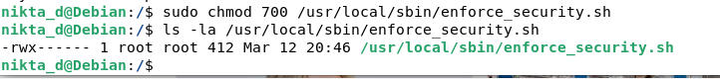
Enforcement logs after system was re-booted
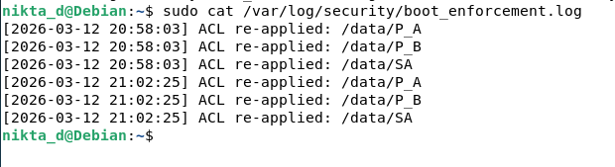

Step 2 — Create the systemd Service
The service uses Type=oneshot (runs once at boot) and RemainAfterExit=yes (stays "active" so systemctl status shows it ran successfully):
sudo tee /etc/systemd/system/security-hardening.service << 'SVC'
[Unit]
Description=Security Hardening Enforcement
After= rsyslog.service
Wants= rsyslog.service

[Service]
Type=oneshot
ExecStart=/usr/local/sbin/enforce_security.sh
RemainAfterExit=yes
User=root

[Install]
WantedBy=multi-user.target
SVC

# Enable service to start at every boot
sudo systemctl daemon-reload
sudo systemctl enable security-hardening.service
sudo systemctl start security-hardening.service
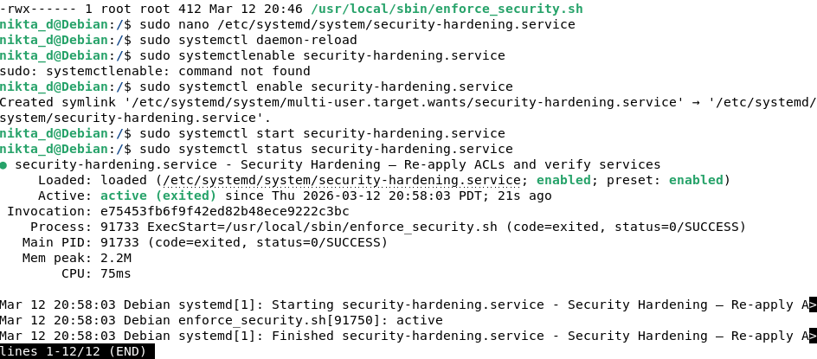

After re-boot the security permissions exists:
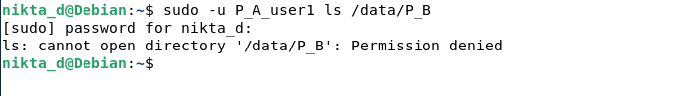
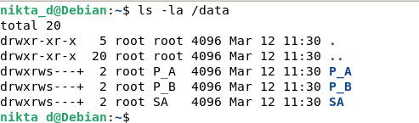

Key File Locations
File/Directory | Purpose
/var/log/security/ | All security event logs (640 root:adm)
/etc/rsyslog.d/99-security-monitoring.conf | Rsyslog routing rules
/etc/audit/rules.d/security-acl.rules | Auditd kernel monitoring rules (immutable)
/usr/local/sbin/enforce_security.sh | Boot enforcement script
/etc/systemd/system/security-hardening.service | Systemd persistence service
/etc/sysctl.d/99-security-hardening.conf | Persistent kernel security params
/etc/splunk-inputs/security_inputs.conf | Splunk Universal Forwarder config
/etc/profile.d/histsize_defaults.sh | Global HISTSIZE policy
/etc/cron.hourly/verify_security | Hourly ACL drift detection

