Пензенский государственный университет

Факультет вычислительной техники

Кафедра «Вычислительная техника»

Отчет о лабораторной работе № 3

по дисциплине «Программирование на языке JAVA»

Вариант № 7

Выполнили: ст-ты гр. 20ВВП2

Педай Н.Д.

Мальков И.А.

Проверили:

Юрова О.В.

Карамышева Н.С.

2022

**Цель работы:** изучить механизм обработки исключительных ситуаций.

**Задание на лабораторную работу:** модифицировать приложение из предыдущей лабораторной работы, реализовав проверку вводимых данных с использованием механизма исключений. Необходимо создать свой класс, унаследованный от класса Exception, и генерировать исключение, если возникает попытка создать экземпляр класса RecIntegral со значениями, не являющимися числами в диапазоне от 0,000001 до 1000000. В качестве обработки исключения необходимо выводить диалог, содержащий предупреждение о некорректности введенных данных. Оформление лабораторной работы должно быть выполнено в соответствии с требованиями, приведенными в Приложении 2.

Вариант:

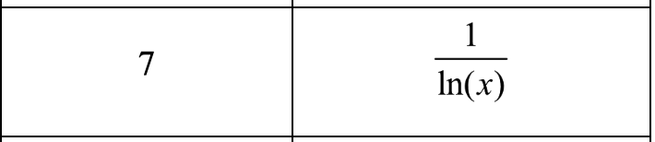

**Решение:**

**Ошибка – значение в числителе больше минимального численного предела (**0,000001):

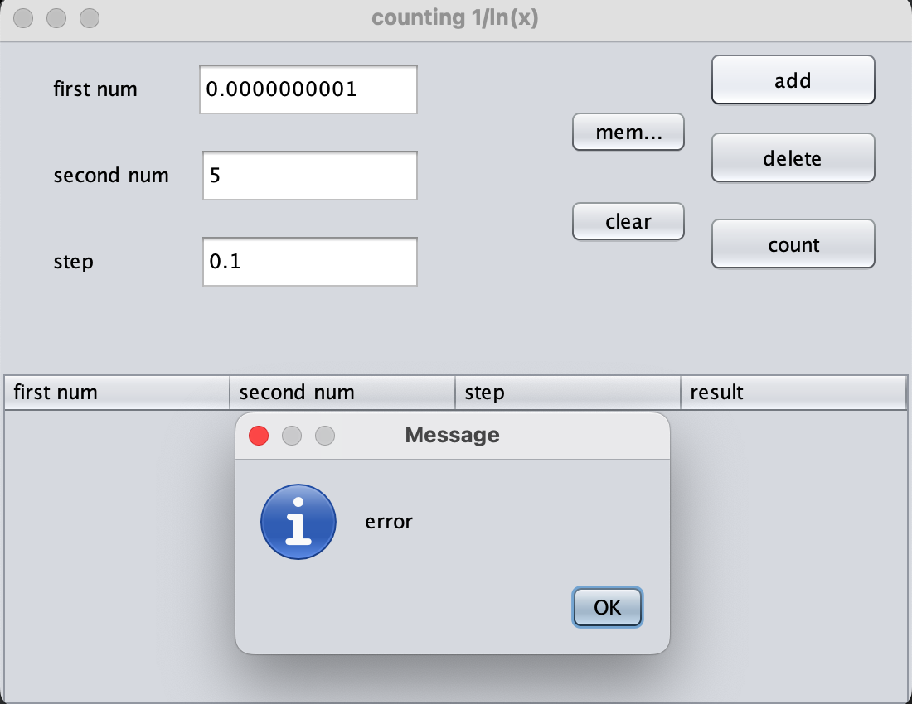

**Ошибка – значение в числителе больше максимального численного предела (**1000000):

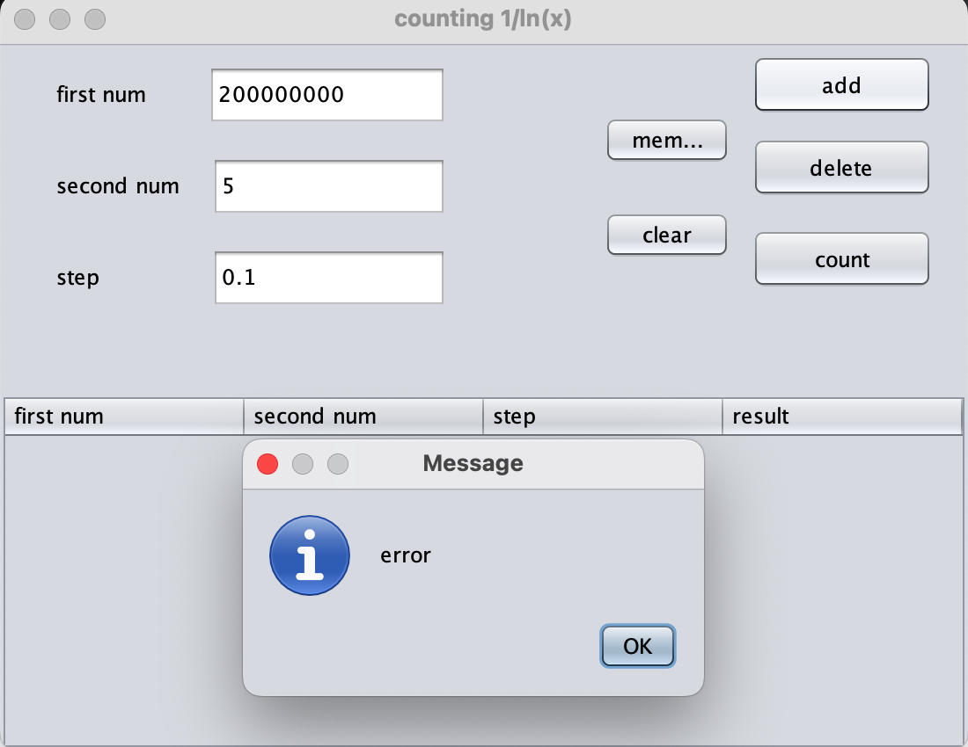

**Листинг**

import javax.swing.table.DefaultTableModel;  
import java.io.IOException;  
import java.util.ArrayList;  
import java.util.Vector;  
  
import static javax.swing.JOptionPane.*showMessageDialog*;  
  
/*  
 * To change this license header, choose License Headers in Project Properties.  
 * To change this template file, choose Tools | Templates  
 * and open the template in the editor.  
 */  
  
*/**  
 \** ***@author*** *student  
 */*class Main extends javax.swing.JFrame {  
  
 */**  
 * Creates new form NewJFrame  
 */* //CollectionList OurCollection = new CollectionList();  
 ArrayList<RecIntegral> OurArray = new ArrayList();  
 // Variables declaration - do not modify  
 private javax.swing.JButton AddButton;  
 private javax.swing.JButton CalculateButton;  
 private javax.swing.JButton ClearButton;  
 private javax.swing.JButton DeleteButton;  
 private javax.swing.JTextField LowerThreshold;  
 private javax.swing.JTable MainTable;  
 private javax.swing.JButton ReadButton;  
 private javax.swing.JTextField Step;  
 private javax.swing.JTextField UpperThreshold;  
 private javax.swing.JScrollPane jScrollPane1;  
 private javax.swing.JScrollPane jScrollPane2;  
 private javax.swing.JScrollPane jScrollPane3;  
 private javax.swing.JTable jTable1;  
 private javax.swing.JTable jTable2;  
  
 public Main() {  
  
 initComponents();  
 }  
  
 */**  
 \** ***@param*** *args the command line arguments  
 */* public static void main(String[] args) {  
 /* Set the Nimbus look and feel */  
 //<editor-fold defaultstate="collapsed" desc=" Look and feel setting code (optional) ">  
 /* If Nimbus (introduced in Java SE 6) is not available, stay with the default look and feel.  
 * For details see http://download.oracle.com/javase/tutorial/uiswing/lookandfeel/plaf.html  
 */  
 try {  
 for (javax.swing.UIManager.LookAndFeelInfo info : javax.swing.UIManager.*getInstalledLookAndFeels*()) {  
 if ("Nimbus".equals(info.getName())) {  
 javax.swing.UIManager.*setLookAndFeel*(info.getClassName());  
 break;  
 }  
 }  
 } catch (ClassNotFoundException ex) {  
 java.util.logging.Logger.*getLogger*(Main.class.getName()).log(java.util.logging.Level.*SEVERE*, null, ex);  
 } catch (InstantiationException ex) {  
 java.util.logging.Logger.*getLogger*(Main.class.getName()).log(java.util.logging.Level.*SEVERE*, null, ex);  
 } catch (IllegalAccessException ex) {  
 java.util.logging.Logger.*getLogger*(Main.class.getName()).log(java.util.logging.Level.*SEVERE*, null, ex);  
 } catch (javax.swing.UnsupportedLookAndFeelException ex) {  
 java.util.logging.Logger.*getLogger*(Main.class.getName()).log(java.util.logging.Level.*SEVERE*, null, ex);  
 }  
 //</editor-fold>  
  
 /* Create and display the form */  
 java.awt.EventQueue.*invokeLater*(new Runnable() {  
 public void run() {  
 new Main().setVisible(true);  
 }  
 });  
 }  
  
 */**  
 * This method is called from within the constructor to initialize the form.  
 * WARNING: Do NOT modify this code. The content of this method is always  
 * regenerated by the Form Editor.  
 */* @SuppressWarnings("unchecked")  
 // <editor-fold defaultstate="collapsed" desc="Generated Code">  
 private void initComponents() {  
  
 jScrollPane1 = new javax.swing.JScrollPane();  
 jTable1 = new javax.swing.JTable();  
 jScrollPane2 = new javax.swing.JScrollPane();  
 jTable2 = new javax.swing.JTable();  
 javax.swing.JPanel jPanel1 = new javax.swing.JPanel();  
 AddButton = new javax.swing.JButton();  
 DeleteButton = new javax.swing.JButton();  
 CalculateButton = new javax.swing.JButton();  
 ReadButton = new javax.swing.JButton();  
 ClearButton = new javax.swing.JButton();  
 javax.swing.JPanel jPanel2 = new javax.swing.JPanel();  
 UpperThreshold = new javax.swing.JTextField();  
 javax.swing.JLabel jLabel3 = new javax.swing.JLabel();  
 javax.swing.JLabel jLabel1 = new javax.swing.JLabel();  
 LowerThreshold = new javax.swing.JTextField();  
 javax.swing.JLabel jLabel2 = new javax.swing.JLabel();  
 Step = new javax.swing.JTextField();  
 javax.swing.JPanel jPanel3 = new javax.swing.JPanel();  
 jScrollPane3 = new javax.swing.JScrollPane();  
 MainTable = new javax.swing.JTable();  
  
 jTable1.setModel(new javax.swing.table.DefaultTableModel(  
 new Object[][]{  
 {null, null, null, null},  
 {null, null, null, null},  
 {null, null, null, null},  
 {null, null, null, null}  
 },  
 new String[]{  
 "Title 1", "Title 2", "Title 3", "Title 4"  
 }  
 ));  
 jScrollPane1.setViewportView(jTable1);  
  
 jTable2.setModel(new javax.swing.table.DefaultTableModel(  
 new Object[][]{  
 {null, null, null, null},  
 {null, null, null, null},  
 {null, null, null, null},  
 {null, null, null, null}  
 },  
 new String[]{  
 "Title 1", "Title 2", "Title 3", "Title 4"  
 }  
 ));  
 jScrollPane2.setViewportView(jTable2);  
  
 setDefaultCloseOperation(javax.swing.WindowConstants.*EXIT_ON_CLOSE*);  
 setTitle("counting 1/ln(x)");  
 setPreferredSize(new java.awt.Dimension(550, 430));  
  
 AddButton.setText("add");  
 AddButton.addMouseListener(new java.awt.event.MouseAdapter() {  
 public void mouseClicked(java.awt.event.MouseEvent evt) {  
 AddButtonMouseClicked(evt);  
 }  
 });  
 AddButton.addActionListener(new java.awt.event.ActionListener() {  
 public void actionPerformed(java.awt.event.ActionEvent evt) {  
 AddButtonActionPerformed(evt);  
 }  
 });  
  
 DeleteButton.setText("delete");  
 DeleteButton.addActionListener(new java.awt.event.ActionListener() {  
 public void actionPerformed(java.awt.event.ActionEvent evt) {  
 DeleteButtonActionPerformed(evt);  
 }  
 });  
  
 CalculateButton.setText("count");  
 CalculateButton.addActionListener(new java.awt.event.ActionListener() {  
 public void actionPerformed(java.awt.event.ActionEvent evt) {  
 CalculateButtonActionPerformed(evt);  
 }  
 });  
  
 ReadButton.setText("memory");  
 ReadButton.addActionListener(new java.awt.event.ActionListener() {  
 public void actionPerformed(java.awt.event.ActionEvent evt) {  
 ReadButtonActionPerformed(evt);  
 }  
 });  
  
 ClearButton.setText("clear");  
 ClearButton.addActionListener(new java.awt.event.ActionListener() {  
 public void actionPerformed(java.awt.event.ActionEvent evt) {  
 ClearButtonActionPerformed(evt);  
 }  
 });  
  
 javax.swing.GroupLayout jPanel1Layout = new javax.swing.GroupLayout(jPanel1);  
 jPanel1.setLayout(jPanel1Layout);  
 jPanel1Layout.setHorizontalGroup(  
 jPanel1Layout.createParallelGroup(javax.swing.GroupLayout.Alignment.*LEADING*)  
 .addGroup(javax.swing.GroupLayout.Alignment.*TRAILING*, jPanel1Layout.createSequentialGroup()  
 .addContainerGap(73, Short.*MAX_VALUE*)  
 .addGroup(jPanel1Layout.createParallelGroup(javax.swing.GroupLayout.Alignment.*TRAILING*, false)  
 .addGroup(jPanel1Layout.createSequentialGroup()  
 .addComponent(ClearButton, javax.swing.GroupLayout.*DEFAULT_SIZE*, javax.swing.GroupLayout.*DEFAULT_SIZE*, Short.*MAX_VALUE*)  
 .addPreferredGap(javax.swing.LayoutStyle.ComponentPlacement.*UNRELATED*)  
 .addComponent(CalculateButton, javax.swing.GroupLayout.*PREFERRED_SIZE*, 103, javax.swing.GroupLayout.*PREFERRED_SIZE*))  
 .addGroup(jPanel1Layout.createSequentialGroup()  
 .addComponent(ReadButton, javax.swing.GroupLayout.*PREFERRED_SIZE*, 72, javax.swing.GroupLayout.*PREFERRED_SIZE*)  
 .addPreferredGap(javax.swing.LayoutStyle.ComponentPlacement.*UNRELATED*)  
 .addGroup(jPanel1Layout.createParallelGroup(javax.swing.GroupLayout.Alignment.*LEADING*)  
 .addComponent(AddButton, javax.swing.GroupLayout.Alignment.*TRAILING*, javax.swing.GroupLayout.*PREFERRED_SIZE*, 103, javax.swing.GroupLayout.*PREFERRED_SIZE*)  
 .addComponent(DeleteButton, javax.swing.GroupLayout.Alignment.*TRAILING*, javax.swing.GroupLayout.*PREFERRED_SIZE*, 103, javax.swing.GroupLayout.*PREFERRED_SIZE*))))  
 .addGap(20, 20, 20))  
 );  
 jPanel1Layout.setVerticalGroup(  
 jPanel1Layout.createParallelGroup(javax.swing.GroupLayout.Alignment.*LEADING*)  
 .addGroup(jPanel1Layout.createSequentialGroup()  
 .addGroup(jPanel1Layout.createParallelGroup(javax.swing.GroupLayout.Alignment.*LEADING*)  
 .addGroup(jPanel1Layout.createSequentialGroup()  
 .addContainerGap()  
 .addComponent(AddButton, javax.swing.GroupLayout.*PREFERRED_SIZE*, 34, javax.swing.GroupLayout.*PREFERRED_SIZE*)  
 .addGap(13, 13, 13)  
 .addComponent(DeleteButton, javax.swing.GroupLayout.*PREFERRED_SIZE*, 34, javax.swing.GroupLayout.*PREFERRED_SIZE*)  
 .addGap(18, 18, 18)  
 .addComponent(CalculateButton, javax.swing.GroupLayout.*PREFERRED_SIZE*, 34, javax.swing.GroupLayout.*PREFERRED_SIZE*))  
 .addGroup(jPanel1Layout.createSequentialGroup()  
 .addGap(41, 41, 41)  
 .addComponent(ReadButton)  
 .addGap(27, 27, 27)  
 .addComponent(ClearButton)))  
 .addContainerGap(javax.swing.GroupLayout.*DEFAULT_SIZE*, Short.*MAX_VALUE*))  
 );  
  
 UpperThreshold.addActionListener(new java.awt.event.ActionListener() {  
 public void actionPerformed(java.awt.event.ActionEvent evt) {  
 UpperThresholdActionPerformed(evt);  
 }  
 });  
  
 jLabel3.setText("step");  
  
 jLabel1.setText("first num");  
  
 LowerThreshold.addActionListener(new java.awt.event.ActionListener() {  
 public void actionPerformed(java.awt.event.ActionEvent evt) {  
 LowerThresholdActionPerformed(evt);  
 }  
 });  
  
 jLabel2.setText("second num");  
  
 Step.addActionListener(new java.awt.event.ActionListener() {  
 public void actionPerformed(java.awt.event.ActionEvent evt) {  
 StepActionPerformed(evt);  
 }  
 });  
  
 javax.swing.GroupLayout jPanel2Layout = new javax.swing.GroupLayout(jPanel2);  
 jPanel2.setLayout(jPanel2Layout);  
 jPanel2Layout.setHorizontalGroup(  
 jPanel2Layout.createParallelGroup(javax.swing.GroupLayout.Alignment.*LEADING*)  
 .addGroup(javax.swing.GroupLayout.Alignment.*TRAILING*, jPanel2Layout.createSequentialGroup()  
 .addGap(32, 32, 32)  
 .addGroup(jPanel2Layout.createParallelGroup(javax.swing.GroupLayout.Alignment.*LEADING*)  
 .addComponent(jLabel2)  
 .addComponent(jLabel3)  
 .addComponent(jLabel1))  
 .addGroup(jPanel2Layout.createParallelGroup(javax.swing.GroupLayout.Alignment.*LEADING*)  
 .addGroup(jPanel2Layout.createSequentialGroup()  
 .addGap(18, 18, 18)  
 .addComponent(LowerThreshold, javax.swing.GroupLayout.*DEFAULT_SIZE*, 134, Short.*MAX_VALUE*))  
 .addGroup(jPanel2Layout.createSequentialGroup()  
 .addGap(16, 16, 16)  
 .addComponent(UpperThreshold))  
 .addGroup(jPanel2Layout.createSequentialGroup()  
 .addGap(18, 18, 18)  
 .addComponent(Step)))  
 .addGap(48, 48, 48))  
 );  
 jPanel2Layout.setVerticalGroup(  
 jPanel2Layout.createParallelGroup(javax.swing.GroupLayout.Alignment.*LEADING*)  
 .addGroup(jPanel2Layout.createSequentialGroup()  
 .addGap(12, 12, 12)  
 .addGroup(jPanel2Layout.createParallelGroup(javax.swing.GroupLayout.Alignment.*BASELINE*)  
 .addComponent(UpperThreshold, javax.swing.GroupLayout.*PREFERRED_SIZE*, 34, javax.swing.GroupLayout.*PREFERRED_SIZE*)  
 .addComponent(jLabel1))  
 .addGap(18, 18, 18)  
 .addGroup(jPanel2Layout.createParallelGroup(javax.swing.GroupLayout.Alignment.*BASELINE*)  
 .addComponent(jLabel2)  
 .addComponent(LowerThreshold, javax.swing.GroupLayout.*PREFERRED_SIZE*, 34, javax.swing.GroupLayout.*PREFERRED_SIZE*))  
 .addGap(18, 18, 18)  
 .addGroup(jPanel2Layout.createParallelGroup(javax.swing.GroupLayout.Alignment.*BASELINE*)  
 .addComponent(Step, javax.swing.GroupLayout.*PREFERRED_SIZE*, 34, javax.swing.GroupLayout.*PREFERRED_SIZE*)  
 .addComponent(jLabel3))  
 .addContainerGap(43, Short.*MAX_VALUE*))  
 );  
  
 MainTable.setModel(new javax.swing.table.DefaultTableModel(  
 new Object[][]{  
  
 },  
 new String[]{  
 "first num", "second num", "step", "result"  
 }  
 ) {  
 final Class[] types = new Class[]{  
 java.lang.Integer.class, java.lang.Integer.class, java.lang.Float.class, java.lang.Double.class  
 };  
 final boolean[] canEdit = new boolean[]{  
 true, true, true, false  
 };  
  
 public Class getColumnClass(int columnIndex) {  
 return types[columnIndex];  
 }  
  
 public boolean isCellEditable(int rowIndex, int columnIndex) {  
 return canEdit[columnIndex];  
 }  
 });  
 MainTable.getTableHeader().setReorderingAllowed(false);  
 jScrollPane3.setViewportView(MainTable);  
 if (MainTable.getColumnModel().getColumnCount() > 0) {  
 MainTable.getColumnModel().getColumn(0).setResizable(false);  
 MainTable.getColumnModel().getColumn(1).setResizable(false);  
 MainTable.getColumnModel().getColumn(2).setResizable(false);  
 MainTable.getColumnModel().getColumn(3).setResizable(false);  
 }  
  
 javax.swing.GroupLayout jPanel3Layout = new javax.swing.GroupLayout(jPanel3);  
 jPanel3.setLayout(jPanel3Layout);  
 jPanel3Layout.setHorizontalGroup(  
 jPanel3Layout.createParallelGroup(javax.swing.GroupLayout.Alignment.*LEADING*)  
 .addComponent(jScrollPane3)  
 );  
 jPanel3Layout.setVerticalGroup(  
 jPanel3Layout.createParallelGroup(javax.swing.GroupLayout.Alignment.*LEADING*)  
 .addComponent(jScrollPane3, javax.swing.GroupLayout.*DEFAULT_SIZE*, 233, Short.*MAX_VALUE*)  
 );  
  
 javax.swing.GroupLayout layout = new javax.swing.GroupLayout(getContentPane());  
 getContentPane().setLayout(layout);  
 layout.setHorizontalGroup(  
 layout.createParallelGroup(javax.swing.GroupLayout.Alignment.*LEADING*)  
 .addGroup(layout.createSequentialGroup()  
 .addComponent(jPanel2, javax.swing.GroupLayout.*PREFERRED_SIZE*, javax.swing.GroupLayout.*DEFAULT_SIZE*, javax.swing.GroupLayout.*PREFERRED_SIZE*)  
 .addPreferredGap(javax.swing.LayoutStyle.ComponentPlacement.*RELATED*)  
 .addComponent(jPanel1, javax.swing.GroupLayout.*DEFAULT_SIZE*, javax.swing.GroupLayout.*DEFAULT_SIZE*, Short.*MAX_VALUE*))  
 .addComponent(jPanel3, javax.swing.GroupLayout.*DEFAULT_SIZE*, javax.swing.GroupLayout.*DEFAULT_SIZE*, Short.*MAX_VALUE*)  
 );  
 layout.setVerticalGroup(  
 layout.createParallelGroup(javax.swing.GroupLayout.Alignment.*LEADING*)  
 .addGroup(layout.createSequentialGroup()  
 .addGroup(layout.createParallelGroup(javax.swing.GroupLayout.Alignment.*LEADING*, false)  
 .addComponent(jPanel1, javax.swing.GroupLayout.*DEFAULT_SIZE*, javax.swing.GroupLayout.*DEFAULT_SIZE*, Short.*MAX_VALUE*)  
 .addComponent(jPanel2, javax.swing.GroupLayout.*DEFAULT_SIZE*, javax.swing.GroupLayout.*DEFAULT_SIZE*, Short.*MAX_VALUE*))  
 .addPreferredGap(javax.swing.LayoutStyle.ComponentPlacement.*RELATED*)  
 .addComponent(jPanel3, javax.swing.GroupLayout.*DEFAULT_SIZE*, javax.swing.GroupLayout.*DEFAULT_SIZE*, Short.*MAX_VALUE*))  
 );  
  
 pack();  
 }// </editor-fold>  
  
 private void StepActionPerformed(java.awt.event.ActionEvent evt) {  
 // *TODO add your handling code here:* }  
  
 private void LowerThresholdActionPerformed(java.awt.event.ActionEvent evt) {  
 // *TODO add your handling code here:* }  
  
 private void UpperThresholdActionPerformed(java.awt.event.ActionEvent evt) {  
 // *TODO add your handling code here:* }  
  
 private void CalculateButtonActionPerformed(java.awt.event.ActionEvent evt) {  
 // *TODO add your handling code here:* DefaultTableModel module = (DefaultTableModel) MainTable.getModel();  
 FunctionIntegral funk = new FunctionIntegral();  
 Vector data = module.getDataVector();  
 for (int i = 0; i < data.size(); i++) {  
 Vector CurrentData = (Vector) data.get(i);  
 int j;  
 double result = 0;  
 int n = (int) (((int) CurrentData.get(1) - (int) CurrentData.get(0)) / (float) CurrentData.get(2));  
 for (j = 1; j <= n; j++)  
 result += funk.f((int) CurrentData.get(0) + j * (float) CurrentData.get(2)) * (float) CurrentData.get(2);  
  
 if (n * (float) CurrentData.get(2) < (int) CurrentData.get(1) - (int) CurrentData.get(0)) {  
 float newstep = ((int) CurrentData.get(1) - (int) CurrentData.get(0)) - n * (float) CurrentData.get(2);  
 result += funk.f((int) CurrentData.get(1) + newstep);  
 }  
 module.setValueAt(result, i, 3);  
  
 }  
 }  
  
 private void DeleteButtonActionPerformed(java.awt.event.ActionEvent evt) {  
 DefaultTableModel module = (DefaultTableModel) MainTable.getModel();  
 int SelectedRow = MainTable.getSelectedRow();  
 if (MainTable.getRowCount() != 0) {  
 if (SelectedRow == -1)  
 module.removeRow(MainTable.getRowCount() - 1);  
 else  
 module.removeRow(MainTable.getSelectedRow());  
 }  
 }  
  
 public class Exc extends Exception{  
 Exc(String text){  
 super(text);  
 }  
 }  
 private void AddButtonActionPerformed(java.awt.event.ActionEvent evt) {  
 // *TODO add your handling code here:* DefaultTableModel module = (DefaultTableModel) MainTable.getModel();  
 String a = null;  
 String b = null;  
 String c = null;  
 try{  
 a = UpperThreshold.getText();  
 b = LowerThreshold.getText();  
 c = Step.getText();  
  
 if ("".equals(a) || "".equals(b) || "".equals(c)){  
 throw new Exc("empty field");  
 } else if ("0".equals(a) || "0".equals(b) || "0".equals(c)) {  
 throw new Exc("error");  
 } else if (Float.*parseFloat*(a) > Float.*parseFloat*(b)){  
 throw new Exc("error");  
 } else if (Float.*parseFloat*(c) > (Float.*parseFloat*(b) - Float.*parseFloat*(a))) {  
 throw new Exc("error");  
 } else if (Float.*parseFloat*(a) > 1000000 || Float.*parseFloat*(b) > 1000000) {  
 throw new Exc("error");  
 }  
 RecIntegral Node = new RecIntegral();  
 Node.addNode(Integer.*parseInt*(a), Integer.*parseInt*(b), Float.*parseFloat*(c));  
 module.addRow(new Object[]{Integer.*parseInt*(a), Integer.*parseInt*(b), Float.*parseFloat*(c), null});  
 OurArray.add(Node);  
  
 } catch (Exception e){  
 *showMessageDialog*(null, e.getMessage());  
 }  
  
  
  
 }  
  
 private void AddButtonMouseClicked(java.awt.event.MouseEvent evt) {  
  
 }  
  
 private void ClearButtonActionPerformed(java.awt.event.ActionEvent evt) {  
 DefaultTableModel module = (DefaultTableModel) MainTable.getModel();  
 while (MainTable.getRowCount() != 0)  
 module.removeRow(MainTable.getRowCount() - 1);  
 }  
  
 private void ReadButtonActionPerformed(java.awt.event.ActionEvent evt) {  
 DefaultTableModel module = (DefaultTableModel) MainTable.getModel();  
 for (int i = 0; i < OurArray.size(); i++) {  
 RecIntegral Node = OurArray.get(i);  
 module.addRow(new Object[]{Node.Top, Node.Lower, Node.Step, null});  
 }  
  
 }  
  
 class FunctionIntegral {  
 // {Функция, площадь которой нужно вычислить}  
 public double f(double x) {  
 double F = 1 / Math.*log*(x);  
 return F;  
  
 }  
 }  
  
 class RecIntegral {  
 public int Lower, Top;  
 public float Step;  
  
 public void addNode(int top, int lower, float c) {  
 Step = c;  
 Lower = lower;  
 Top = top;  
 }  
 }  
  
 class CollectionList {  
 public ArrayList collectionarray;  
  
 public void addNewNode(Object element) {  
 collectionarray.add(element);  
 }  
 }  
 // End of variables declaration  
}

**Вывод:** в ходе лабораторной работы мы изучили механизм обработки исключительных ситуаций (если возникает попытка создать экземпляр класса RecIntegral со значениями, не являющимися числами в диапазоне от 0,000001 до 1000000).