SQL Real Steel

## Round 1 – ‘Kid’ mode

Write DML queries for the following questions

1. Display unique Jobs from EMP table

ANS: Select distinct job from scott.emp;

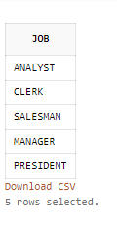

1. List the employees in the ascending order of their salaries

ANS : Select * from scott.emp order by sal ASC;

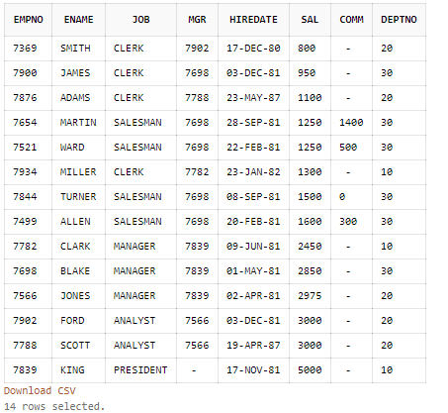

1. List the details of the employees in ascending order of the dept no and descending of Jobs

ANS : Select * from scott.emp order by deptno asc,job DESC;

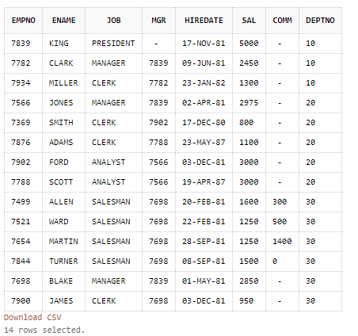

1. Display all the unique job groups in the descending order

ANS : Select distinct job from scott.emp order by job DESC;

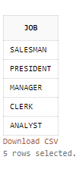

1. Display all the employees who are managers

ANS: Select * from scott.emp where empno in ( select mgr from scott.emp) ;

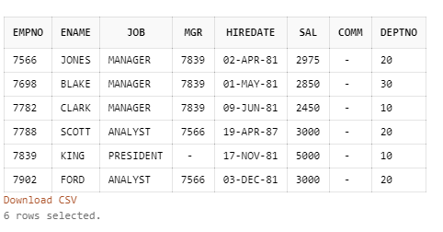

1. List the employees who joined before 1981

ANS : Select * from scott.emp where hiredate<('01-JAN-1981');

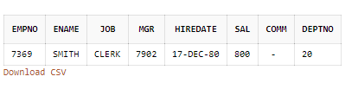

1. List the Empno, Ename, Sal, daily sal of all employees in the ascending order of annual sal

ANS: select empno,ename,sal,sal/30 m_sal,12*sal a_sal from scott.emp order by a_sal asc;

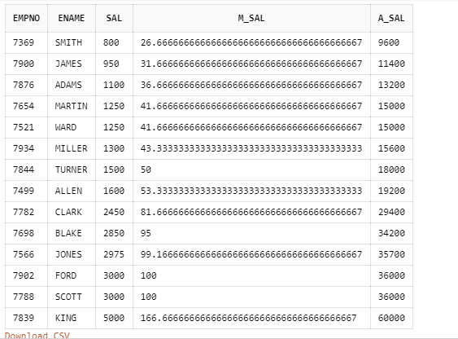

1. Display the Empno, Ename, job, Hiredate, Exp of all Mgrs

Ans: SELECT EMPNO,ENAME,JOB,HIREDATE,MONTHS_BETWEEN(SYSDATE,HIREDATE)/12 EXP FROM scott.emp WHERE job= 'MANAGER';

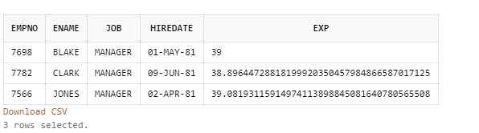

1. List the Empno, Ename, Sal, experience of all employees working for Mgr=7369

ANS: select empno,ename,sal,HIREDATE,MONTHS_BETWEEN(SYSDATE,HIREDATE)/12 exp from scott.emp where mgr = 7369;

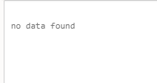

1. Display all the details of the employees whose Comm. Is more than their Sal

ANS : select * from scott.emp where comm > sal;

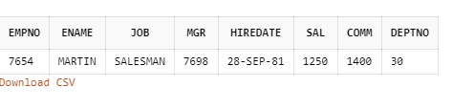

1. List the employees in the asc order of Designations of those joined after the second half of 1981

ANS : select * from scott.emp where hiredate > ('30-jun-81') and to_char(hiredate,'YYYY') = 1981 order by job asc;

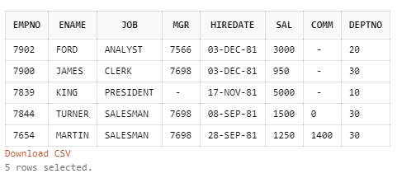

1. List the employees along with their experience and daily salary is more than Rs.100

ANS : select empno,ename,job,HIREDATE,MONTHS_BETWEEN(SYSDATE,HIREDATE)/12 exp from scott.emp where (sal/30) >100;

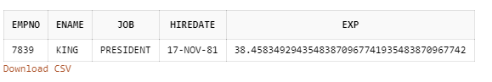

1. List the employees who are either ‘CLERK’ or ‘ANALYST’ in the Desc order

ANS: select * from scott.emp where job = 'CLERK' or job = 'ANALYST' order by job desc;

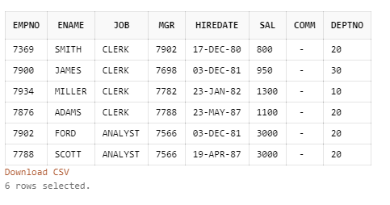

1. List the employees who joined on 1-MAY-81,3-DEC-81,17-DEC-81,19-JAN-80 in asc order of seniority.

ANS : select * from scott.emp where hiredate in ('01-may-81','03-dec-81','17-dec-81','19-jan-80') order by hiredate asc;

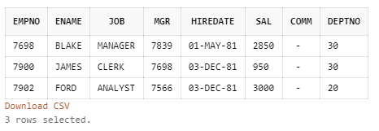

1. List the emp who are working for the Deptno 10 or 20

ANS : select * from scott.emp where deptno = 10 or deptno = 20;

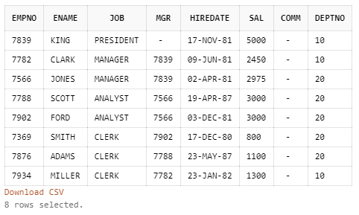

1. List the employees who are joined in the year ‘81

ANS : select * from scott.emp where hiredate between '01-jan-81' and '31-dec-81';

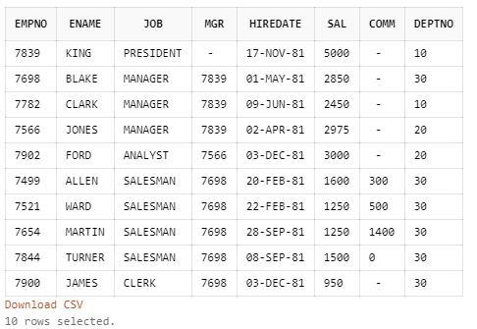

1. List the employees who are joined in the month of Aug 1980

ANS : select * from scott.emp where hiredate between '01-aug-80' and '31-aug-80';



1. List the Enames those are having five characters in their Names.

ANS : select ename from scott.emp where length (ename) = 5;

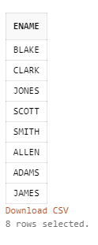

1. List the Enames those are starting with ‘S’ and with five characters

ANS : select ename from scott.emp where ename like 'S%' and length (ename) = 5;

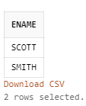

1. List the employees those are having four chars and third character must be ‘r’.

ANS : select * from scott.emp where length(ename) = 4 and ename like '__R%' ;

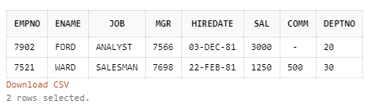

1. List the names of those employees whose employee numbers are 7369, 7521, 7839, 7934, 7788.

ANS : select ename from scott.emp where empno in(7369, 7521, 7839, 7934, 7788);

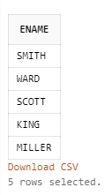

1. List those employees who do not belonging to department 30, 40, or 10.

ANS : select * from scott.emp where deptno not in(30,40,10);

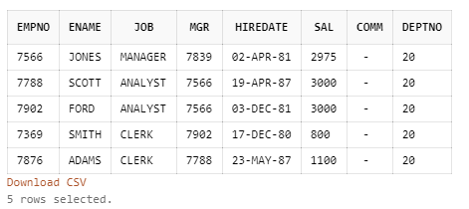

1. List those employee names who have joined between 30 June and 31 Dec ‘81.

ANS : select * from scott.emp where hiredate between '30-jun-1981' and '31-dec-1981';

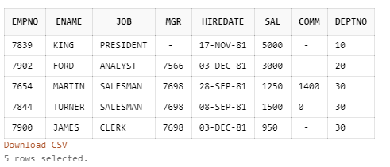

1. List the different designations available in the company

ANS : select distinct job from scott.emp;

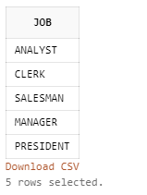

1. List those employees name that are not eligible for commission

ANS : select * from scott.emp where comm is NULL;

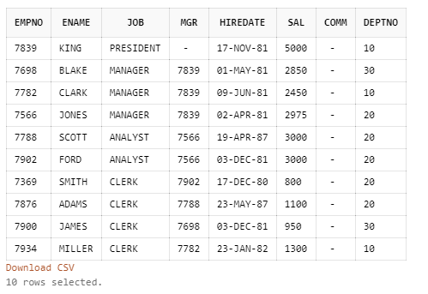

1. List the name of the employee and designation of the employee who does not report to anybody

ANS : select ename,job from scott.emp where job='President';

1. List the employees who are eligible for commission

ANS : select * from scott.emp where comm is not NULL;

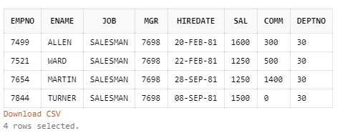

1. List names of employees if the names have “i” as the second character

ANS : select * from scott.emp where ename like '_i%';

1. Display the names of all employees with their salary and commission earned. Employees with a null commission field should have 0 in the commission column

ANS : select ename,sal,comm from scott.emp where comm is not null;

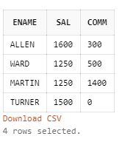

## Round 2 – Group by clause

Write queries for the following questions

1. List the count and average salary for employees in department 20.

ANS: select count(ename),avg(sal) from scott.emp where deptno=20;

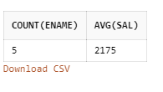

1. List names of employees who are older than 30 years in the company.
2. List the employee name , hire date in the descending order of the hire date.

ANS: select ename,hiredate from scott.emp order by hiredate desc;

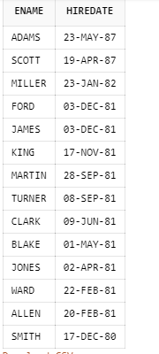

1. List employee name, salary, PF, HRA, DA and gross; order the results in the ascending order of gross. HRA is 50% of the salary and DA is 30% of the salary.
2. List the department numbers and number of employees in each department.

ANS: SELECT deptno,count(*) from scott.emp group by deptno;

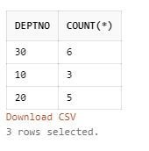

## Round 3 – SUBQUERIES

Write queries for the following questions

1. List employees whose job is same as that of Smith

ANS: select * from scott.emp where job in (select job from scott.emp where ename in ('SMITH'));

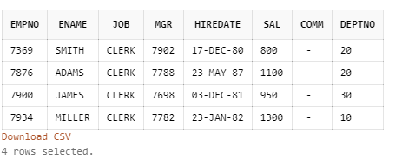

1. List employees who have joined after Adam

ANS: select * from scott.emp where hiredate > ( select hiredate from scott.emp where ename = 'ADAMS');

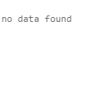

1. List employees who salary us greater than Scott’s salary

ANS: select * from scott.emp where sal >(select sal from scott.emp where ename='Scott');

1. List employees getting the max salary

ANS: SELECT * FROM scott.emp WHERE sal IN (SELECT max(sal) FROM scott.emp);

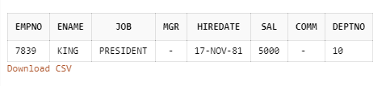

1. List employees show salary is > the max salary in deptno 30

ANS: select * from scott.emp where sal >(select max(sal) from scott.emp where deptno='30');

## Round 4 – Joins (Mortal mode)

1. List employee name, department number and their corresponding department name.

ANS : select e.ename,e.deptno,d.dname from scott.emp e join scott.dept d on e.deptno=d.deptno;

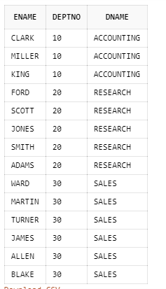

1. List employee name and their manager name

ANS : select e.ename,m.ename as manager from scott.emp e join scott.emp m on e.mgr=m.empno;

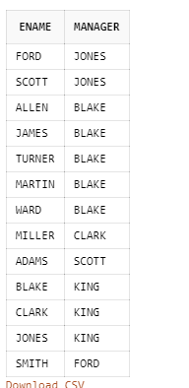

1. List employees who work in Research department

ANS : select e.ename,d.dname from scott.emp e left join scott.dept d on e.deptno=d.deptno where dname='RESEARCH';

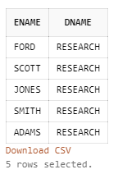

1. List all rows from EMP table and only the matching rows from DEPT table.

ANS: select * from scott.emp e left join scott.dept d on e.deptno=d.deptno;

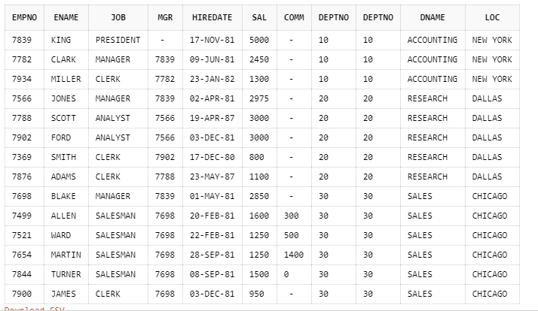

1. List all rows from EMP table and only the matching rows from DEPT table.

ANS : select * from scott.emp e left join scott.dept d on e.deptno=d.deptno;

