app-routing.module.ts

import { NgModule } from '@angular/core';

import { RouterModule, Routes } from '@angular/router';

import { HeroDetailComponent } from './hero-detail/hero-detail.component';

import { LoginComponent } from './login/login.component';

import { RegisterComponent } from './register/register.component';

const routes: Routes = [

  {path: "login", component:LoginComponent},

  {path:"register", component:RegisterComponent},

  {path:"hero-detail",component:HeroDetailComponent}

];

@NgModule({

  imports: [RouterModule.forRoot(routes)],

  exports: [RouterModule]

})

export class AppRoutingModule { }

app.component.html

<app-hero-detail></app-hero-detail>

<router-outlet></router-outlet>

Hero-detail.component.html

<!DOCTYPE html>

<html lang="en">

<head>

    <meta charset="UTF-8">

    <meta http-equiv="X-UA-Compatible" content="IE=edge">

    <meta name="viewport" content="width=device-width, initial-scale=1.0">

    <link href="https://cdn.jsdelivr.net/npm/bootstrap@5.1.3/dist/css/bootstrap.min.css" rel="stylesheet" integrity="sha384-1BmE4kWBq78iYhFldvKuhfTAU6auU8tT94WrHftjDbrCEXSU1oBoqyl2QvZ6jIW3" crossorigin="anonymous">

    <script src="https://cdn.jsdelivr.net/npm/bootstrap@5.1.3/dist/js/bootstrap.bundle.min.js" integrity="sha384-ka7Sk0Gln4gmtz2MlQnikT1wXgYsOg+OMhuP+IlRH9sENBO0LRn5q+8nbTov4+1p" crossorigin="anonymous"></script>

    <script src="https://cdn.jsdelivr.net/npm/@popperjs/core@2.10.2/dist/umd/popper.min.js" integrity="sha384-7+zCNj/IqJ95wo16oMtfsKbZ9ccEh31eOz1HGyDuCQ6wgnyJNSYdrPa03rtR1zdB" crossorigin="anonymous"></script>

<script src="https://cdn.jsdelivr.net/npm/bootstrap@5.1.3/dist/js/bootstrap.min.js" integrity="sha384-QJHtvGhmr9XOIpI6YVutG+2QOK9T+ZnN4kzFN1RtK3zEFEIsxhlmWl5/YESvpZ13" crossorigin="anonymous"></script>

    <title>Document</title>

</head>

<body>

    <nav class="navbar navbar-expand-lg navbar-light bg-light">

        <div class="container-fluid">

          <a class="navbar-brand" href="#">Navbar</a>

          <button class="navbar-toggler" type="button" data-bs-toggle="collapse" data-bs-target="#navbarSupportedContent" aria-controls="navbarSupportedContent" aria-expanded="false" aria-label="Toggle navigation">

            <span class="navbar-toggler-icon"></span>

          </button>

          <div class="collapse navbar-collapse" id="navbarSupportedContent">

            <ul class="navbar-nav me-auto mb-2 mb-lg-0">

                <button onclick="document.getElementById('id01').style.display='block'" style="width:auto;" routerLink="/login">Login</button>

                <button onclick="document.getElementById('id01').style.display='block'" style="width:auto;" routerLink="/register">Sign Up</button>

            </ul>

          </div>

        </div>

      </nav>

</body>

</html>

Hero-detail.component.css

<!DOCTYPE html>

<html lang="en">

<head>

    <meta charset="UTF-8">

    <meta http-equiv="X-UA-Compatible" content="IE=edge">

    <meta name="viewport" content="width=device-width, initial-scale=1.0">

    <link href="https://cdn.jsdelivr.net/npm/bootstrap@5.1.3/dist/css/bootstrap.min.css" rel="stylesheet" integrity="sha384-1BmE4kWBq78iYhFldvKuhfTAU6auU8tT94WrHftjDbrCEXSU1oBoqyl2QvZ6jIW3" crossorigin="anonymous">

    <script src="https://cdn.jsdelivr.net/npm/bootstrap@5.1.3/dist/js/bootstrap.bundle.min.js" integrity="sha384-ka7Sk0Gln4gmtz2MlQnikT1wXgYsOg+OMhuP+IlRH9sENBO0LRn5q+8nbTov4+1p" crossorigin="anonymous"></script>

    <script src="https://cdn.jsdelivr.net/npm/@popperjs/core@2.10.2/dist/umd/popper.min.js" integrity="sha384-7+zCNj/IqJ95wo16oMtfsKbZ9ccEh31eOz1HGyDuCQ6wgnyJNSYdrPa03rtR1zdB" crossorigin="anonymous"></script>

<script src="https://cdn.jsdelivr.net/npm/bootstrap@5.1.3/dist/js/bootstrap.min.js" integrity="sha384-QJHtvGhmr9XOIpI6YVutG+2QOK9T+ZnN4kzFN1RtK3zEFEIsxhlmWl5/YESvpZ13" crossorigin="anonymous"></script>

    <title>Document</title>

</head>

<body>

    <nav class="navbar navbar-expand-lg navbar-light bg-light">

        <div class="container-fluid">

          <a class="navbar-brand" href="#">Navbar</a>

          <button class="navbar-toggler" type="button" data-bs-toggle="collapse" data-bs-target="#navbarSupportedContent" aria-controls="navbarSupportedContent" aria-expanded="false" aria-label="Toggle navigation">

            <span class="navbar-toggler-icon"></span>

          </button>

          <div class="collapse navbar-collapse" id="navbarSupportedContent">

            <ul class="navbar-nav me-auto mb-2 mb-lg-0">

                <button onclick="document.getElementById('id01').style.display='block'" style="width:auto;" routerLink="/login">Login</button>

                <button onclick="document.getElementById('id01').style.display='block'" style="width:auto;" routerLink="/register">Sign Up</button>

            </ul>

          </div>

        </div>

      </nav>

</body>

</html>

Login.component.html

<div id="id01" class="modal">

    <form class="modal-content animate" action="/action_page.php" method="post">

      <div class="imgcontainer">

        <span onclick="document.getElementById('id01').style.display='none'" class="close" title="Close Modal">&times;</span>

        <img src="img_avatar2.png" alt="Avatar" class="avatar">

      </div>

      <div class="container">

        <label for="uname"><b>Username</b></label>

        <input type="text" placeholder="Enter Username" name="uname" required>

        <label for="psw"><b>Password</b></label>

        <input type="password" placeholder="Enter Password" name="psw" required>

        <button type="submit">Login</button>

        <label>

          <input type="checkbox" checked="checked" name="remember"> Remember me

        </label>

      </div>

      <div class="container" style="background-color:#f1f1f1">

        <button type="button" onclick="document.getElementById('id01').style.display='none'" class="cancelbtn">Cancel</button>

        <span class="psw">Forgot <a href="#">password?</a></span>

      </div>

    </form>

  </div>

  <script>

    // Get the modal

    var modal = document.getElementById('id01');

    // When the user clicks anywhere outside of the modal, close it

    window.onclick = function(event) {

        if (event.target == modal) {

            modal.style.display = "none";

        }

    }

    </script>

Register.component.html

<div id="id01" class="modal">

  <span onclick="document.getElementById('id02').style.display='none'" class="close" title="Close Modal">&times;</span>

  <form class="modal-content" action="/action_page.php">

    <div class="container">

      <h1>Sign Up</h1>

      <p>Please fill in this form to create an account.</p>

      <hr>

      <label for="email"><b>Email</b></label>

      <input type="text" placeholder="Enter Email" name="email" required>

      <label for="psw"><b>Password</b></label>

      <input type="password" placeholder="Enter Password" name="psw" required>

      <label for="psw-repeat"><b>Repeat Password</b></label>

      <input type="password" placeholder="Repeat Password" name="psw-repeat" required>

      <label>

        <input type="checkbox" checked="checked" name="remember" style="margin-bottom:15px"> Remember me

      </label>

      <p>By creating an account you agree to our <a href="#" style="color:dodgerblue">Terms & Privacy</a>.</p>

      <div class="clearfix">

        <button type="button" onclick="document.getElementById('id01').style.display='none'" class="cancelbtn">Cancel</button>

        <button type="submit" class="signupbtn">Sign Up</button>

      </div>

    </div>

  </form>

</div>

<script>

// Get the modal

var modal = document.getElementById('id01');

// When the user clicks anywhere outside of the modal, close it

window.onclick = function(event) {

  if (event.target == modal) {

    modal.style.display = "none";

  }

}

</script>

Output:

Navbar -page

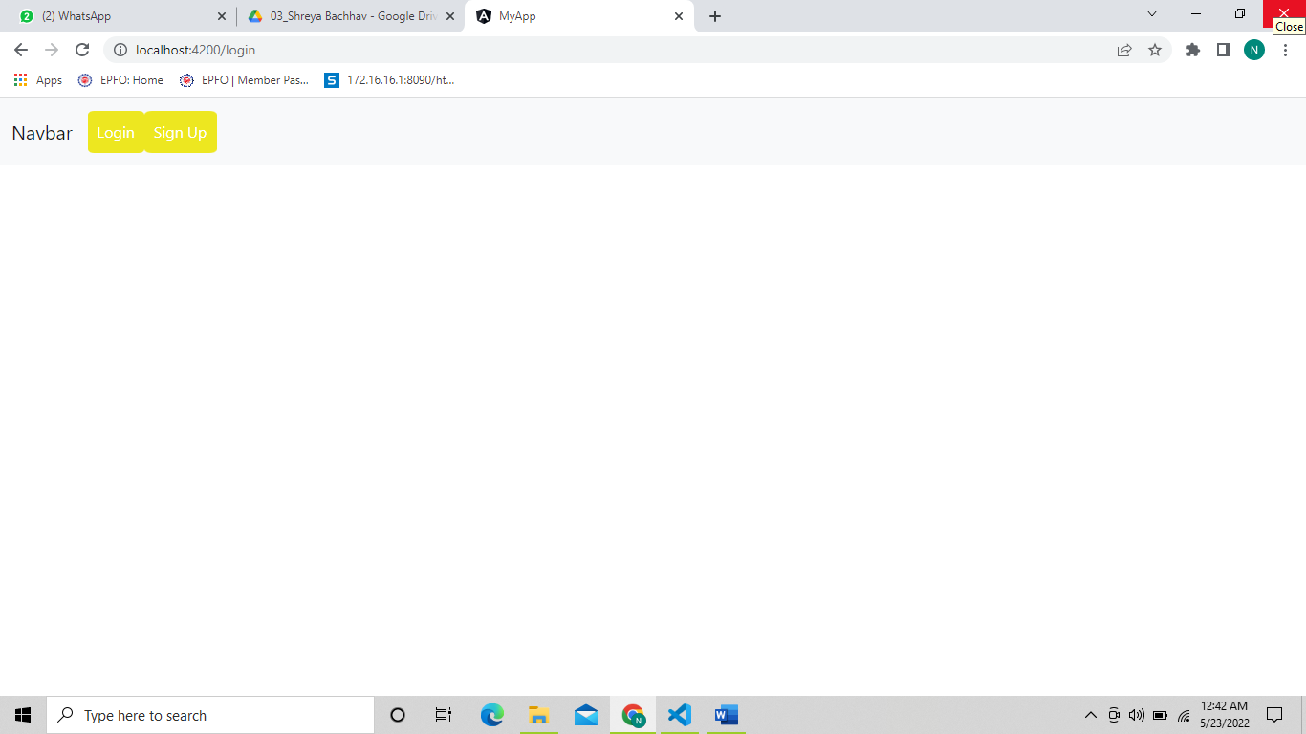

Login page

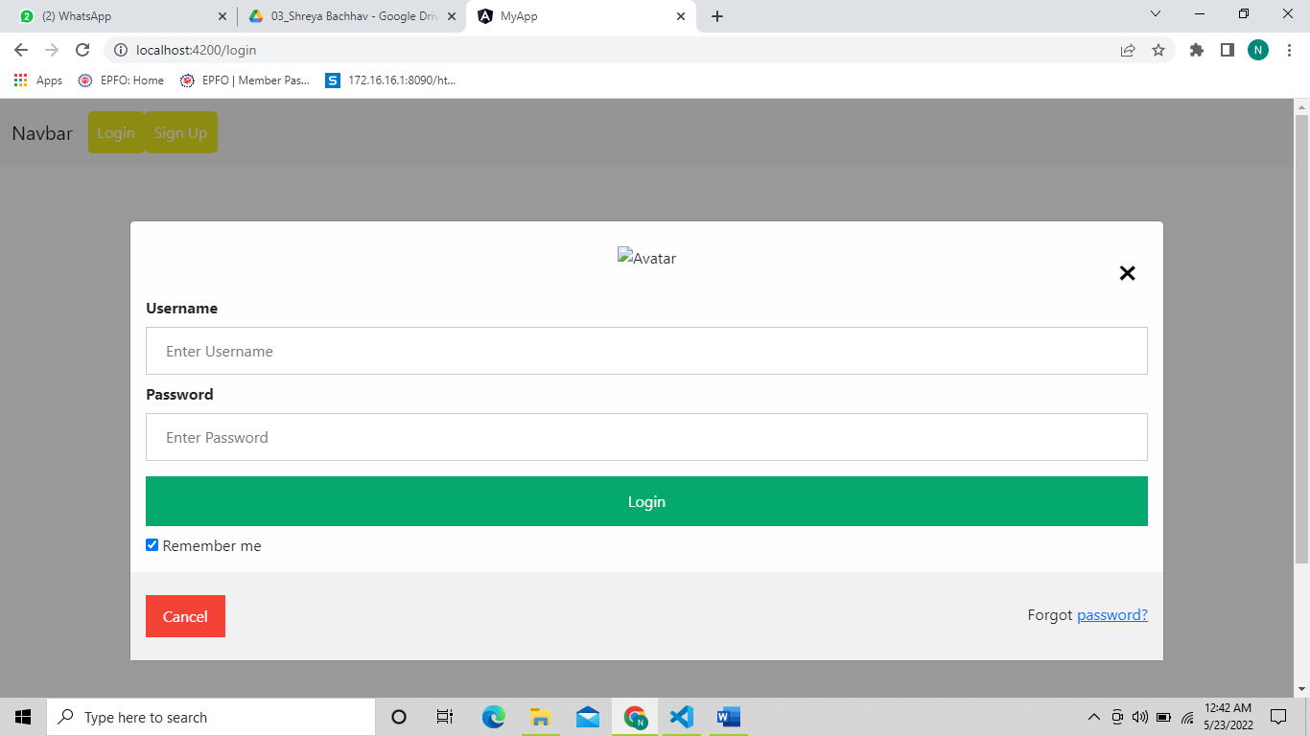

Register Page

