**ДЕРЖАВНИЙ УНІВЕРСИТЕТ ІНТЕЛЕКТУАЛЬНИХ**

**ТЕХНОЛОГІЙ І ЗВ’ЯЗКУ**

**Звіт**

**з дисципліни Основи Баз Даних та Знань**

**Лабораторна робота №4**

**на тему: «Представление. Подзапросы. Аналитические функции»**

Виконав: студент 3 курсу, групи ІПЗ-3.04 спеціальності

121 Інженерія програмного забезпечення

____________________________Бухта М.М.

Перевірив________________Глазунова Л.В.

**Одеса  2024**

**ЗАВДАННЯ**

1. Составить представление, отображающее список болезней у максимального количества пациентов каждого врача.

2.Аналит. ф-ции  
Получить рейтинг каждого врача при ранжировании по: – количеству принятых пациентов; – количеству выписанных анализов; – количеству назначенных препаратов за последний квартал.

3. Аналит. ф-ции Составить представление для отображения тенденции количества посещений врачей (по датам посещений).

**ВИКОНАННЯ**

**Task 1**

/* Descripiton:

* Create a view displaying the list of diseases for the maximum number of patients of each doctor.

*/

CREATE VIEW doctor_patient_diseases AS

WITH max_patients_per_doctor AS (

SELECT

bd.doctor_id,

COUNT(DISTINCT bd.patient_id) AS patient_count

FROM

booked_doctors bd

GROUP BY

bd.doctor_id

HAVING

COUNT(DISTINCT bd.patient_id) = (

SELECT

MAX(patient_count)

FROM (

SELECT

COUNT(DISTINCT patient_id) AS patient_count

FROM

booked_doctors

GROUP BY

doctor_id

) AS subquery

)

)

SELECT

d.name AS doctor_name,

d.surname AS doctor_surname,

d.middle_name AS doctor_middle_name,

p.name AS patient_name,

p.surname AS patient_surname,

p.middle_name AS patient_middle_name,

da.complaint AS disease

FROM

max_patients_per_doctor mpd

JOIN

users d ON mpd.doctor_id = d.id

JOIN

booked_doctors bd ON mpd.doctor_id = bd.doctor_id

JOIN

doctor_appointments da ON bd.id = da.booked_doctor_id

JOIN

users p ON bd.patient_id = p.id

ORDER BY

d.id, p.id;

**Task 2**

/* Description:

* Get the ranking of each doctor based on:

* - the number of patients seen;

* - the number of analyses prescribed;

* - the number of drugs prescribed in the last quarter.

*/

WITH patient_count AS (

SELECT

bd.doctor_id,

COUNT(DISTINCT bd.patient_id) AS patient_count

FROM

booked_doctors bd

WHERE

bd.appointment_time >= date_trunc('quarter', CURRENT_DATE) - interval '3 month'

GROUP BY

bd.doctor_id

),

analyse_count AS (

SELECT

bd.doctor_id,

COUNT(aa.id) AS analyse_count

FROM

analyse_appointments aa

JOIN

doctor_appointments da ON aa.doctor_appointment_id = da.id

JOIN

booked_doctors bd ON da.booked_doctor_id = bd.id

WHERE

aa.is_completed = TRUE

AND bd.appointment_time >= date_trunc('quarter', CURRENT_DATE) - interval '3 month'

GROUP BY

bd.doctor_id

),

drug_count AS (

SELECT

bd.doctor_id,

COUNT(pd.id) AS drug_count

FROM

prescription_drugs pd

JOIN

doctor_appointments da ON pd.doctor_appointment_id = da.id

JOIN

booked_doctors bd ON da.booked_doctor_id = bd.id

WHERE

bd.appointment_time >= date_trunc('quarter', CURRENT_DATE) - interval '3 month'

GROUP BY

bd.doctor_id

),

combined AS (

SELECT

u.id AS doctor_id,

u.name AS doctor_name,

u.surname AS doctor_surname,

u.middle_name AS doctor_middle_name,

COALESCE(pc.patient_count, 0) AS patient_count,

COALESCE(ac.analyse_count, 0) AS analyse_count,

COALESCE(dc.drug_count, 0) AS drug_count

FROM

users u

LEFT JOIN

patient_count pc ON u.id = pc.doctor_id

LEFT JOIN

analyse_count ac ON u.id = ac.doctor_id

LEFT JOIN

drug_count dc ON u.id = dc.doctor_id

WHERE

EXISTS (SELECT 1 FROM users_roles ur WHERE ur.user_id = u.id AND ur.role_id = 2)

)

SELECT

doctor_id,

doctor_name,

doctor_surname,

doctor_middle_name,

patient_count,

RANK() OVER (ORDER BY patient_count DESC) AS patient_rank,

analyse_count,

RANK() OVER (ORDER BY analyse_count DESC) AS analyse_rank,

drug_count,

RANK() OVER (ORDER BY drug_count DESC) AS drug_rank

FROM

combined

ORDER BY

doctor_id;

**Task 3**

/* Description:

* Create a view to display the trend in the number of doctor visits (by visit dates).

*/

CREATE VIEW doctor_visit_trend AS

WITH daily_visits AS (

SELECT

bd.doctor_id,

date_trunc('day', bd.appointment_time) AS visit_date,

COUNT(*) AS daily_visit_count

FROM

booked_doctors bd

GROUP BY

bd.doctor_id, date_trunc('day', bd.appointment_time)

)

SELECT

u.id AS doctor_id,

u.name AS doctor_name,

u.surname AS doctor_surname,

u.middle_name AS doctor_middle_name,

dv.visit_date,

dv.daily_visit_count,

SUM(dv.daily_visit_count) OVER (PARTITION BY dv.doctor_id ORDER BY dv.visit_date) AS cumulative_visits

FROM

daily_visits dv

JOIN

users u ON dv.doctor_id = u.id

ORDER BY

u.id, dv.visit_date;

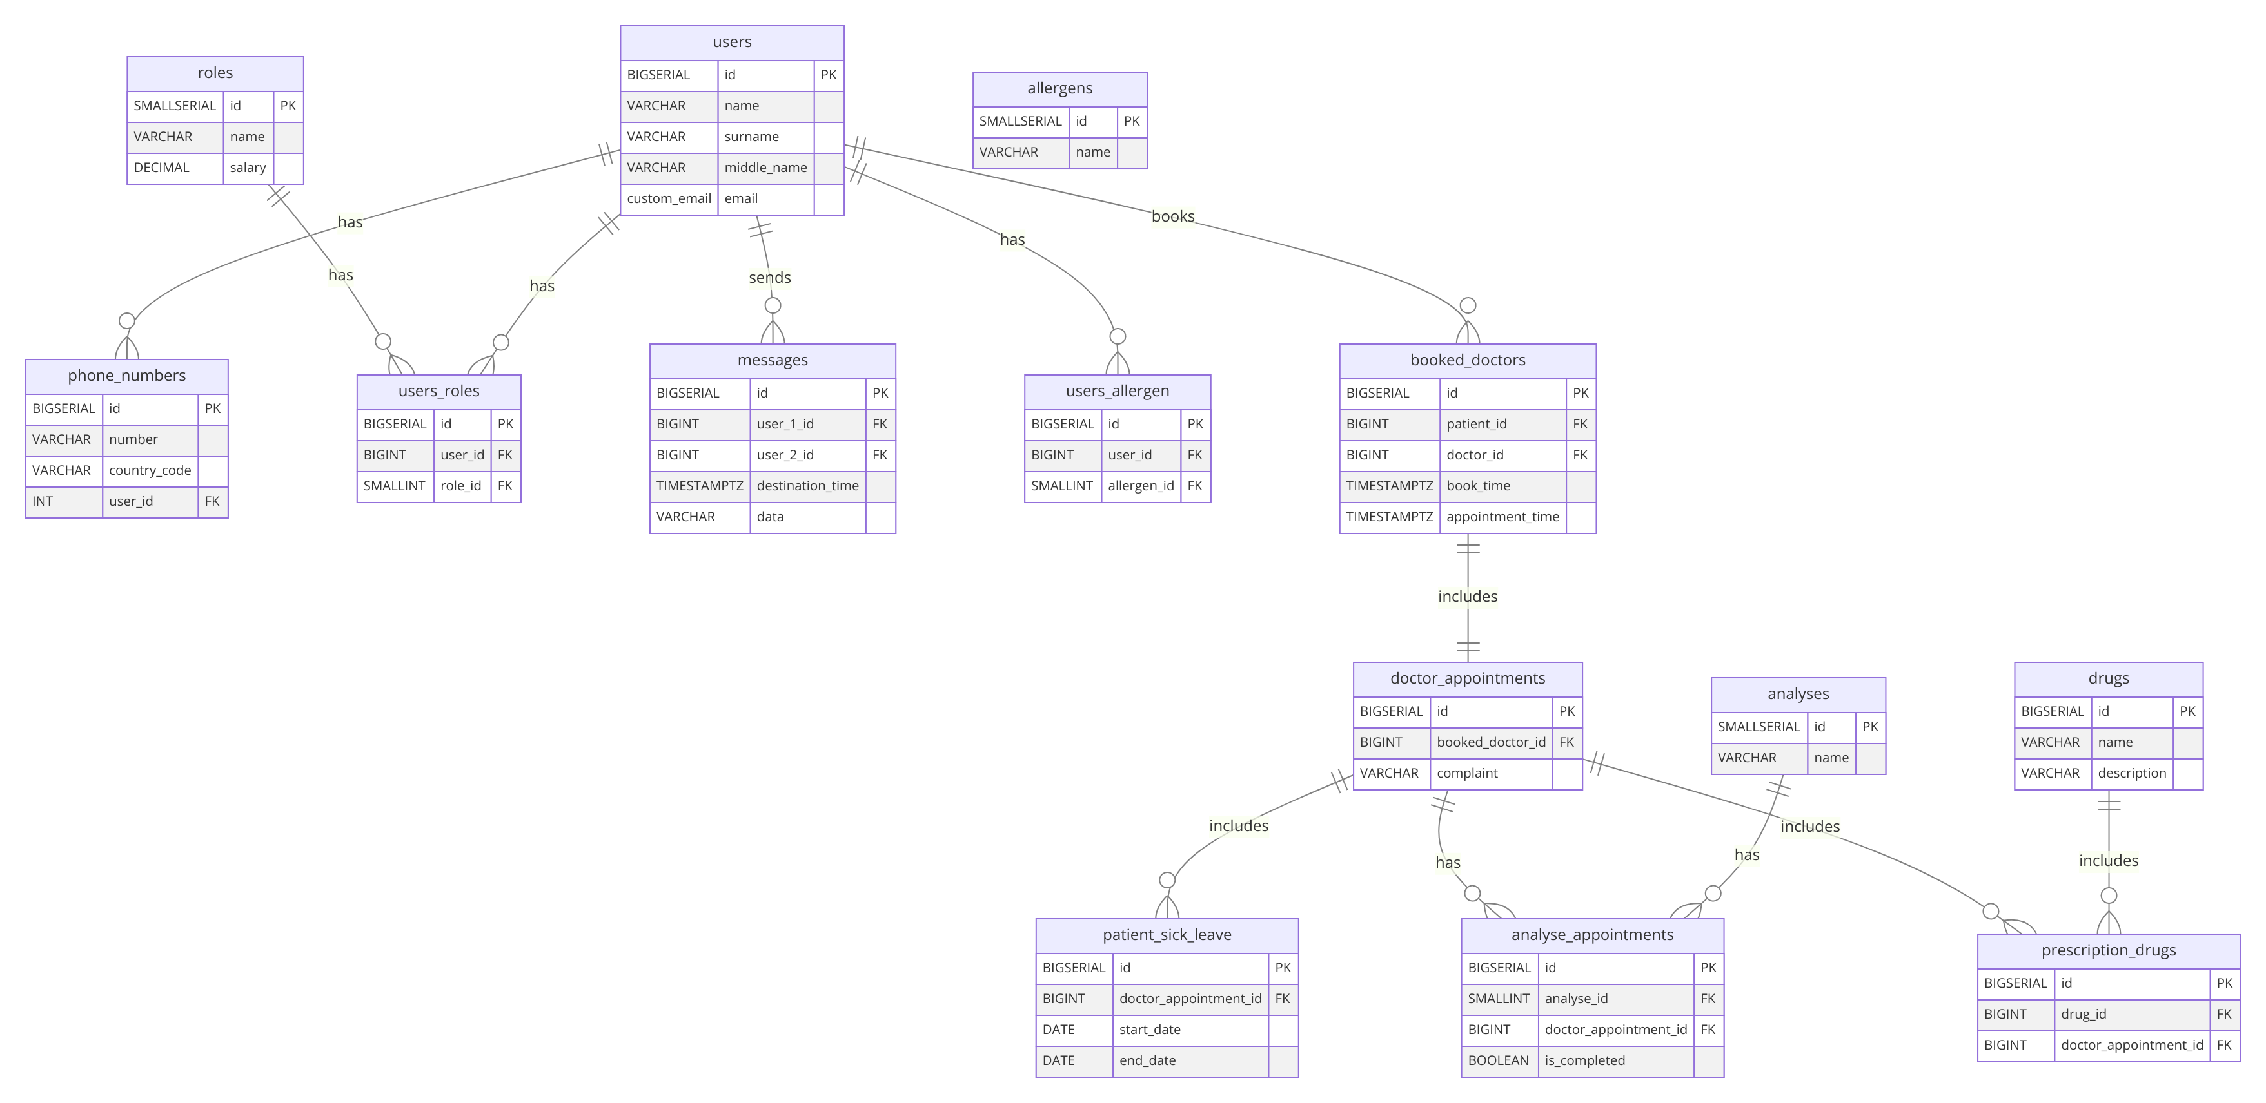

Рисунок 1 – ER діаграмма

**РЕЗУЛЬТАТ ВИКОНАННЯ**

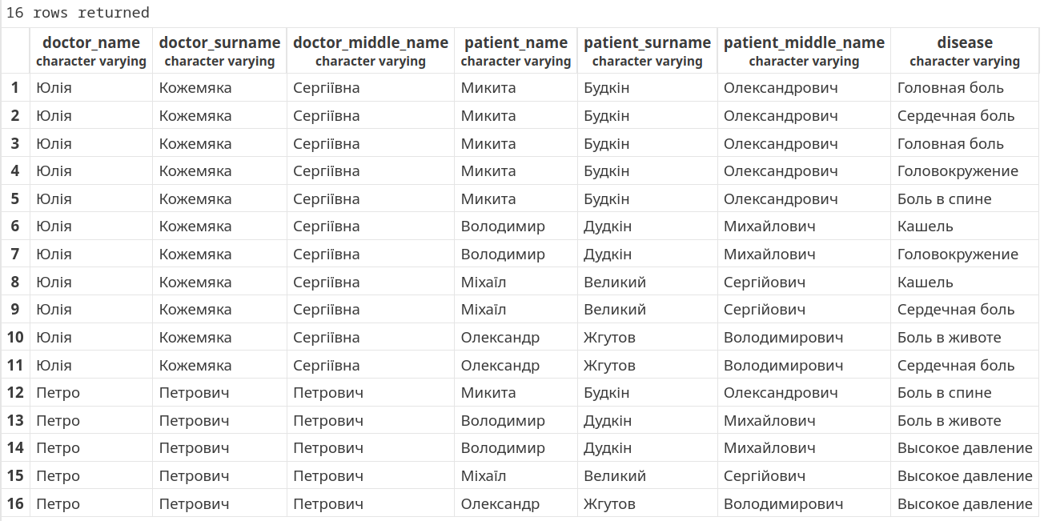Рисунок 2 – результат виконання завдання 1

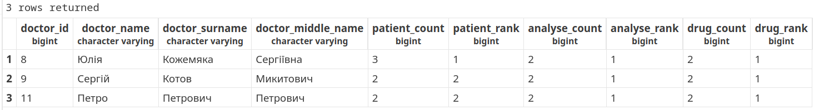Рисунок 3 – результат виконання завдання 2

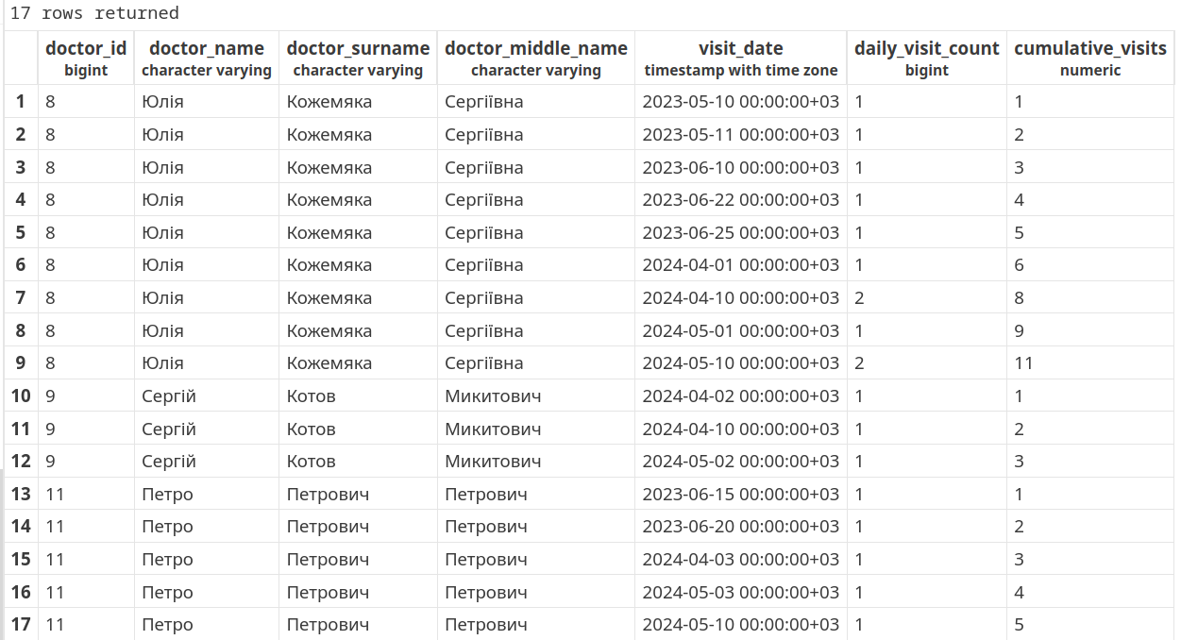Рисунок 4 – результат виконання завдання 3