To successfully install this project, you will need to follow these steps:

1. Install TomCat server (version 9.0.43) - <https://tomcat.apache.org/download-90.cgi>;
2. Install PostgreSQL to the server - <https://www.postgresql.org/download/>;
3. Install JDK (latest version) - <https://www.oracle.com/ru/java/technologies/javase-downloads.html>;
4. IDE – Intellij IDEA Ultimate - <https://www.jetbrains.com/ru-ru/idea/download/#section=windows>;
5. Download this project and open it as project in IDEA;
6. Download Maven dependencies (they will pop-up in the bottom-right corner)

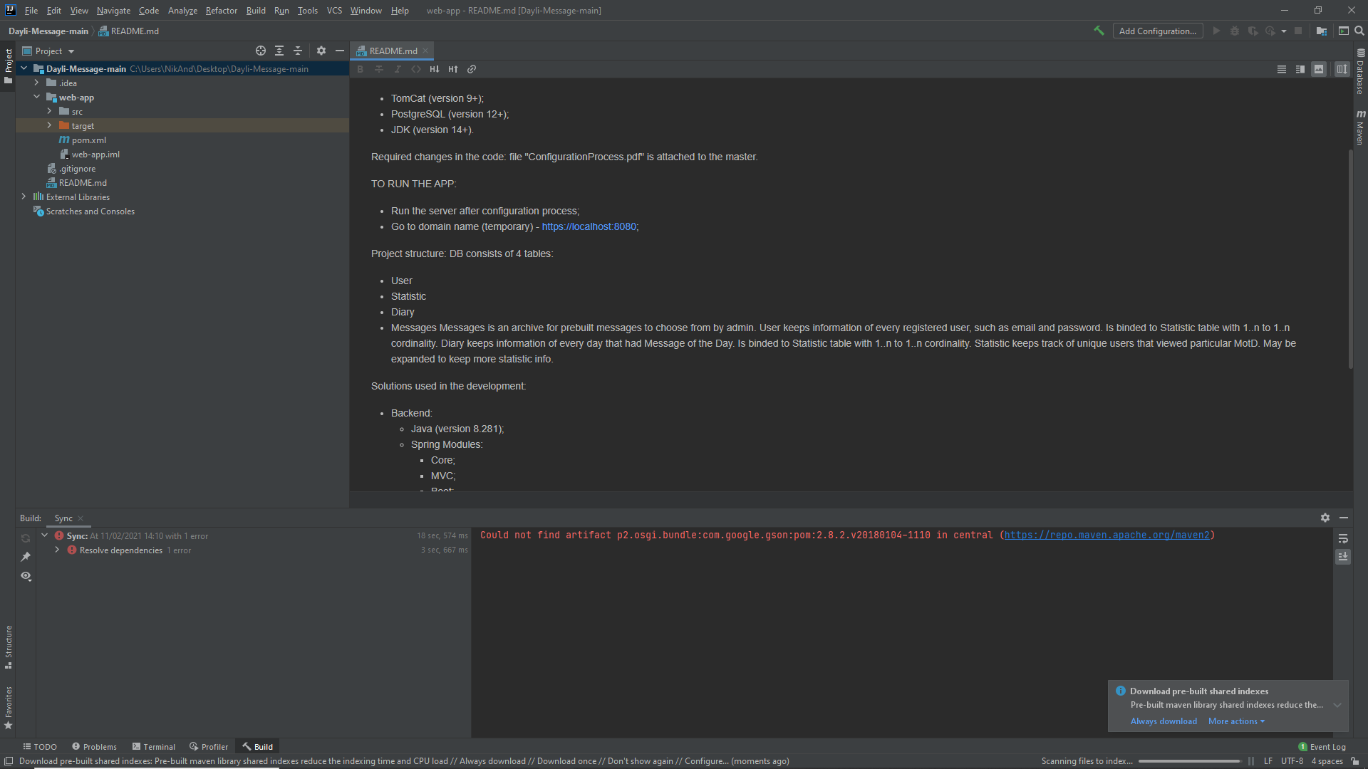

1. Find this XML code in the pom.xml and just delete it

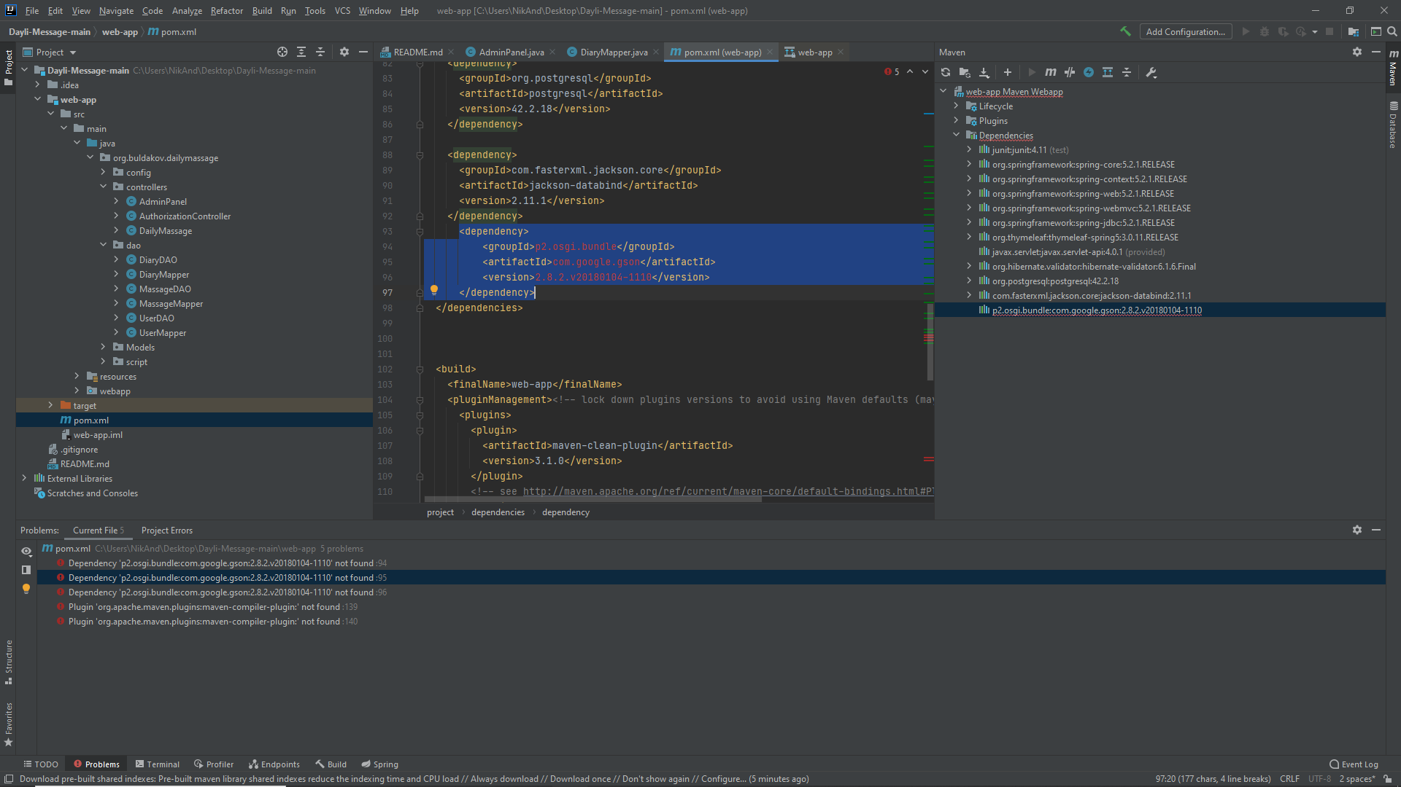

1. Reload your maven dependencies (you can find maven tab on the top right)

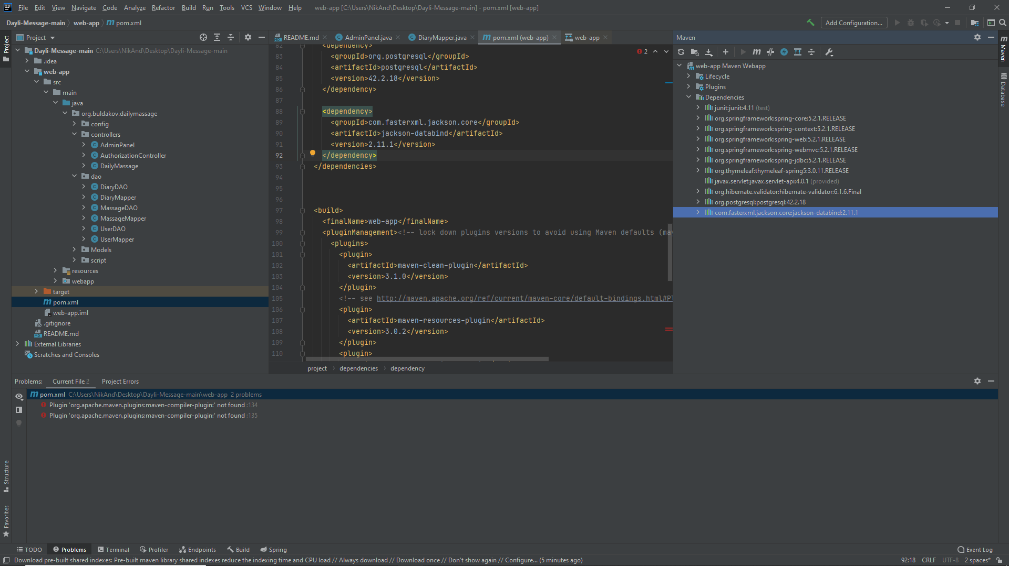

1. Press Add Configuration on the top right

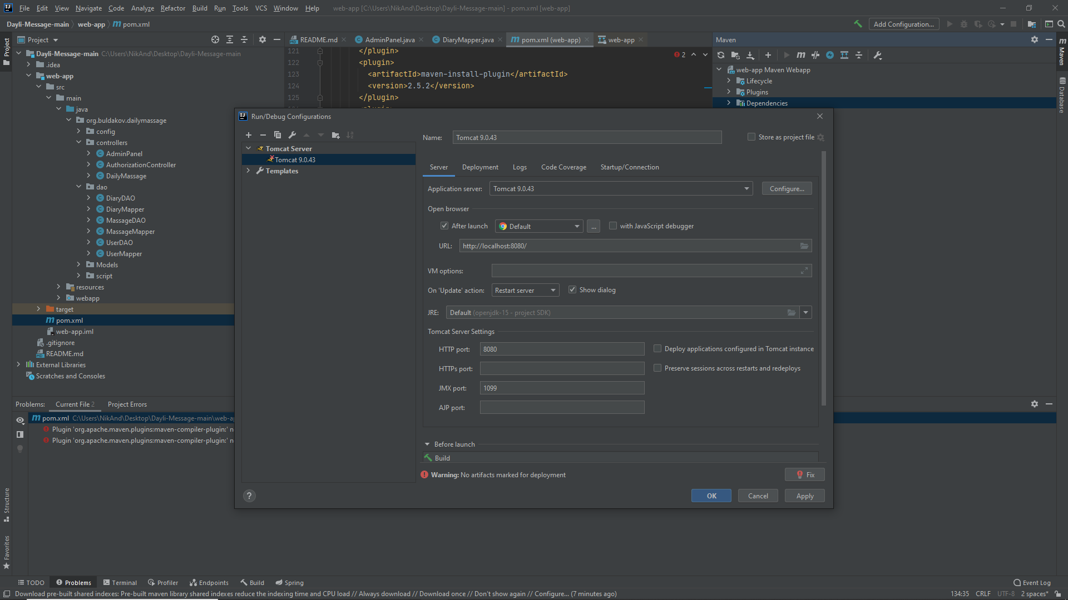

1. Press the + sign in the pop-up window



1. Add Tomcat server local and press Enter. You will have this window if done correctly.

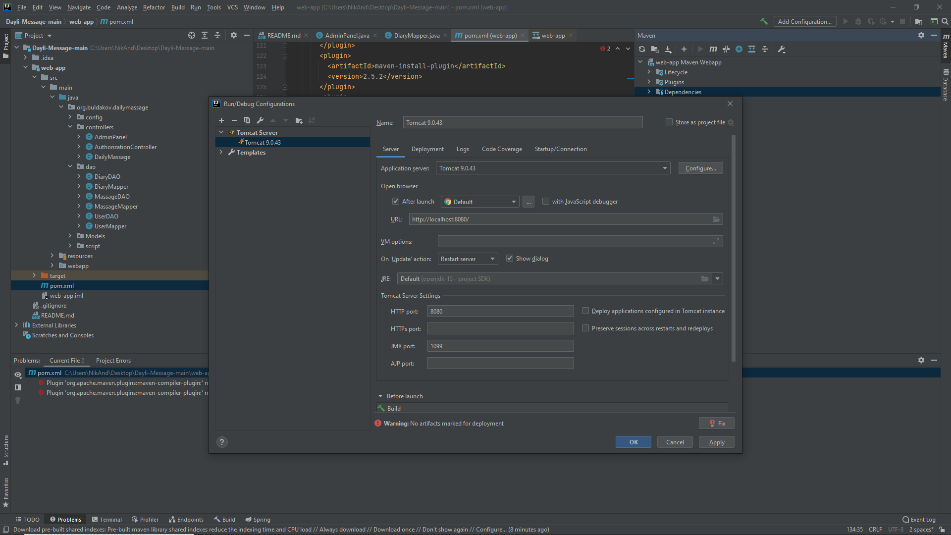

1. Press configure (on the same line as Application server dropdown). You will see the window below. Add your path to the installed tomcat to the Tomcat Home.

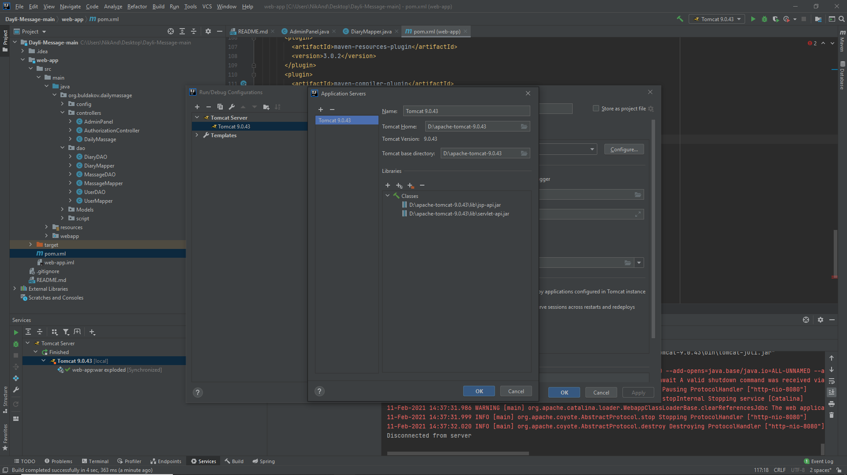

1. You will have some issues, press fix -> web-app: war exploded

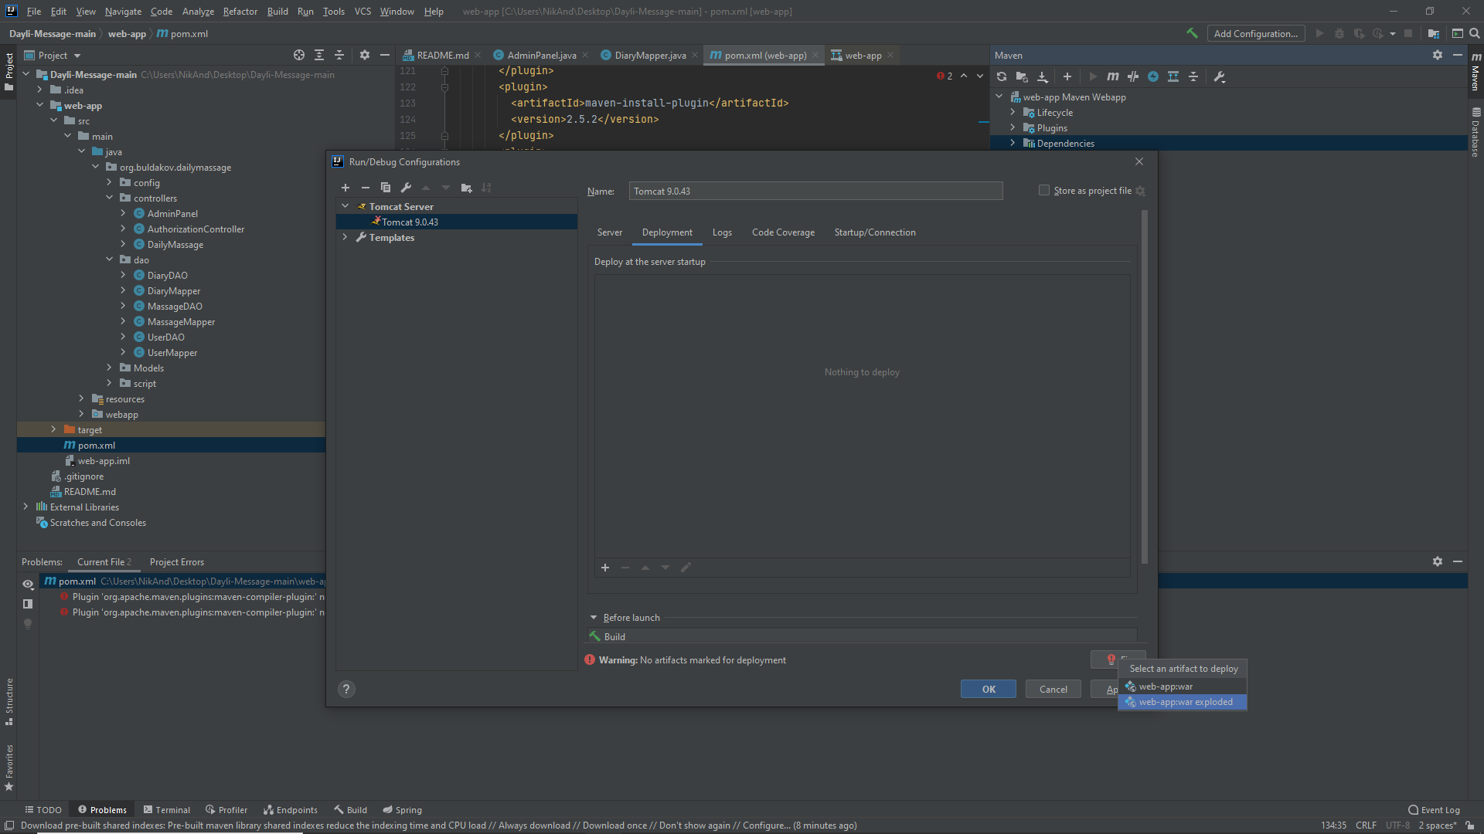

1. Clear Application context. Press apply and ok.

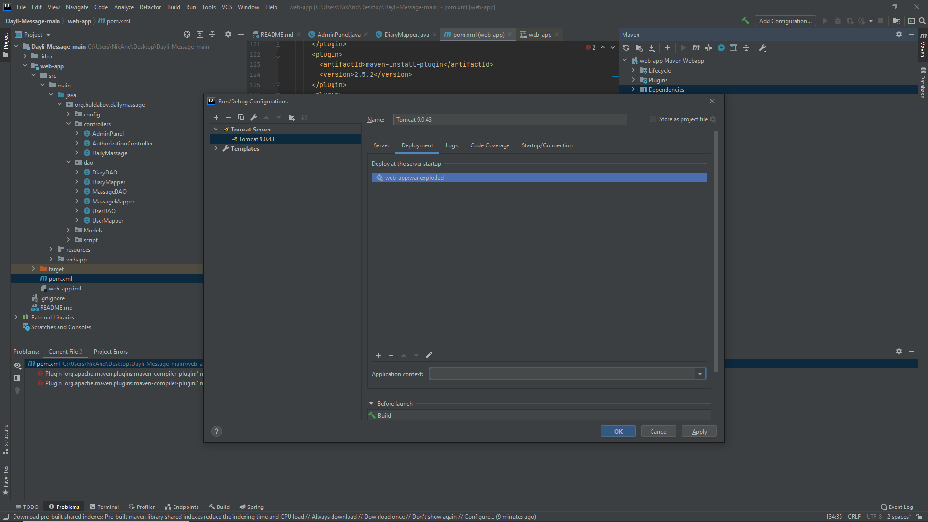

1. Find Database tab on the right. Open it and then press + -> Data Source -> PostgreSQL

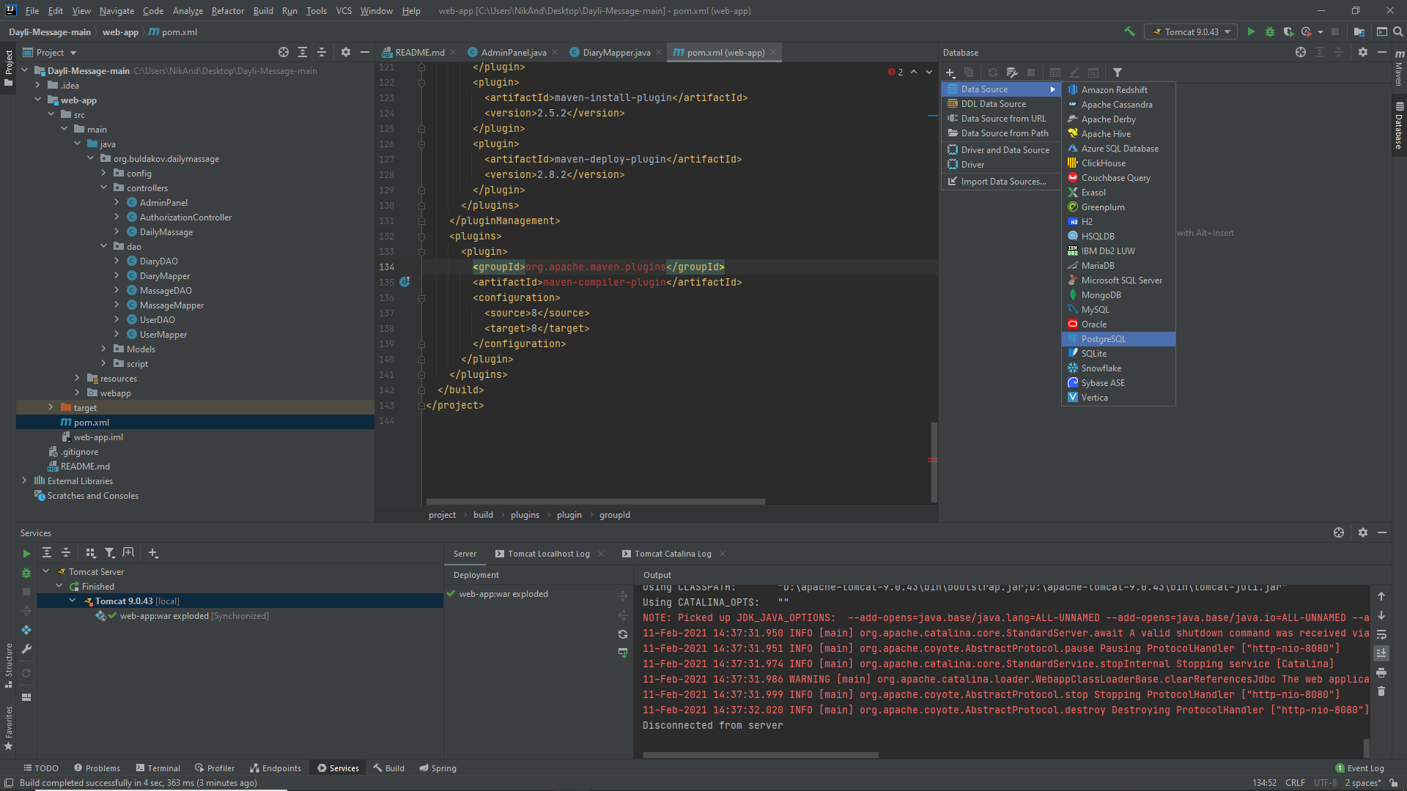

1. In the pop-ip window find user and password (if not sure, use default: postgres, rty456)

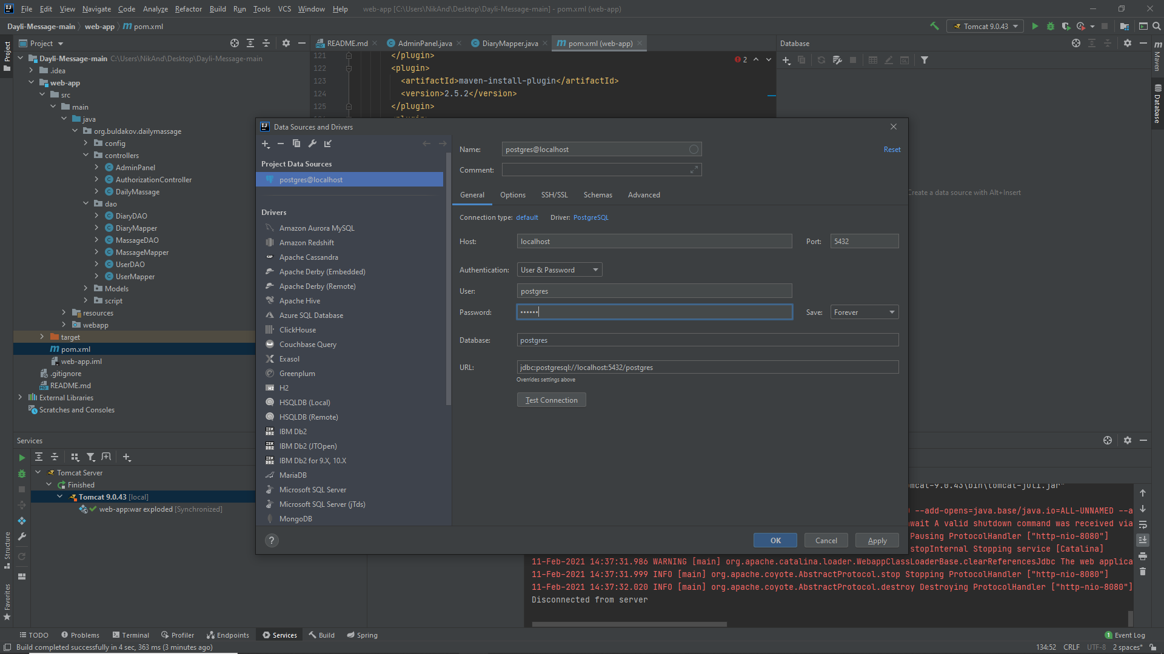

1. Press test connection. If everything is ok, press apply and ok.

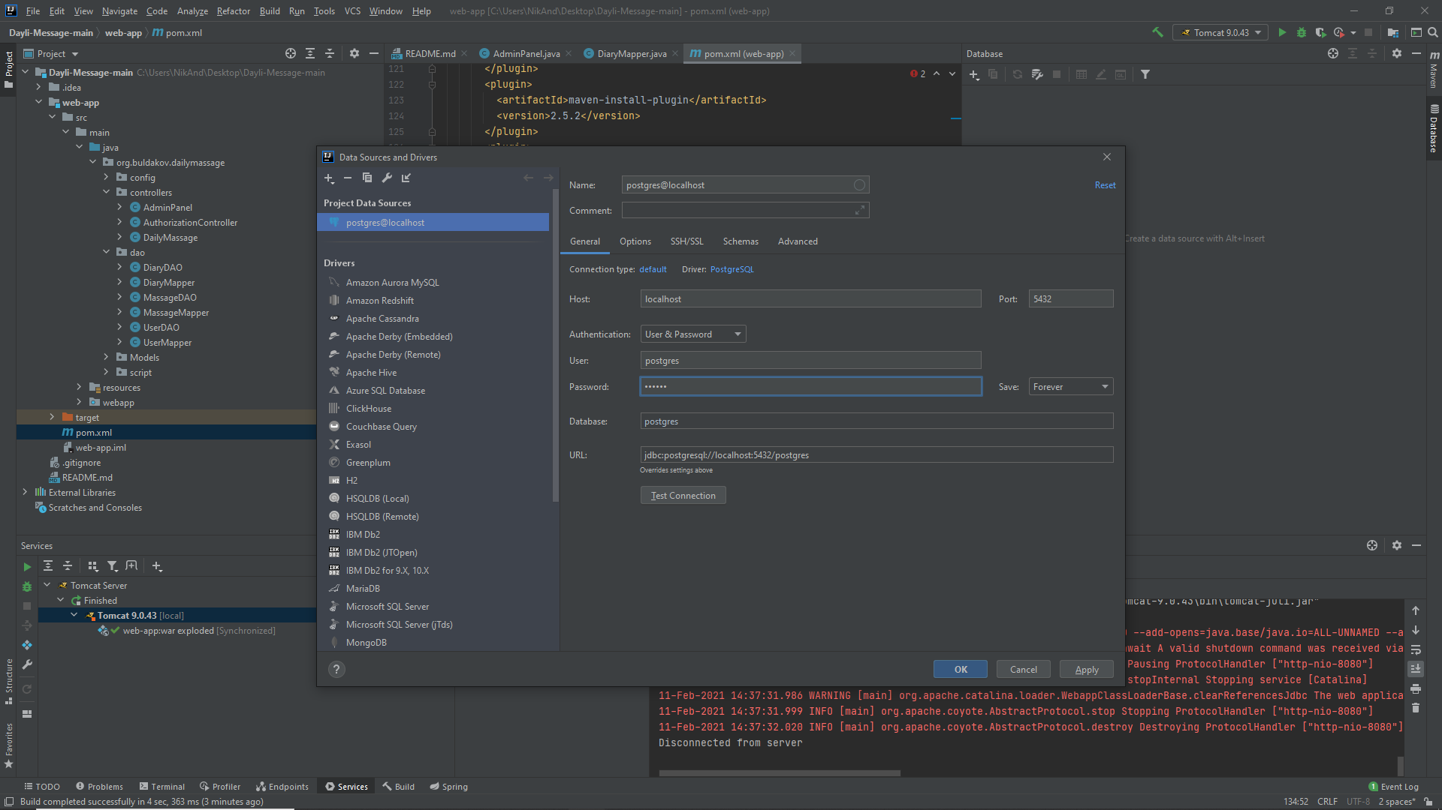

1. In the following screenshots you will find paths to the files that have absolute paths in them. You will need to change them to your own paths to the same files.

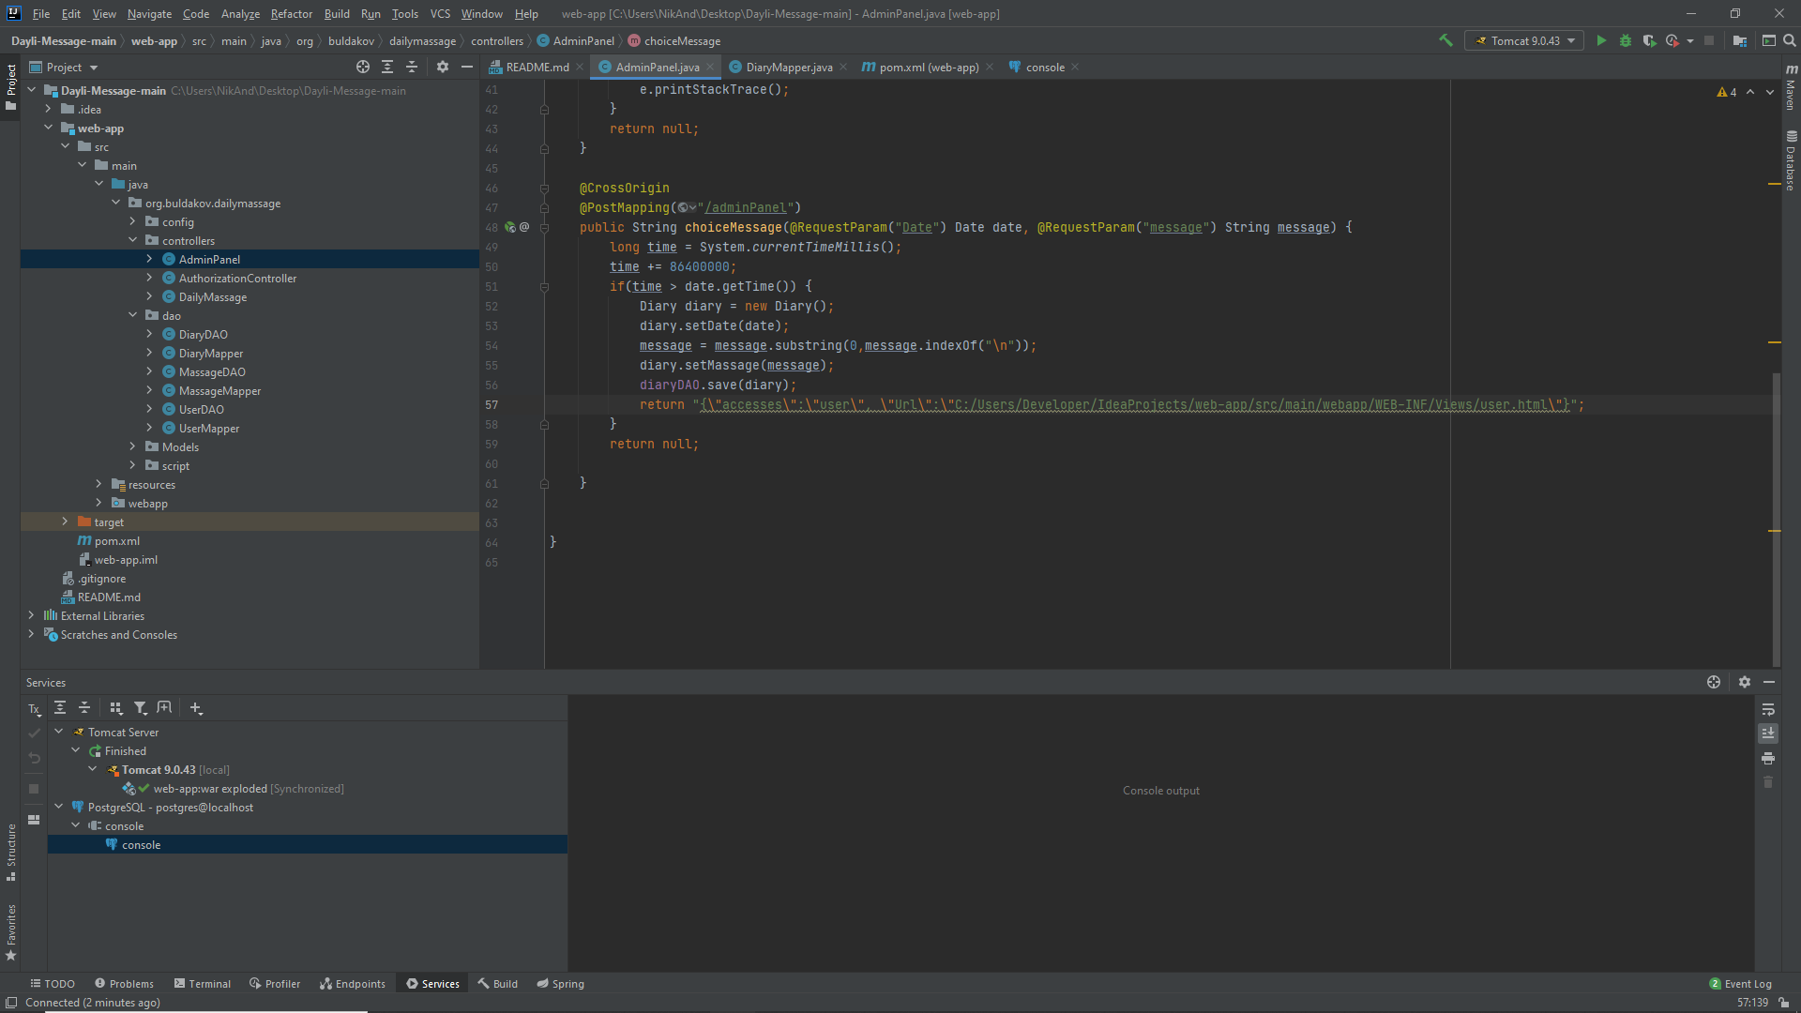

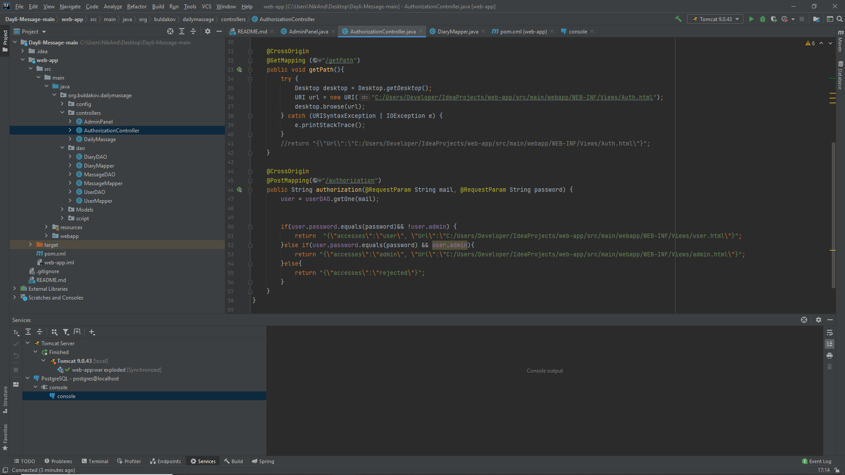

Every html file here.

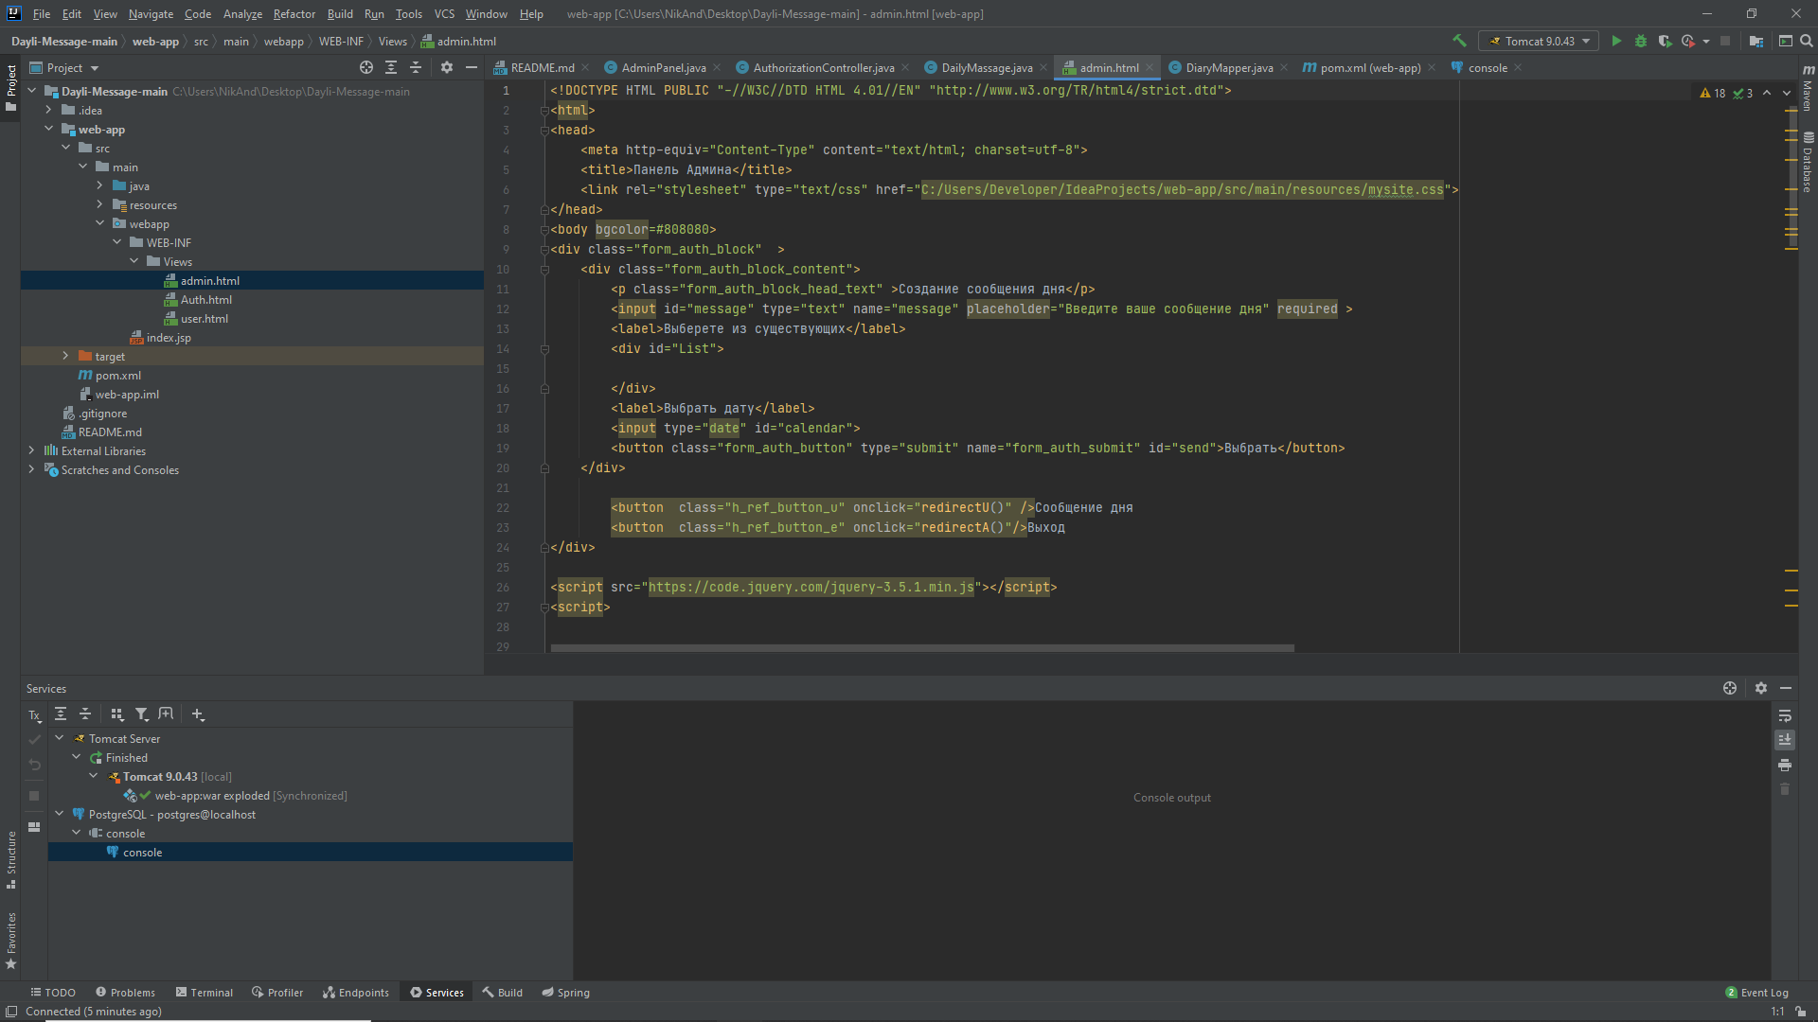

1. Installation is done to the linux type server. After all the previous steps, it is necessary to show path to the server inner util – cron, to the “script class”.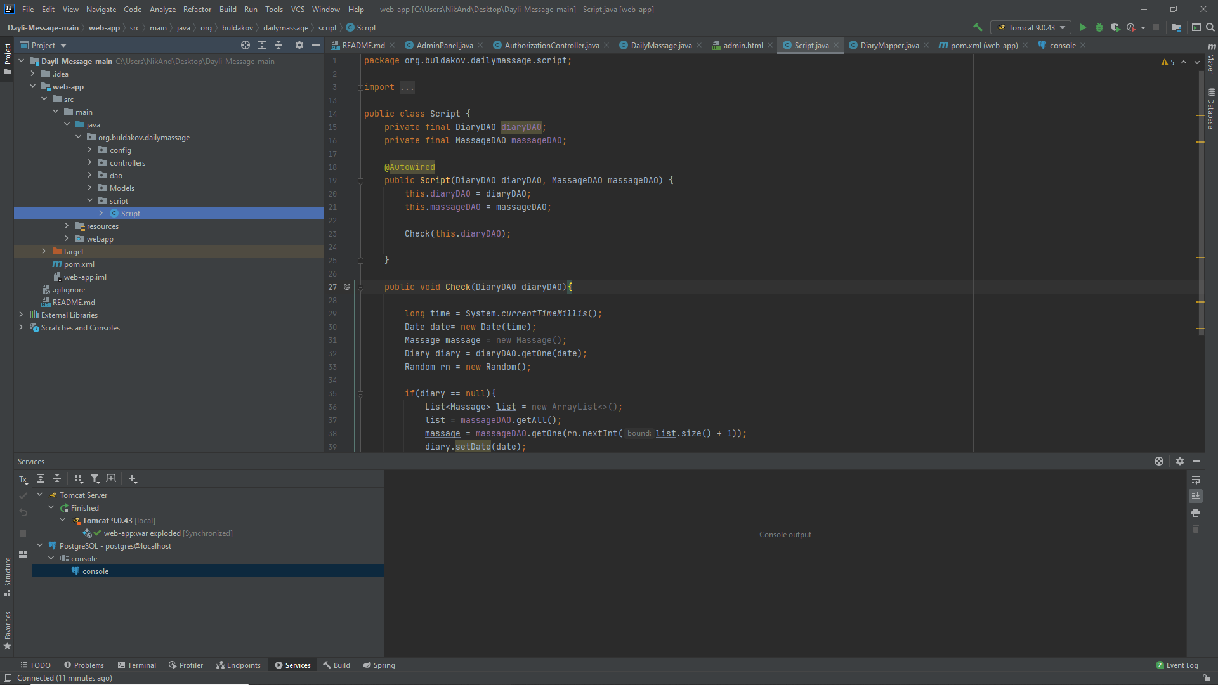
   1. Сron can be configured using the command line of the server on which you install the application

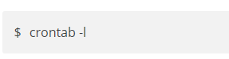

using this command you can open the configuration of your script, which will be executed on the server.

in the next screenshot you can see what parameters you should specify when configuring.

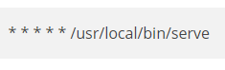

here is an example of what parameters you should specify in the console:

**@midnight../your directory /../ script**

you can also read more about this on this resource: https://losst.ru/nastrojka-cron

1. Run the server with “Run” button.

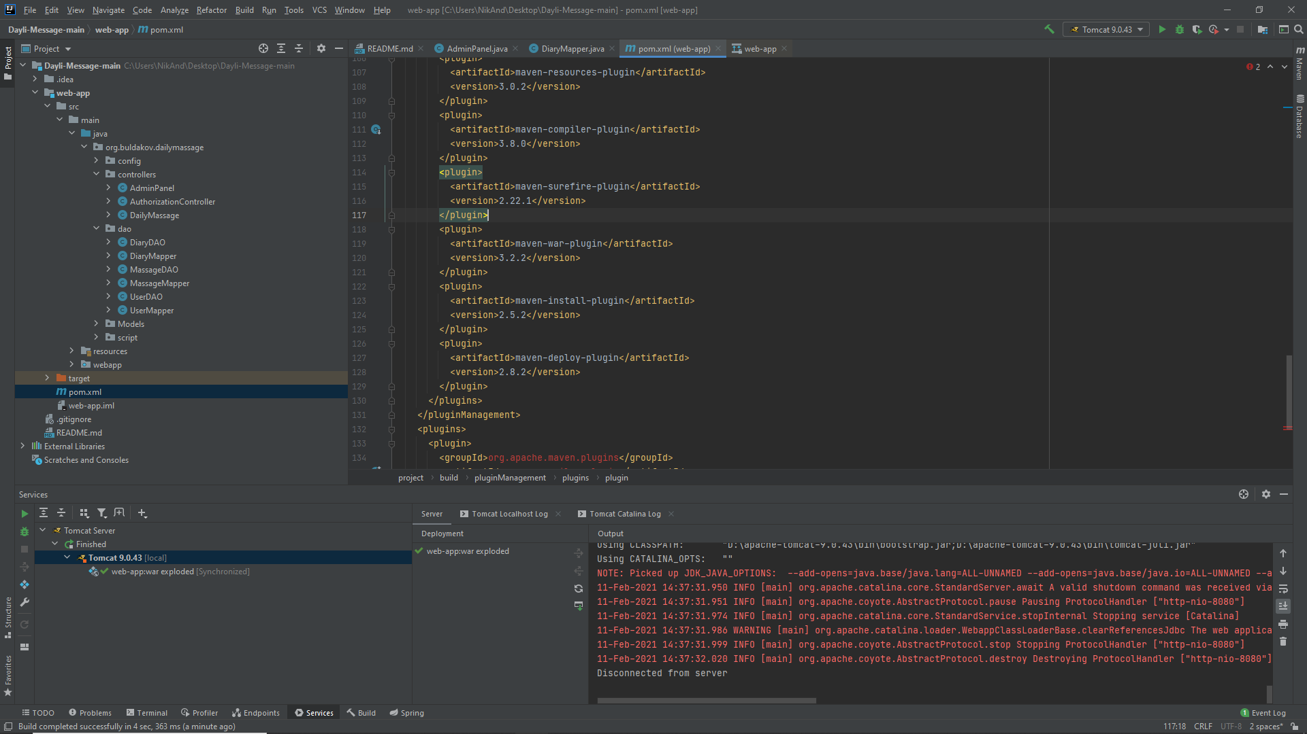

Your browser will open tab with the project started. Hopefully.