To successfully install this project, you will need to follow these steps:

1. Install TomCat server (version 9.0.43) - <https://tomcat.apache.org/download-90.cgi>;
2. Install PostgreSQL to the server - <https://www.postgresql.org/download/>;
3. Install JDK (latest version) - <https://www.oracle.com/ru/java/technologies/javase-downloads.html>;
4. IDE – Intellij IDEA Ultimate - <https://www.jetbrains.com/ru-ru/idea/download/#section=windows>;
5. Download this project and open it as project in IDEA;
6. Download Maven dependencies (they will pop-up in the bottom-right corner)

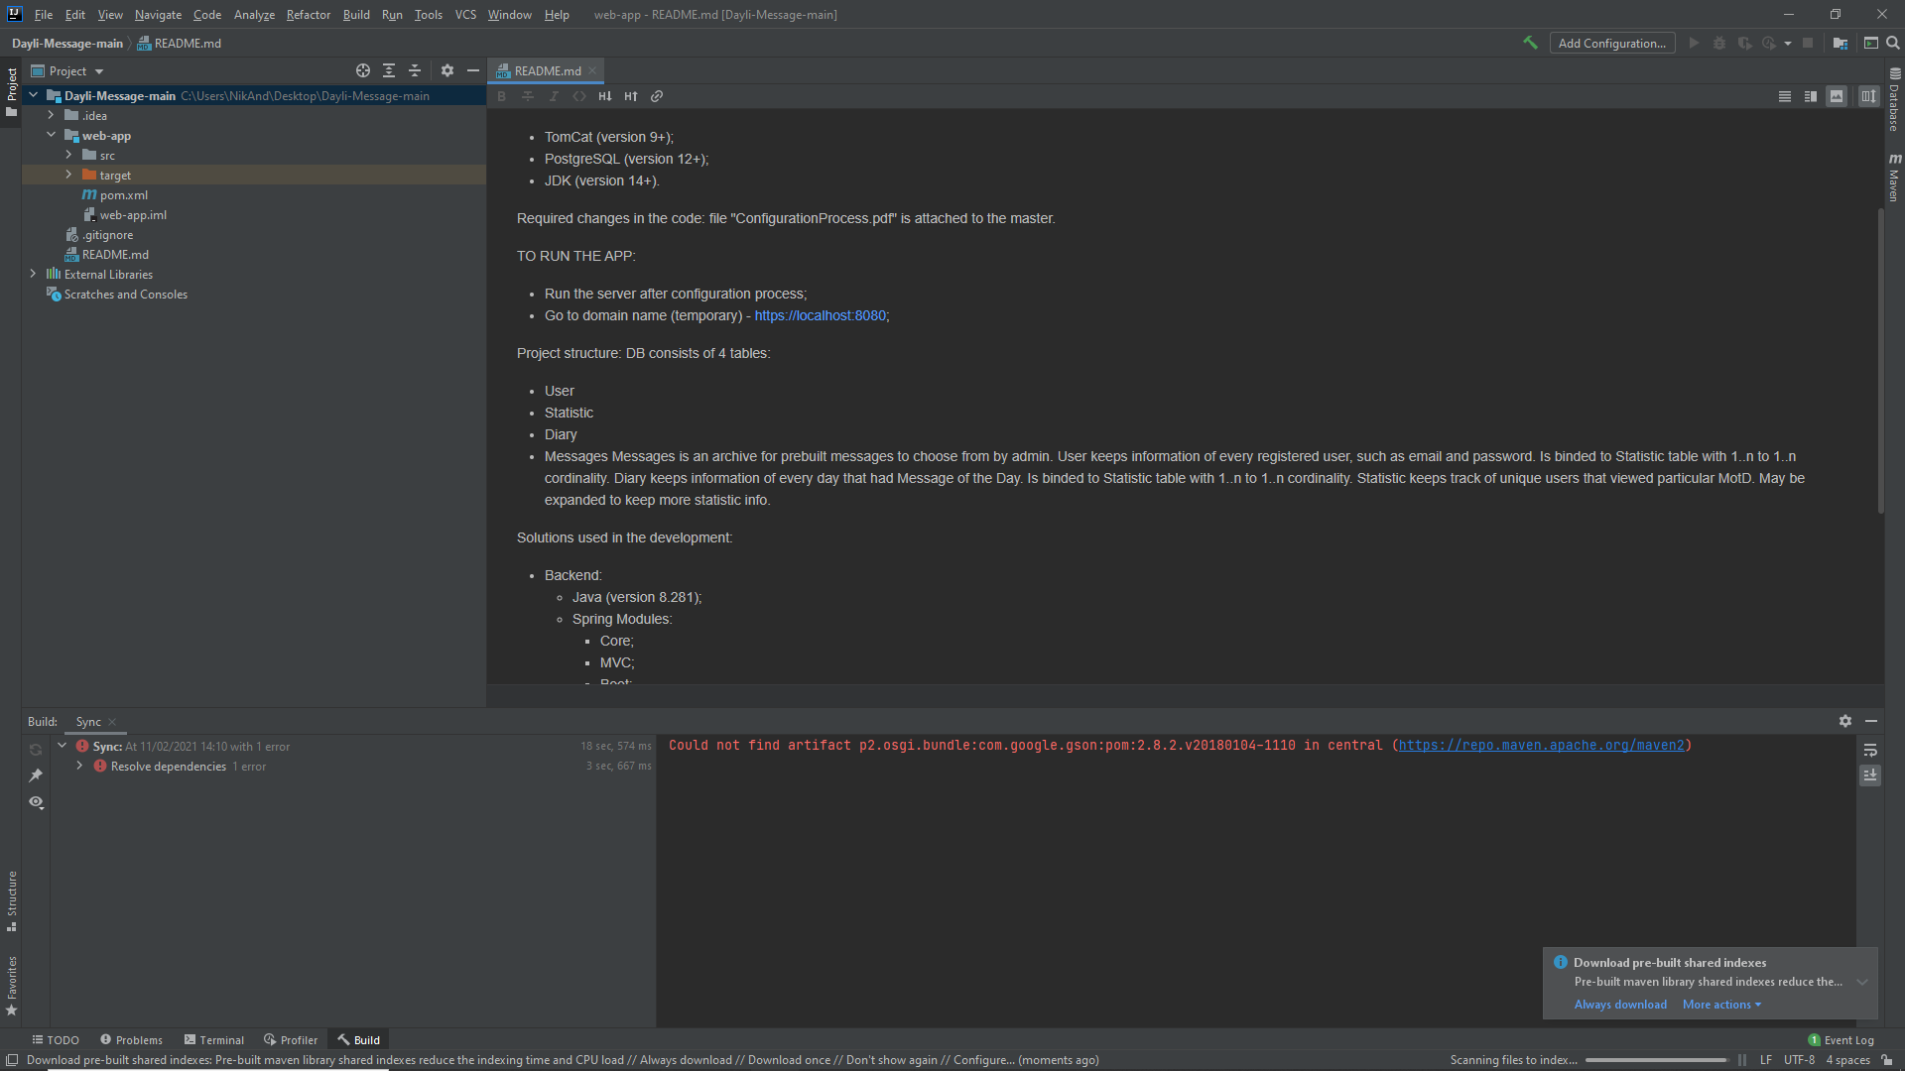

1. Press Add Configuration on the top right

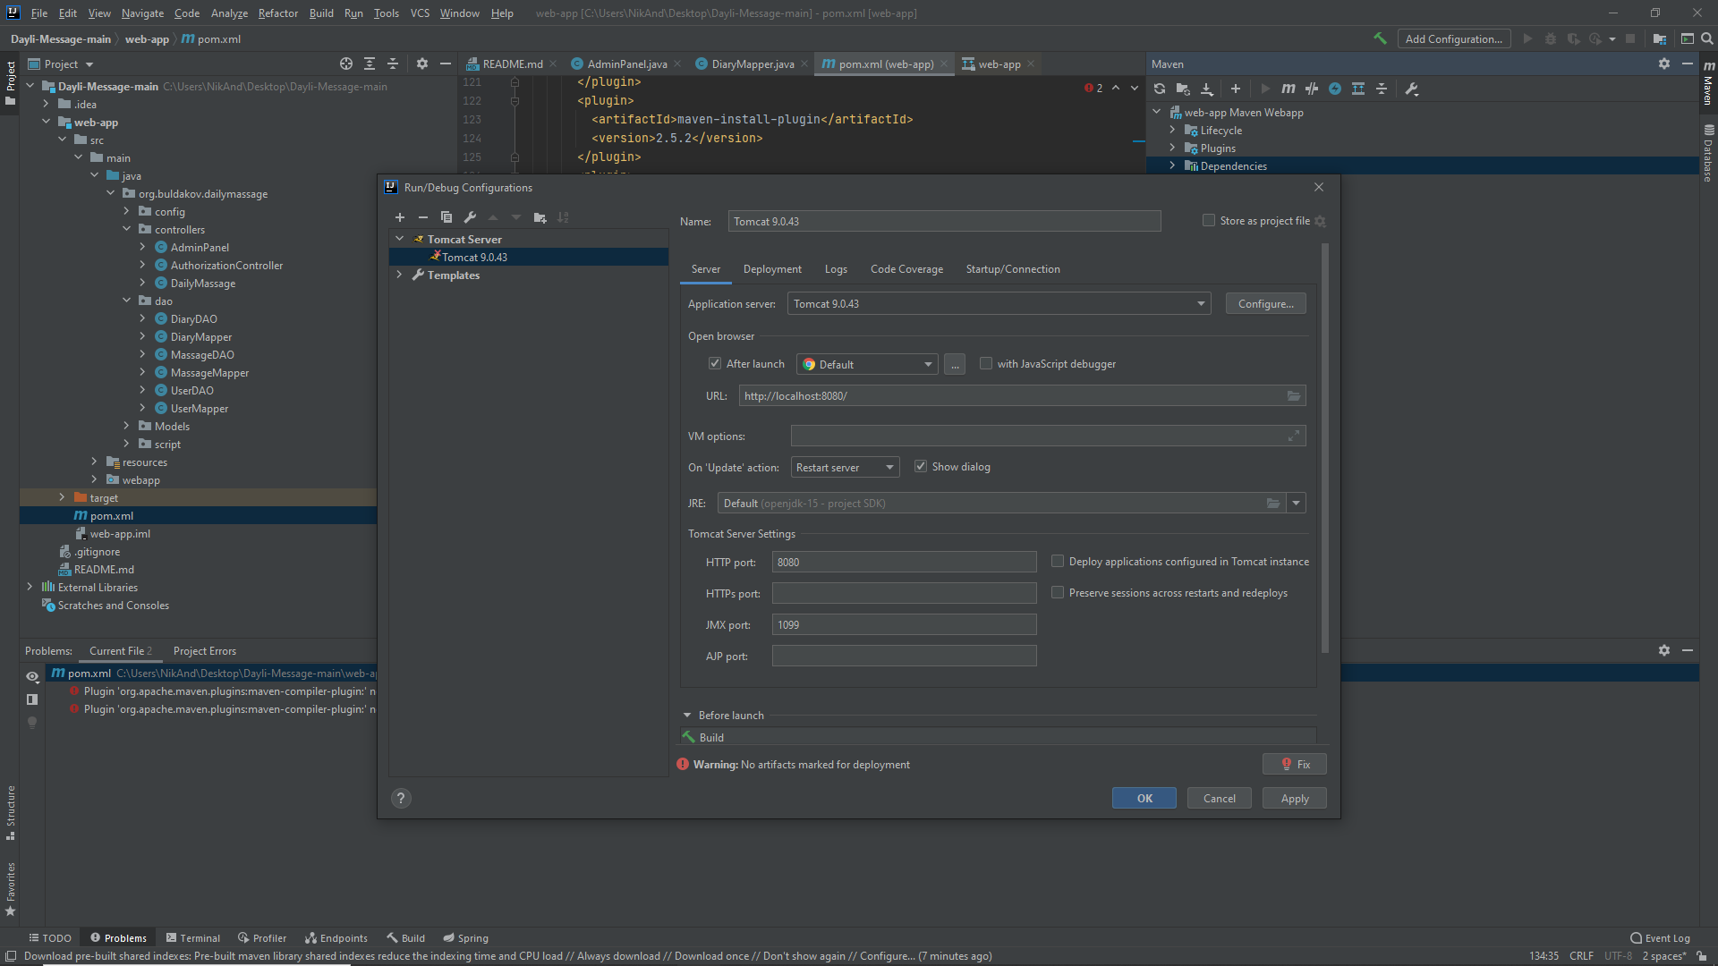

1. Press the + sign in the pop-up window



1. Add Tomcat server local and press Enter. You will have this window if done correctly.

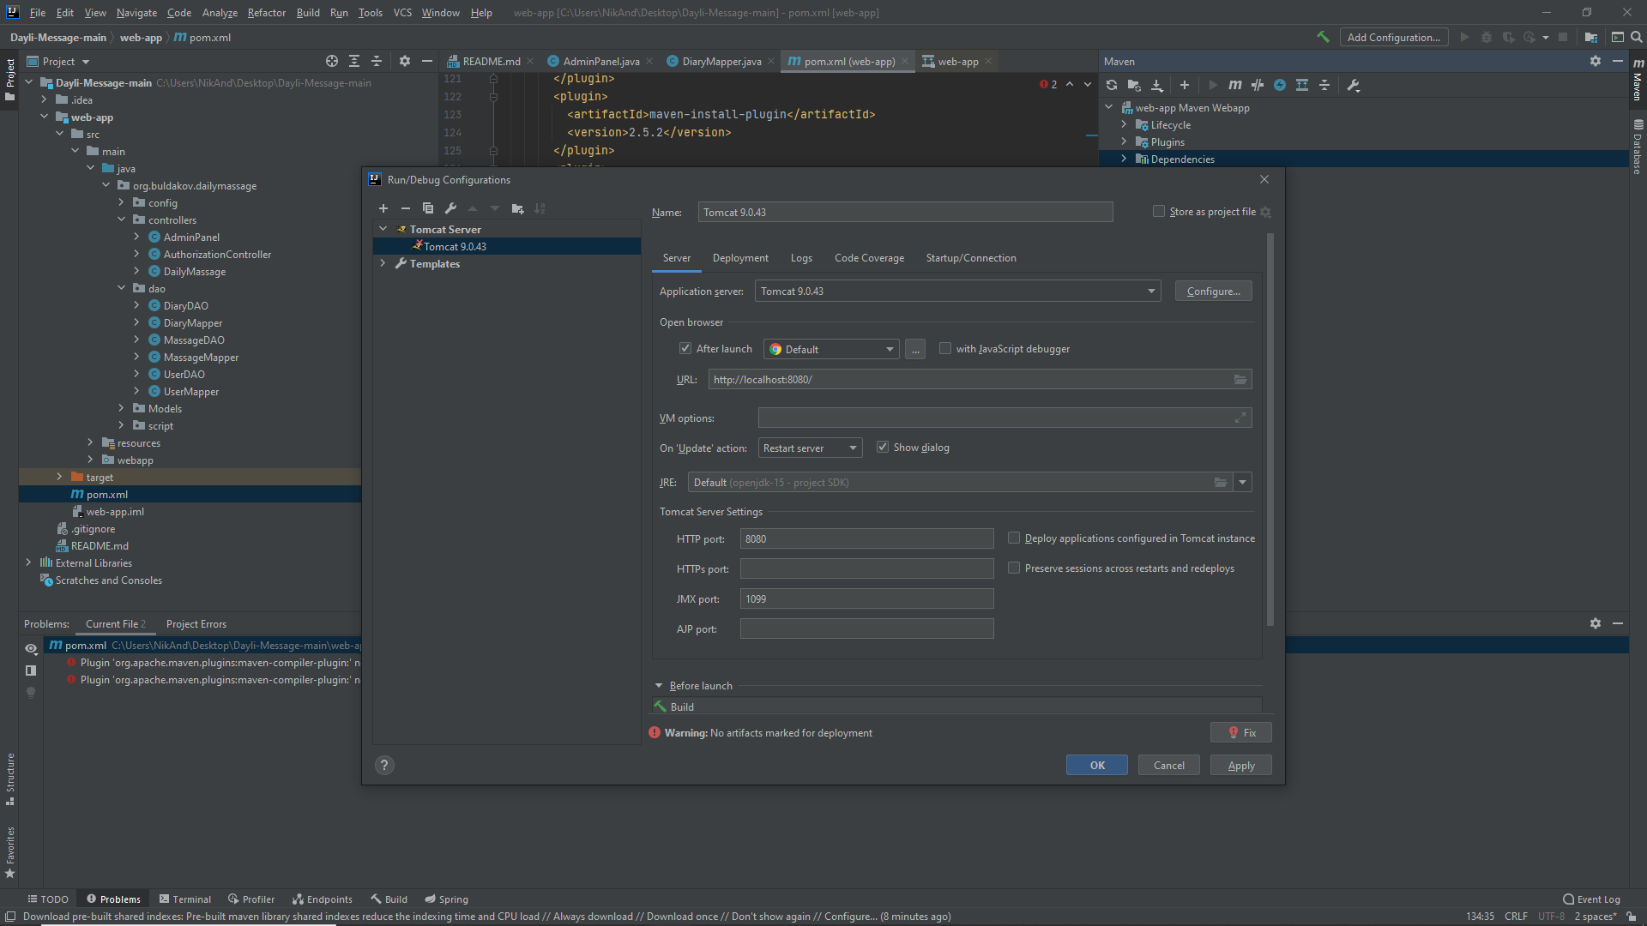

1. Press configure (on the same line as Application server dropdown). You will see the window below. Add your path to the installed tomcat to the Tomcat Home.

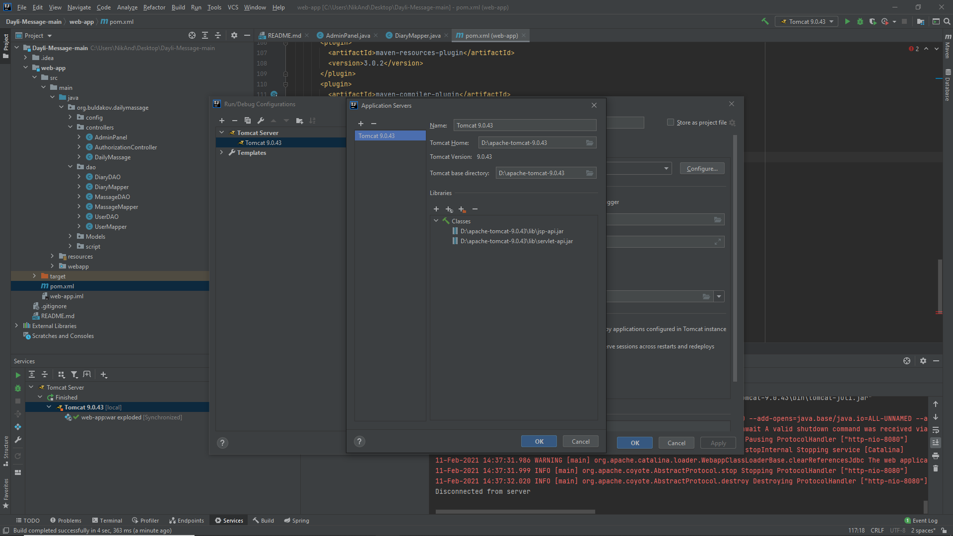

1. You will have some issues, press fix -> web-app: war exploded

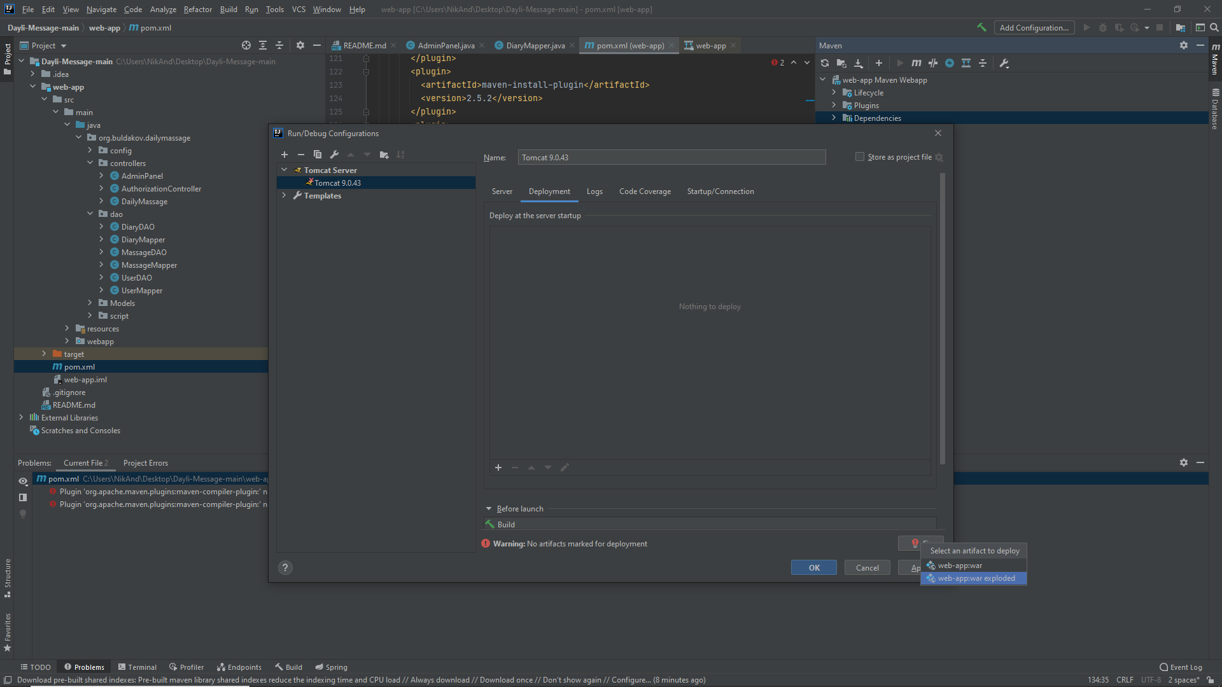

1. Clear Application context. Press apply and ok.

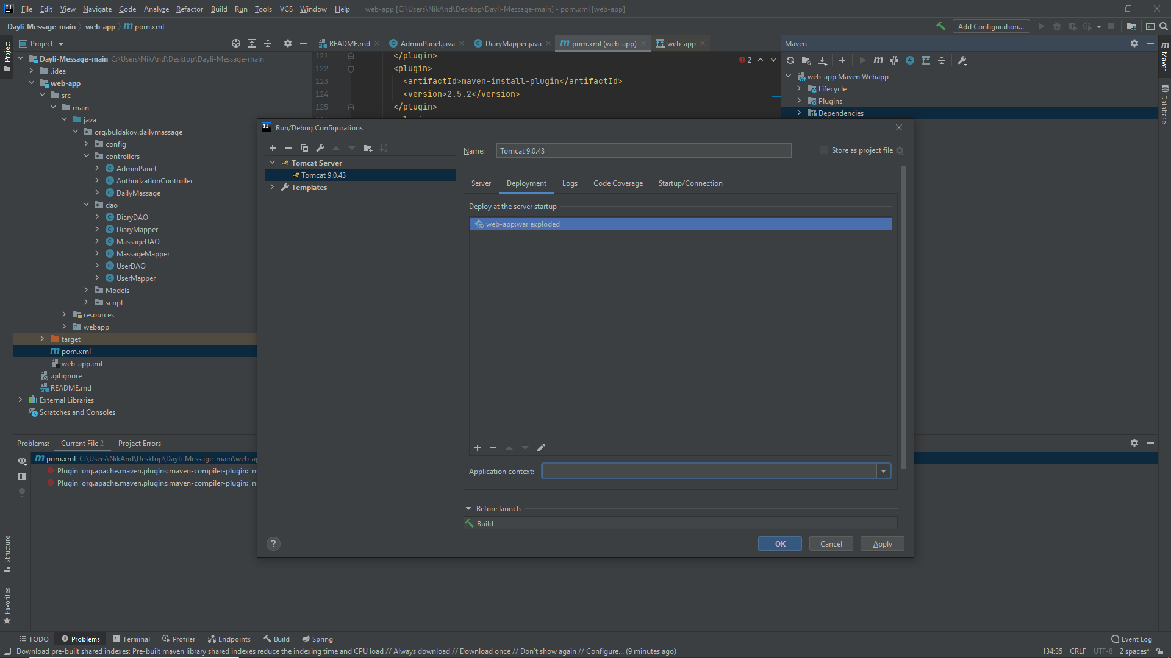

1. Find Database tab on the right. Open it and then press + -> Data Source -> PostgreSQL

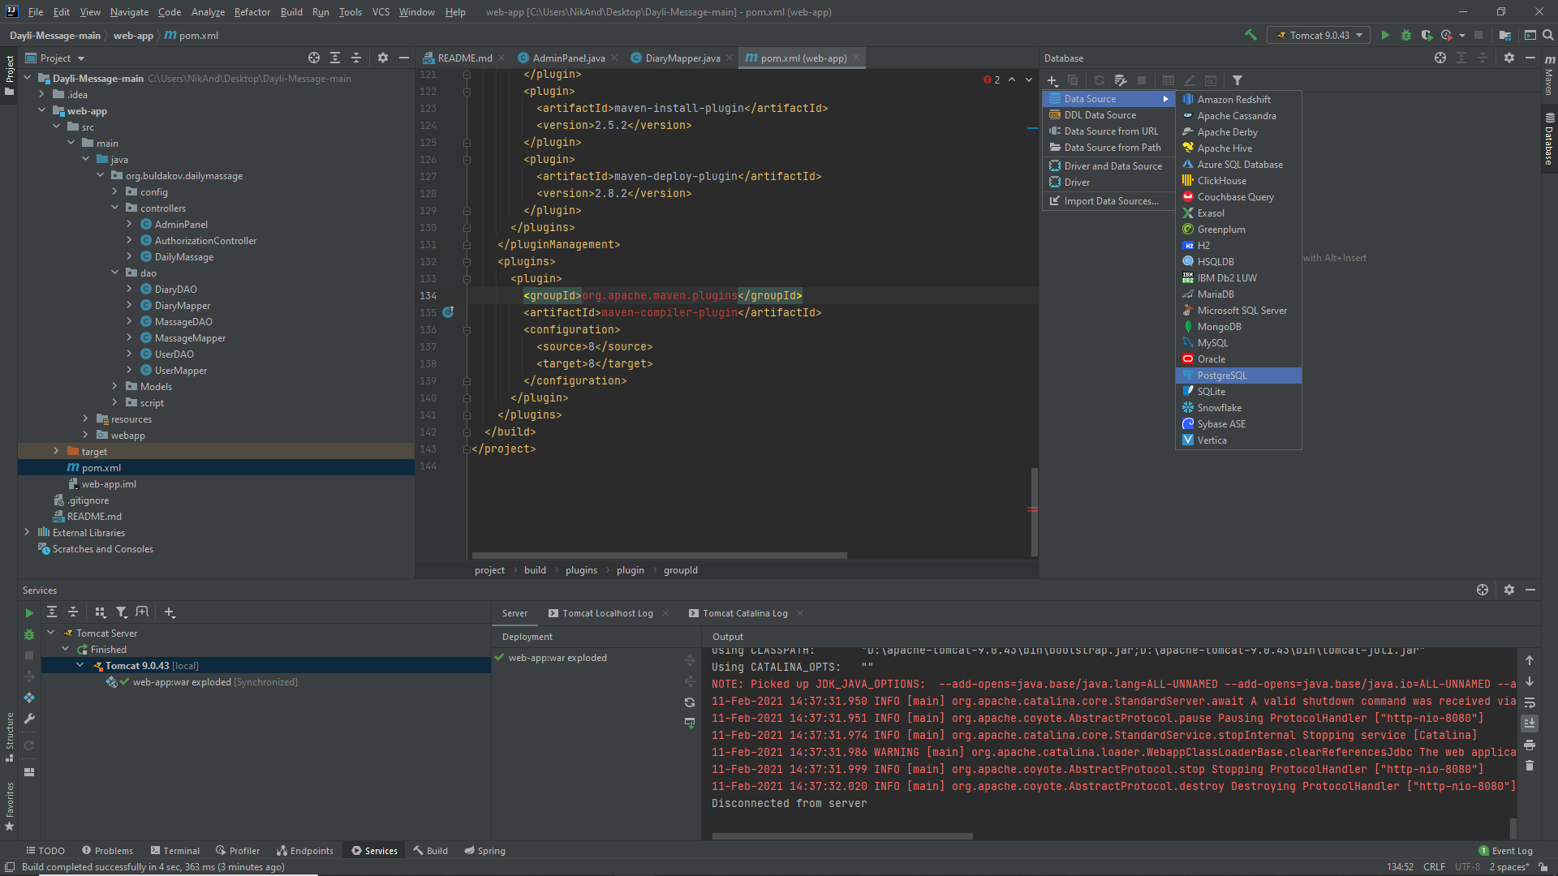

1. In the pop-ip window find user and password (if not sure, use default: postgres, rty456)

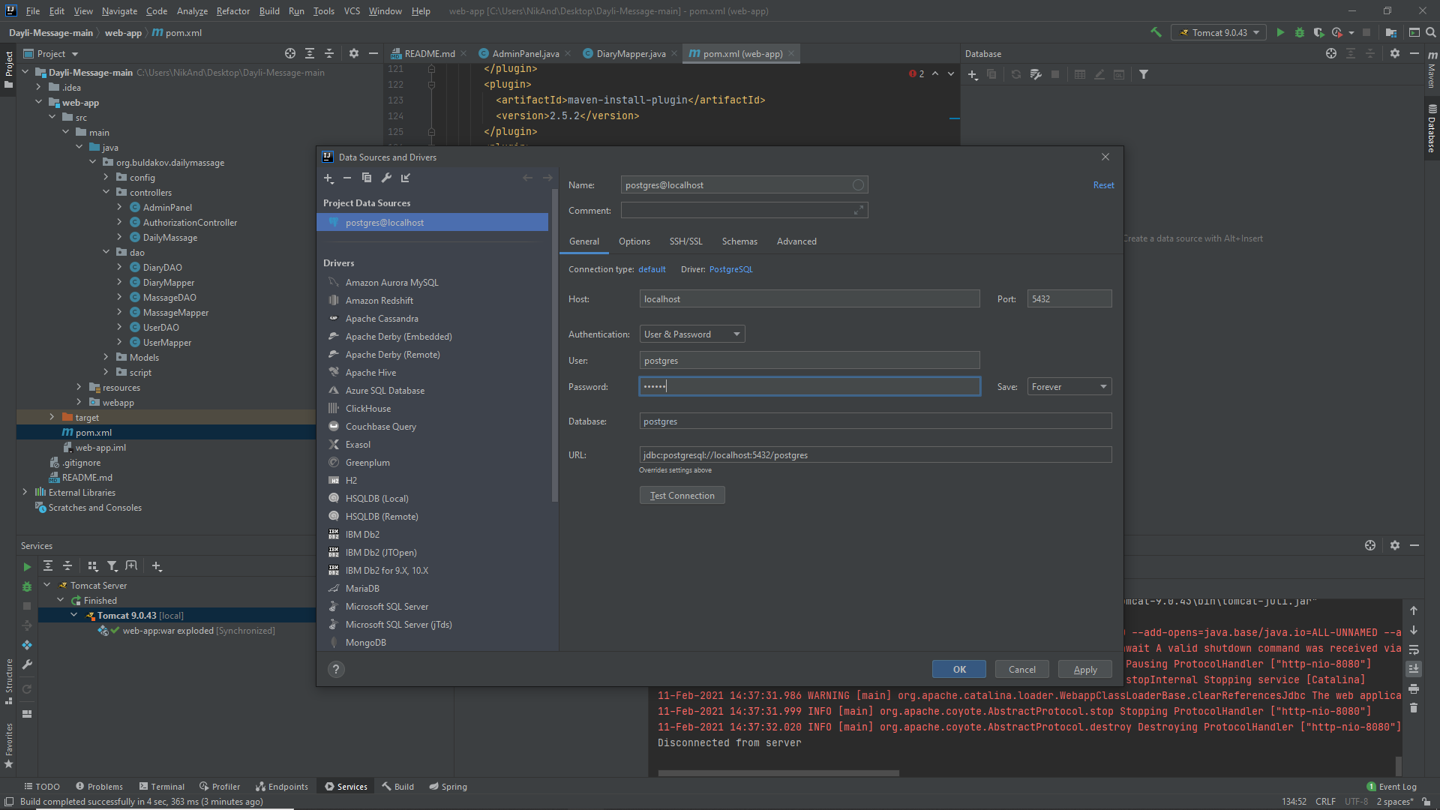

1. Press test connection. If everything is ok, press apply and ok.

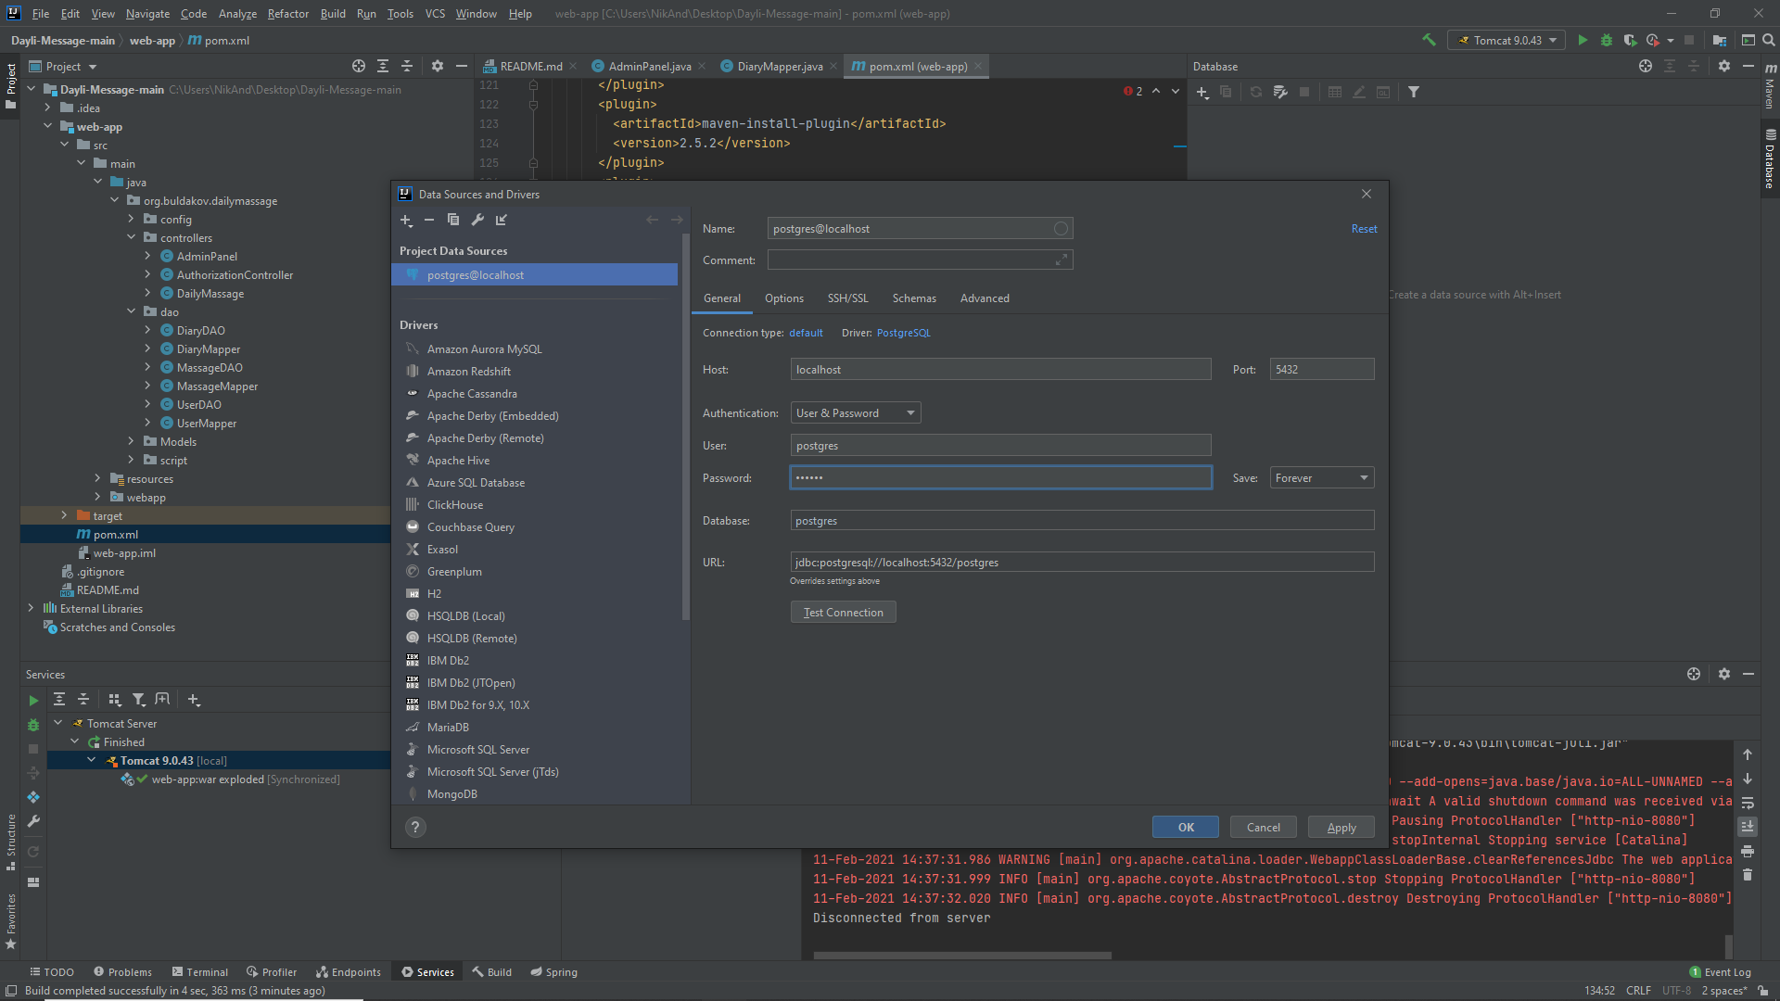

1. On the right side you can find DB tab. Right click on DB name and left click on “Jump to Query Console”

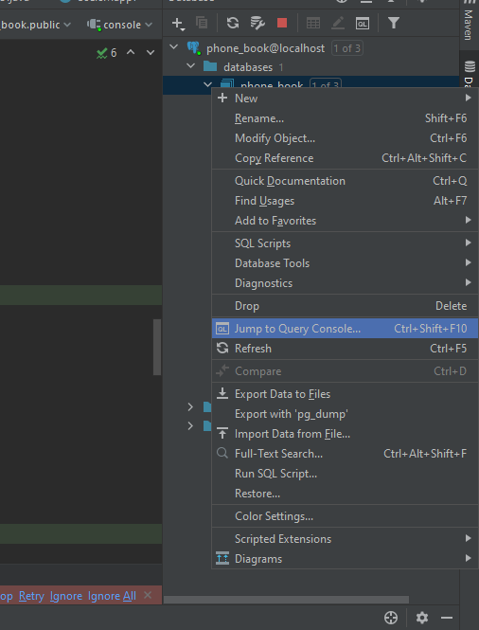

1. Find on left tab resources derictory and copy all data from PhoneBookDump to Console

