**PIZZA SALES SQL QUERIES**

**A. KPI’s**

**1. Total Revenue:**

SELECT SUM(total_price) AS Total_Revenue FROM pizza_sales;

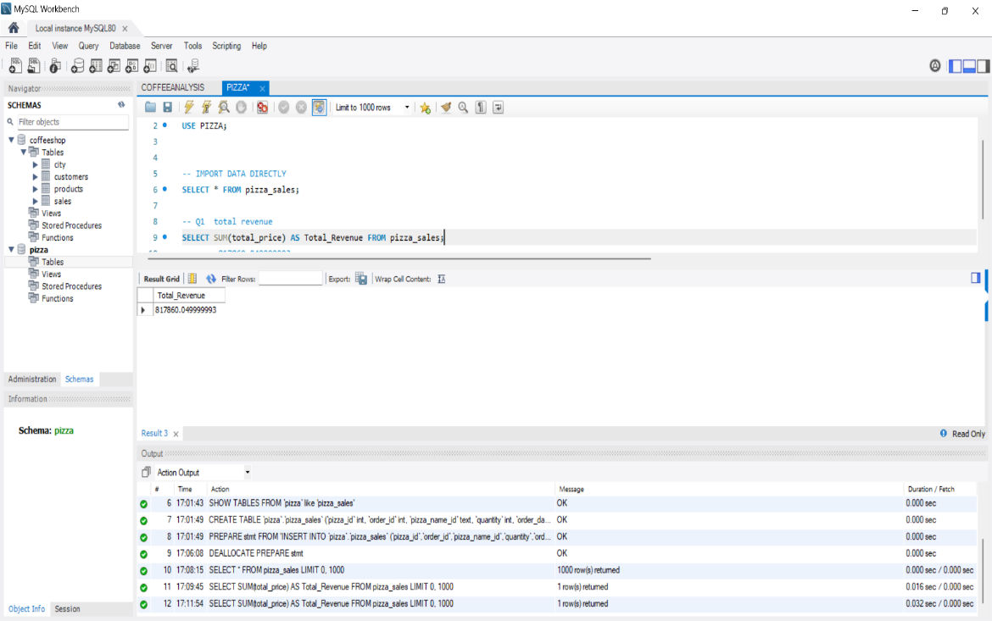

**2. Average Order Value**

SELECT (SUM(total_price) / COUNT(DISTINCT order_id)) AS Avg_order_Value FROM pizza_sales;

**3. Total Pizzas Sold**

SELECT SUM(quantity) AS Total_pizza_sold FROM pizza_sales;

**4. Total Orders**

SELECT COUNT(DISTINCT order_id) AS Total_Orders FROM pizza_sales;

**5. Average Pizzas Per Order**

SELECT CAST(CAST(SUM(quantity) AS DECIMAL(10,2)) /

CAST(COUNT(DISTINCT order_id) AS DECIMAL(10,2)) AS DECIMAL(10,2))

AS Avg_Pizzas_per_order

FROM pizza_sales;

**C. Hourly Trend for Orders**

SELECT HOUR( order_time) as order_hours, COUNT(DISTINCT order_id) as total_orders

from pizza_sales

group by HOUR (order_time)

order by HOUR (order_time);

***Output***

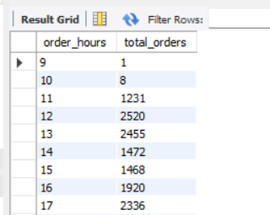

**D. % of Sales by Pizza Category**

SELECT pizza_category, CAST(SUM(total_price) AS DECIMAL(10,2)) as total_revenue,

CAST(SUM(total_price) * 100 / (SELECT SUM(total_price) from pizza_sales) AS DECIMAL(10,2)) AS PCT

FROM pizza_sales

GROUP BY pizza_category;

***Output***

**E. % of Sales by Pizza Size**

SELECT pizza_size, CAST(SUM(total_price) AS DECIMAL(10,2)) as total_revenue,

CAST(SUM(total_price) * 100 / (SELECT SUM(total_price) from pizza_sales) AS DECIMAL(10,2)) AS PCT

FROM pizza_sales

GROUP BY pizza_size

ORDER BY pizza_size;

***Output***

**G. Top 5 Best Sellers by Total Pizzas Sold**

SELECT pizza_name, SUM(quantity) AS Total_Pizza_Sold

FROM pizza_sales

GROUP BY pizza_name

ORDER BY Total_Pizza_Sold DESC

LIMIT 5;

***Output***

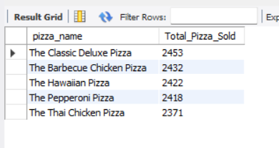

**H. Bottom 5 Best Sellers by Total Pizzas Sold**

SELECT SUM(quantity) AS Total_Pizza_Sold

FROM pizza_sales

GROUP BY pizza_name

ORDER BY Total_Pizza_Sold ASC

LIMIT 5;

***Output***

