Heart Disease Risk Classifier
End-to-end ML model development, CI/CD and production deployment
MLOps Experiential Learning Assignment · Introduction to MLOps (AIMLCZG523)
Item | Details
Code repository | <add your GitHub URL after pushing — see section 11>
Dataset | UCI Heart Disease, Cleveland subset (303 patients, 13 attributes)
Champion model | Logistic regression (C = 0.3, L2, class_weight = balanced)
Headline result | CV ROC-AUC 0.907 ± 0.019 · test ROC-AUC 0.961 · test recall 0.929
Serving | FastAPI /predict in Docker, Kubernetes Deployment (2 replicas) behind a LoadBalancer Service
Access | Local: http://localhost:8000 (Docker) or the LoadBalancer IP (Kubernetes) — section 11
Video | video/pipeline_walkthrough.mp4 in the repository

1. Problem and approach
The goal is to predict whether a patient has heart disease from routine clinical measurements, and to run that model as a reproducible, tested, containerised and monitored service. The target is binary: num = 0 means no disease and num = 1–4 (angiographic narrowing > 50 %) is treated as disease.
The work follows the MLOps lifecycle covered in the course: versioned data and code, experiment tracking, a single preprocessing-plus-model pipeline for training and serving, automated tests and quality gates in CI, an immutable container image, a declarative Kubernetes deployment with probes and rolling updates, and request-level logging and metrics. Figure 1 shows how the pieces fit together.
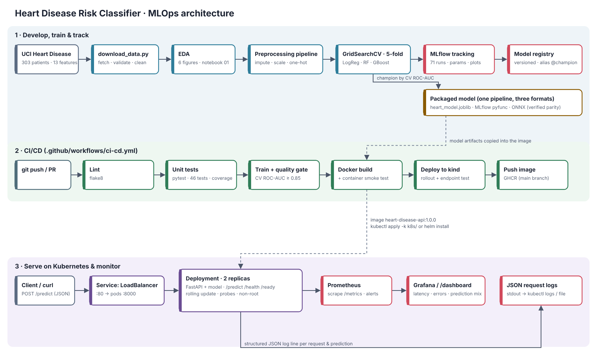
Figure 1. Solution architecture: develop and track (lane 1), CI/CD (lane 2), serve and monitor (lane 3).

2. Setup and installation
Everything runs from a clean environment with requirements.txt (Python 3.11 in CI, 3.12 also tested). Versions of every direct dependency are pinned, plus SQLAlchemy, whose 2.1 release breaks the MLflow 2.22 SQLite backend. The serving image uses a smaller requirements-serve.txt.
git clone <repo-url> heart-disease-mlops && cd heart-disease-mlops
python -m venv .venv && source .venv/bin/activate
pip install -r requirements.txt && pip install -e .
python scripts/download_data.py # raw + cleaned data
python -m heart.eda # figures
python -m heart.train # tuning, MLflow, packaged model
python -m pytest -v && flake8 # tests and lint
mlflow ui --backend-store-uri sqlite:///mlflow.db --port 5000
make help exposes the same steps, and scripts/run_ci_locally.sh runs the full CI sequence on a workstation. The setup was verified by cloning the repository into an empty directory, creating a new virtual environment with plain pip, deleting the data and model folders, and running every step above plus the three notebooks.

3. Data acquisition and EDA

3.1 Acquisition and cleaning
scripts/download_data.py downloads processed.cleveland.data from the UCI archive. If UCI is unreachable it falls back to the direct file URL and then to a public mirror of the same 303 records, converting its text labels back to UCI codes. It writes the URL used and the file's SHA-256 to data/raw/SOURCE.txt, so every run is traceable to its exact input.
Cleaning (heart.data.clean) coerces every column to numeric, drops duplicates and unlabelled rows, turns physiologically impossible values and unknown category codes into missing values, and binarises the target. The data has only six missing cells (ca: 4, thal: 2). They are deliberately not imputed in the cleaned file. Imputation happens inside the model pipeline and is fitted on training folds only, so statistics from the test set never leak into training.

3.2 Findings
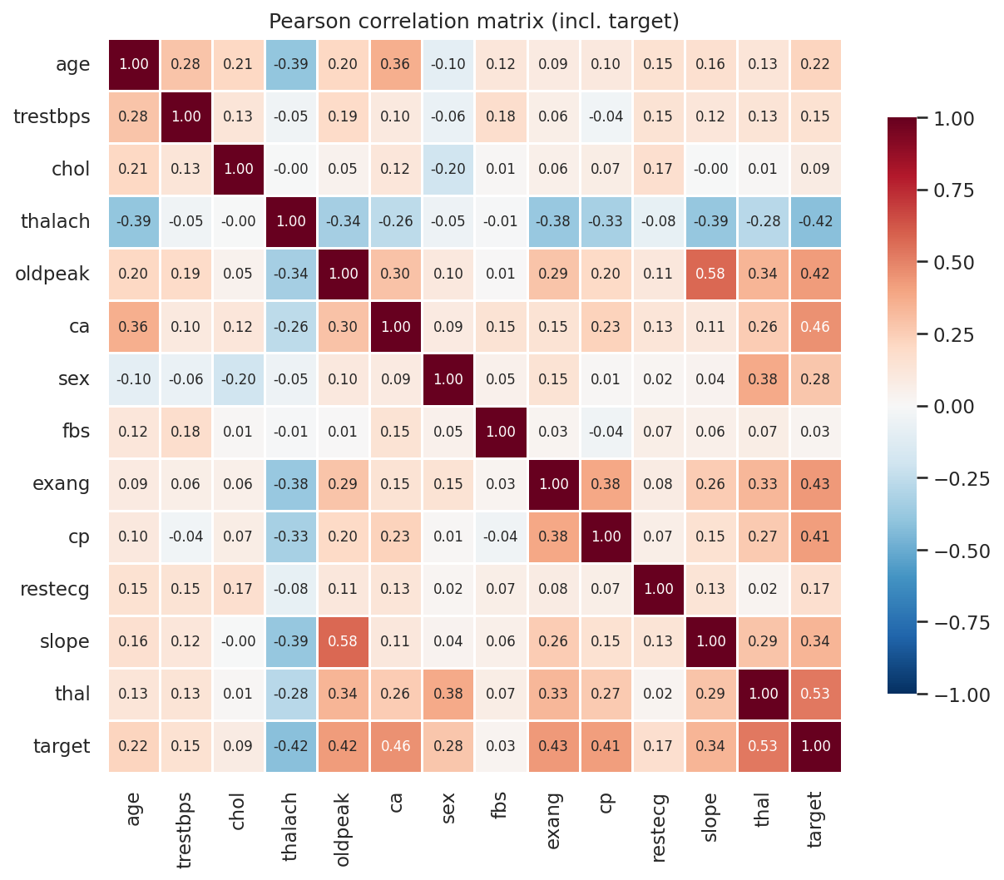
Figure 2. Correlation matrix including the target.
- Balanced classes (164 vs 139, 54 % / 46 %), so no resampling is needed. ROC-AUC is the selection metric because it does not depend on a threshold, and recall is reported because a missed case is the costliest error.
- Strongest signals: thal (0.53), ca (0.46), exang, oldpeak, cp (≈ 0.41–0.43) and a negative effect of maximum heart rate thalach (−0.42). These agree with clinical knowledge.
- chol (0.09) and fbs (0.03) carry little signal on their own. They are kept and left to regularisation.
- cp, restecg, slope and thal are nominal codes (thal = 3/6/7), so they are one-hot encoded rather than used as numbers.
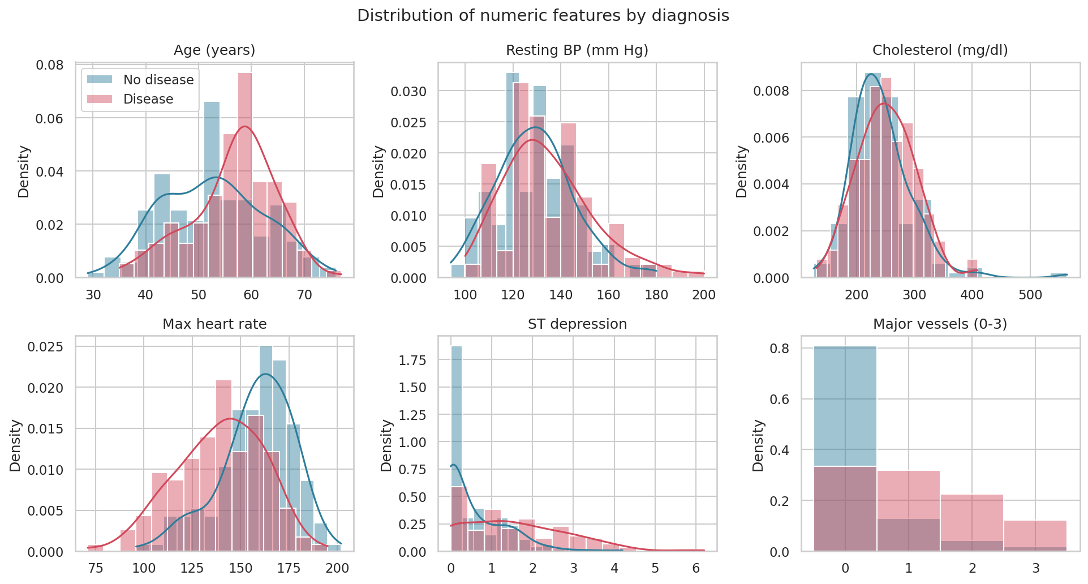
Figure 3. Numeric features by diagnosis. Disease shifts age and ST depression up and maximum heart rate down.
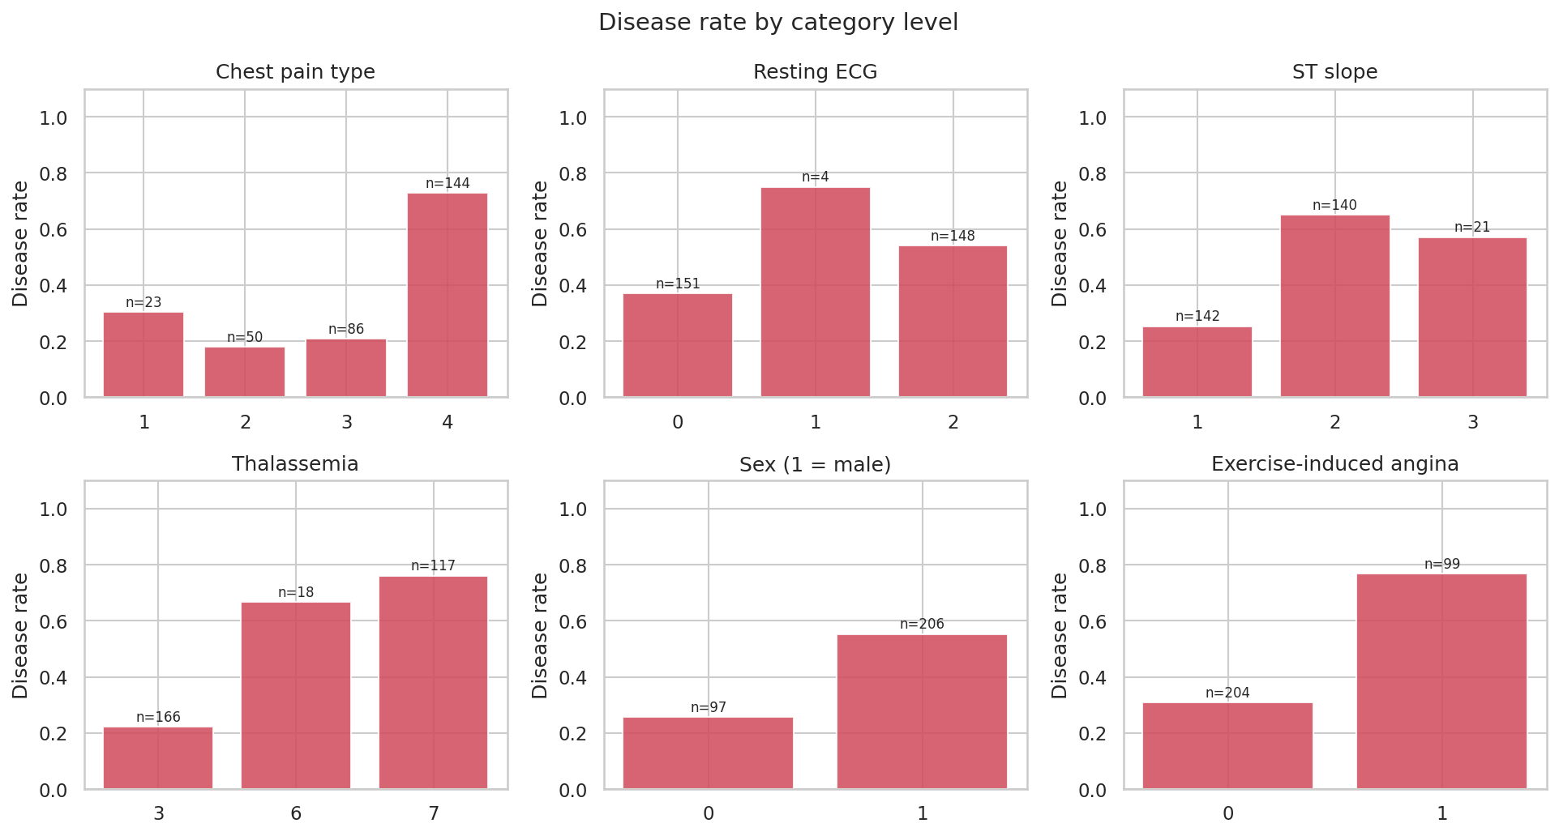
Figure 4. Disease rate per category level (n = patients in the level).
The remaining figures (class balance, missing values, outlier box plots) are in reports/figures/ and notebooks/01_eda.ipynb.

4. Feature engineering and model development

4.1 Preprocessing pipeline
A single scikit-learn ColumnTransformer (heart.features) turns 13 raw inputs into 22 model features:
- 6 numeric features (age, trestbps, chol, thalach, oldpeak, ca): median imputation, then standard scaling. Scaling is switched off for tree models, which do not need it.
- 3 binary flags (sex, fbs, exang): most-frequent imputation.
- 4 nominal features: most-frequent imputation, then one-hot encoding with the fixed UCI category levels and handle_unknown="ignore", so the encoding is identical in every fold and at serving time.
The transformer is the first step of the saved Pipeline. The API therefore applies exactly the medians, scaling statistics and categories learned in training, which removes training-serving skew by construction.

4.2 Models, tuning and selection
Data is split 80/20, stratified and seeded (242 training, 61 test). Three model families are tuned with GridSearchCV and 5-fold stratified CV on the training split. Each candidate is scored on accuracy, precision, recall, F1 and ROC-AUC, and the best is refitted on ROC-AUC. Validation curves in notebooks/02_training.ipynb set the grid ranges: logistic regression is flat for C ≥ 0.1, and random-forest training AUC reaches 1.0 for deep trees while CV AUC plateaus at depth 4–8.
Model | Grid (candidates) | Best parameters
Logistic regression | C ∈ {0.01…10} × L1/L2 × class weight (24) | C = 0.3, L2, balanced
Random forest | trees × depth × min leaf × max features (36) | 200 trees, depth 4, leaf 5, sqrt
Gradient boosting | trees × learning rate × depth (8) | 100 trees, lr 0.03, depth 2

The champion is chosen on mean CV ROC-AUC, never on the test set, which is used only once for the final estimate.
Model | CV ROC-AUC | CV accuracy | CV precision | CV recall | Test ROC-AUC | Test recall
Logistic regression | 0.907 ± 0.019 | 0.855 ± 0.027 | 0.882 ± 0.070 | 0.801 ± 0.075 | 0.961 | 0.929
Random forest | 0.901 ± 0.024 | 0.826 ± 0.029 | 0.841 ± 0.049 | 0.773 ± 0.087 | 0.956 | 0.929
Gradient boosting | 0.879 ± 0.029 | 0.822 ± 0.029 | 0.831 ± 0.068 | 0.783 ± 0.085 | 0.954 | 0.929

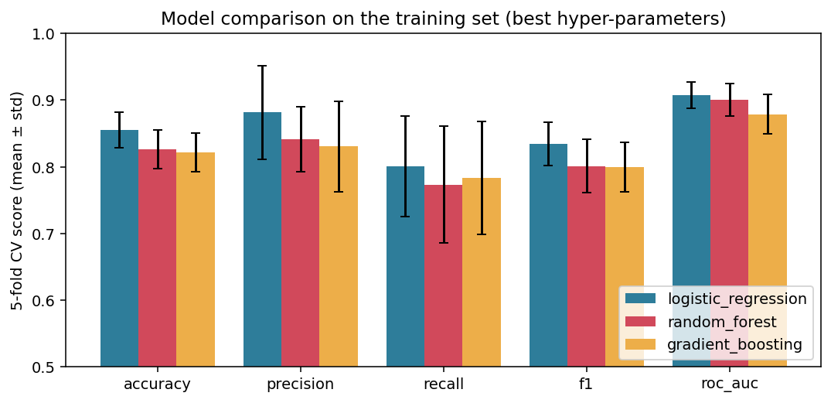
Figure 5. 5-fold CV scores of the tuned models (error bars = standard deviation across folds).
Why logistic regression wins. With 242 training rows and mostly additive, monotonic risk factors, a regularised linear model matches or beats the ensembles on CV ROC-AUC (0.907 vs 0.901 and 0.879) and has the lowest variance across folds. It is also interpretable and tiny to serve. Its test scores are higher than its CV scores, but with only 61 test patients that gap is within sampling noise, so the CV estimate is treated as the reliable one. At the 0.5 threshold it misses 2 of 28 disease cases in the test set (recall 0.93).
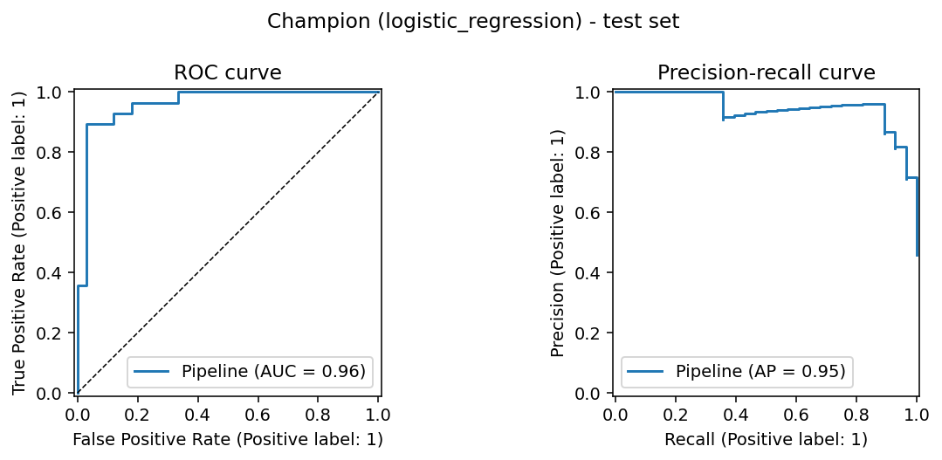
Figure 6. Champion on the held-out test set: ROC and precision-recall curves.

5. Experiment tracking (MLflow)
heart.train logs to an MLflow tracking store (SQLite backend, local artifact store). Every training run creates:
- One parent run per model family: best hyper-parameters, CV mean/std for all five metrics, test metrics, fit time, a train-vs-CV gap, the fitted pipeline with an input signature and example, and evaluation artifacts (confusion matrix, ROC/PR curves, feature importance, full cv_results.csv).
- One nested run per grid candidate (68 in total) with its parameters and CV metrics, so every configuration that was tried is tracked, not only the winners.
- Lineage tags on every run: git commit, SHA-256 of the cleaned data, dataset name and mode.
- Model Registry: the champion is registered as heart-disease-classifier with the alias @champion and a cv_roc_auc tag.
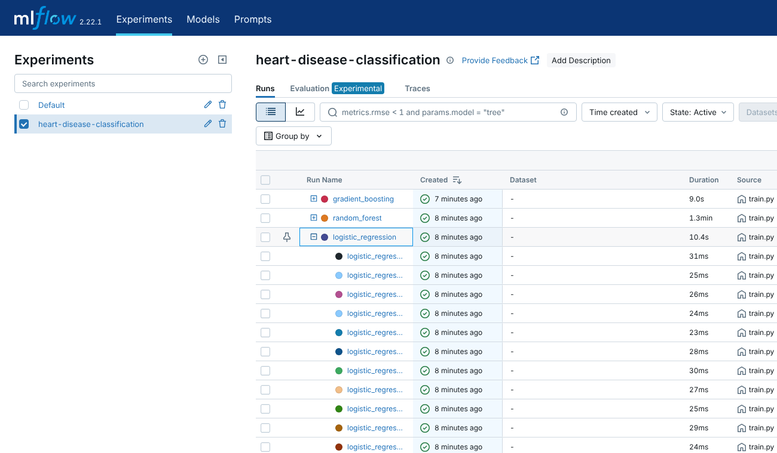
Figure 7. MLflow experiment: three parent runs, with the logistic-regression run expanded to show its nested grid candidates.
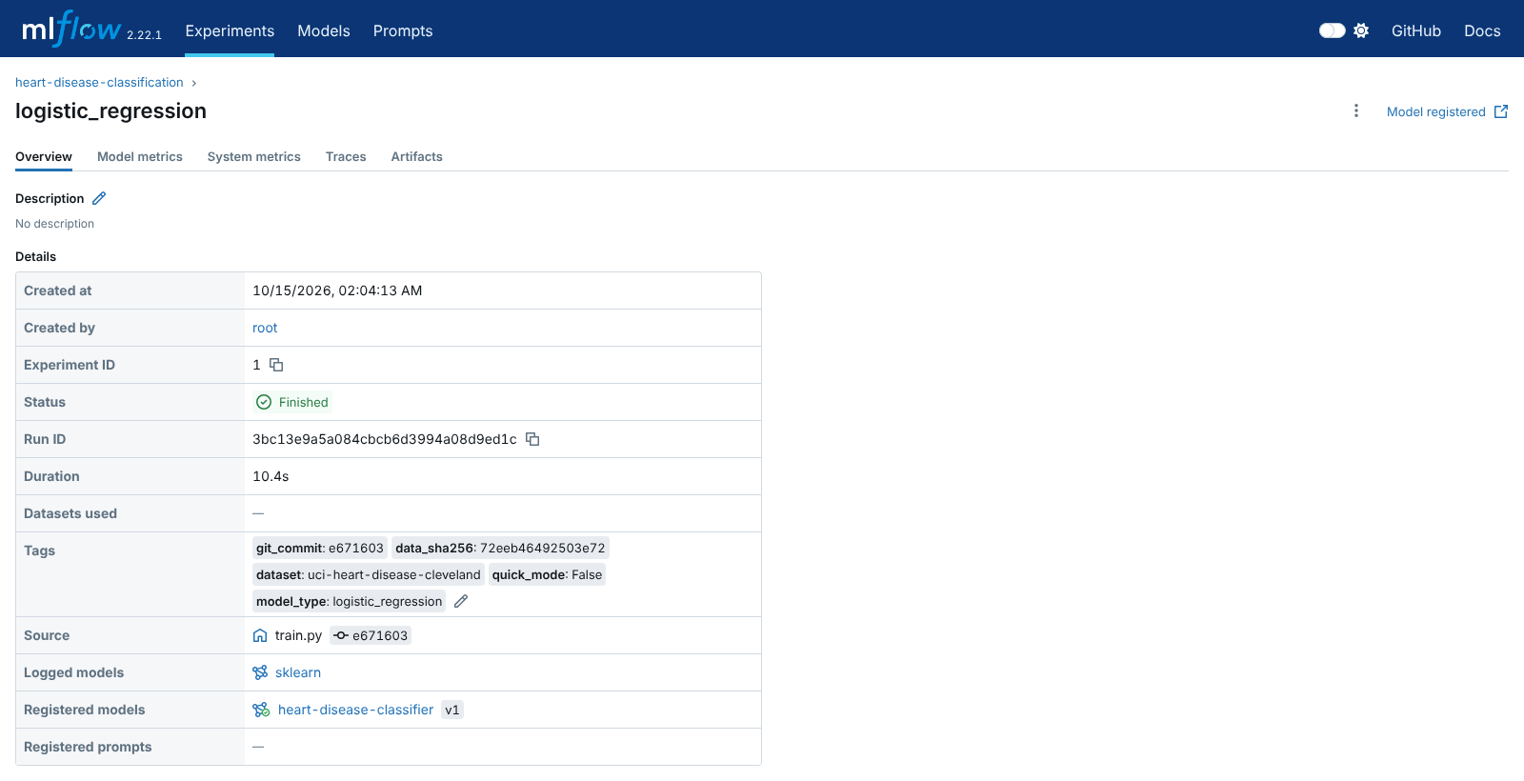
Figure 8. Champion run: lineage tags (git commit, data hash), parameters and metrics.
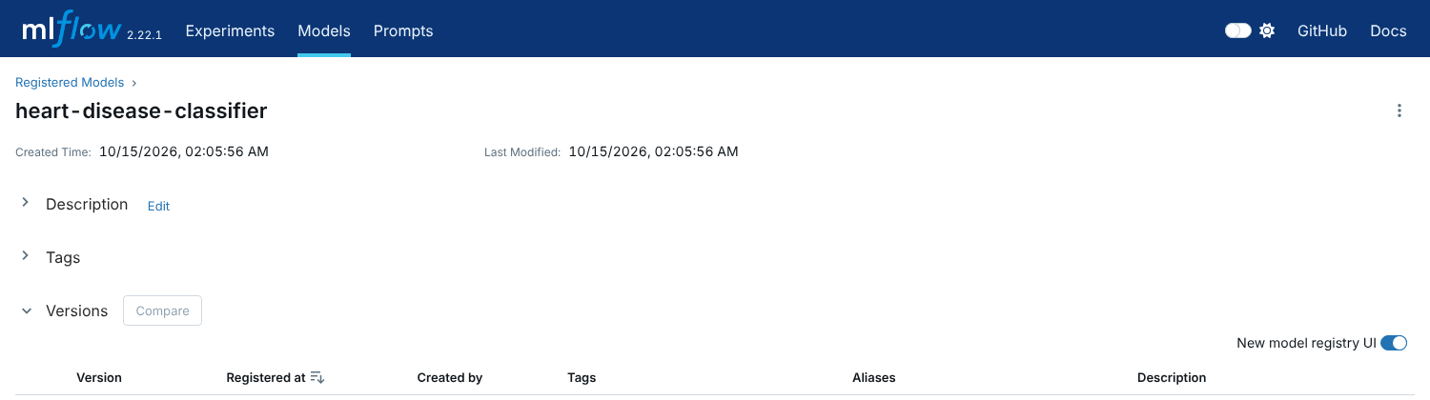
Figure 9. Model Registry: version 1 with the @champion alias.
scripts/export_mlflow_runs.py exports all 71 runs to reports/mlflow_runs.csv for reporting. More views (chart comparison, artifacts) are in screenshots/.

6. Model packaging and reproducibility
The full pipeline (preprocessing plus classifier) is saved in three formats:
- models/heart_model.joblib – the scikit-learn pipeline, loaded by the API.
- models/mlflow_model/ – MLflow model (pyfunc + sklearn flavours) with signature, input example, conda.yaml and requirements.txt.
- models/heart_model.onnx – ONNX graph including preprocessing. The export is checked automatically: predictions must match scikit-learn within 1e-3, and the maximum difference observed was 9e-8.
models/model_metadata.json records the algorithm, parameters, CV and test metrics, decision threshold, feature list, training time, MLflow run id, git commit, data hash and library version. The API serves it at GET /model, so any prediction can be traced back to the code, data and run that produced the model. Reproducibility also rests on: fixed random seeds for the split, CV folds and models; pinned dependency versions; the committed cleaned dataset and train/test split; and a container image that freezes the runtime.

7. CI/CD pipeline and automated testing

7.1 Tests
Test module | Tests | What is checked
test_data.py | 12 | UCI parsing ('?' → NaN), mirror conversion, target binarisation, duplicates, impossible values, missing columns, download fallback and failure, committed dataset shape and class counts
test_features.py | 7 | output shape and names, no NaN after imputation, standardisation, one-hot integrity, unseen category handling, determinism
test_model.py | 10 | CV ROC-AUC > 0.85, valid probabilities, metric maths, confidence for both classes, risk ordering, packaged model reload, end-to-end training run in a temp dir
test_api.py | 17 | health, readiness, /predict output and confidence, null ca/thal, 7 invalid-input cases → 422, batch, metrics, /stats, dashboard, 503 without a model

Coverage is 86 % overall (100 % on features and schemas, 91 % on the API). The tests earned their place during development. An injected bug that computed the confidence from the wrong class initially passed, because the test patients were all low-risk. The tests were then extended to require both classes, and the bug is now caught (Figure 12).

7.2 GitHub Actions workflow
.github/workflows/ci-cd.yml (validated with actionlint) runs on every push and pull request. Jobs depend on each other in sequence, and every step runs under bash -euo pipefail.
Job | Steps | Artifacts / logs
lint | flake8, with errors annotated on the PR | lint-report
test | install from requirements, pytest + coverage, summary in the run page | JUnit XML, coverage XML/HTML
train | download + clean, EDA, GridSearchCV + MLflow, quality gate (fail if CV ROC-AUC < 0.85), comparison table in the summary | models/, reports/, training.log, MLflow store
docker | build image, run container, smoke_test.sh (health, ready, predict, batch, 422, metrics), push to GHCR on main | image tarball, build and container logs
deploy-k8s | kind cluster, helm lint + template, apply manifests, wait for rollout, smoke test through the Service, describe/logs on failure | kubectl status, rendered Helm chart

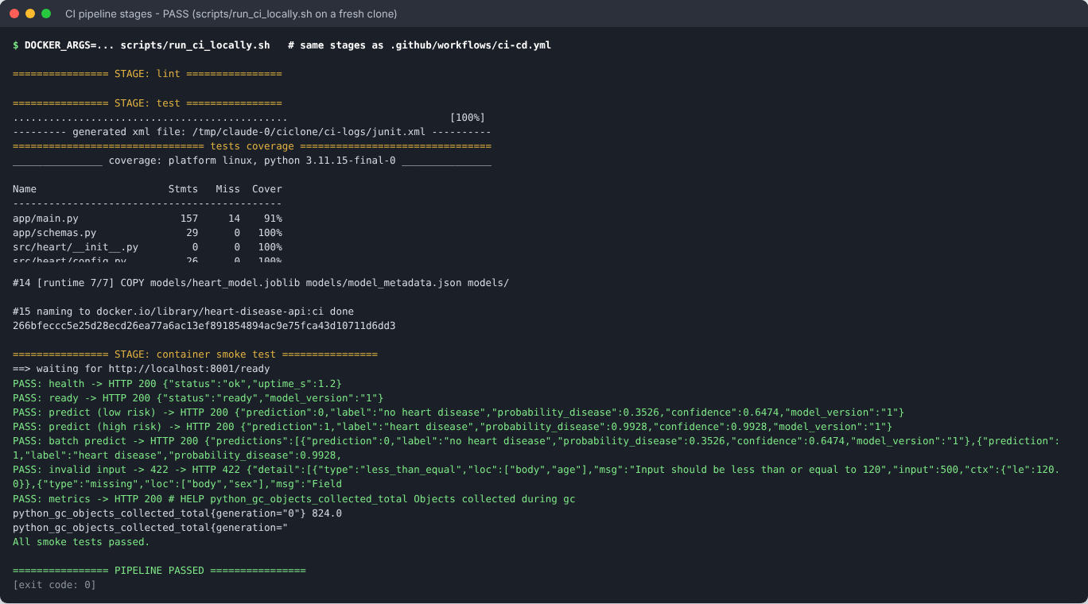
Figure 10. All pipeline stages passing on a fresh clone (scripts/run_ci_locally.sh runs the same stages as the workflow). Middle section trimmed.
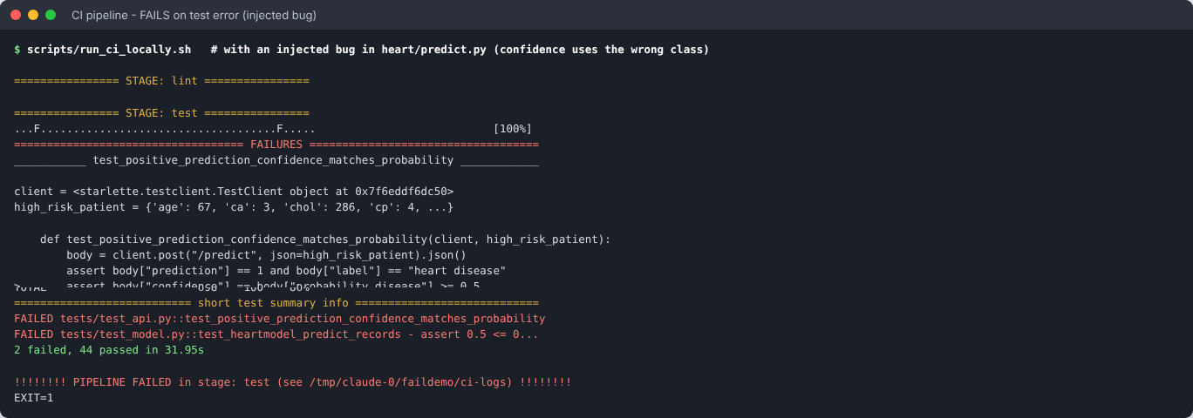
Figure 11. The pipeline stops at the test stage on an injected bug, with the failing assertions and a clear stage name. Middle section trimmed.
A lint error stops the pipeline at the first stage in the same way (screenshots/term_15_ci_fails_on_lint_error.png).

8. Model containerisation
The FastAPI service (app/main.py) exposes POST /predict, which takes one patient as JSON and returns the prediction, label, probability of disease, confidence (probability of the predicted class) and model version. It also exposes /predict/batch, /health, /ready, /model, /metrics, /stats and /dashboard. Pydantic validates every field's range and code set, rejects unknown fields, and accepts null for ca/thal.
The Dockerfile is multi-stage. A builder stage creates a virtual environment with serving dependencies only. The runtime stage copies that environment, the package, the API and the model, runs as a non-root user (uid 10001), and defines a HEALTHCHECK on /health. The base image is a build argument (default python:3.11-slim).
docker build -t heart-disease-api:1.0.0 .
docker run -d -p 8000:8000 --name heart-api heart-disease-api:1.0.0
curl -X POST localhost:8000/predict -H 'content-type: application/json' -d @samples/patient_high_risk.json
{"prediction":1,"label":"heart disease","probability_disease":0.9928,"confidence":0.9928,"model_version":"1"}
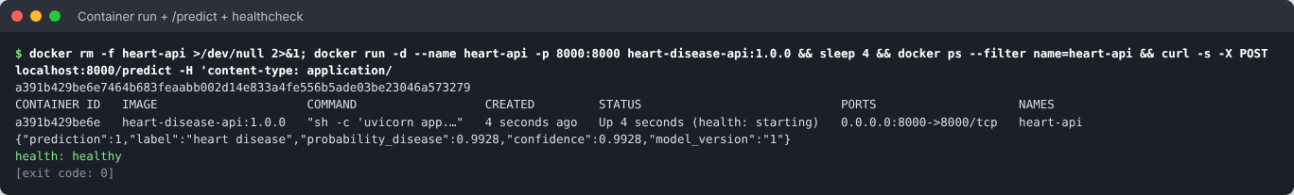
Figure 12. Container running locally: prediction with confidence, healthcheck reported healthy.

9. Production deployment (Kubernetes)
k8s/ holds plain manifests applied with kubectl apply -k k8s/: a namespace, a ConfigMap, a Deployment, a LoadBalancer Service, an Ingress and an HPA. helm/heart-api/ packages the same deployment as a Helm chart. The Deployment has the following settings:
- 2 replicas and a rolling update with maxUnavailable: 0.
- A readiness probe on /ready, so traffic is routed only once the model is loaded, and a liveness probe on /health.
- CPU and memory requests and limits.
- A read-only root filesystem, dropped capabilities and a non-root user.
- Prometheus scrape annotations.
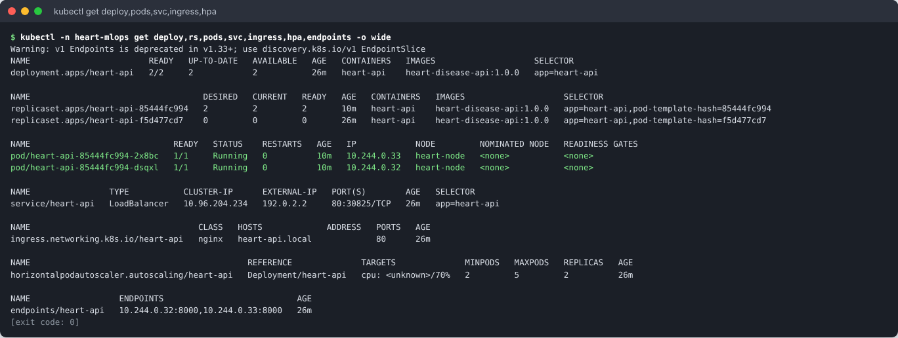
Figure 13. Deployment 2/2 ready, both pods running, LoadBalancer Service with an external IP, Ingress and HPA.
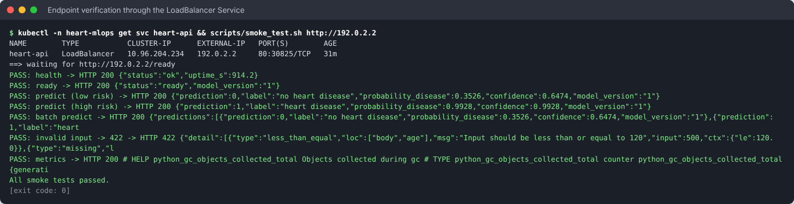
Figure 14. Endpoint verification through the LoadBalancer IP: all smoke checks pass.
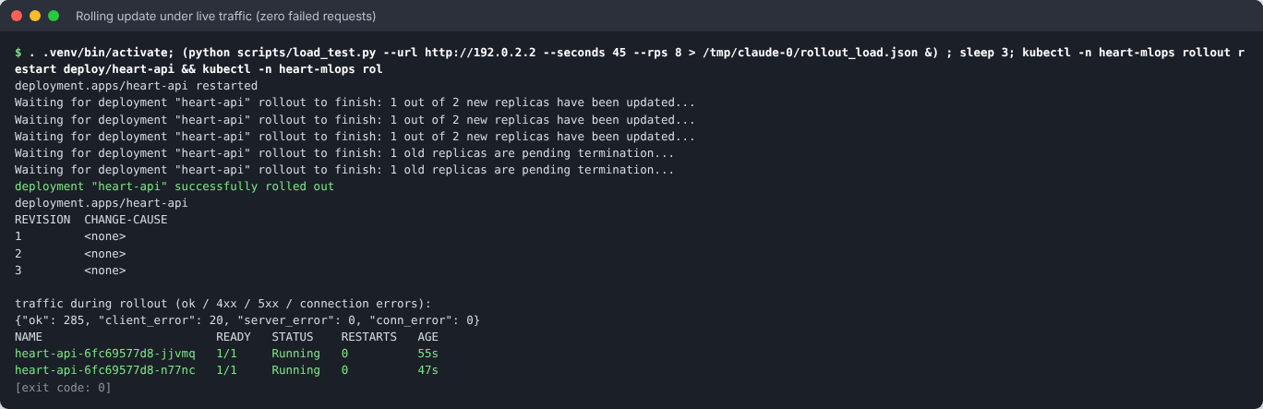
Figure 15. Rolling update under live traffic: 285 successful requests and 0 server or connection errors. The 20 4xx are deliberately malformed requests from the load generator.
A live /predict call through the LoadBalancer from the Swagger UI is in screenshots/api_03_swagger_predict_executed.png. The CI deploy-k8s job repeats the deployment on a fresh kind cluster for every commit.

10. Monitoring and logging
- Logging: middleware writes one JSON line per request (request id, method, path, status, latency, client). Each prediction is logged with its inputs, output and model version. The request id is returned in the x-request-id header for correlation. Logs go to stdout (read with kubectl logs) and optionally to a rotating file.
- Metrics (/metrics, Prometheus format): request count by endpoint and status, a latency histogram, predictions by class, a predicted-probability histogram, error count, model_loaded and model_info{version}.
- Alerts (monitoring/alerts.yml, checked with promtool): API down, error rate > 5 %, p95 latency > 500 ms, model not loaded, and a prediction-mix drift signal (share of positive predictions far from the 46 % training prevalence).
- Dashboards: a provisioned Grafana dashboard (docker compose up) and a built-in /dashboard page in the API showing traffic, latency percentiles, error rate, prediction mix and the recent request log.
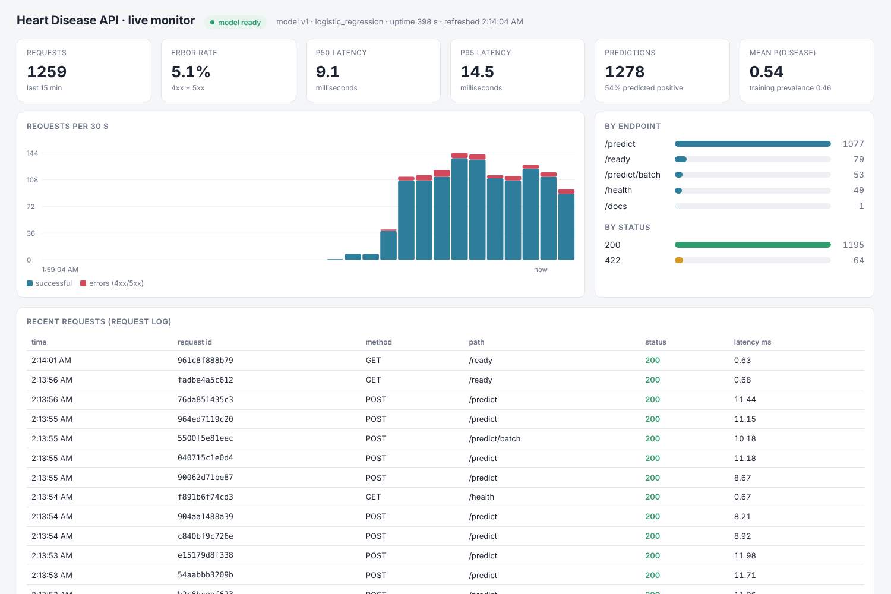
Figure 16. Built-in API monitoring dashboard during a load test (the error rate is the intentional 422 traffic).
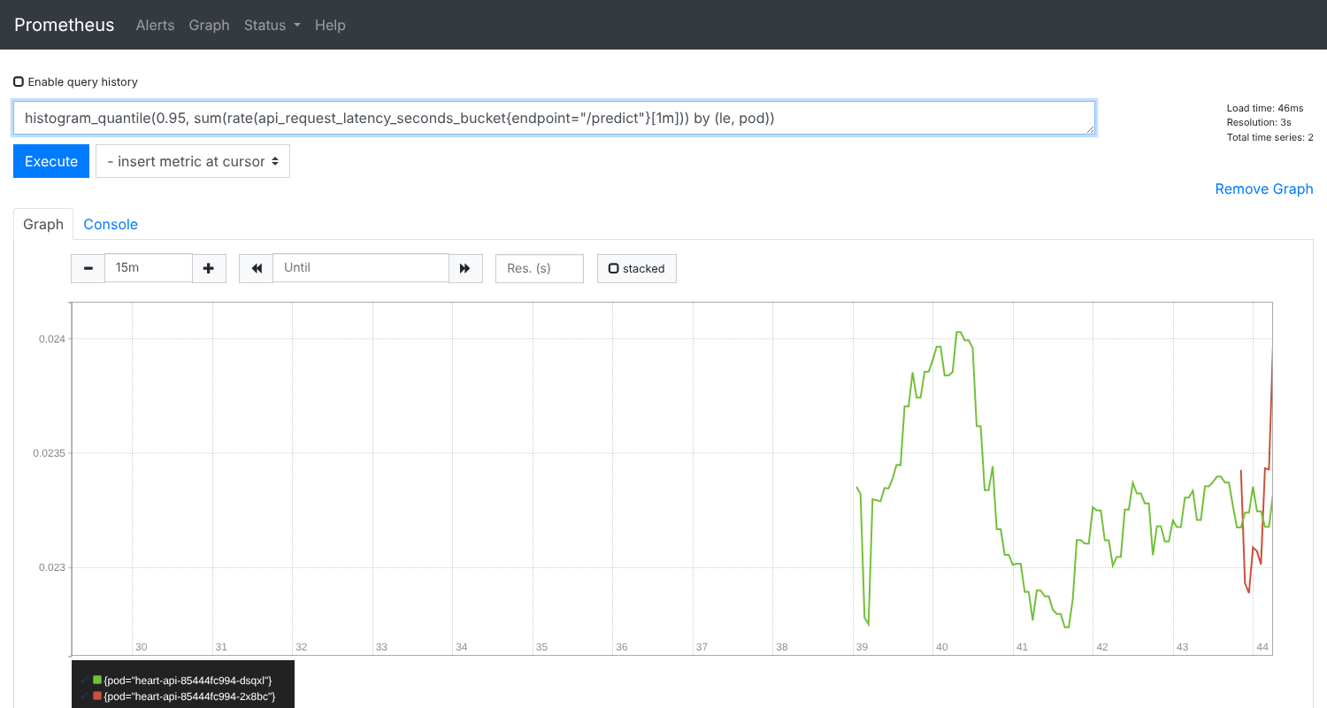
Figure 17. Prometheus: p95 latency of /predict per pod (about 23 ms) while the pods are scraped via pod discovery.

11. Repository, access and environment notes
Code repository: add the GitHub URL here after pushing (git remote add origin <url> && git push -u origin main). The first push triggers the GitHub Actions workflow; save screenshots of the run into screenshots/.
API access (local): run docker run -p 8000:8000 heart-disease-api:1.0.0 and open http://localhost:8000/docs. On Docker Desktop Kubernetes, kubectl apply -k k8s/ exposes the API at http://localhost/ through the LoadBalancer. On Minikube, run minikube tunnel and use the Service's EXTERNAL-IP. Test with scripts/smoke_test.sh <url>.
How the evidence was produced. The screenshots were captured in a Linux build sandbox whose network allowed only package registries and GitHub source code:
- Docker Hub was blocked, so the image was built with BASE_IMAGE set to a local Ubuntu 24.04 + Python 3.12 image. The Dockerfile is otherwise unchanged.
- The cluster is single-node Kubernetes v1.33.1 compiled from the official source, with containerd, CNI bridge networking and kube-proxy.
- A minimal controller assigned the node IP to the LoadBalancer Service, the role Docker Desktop or minikube tunnel plays.
- No Ingress controller or Grafana image could be pulled. The Ingress object is therefore defined but unused, and dashboards were shown with Prometheus and the API's built-in page. Both run normally with docker compose or on Minikube.
Limitations and next steps:
- The dataset is small (303 patients from one hospital), so performance estimates have wide uncertainty and need external validation before clinical use.
- The 0.5 decision threshold could be tuned for higher recall.
- Drift monitoring currently tracks the prediction mix. Input-distribution checks (e.g. Evidently) and automatic retraining from the registry would be the next additions.

