Design of PWM Controller for LED’s with GUI

Features:

* Parallel port generated PWM signals
* 256 variety of colours obtained
* Parallel port operates at upto 5 MHz
* Can generate Static, Discrete and Random colours as per user’s choice
* Works with +12 to +22 V dc supply
* Buffered parallel port for safety of the mother board
* Adjustable phase sequence of the PWM signals
* Gradual intensity control

Description:

This is a 3-channel LED driver that generates three independent PWM signals with adjustable phase shift. It controls LED brightness and colour with a Pulse Width Modulation (PWM) scheme that displays colours in the RGB or HSV colour space. The PWM signal is output from the LPTI parallel port in a standard desktop.

A parallel port is a [parallel communication](http://en.wikipedia.org/wiki/Parallel_communication) physical interface. It is also known as a **printer port.** This port will allow the input of up to 9 bits or the output of 12 bits at any one given time, thus requiring minimal external circuitry to implement many simpler tasks. The port is composed of 4 control lines, 5 status lines and 8 data lines. It's found commonly on the back of our PC as a D-Type 25 Pin female connector. A D-Type 25 pin male connector is used to connect the female connector with the circuit used for the LEDs.

The parallel port is kept in ECP mode (Extended Capabilities Mode) for our purpose. Output is sent via data pins 2, 3, 4. Pin no. 25 provides ground. These pins are connected with the driver circuit using the male connector. Driver circuit is used to enhance current capability of parallel port. Buffer is used to avoid loading the input circuit or source from the output stage.

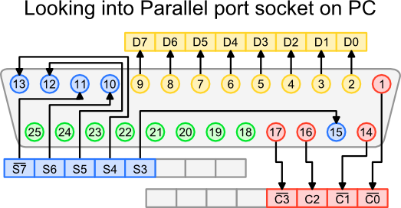

**Op-amp as a buffer** - The output of the Parallel Port is normally TTL logic levels. The voltage levels are the easy part. The sink and source current varies from port to port. Most Parallel Ports can sink and source around 12mA.A buffer amplifier is used, so the least current is drawn from the Parallel Port.

The output from the parallel port is buffered using LM741 for limiting the current drawn from the parallel port. This serves to protect the motherboard against any possible damage. The input impedance of the op-amp is very high (1 [MΩ](http://en.wikipedia.org/wiki/Ohm) to 10 [TΩ](http://en.wikipedia.org/wiki/Teraohm)), meaning that the input of the op-amp does not load down the source or draw any current from it. Because the output impedance of the op-amp is very low, it drives the load as if it were a perfect [voltage](http://en.wikipedia.org/wiki/Voltage_source) source.

**UNITY GAIN BUFFER**

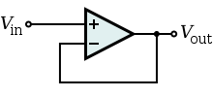

**Op-amp as an amplifier:**

The output from the buffer is amplified by LM741 operating in non inverting mode. LED strip requires 12 V in each channel at maximum intensity.

* Required Gain=12/4.45=2.69
* In Non Inverting Mode

Gain = (1+R2/R1)

Keeping R1=1KΩ

We have R2=1.69KΩ set by the POT.

+12V Supply to LM741 is given through SMPS.

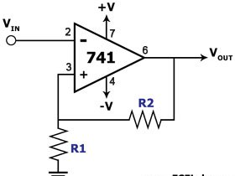

GND

**PWM Generation:**

Pulse width modulated signal is used to drive the leds so that they will be either completely ON or OFF. Duty ratio of a particular colour is calculated with the help of the parameter introduced in the program.

D(red) = (pixel value of RED entered by the user in the GUI window)/255

Similarly,duty ratio for the other 2 colours are decided.

With the help of duty ratio ON time of a particular colour is decided.

Different shades of colour are decided by combining different prportions of R,G and B.