Q1. Given the provided data, what are three conclusions that we can draw about crowdfunding campaigns?

* The provided data shows that the percent of successful campaigns (60.9%) were more than the failed and cancelled campaigns combined (37.4%). The top three popular crowdfunding campaign were Theater (specially Plays), Film and video, and Music, however the ratio of successful campaigns to failed + cancelled campaigns in these categories ranged between 1.2 to 1.4
* Journalism is the only category that showed 100% success rate; however, the number of campaigns were only 4 in 10 years. Under sub-category ‘World Music’ showed 100% success rate, but again the number of campaigns were only 3 in 10 years. After Journalism, technology campaigns had the maximum success rate (66.7%).

|  |  |  |  |  |  |  |  |  |
| --- | --- | --- | --- | --- | --- | --- | --- | --- |
| **Categories** | **Outcome** | | | | | | | |
| **Canceled** | **Failed** | **Live** | **Successful** | **Grand Total** | **% Successful** | **%Failure & Cancelled** | **Ratio (Successful)/ (Failed + Cancelled)** |
| **Film & Video** | 11 | 60 | 5 | 102 | 178 | 57.3 | 39.89 | 1.44 |
| **Food** | 4 | 20 |  | 22 | 46 | 47.83 | 52.17 | 0.92 |
| **Games** | 1 | 23 | 3 | 21 | 48 | 43.75 | 50 | 0.88 |
| **Journalism** |  |  |  | 4 | 4 | 100 | 0 | N/A |
| **Music** | 10 | 66 |  | 99 | 175 | 56.57 | 43.43 | 1.3 |
| **Photography** | 4 | 11 | 1 | 26 | 42 | 61.9 | 35.71 | 1.73 |
| **Publishing** | 2 | 24 | 1 | 40 | 67 | 59.7 | 38.81 | 1.54 |
| **Technology** | 2 | 28 | 2 | 64 | 96 | 66.67 | 31.25 | 2.13 |
| **Theater** | 23 | 132 | 2 | 187 | 344 | 54.36 | 45.06 | 1.21 |
| **Grand Total** | 57 | 364 | 14 | 565 | 1000 | 56.5 | 42.1 | 1.34 |
| **Average** |  |  |  |  |  | 60.9 | 37.37 |  |

* The number of backers for the successful campaigns were higher as compared to the one that failed, however, the average donations for successful and failed campaigns were more or less similar.

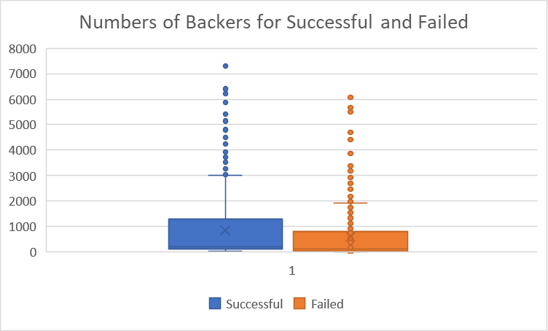 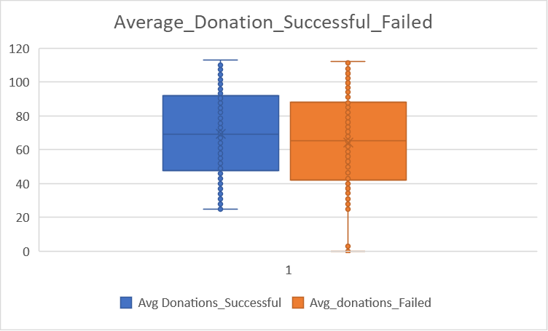

* The campaigns that aimed at raising more than 60,000 were at a higher risk of failure, whereas the campaigns with goals of raising less than 60,000 were more successful

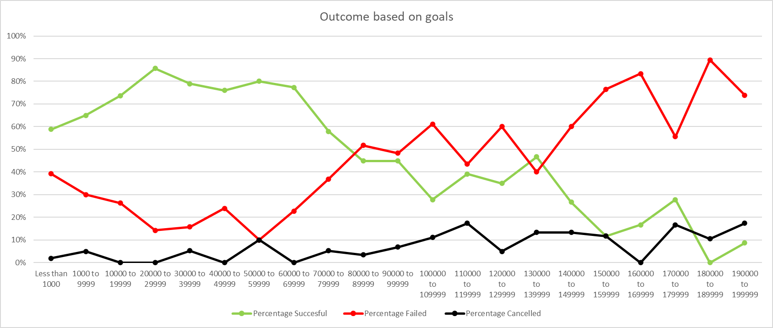

* 73% of the crowdfunding campaigns were originated in the US. From 2010 to 2019, US consistently had maximum number of crowdfunding campaign and therefore raised maximum amount of funds

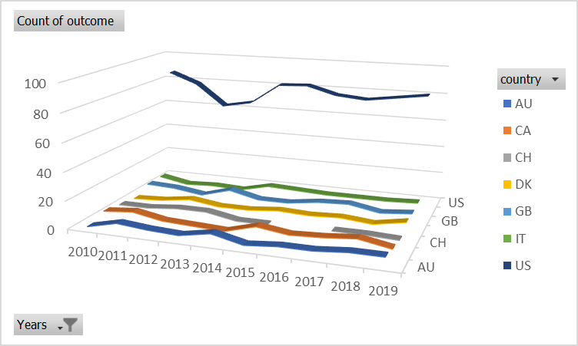

Q2. What are some limitations of this dataset?

* More details about the campaigns could have helped in defining the “the trick” to find success. A few details could have been:
  + On what platform these crowdfunding campaigns were launched. It could be highly possible that a particular platform has more audience as compared to others and therefore might affect the number of backers
  + The sub-categories could have been broadened like the genre of Theater (plays) and films that were successful or failed. Similarly, for the food, which cuisines were most supported and which were least
  + The reasons why a few crowd-funding projects have been cancelled, and why a few campaigns are still Live even years after their deadline

Q3. What are some other possible tables and/or graphs that we could create, and what additional value would they provide?

* Sum of backers count for each category and sub-category and relating it to the outcome of the campaign. This will help in understanding the range of audience to expect and accordingly setting up the goal (based on average donations and approximate number of funders)
* Checking if staff pick or the spotlight helped the campaign in being a success or not. If yes, then looking back on the campaigns that were staff picked or were in spotlight and understanding their strategies
* Mapping the duration of the campaign (start date-deadline), and if that is related to success rate? Did projects with longer duration had more success rate as compared to the one with shorter duration. This will help in structuring the campaigns.