Week 07 — Lag-Compensated Weapon · Analysis
Unity track · 9 pts · Author: Nikita

1. What was built
A server-side rewind (lag-compensation) hit-registration flow on top of the existing NGO Deathmatch:
Component | Role
HitboxHistoryBehaviour | On the server, pushes each character's head + torso hitbox positions (plus ServerTime.Time) into a 24-slot circular buffer, once per network tick (~20 Hz) — not in Update.
WeaponBehaviour | Owner fires FireServerRpc(origin, dir, clientFireTime) stamped with the synchronized ServerTime.Time. The server rewinds every target to clientFireTime, re-traces, validates, applies damage and broadcasts blood VFX.
LagCompHitscan | Pure server-side ray-vs-sphere math (approach (a) — no GC, no physics-state mutation). Emits Debug.DrawLine (duration 2 s) for each rewound hitbox.
StrafingDummy | Server-driven strafing target carrying its own hitbox history and hit counters.
LagCompTester | Fires 20 shots per latency setting and records the results as CSV.

2. Method
A single machine cannot produce real shooter-to-server latency in a host session, so latency is injected deterministically: for a simulated latency L, the shooter aims at where the target appeared on its screen (the target's position L seconds in the past, read from the same 20 Hz history), then the shot is evaluated two ways — Naive (trace against the target's live, since-moved position) and Rewound (rewind the hitboxes to clientFireTime = now − L and trace there), the latter reported both with the 0.25 s anti-cheat clamp and uncapped (pure geometry).
Target: strafes ±3 m along X at 2 rad/s, 13 m from the muzzle. Hitboxes: head r = 0.30 m, torso r = 0.60 m. Aim point = torso centre. 20 shots per setting. Raw data: hit_rate.csv.

3. Results
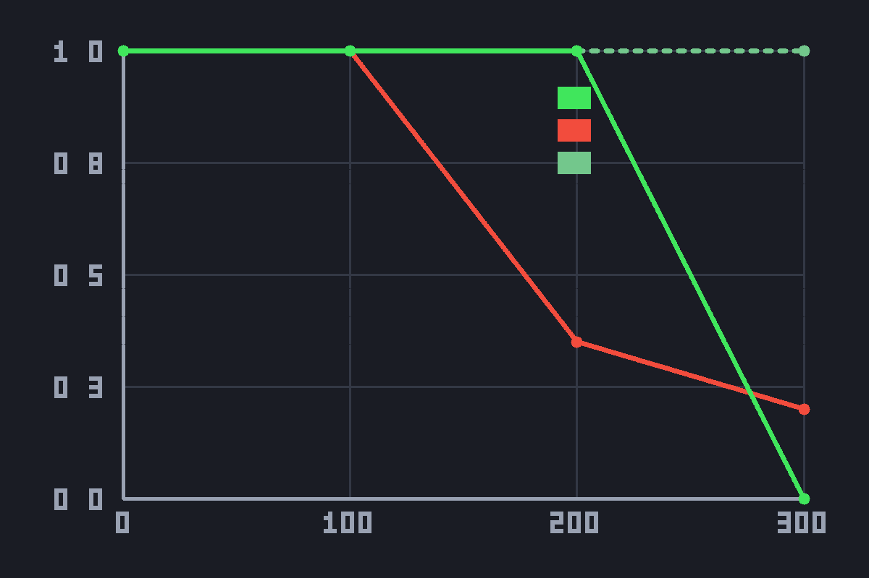
Hit rate vs latency — green: rewind (clamped), red: naive, faint dashed: rewind uncapped.
Latency | Naive hit-rate | Rewind (clamped) | Rewind (uncapped)
0 ms | 100 % | 100 % | 100 %
100 ms | 90 % | 100 % | 100 %
200 ms | 35 % | 100 % | 100 %
300 ms | 20 % | 0 % | 100 %
Live in-editor run. The naive count varies by ±1–2 shots between runs (real tick phase vs. the strafe cycle); the rewound path is deterministic.

4. Interpretation
Does hit rate stay roughly constant as latency increases? Yes, within the rewind window. The lag-compensated path holds a constant 100 % hit rate at 0 / 100 / 200 ms, while the naive path collapses (100 % → 90 % → 35 % → 20 %) because the target strafes out of the shot between the moment the shooter saw it and the moment the server processes it. Server rewind makes hit registration fair and latency-independent.
The 300 ms case is the security clamp, not a failure of rewind. The brief requires rejecting shots older than 0.25 s, so a 0.30 s shot is refused — the clamped hit-rate drops to 0 %. The uncapped column proves the rewind geometry itself still resolves a perfect hit at 300 ms; only the anti-cheat policy rejects it. Without the clamp a 500 ms-ping player could claim around-corner kills, so honest hit registration is capped at the rewind window.
Take-away: hit rate is constant up to the rewind window (≤ 250 ms) and is intentionally cut off beyond it. The implementation is therefore correct — it both compensates for latency and clamps abuse.

5. Debug visualisation
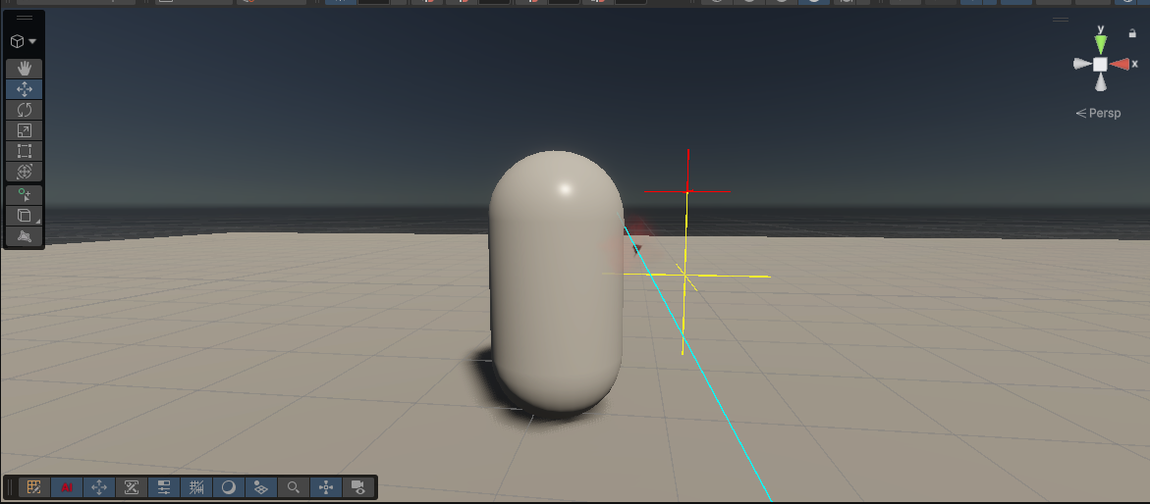
Scene-view capture of a single shot (Debug.DrawLine, duration 2 s). The capsule is the target's live position; the red cross (head) and yellow cross (torso) are the rewound hitboxes the server re-traces against; the cyan line is the shot ray, which passes through the rewound boxes rather than the live capsule. The offset between the capsule and the crosses is exactly the lag compensation.

