Creating an EBSCOhost Page Viewer Web Part
Organizations can embed the entire EBSCOhost experience within SharePoint by using the SharePoint-provided page viewer web part. The page viewer web part enables the full functionality of EBSCOhost, including the My EBSCOhost folders, to be made available to end users. The page viewer web part leverages all of the existing authentication options offered by EBSCOhost thus allowing for the rapid deployment of EBSCOhost within SharePoint.

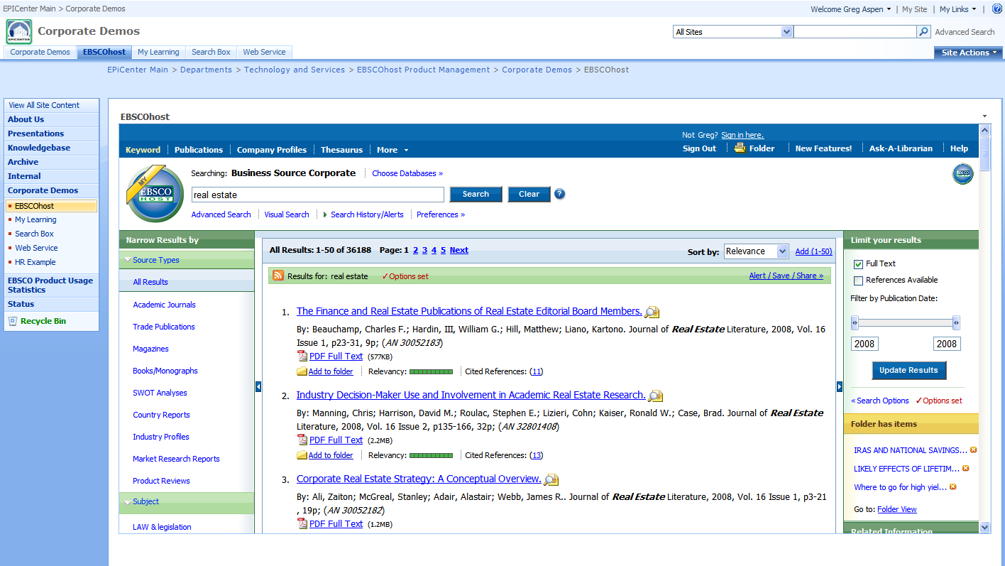

Access to the page viewer Web Part by a SharePoint user will be controlled as part of the standard SharePoint group and user permissions as determined by the SharePoint site owner. This means that no special security considerations for any EBSCOhost page viewer Web Part need to be considered above and beyond what must be done at the time the user is granted access to the site and/or page.

For more information on security considerations pertaining to web parts, please refer to the following SharePoint article:

http://office.microsoft.com/en-us/sharepointserver/HA101001491033.aspx?pid=CH101248581033

- Log on to SharePoint. Navigate to the desired site or page where you intend to add the EBSCOhost web part.
- On the Site Actions menu, click Edit Page if you intend to add the EBSCOhost to an existing page. Click Create Page if you will be creating a new page.
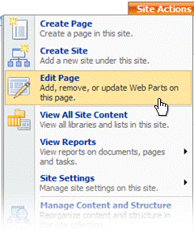
Notice that the page has switched to Design mode, and the page's Web Part zones and their titles are visible.

- Click Add a Web Part in the Web Part zone (e.g. Header, Top Left) for which you want to add the Web Part.

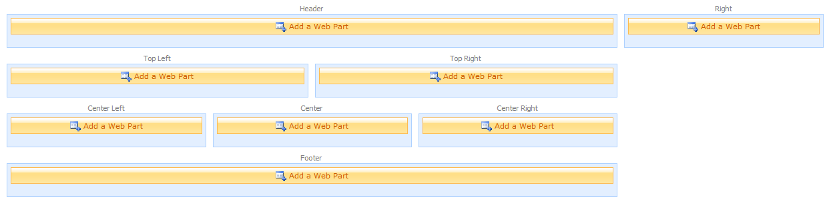

The Add Web Parts window opens indicating which zone you clicked (e.g. Header, Center Right). Check the Page Viewer Web Part option within the Miscellaneous section.

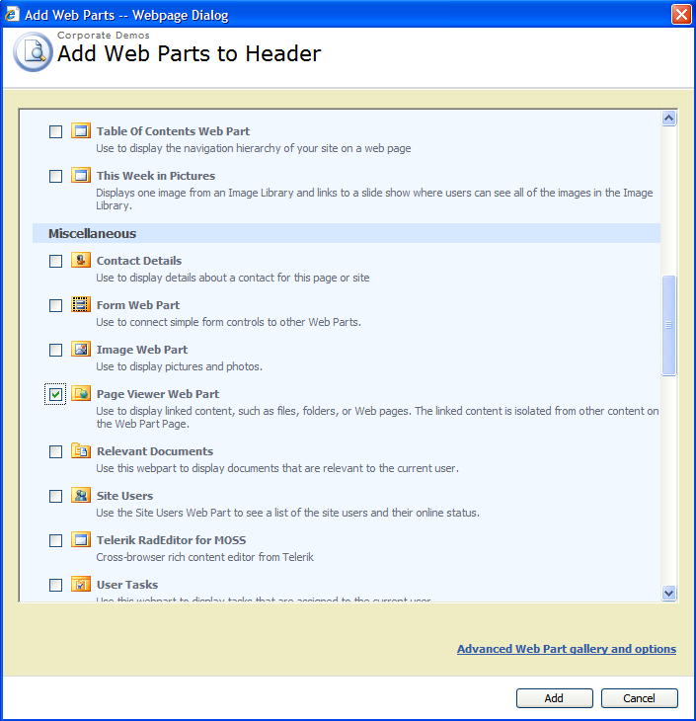

- Within the Page Viewer Web Part that you added to the web part zone, click open the tool pane.

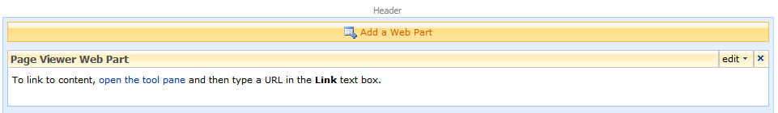

The Page Viewer Web Part tool pane will open on the right side of the page.

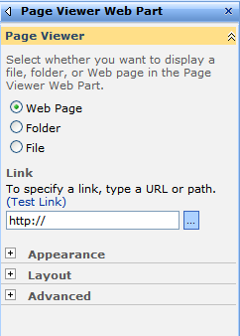

- In the Page Viewer field of the tool pane, make sure that Web Page radio button choice is selected.
- In the Link field of the tool pane, type the URL of the page to display. To specify the correct URL, you will need to know which EBSCOhost authentication method your organization is using. Listed below are examples for each method.

- IP Address authentication
http://search.ebscohost.com/login.aspx?authtype=ip

- Patterned ID authentication
http://search.ebscohost.com/login.aspx?authtype=cpid&custid=custid

- Patron ID (Customer Coordinated) authentication
http://search.ebscohost.com/login.aspx?authtype=custuid&custid=custid

- Referring URL authentication
http://search.ebscohost.com/login.aspx?authtype=url
- User ID and Password authentication
http://search.ebscohost.com/login.aspx?authtype=uid

- Cookie authentication
http://search.ebscohost.com/login.aspx?authtype=cookie

- Athens authentication
http://search.ebscohost.com/login.aspx?authtype=athens

- Shibboleth authentication
http://search.ebscohost.com/login.aspx?authtype=shib

Use HTTPS for any of the above authentication methods when a secure connection is required.
For more information on specifying your direct access URL, please refer to the following knowledge base article on the EBSCO support web site:
http://support.epnet.com/knowledge_base/detail.php?id=3572

If you would like help determining which URL method best meets your organization’s requirements, please feel free to contact the EBSCO Technical Support Department for assistance.
- Telephone U.S. or Canada: (800) 758-5995
- Telephone outside the U.S. and Canada: access code + (800) 3272-6000
- Email EBSCO Tech Support: eptech@ebscohost.com
- Email via the support site using the E-mail Support link along the top toolbar or the following link: http://support.ebsco.com/contact/askus.php

- In the Appearance section of the tool pane, specify properties to enhance the appearance of the Web Part.

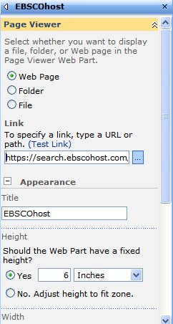

- In the Title field, type the Web Part's new title
- In the Height field, click Yes, type the value of the height, and select the units, such as Pixels or Inches.

EBSCO recommends a height of at least 6 inches in order to maximize the viewing area of the EBSCOhost interface within the Web Part zone.

- Click OK to apply the changes and close the tool pane.

