Creating an EBSCOhost RSS Web Part for SharePoint
Organizations can embed EBSCOhost RSS feeds within any SharePoint Web Part page. By utilizing a RSS Web Part, you can integrate EBSCOhost RSS feeds within any SharePoint page.

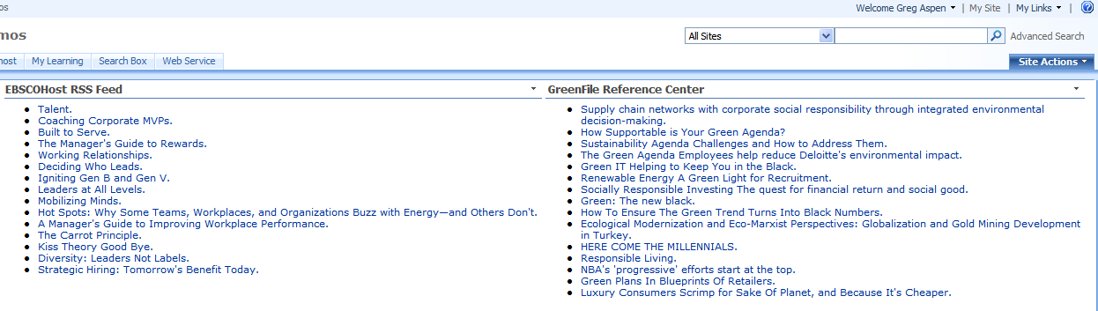
RSS stands for Really Simple Syndication. An RSS feed, also known as a news feed, is a syndicated data feed in an XML format to which you can subscribe. SharePoint offers a RSS Web Part that will automatically render any RSS feed it is configured to access.
Access to an EBSCOhost RSS Web Part by a SharePoint user will be controlled as part of the standard SharePoint group and user permissions as determined by the SharePoint site owner. This means that no special security considerations for any EBSCOhost RSS Web Part need to be considered above and beyond what must be done at the time the user is granted access to the site and/or page.

For more information on security considerations pertaining to Web Parts, please refer to the following SharePoint article:

http://office.microsoft.com/en-us/sharepointserver/HA101001491033.aspx?pid=CH101248581033

- Create the RSS feed in EBSCOhost by clicking on the RSS icon located at the top of the search results pane.
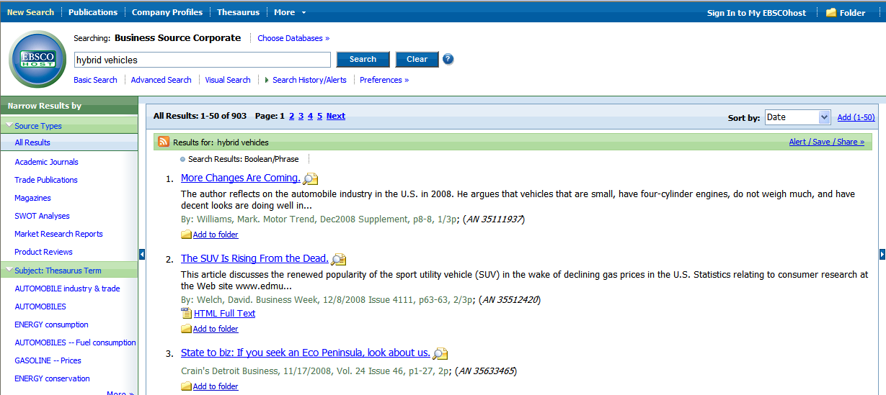

For more information on RSS feeds in EBSCOhost, please refer to the following article:

http://support.ebscohost.com/knowledge_base/detail.php?id=2932

- Copy to clipboard the RSS syndication feed link. It will be used in Step 6 once the RSS Web Part is created.

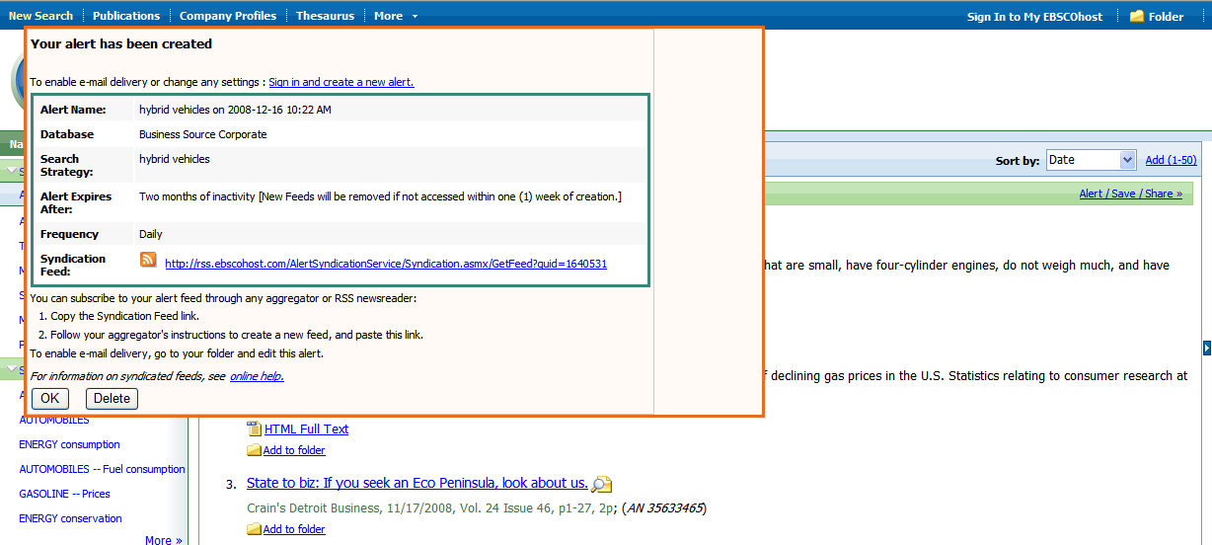

- On the Site Actions menu, click Edit Page if you intend to add the RSS Web Part to an existing page. Click Create Page if you will be creating a new page.
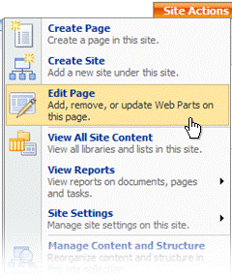
Notice that the page has switched to Design mode, and the page's Web Part zones and their titles are visible.

- Click Add a Web Part in the Web Part zone for which you want to add the RSS feed.

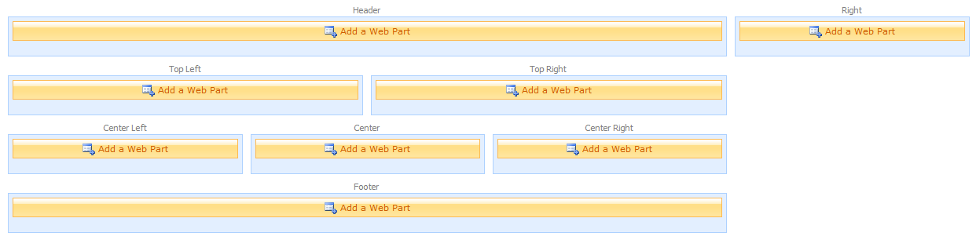

The Add Web Parts window opens indicating which zone you clicked (e.g. Center Left, Right). Check the RSS Viewer option within the Default section.

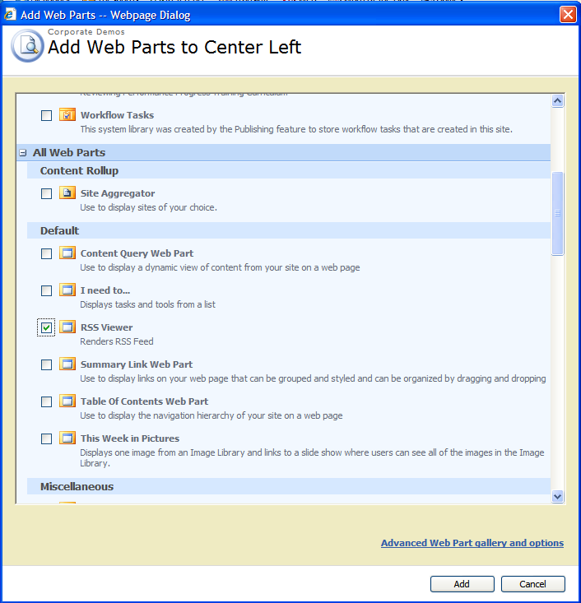

- Within the Web Part that you added to the chosen zone, click open the tool pane.
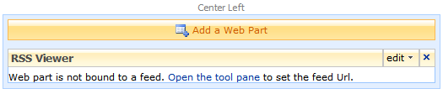

The RSS Web Part tool pane will open on the right side of the page.

- Paste the feed link copied in Step 2 above into the RSS Feed URL field.

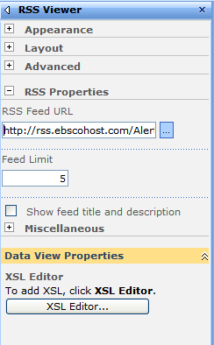

You can optionally set the Feed Limit value to something greater or less than the default value of 5.

- In the Data View Properties section of the tool pane, you can customize the formatting of the RSS feed as desired. Feed variables that can be used for display include: link, title, description and author

- In the Appearance section of the tool pane, specify properties to enhance the appearance of the Web Part.

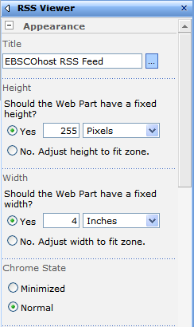

- In the Title field, type the Web Part's new title.
- In the Height field, click Yes, type the value of the height, and select the units, such as Pixels or Inches.
- In the Width field, click Yes, type the value of the width, and select the units, such as Pixels or Inches.

- Click OK to apply the changes and close the tool pane.

If you would like help implementing the RSS Web Part, contact the EBSCO Technical Support Department for assistance.
- Telephone U.S. or Canada: (800) 758-5995
- Telephone outside the U.S. and Canada: access code + (800) 3272-6000
- Email EBSCO Tech Support: eptech@ebscohost.com
- Email via the support site using the E-mail Support link along the top toolbar or the following link: http://support.ebsco.com/contact/askus.php

