Creating an EBSCOhost Search Box Web Part for SharePoint
Organizations can embed an EBSCOhost search box within any SharePoint Web Part page. By utilizing a Page Viewer Web Part, EBSCOhost search functionality can be quickly added to any SharePoint page.

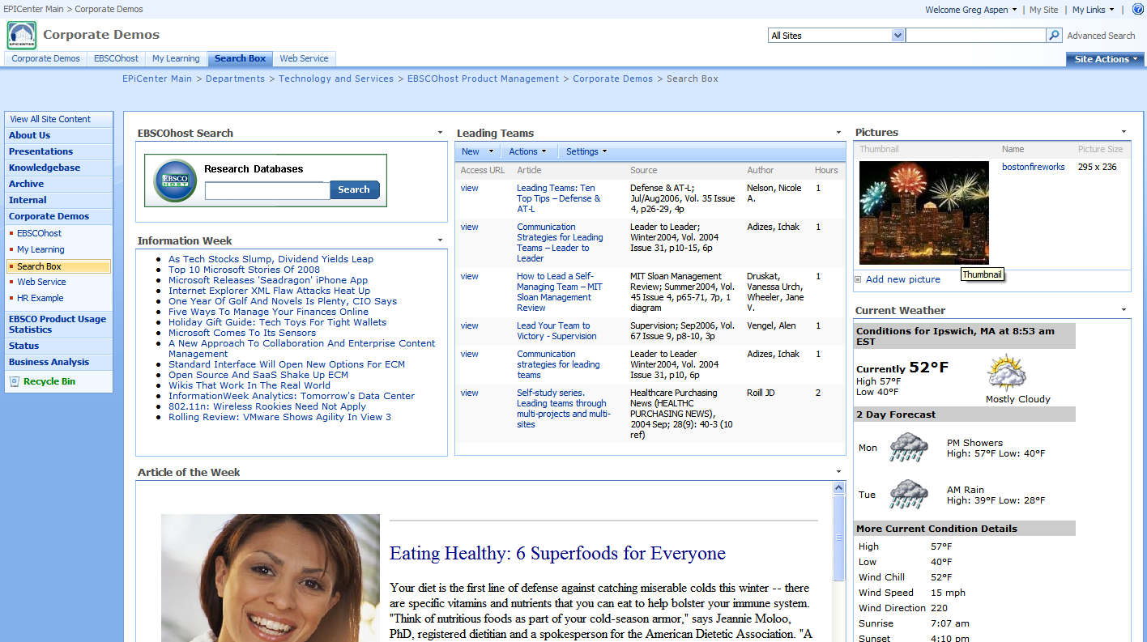

Access to a Search Box Web Part by a SharePoint user will be controlled as part of the standard SharePoint group and user permissions as determined by the SharePoint site owner. This means that no special security considerations for any EBSCOhost Search Box Web Part need to be considered above and beyond what must be done at the time the user is granted access to the site and/or page.

For more information on security considerations pertaining to Web Parts, please refer to the following SharePoint article:

http://office.microsoft.com/en-us/sharepointserver/HA101001491033.aspx?pid=CH101248581033

- Create your search box using EBSCO’s web-based Search Box Builder tool which is freely available to all EBSCOhost users.
http://supportforms.epnet.com/eit/searchboxbuilder

Step 1
Specify the database that you wish to search. The database represents the product(s) to which your organization has subscribed. Click Lookup databases to find the desired database.
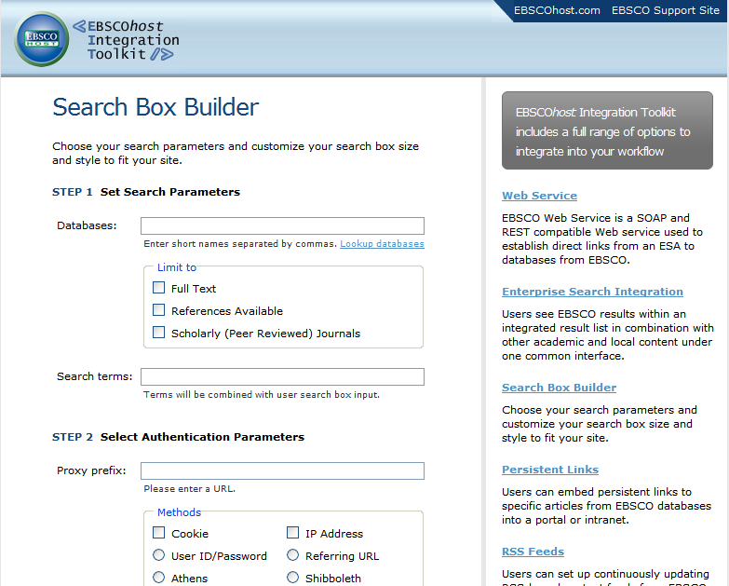

You can optionally choose to limit all searches issued through the search box to return only those matches that have an associated Full Text article, where References are available or that are Scholarly Journals. In addition, you can also choose to optionally specify a default search term(s) that will be combined with the search term(s) specified by the user whenever the Search Box Web Part is used.

Step 2
If you organization utilizes a proxy server to manage web page requests, you should specify the URL of the proxy server in the Proxy prefix box. If your organization has not implemented a proxy server, simply leave the input box blank. Within the Methods section, select each of the EBSCOhost authentication methods that your organization supports. You may select more than 1 method if you organization uses multiple methods. If you do not know which methods are supported, you can access EBSCO Admin (http://eadmin.ebscohost.com) and view your organization’s Authentication settings.

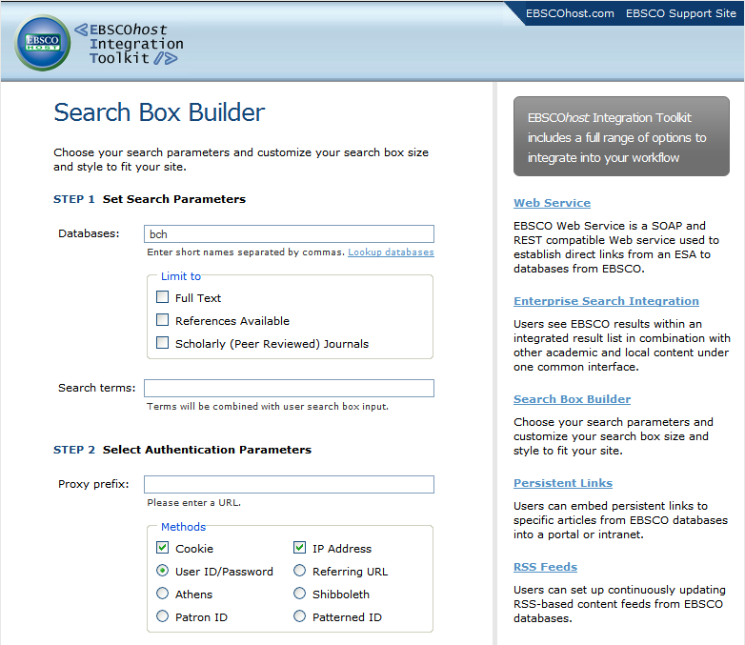

Step 3
Choose which style of search box you would like to use within the SharePoint page. Simply clicking on one of the 3 options provided automatically selects the style of your choice.
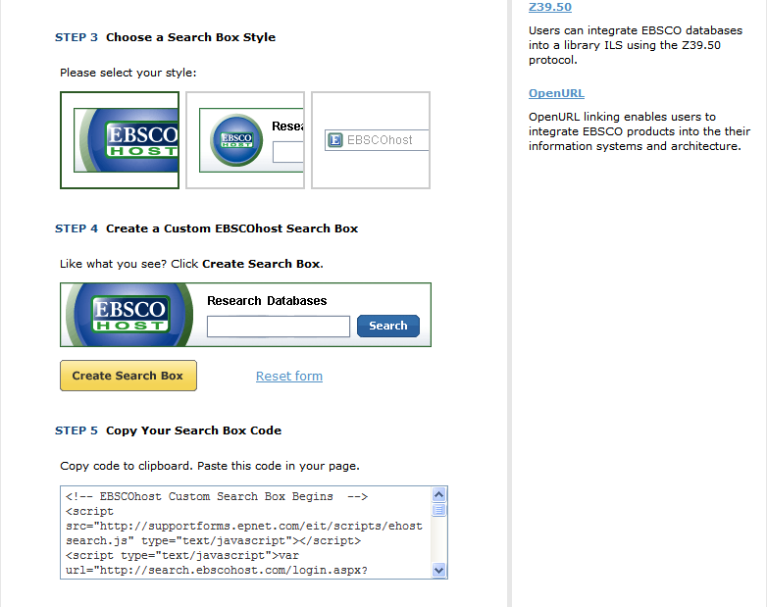

Step 4
Once you have chosen the preferred style, click the Create Search Box button. This will generate the HTML code that you will use to build your Search Box web page.

Step 5
Create a new file (e.g. htm or aspx) using the HTML code generated in Step 4 above.

- Upload the newly created search file into SharePoint. The Web Part will point to this file. You may choose to add the file to the existing Document Library within SharePoint or any other library you choose to create.

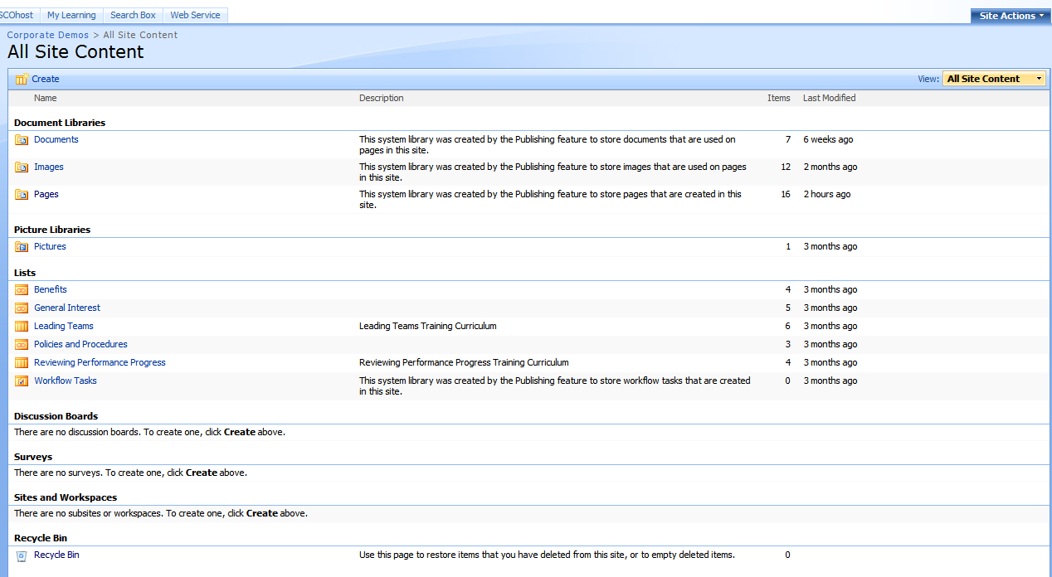

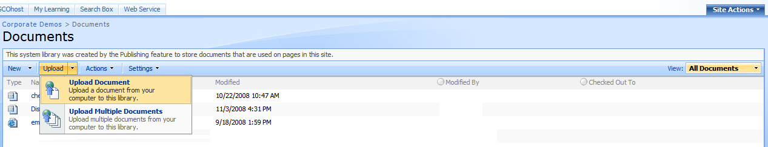

- Once the document has been uploaded, you can now add a new Web Part to the desired page
- On the Site Actions menu, click Edit Page if you intend to add the Search Box Web Part to an existing page. Click Create Page if you will be creating a new page.
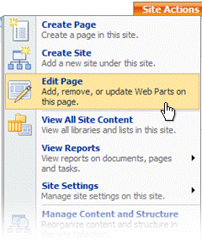
Notice that the page has switched to Design mode, and the page's Web Part zones and their titles are visible.

- Click Add a Web Part in the Web Part zone for which you want to add the Search Box.

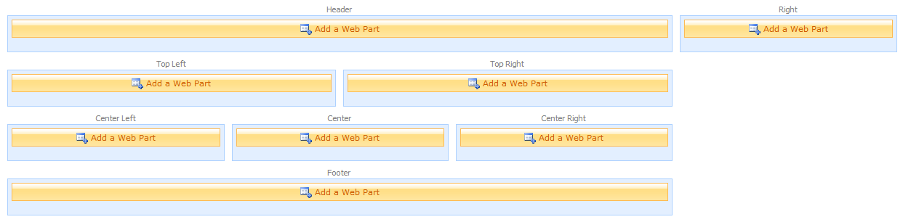

The Add Web Parts window opens indicating which zone you clicked (e.g. Top Left, Center Right). Check the Page Viewer Web Part option within the Miscellaneous section.

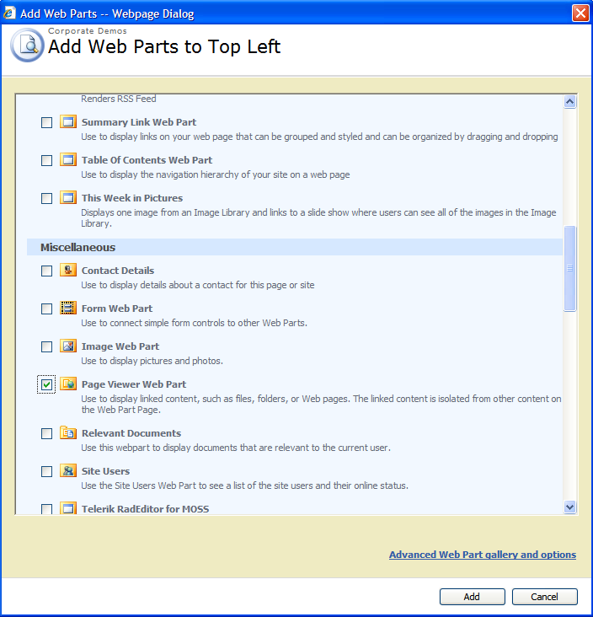

- Within the Web Part that you added to the chosen zone, click open the tool pane.

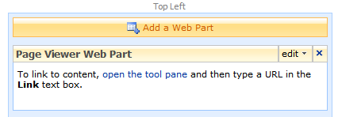

The Page Viewer Web Part tool pane will open on the right side of the page

- In the Page Viewer field of the tool pane, make sure that Web Page radio button choice is selected
In the Link field of the tool pane, specify the path to the search box web page that was uploaded in Step 2 above.

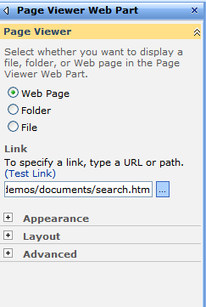

- In the Appearance section of the tool pane, specify properties to enhance the appearance of the Web Part.

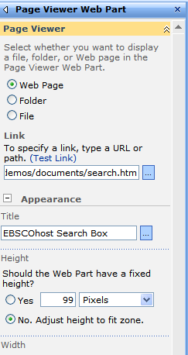

- In the Title field, type the Web Part's new title
- In the Height field, click Yes, type the value of the height, and select the units, such as Pixels or Inches.

- Click OK to apply the changes and close the tool pane.

If you would like help implementing the Search Box Web Part, contact the EBSCO Technical Support Department for assistance.
- Telephone U.S. or Canada: (800) 758-5995
- Telephone outside the U.S. and Canada: access code + (800) 3272-6000
- Email EBSCO Tech Support: eptech@ebscohost.com
- Email via the support site using the E-mail Support link along the top toolbar or the following link: http://support.ebsco.com/contact/askus.php

