Browsing Reading Lists by Topic (Recommended Reads)

Most users know what they’re looking for when they visit NoveList and go directly to the Search box at the top of each page, while others don’t really know what they want to read and prefer to browse through a list of suggested books. NoveList has hand-selected over 800 lists for adult, teen, and child readers and organized them by fiction (and nonfiction in NoveList Plus), genre or topic, and reading level in the “Recommended Reads” section of the homepage. If you are a mystery reader looking for some new ideas, selecting the Mystery link will display a pop-up with several available mystery lists. If you are working with a reader in an unfamiliar genre, like westerns, for example, select the Westerns link to view the lists available. Parents can select the appropriate age level and get ideas for books on a variety of topics and interests. All lists are updated regularly with books chosen by librarians who are well-versed in the genre/topic.

Browsing Other Lists and Articles

We have created complete listings, or indexes, of certain types of content and have provided ways for you to browse through or jump to the section of the index that is interesting to you. There are two types of these listings in NoveList:
- Indexes of all titles, authors, series, subject headings (and appeal terms) and books by Dewey used in the database, and
- Listings of our proprietary content such as Author Read-alikes, Book Discussion Guides, BookTalks, Feature Articles, Grab and Go Book Lists, and Picture Book Extenders.

These listings are available from the toolbar at the top of each page in NoveList; several of them can be found under the More drop-down.

You can easily browse some of the more popular listings from the right hand panel of the homepage under “NoveList Resources.”

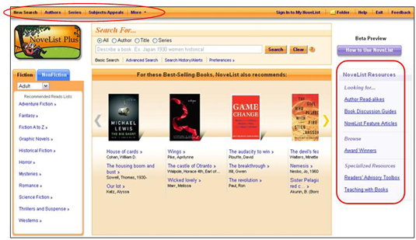

The View By: tab indicates the way in which the listing is organized. Many of the listings have more than one organizational option; see the chart below for more information.

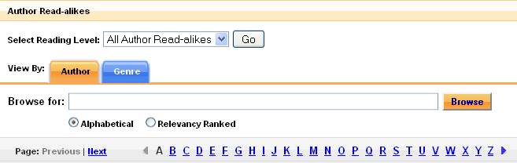
To browse through the list, you can:

- Change the sort option by selecting one of the available tabs. For example, you can view Author Read-alikes by author name (the default) or by the genre in which the author writes.
- Enter the author name in the Browse for: box. By default, the closest terms will be returned alphabetically.
- Use the Alpha listing to jump to the part of the list that you want to browse. (e.g., click on the M to browse through the Read-alikes for all authors whose last name begins with M).

Certain indexes can also be filtered by reading level. The Reading Level drop-down lets you limit the items in that list to a specific reading level. Because there is only one reading level available for Author Read-alikes, Subjects, and Dewey Numbers, these lists cannot be filtered by reading level.

NoveList Indexes – View By:

Index: | View By:  (Bold is default) | Reading Level Sort Available:
Author Read-alikes | Author or Genre | None: there are only adult read-alikes
Awards | Award Name or Genre | All, Adults, Teens, Ages 9-12, Ages 0-8
Book Discussion Guides | Title (of book) or Author (of book) | All, Adults, Teens
BookTalks | Title (of book) or Author (of book) | All, Teens, Ages 9-12
Feature Articles | Article Name or Genre | All, Adults, Teens, Ages 9-12, Ages 0-8
Grab & Go Book Lists | Title (of list) or Country (US or Canada curricula) | All, Teens, Ages 9-12, Ages 0-8
Picture Book Extenders | Title (of book) or Author (of book) | None: There are only picture book extenders for Ages 0-8

