How do I find another series like the one I read?

You just finished reading the last title in your favorite series, and now you’d like to read another just like it. NoveList makes it easy to find series recommendations.

To find series recommendations, you first need to pull up the Series Detail page:

- At the Basic Search box on the homepage, enter your series title, select the Series limiter, and click Search.
- If there is only one series that matches your search terms, you will be taken directly to the Series Detail page. If more than one series matches your search terms, you can click on the correct series title link from the Series tab to access that Detail page.

In the “NoveList Also Recommends” section, you’ll find up to nine series recommendations taken from Author Read-alikes, Book Discussion Guides, and Recommended Reads lists created by professional librarians. Some recommendations are provided by direct input by RA librarians, while NoveList creates others by finding similarities among the subject headings, genres, and appeal factors associated with those series.

With your mouse, you can hover over a book jacket image to view information about the series recommendation and why it is being recommended.
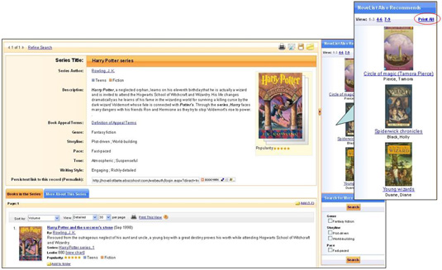

You can print all of the series recommendations, along with the reason why they were recommended, by clicking the Print All link in the “NoveList Also Recommends” section.

The “Search for More” feature allows you to find series that share genre, subject, location, and appeal factors (storyline, tone, pace, writing style) with your series.

