How do I find other authors who write like my favorite?

NoveList makes it easy to find authors who write like your favorite, using similar subjects, themes, and appeal factors.

You can find author recommendations from within an Author Detail page. To view an author’s Detail page, enter their name in the Basic Search box, select the Author radio button, and click Search.

Author information is provided at the top of each Author Detail page. For many of the most popular authors, you will find a description of their works, along with the appeal factors typical of their writing. The hand-crafted author description summarizes why people enjoy this particular author and includes a title suggestion for first time readers of this author.

In the “NoveList Also Recommends” section, you’ll find up to nine recommendations for authors whose works include the appeal terms listed in that author’s information. Recommendations were taken from Author Read-alikes when available for that author, while others were provided by direct input from NoveList’s team of librarians and readers’ advisory experts following a strict protocol designed to ensure quality.

To view the reason why the particular author was recommended, hover over the magnifying glass next to the recommended author’s name. For more information on the recommended author, click on their name to access their Author Detail page.

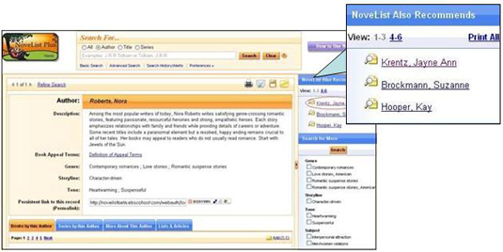

You can print all of the author recommendations by clicking the Print All link in the “NoveList Also Recommends” section.
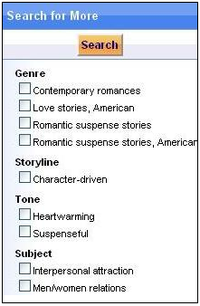
The “Search for More” feature lets you find more authors who use genres, subjects, locations, and appeal factors (storyline, tone, pace, writing style) similar to those used by the author searched. Select one or more options and click Search to customize your author search.

