How do I find more books like the one I read?

NoveList makes it easy to find your next book based on one you’ve already read.

To find title recommendations:

- At the Basic Search box at the homepage, enter a title and click Search.
- Access the Title Detail page by selecting the title for which you want recommendations.

In the “NoveList Also Recommends” section, you’ll find up to nine title recommendations taken from Author Read-alikes, Book Discussion Guides, and Recommended Reads lists created by professional librarians. Some recommendations are provided by direct input by RA librarians, while NoveList creates others by finding similarities among the subject headings, genres, and appeal factors associated with that title.

With your mouse, you can hover over a book jacket image or hover icon to view information about the title recommendation and why it is recommended.

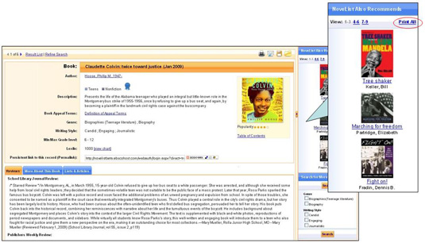

You can print all of the title recommendations, along with the reason they were recommended by clicking the Print All link in the “NoveList Also Recommends” section.

The “Search for More” feature allows you to find similar titles based on the genre, subject, location, and appeal factors (storyline, tone, pace, writing tyle) associated with your title.

