EBSCO module for VuFind 1.3

# Description

The EBSCO Discovery module for VuFind adds the search capabilities of EBSCOhost Discovery Service to an existing VuFind 1.3 installation.

The module does not replace or modify the VuFind search. Instead, it adds a three-tab Discovery module that combines VuFind local catalog and EDS discovery results on the first tab and shows an expanded VuFind or EDS results page on the second and third tabs. The VuFind search object in the Combined Results tab and the Books & more tab is the standard VuFind 1.3 search object.

EDS Search object features includes facets, limiters, expanders, search modes, page options, advanced search, and other EDS capabilities.

The install package includes a short installation script that copies our files to the corresponding VuFind directories and edits two configuration files. If you are using user ID authentication, you will need to set your own credentials in the EBSCO config file, as described in the next section. Because this Discovery module is not yet included in the VuFind distribution, it requires modification to one VuFind PHP file, to tell VuFind to recognize the optimized EBSCO module. This process is detailed below in the “Installation” section.

The EBSCO Discovery module Combined Results tab looks like this:



The Articles & more tab looks like this:

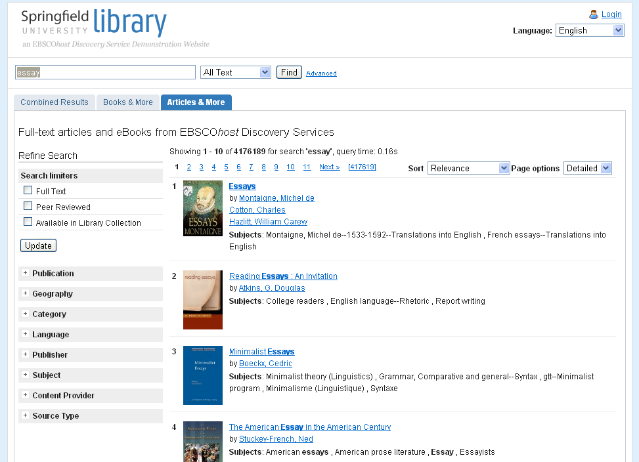

The detail page looks like this:

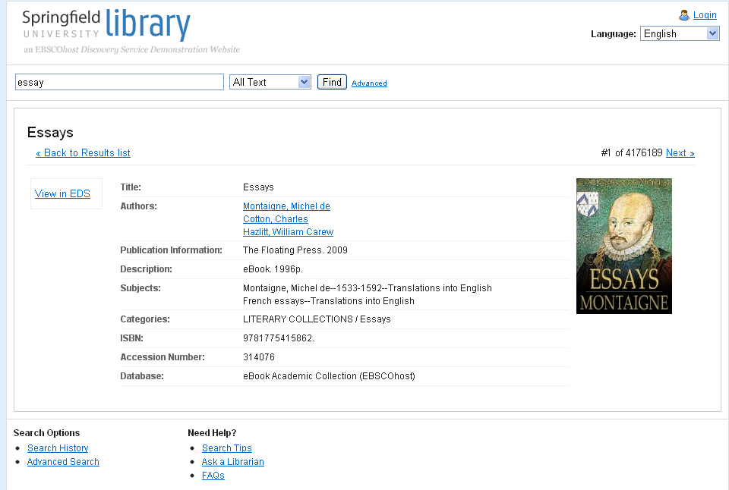

# Installation

These are the steps for installing the EBSCO module on a Linux platform:

1. Get the archive

wget <http://support.ebsco.com/eit/samples/EBSCO_Discovery_Module_for_VuFind_1.3.tar.gz>

1. Unpack the archive

tar xvzf ebsco.tar.gz

1. Go to the /ebsco directory

cd ebsco

1. You may need to make the installation script executable

chmod +x install.sh

1. Run the installation script

bash install.sh <path to vufind>

Example: If your VuFind installation directory is /usr/local/vufind then the command is :

bash install.sh /usr/local/vufind

And you will then see:

Copied files from /usr/local/ebsco/web to /usr/local/vufind

Copied files from /usr/local/ebsco/tests directory to /usr/local/vufind

The EBSCO module was successfully installed.

The installation script does two things:

* Copies the EBSCO module files to your VuFind installation directory;
* Modifies the VuFind config.ini file in two places, setting the theme to include the EBSCO Discovery theme files, and telling VuFind to include the new ebsco.ini config file.

[Site]

theme = EBSCO, blueprint (or whatever theme you are using)

…

[Extra_Config]

EBSCO = ebsco.ini

Notes :

* You need to run this command with a user that has write permissions for /usr/local/vufind directory;

1. If you don’t use the VuFind “blueprint” theme, then change your config.ini to one of the other supported theme in web/conf/config.ini.

For “default” theme, change it to:

[Site]

theme = EBSCO_default, default

For “classic” theme, change it to:

[Site]

theme = EBSCO_classic, classic

1. Locate the following VuFind file

<path to vufind>/web/sys/SearchObject/Factory.php

and add the following code in static function deminify

case ‘EBSCO’:

case 'EBSCOAdvanced':

$type = 'EBSCO';

break;

VuFind Factory class is used to initialize SearchObject objects and to unserialize SearchObject objects saved in MySQL database. The two lines of code will be used by VuFind to use the EBSCO SearchObject class in order to unserialize the MySQL database saved objects instead of the default Solr SearchObject class.

# Settings

The EBSCO module is installed with EBSCO EDS API demo credentials for testing, but you should change them to your own customer credentials.

Locate the following file :

<path to vufind>/web/conf/ebsco.ini

and complete the following settings :

Password = <Your password for EBSCO EDS API>

UserId = <Your user identifier for EBSCO EDS API>

ProfileId = <Your profile identifier for EBSCO EDS API>

You’re all set to run VuFind 1.3 with the EBSCO EDS Discovery module.

# Debugging API calls

If API calls fail, or if you want to track calls to the API, you can debug the HTTP requests and responses sent and received using the following :

1. Turn on the EBSCO module API logging

Open <path to vufind>/web/conf/ebsco.ini and locate the [Logging] section.

Modify

logAPIRequests = false

to

logAPIRequests = true

2. Turn on the VuFind logging , if you haven’t already

Open <path to vufind>/web/conf/config.ini and locate the [Logging] section.

Uncomment, and setup if necessary, one of the logging methods : database, file or email

3. You can now go to browser and do another search

# Dependencies

The EBSCO module is using the default VuFind 1.3 dependencies. No other libraries are needed.

# Customizing UI

The EBSCO module was designed to integrate very well with the VuFind blueprint theme.

The EBSCO module files that you may want to customize are located here:

<path to vufind>/web/interface/themes/EBSCO

# Uninstall

Follow these steps to uninstall EBSCO module:

1. Go to directory where you unpacked the EBSCO module archive
2. Make the uninstall script executable

chmod +x uninstall.sh

1. Run the uninstall script

bash uninstall.sh <path to vufind>

The uninstall script does two things:

- Removes the EBSCO module files from your VuFind installation directory;

- Removes EBSCO settings from the VuFind config.ini file.

Note :

- You need to run this command with a user that has write permissions for /usr/local/vufind directory;

1. Locate the following VuFind file

<path to vufind>/web/sys/SearchObject/Factory.php

and remove the following code from static function deminify

case ‘EBSCO’:

case 'EBSCOAdvanced':

$type = 'EBSCO';

break;

1. If you enabled VuFind logging just for debugging EBSCO API calls

Open <path to vufind>/web/conf/ebsco.ini , locate the[Logging]section and comment the logging method that you previously uncommented.

These are all the steps required for uninstalling EBSCO module.