Task1

docker run –d redis

docker run –d nginx

docker run –d memcached

docker –ps a #get id of container which we want to stop (for example memcached)

docker stop <container_id>

docker ps -a

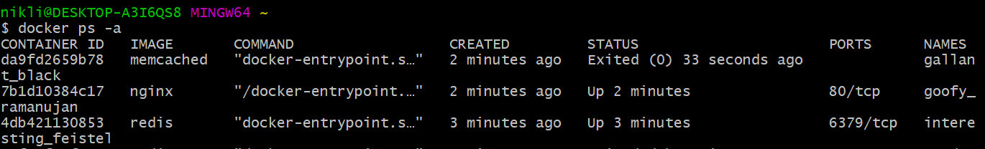

Task2

docker rm –f $(docker ps –a -q)

docker ps –a

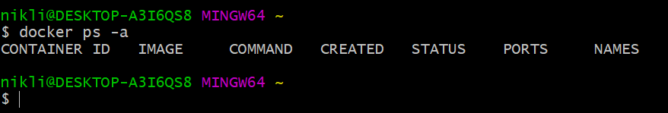

Task3

docker run devopsdockeruh/exec_bash_exercise

winpty docker exec –it <container_id> tail –f ./logs.txt

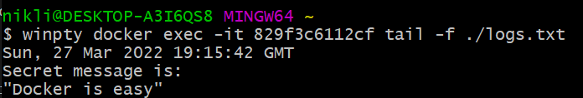

Task4

Dockerfile:

FROM devopsdockeruh/overwrite_cmd_exercise

CMD ["devopsdockeruh/overwrite_cmd_exercise"]

Building:

docker build –f ./Dockerfile –t docker-sequence .

Running:

docker run docker-sequence –c 1

Task 5

docker run -d -it --name bind_mount --mount type=bind,src="$(pwd)"/logs,dst=/usr/app/ devopsdockeruh/first_volume_exercise

docker inspect bind_mount

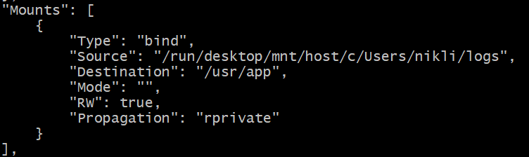

Task 6

docker run –p 80:80 devopsdockeruh/ports_exercise

