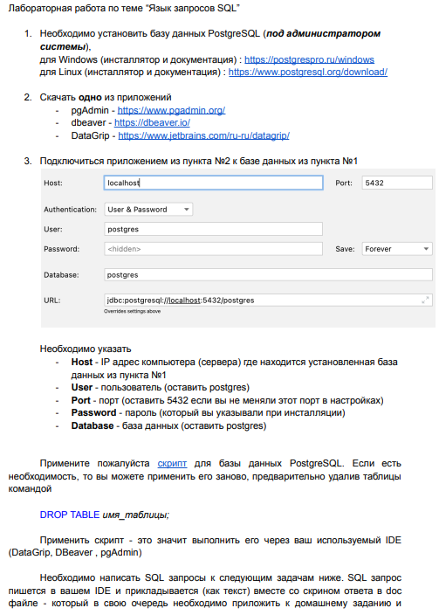





**SELECT** "name", "telegram_contact" **FROM** public.student

**WHERE** city = 'Казань' **or** city = 'Москва'

**order** **by** "name"

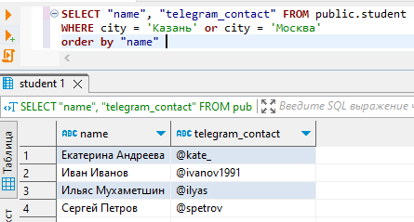

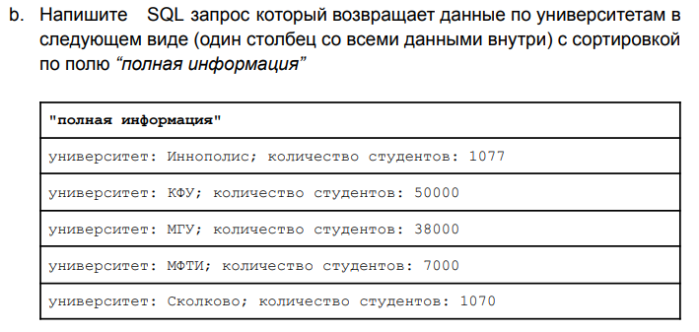

**SELECT** 'университет: ' || **name** || ' количество студентов: ' || **size** **as** "полная информация" **FROM** public.college

**order** **by** **name**

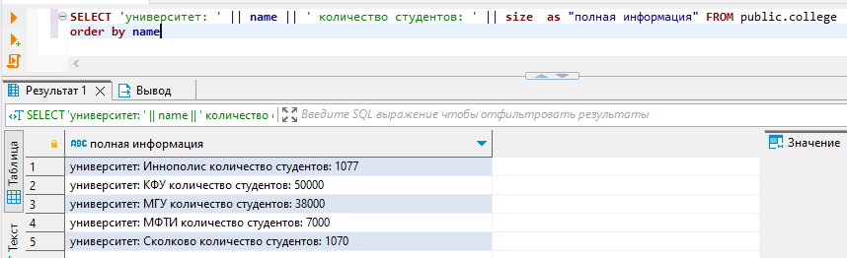



**SELECT** **name** **as** "Университет", **size** **as** "Количество студентов" **FROM** public.college

**where** id **in** (10, 30, 50)

**order** **by** **size**, **name**

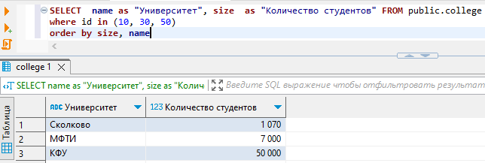



**SELECT** **name** **as** "Университет", **size** **as** "Количество студентов" **FROM** public.college

**where** id **not** **in** (10, 30, 50)

**order** **by** **size**, **name**

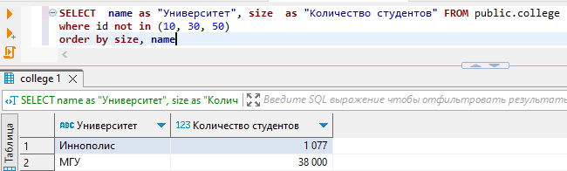

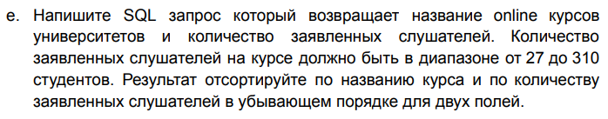

**SELECT** **name** **as** "Название online курса", amount_of_students **as** "Количество заявленных слушателей" **FROM** public.course

**where** amount_of_students **between** 27 **and** 310

**order** **by** **name** **desc**, amount_of_students **desc**

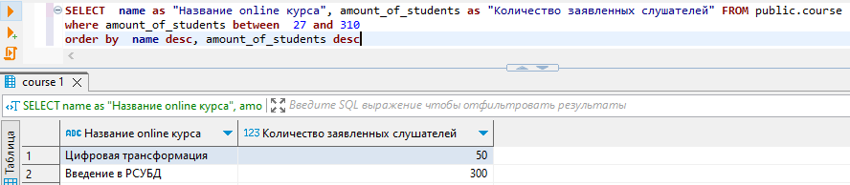

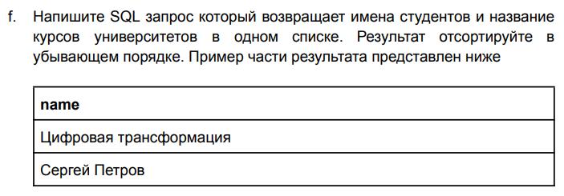



**SELECT** **name** **from** student s

**UNION** **ALL** **SELECT** **name** **from** course c

**order** **by** **name** **desc**

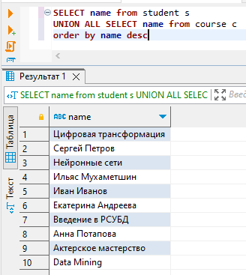

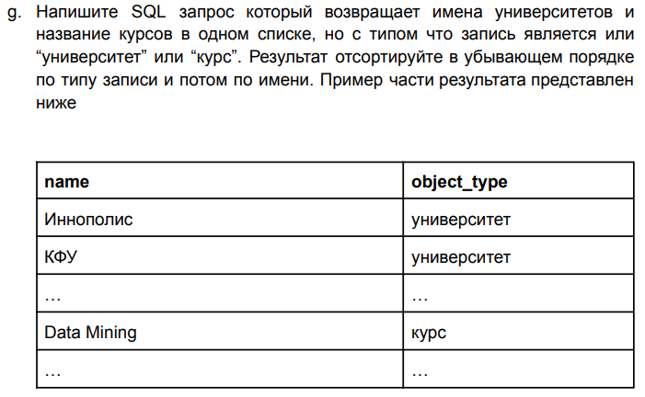

**SELECT** **name**, 'университет' **as** "object_type" **from** college c

**UNION** **ALL** **SELECT** **name**, 'курс' **as** "object_type" **from** course c2

**order** **by** object_type **desc**, **name**

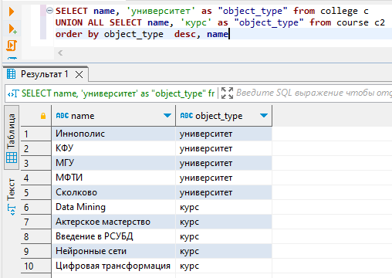

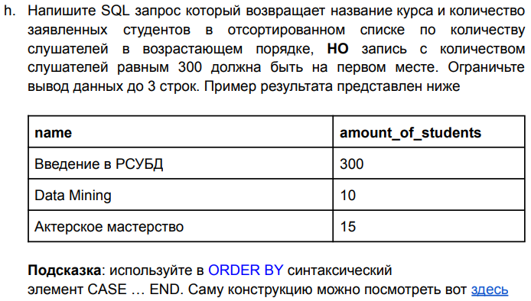

**SELECT** **name** **as** "Название online курса", amount_of_students **as** "Количество заявленных слушателей" **FROM** public.course

**order** **by** **CASE**

**WHEN** amount_of_students = 300 **THEN** 1

**ELSE** amount_of_students

**end**

**LIMIT** 3

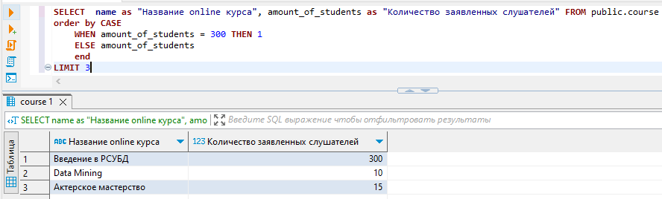

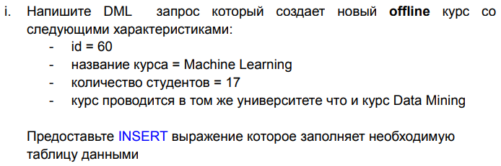



**insert** **into** public.course(id, **name**, is_online, amount_of_students, college_id) **values** (60,'Machine Learning', **false**, 17,

(**select** college_id **from** public.course **where** **name** ='Data Mining'));

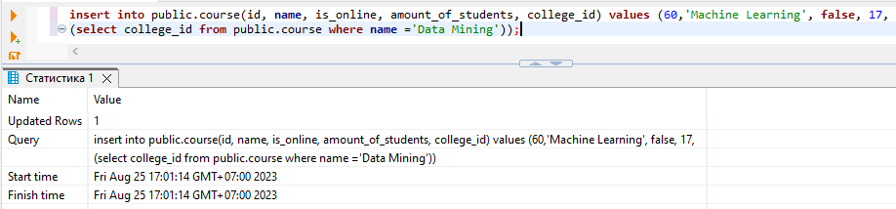

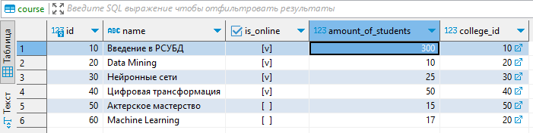



(

(**select** id **from** course)

**except**

(**select** id **from** student_on_course)

)

**UNION**

(

(**select** id **from** student_on_course)

**except**

(**select** id **from** course)

)

**order** **by** id

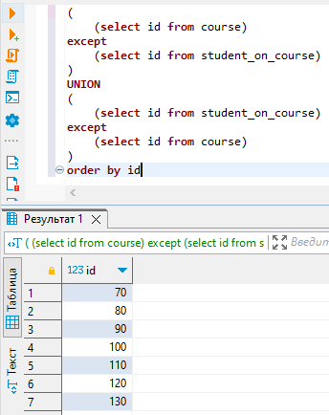

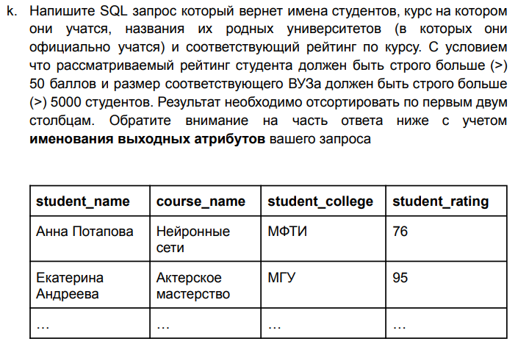

**select** s.**name** **as** "student_name", c.**name** **as** "course_name", c2."name" **as** "student_college", soc.student_rating **as** "student_rating"

**from** student s

**JOIN** student_on_course soc **ON** soc.student_id = s.id

**JOIN** course c **ON** c.id = soc.course_id

**JOIN** college c2 **on** s.college_id = c2.id

**where** soc.student_rating > 50 **and** c2."size" > 5000

**order** **by** student_name, course_name

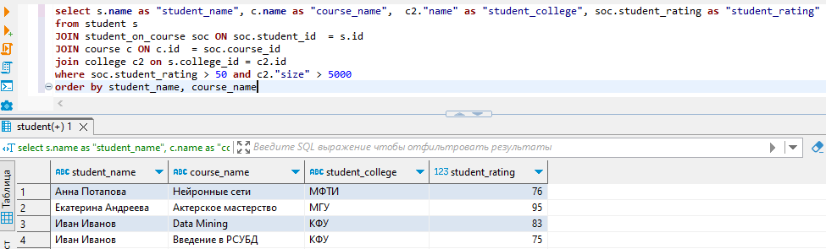



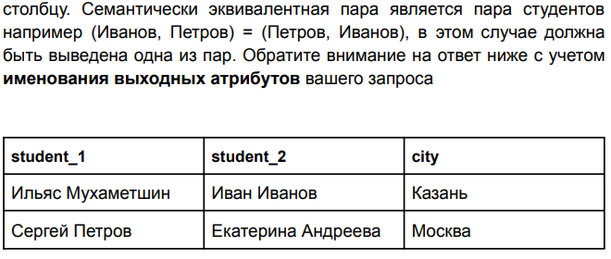

**select** s.**name** **as** "student_1", s2.**name** **as** "student_2", s.city

**from** student s

**inner** **join** student s2 **on** s.city = s2.city **and** s.**name** > s2.**name**

**order** **by** student_1

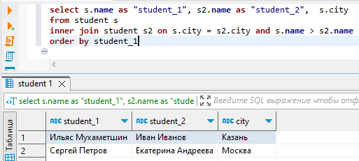

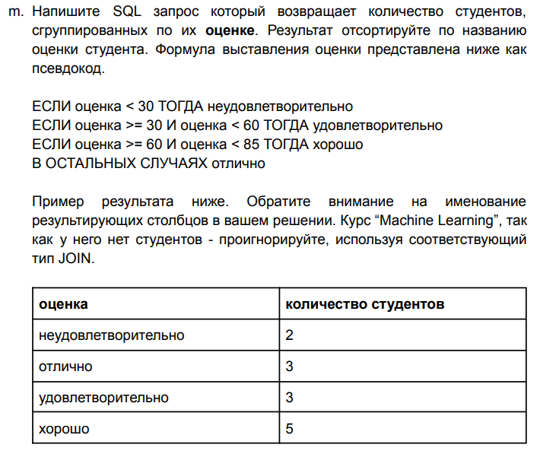

**select** 'неудовлетворительно' **as** "оценка", **COUNT**(soc.student_id) **as** "количество студентов"

**from** student_on_course soc

**where** soc.student_rating < 30

**union**

**select** 'удовлетворительно' **as** "оценка", **COUNT**(soc.student_id) **as** "количество студентов"

**from** student_on_course soc

**where** soc.student_rating >= 30 **and** soc.student_rating < 60

**union**

**select** 'хорошо' **as** "оценка", **COUNT**(soc.student_id) **as** "количество студентов"

**from** student_on_course soc

**where** soc.student_rating >= 60 **and** soc.student_rating < 85

**union**

**select** 'отлично' **as** "оценка", **COUNT**(soc.student_id) **as** "количество студентов"

**from** student_on_course soc

**where** soc.student_rating >= 85

**order** **by** "оценка"

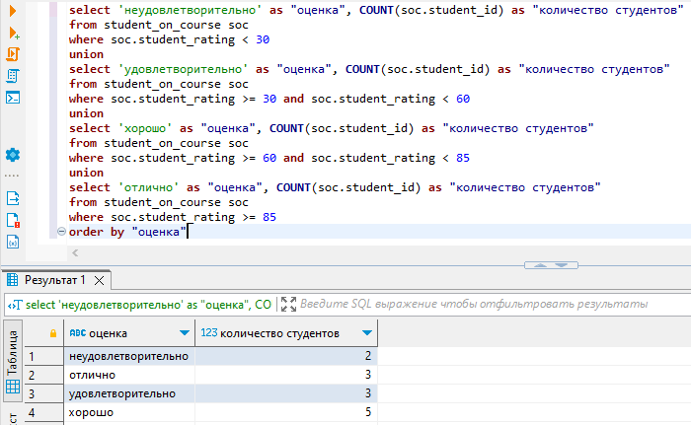

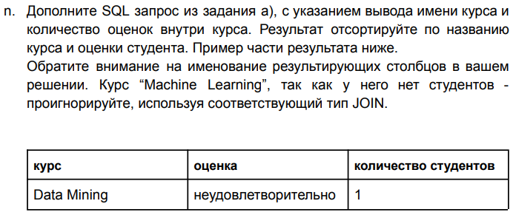



**select** c.**name** **as** "курс", 'неудовлетворительно' **as** "оценка", **COUNT**(soc.student_id) **as** "количество студентов"

**from** student_on_course soc

**JOIN** course c **on** c.id = soc.course_id

**where** soc.student_rating < 30

**group** **by** c.**name**

**union**

**select** c.**name** **as** "курс", 'удовлетворительно' **as** "оценка", **COUNT**(soc.student_id) **as** "количество студентов"

**from** student_on_course soc

**JOIN** course c **on** c.id = soc.course_id

**where** soc.student_rating >= 30 **and** soc.student_rating < 60

**group** **by** c.**name**

**union**

**select** c.**name** **as** "курс", 'хорошо' **as** "оценка", **COUNT**(soc.student_id) **as** "количество студентов"

**from** student_on_course soc

**JOIN** course c **on** c.id = soc.course_id

**where** soc.student_rating >= 60 **and** soc.student_rating < 85

**group** **by** c.**name**

**union**

**select** c.**name** **as** "курс", 'отлично' **as** "оценка", **COUNT**(soc.student_id) **as** "количество студентов"

**from** student_on_course soc

**JOIN** course c **on** c.id = soc.course_id

**where** soc.student_rating >= 85

**group** **by** c.**name**

**order** **by** "курс", "оценка"

