1.SELECT count(ContactName) FROM Customers

where Country='Germany';

**Result:** 11

2.SELECT Count(ContactName) FROM Customers

where ContactName like '%e';

**Result:** 4

3.INSERT INTO Customers (CustomerName)

VALUES ('Nikita Mayorov');

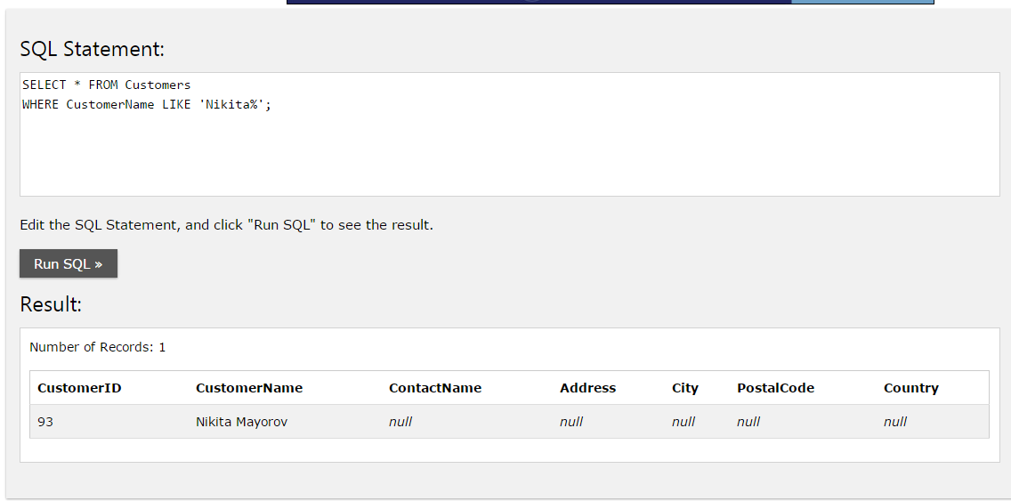

4. UPDATE Customers

SET CustomerName='Nik'

WHERE CustomerName='Nikita Mayorov';

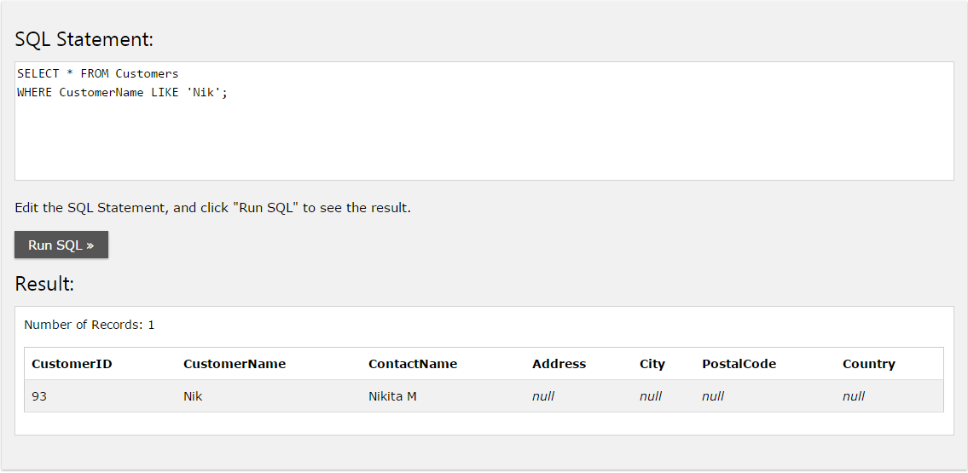

5. DELETE FROM Customers

WHERE City LIKE 'Nantes';

**Result:** delete 2 Customers

6. SELECT Orders.OrderID FROM Orders

INNER JOIN Employees ON Orders.EmployeeID=Employees.EmployeeID

WHERE Employees.EmployeeID=5;

**Result:**

OrderID

10248

10254

10269

10297

10320

10333

10358

10359

10372

10378

10397