A Prescriptive Inventory Management Decision Model: Economic Order Quantity Analysis and Monte Carlo Simulation

Student Name: Nikita Mishra
Northeastern University
Class: ALY-6050: Enterprise Analytics, Section 28,
Instructor: Michael Prokle
Date: June 14, 2026.
Abstract
This report develops and evaluates a prescriptive inventory-management decision model for a manufacturing client’s key engine component, with the goal of identifying the order quantity that minimizes total annual inventory cost — the sum of ordering and holding costs. Part I builds a deterministic Economic Order Quantity (EOQ) model assuming constant annual demand of 15,000 units, a unit cost of $80, an ordering cost of $220 per order, and an 18% annual holding-cost rate. The optimum is located with a data-table search and verified with Excel Solver and the optimize() function in R. The model recommends ordering approximately 677 units per replenishment, placing roughly 22 orders per year, at a minimum total annual cost near $9,749, with ordering and holding costs balanced at the optimum. Part II relaxes the certainty assumption by modelling annual demand as a triangular random variable (13,000 to 17,000 units, mode 15,000) and running a 1,000-trial Monte Carlo simulation. The simulation produces an expected total cost of $9,742.77 (95% CI [$9,726.39, $9,759.15]) and confirms that a normal distribution adequately fits the total-cost, order-quantity, and order-frequency outputs (Kolmogorov–Smirnov p ≈ .44). The findings support adopting the EOQ policy with limited risk across the plausible demand range.
Keywords: inventory management, economic order quantity, Monte Carlo simulation, confidence interval, distribution fitting
Introduction
Inventories represent a considerable investment for most organizations and managing them well is a core operational responsibility. Excess inventory ties up capital and signals poor financial and operational control, while insufficient inventory risks stockouts that can disrupt production. Managers therefore face two linked decisions: how much to order at a time and how often to order, so that total inventory cost — the sum of holding cost and ordering cost — is minimized (Evans, 2020). Holding cost accrues per unit held per unit of time and rises with order size, whereas ordering cost is incurred per order placed and falls as order size grows; the optimal policy balances these opposing forces.
This report presents a prescriptive decision model built for a manufacturing client to manage a key engine component. Part I develops a deterministic Economic Order Quantity (EOQ) model and verifies the optimum using a data-table search and numerical optimization. Part II treats annual demand as a triangularly distributed random variable and uses a 1,000-trial Monte Carlo simulation to characterize the expected cost, order quantity, and order frequency under uncertainty, with confidence intervals and fitted distributions. The model was implemented in both Microsoft Excel and R; the values reported below were produced in R, with Excel used to corroborate Part I. The eight Part I tasks and the Part II steps are addressed in the order set out in the assignment.

Part I: The Economic Order Quantity Model
Step 1: Data, Uncontrollable Inputs, Model Parameters, and Decision Variable
The first task is to identify the quantities that drive total inventory cost and classify each. The data and uncontrollable inputs — values taken as given and not controlled by the analyst — are the annual demand (D = 15,000 units, assumed constant throughout the year), the unit cost (C = $80), the ordering cost (S = $220 per order), and the annual holding-cost rate (18% of unit value). The model parameter, derived from these inputs, is the annual holding cost per unit, H = 0.18 × $80 = $14.40, expressed as the dollars required to carry one unit of inventory for one year. The single decision variable — the quantity management actually controls — is the order quantity, Q. The model outputs are the economic order quantity, the minimum total annual cost, and the annual number of orders. Classifying the quantities this way frames the problem precisely: choose Q to minimize total cost while holding all inputs fixed (Evans, 2020).
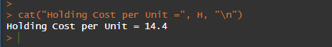
Step 2: Mathematical Model for Total Inventory Cost
Total inventory cost has two opposing components. Annual ordering cost equals the number of orders placed per year times the cost per order, (D / Q) × S; ordering less frequently (a larger Q) lowers this term. Annual holding cost equals the average inventory level times the per-unit holding cost, (Q / 2) × H, where Q / 2 is the average stock because inventory is drawn down linearly from Q to zero; carrying more stock (a larger Q) raises this term. The total annual inventory cost is their sum, TC(Q) = (D / Q)S + (Q / 2)H. This function is convex in Q and therefore has a unique minimum. Setting its first derivative to zero and solving yields the closed-form economic order quantity, Q* = √(2DS / H) (Evans, 2020). At Q* the ordering and holding cost components are exactly equal, which is the defining property of the EOQ.
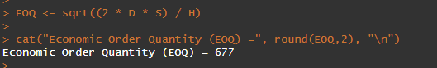
Step 3: Implementation in Excel and in R
The model was implemented in both Microsoft Excel and R, as required. Both use identical inputs and the same cost equations and return the same results: H = $14.40, EOQ ≈ 677.00 units, minimum total cost ≈ $9,748.85, and ≈ 22.16 orders per year. The agreement confirms the model was specified consistently across the two tools; aside from rounding, the Excel and R results do not differ materially, as the assignment anticipates. The Excel implementation is shown in Figure 1, and the R implementation is contained in the accompanying script file.
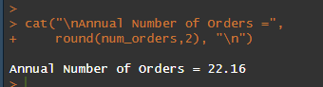
Figure 1
Excel Implementation of the EOQ Model
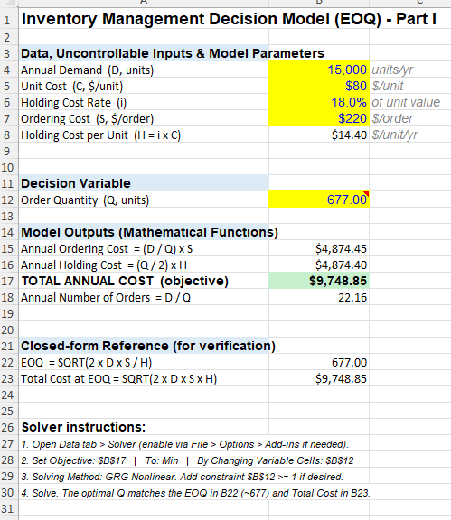

Step 4: Data-Table Search for the Approximate Optimal Order Quantity
To locate the optimum without relying solely on the formula, total cost was evaluated across a range of order quantities (Q from 100 to 1,500 in increments of 50), and the quantity with the lowest cost was selected. As shown in the data table (Figure 2), total cost decreases as Q increases, reaches its lowest value at Q = 700 units ($9,754.29), and then rises again — identifying Q = 700 as the grid point nearest the true optimum. This data-table search confirms the formula-based EOQ from Steps 2–3 and brackets the exact optimum verified later in Step 6. Table 1 consolidates the Part I results, listing the holding cost per unit ($14.40), the formula EOQ (677 units), the minimum total cost ($9,748.85) with its equal ordering and holding components ($4,874.42 each), the annual number of orders (22.16), the data-table approximation (Q = 700), and the Solver-verified optimum (Q = 677).
Figure 2
Data Table of Total Cost by Order Quantity (R output)
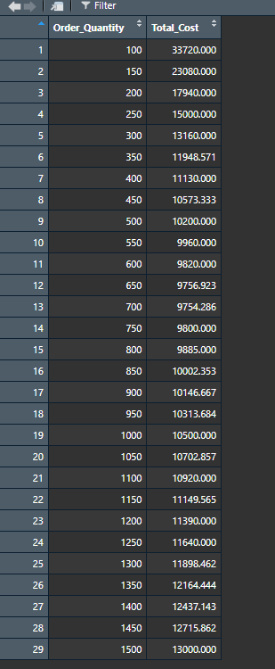

Table 1
Economic Order Quantity Model Results (Part I)
Quantity | Value
Holding cost per unit per year (H) | $14.40
Economic Order Quantity (EOQ), formula | 677.00 units
Minimum total annual cost | $9,748.85
Annual ordering cost | $4,874.42
Annual holding cost | $4,874.42
Annual number of orders | 22.16
Data-table approximate Q (Step 4) | 700 units ($9,754.29)
Solver / optimize verified Q (Step 6) | 677.00 units ($9,748.85)
Note. Computed from D = 15,000, C = $80, S = $220, and an 18% holding-cost rate. Ordering and holding costs are equal at the optimum.

Step 5: Plot of Total Cost Versus Order Quantity
Plotting total cost against order quantity (Figure 3) shows the characteristic U-shape: cost falls steeply as Q increases from small values (where orders are placed too frequently), reaches a minimum near the EOQ, and then rises gradually as holding cost begins to dominate. The dashed vertical line marks the EOQ at 677 units, visually confirming that it lies at the bottom of the cost curve.

Figure 3
Total Cost Versus Order Quantity (R output)
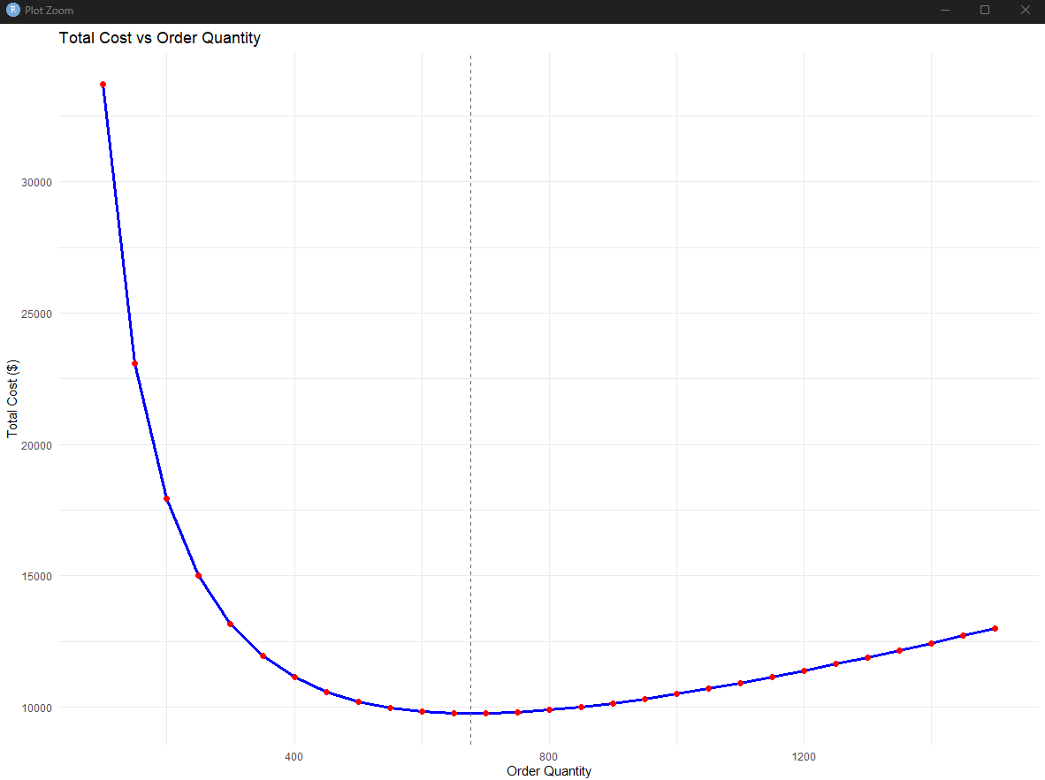

Step 6: Solver Verification of the Optimum
A data-table search returns only an approximate answer because it is limited to the grid points tested. To find the exact optimum, Excel Solver was used to minimize TC(Q) with respect to Q, and the optimize() function in R served as an independent check (R’s equivalent of Solver). Both return Q ≈ 677.00 units with a minimum total cost of $9,748.85 (Figure 4). The agreement among the closed-form formula, the data-table approximation (Q = 700), and the Solver/optimize result (Q = 677) confirms the model and its optimum.
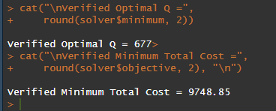

Figure 4
Excel Solver Result Verifying the Optimal Order Quantity
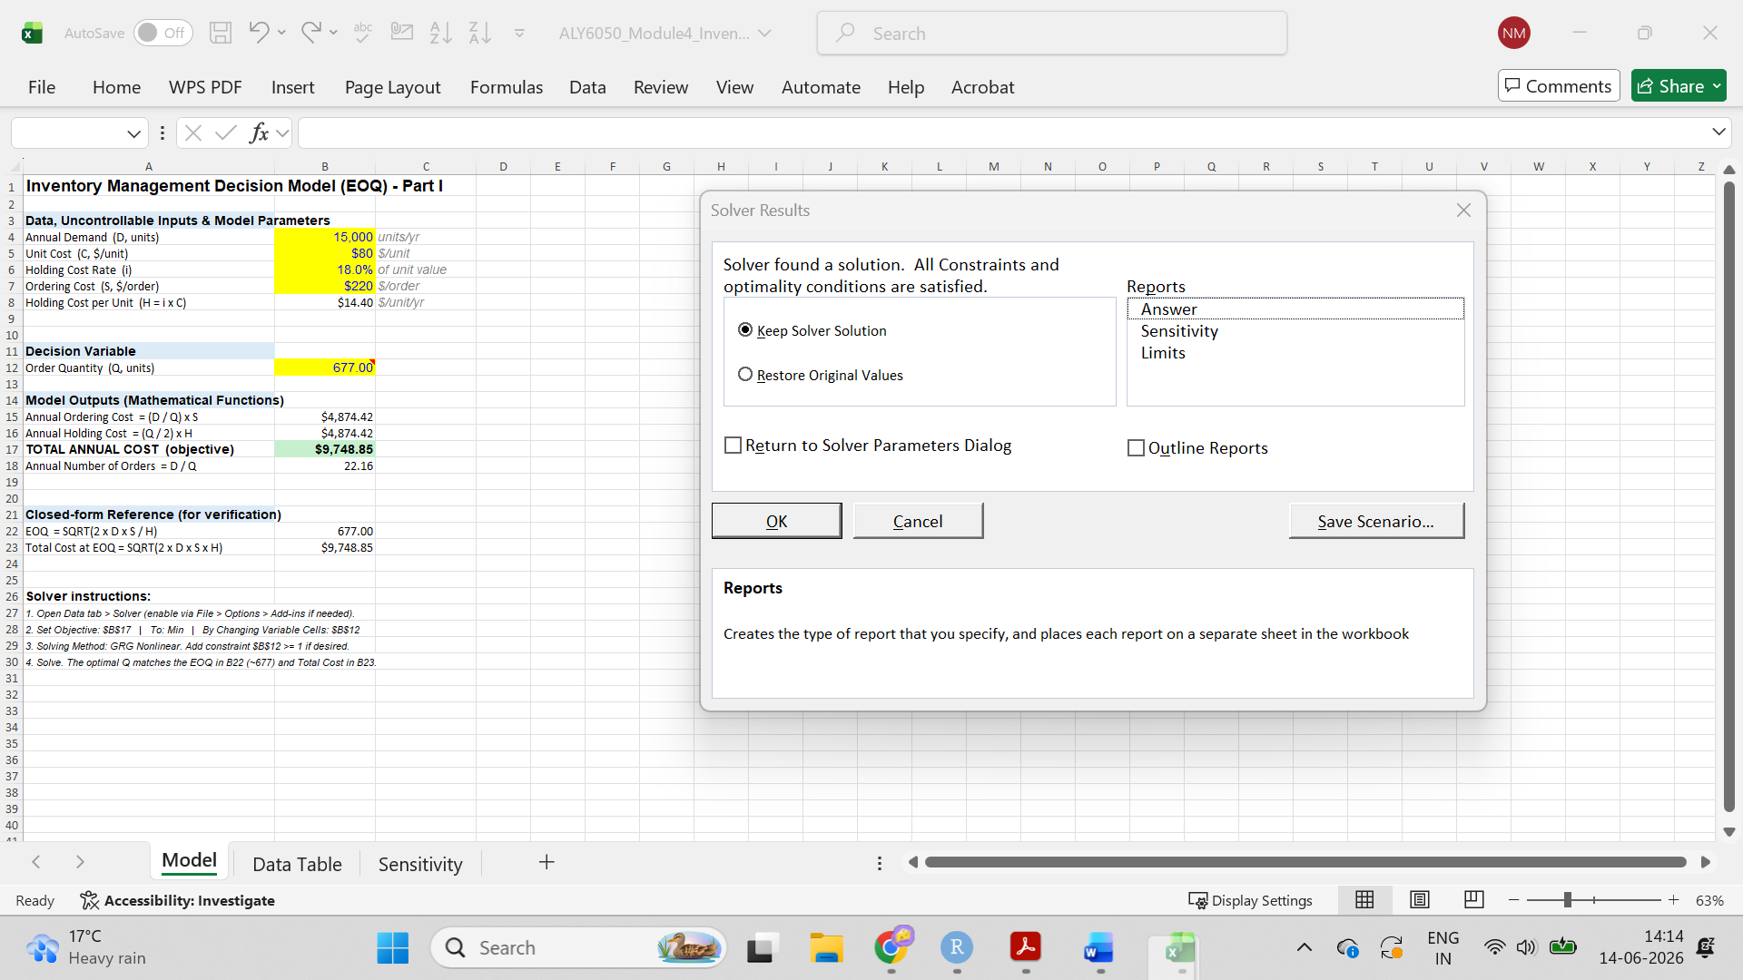
Step 7: Two-Way What-If (Sensitivity) Analysis
To test how sensitive the optimal cost is to the cost assumptions, a two-way data table was constructed in Excel that varies two model parameters simultaneously — the ordering cost (S) and the holding-cost rate (i) — and records the resulting minimum total cost in each cell (Figure 5). The table shows that total cost rises as either parameter increases: holding S fixed, a higher holding rate raises cost (e.g., at S = $220, cost climbs from about $7,266 at i = 10% to $11,717 at i = 26%), and holding i fixed, a higher ordering cost raises cost as well. The optimal order quantity moves in the opposite direction, falling as the holding rate increases. This confirms that the model behaves as theory predicts — EOQ varies with the square root of S and inversely with the square root of H — and it identifies the holding-cost rate as the more influential driver, which is the parameter management should estimate most carefully.

Figure 5
Excel Two-Way Sensitivity Table for Total Cost
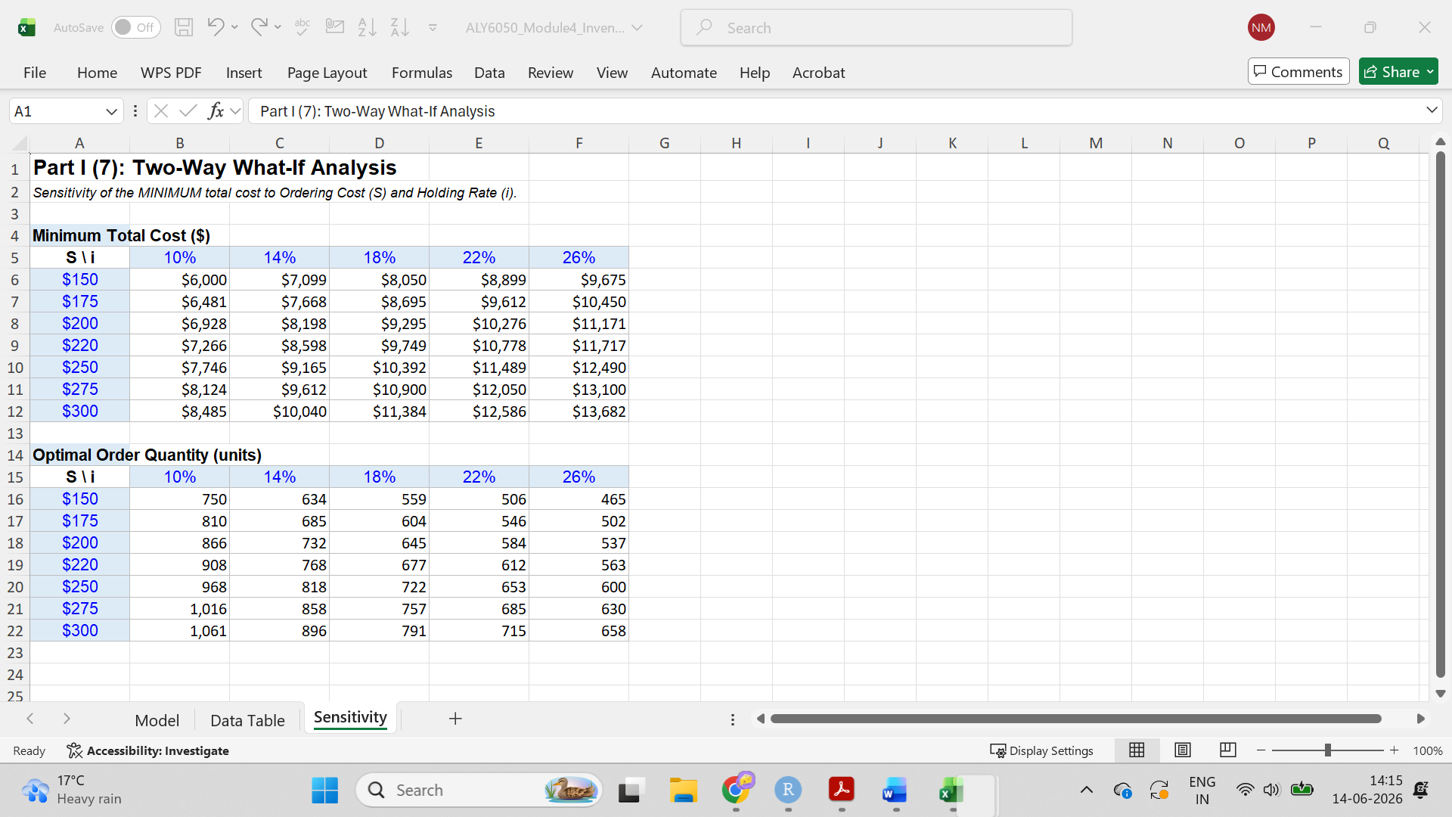

Part II: Simulation Under Demand Uncertainty

Step 1: Monte Carlo Simulation of 1,000 Occurrences
Part II keeps every Part I parameter but treats annual demand as uncertain. Demand is modeled as a triangular distribution with a minimum of 13,000 units, a maximum of 17,000 units, and a most-likely value (mode) of 15,000 units — a common choice when only a plausible range and a best estimate are known. A Monte Carlo simulation of 1,000 occurrences was run in R with a fixed random seed for reproducibility. For each simulated demand, the EOQ, the corresponding minimum total cost, and the annual number of orders were computed using the Part I formulas, and all 1,000 outcomes were stored for statistical analysis. The simulation setup and the resulting 95% confidence intervals appear in the R console output in Figure 6.

Figure 6
R Console Output: Simulation Setup and 95% Confidence Intervals
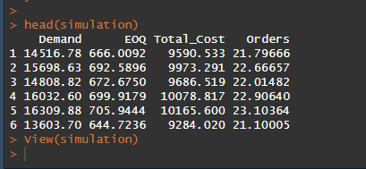

Step 1(i): Expected Minimum Total Cost
The expected minimum total cost is estimated by the sample mean across the 1,000 runs, $9,742.77, with a 95% confidence interval of [$9,726.39, $9,759.15]. A confidence interval expresses the precision of the estimate were the simulation repeated many times, about 95% of such intervals would contain the true mean. The interval here spans only about $33 around a $9,743 mean, so the estimate is precise. A Normal distribution was fitted by maximum likelihood, giving N($9,742.77, $264.13). Its adequacy was verified with diagnostic plots and a Kolmogorov–Smirnov (KS) goodness-of-fit test, which compares the empirical distribution to the fitted Normal. The test returned a statistic of 0.027 and p = .44; because p exceeds .05, the Normal model cannot be rejected and is an appropriate fit (Figure 7).

Figure 7
Histogram and Distribution-Fit Diagnostics: Minimum Total Cost
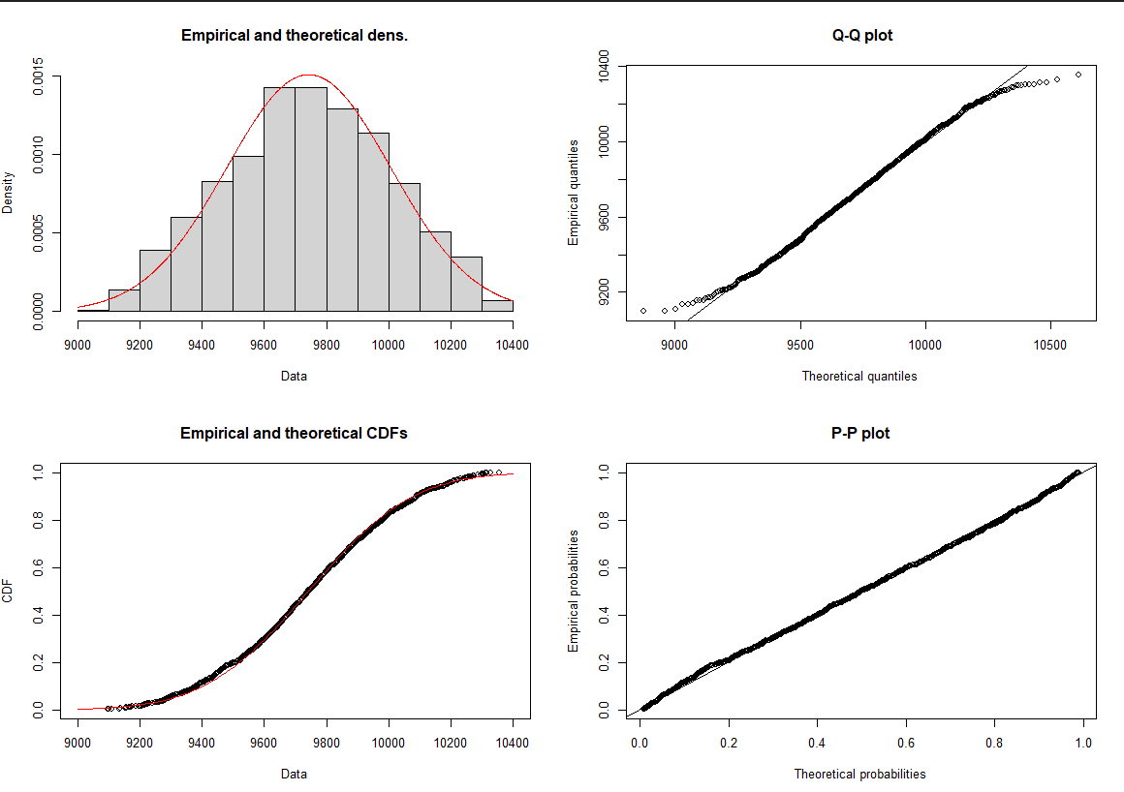

Step 1(ii): Expected Order Quantity
The expected order quantity is 676.58 units, with a 95% confidence interval of [675.44, 677.72] — essentially centered on the deterministic EOQ of 677 units from Part I, which is reassuring evidence that the simulation is consistent with the closed-form model. The narrow interval, spanning roughly two units, shows the estimate is precise despite the demand uncertainty. This stability arises because the EOQ grows with the square root of demand, so even a sizable swing in demand (13,000 to 17,000 units) produces only a modest change in the optimal order quantity. The fitted distribution is N(676.58, 18.34), indicating order quantities cluster tightly around the mean with a standard deviation of about 18 units. The KS test again returns a statistic of 0.027 and p = .44 (> .05), so the Normal fit is supported, and the Q–Q and P–P plots show the points lying close to the reference line (Figure 8). In practical terms, an order quantity near 677 units remains optimal across the plausible demand range, so management can commit to that policy with confidence.

Figure 8
Histogram and Distribution-Fit Diagnostics: Order Quantity (EOQ)
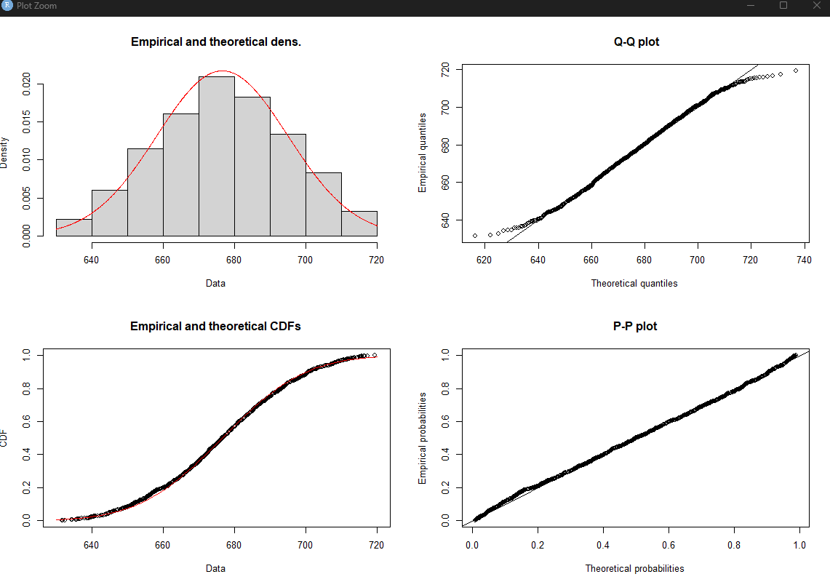
Step 1(iii): Expected Annual Number of Orders
The expected annual number of orders is 22.14, with a 95% confidence interval of [22.11, 22.18], closely matching the deterministic value of 22.16 orders per year from Part I. The narrow interval — a spread of less than one order — indicates that the estimate is highly precise and that demand uncertainty has little effect on how often the company must reorder. This is expected, since the number of orders is the most stable of the three outputs: it depends on the ratio of demand to order quantity, and both rise or fall together as demand varies, partly cancelling out. The fitted distribution is N(22.14, 0.60), and the KS test returns a statistic of 0.027 and p = .44 (> .05), confirming the Normal fit (Figure 9). The diagnostic plots reinforce this, with the points falling closely along the reference line in the Q–Q and P–P panels. In practical terms, management can plan on roughly 22 replenishments per year with high confidence. Table 2 consolidates the confidence intervals and fitted distributions for all three outputs.

Figure 9
Histogram and Distribution-Fit Diagnostics: Annual Number of Orders
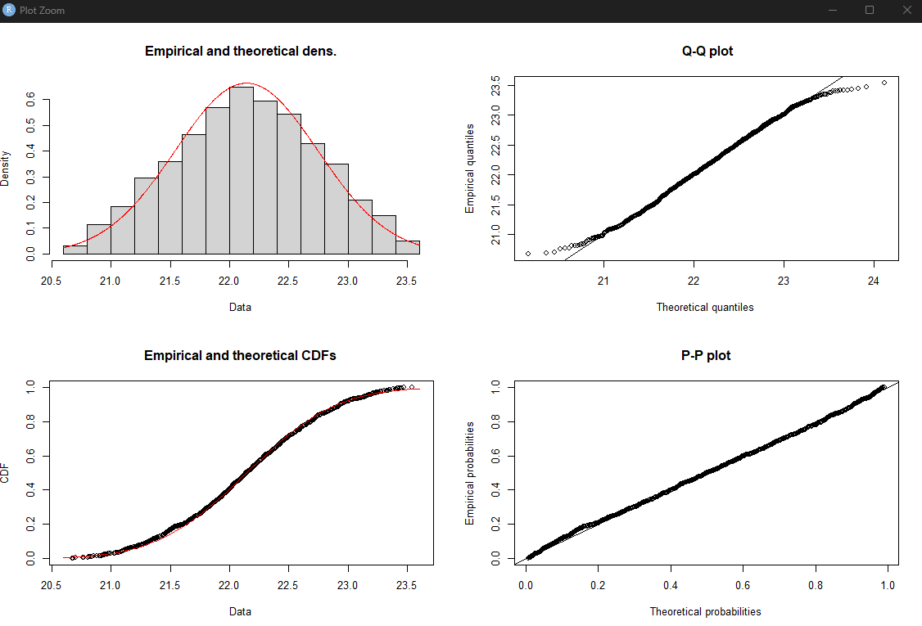

Table 2
Simulation Results: 95% Confidence Intervals and Fitted Distributions (Part II)
Output | Mean | 95% CI | Best fit
Minimum total cost | $9,742.77 | ($9,726.39, $9,759.15) | Normal
Order quantity (EOQ) | 676.58 units | (675.44, 677.72) | Normal
Annual number of orders | 22.14 | (22.11, 22.18) | Normal
Note. CI = 95% confidence interval (mean ± 1.96 × standard error) from 1,000 simulated occurrences. Distributions were fitted by maximum likelihood (fitdistrplus). All three KS tests yield the same statistic (0.027) and p-value (.44) because the order quantity, total cost, and number of orders are each monotonic transformations of the same simulated demand values.

Conclusion and Recommendations
The deterministic analysis (Part I) recommends ordering approximately 677 units per replenishment, which places roughly 22 orders per year and yields a minimum total annual inventory cost of about $9,749, with ordering and holding costs balanced at the optimum. The data-table search (Q = 700), Excel Solver, and R optimization (Q = 677) all converge on this result, and the two-way sensitivity analysis shows the policy is stable under reasonable variation in the cost parameters. When demand uncertainty is introduced (Part II), the 1,000-trial simulation produces an expected total cost of $9,742.77 (95% CI [$9,726.39, $9,759.15]), an expected order quantity of about 676.58 units, and about 22.14 orders per year — values that closely match the deterministic optimum and have narrow confidence intervals. The Normal distribution provides an adequate fit to all three outputs, supported by the diagnostic plots and the Kolmogorov–Smirnov tests (p ≈ .44). The vice president of operations can therefore adopt the EOQ policy with confidence: order about 677 units per replenishment and expect total annual costs near $9,749, with limited downside risk across the plausible demand range. We recommend monitoring realized ordering and holding costs against these estimates and re-running the model if the unit cost, ordering cost, or holding-cost rate changes materially.

References
Carnell, R. (2024). triangle: Provides the standard distribution functions for the triangle distribution [R package]. The Comprehensive R Archive Network. https://CRAN.R-project.org/package=triangle
Delignette-Muller, M. L., & Dutang, C. (2015). fitdistrplus: An R package for fitting distributions. Journal of Statistical Software, 64(4), 1–34. https://doi.org/10.18637/jss.v064.i04
Evans, J. R. (2020). Business analytics: Methods, models, and decisions (3rd ed.). Pearson.
R Core Team. (2024). R: A language and environment for statistical computing. R Foundation for Statistical Computing. https://www.R-project.org/

