|  |
| --- |
| Experiment No. 1 |
| Analyze the Boston Housing dataset and apply appropriate Regression Technique |
| Date of Performance: 17/07/2023 |
| Date of Submission: 24/07/2023 |

**Aim:** Analyze the Boston Housing dataset and apply appropriate Regression Technique.

**Objective:** Ablility to perform various feature engineering tasks, apply linear regression on the given dataset and minimise the error.

**Theory:**

Linear Regression is a machine learning algorithm based on supervised learning. It performs a regression task. Regression models a target prediction value based on independent variables. It is mostly used for finding out the relationship between variables and forecasting. Different regression models differ based on – the kind of relationship between dependent and independent variables they are considering, and the number of independent variables getting used.

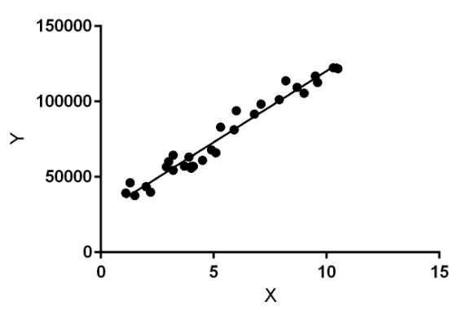

Linear regression performs the task to predict a dependent variable value (y) based on a given independent variable (x). So, this regression technique finds out a linear relationship between x (input) and y(output). Hence, the name is Linear Regression.

In the figure above, X (input) is the work experience and Y (output) is the salary of a person. The regression line is the best fit line for our model.

**Dataset:**

The Boston Housing Dataset

The Boston Housing Dataset is a derived from information collected by the U.S. Census Service concerning housing in the area of Boston MA. The following describes the dataset columns:

CRIM - per capita crime rate by town

ZN - proportion of residential land zoned for lots over 25,000 sq.ft.

INDUS - proportion of non-retail business acres per town.

CHAS - Charles River dummy variable (1 if tract bounds river; 0 otherwise)

NOX - nitric oxides concentration (parts per 10 million)

RM - average number of rooms per dwelling

AGE - proportion of owner-occupied units built prior to 1940

DIS - weighted distances to five Boston employment centres

RAD - index of accessibility to radial highways

TAX - full-value property-tax rate per $10,000

PTRATIO - pupil-teacher ratio by town

B - 1000(Bk - 0.63)^2 where Bk is the proportion of blacks by town

LSTAT - % lower status of the population

MEDV - Median value of owner-occupied homes in $1000's

**Code:**

import numpy as np

import pandas as pd

from sklearn.datasets import load_boston

from sklearn.model_selection import train_test_split

from sklearn.linear_model import LinearRegression

from sklearn.metrics import mean_squared_error, r2_score

boston = load_boston()

data=pd.DataFrame(data=np.c_[boston.data,boston.target], columns=np.append(boston.feature_names, 'PRICE'))

X = data.drop('PRICE', axis=1)

y = data['PRICE']

X_train, X_test, y_train, y_test = train_test_split(X, y, test_size=0.2, random_state=42)

model = LinearRegression()

model.fit(X_train, y_train)

y_pred = model.predict(X_test)

mse = mean_squared_error(y_test, y_pred)

r2 = r2_score(y_test, y_pred)

print(f"Mean Squared Error: {mse:.2f}")

print(f"R-squared (R2) Score: {r2:.2f}")

print("Coefficients:", model.coef_)

print("Intercept:", model.intercept_)

**Output:**

Mean Squared Error: 24.29

R-squared (R2) Score: 0.67

**Conclusion:**

To conclude, the accuracy and effectiveness of a house price prediction model depend significantly on the meticulous selection of appropriate features. Opting for pertinent attributes like the count of bedrooms, bathrooms, square footage, the property's location, and other vital determinants empowers the creation of a model capable of furnishing precise and meaningful housing price estimates. The model's prosperity is contingent on the thoughtful curation of features that aptly capture the intricate dynamics of the real estate market, thereby facilitating valuable insights and forecasts within the housing industry.