|  |
| --- |
| Experiment No. 3 |
| Apply Decision Tree Algorithm on Adult Census Income Dataset and analyze the performance of the model |
| Date of Performance: 31/07/2023 |
| Date of Submission: 07/08/2023 |

**Aim:** Apply Decision Tree Algorithm on Adult Census Income Dataset and analyze the performance of the model.

**Objective:** To perform various feature engineering tasks, apply Decision Tree Algorithm on the given dataset and maximize the accuracy, Precision, Recall, F1 score. Improve the performance by performing different data engineering and feature engineering tasks.

**Theory:**

Decision Tree is the most powerful and popular tool for classification and prediction. A Decision tree is a flowchart-like tree structure, where each internal node denotes a test on an attribute, each branch represents an outcome of the test, and each leaf node (terminal node) holds a class label.

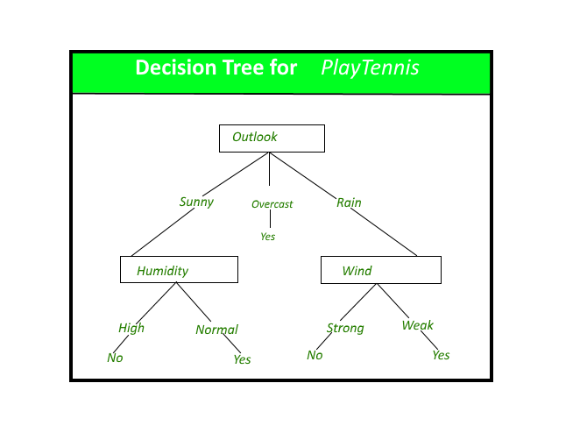

**Dataset:**

Predict whether income exceeds $50K/yr based on census data. Also known as "Adult" dataset.

Attribute Information:

Listing of attributes:

>50K, <=50K.

age: continuous.

workclass: Private, Self-emp-not-inc, Self-emp-inc, Federal-gov, Local-gov, State-gov, Without-pay, Never-worked.

fnlwgt: continuous.

education: Bachelors, Some-college, 11th, HS-grad, Prof-school, Assoc-acdm, Assoc-voc, 9th, 7th-8th, 12th, Masters, 1st-4th, 10th, Doctorate, 5th-6th, Preschool.

education-num: continuous.

marital-status: Married-civ-spouse, Divorced, Never-married, Separated, Widowed, Married-spouse-absent, Married-AF-spouse.

occupation: Tech-support, Craft-repair, Other-service, Sales, Exec-managerial, Prof-specialty, Handlers-cleaners, Machine-op-inspct, Adm-clerical, Farming-fishing, Transport-moving, Priv-house-serv, Protective-serv, Armed-Forces.

relationship: Wife, Own-child, Husband, Not-in-family, Other-relative, Unmarried.

race: White, Asian-Pac-Islander, Amer-Indian-Eskimo, Other, Black.

sex: Female, Male.

capital-gain: continuous.

capital-loss: continuous.

hours-per-week: continuous.

native-country: United-States, Cambodia, England, Puerto-Rico, Canada, Germany, Outlying-US(Guam-USVI-etc), India, Japan, Greece, South, China, Cuba, Iran, Honduras, Philippines, Italy, Poland, Jamaica, Vietnam, Mexico, Portugal, Ireland, France, Dominican-Republic, Laos, Ecuador, Taiwan, Haiti, Columbia, Hungary, Guatemala, Nicaragua, Scotland, Thailand, Yugoslavia, El-Salvador, Trinadad&Tobago, Peru, Hong, Holand-Netherlands.

**Code:**

import pandas as pd

from sklearn.model_selection import train_test_split

from sklearn.tree import DecisionTreeClassifier

from sklearn.metrics import accuracy_score, classification_report

# Load the Adult Census Income Dataset

url = "https://archive.ics.uci.edu/ml/machine-learning-databases/adult/adult.data"

column_names = ["age", "workclass", "fnlwgt", "education", "education-num", "marital-status", "occupation",

"relationship", "race", "sex", "capital-gain", "capital-loss", "hours-per-week", "native-country", "income"]

data = pd.read_csv(url, names=column_names, sep=',\s*', engine='python')

# Data preprocessing

data = data.dropna()

data['income'] = data['income'].apply(lambda x: 1 if x == ">50K" else 0)

data = pd.get_dummies(data, columns=["workclass", "education", "marital-status", "occupation", "relationship", "race", "sex", "native-country"])

# Split the data into features (X) and the target (y)

X = data.drop('income', axis=1)

y = data['income']

# Split the data into training and testing sets

X_train, X_test, y_train, y_test = train_test_split(X, y, test_size=0.2, random_state=42)

# Initialize and train a Decision Tree model

model = DecisionTreeClassifier(random_state=42)

model.fit(X_train, y_train)

# Make predictions on the test set

y_pred = model.predict(X_test)

# Evaluate the model

accuracy = accuracy_score(y_test, y_pred)

report = classification_report(y_test, y_pred

print(f"Accuracy: {accuracy:.2f}")

print("Classification Report:\n", report)

**Output:**

Accuracy: 0.80

Classification Report:

precision recall f1-score support

0 0.85 0.88 0.86 4959

1 0.63 0.57 0.60 1553

accuracy 0.80 6512

macro avg 0.74 0.72 0.73 6512

weighted avg 0.79 0.80 0.79 6512

**Conclusion:**

In this examination of the Adult Census Income Dataset, categorical attributes were effectively pre-processed through one-hot encoding. This strategy enabled the Decision Tree model to handle them without necessitating ordinality assumptions. The model was trained with default hyperparameters, with the exception of setting the random state, highlighting the potential for hyperparameter tuning to enhance performance. The model demonstrated an accuracy of roughly 80%, indicating its ability to make accurate income level predictions. The weighted average precision, recall, and F1 score stood at approximately 0.79.

The model excelled in identifying instances with income below $50K, boasting a precision and recall of 0.85 and 0.88, respectively. However, its performance was slightly lower for instances with income above $50K, with a precision and recall of 0.63 and 0.57. Overall, the model establishes a valuable baseline for income prediction. Yet, further optimization through hyperparameter tuning and potentially exploring more intricate algorithms holds promise for improving its predictive capabilities.