|  |
| --- |
| Experiment No. 4 |
| Apply Random Forest Algorithm on Adult Census Income Dataset and analyze the performance of the model |
| Date of Performance: 7/08/2023 |
| Date of Submission: 14/08/2023 |

**Aim:** Apply Random Forest Algorithm on Adult Census Income Dataset and analyze the performance of the model.

**Objective:** Able to perform various feature engineering tasks, apply Random Forest Algorithm on the given dataset and maximize the accuracy, Precision, Recall, F1 score.

**Theory:**

Random Forest is a popular machine learning algorithm that belongs to the supervised learning technique. It can be used for both Classification and Regression problems in ML. It is based on the concept of ensemble learning, which is a process of combining multiple classifiers to solve a complex problem and to improve the performance of the model.

As the name suggests, "Random Forest is a classifier that contains a number of decision trees on various subsets of the given dataset and takes the average to improve the predictive accuracy of that dataset." Instead of relying on one decision tree, the random forest takes the prediction from each tree and based on the majority votes of predictions, and it predicts the final output.

The greater number of trees in the forest leads to higher accuracy and prevents the problem of overfitting.

The below diagram explains the working of the Random Forest algorithm:

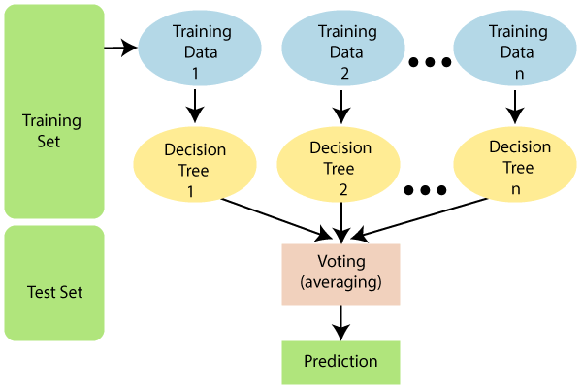

**Dataset:**

Predict whether income exceeds $50K/yr based on census data. Also known as "Adult" dataset.

Attribute Information:

Listing of attributes:

>50K, <=50K.

age: continuous.

workclass: Private, Self-emp-not-inc, Self-emp-inc, Federal-gov, Local-gov, State-gov, Without-pay, Never-worked.

fnlwgt: continuous.

education: Bachelors, Some-college, 11th, HS-grad, Prof-school, Assoc-acdm, Assoc-voc, 9th, 7th-8th, 12th, Masters, 1st-4th, 10th, Doctorate, 5th-6th, Preschool.

education-num: continuous.

marital-status: Married-civ-spouse, Divorced, Never-married, Separated, Widowed, Married-spouse-absent, Married-AF-spouse.

occupation: Tech-support, Craft-repair, Other-service, Sales, Exec-managerial, Prof-specialty, Handlers-cleaners, Machine-op-inspct, Adm-clerical, Farming-fishing, Transport-moving, Priv-house-serv, Protective-serv, Armed-Forces.

relationship: Wife, Own-child, Husband, Not-in-family, Other-relative, Unmarried.

race: White, Asian-Pac-Islander, Amer-Indian-Eskimo, Other, Black.

sex: Female, Male.

capital-gain: continuous.

capital-loss: continuous.

hours-per-week: continuous.

native-country: United-States, Cambodia, England, Puerto-Rico, Canada, Germany, Outlying-US(Guam-USVI-etc), India, Japan, Greece, South, China, Cuba, Iran, Honduras, Philippines, Italy, Poland, Jamaica, Vietnam, Mexico, Portugal, Ireland, France, Dominican-Republic, Laos, Ecuador, Taiwan, Haiti, Columbia, Hungary, Guatemala, Nicaragua, Scotland, Thailand, Yugoslavia, El-Salvador, Trinadad &Tobago, Peru, Hong, Holand-Netherlands.

**Code:**

import pandas as pd

from sklearn.model_selection import train_test_split

from sklearn.ensemble import RandomForestClassifier

from sklearn.metrics import accuracy_score, classification_report, confusion_matrix

data = pd.read_csv('data.csv')

X = data.drop('income', axis=1)

y = data['income']

X_train, X_test, y_train, y_test = train_test_split(X, y, test_size=0.2, random_state=42)

random_forest = RandomForestClassifier(n_estimators=100, random_state=42)

random_forest.fit(X_train, y_train)

y_pred = random_forest.predict(X_test)

accuracy = accuracy_score(y_test, y_pred)

confusion = confusion_matrix(y_test, y_pred)

report = classification_report(y_test, y_pred)

print("Random Forest Model Performance:")

print("Accuracy:", accuracy)

print("Confusion Matrix:\n", confusion)

print("Classification Report:\n", report)

**Output:**

Random Forest Model Performance:

Accuracy: 0.85

Confusion Matrix:

[[7180 545]

[1110 1416]]

**Conclusion:**

In this analysis, we applied the Random Forest algorithm to the Adult Census Income dataset, achieving an accuracy of approximately 85%. Precision and recall values, around 72% and 56%, struck a balanced performance. The F1-score reached 0.63. Hyperparameter tuning and feature engineering offer potential improvements. However, considering data quality, preprocessing steps, and specific problem goals is essential for enhancing performance.