WEB SCRAPING

It refers to the extraction of data from a website.
Web scrapers is a software tools for web scrapping. Once the data is scraped , then data is export it in a more convenient format such a Excel spreadsheet or JSON.

When attempting to scrape some websites , we may encounter captchas . We have to avoid and bypass captchas before scraping a website.

What is CAPTCHA ?

Completely Automated Public Turing test to tell Computers and Humans Apart
Turing means it’s a test to determine whether the entity we’re interacting with is a computer or human.

Purpose of CAPTCHA ?

The main purpose of CAPTCHA tests is to filter human traffic from bots . The challenges are designed to be easily solved by humans bur very hard to crack for computers .
CAPTCHAs allows website administrators to curb(control) unwelcome automated activites , such as spams , Ddos attacks , and something web scraping .

CAPTCHAs also have secondary purposes . Originally they helped to digitize badly scanned text passages that OCR (Optical Content Recognition ) Technologies couldn’t crack . Nowdays , provide free labor for Google’s ML algorithms by labeling objects in image .

How Do CAPTCHAs Work ?
CAPTCHAs function as a final test to determine if a website visitor is human or bot. They appear when a website detects unusal traffic , then they present the visitor with a challenge.

The exact configuration of a CAPTCHA depends on the webmaster , it can protect the whole website or specific pages .

MAIN FACTORS THAT CAUSE A CAPTCHA are :

- Simple CAPTCHA triggers : These include unusal traffic, high number of connections from a single IP address , or the use of low quality datacenter IP . Eg , VPN users see more CAPTCHAs than regular website visitors because VPNs get their IP from a datacenter .
- Passive fingerprinting : a collection of parameters that evaluate your network and device.
- Active fingerprinting : An even more elaborate technique that sniffs out advanced information about our hardware and software through javascript .

Main Types Of CAPTCHAs

- Text entry CAPTCHAs : string of distorted letters and numbers
- Image CAPTCHAs :
- Audio CAPTCHAs
- Puzzle CAPTCHAs : include math problems , word puzzles , spatial tasks and similar tests .
- Button CAPTCHAs
- Social Medis Sign In : Ask new users to register using their social edia account before they can see content or use a service.

HOW TO BYPASS CAPTCHA :

If our web scraper is encountering CAPTCHAs . First recourse should be to rotate our IP Address . If we using a quality proxy network , it helps surprisingly often.

Otherwise , there are 2 main approaches to bypass CAPTCHAs.
Solving the challenge , Avoiding the challenge

HOW DOES WEB SCRAPING WORK ?

Web scrapers goal is to understand the structure of a website in order to extract the data needed and export it as a whole new format.

In most cases, web scrapers scrape data from given a specific URL . The scraper then loads the entire HTML code for the page .Then the scraper will either extract all the data on the page or able to select the specific data we want to extract. Lastly , the scraper will run and let the user download the data as Excel sheet or other formats.

KIND OF WEB SCRAPERS :
- self-built or pre-built : Anyone can build their own web scraper . However , the tools available to build our own web scrapper that we can download and run right away . Advanced options addes such as scrape scheduling , JSON and Google sheets
- browser extension vs software : web scrapers come in two forms
  - browser extension : are app-like program that can be added to our browser such as Google Chorme or Firefox .
  - Computer software : we have actual web scraping software that can be downloaded and istalled on our computer.
- user interface :
- cloud vs local : from where does our web scraper actually do its job ?

Local web scrapers will run on our computer using its resources and internet connection. This means that if our web scraper has a high usage of CPU OR RAM,our computer might become quite slow while our scrape runs . With long scraping tasks , this could put our computer out out of comission for hours.

Cloud based web scrapers run on an off-site server which is usually provided by the company that developed the scraper itself. This means that our computer resources are freed (free) up while our scraper runs and gather data . We can work on other tasks and be notified later once our scrape is ready to be exported . Allow advanced features such as IP rotation , which can prevent our scraper from getting blocked from major websites due to their scraping activity .

HTML FOR WEB SCRAPING
In web scraping inspecting an element within a website in order to obtain the HTML code behind it
- HTML Element syntax : it usually uses tags and attributes
- Tags define how our web browser must format and display the content .
- HTML elements are written with an opening tag and closing tag , with content in between .
- Attributes define the additional properties of the element .

Attribute Affected content
<h1 class = “title”> Titanic (1997) </h1>

Tag Attribute Attribute End
name name value tag

HTML Element

Element Nodes
Attribute Nodes
Text Nodes

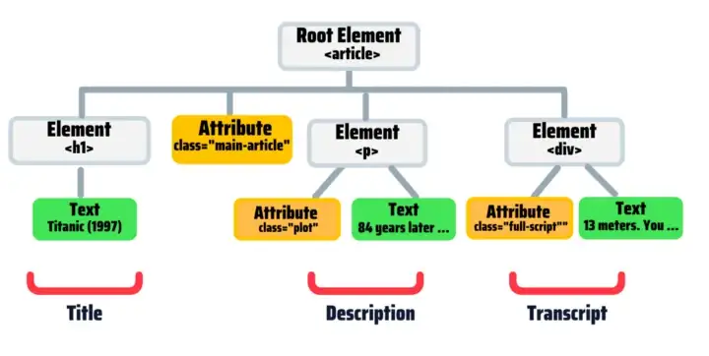

Root node is the top node.
Every node has exactly one “parent” , except the root.
An element node has can have zero,one, or several “children”.
“Sibling” are nodes with the same parent (eg h1,p and div)

Web Scraping Using Python & BeautifulSoup

BEAUTIFUL SOUP
It is the web scrapping tool in python . Although it has some limitations (e.g. it doesn’t scrape Javascrpit-driven websites)

Step 1 : Setting up the environment
Installing the libraries
We need 3 libraries
- beautifulsoup4 : to scrape the website
- requests : to send request to the website
- lxml : for parsing XML and HTML

Step 2 : Get the HTML
get the HTML as a string
requests module to get this done
parse the HTML content and give it a tree like structure so that it can be traversed

Step 3 : Parse the HTML
once the HTML is fetched using requests as an string , we need to parse it .
For parsing , we will use python’s BeautifulSoup module whuch will create tree like structure for our DOM
Step 4 : HTML tree traversal
once the HTML is fetched and parsed , the next step is to manipulate the tree using BeautifulSoup functions to get our job done

