BDA LAB3
NAME : NIKITA PARAS TOLIYA
USN:1BM19CS103

1. mkdir
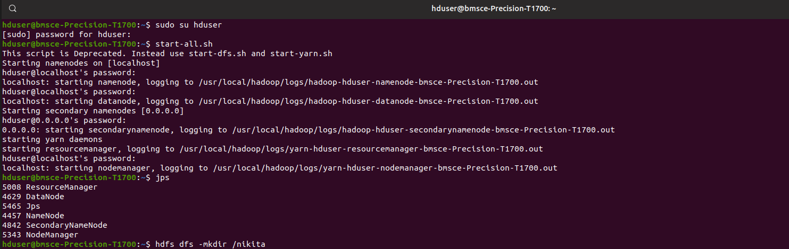

2. ls
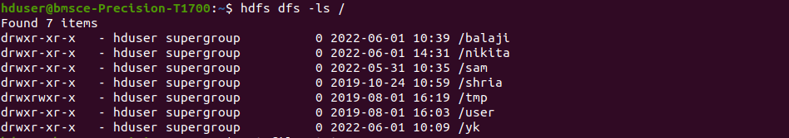
3. put
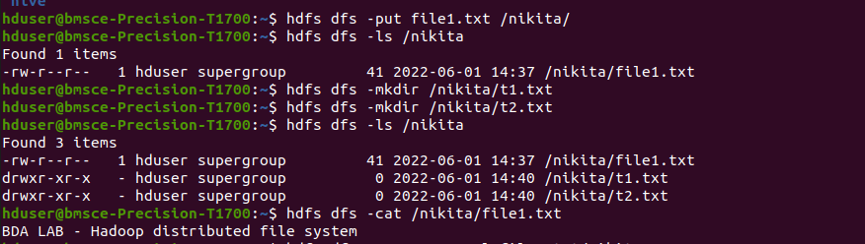

4. copyFromLocal
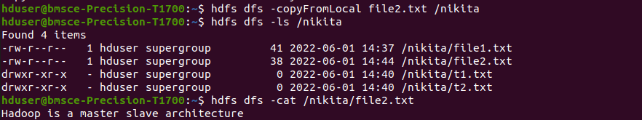

5. get
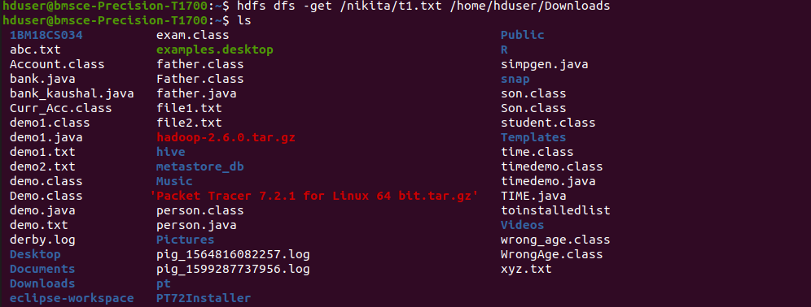

6. copyToLocal
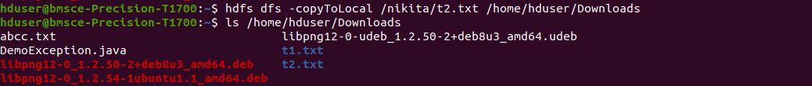
7. cat
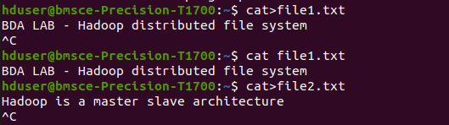

8. mv
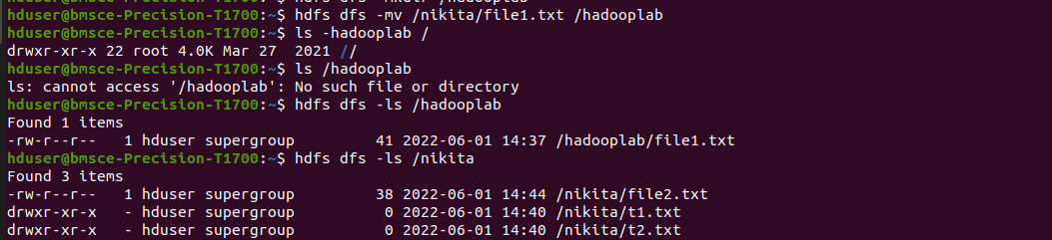

9. cp

