**Flat Robot**

This model is a flat robot that can move or rotate with the help of two wheels, similar to a home vacuuming robot. This model assumes that the robot moves in one of two ways:

* Linear — Both wheels turn in the same direction with the same speed and the robot moves linearly.
* Rotational — The wheels turn in opposite directions with the same speed and the robot rotates in place.

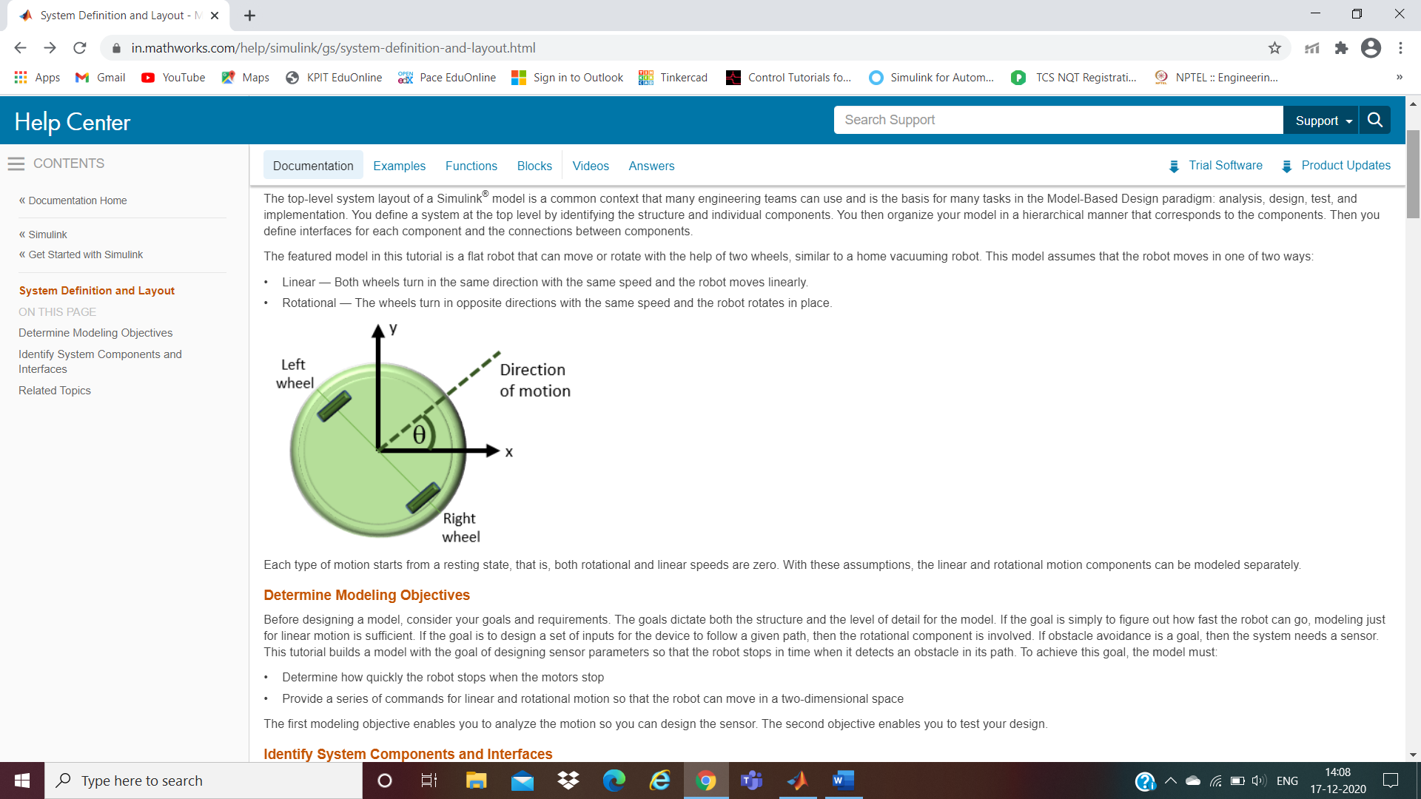

**Identify Robot Motion Components**

The system in this tutorial defines a robot that moves with two electric wheels in two dimensions. It includes:

* Linear motion characteristics
* Rotational motion characteristics
* Transformations to determine the location of the system in two dimensions
* A sensor to measure the distance of the robot from an obstacle

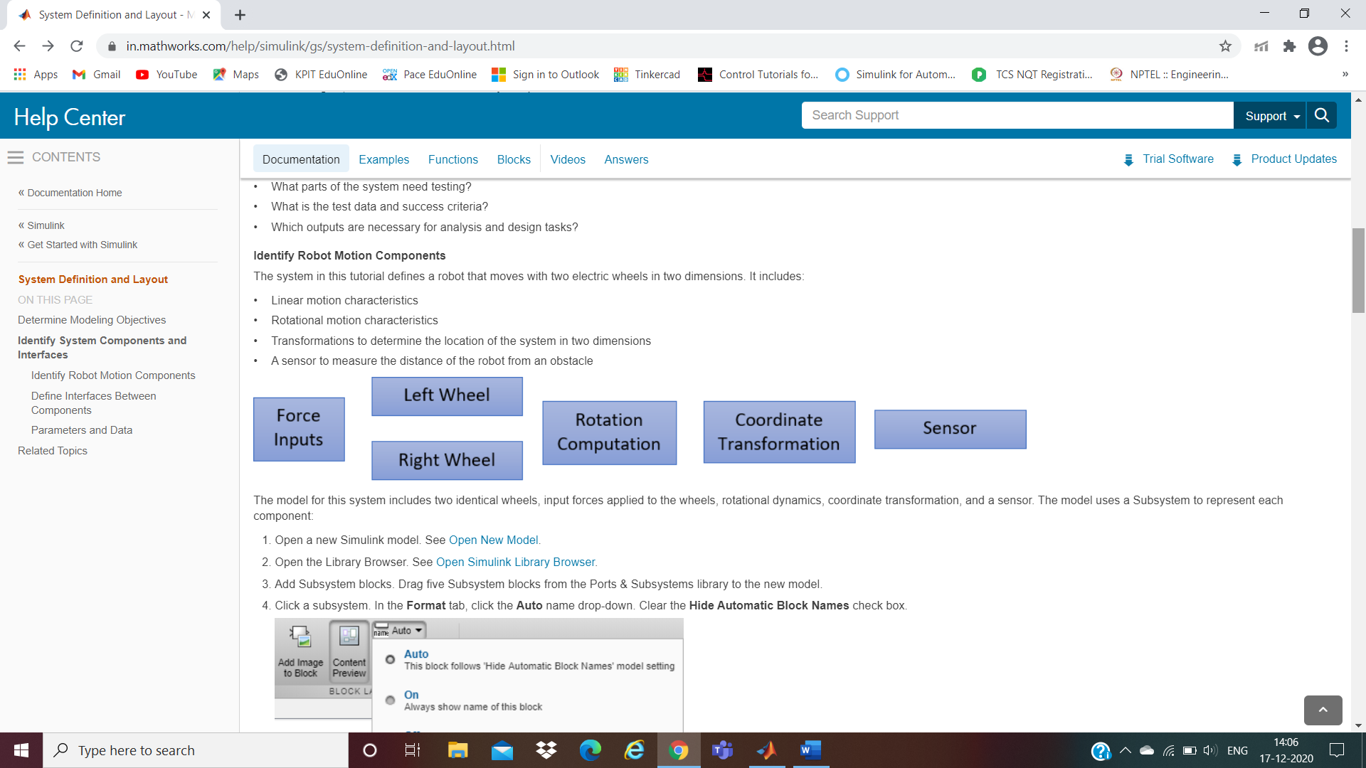

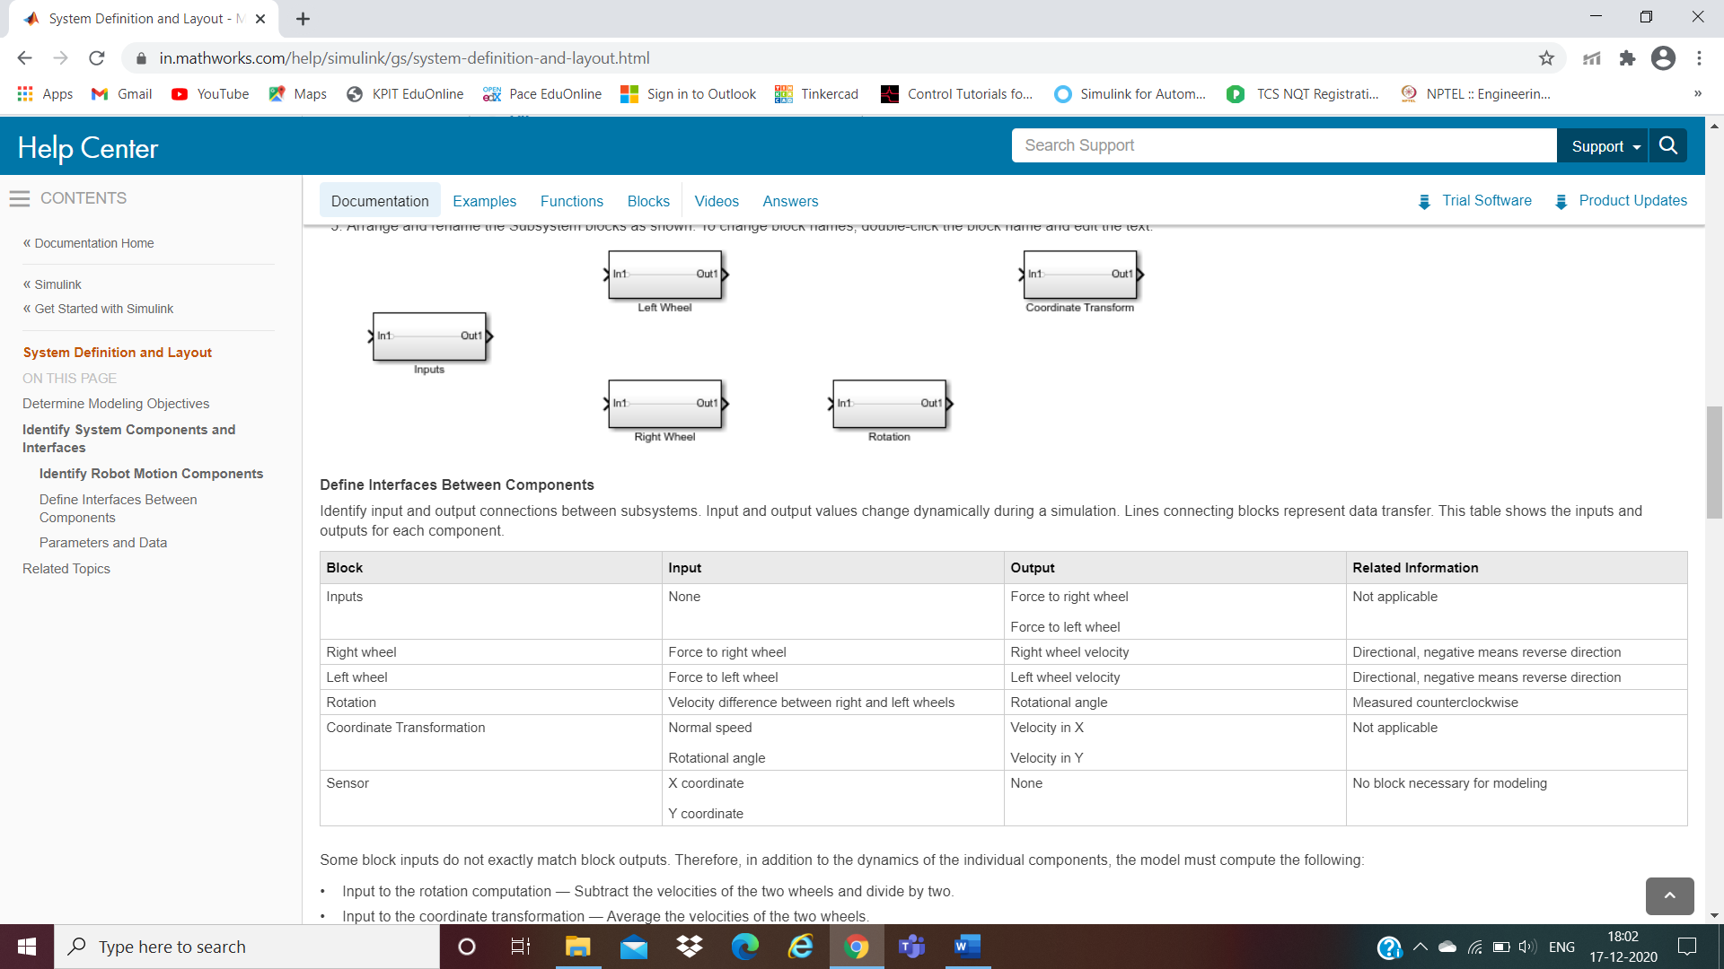**Define Interfaces Between Components**

**Parameters and Data**

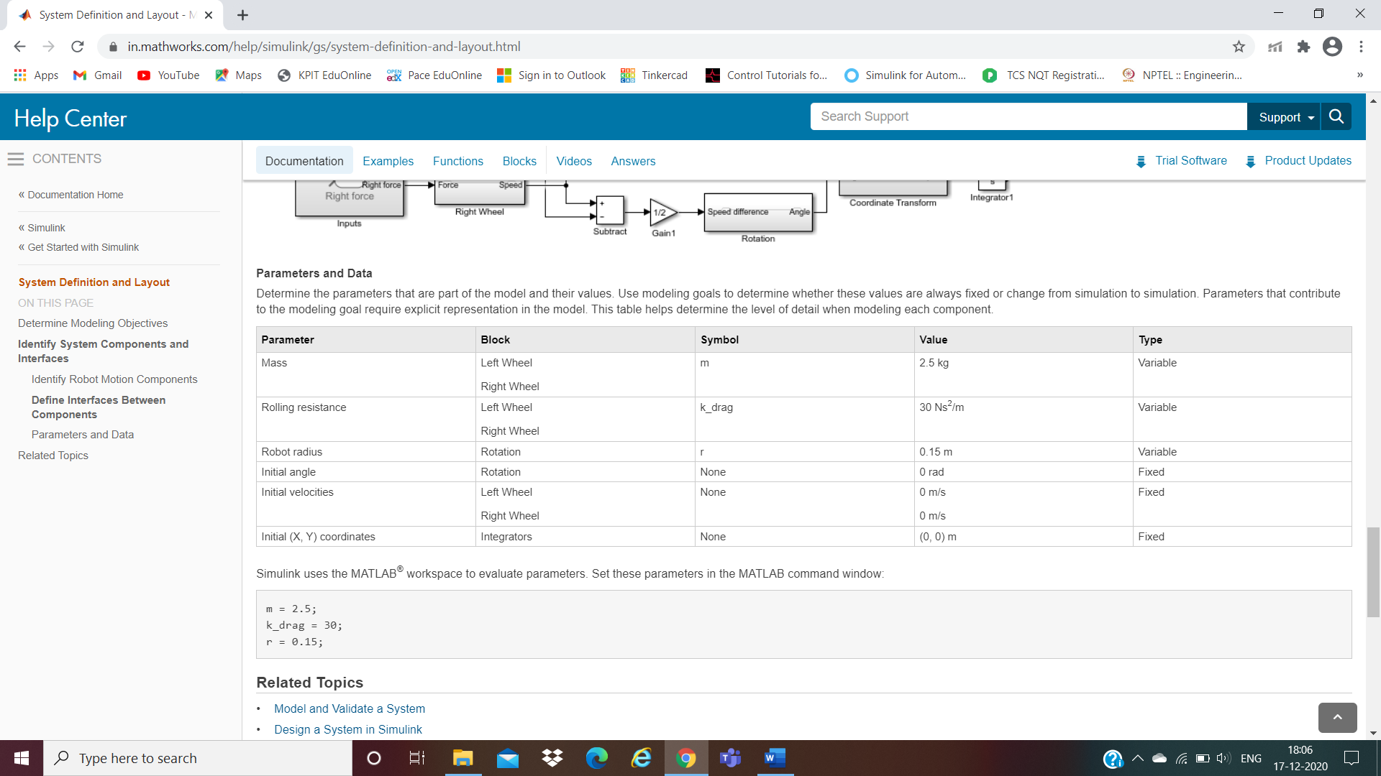

**Callbacks**

m = 2.5;

k_drag = 30;

r = 0.15;

**Simulink Model**

Inputs

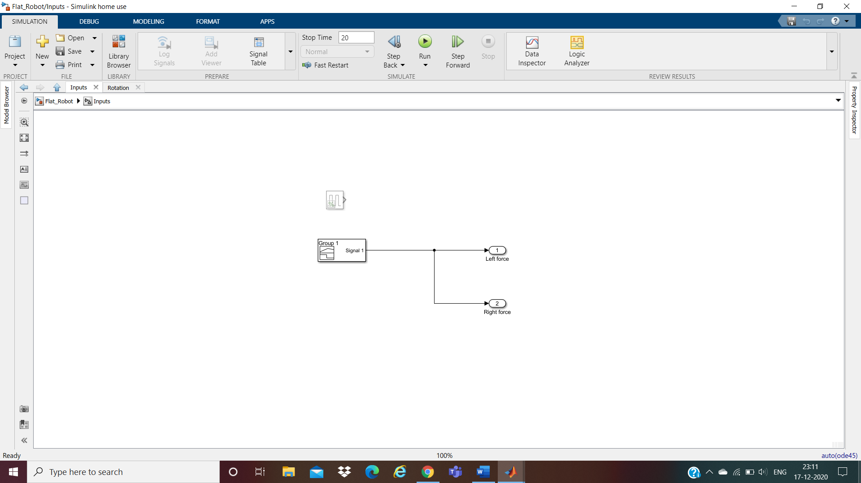

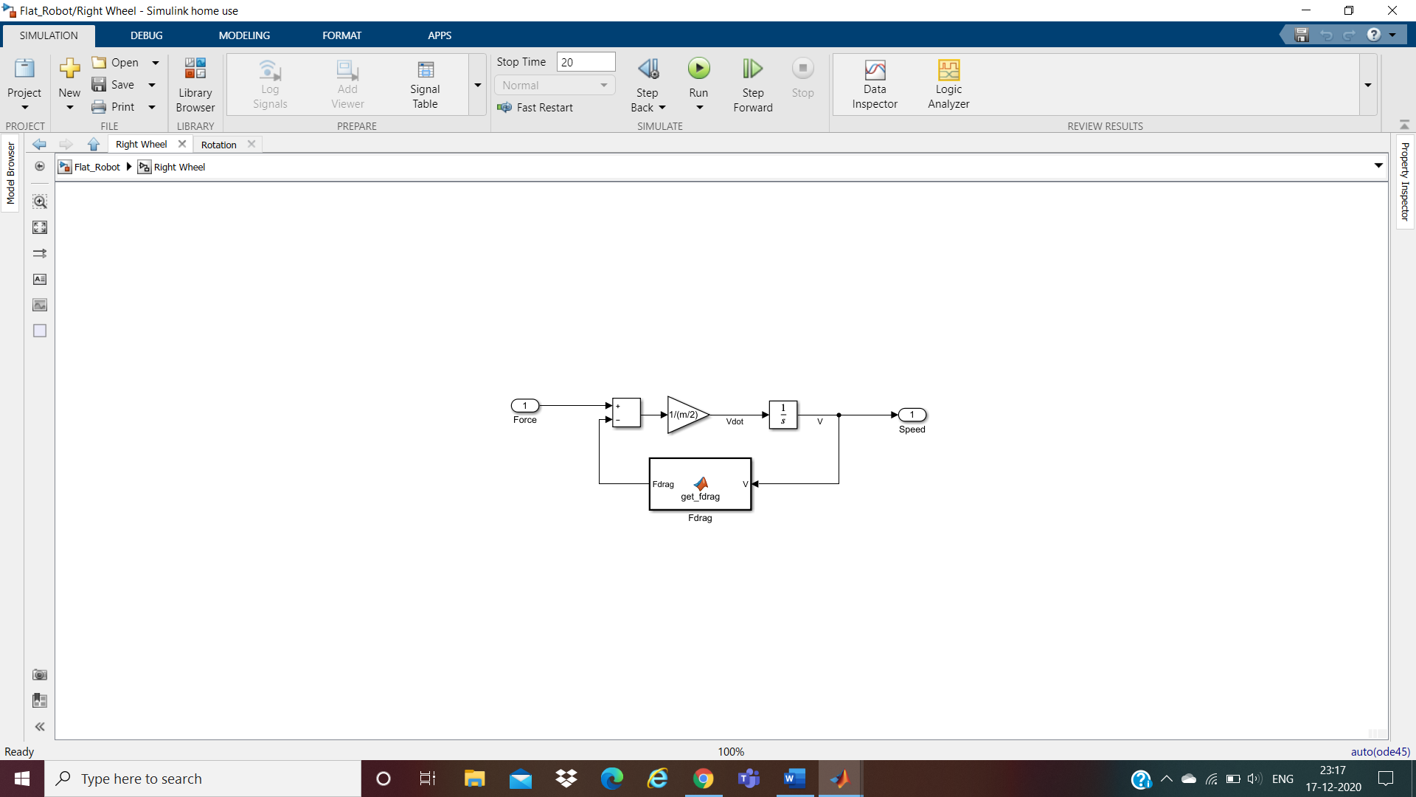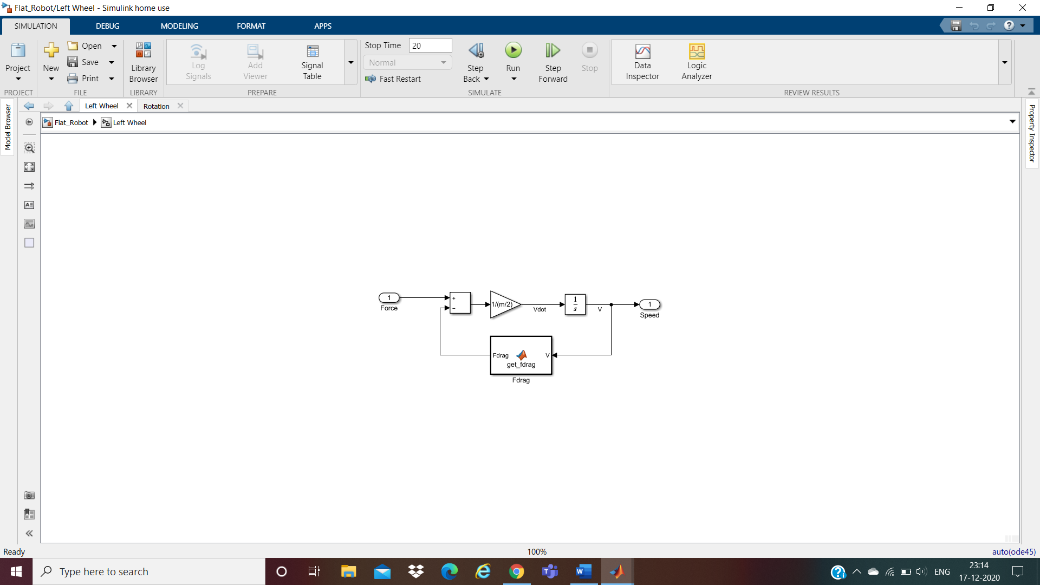Left Wheel Right Wheel

Rotation

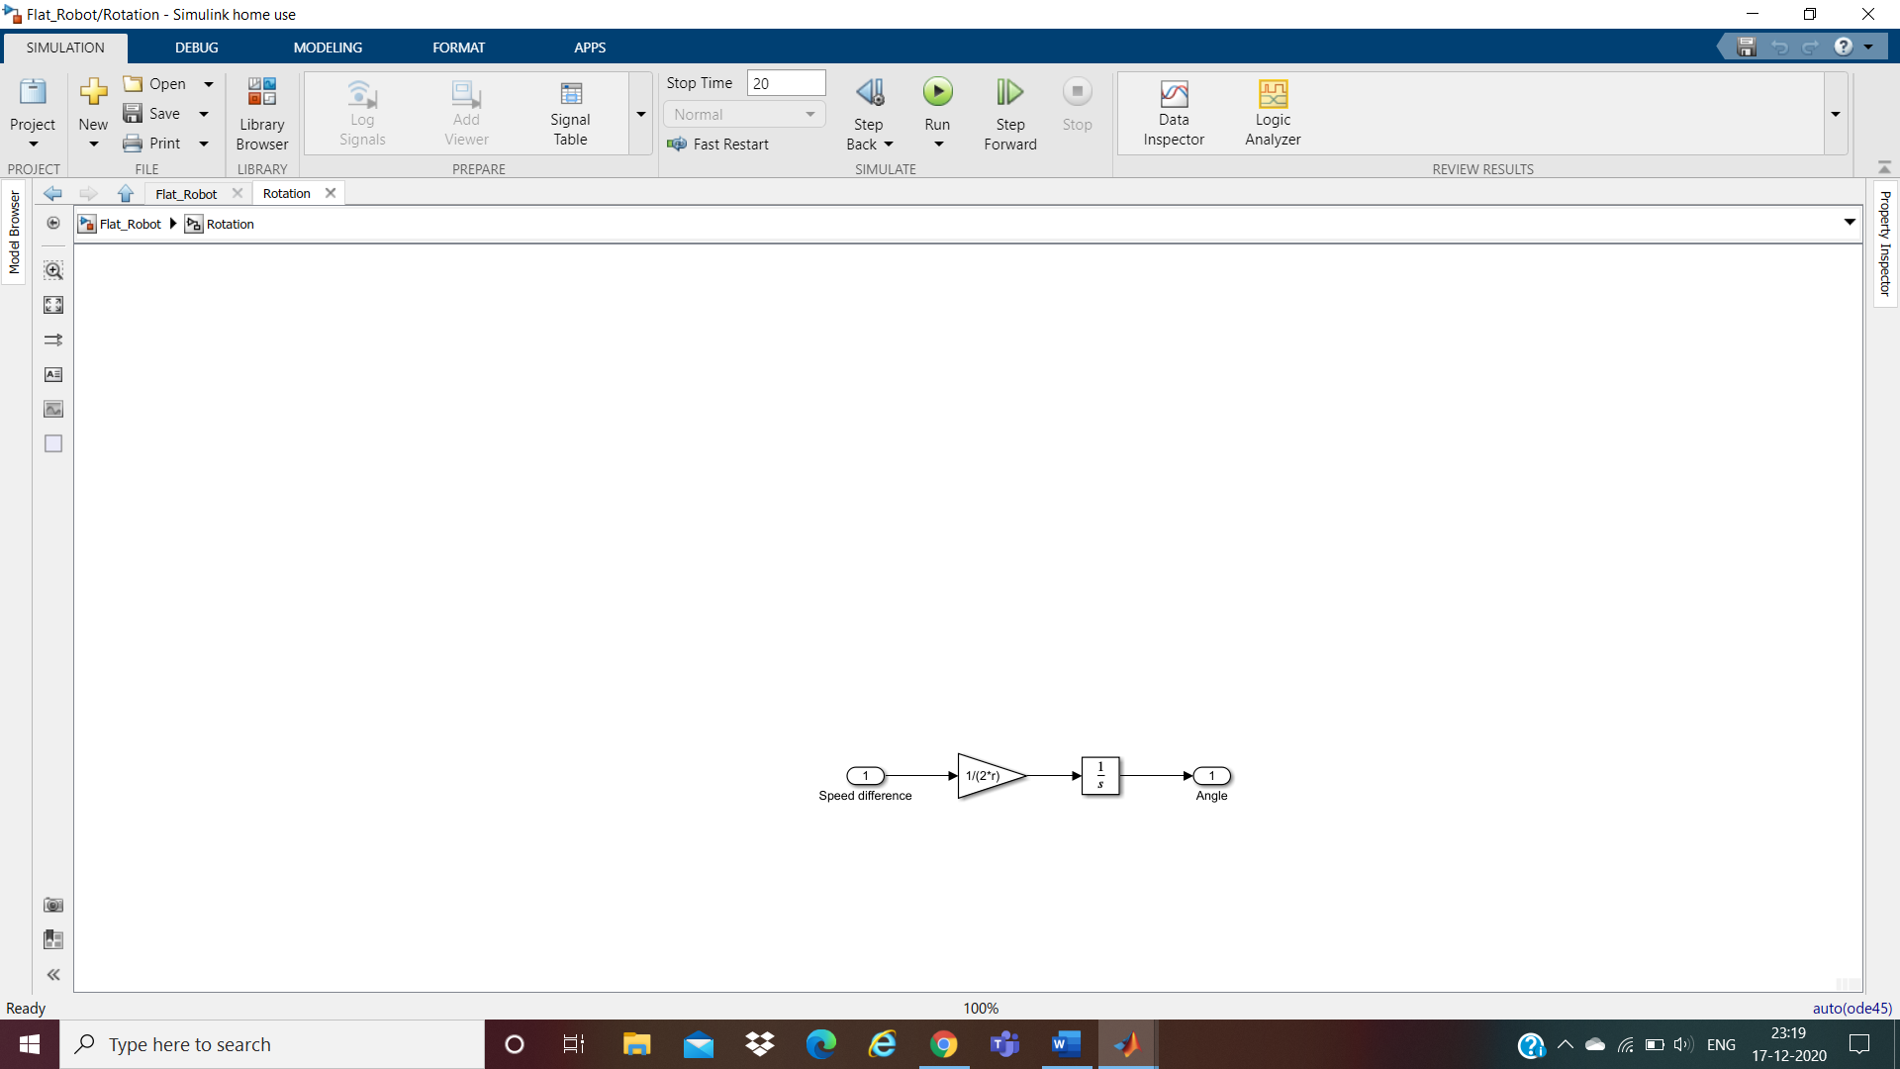

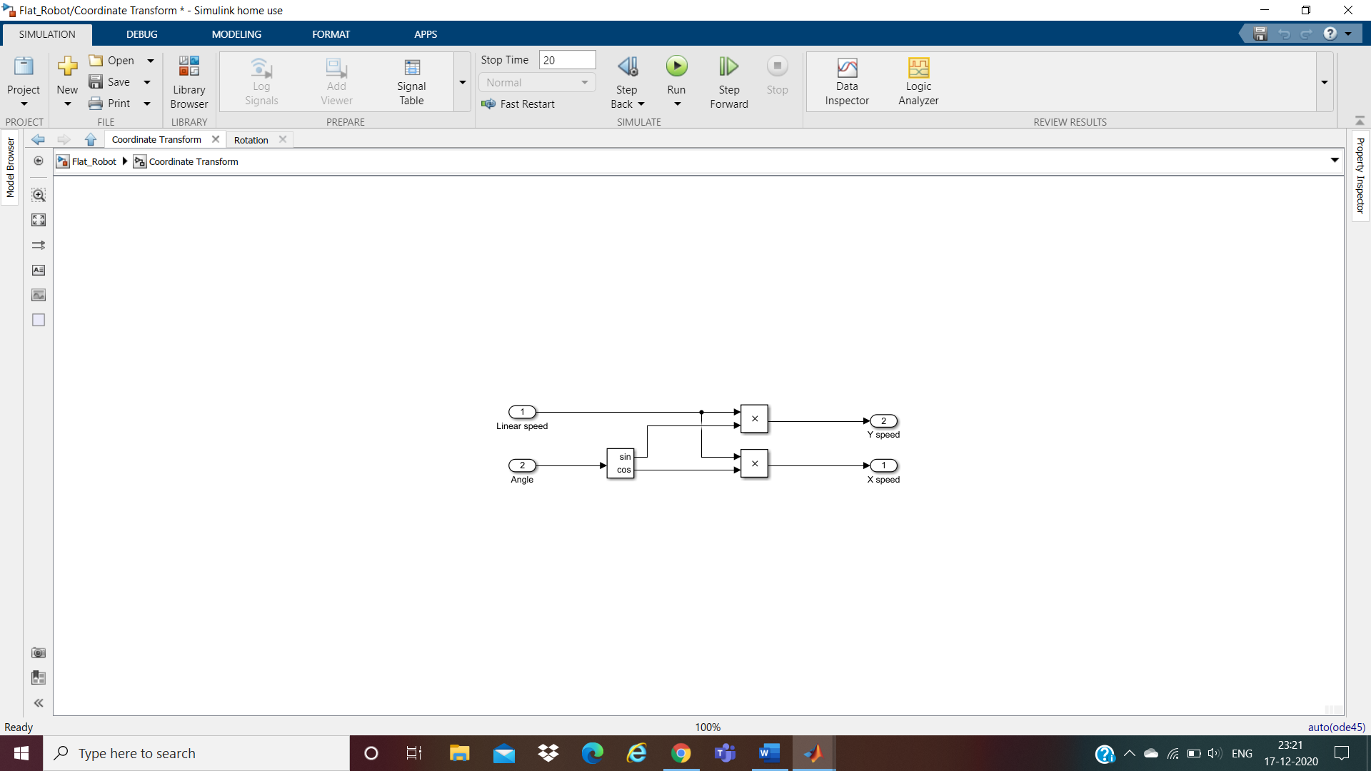Coordinate Transform

Sensor Model

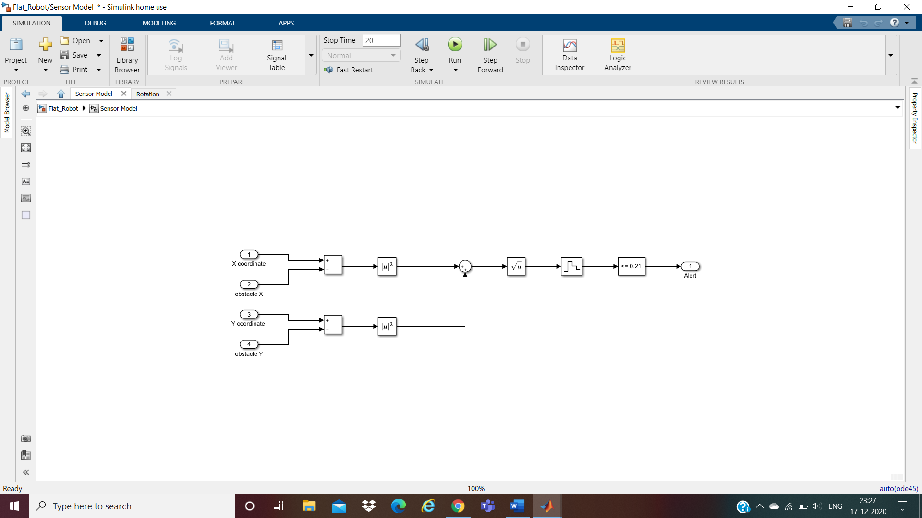

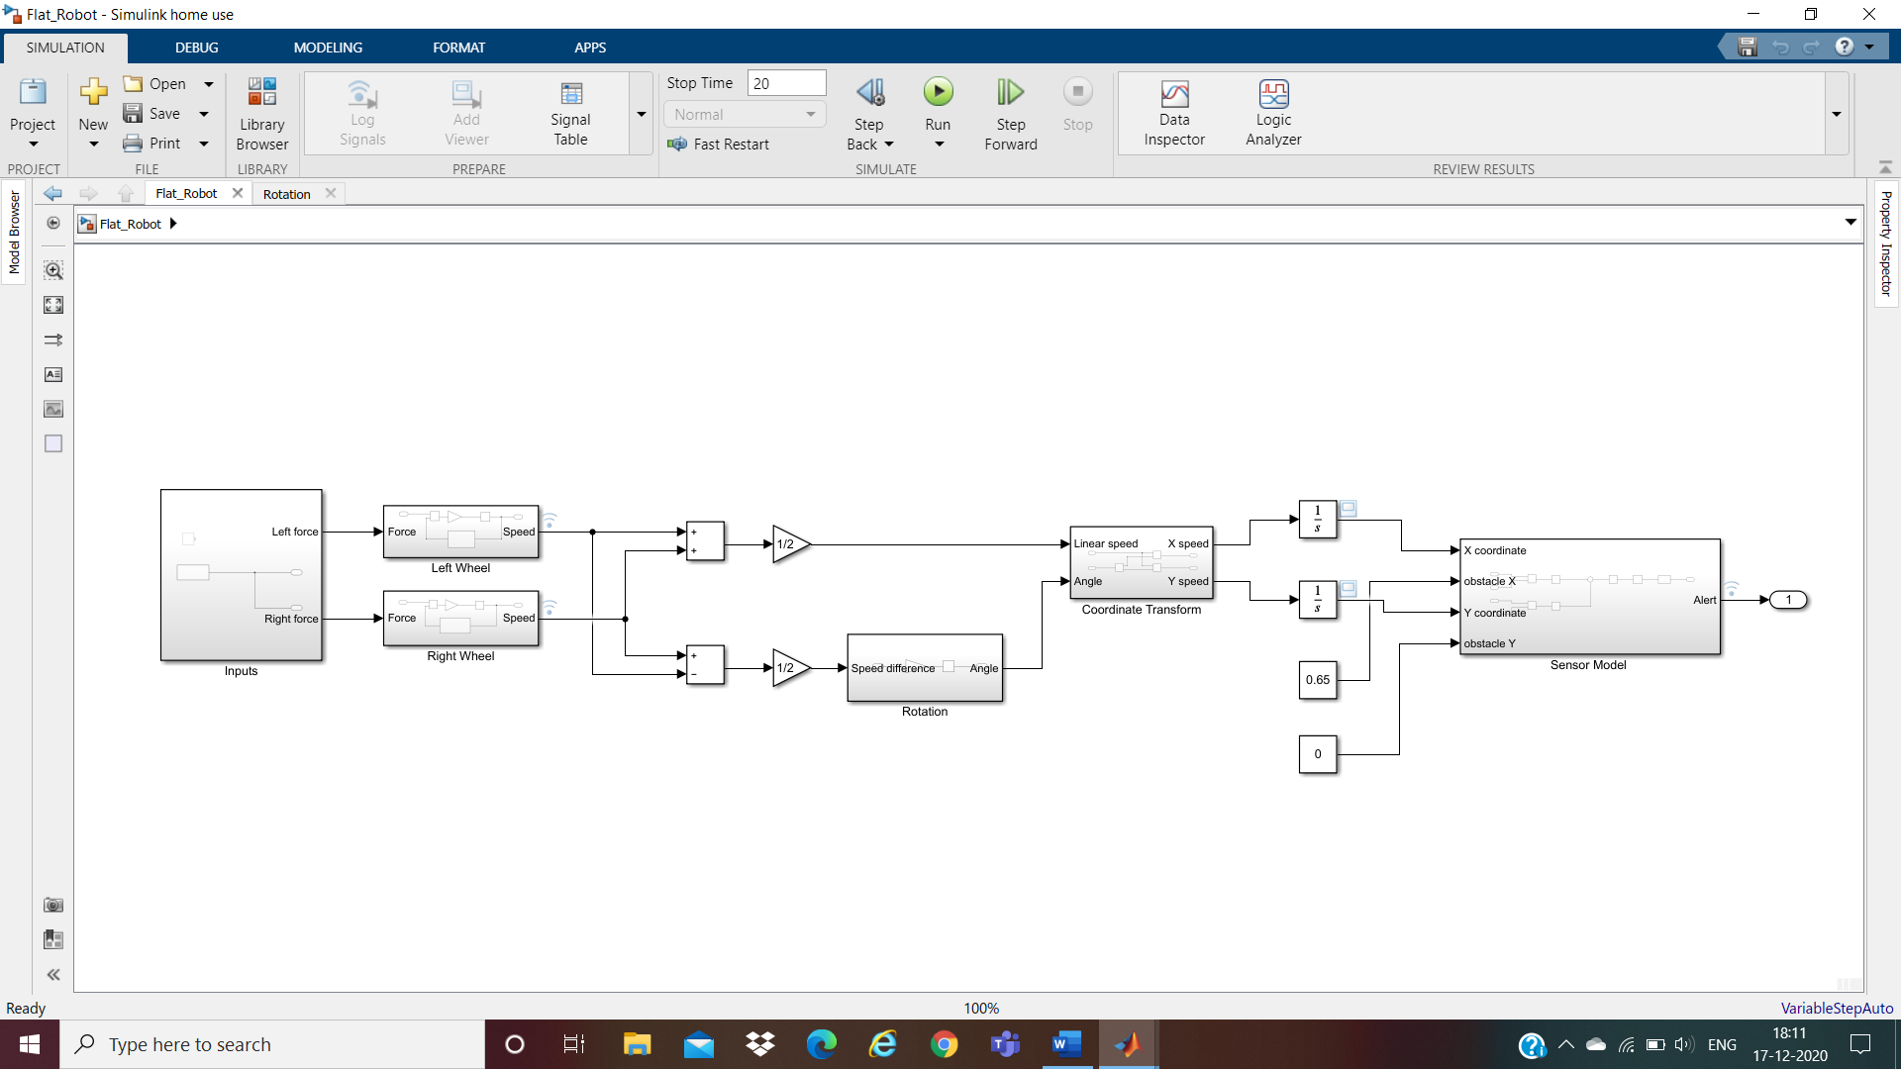

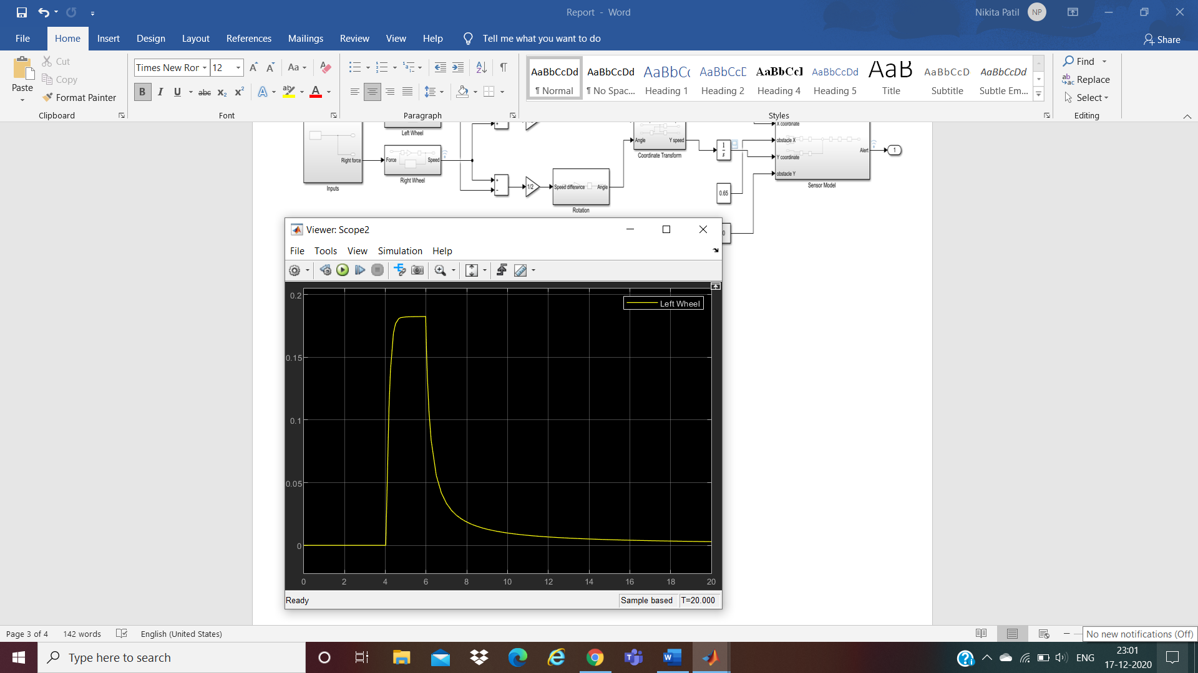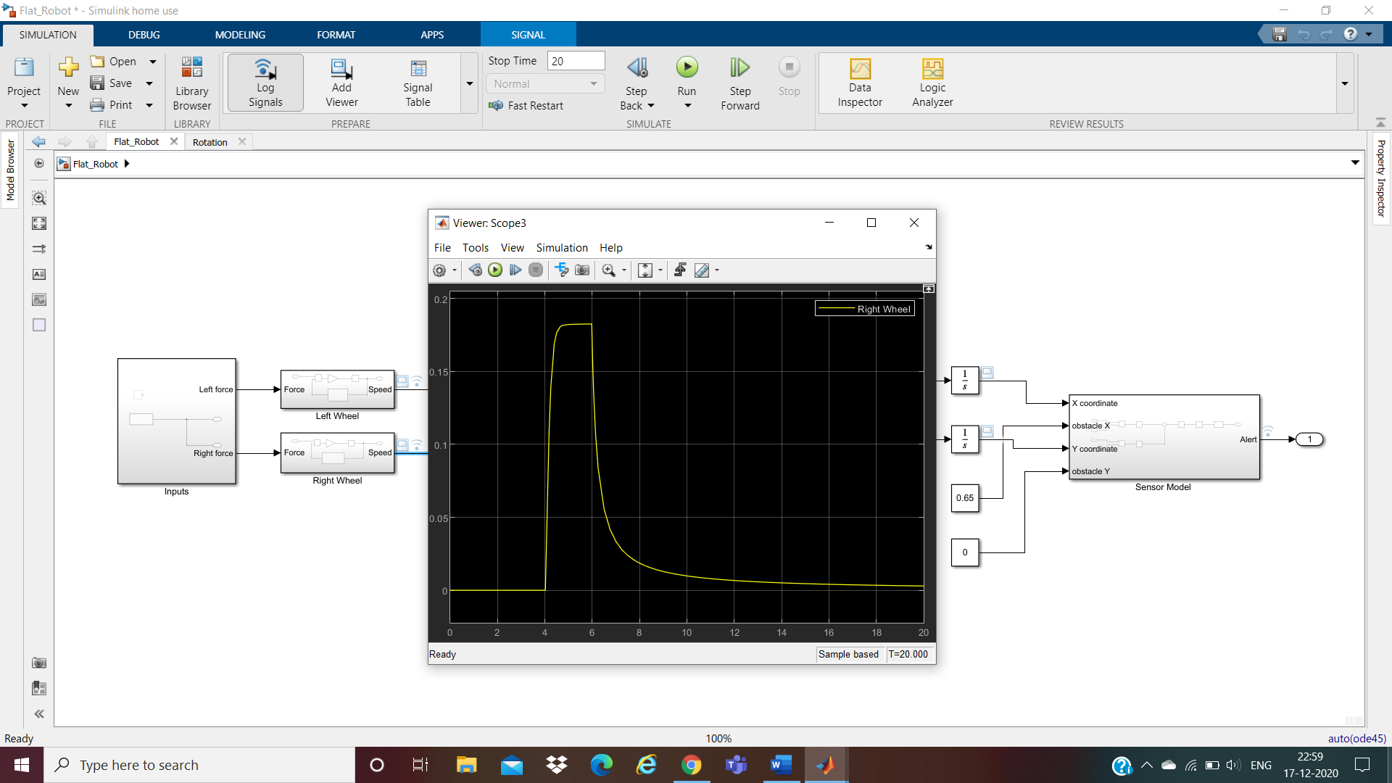**Outputs**

**Data Inspector**

