PERSONAL DATA

|  |  |
| --- | --- |
| **Name:** | Nikita Radzkov |
| **Date of Birth:** | 13/02/2001 |
| **Location:** | Belarus, Minsk |
| **Mobile:** | +375 (44) 472-12-17 |
| **E-mail:** | nikita.radzkou@gmail.com |
| **Skype:** | Login: live:.cid.6518487b600a78ad |
| **LinkedIn:** | [**https://www.linkedin.com/in/nikita-radzkov/**](https://www.linkedin.com/in/nikita-radzkov/) |

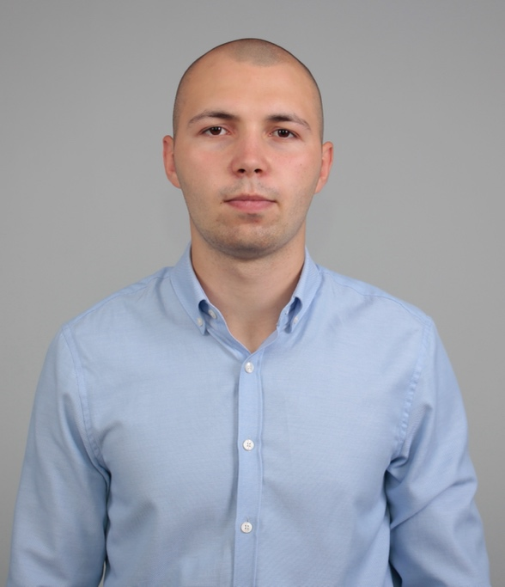

OBJECTIVE

|  |  |
| --- | --- |
| **Desired Position:** | QA Engineer / QA Automation Engineer |

SUMMARY OF QUALIFICATION

|  |
| --- |
| I am working QA engineer and JavaScript platform starting from the **september of 2020**.  My current stack of technologies is: **JS, HTML5, CSS3**, **Cypress, React, Redux, Jest** |

TECHNICAL SKILLS

* Functional Testing, Regression Testing, Automation Testing, Test Documentation, Integration Testing
* TestRail, JMeter, Pict, Postman, SoapUI, Jira, JSON, XML, Agile
* Cypress, HTML, CSS, SASS, Bootstrap, Tailwind, JS, React, Redux, Jest Node.js, Express,
* Gulp, Webpack, NPM, Yarn, Git, GitHub, SQL, MongoDB, Firebase
* Zeplin, Avocode, Figma, Sketch, Adobe XD, Adobe Photoshop, Webflow, Material UI
* Visual Studio Code, WebStorm, Sublime text

RELEVANT EXPERIENCE

* Communication with the customer
* Clarification of business requirements
* Projects and features development
* Tasks review and estimations
* Creating test documentation
* LANGUAGES
* English – Intermediate
* Russian – Native Speaker
* Belarussian – Native Speaker

EDUCATION

* 2018 – 2022 /University of Civil Protection, Prevention and Elimination of Emergency Situations Faculty / Engineer for the prevention and elimination of emergency situations (Industrial Safety Engineer) / Minsk, Belarus
* September 2020 – December 2020 / Educational Center for Programming and High Tech (IT-Academy) / Certificate of completion of the educational program of training courses for software testing (QA engineer)/ Minsk, Belarus

SEVERAL FACTS ABOUT ME

|  |
| --- |
| I prefer a healthy lifestyle like traveling, biking, jogging and so on.  I am interested in management theory, the natural sciences, sci fiction literature and history.  I am free of the bad habits.  I can find the optimal way from difficult situation by myself in short time period. |

COURSES AND CERTIFICATES

|  |  |  |  |  |  |  |  |  |  |  |
| --- | --- | --- | --- | --- | --- | --- | --- | --- | --- | --- |
| |  |  | | --- | --- | | **Course name:** | Software testing | | **Issued:** | Educational Center for Programming and High Tech (IT-Academy) | | **Years of study:** | 09/2020 – 12/2020 | | **Certificate license number:** | M-ST1-210-20-3 | | **Files:** | <https://raw.githubusercontent.com/NikitaRadzkou/radkov.cv/master/docs/Certificates/QA_1.jpg>  <https://raw.githubusercontent.com/NikitaRadzkou/radkov.cv/master/docs/Certificates/QA_2.jpg>  <https://raw.githubusercontent.com/NikitaRadzkou/radkov.cv/master/docs/Certificates/QA.pdf> | |

PROFESSIOANL EXPERIENCE

|  |  |
| --- | --- |
| **“Freelance”** | |
| **Company:** | “Freelance” |
| **Project Industry:** | Restaurant service |
| **Duration:** | 09/2020 – present time |
| **Description:** | Developed and tested web applications, landing pages, online stores, business card website. A regular customer is an online store for the sale of spare parts. Development of new functionality for the store, testing of new components, summarizing the work done. |
| **Position:** | Software Test Engineer / Web Developer |
| **Responsibilities:** | * Development web applications * Development of landing pages * Development of online stores * Development of business card websites * Product testing assistance * Communication with the customer |
| **Tools & Technologies:** | **Platforms:** .JS  **Tools:** Visual Studio Code, Docker, Git, TestRail, Jira  **Languages & Technologies:** JavaScript, React, Redux, Node.js, Express, MongoDB, Postman, SoapUI |

|  |  |
| --- | --- |
| **“Trainee full stack JavaScript developer”** | |
| **Company:** | “Itransition” (Itransition Group) |
| **Company Location:** | Belarus, Minsk |
| **Duration:** | 09/2021 – 11/2021 |
| **Description:** | I worked Trainee full stack javascript developer. Created web applications on MERN platform |
| **Position:** | Trainee full stack JavaScript developer |
| **Overall Team Size:** | 3 backend developers, 5 frontend developers, 2 QA engineer |
| **Responsibilities:** | * User interface prototyping and implementation * Fixing some small bugs in front-end and back-end * Learning MERN platform and related technologies |
| **Tools & Technologies:** | **Platforms:** .JS  **Tools:** Visual Studio Code, Docker, Git  **Languages & Technologies:** JavaScript, React, Redux, Node.js, Express, MongoDB |